SUPPLEMENTARY MATERIAL

A pipeline for improved 16S rRNA gene-based phylogeny and diversity analyses of Bacteria and Archaea

Tomeu Viver¹, Pere Palmer², Ralf Westram³, Esteban Bustos-Caparros^{1,4}, Juan Francisco Gago¹, Jaime González-Méndez¹, Mercè Llabrés², Wolfgang Ludwig⁵, Rudolf Amann⁵, Ramon Rossello-Mora¹

- Marine Microbiology Group, Department of Animal and Microbial Biodiversity, Mediterranean Institute for Advanced Studies (IMEDEA, CSIC-UIB), Esporles, Spain.
- Department of Mathematics and Computer Science, University of the Balearic Islands, Palma 07122, Spain.
- Ribocon GmbH, Fahrenheitstraße. 1, D-28359 Bremen, Germany
- Nordcee, Department of Biology, University of Southern Denmark, 5230 Odense, Denmark
- Department of Molecular Ecology, Max Planck Institute for Marine Microbiology, Bremen, Germany

All precalculated data for this table can be found at: https://bioinfo.uib.es/ltp/opucheck

Supplementary Text Stxt1: Recommendations for accurate tree reconstructions
For an adequate treeing approach for taxonomic analyses, we recommend the following steps:

- Align the query sequences using the universal alignment implemented in the LTPlus. If you encountered close relative sequences using blast in public databases that do not appear in the LTPlus, just include them in your query list.
- Insert the aligned sequences in the preexisting tree that is available in the LTPlus database.
- Select the closest relative type sequences as well as other reference sequences that may appear in the vicinity of the query sequences.
- Select only high-quality sequences covering the almost complete gene stretch for the treeing approach. The non-qualified sequences should not be used for de novo reconstructions.
- With the selection of sequences, we strongly recommend generating multiple trees with different algorithms. Our major recommendation is to always use the filters 'termini' and 'gap_q5_95_08may24', and for all conservational filter combinations in independent trees using both -parsimony and FastTree algorithms independently.
- Generate your final tree using the ARB consensus tree tool.
- Add, using the ARB-parsimony tool all sequences ranked as low quality into your calculated tree. This tool conserves the topology and places the query sequences in its best position in accordance with the Parsimony algorithm.
- In case of dubious treeing observations, modify the dataset by removing bad sequences, balancing the number of sequences in the independent different branches and evaluate the use of different conservational filters for a stable topology.

Supplementary Figure SF1: Examples of aligned metagenomic reads: The figure shows aligned reads within the universal alignment showing distinct positions in the 16S rRNA gene stretch. Highlighted in yellow are the full-length reference sequences with which the different reads affiliate. In Bustos-Caparrós et al., 2023, the read length mean was 136± 22 nucleotides and the median 148 nucleotides.

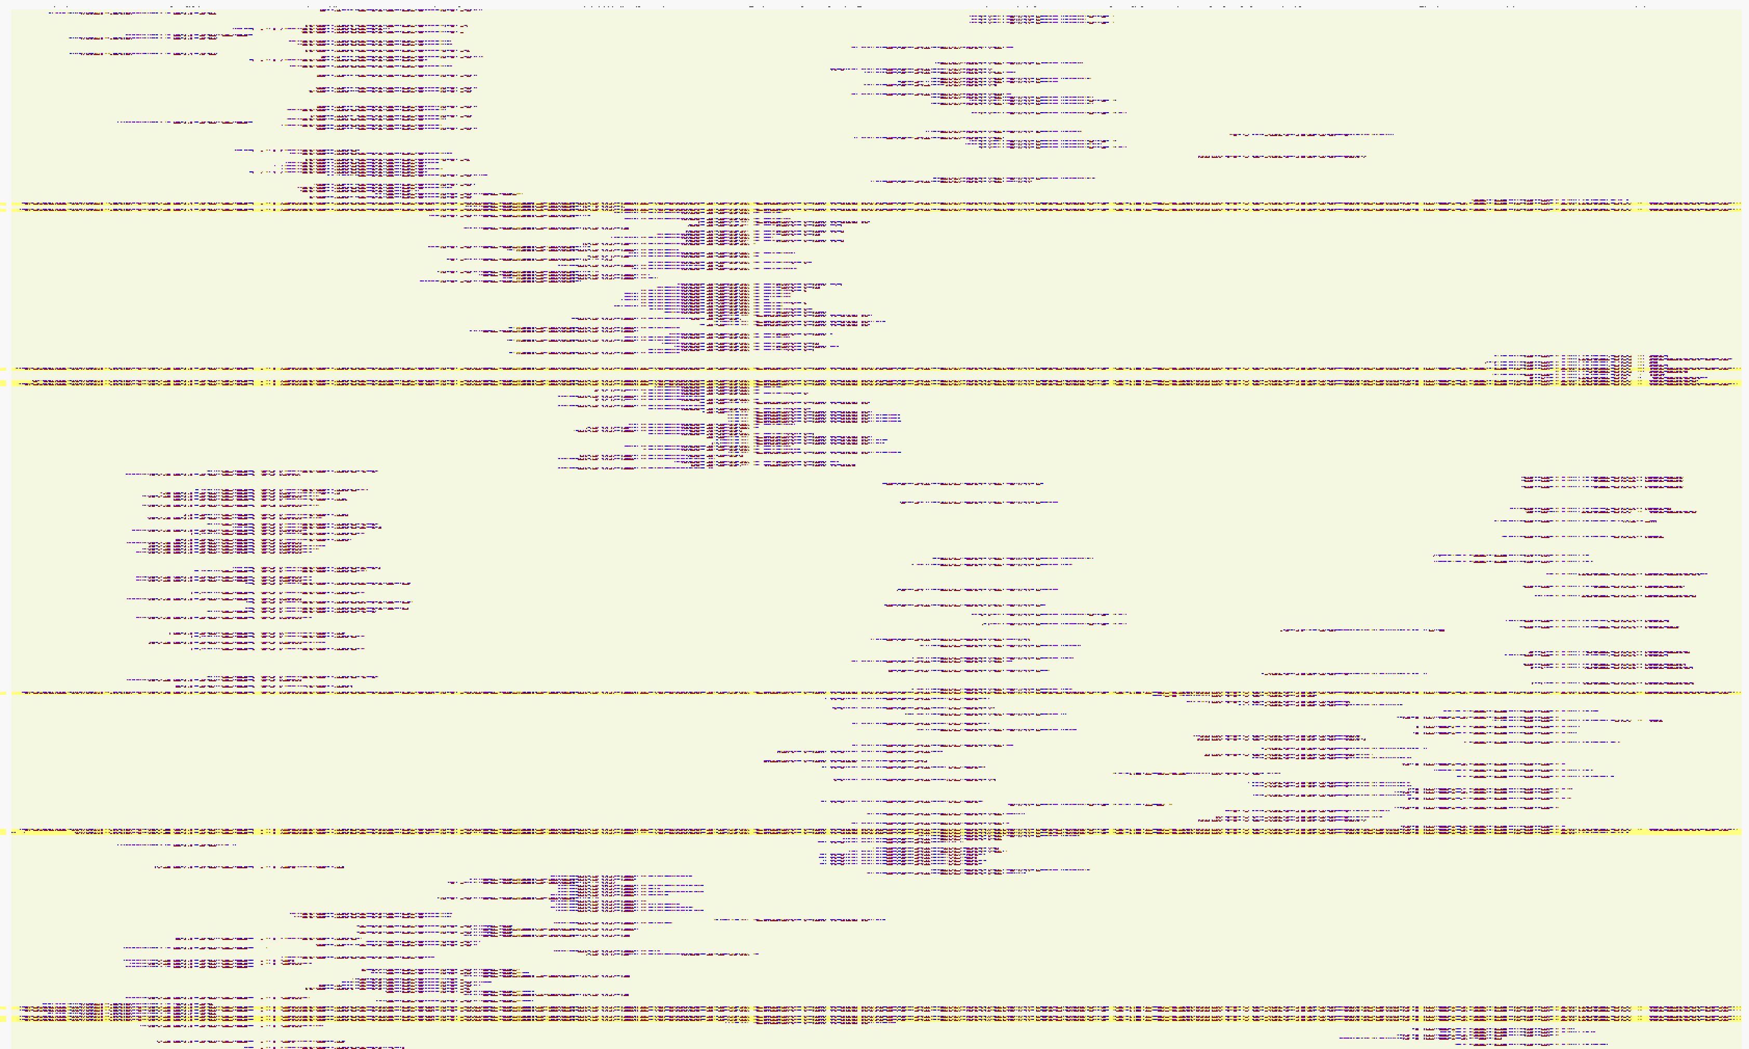

Supplementary Table ST1: statistics of kept and discarded OTU, ASV o metagenomic read sequences due to their long branches or ungrouped nature from published and unpublished data (part of the data collection of the IMEDEA). The last column of discarded OTUs is calculated by removing the eukaryote identified reads or amplicons.

 | Platform | Total | Kept | Discarded | Discarded % | Euk | Euk %
Mice gut  (Pomar et al., 2023) | Illumina | 7780 | 7620 | 165 | 2.12 | 8 | 0.10
Fish gut  (Viver et al., 2023) | Illumina | 4959 | 4657 | 308 | 6.21 | 22 | 0.44
Hypersaline sediments  (Font et al., 2021) | Illumina | 6767 | 6259 | 517 | 7.64 | 12 | 0.18
Sponge microbiome  (Glasl et al.,M 2024) | Illumina | 514 | 450 | 66 | 12.84 | 10 | 1.95
Stalagmite  (Unpublished) | Illumina | 4382 | 4113 | 269 | 6.14 | 2 | 0.05
Brines  (Bustos-Caparros, unpublished) | Illumina | 1506 | 1403 | 105 | 6.97 | 3 | 0.20
Arctic samples  (Unpublished) | Illumina | 6303 | 5910 | 396 | 6.28 | 7 | 0.11
Brines  (Liebana et al., unpublished) | Illumina | 2812 | 2705 | 107 | 3.81 | 0 | 0.00
Sandy sediments  (Heritier-Robins et al., 2021) | Illumina | 4094 | 3536 | 558 | 13.63 | 0 | 0.00
Helgoland Sand  (Miksch et al., 2021) | Illumina | 4999 | 4982 | 17 | 0.34 | 0 | 0.00
Svalbard Sand  (Miksch et al., 2021) | Illumina | 4985 | 4933 | 56 | 1.12 | 6 | 0.12
Marine sediments and sea cucumber gut microbiomes  (Maritan et al., 2025) | Illumina  (7K A subs) | 7000 | 5630 | 1416 | 20.23 | 175 | 2.50
Marine sediments and sea cucumber gut microbiomes  (Maritan et al., 2025) | Illumina  (7K B subs) | 7000 | 5586 | 1473 | 21.04 | 172 | 2.46
Rabbit gut  (Biada et al., 2025) | Illumina | 1456 | 1437 | 19 | 1.30 | 0 | 0.00
Epilithic biofilms  (Anderson et al., 2025) | Illumina | 5871 | 5182 | 697 | 11.87 | 31 | 0.53
Soil microbiome  (Veselovsky et al., 2025) | Illumina  (7K A subs) | 6942 | 6549 | 393 | 5.66 | 0 | 0.00
Soil microbiome  (Veselovsky et al., 2025) | Illumina  (7K B subs) | 6852 | 6428 | 424 | 6.19 | 0 | 0.00
Rabbit gut  (Biada et al., 2025) | PacBio | 1892 | 1809 | 83 | 4.39 | 0 | 0.00
Epilithic biofilms  (Anderson et al., 2025) | PacBio  (10K A subs) | 10082 | 8986 | 1155 | 11.46 | 94 | 0.93
Epilithic biofilms  (Anderson et al., 2025) | PacBio  (10K B subs) | 10115 | 8860 | 1305 | 12.90 | 86 | 0.85
Poultry litter  (Ivulic et al., 2022) | PacBio | 2172 | 1759 | 414 | 19.06 | 55 | 2.53
Soil microbiome  (Veselovsky et al., 2025) | PacBio  (7K B subs) | 6854 | 5595 | 1711 | 24.96 | 552 | 8.05
Soil microbiome  (Veselovsky et al., 2025) | PacBio  (7K B subs) | 6928 | 5674 | 1737 | 25.07 | 575 | 8.30
Human Gut  (Buetas et al., 2024) | PacBio | 4745 | 4294 | 451 | 9.50 | 1 | 0.02
Rabbit gut  (Biada et al., 2025) | Nanopore | 4147 | 3740 | 407 | 9.81 | 0 | 0.00
Soil microbiome  (Veselovsky et al., 2025) | Nanopore  (7K A subs) | 6840 | 5802 | 1581 | 23.11 | 597 | 8.73
Soil microbiome  (Veselovsky et al., 2025) | Nanopore  (7K B subs) | 6654 | 5652 | 1502 | 22.57 | 570 | 8.57
Gut mock microbiome  (Curry et al., 2022) | Nanopore  (10K A subs) | 9759 | 8134 | 2157 | 22.10 | 622 | 6.37
Gut mock microbiome  (Curry et al., 2022) | Nanopore  (10K B subs) | 9838 | 8330 | 2021 | 20.54 | 611 | 6.21
Gut mock microbiome  (Curry et al., 2022) | Nanopore  (10K C subs) | 9759 | 7883 | 2371 | 24.30 | 619 | 6.34
Gut mock microbiome  (Curry et al., 2022) | Nanopore  (10K D subs) | 9985 | 8226 | 2274 | 22.77 | 606 | 6.07
Gut mock microbiome  (Curry et al., 2022) | Nanopore  (10K E subs) | 9798 | 7855 | 2430 | 24.80 | 602 | 6.14
Hypersaline brines  (Bustos-Caparros et al., 2024) | Metagen. reads | 7968 | 7250 | 754 | 9.46 | 44 | 0.55
Hypersaline brines  (Bustos-Caparros et al., 2024) | Metagen. contigs | 1858 | 1758 | 208 | 11.19 | 128 | 6.89
Hypersaline brines  (Gonzalez-Mendez, unpubl.) | Metagen. reads | 4763 | 4294 | 474 | 9.95 | 6 | 0.13
Hypersaline brines  (Gonzalez-Mendez, unpubl.) | Metagen. contigs | 255 | 234 | 23 | 9.02 | 7 | 2.75
Ground water  (Gago et al.,2024) | Metagen. reads | 17055 | 14762 | 2308 | 13.53 | 30 | 0.18
Ground water  (Gago et al.,2024) | Metagen. contigs | 817 | 565 | 254 | 31.09 | 5 | 0.61

Supplementary Figure SF2: Examples of good sequences to keep. The figure shows the 5’ end of the aligned amplicons of a selection of sequences that are to be kept for the analysis. In this figure, the number of unpaired bases (having a symbol # under the nucleotide) is low, and in general, the alignment seems adequate. Yet, the alignment of some sequences could be manually improved, but in general, the use of the gap filter would remove some of the wrong placed bases in the homologous sites.

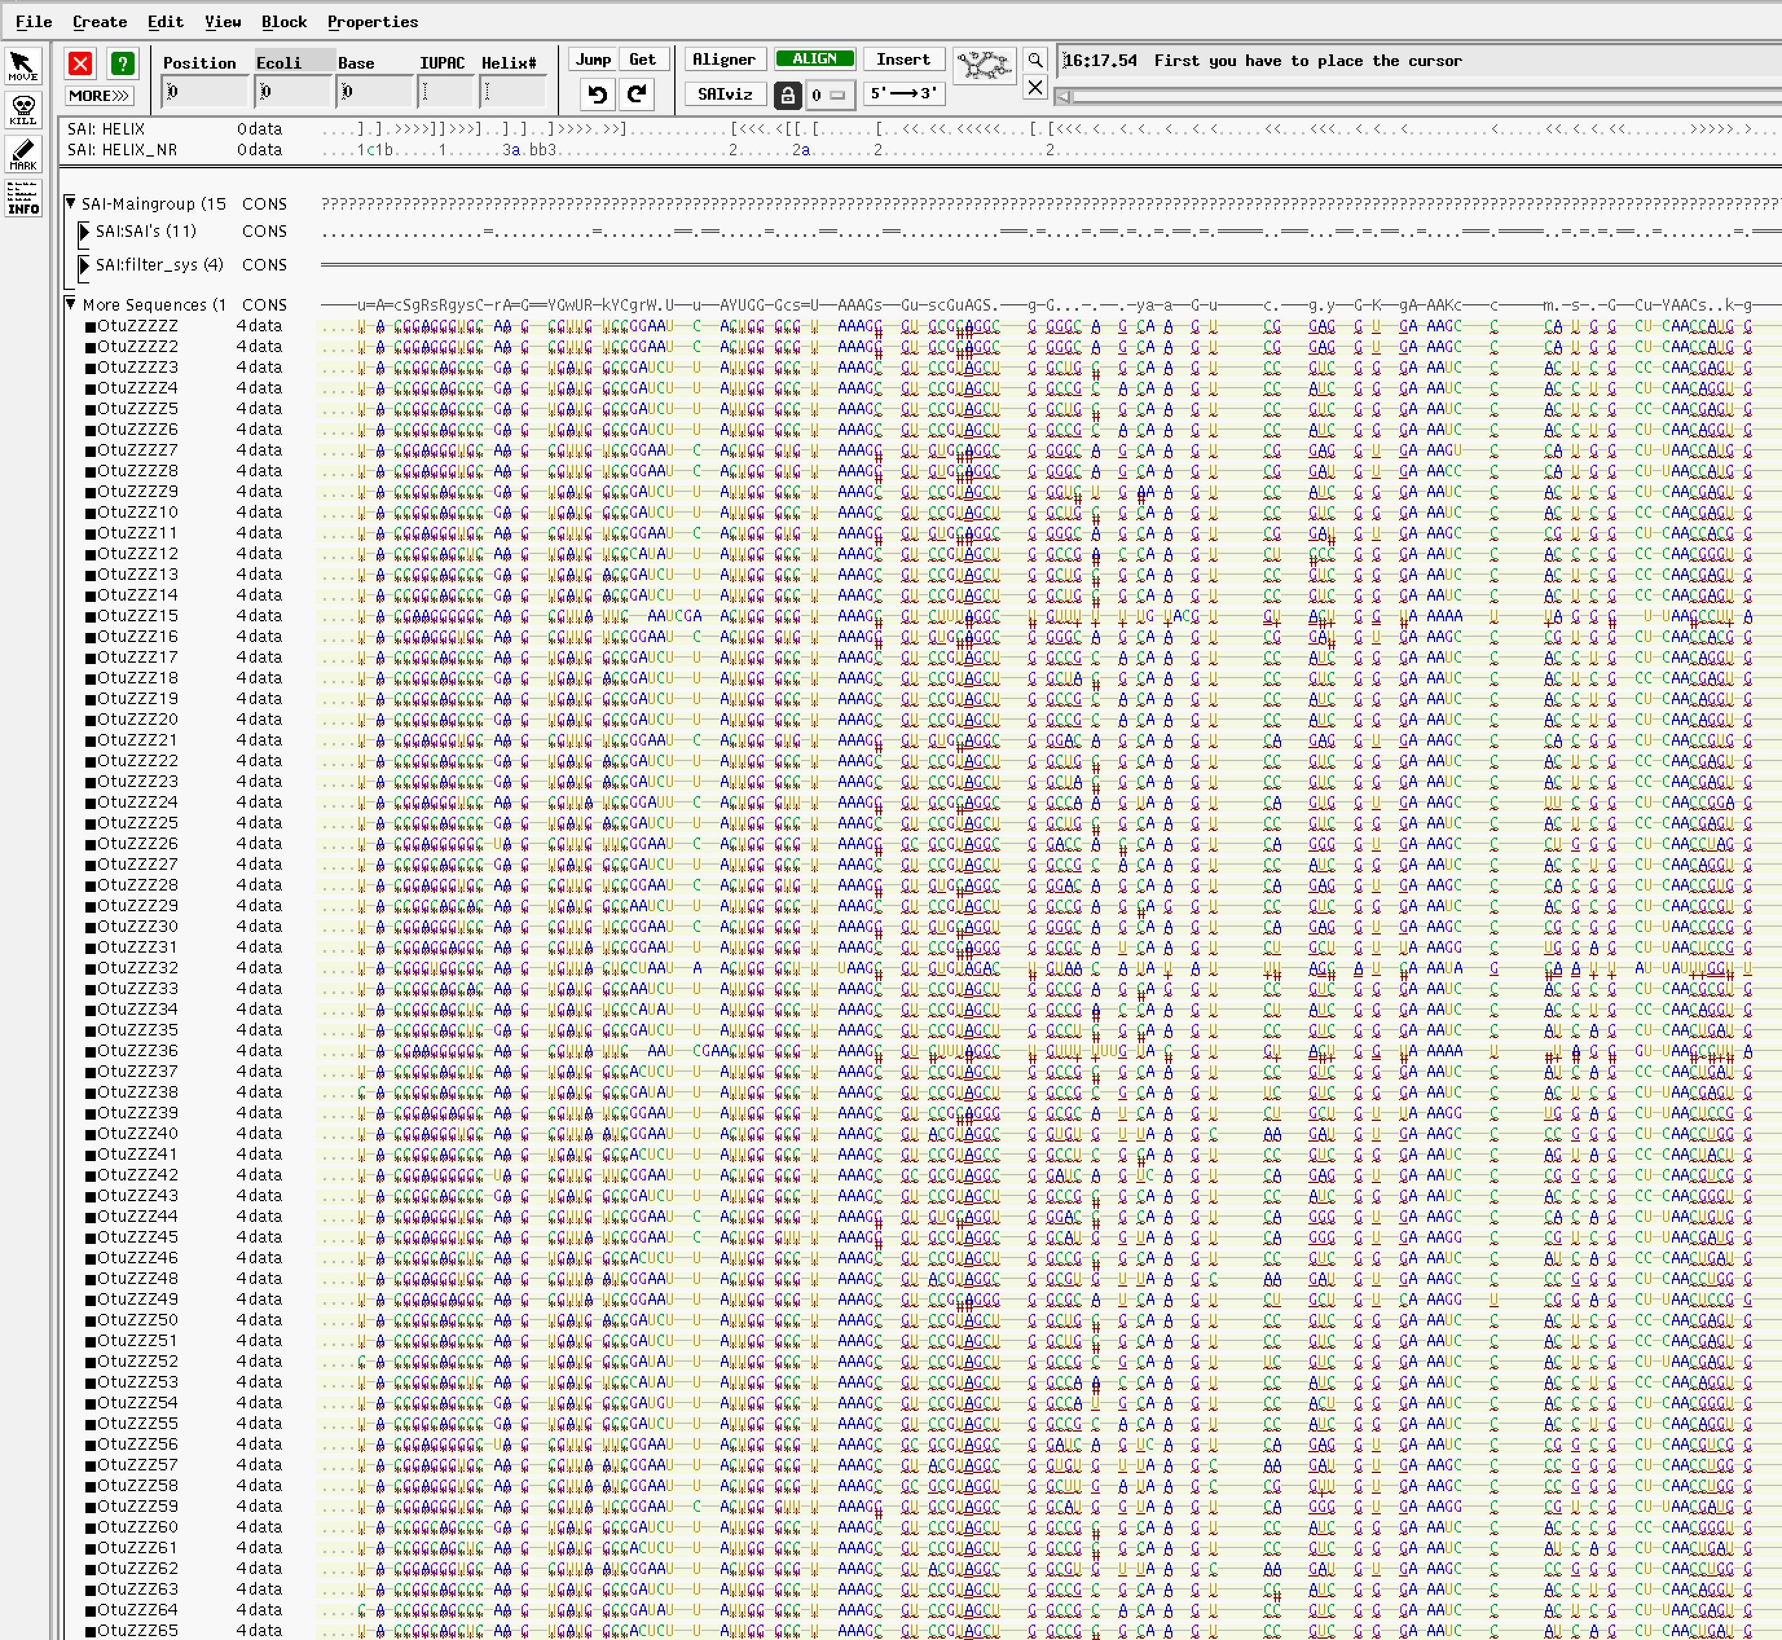

Supplementary Figure SF3: Examples of bad sequences to remove. The figure shows the 5’ end of some sequences that were aligned out from the specific correct homologous sites. In general, these unaligned sequences belonged to 18S rRNA genes, not taken into account in the LTPlus.

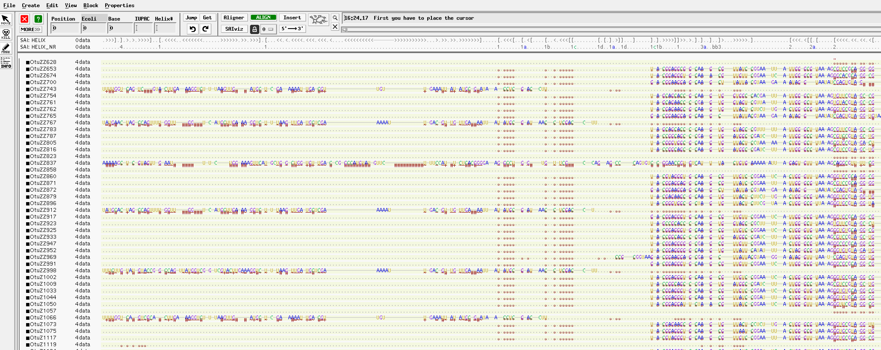
Supplementary Figure SF4: Examples of bad sequences to remove. The figure shows the 5’ end of some sequences which alignment shows a large portion of wrong pairing. For the number of mismatches that seem to violate the helix pairing, we believe that may be chimera fruit from the wrong assembly during the sequencing process.
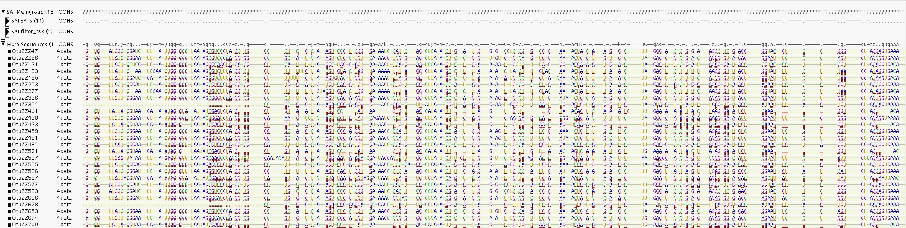
Supplementary Figure SF5: Examples of bad sequences to remove and adequate to keep. Sequences aligned out of the Illumina amplified range may not be true 16S rRNA gene sequences. The majority of the sequences align within the amplified stretch and unless the alignments are bad, the sequences are kept. Seq obtained from Maritan et al., 2025, which resulted from the amplification of extracted DNA from sea cucumber gut microbiome.

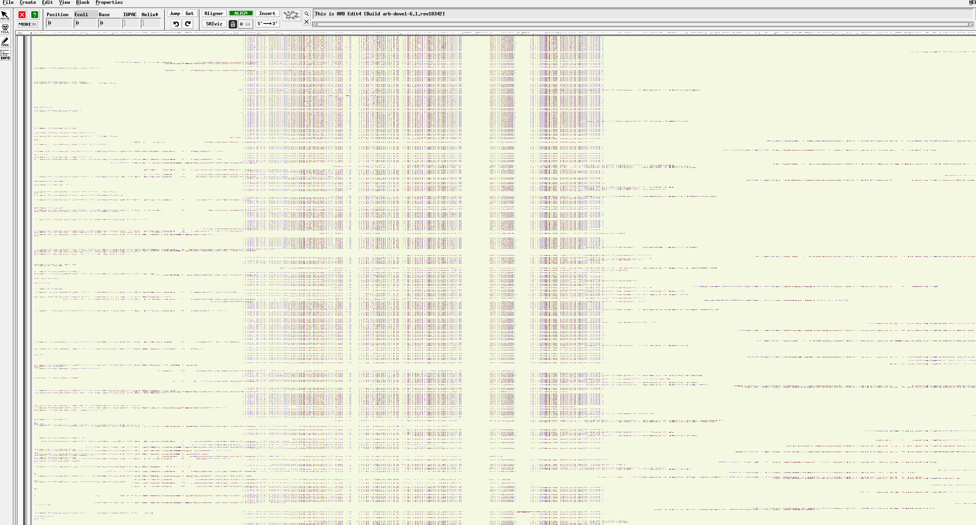
Supplementary Figure SF6: Examples of bad sequences to remove and adequate to keep. Sequences aligned out of the Illumina amplified range may not be true 16S rRNA gene sequences. The majority of the sequences align within the amplified stretch and unless the alignments are bad, the sequences are kept. Seq obtained from Glasl et al., 2024, which resulted from the amplification of extracted DNA from sponge microbiome.

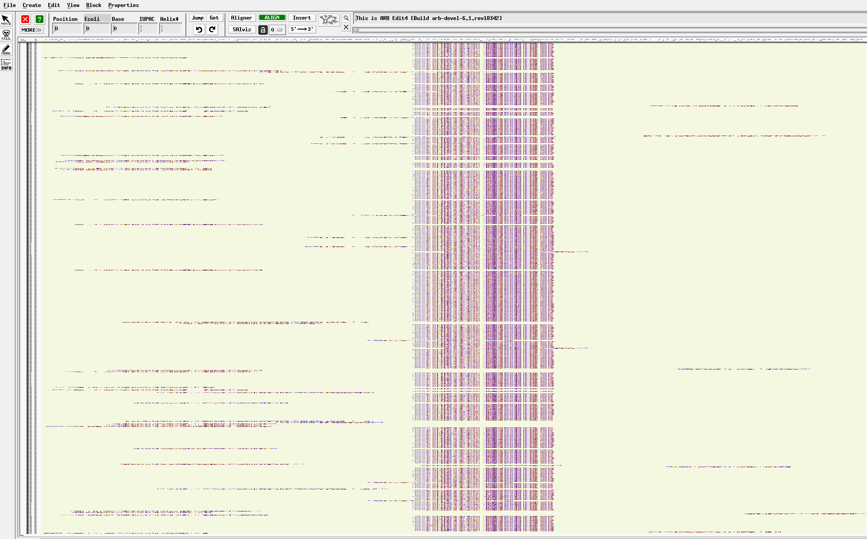

Supplementary Figure SF7: Example of optimal amplicon sequences affiliating with their next relatives in the LTPlus. The images exemplify how different OPUs with are nested depending on their relative internal distances, and that (in general) most of the sequences affiliate with a very short branch with closest relatives. The short distance is due to the short length of the amplicon lacking enough sequence information. Longer branches may indicate alignment problems.

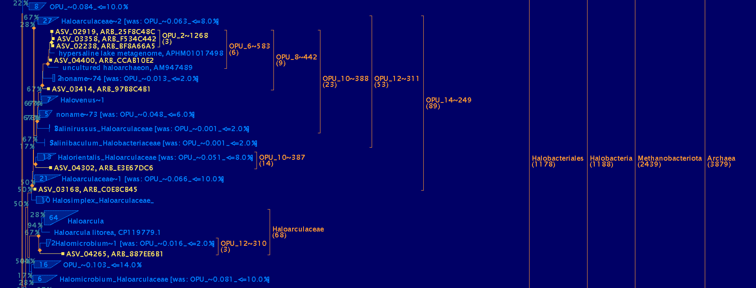

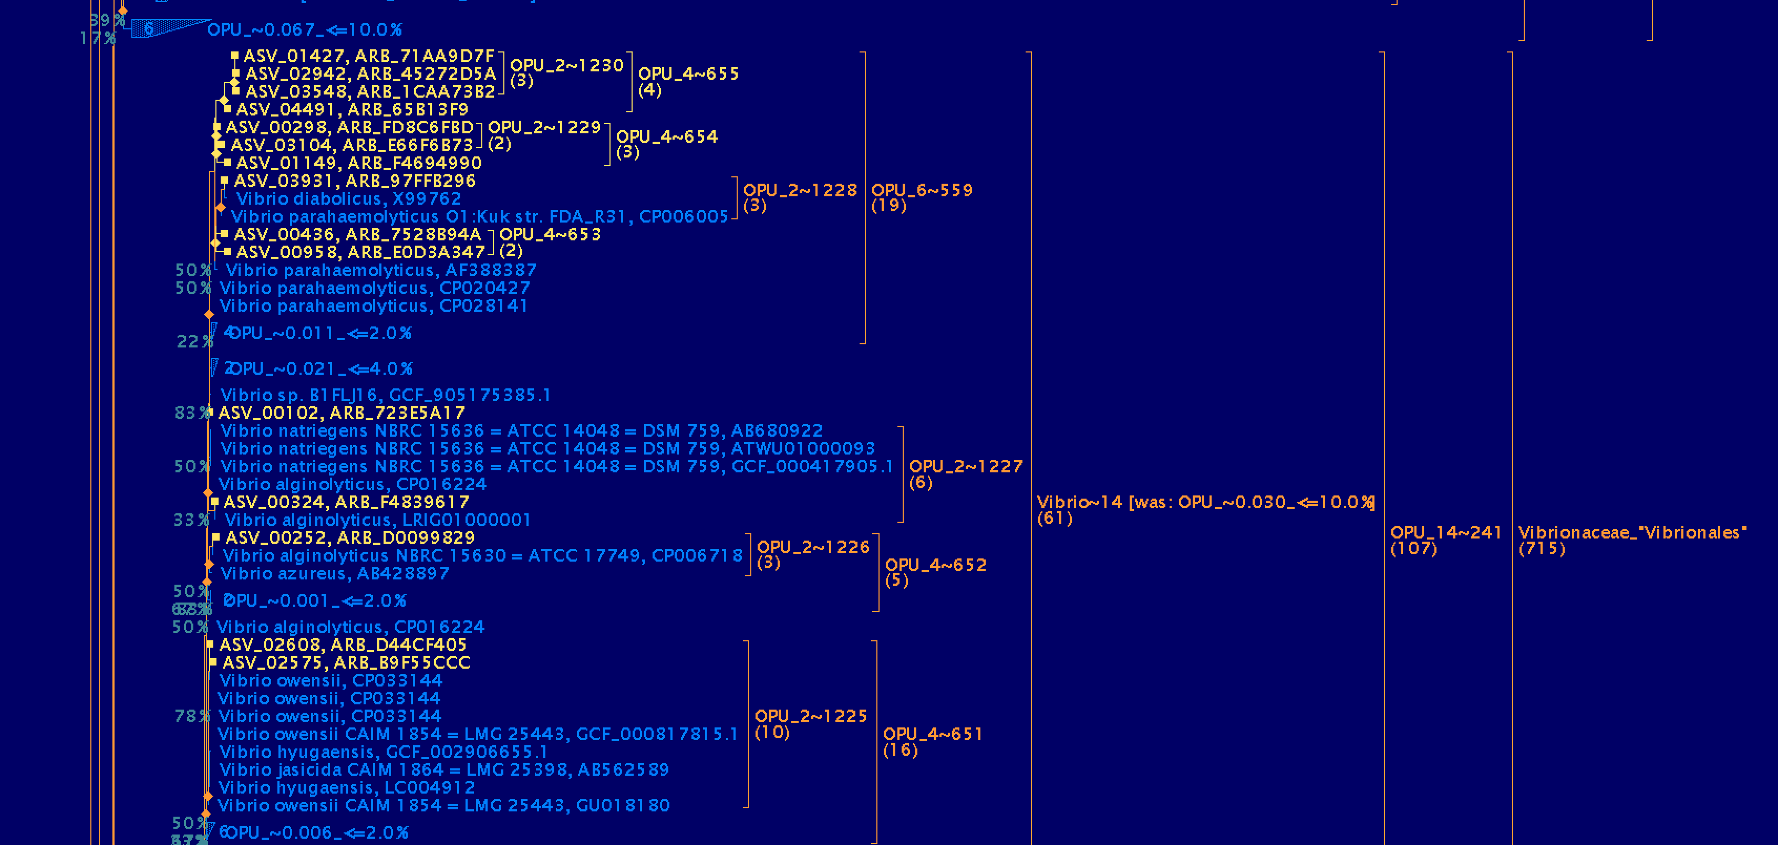

Supplementary Figure SF8: Example of sequences of Eukarya that have not been removed from the tree. The macros not always detect non prokaryotic amplicon sequences to be removed. In general, if belonging to an eukaryote, the sequences affiliate outside both prokaryotic domains as the LTPlus does not take into account eukaryote 18S rRNA gene sequences.
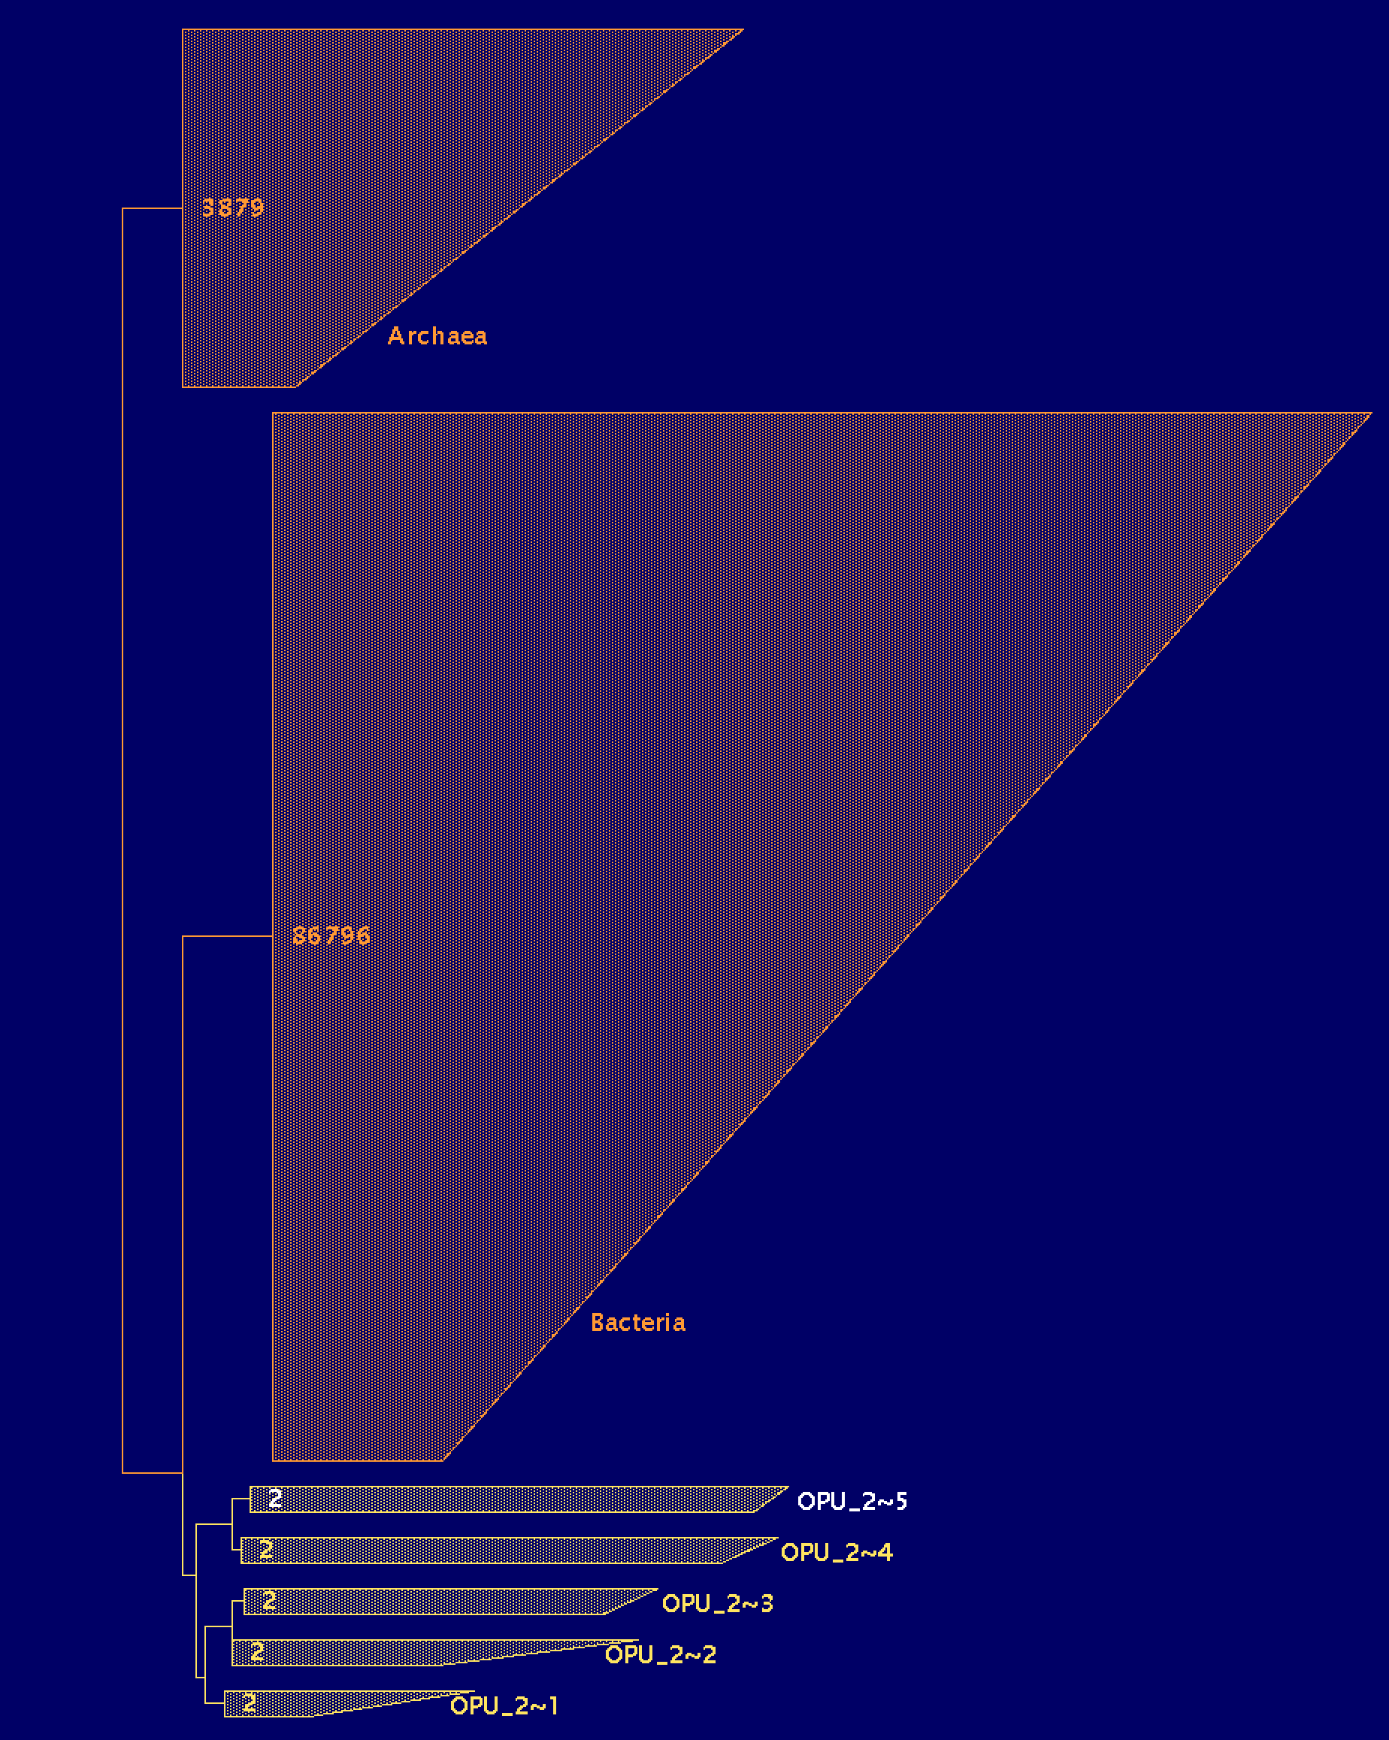

Supplementary Figure SF9: Example of no 16S rRNA gene amplicon sequence. Among the amplicon sequences, there were some that affiliate always with long branches and need to be removed from the study. This example of ASV _00386 seems to affiliate with uncultured members of the Selenomonadaceae (A). However, the alignment itself was wrong and did not align within the homologous base range expected (B), and the blast results did not render any close relative sequence using megablast, and only some similar sequences (70% identity) with some sequences of a published genome (in this case OZ006997.1) were identified using discontinuous megablast (C).

A) tree excerpt showing the position of the sequence ASV_00386 with long branches affiliating within the Selenomonadaceae.

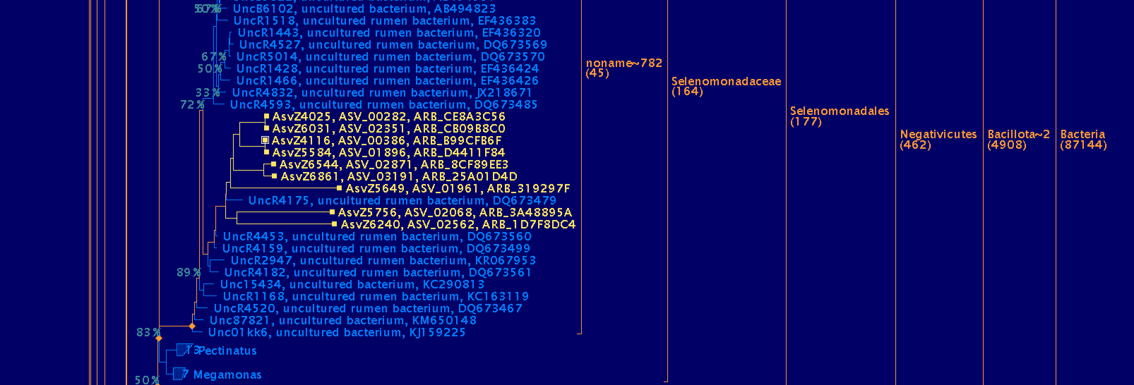

B) sequence alignment showing that ASV_00836 (highlighted in yellow) is not aligned with the expected homologous base range for which the amplicon sequences were generated.

C) discontinuous megablast results showing that the read does not match a 16S rRNA gene sequence, but some sequences in the (in this case) genome of a Ligilactobacillus.

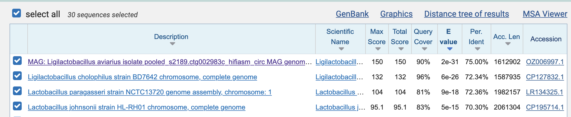

Supplementary Figure SF10: Example of amplicon reads sequenced using the Illumina (A and C) and Nanopore (B and D) platforms, and inserted in the same phylogenetic branch showing different branch lengths. A and B show the sequence insertion in the tree and C and D show the alignments with the reference sequences highlighted in yellow. (data from Veselovsky.et al., 2025).
A | B
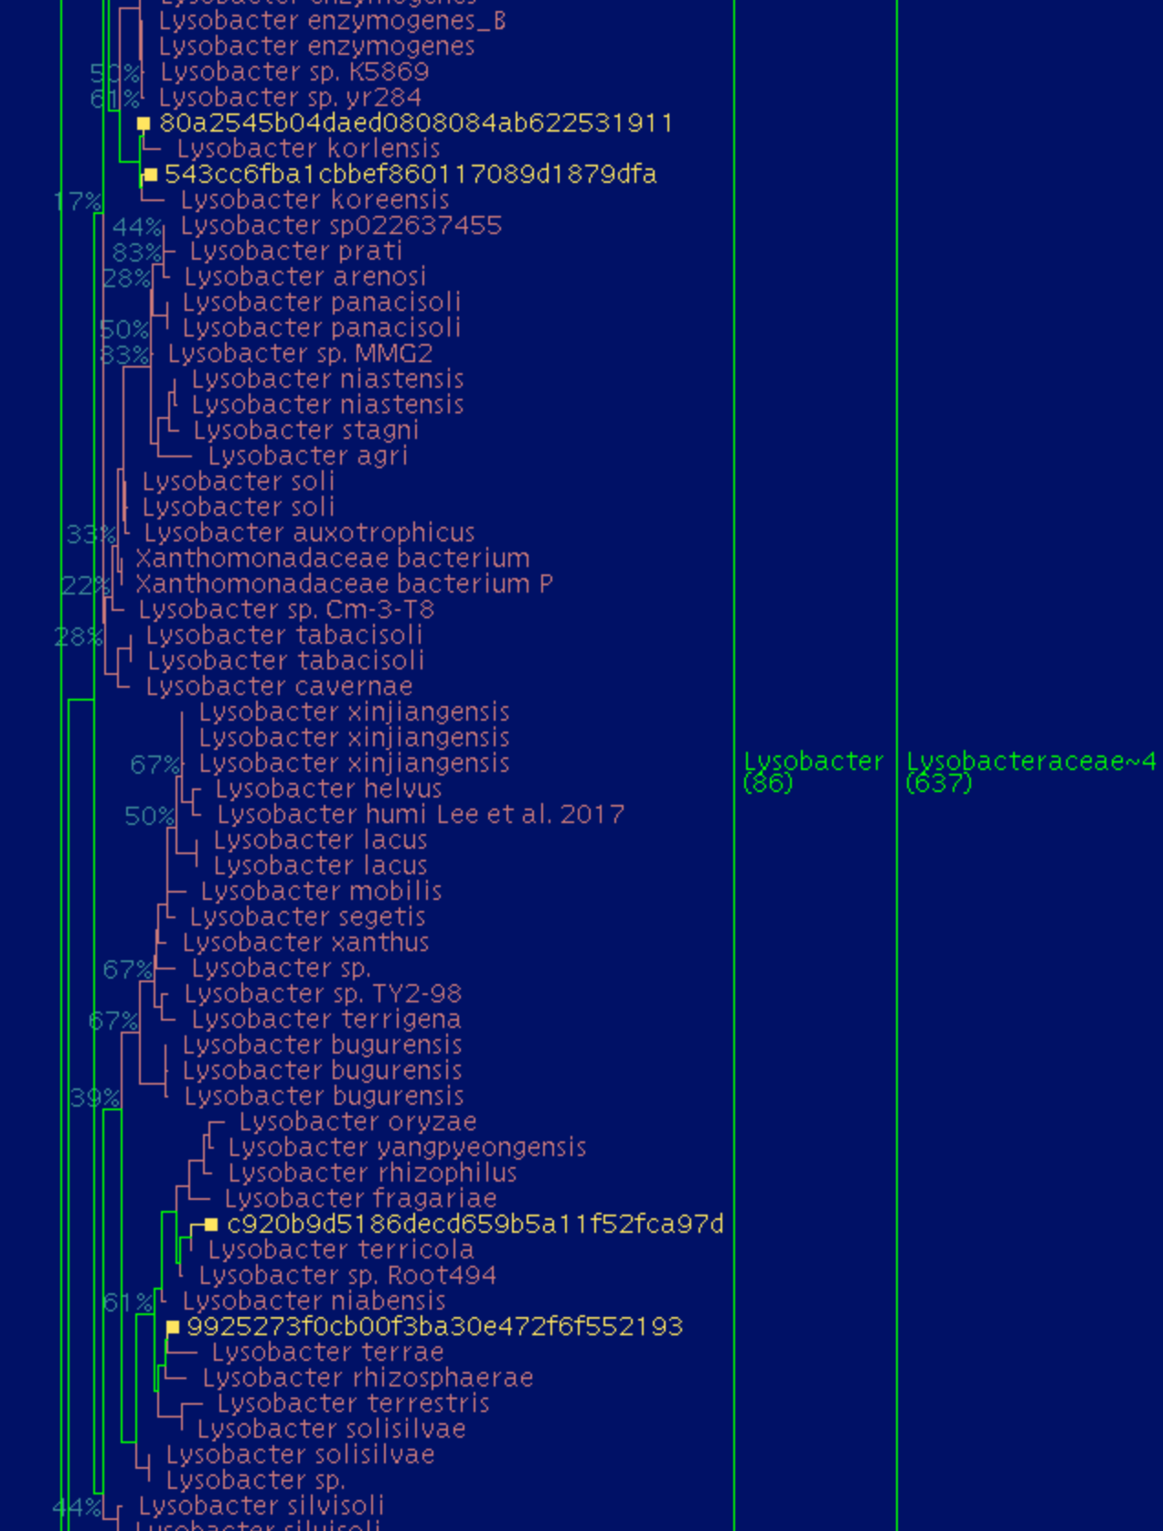 | 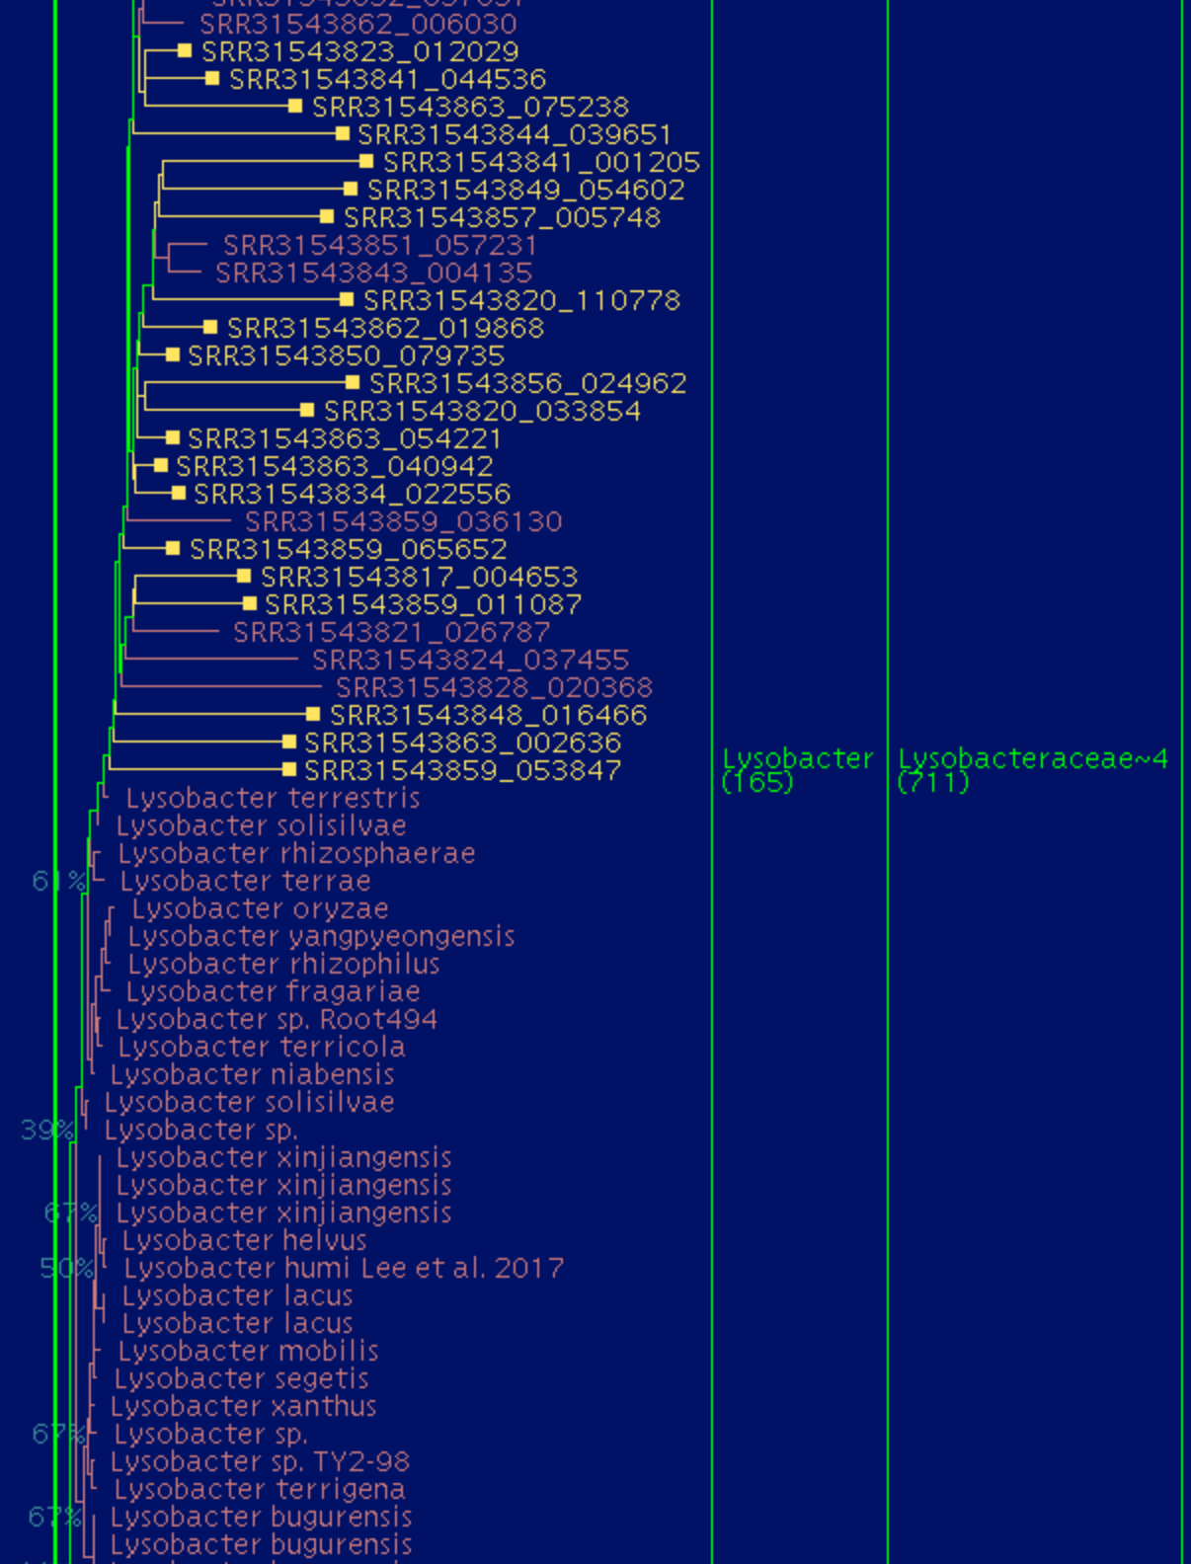
C
D

Supplementary Text Stxt2: Recommendations for manual evaluation of the OTUs that had been removed from the approach
In general, the affiliation of most sequences seems to be correct. There is always a percentage <15% of the sequences that are discarded. It is highly recommendable to manually inspect the tree positions of these discarded sequences, just because the program may not be infallible and either some discarded sequences could be good and usable amplicon reads. This may be especially relevant if the discarded sequences belong to relevant OTUs or ASVs. However, in our experience these discarded reads may not modify significantly the final results as in general, relevant OPUs representing the most abundant taxa are formed by a large number of amplicon sequences rather than being singletons that appear unclustered.
In addition to this, it is recommended to manually supervise the tree to detect sequences exhibiting long branches that had not been discarded, which should be removed as they may lead to misinterpretations. Such actions would help in fine-tuning the results, but in general, the output generated after automatization would render good results to be analyzed.
Example of inadequate aligned and bad aligned Pacbio sequences (Biada et al., ) sea Rabbit gut microbiome.

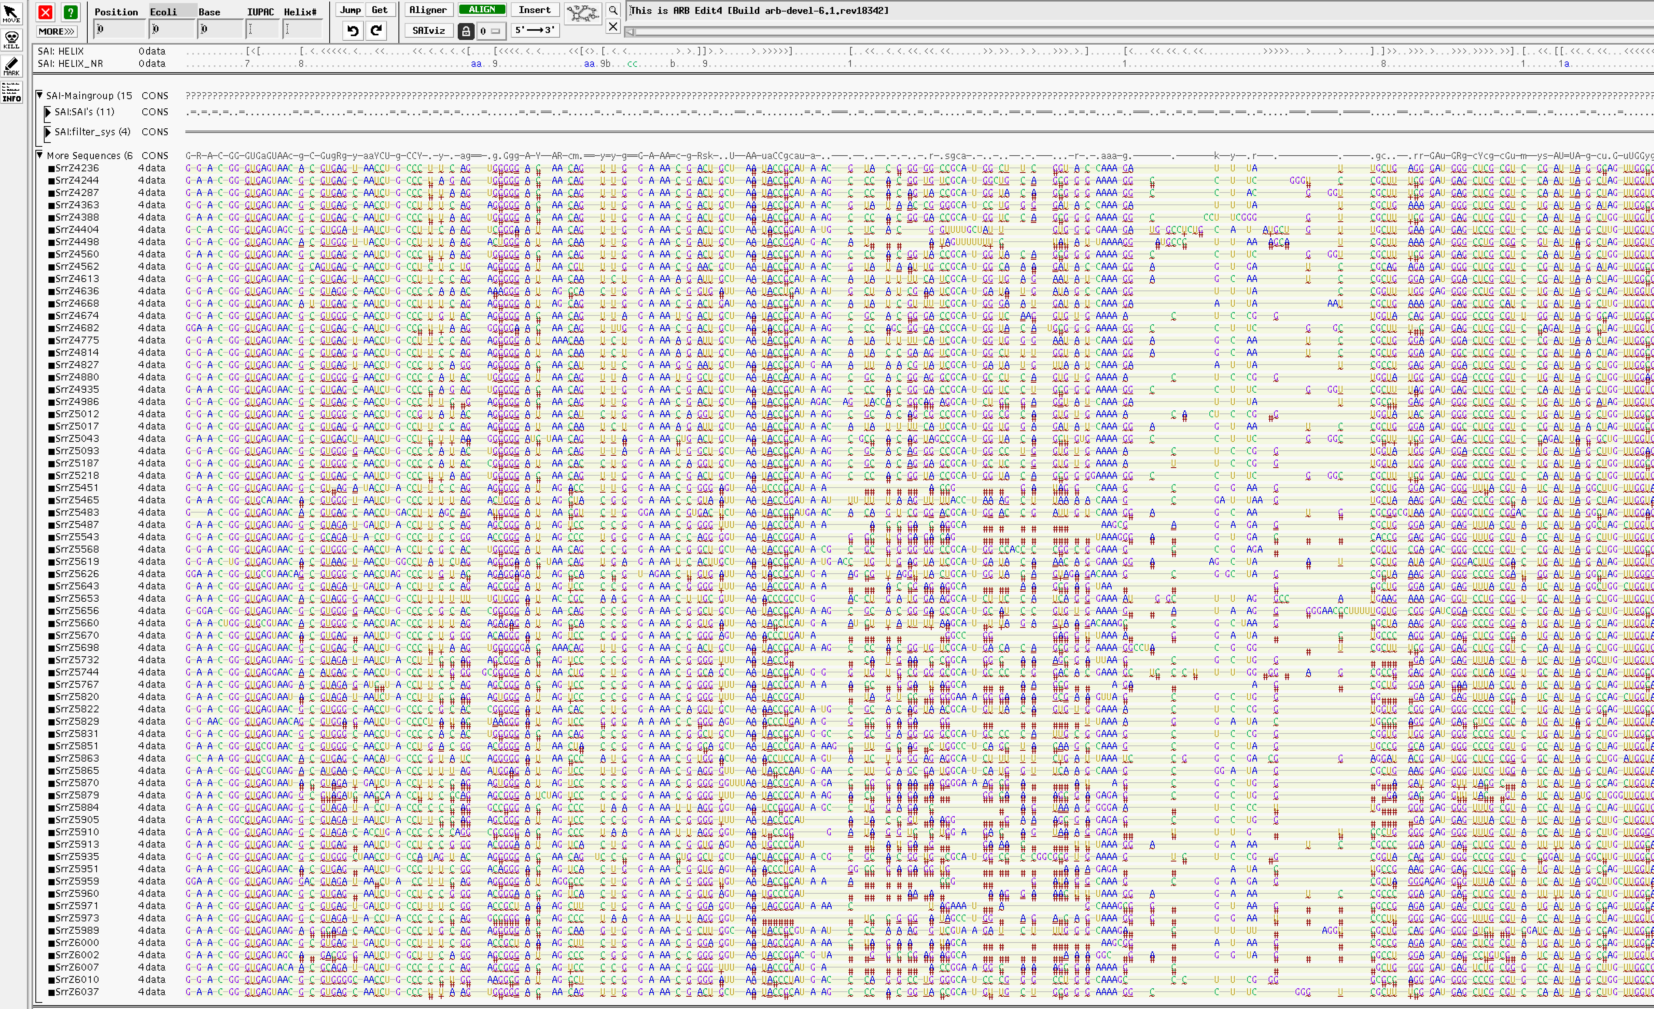

Text Stxt3: Evaluation of the automatized OPU design using 16S rRNA amplicon sequences.
The tests were done with our former amplicon data that had been either published or is awaiting to be published from both Illumina and PacBio platforms, as well as from data retrieved from published surveys (Table ST1). In general, the sequences kept in the tree and OPU reconstructions affiliated with known reference sequences with relative short branches (Figure SF7). The approach discards <10% of the reads, from the survey analyzed in Table ST4, the mean of discarded sequences is 13.03% ± 8.31 and a median of 8.31%. Only for 13 out of 38 samples the discarded value was >14%. In accordance with the results, a great part of the sequences discarded were probably either non-rRNA sequences or chimaeras. Only few sequences could be just singletons, which identity, if necessary, should be manually analyzed.
The wrong sequences could be identified as these exhibited longer branches, many where not aligned within the amplified range of homologous positions, or their alignments were very bad. In general, some of the discarded sequences belonged to amplified Eukarya 18S (2.34% ± 3.1, and a median of 0.54%). In most of the cases the removed sequences were of 16S rRNA gene amplicons, but the lack of pairing in the helixes seemed to indicate that these sequences could be chimeras, or sequencing/amplifying errors (see Figures SF1 to SF10). This is an important fact to be taken into account as all surveys using ASV or OTUs just take for granted that all sequences belong to rRNA and are correct.
There may be discarded sequences that, when inspecting the tree, the short branch observed indicated that were real 16S rRNA gene sequences that should have been taken into account. However, in general these sequences represented very low abundant ASVs, and being discarded did not change the real output. In any case, as we indicated below, the optimal procedure would be when a final manual inspection of the tree is performed to recognize discarded sequences that should be included, and fine-tune the results.
As it can be seen in the Table ST1, the approach can be used to analyze all different platforms and approaches rendering short and long sequences. We have tested not only Illumina amplicon reads, but also PacBio and Nanopore amplicons and raw reads and contigs extracted from metagenomes. One of the goodness of the approach is that metagenome sequences belong to different 16S rRNA gene sequence regions, but the OPU approach affiliates them using high quality and almost complete sequences and therefore the affiliation is accurate with independence of the region sequenced.

Reevaluation of published surveys
The raw sequences of the different published surveys (see below) were downloaded and ASVs generated to evaluate the results of the OPUcheck approach. Here, we compare first our own published results with the current platform, and reanalyze some published data to validate the OPU approach.

Pomar et al., 2023
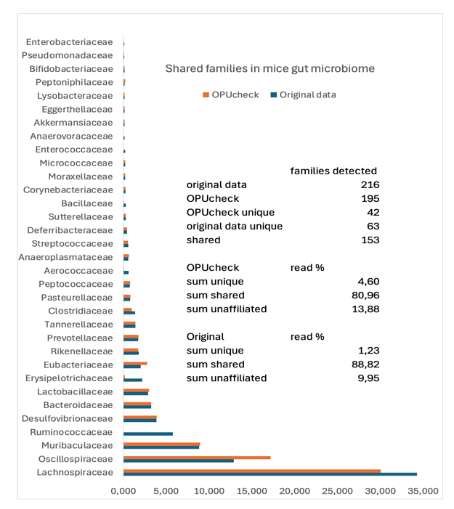
In this study, the sequences were obtained using the Illumina platform, denoised and clustered into amplicon sequence variants (ASVs), and finally the OPUs were identified using the SILVA non-redundant database (release 138.1; SILVA database; Quast et al., 2013). In Pomar et al., 2023, a total of 7,780 ASVs were grouped into 1,423 OPUs through manual curation, whereas OPUcheck generated 2,627 OPUs from the same dataset. Despite the higher number of OPUs obtained with OPUcheck, family-level relative abundance profiles were highly consistent between both approaches. In decreasing order of abundance, the dominant families were Lachnospiraceae > Oscillospiraceae > Muribaculaceae > Ruminococcaceae > Desulfovibrionaceae > Bacteroidaceae > Lactobacillaceae > Erysipelotrichaceae.
In Pomar et al., 2023, 216 families were identified, of which 13 exhibited relative abundances above 1%. Using OPUcheck, 196 families were detected, and the same 13 families exceeded the 1% relative abundance threshold. Overall, these results indicate that both approaches yield highly comparable patterns. The results between our original analyses performing the OPU assignation by manually inspecting the tree and the current based on our OPUcheck tool rendered surprisingly similar results for most of the taxa detected. The shared taxa detected covered between ~81-89% of the total read abundance, and only between ~1-5% of the reads had been assigned to different families. With some minor differences, the yields at the family level could be considered nearly identical.
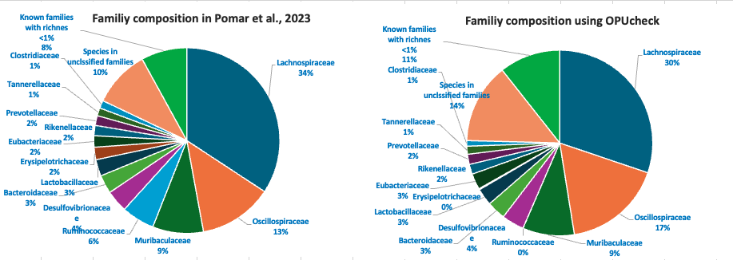
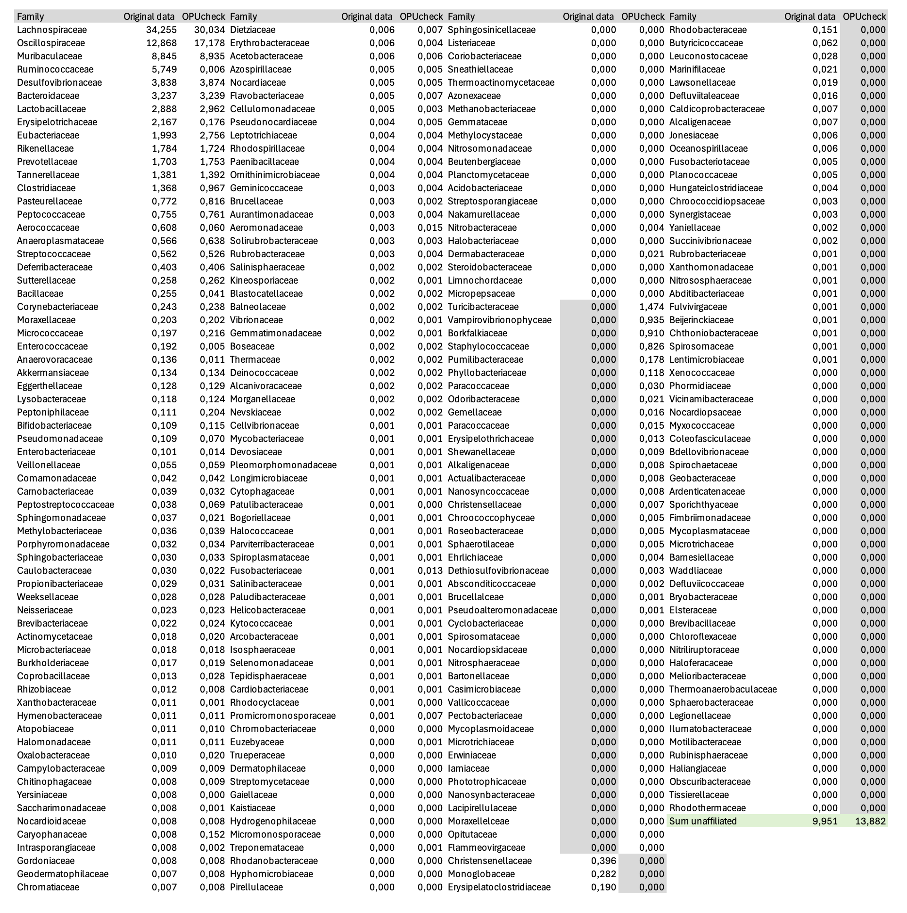

Viver et al., 2023
In this study, the sequences were also obtained using the Illumina platform, denoised and clustered into amplicon sequence variants (ASVs), and finally the OPUs were identified using the SILVA non-redundant database (release 138.1; SILVA database; Quast et al., 2013). In Viver et al., 2023, a total of 197 families were identified based on manual OPU delineation, whereas OPUcheck detected 207 families from the same dataset. The overall family-level relative abundance profiles were highly consistent between both approaches. In both analyses, Lactobacillaceae dominated the community, accounting for 73.87% of the total relative abundance in the manual approach and 73.73% using OPUcheck.
The second most abundant families in the manual approach were Rhodobacteraceae (6.01%) and Stappiaceae (4.11%). Using OPUcheck, Stappiaceae was recovered at a comparable relative abundance (4.05%); however, sequences previously assigned to Rhodobacteraceae were largely reclassified, resulting in a negligible relative abundance for this family (0.0005%) and a corresponding detection of Roseobacteraceae at 5.32%. Notably, Rhodobacteraceae and Roseobacteraceae both belong to the order Rhodobacterales, and differences in database sequence composition can lead to alternative family-level assignments.
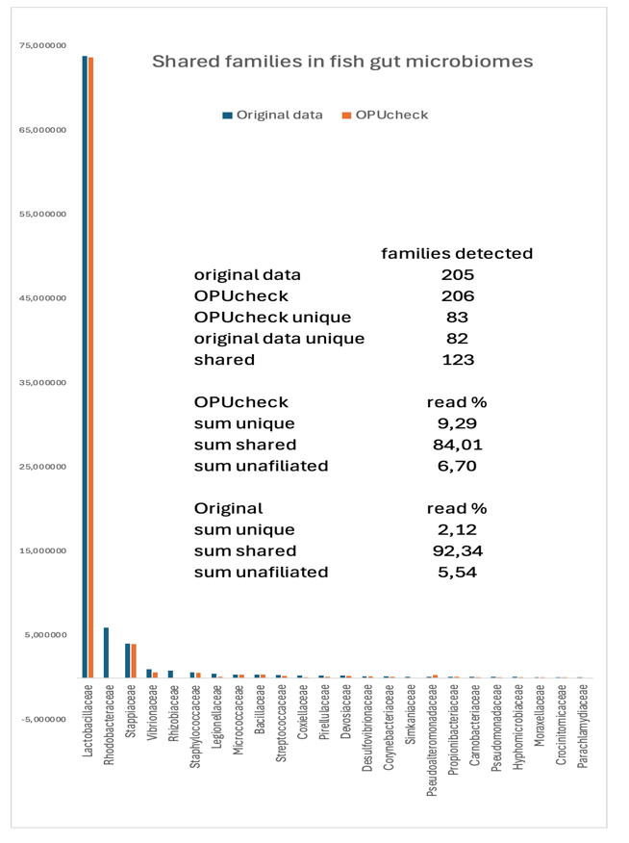
Other moderately abundant families showed very similar proportions between methods, including Vibrionaceae (1.06% vs. 0.67%), Staphylococcaceae (0.69% vs. 0.63%), Bacillaceae (0.43% vs. 0.42%), Micrococcaceae (0.43% vs. 0.40%), Rhizobiaceae (0.90% vs. 0.07%), and Legionellaceae (0.52% vs. 0.14%). Leuconostocaceae was detected at low abundance in the manual dataset (0.44%) but was not recovered by OPUcheck. Additionally, families with relative abundances below 0.4% collectively represented 6% of the community in the manual approach and 11.16% with OPUcheck.
The proportion of sequences assigned to species within unclassified families was also comparable (5.54% vs. 6.70%). The results between our original analyses performing the OPU assignation by manually inspecting the tree and the current based on our OPUcheck tool rendered again highly similar results for most of the taxa detected. The shared taxa detected covered between ~84-92% of the total read abundance, and only between ~2-9% of the reads had been assigned to different families. With some minor differences, the yields at the family level could be considered nearly identical.

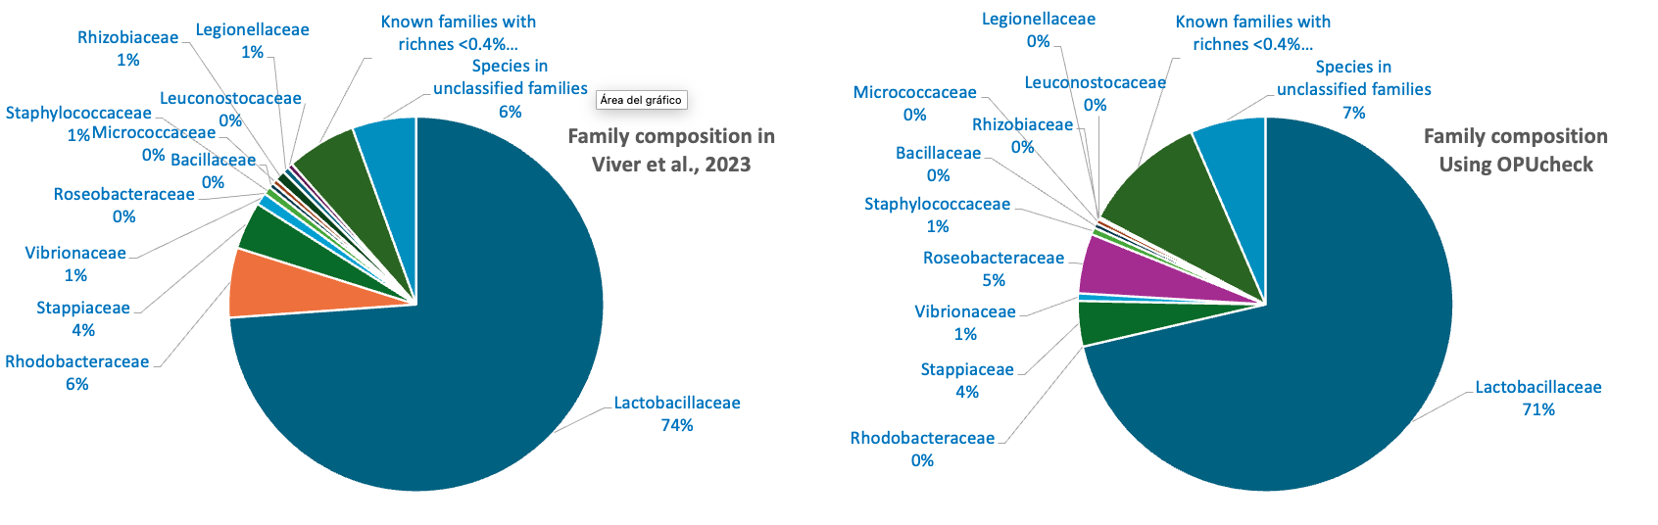

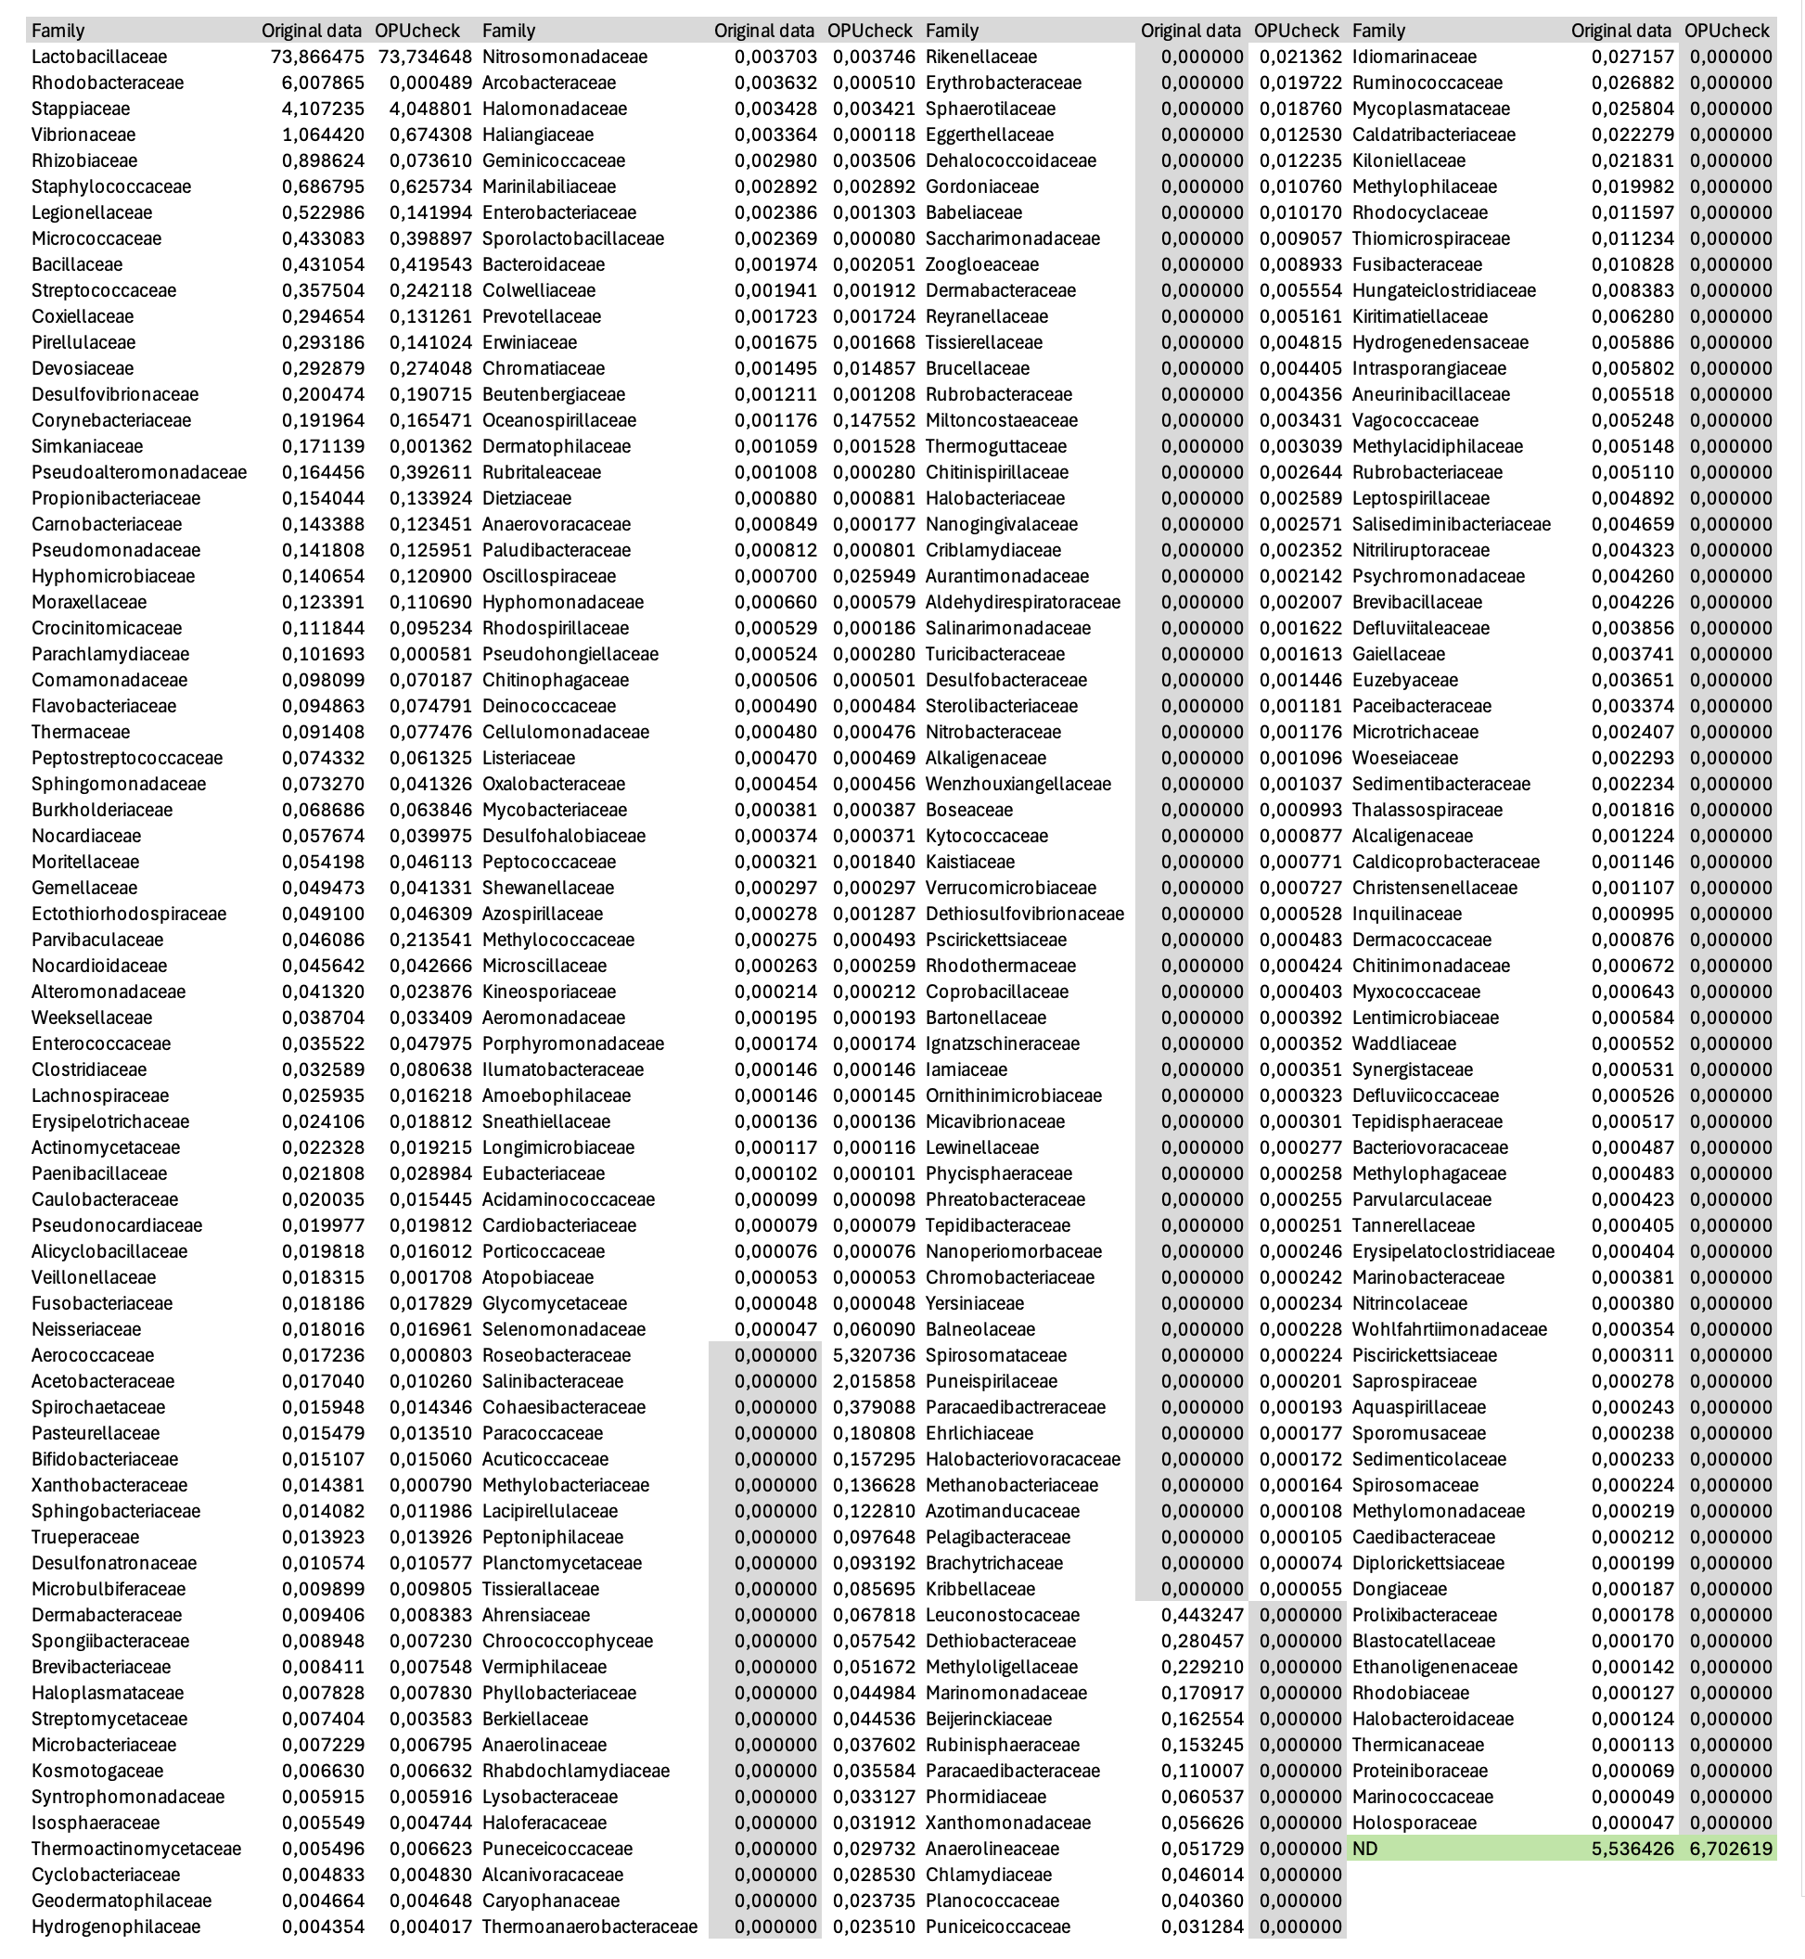

Font et al., 2021
In this study, the sequences were also obtained using the Illumina platform, denoised and clustered into amplicon sequence variants (ASVs), and finally the OPUs were identified using the SILVA non-redundant database (release 138.1; SILVA database; Quast et al., 2013). The manual supervision identified a total of 221 families, whereas OPUcheck recovered 217 families from the same dataset. Despite this slight difference in richness, the overall community structure was broadly consistent between both approaches. A substantial proportion of sequences was assigned to species belonging to unclassified families, representing 43.36% of the community in the original manuscript and 65.06% with OPUcheck. Among classified families, Bacillaceae remained one of the most dominant groups in both approaches, showing comparable relative abundances (13.98% in the manual approach vs. 12.94% with OPUcheck). Marinilabiliaceae, which was abundant in the original classification (10.74%), was nearly absent in the OPUcheck results (0.01%), while Halanaerobiaceae showed similar abundance (7.51% vs. 6.74%). Regarding Desulfobacteraceae, the manual OPU approach showed 6.43% vs. 1.53% recovered using the OPUcheck pipeline.
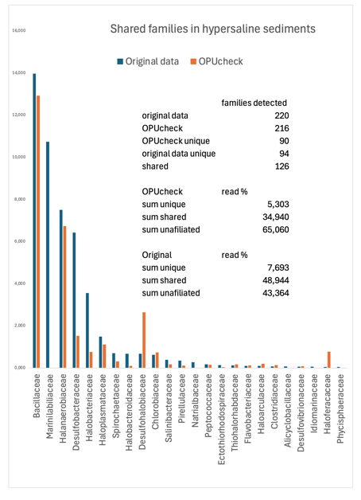
Halobacteriaceae also displayed a decrease, dropping from 3.56% in the manual analysis to 0.77% with OPUcheck. Several families detected in Font‑Verdera et al., 2023 (such as Christensenellaceae (2.49%), Brocadiaceae (2.36%), and others) were not recovered in the OPUcheck output. Conversely, OPUcheck identified families that were absent from the manual approach, including Vermiphilaceae (1.35%), Methanonatronarchaceae (1.04%), and Haloferacaceae (0.78%). Additional families with relative abundances below 1% collectively accounted for 22.92% of the community in the original study, compared with 6.03% when using the OPUcheck pipeline.
Similarly with the previous studies based on OPUs, the results here were in a great agreement excepting for some families. The shared taxa detected covered between ~35-49% of the total read abundance, and only between ~5-8% of the reads had been assigned to different families. The unaffiliated reads to known families responded to a range between 35 to 65% of the total sequences.

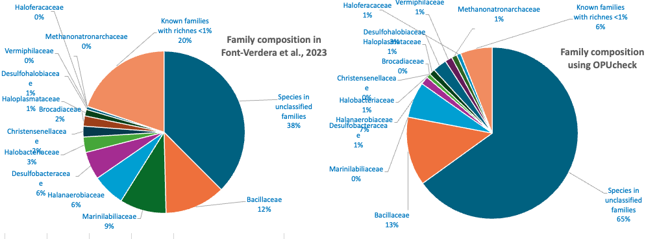
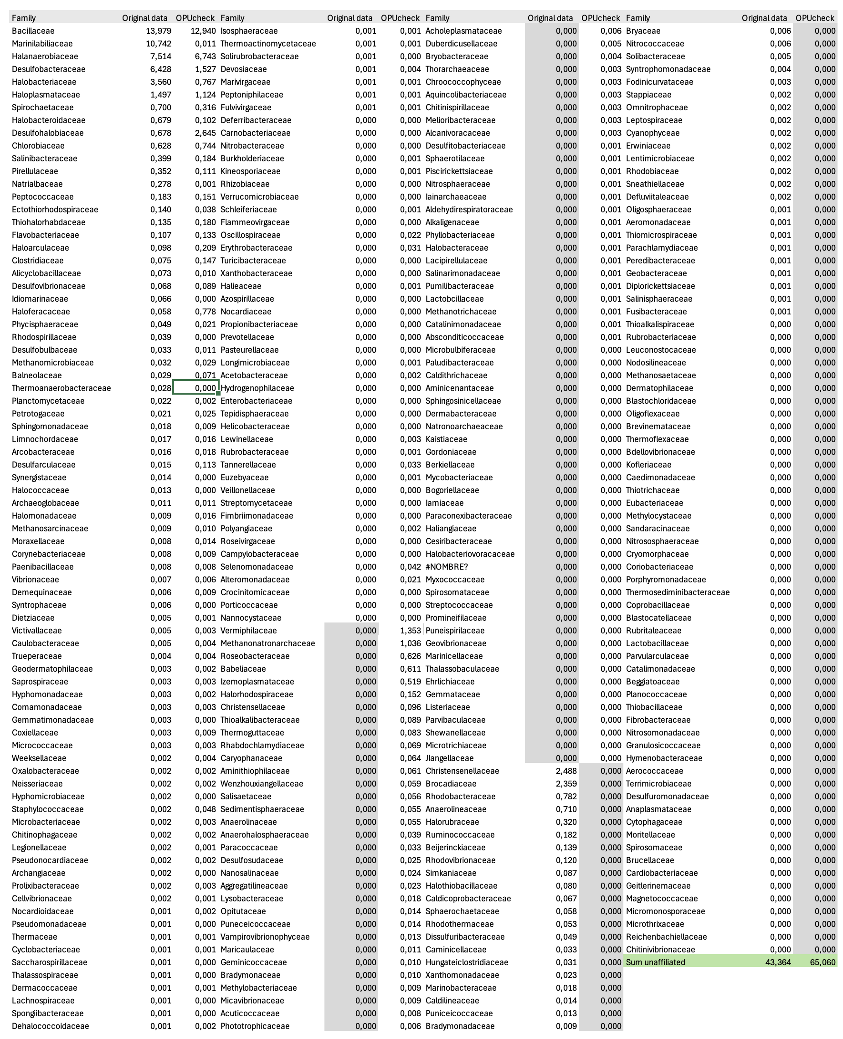

Glasl et al., 2024
The manuscript reports different microbiomes between adult and larvae of marine sponges. The results below reproduce the ones reported in the manuscript in their Figure 1B showing Thermoproteota, Pseudomonadota Acidobacterota and Chloroflexota showing the relevant differences.

Heritier-Robbins et al., 2021
The manuscript does not report any taxonomic affiliation in the main text, nor in the supplementary material, therefore we cannot compare the taxonomic affiliation yields. Here we report the read abundance within each family detected for the whole sequenced dataset. The number of OPUs (species) detected was 2666, among which 1508 species did not affiliate within any classified family, 762 species affiliated within 180 families with <25 different species (median =3) and 7 families were represented by 427 species (median = 55) making 16% of the total richness.

Miksch et al., 2021
The comparison between the published results and our analyses using OPUcheck rendered similar results for the families detected in both surveys (summing between 20 -30% of the total amplicon reads). However, OPUcheck with the new DB and phylogenetic inference detected 4 to 5 fold more diversity at the familiy level than the use of the program dada2 with the database SSU 138 Ref NR99. The differences, especially in the non-shared families with high read representation (e.g. “Microtrichaceae” for the original analyses or “Salibacteraceae” or Moritellaceae in our survey), could be due to differences in the alignment quality, implementation in the LTPlus of the GTDB-Tk taxonomy and differences in the identity inference.
Amplicon survey Svalbard sediments: The OPUcheck analysis showed similar results for the families capturing the majority of the reads, but important discrepancies in the low abundant families. Both approaches showed similar values of unaffiliated reads from known families (~55%). However, under the OPUcheck approach the number of families detected was 149 whereas the original data just 30. Only 17 families were shared between approaches, but showed similar trends. In grey shaded the families reciprocally not detected are highlighted.

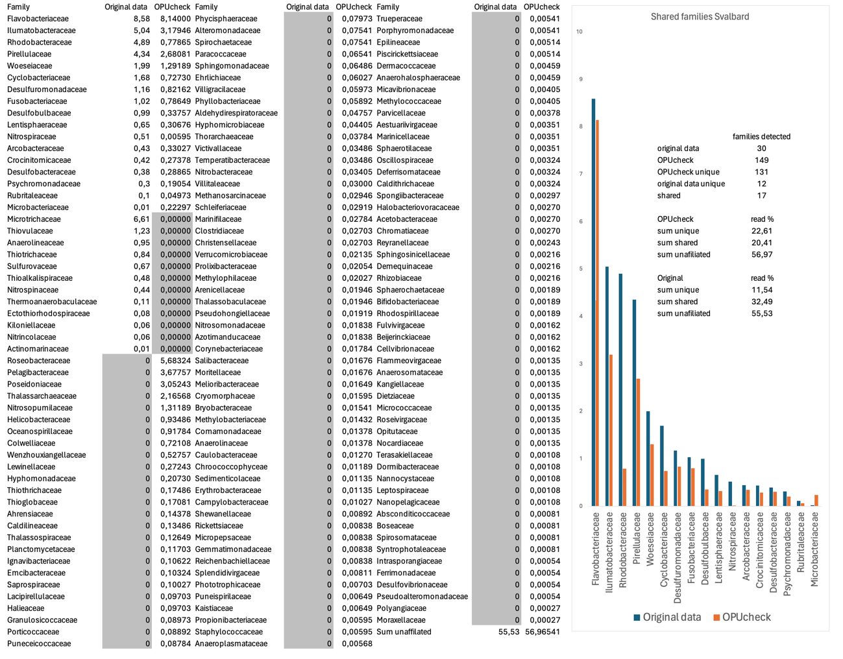

Amplicon survey Helgoland sand:
The OPUcheck analysis showed similar results for the families capturing the majority of the reads, but important discrepancies in the low abundant families. While 84.5% of the reads appeared unaffiliated from known families, only 52.2% occurred under our approach. In grey shaded the families reciprocally not detected are highlighted.
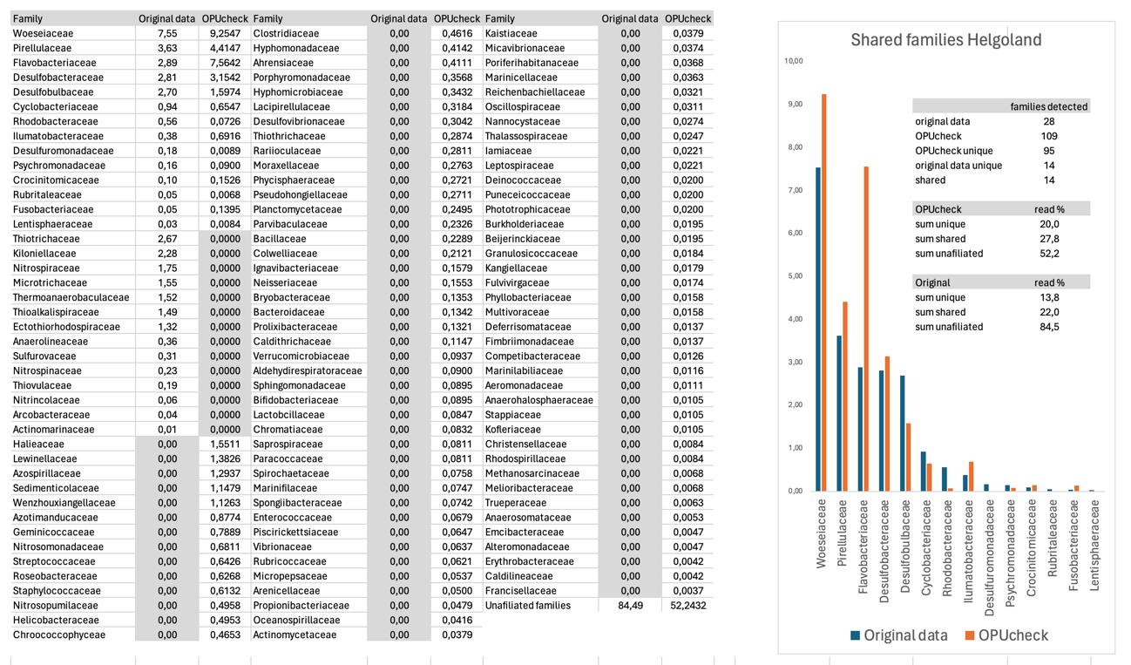

Maritan et al., 2025
All amplicon datasets were pooled in a single one to generate the ASVs and then, given the large amount of different ASVs generated, two subsampling of 7000 sequences each had been used to be included in the OPUcheck. Our results reproduce the main tendencies at the phylum level given in the Maritan et. al 2005 figure 2B in where the major phyla detected in decreasing abundances were Pseudomonadota > Bacteroidota >Cyanobacteria > Desulfobacterota > Planctomycetota. In our case, the Planctomycetota was the second most represented phylum in the dataset with 1279 ASVs (763 OPUs) out of which, 377 ASVs (215 OPUs) were of the family Pirellulaceae. As one of the families discarded as potential amplicon contaminants were the family Pirellulaceae (Supplementary Table 3 in Maritan et al., 2025), we cannot discard that the removal of the 215 Pirellulaceae OPUs out of the 3959 total detected could reduce the relevance of this phylum in the final composition despite there are still 548 OPUs of the phylum that may not be discarded. However, and despite we could not access the ASV tables, our results seem to agree with the ones published.
Biada et al., 2025

The results of the OPUcheck were in a general accordance with the main results shown in their Figure 1. However, the assignment of reads to some families are discrepant with our assignation based on phylogenetic inference. The major composition on the three major families Oscillospiraceae, Lachnospiraceae and Eubacteriaceae, despite some differences in our read counts show close patterns.

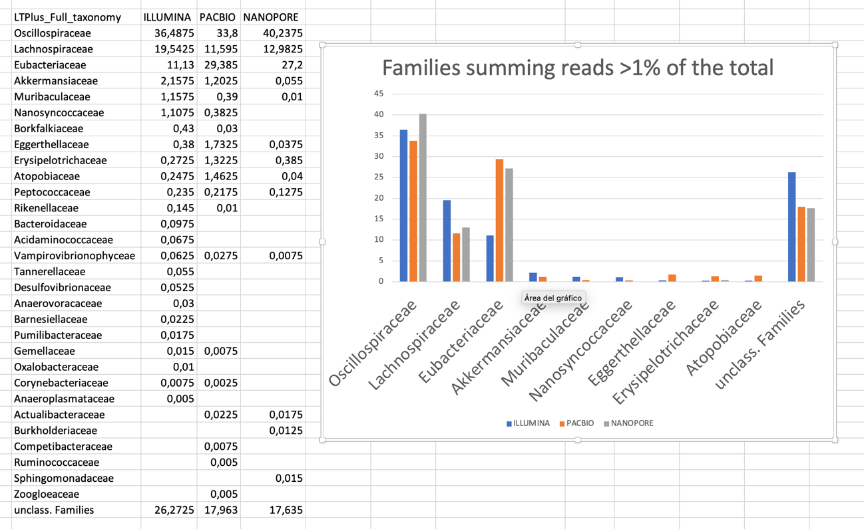

Anderson et al., 2025

The results of the OPUcheck were in a general accordance with the main results shown in their manuscript. In the one hand, the major phyla shown in their Figure 3A followed a similar trend in all three analyses: Illumina (A) and two subsampling analyses on 10000 sequences retrieved from the PacBio data (B & D). Similar trends were obtained at the OPU level (D). The trends in the representative ASVs used to calculate are similar, but in our case the OPUcheck discarded larger number given their lack of adequacy for the inference in accordance with our criteria (PacBio: original 10,480 ASVs, OPUcheck ~8900; Illumina 6507 ASVs, OPUcheck 5182). In general, using the OPUcheck approach both platforms sem to show similar results on the most abundant taxa.

A  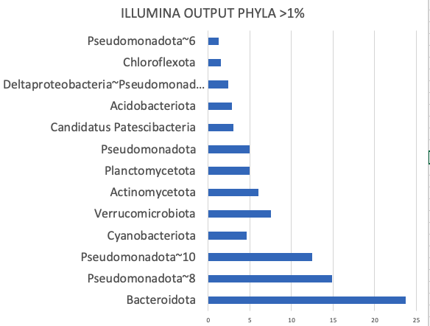 | C  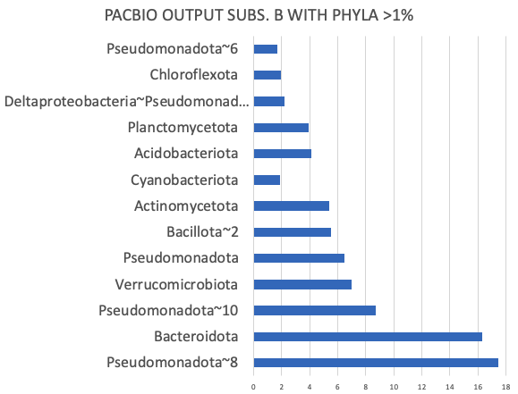
B  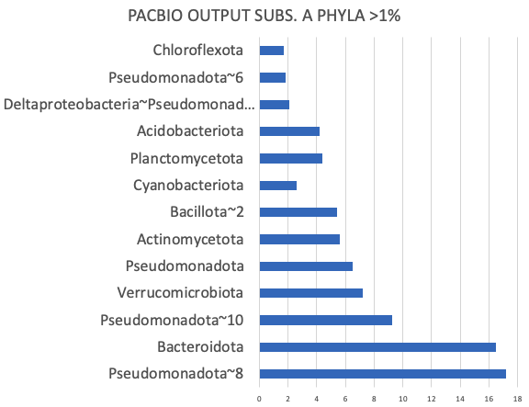 | D  Top most abundant OPUs in the two platforms, for time-efficiency we performed 2 subsampling of the PacBio results which resulted in nearly identical values  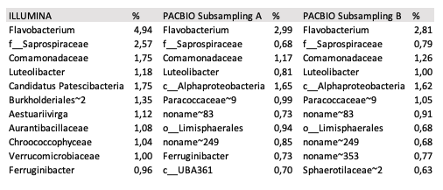

Ivulic et al., 2022
In this study, the sequences were also obtained using the PacBio platform, denoised and clustered into amplicon sequence variants (ASVs), and finally the OPUs were identified using the SILVA non-redundant database (release 138.1; SILVA database; Quast et al., 2013). To evaluate the consistency between manual OPU delineation and automated classification, we compared the family‑level taxonomic profiles reported by Ivulic et al., 2022 with those obtained using the OPUcheck pipeline. The manual analysis identified 88 families, whereas OPUcheck recovered 86 families from the same dataset, indicating a similar level of detected richness across approaches. Overall, the relative abundance profiles of the dominant bacterial families were highly concordant. Enterobacteriaceae and Pasteurellaceae remained the most abundant taxa in both workflows, with nearly identical proportions between the two methods (21.30% vs. 21.42% and 14.76% vs. 14.76%, respectively). Likewise, several other common families, including Staphylococcaceae (8.85% vs. 8.87%), Lactobacillaceae (7.27% vs. 7.32%), Streptococcaceae (5.17% vs. 5.19%), Oxalobacteraceae (5.09% vs. 5.09%), and Erysipelatoclostridiaceae (3.07% vs. 1.40%) showed minimal differences between classifications. Minor shifts were observed in families of intermediate abundance. Corynebacteriaceae decreased from 4.58% in the original dataset to 3.32% in OPUcheck, whereas Sphingomonadaceae remained stable (4.37% vs. 4.33%). Also, Oscillospiraceae and Lachnospiraceae showed similar abundances (1.29% to 2.09% and 0.51% to 1.69%, respectively). The proportion of sequences assigned to species within unclassified families was similar between methods (12.45% vs. 12.74%). Families with relative abundances below 1% contributed 7.67% of the community in the manual analysis compared with 9.89% in the OPUcheck dataset.
The results between our original analyses performing the OPU assignation by manually inspecting the tree and the current based on our OPUcheck tool rendered again highly similar results for most of the taxa detected. Here, the amplicon sequences were obtained using PacBio platform that affiliates sequences with higher accuracy given the length of the amplified stretch. The shared taxa detected covered between ~84% of the total read abundance, and only between ~3-4% of the reads had been assigned to different families. With some minor differences, the yields at the family level could be considered nearly identical.

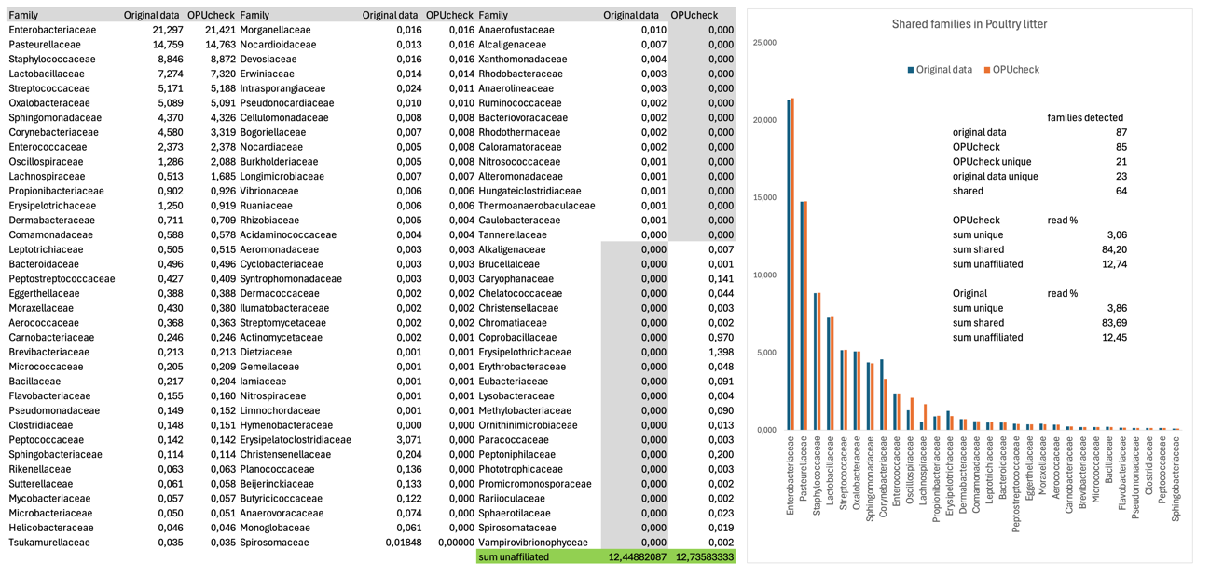

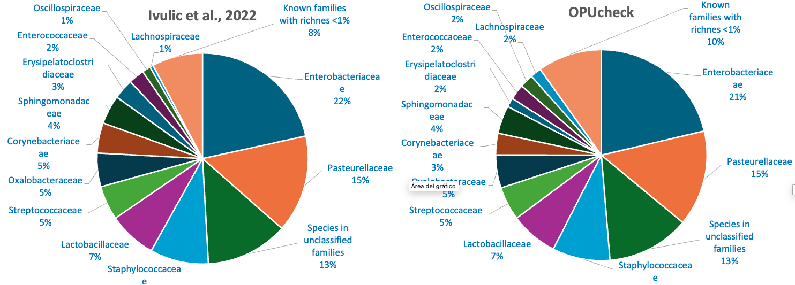

Veselovsky et al., 2025
In this study we compared 2 subsets of each dataset generated with the three platforms Illumina, PacBio and Oxford Nanopore. Derived from our results based on the OPUcheck at the family level, we could observe that Illumina was the platform with higher resolution in family diversity, detecting OTUs inserted within a total of 200 distinct families, whereas the long-read platforms yielded 37% to 20% less families. These results can be a product of either the lower detection of low abundant taxa, or the lack of amplification of these taxa due to primer constrains. Also, both long-read platforms yielded a large number of sequences (~8.5%) that originated from eukaryotes, whereas Illumina primers did not amplify any eukaryotic rRNA. All three platforms yielded similar numbers of OTUs affiliating with unknown families. When comparing the results at the family level, the greatest proportion of the common families were shared among the three platforms indicating a great coherence of the amplicon identification, and the platform-unique are reflecting the distinct accuracies or imprecisions when amplifying the gene sequences.

Families | Illumina | PacBio | Nanopore
Arenimicrobiaceae | 2.48 | - | 0.01
Bacillaceae | 5.25 | 13.47 | 23.15
Blastocatellaceae | 1.24 | 0.00 | 0.04
Bryobacteraceae | 2.02 | 0.14 | 0.02
Caryophanaceae | 0.61 | 1.50 | 1.96
Chitinophagaceae | 1.73 | - | -
Gaiellaceae | 1.40 | 0.24 | 2.19
Geminicoccaceae | 1.18 | 0.17 | 0.05
Lysobacteraceae | 0.50 | 0.20 | 0.89
Methylobacteriaceae | 1.04 | 0.43 | 0.34
Micrococcaceae | 1.03 | 0.31 | 0.80
Micromonosporaceae | 1.07 | 0.12 | 0.03
Nitrobacteraceae | 2.28 | 0.17 | 0.20
Nocardioidaceae | 1.40 | 0.49 | 0.03
Oscillospiraceae | - | 0.01 | 2.20
Paenibacillaceae | 0.68 | 1.06 | 2.86
Peptococcaceae | - | 11.71 | 7.37
Propionibacteriaceae | 0.02 | 4.06 | 0.48
Rubrobacteraceae | 1.57 | 0.01 | 0.05
Sphingomonadaceae | 3.31 | 0.70 | 0.48
Steroidobacteraceae | 0.67 | 0.32 | 0.78
Other known families | 22.98 | 6.66 | 6.95
Unaffilated families | 47.55 | 58.38 | 49.03
Nr families detected | 217 | 195 | 149
 |  | 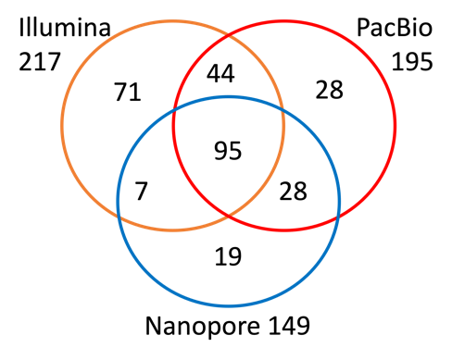
Shared all platforms | 95
Shared Illumina & PacBio | 139
Shared Illumina & Nanopore | 102
Shared PacBio & Nanopore | 123
Illumina unique | 71
PacBio unique | 28
Nanopore unique | 19

Unpublished results

In this section we report the results based on own amplicon sequences that had not been published yet but can be used as examples of the goodness of the OPUcheck approach.

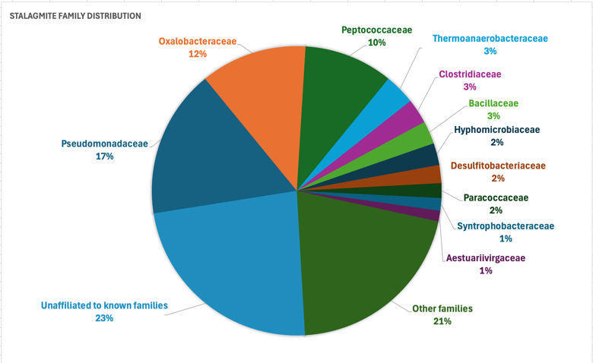 | Stalagmite amplicon sequencing with Illumina platform:  After trimming 1,111,332 amplicons were grouped in a total of 4114 ASVs which after the OPUcheck analysis rendered 2609 single OPUs (species) that represent an equal number of different putative species. These OPUs affiliated with 203 families, eleven of which summed >50% of the reads.
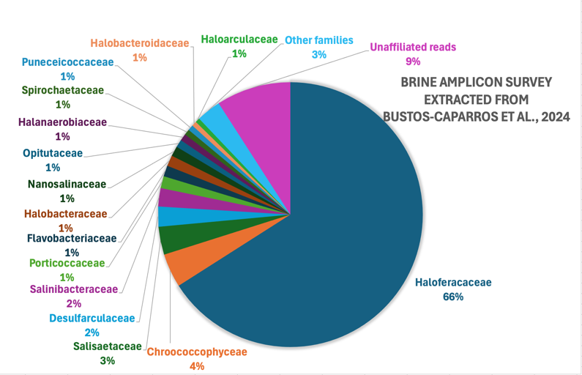 | Brine amplicon sequencing with Illumina platform from samples taken from Bustos-Caparros et al., 2024:  After trimming 4,240,232 amplicons were grouped in a total of 1401 ASVs which after the OPUcheck analysis rendered 648 single OPUs (species) that represent an equal number of different putative species. These OPUs affiliated with 35 families, 15 of which summed ~88% of the reads, and the single family Haloferacaceae >66% of the total reads.
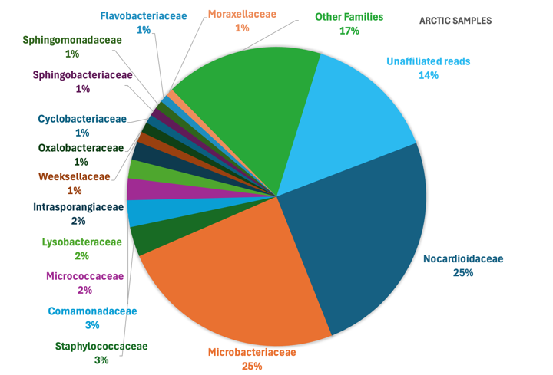 | Amplicon sequencing with Illumina platform from arctic samples:  After trimming 2,397,963 amplicons were grouped in a total of 5907 ASVs which after the OPUcheck analysis rendered 4036 single OPUs (species) that represent an equal number of different putative species. These OPUs affiliated with 277 families, 14 of which summed >68% of the reads.

Metagenome and read results
In this section we report the results based on own metagenome read sequences of own published studies.

Brine 16S rRNA gene sequences extracted from metagenome reads of Bustos-Caparros et al., 2023:
The reads from the metagenomes of Bustos-Caparros et al., 2023 were recruited and the representative ASVs were used to infer diversity using the OPUcheck. The 5,212,357 recruited reads were grouped in a total of 7,968 ASVs which after the OPUcheck analysis the 7250 retained ASVs rendered 2,662 single OPUs (species) that represent an equal number of different putative species. These OPUs affiliated with 159 families, 2 of which (Haloferacaceae and Salilnibacteraceae) summed >83% of the reads. The read length mean was 136 ±22 nucleotides and the median 148 nucleotides. If contigs are recruited, we obtained 1858 ASVs of which 1758 were retained ASVs and affiliated with 630 single OPUs or species. The contig length mean was 980 ±380 nucleotides and the median 919 nucleotides.
Family distribution of the reads recruited from the raw metagenome sequence dataset and analyzed using the OPUcheck.

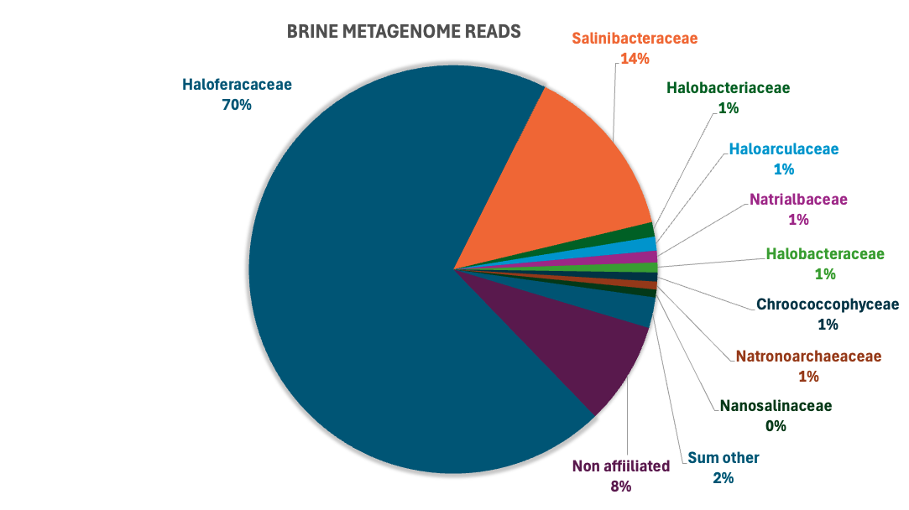
Example of aligned reads in the universal alignment showing distinct positions in the 16S rRNA gene stretch. Highlighted in yellow are the full-length reference sequences with which the different reads affiliate. The read length mean was 136± 22 nucleotides and the median 148 nucleotides.

Brine 16S rRNA gene sequences extracted from metagenome reads unpublished surveys on brine analyses (González-Méndez, unpublished):

The 2,446,550 recruited reads were grouped in a total of 4,289 ASVs which after the OPUcheck analysis rendered 1,436 single OPUs (species) that represent an equal number of different putative species. These OPUs affiliated with 92 families. If instead the raw reads, the contigs are recruited, we obtained 232 single ASVs which affiliated with 152 single OPUs or species. These OPUs affiliated with 40 families. Six families of the latter were not detected in the raw read analysis, but altogether the shared families summed ~86% of the total raw read recruited and ~76% of the contigs. In general, there was a good agreement between both datasets and the differences in identity could be due to the lower information content of the short length reads which affiliation could render dubious position inferences.
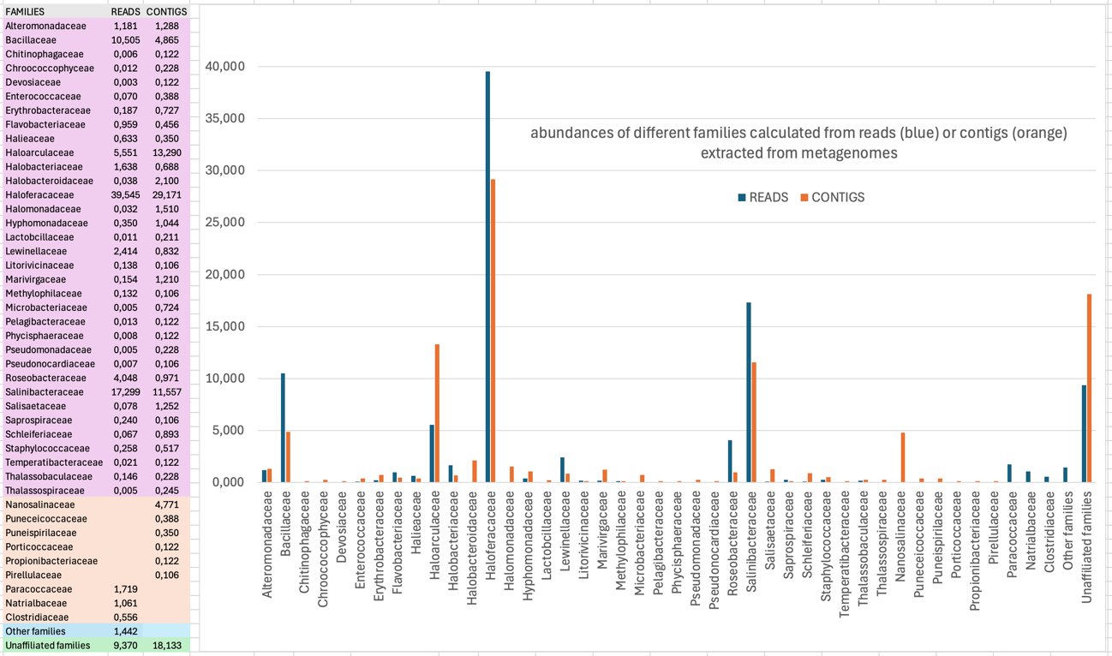

Supplementary Table ST2: list of SILVA_138.1_SSUREF_N99 and SILVA__138.2_SSUREF_N99 groups not represented
List of SILVA_138.1_SSUREF_N99 group names not represented in the LTPlus
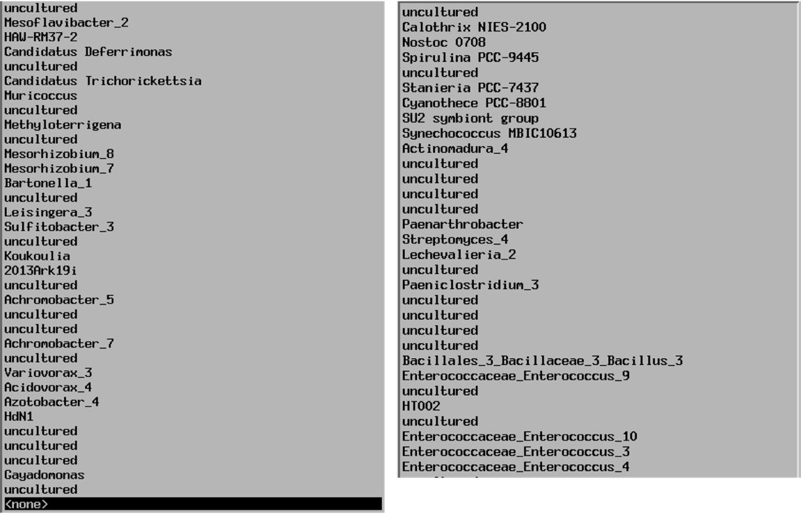

Supplementary Table ST3: Reference sequences of SILVA_138.1_SSUREF_N99 for the groups not represented in the LTPlus
List of sequences representative of the 65 groups in the latest SILVA database that did not qualify to remain in the LTPlus and therefore the groups that they represented remained excluded from the LTPlus selection:
Accesion Number | full_name | tax_slv
AB003166 | Spirulina subsalsa IAM M-223 | Bacteria;Cyanobacteria;Cyanobacteriia;Cyanobacteriales;Paraspirulinaceae;Spirulina PCC-9445
KU230304 | Azotobacter salinestris | Bacteria;Proteobacteria;Gammaproteobacteria;Pseudomonadales;Pseudomonadaceae;Azotobacter
JN566022 | Streptomyces albulus | Bacteria;Actinobacteriota;Actinobacteria;Streptomycetales;Streptomycetaceae;Streptomyces
JN692281 | Azotobacter sp. Az15 | Bacteria;Proteobacteria;Gammaproteobacteria;Pseudomonadales;Pseudomonadaceae;Azotobacter
HG799101 | Halohasta sp. RDI82 | Archaea;Halobacterota;Halobacteria;Halobacterales;Haloferacaceae;uncultured
JQ659794 | Mesorhizobium sp. R5-794 | Bacteria;Proteobacteria;Alphaproteobacteria;Rhizobiales;Rhizobiaceae;Mesorhizobium
AJ582391 | Rhopalodia gibba | Bacteria;Cyanobacteria;Cyanobacteriia;Cyanobacteriales;Microcystaceae;SU2 symbiont group
JQ666178 | Ensifer meliloti | Bacteria;Proteobacteria;Alphaproteobacteria;Rhizobiales;Rhizobiaceae;Bartonella
AJ488505 | Roseomonas rosea | Bacteria;Proteobacteria;Alphaproteobacteria;Acetobacterales;Acetobacteraceae;Muricoccus
DQ869036 | Achromobacter sp. PW-1 | Bacteria;Proteobacteria;Gammaproteobacteria;Burkholderiales;Alcaligenaceae;Achromobacter
EU502866 | Streptomyces platensis | Bacteria;Actinobacteriota;Actinobacteria;Streptomycetales;Streptomycetaceae;Streptomyces
AB039008 | Stanieria cyanosphaera | Bacteria;Cyanobacteria;Cyanobacteriia;Cyanobacteriales;Xenococcaceae;Stanieria PCC-7437
EU521701 | Streptomyces mycarofaciens | Bacteria;Actinobacteriota;Actinobacteria;Streptomycetales;Streptomycetaceae;Streptomyces
AJ936942 | marine alpha proteobacterium SOMBO1 | Bacteria;Proteobacteria;Alphaproteobacteria;Rhodobacterales;Rhodobacteraceae;Leisingera
JQ746428 | Achromobacter xylosoxidans | Bacteria;Proteobacteria;Gammaproteobacteria;Burkholderiales;Alcaligenaceae;Achromobacter
JQ746486 | Achromobacter sp. CCUG 3353 | Bacteria;Proteobacteria;Gammaproteobacteria;Burkholderiales;Alcaligenaceae;Achromobacter
FJ529701 | Roseomonas sp. CPCC 100079 | Bacteria;Proteobacteria;Alphaproteobacteria;Acetobacterales;Acetobacteraceae;Muricoccus
FP929140 | gamma proteobacterium HdN1 | Bacteria;Proteobacteria;Gammaproteobacteria;Pseudomonadales;Halomonadaceae;HdN1
FP929140 | gamma proteobacterium HdN1 | Bacteria;Proteobacteria;Gammaproteobacteria;Pseudomonadales;Halomonadaceae;HdN1
AB073573 | Cytophaga sp. I-545 | Bacteria;Bacteroidota;Bacteroidia;Flavobacteriales;Flavobacteriaceae;Mesoflavibacter
DQ915636 | Sulfitobacter mediterraneus | Bacteria;Proteobacteria;Alphaproteobacteria;Rhodobacterales;Rhodobacteraceae;Sulfitobacter
JQ417271 | Streptomyces sp. Antag4 | Bacteria;Actinobacteriota;Actinobacteria;Streptomycetales;Streptomycetaceae;Streptomyces
JQ746423 | Achromobacter insolitus | Bacteria;Proteobacteria;Gammaproteobacteria;Burkholderiales;Alcaligenaceae;Achromobacter
LN849457 | Acidovorax anthurii | Bacteria;Proteobacteria;Gammaproteobacteria;Burkholderiales;Comamonadaceae;Acidovorax
FP929140 | gamma proteobacterium HdN1 | Bacteria;Proteobacteria;Gammaproteobacteria;Pseudomonadales;Halomonadaceae;HdN1
MF979558 | Enterococcus casseliflavus | Bacteria;Firmicutes;Bacilli;Lactobacillales;Enterococcaceae;Enterococcus
KP126459 | Streptomyces sp. FXJ1.753 | Bacteria;Actinobacteriota;Actinobacteria;Streptomycetales;Streptomycetaceae;Streptomyces
JQ187724 | uncultured bacterium | Bacteria;Proteobacteria;Gammaproteobacteria;Burkholderiales;Alcaligenaceae;uncultured
JQ187980 | uncultured bacterium | Bacteria;Proteobacteria;Gammaproteobacteria;Burkholderiales;Alcaligenaceae;uncultured
FJ903194 | Alteromonas sp. H91 | Bacteria;Proteobacteria;Gammaproteobacteria;Enterobacterales;Alteromonadaceae;uncultured
FJ952826 | Colwellia sp. 1tb5 | Bacteria;Proteobacteria;Gammaproteobacteria;Enterobacterales;Colwelliaceae;uncultured
FM213396 | Arthrobacter sp. MNPB6 | Bacteria;Actinobacteriota;Actinobacteria;Micrococcales;Micrococcaceae;Paenarthrobacter
KR822469 | Enterococcus sp. PF1-24 | Bacteria;Firmicutes;Bacilli;Lactobacillales;Enterococcaceae;Enterococcus
LN906597 | bacterium 2013Arg42i | Bacteria;Proteobacteria;Gammaproteobacteria;Burkholderiales;Burkholderiales Incertae Sedis;2013Ark19i
AB183569 | Synechococcus sp. MBIC10613 | Bacteria;Cyanobacteria;Cyanobacteriia;Synechococcales;Cyanobiaceae;Synechococcus MBIC10613
EF546426 | Actinomadura sp. 171849 | Bacteria;Actinobacteriota;Actinobacteria;Streptosporangiales;Thermomonosporaceae;Actinomadura
FJ826621 | Spirulina subsalsa FACHB-351 | Bacteria;Cyanobacteria;Cyanobacteriia;Cyanobacteriales;Paraspirulinaceae;Spirulina PCC-9445
DI412661 | unidentified | Bacteria;Firmicutes;Bacilli;Lactobacillales;Enterococcaceae;Enterococcus
EF623832 | Achromobacter xylosoxidans | Bacteria;Proteobacteria;Gammaproteobacteria;Burkholderiales;Alcaligenaceae;Achromobacter
KM374759 | Achromobacter spanius | Bacteria;Proteobacteria;Gammaproteobacteria;Burkholderiales;Alcaligenaceae;Achromobacter
EF630354 | Synechococcus sp. MLCB | Bacteria;Cyanobacteria;Cyanobacteriia;Synechococcales;Cyanobiaceae;Synechococcus MBIC10613
AB184745 | Streptomyces rimosus | Bacteria;Actinobacteriota;Actinobacteria;Streptomycetales;Streptomycetaceae;Streptomyces
EF546422 | Actinomadura sp. 171828 | Bacteria;Actinobacteriota;Actinobacteria;Streptosporangiales;Thermomonosporaceae;Actinomadura
EF546421 | Actinomadura sp. 171824 | Bacteria;Actinobacteriota;Actinobacteria;Streptosporangiales;Thermomonosporaceae;Actinomadura
KP245774 | Bacillus firmus | Bacteria;Firmicutes;Bacilli;Bacillales;Bacillaceae;Bacillus
JQ187637 | uncultured bacterium | Bacteria;Proteobacteria;Gammaproteobacteria;Burkholderiales;Alcaligenaceae;uncultured
HK556151 | unidentified | Bacteria;Firmicutes;Clostridia;Peptostreptococcales-Tissierellales;Peptostreptococcaceae;Paeniclostridium
LC215282 | Calothrix sp. NIES-2100 | Bacteria;Cyanobacteria;Cyanobacteriia;Cyanobacteriales;Nostocaceae;Calothrix NIES-2100
MG386290 | Azotobacter salinestris | Bacteria;Proteobacteria;Gammaproteobacteria;Pseudomonadales;Pseudomonadaceae;Azotobacter
HM218546 | Enterococcus faecium | Bacteria;Firmicutes;Bacilli;Lactobacillales;Enterococcaceae;Enterococcus
FJ887954 | Lentzea aerocolonigenes | Bacteria;Actinobacteriota;Actinobacteria;Pseudonocardiales;Pseudonocardiaceae;Lechevalieria
EF623833 | Achromobacter xylosoxidans | Bacteria;Proteobacteria;Gammaproteobacteria;Burkholderiales;Alcaligenaceae;Achromobacter
GU289642 | Alteromonas sp. MEBiC06033 | Bacteria;Proteobacteria;Gammaproteobacteria;Enterobacterales;Alteromonadaceae;uncultured
KF934492 | Azotobacter vinelandii | Bacteria;Proteobacteria;Gammaproteobacteria;Pseudomonadales;Pseudomonadaceae;Azotobacter
KF203122 | Paenarthrobacter aurescens | Bacteria;Actinobacteriota;Actinobacteria;Micrococcales;Micrococcaceae;Paenarthrobacter
KJ457333 | uncultured bacterium | Bacteria;Proteobacteria;Gammaproteobacteria;Burkholderiales;Alcaligenaceae;Achromobacter
KM496556 | Halobacteriaceae archaeon SHRA26 | Archaea;Halobacterota;Halobacteria;Halobacterales;Haloferacaceae;uncultured
KT021534 | Enterococcus casseliflavus | Bacteria;Firmicutes;Bacilli;Lactobacillales;Enterococcaceae;Enterococcus
AB218877 | Koukoulia aurantiaca | Bacteria;Proteobacteria;Gammaproteobacteria;Cardiobacteriales;Wohlfahrtiimonadaceae;Koukoulia
LN906597 | bacterium 2013Arg42i | Bacteria;Proteobacteria;Gammaproteobacteria;Burkholderiales;Burkholderiales Incertae Sedis;2013Ark19i
AB116658 | Aphanothece sacrum | Bacteria;Cyanobacteria;Cyanobacteriia;Cyanobacteriales;Microcystaceae;SU2 symbiont group
KF287190 | Actinomadura sp. PN4222 | Bacteria;Actinobacteriota;Actinobacteria;Streptosporangiales;Thermomonosporaceae;Actinomadura
KT160249 | Kitasatospora psammotica | Bacteria;Proteobacteria;Gammaproteobacteria;Burkholderiales;Alcaligenaceae;Achromobacter
KP265967 | Rhodobacterales bacterium JY-7 | Bacteria;Proteobacteria;Alphaproteobacteria;Rhodobacterales;Rhodobacteraceae;uncultured
MG593930 | Mesorhizobium sp. | Bacteria;Proteobacteria;Alphaproteobacteria;Rhizobiales;Rhizobiaceae;Mesorhizobium
HQ717302 | Enterococcus sp. C6I11 | Bacteria;Firmicutes;Bacilli;Lactobacillales;Enterococcaceae;Enterococcus
HQ882804 | Alcaligenaceae bacterium W36 | Bacteria;Proteobacteria;Gammaproteobacteria;Burkholderiales;Alcaligenaceae;uncultured
HM587927 | Agromyces sp. m7-53 | Bacteria;Actinobacteriota;Actinobacteria;Micrococcales;Micrococcaceae;uncultured
EU195864 | Alcaligenes sp. ACS1 | Bacteria;Proteobacteria;Gammaproteobacteria;Burkholderiales;Alcaligenaceae;Achromobacter
KC862589 | Cystobacter sp. 6tb | Bacteria;Myxococcota;Myxococcia;Myxococcales;Myxococcaceae;uncultured
KU597496 | Achromobacter sp. RD_MATFA_09 | Bacteria;Proteobacteria;Gammaproteobacteria;Burkholderiales;Alcaligenaceae;Achromobacter
JF411519 | bacterium 3D803 | Bacteria;Proteobacteria;Gammaproteobacteria;Enterobacterales;Alteromonadaceae;uncultured
KT260697 | Koukoulia aurantiaca | Bacteria;Proteobacteria;Gammaproteobacteria;Cardiobacteriales;Wohlfahrtiimonadaceae;Koukoulia
JF411437 | bacterium 1D806 | Bacteria;Proteobacteria;Gammaproteobacteria;Enterobacterales;Alteromonadaceae;uncultured
KP010339 | Acidovorax oryzae | Bacteria;Proteobacteria;Gammaproteobacteria;Burkholderiales;Comamonadaceae;Acidovorax
JF411481 | bacterium 1H303 | Bacteria;Proteobacteria;Gammaproteobacteria;Enterobacterales;Alteromonadaceae;uncultured
KJ590041 | uncultured Alteromonadaceae bacterium | Bacteria;Proteobacteria;Gammaproteobacteria;Enterobacterales;Alteromonadaceae;uncultured
AB373956 | Colwelliaceae bacterium 04OKA-12-54 | Bacteria;Proteobacteria;Gammaproteobacteria;Enterobacterales;Colwelliaceae;uncultured
KP843715 | Aestuariibacter sp. Fun4 | Bacteria;Proteobacteria;Gammaproteobacteria;Enterobacterales;Alteromonadaceae;uncultured
AP012549 | cyanobacterium endosymbiont of Epithemia turgida isolate EtSB Lake Yunoko | Bacteria;Cyanobacteria;Cyanobacteriia;Cyanobacteriales;Microcystaceae;SU2 symbiont group
KP992891 | Mesorhizobium sp. PHD15 | Bacteria;Proteobacteria;Alphaproteobacteria;Rhizobiales;Rhizobiaceae;Mesorhizobium
AB546278 | Lentzea sp. IR11-RCA120 | Bacteria;Actinobacteriota;Actinobacteria;Pseudonocardiales;Pseudonocardiaceae;Lechevalieria
KY419870 | Achromobacter xylosoxidans | Bacteria;Proteobacteria;Gammaproteobacteria;Burkholderiales;Alcaligenaceae;Achromobacter
EU214610 | Achromobacter xylosoxidans | Bacteria;Proteobacteria;Gammaproteobacteria;Burkholderiales;Alcaligenaceae;Achromobacter
KY416000 | Gayadomonas sp. | Bacteria;Proteobacteria;Gammaproteobacteria;Enterobacterales;Alteromonadaceae;Gayadomonas
KJ590611 | uncultured bacterium | Bacteria;Proteobacteria;Alphaproteobacteria;Rhodobacterales;Rhodobacteraceae;uncultured
AB546732 | cyanobacterium endosymbiont of Epithemia turgida | Bacteria;Cyanobacteria;Cyanobacteriia;Cyanobacteriales;Microcystaceae;SU2 symbiont group
KY515342 | Mesorhizobium ciceri | Bacteria;Proteobacteria;Alphaproteobacteria;Rhizobiales;Rhizobiaceae;Mesorhizobium
KY515343 | Mesorhizobium ciceri | Bacteria;Proteobacteria;Alphaproteobacteria;Rhizobiales;Rhizobiaceae;Mesorhizobium
AP012549 | cyanobacterium endosymbiont of Epithemia turgida isolate EtSB Lake Yunoko | Bacteria;Cyanobacteria;Cyanobacteriia;Cyanobacteriales;Microcystaceae;SU2 symbiont group
AB680773 | Achromobacter xylosoxidans | Bacteria;Proteobacteria;Gammaproteobacteria;Burkholderiales;Alcaligenaceae;Achromobacter
LT607803 | Variovorax sp. HW608 | Bacteria;Proteobacteria;Gammaproteobacteria;Burkholderiales;Comamonadaceae;Variovorax
AB680772 | Achromobacter denitrificans | Bacteria;Proteobacteria;Gammaproteobacteria;Burkholderiales;Alcaligenaceae;Achromobacter
LT607803 | Variovorax sp. HW608 | Bacteria;Proteobacteria;Gammaproteobacteria;Burkholderiales;Comamonadaceae;Variovorax
KP876580 | Methyloterrigena soli | Bacteria;Proteobacteria;Alphaproteobacteria;Rhizobiales;Devosiaceae;Methyloterrigena
AB680418 | Achromobacter xylosoxidans | Bacteria;Proteobacteria;Gammaproteobacteria;Burkholderiales;Alcaligenaceae;Achromobacter
AB681803 | Achromobacter piechaudii | Bacteria;Proteobacteria;Gammaproteobacteria;Burkholderiales;Alcaligenaceae;Achromobacter
KP992879 | Mesorhizobium sp. PHD3 | Bacteria;Proteobacteria;Alphaproteobacteria;Rhizobiales;Rhizobiaceae;Mesorhizobium
AP017375 | Stanieria sp. NIES-3757 | Bacteria;Cyanobacteria;Cyanobacteriia;Cyanobacteriales;Xenococcaceae;Stanieria PCC-7437
AB681885 | Azotobacter salinestris | Bacteria;Proteobacteria;Gammaproteobacteria;Pseudomonadales;Pseudomonadaceae;Azotobacter
KJ691874 | Bacillus firmus | Bacteria;Firmicutes;Bacilli;Bacillales;Bacillaceae;Bacillus
KU198860 | Achromobacter sp. ACH01 | Bacteria;Proteobacteria;Gammaproteobacteria;Burkholderiales;Alcaligenaceae;Achromobacter
AP017375 | Stanieria sp. NIES-3757 | Bacteria;Cyanobacteria;Cyanobacteriia;Cyanobacteriales;Xenococcaceae;Stanieria PCC-7437
MH244352 | Actinomadura sp. | Bacteria;Actinobacteriota;Actinobacteria;Streptosporangiales;Thermomonosporaceae;Actinomadura
AP018178 | Calothrix sp. NIES-2100 | Bacteria;Cyanobacteria;Cyanobacteriia;Cyanobacteriales;Nostocaceae;Calothrix NIES-2100
AP018178 | Calothrix sp. NIES-2100 | Bacteria;Cyanobacteria;Cyanobacteriia;Cyanobacteriales;Nostocaceae;Calothrix NIES-2100
AP018341 | cyanobacterium endosymbiont of Rhopalodia gibberula | Bacteria;Cyanobacteria;Cyanobacteriia;Cyanobacteriales;Microcystaceae;SU2 symbiont group
AP018178 | Calothrix sp. NIES-2100 | Bacteria;Cyanobacteria;Cyanobacteriia;Cyanobacteriales;Nostocaceae;Calothrix NIES-2100
GU644361 | Sulfitobacter sp. KLE1217 | Bacteria;Proteobacteria;Alphaproteobacteria;Rhodobacterales;Rhodobacteraceae;Sulfitobacter
AP018341 | cyanobacterium endosymbiont of Rhopalodia gibberula | Bacteria;Cyanobacteria;Cyanobacteriia;Cyanobacteriales;Microcystaceae;SU2 symbiont group
AP018178 | Calothrix sp. NIES-2100 | Bacteria;Cyanobacteria;Cyanobacteriia;Cyanobacteriales;Nostocaceae;Calothrix NIES-2100
AP018178 | Calothrix sp. NIES-2100 | Bacteria;Cyanobacteria;Cyanobacteriia;Cyanobacteriales;Nostocaceae;Calothrix NIES-2100
KU711997 | Variovorax soli | Bacteria;Proteobacteria;Gammaproteobacteria;Burkholderiales;Comamonadaceae;Variovorax
AY007684 | unknown marine alpha proteobacterium JP88.1 | Bacteria;Proteobacteria;Alphaproteobacteria;Rhodobacterales;Rhodobacteraceae;Leisingera
LN573393 | uncultured bacterium | Bacteria;Actinobacteriota;Actinobacteria;Kineosporiales;Kineosporiaceae;uncultured
HG315619 | Candidatus Trichorickettsia mobilis | Bacteria;Proteobacteria;Alphaproteobacteria;Rickettsiales;Rickettsiaceae;Candidatus Trichorickettsia
FJ975799 | uncultured Lactobacillales bacterium | Bacteria;Firmicutes;Bacilli;Lactobacillales;Enterococcaceae;Enterococcus
AF022392 | alpha proteobacterium str. 303 | Bacteria;Proteobacteria;Alphaproteobacteria;Rhodobacterales;Rhodobacteraceae;Leisingera
FJ976010 | uncultured Lactobacillaceae bacterium | Bacteria;Firmicutes;Bacilli;Lactobacillales;Lactobacillaceae;uncultured
FJ975785 | uncultured Lactobacillales bacterium | Bacteria;Firmicutes;Bacilli;Lactobacillales;Enterococcaceae;Enterococcus
KX014817 | Mesorhizobium sp. CR7 | Bacteria;Proteobacteria;Alphaproteobacteria;Rhizobiales;Rhizobiaceae;Mesorhizobium
HG315612 | Candidatus Trichorickettsia mobilis | Bacteria;Proteobacteria;Alphaproteobacteria;Rickettsiales;Rickettsiaceae;Candidatus Trichorickettsia
AF132931 | Stanieria cyanosphaera PCC 7437 | Bacteria;Cyanobacteria;Cyanobacteriia;Cyanobacteriales;Xenococcaceae;Stanieria PCC-7437
KU951807 | Synechococcus sp. LEGE 11466 | Bacteria;Cyanobacteria;Cyanobacteriia;Synechococcales;Cyanobiaceae;Synechococcus MBIC10613
MF039744 | Candidatus Trichorickettsia mobilis subsp. hyperinfectiva | Bacteria;Proteobacteria;Alphaproteobacteria;Rickettsiales;Rickettsiaceae;Candidatus Trichorickettsia
KU851040 | Bacillus sp. ADMK84 | Bacteria;Firmicutes;Bacilli;Bacillales;Bacillaceae;Bacillus
MH686079 | Methyloterrigena sp. | Bacteria;Proteobacteria;Alphaproteobacteria;Rhizobiales;Devosiaceae;Methyloterrigena
AF286480 | Bacillus sp. VAN12 | Bacteria;Firmicutes;Bacilli;Bacillales;Bacillaceae;Bacillus
KX014836 | Mesorhizobium sp. CR26 | Bacteria;Proteobacteria;Alphaproteobacteria;Rhizobiales;Rhizobiaceae;Mesorhizobium
AF359532 | marine bacterium ATAM173a_17 | Bacteria;Proteobacteria;Alphaproteobacteria;Rhodobacterales;Rhodobacteraceae;Sulfitobacter
LN612727 | uncultured bacterium | Bacteria;Proteobacteria;Gammaproteobacteria;Burkholderiales;Burkholderiales Incertae Sedis;2013Ark19i
AF296873 | Cyanothece sp. PCC 8801 | Bacteria;Cyanobacteria;Cyanobacteriia;Cyanobacteriales;Microcystaceae;Cyanothece PCC-8801
KX139491 | Streptomyces verticillus | Bacteria;Actinobacteriota;Actinobacteria;Streptomycetales;Streptomycetaceae;Streptomyces
MH899231 | Enterococcus casseliflavus | Bacteria;Firmicutes;Bacilli;Lactobacillales;Enterococcaceae;Enterococcus
KX139490 | Streptomyces verticillus | Bacteria;Actinobacteriota;Actinobacteria;Streptomycetales;Streptomycetaceae;Streptomyces
CP001287 | Cyanothece sp. PCC 8801 | Bacteria;Cyanobacteria;Cyanobacteriia;Cyanobacteriales;Microcystaceae;Cyanothece PCC-8801
CP001287 | Cyanothece sp. PCC 8801 | Bacteria;Cyanobacteria;Cyanobacteriia;Cyanobacteriales;Microcystaceae;Cyanothece PCC-8801
AF329394 | Spirulina subsalsa | Bacteria;Cyanobacteria;Cyanobacteriia;Cyanobacteriales;Paraspirulinaceae;Spirulina PCC-9445
CP001701 | Cyanothece sp. PCC 8802 | Bacteria;Cyanobacteria;Cyanobacteriia;Cyanobacteriales;Microcystaceae;Cyanothece PCC-8801
KC465632 | uncultured bacterium | Bacteria;Proteobacteria;Gammaproteobacteria;Burkholderiales;Alcaligenaceae;Achromobacter
CP001701 | Cyanothece sp. PCC 8802 | Bacteria;Cyanobacteria;Cyanobacteriia;Cyanobacteriales;Microcystaceae;Cyanothece PCC-8801
CP002059 | 'Nostoc azollae' 0708 | Bacteria;Cyanobacteria;Cyanobacteriia;Cyanobacteriales;Nostocaceae;Nostoc 0708
CP002059 | 'Nostoc azollae' 0708 | Bacteria;Cyanobacteria;Cyanobacteriia;Cyanobacteriales;Nostocaceae;Nostoc 0708
KP645122 | uncultured Alcaligenaceae bacterium | Bacteria;Proteobacteria;Gammaproteobacteria;Burkholderiales;Alcaligenaceae;uncultured
CP002059 | 'Nostoc azollae' 0708 | Bacteria;Cyanobacteria;Cyanobacteriia;Cyanobacteriales;Nostocaceae;Nostoc 0708
KC541531 | uncultured bacterium | Bacteria;Proteobacteria;Gammaproteobacteria;Burkholderiales;Alcaligenaceae;Achromobacter
KC554721 | uncultured bacterium | Bacteria;Actinobacteriota;Actinobacteria;Streptomycetales;Streptomycetaceae;Streptomyces
CP002059 | 'Nostoc azollae' 0708 | Bacteria;Cyanobacteria;Cyanobacteriia;Cyanobacteriales;Nostocaceae;Nostoc 0708
GU056112 | uncultured bacterium | Bacteria;Cyanobacteria;Cyanobacteriia;Synechococcales;Cyanobiaceae;Synechococcus MBIC10613
AM500794 | uncultured bacterium | Bacteria;Firmicutes;Clostridia;Peptostreptococcales-Tissierellales;Family XI;uncultured
FN563220 | uncultured bacterium | Bacteria;Bacteroidota;Bacteroidia;Bacteroidales;HAW-RM37-2
FN563203 | uncultured bacterium | Bacteria;Bacteroidota;Bacteroidia;Bacteroidales;HAW-RM37-2
KP746976 | BTEX-degrading bacterium enrichment culture | Bacteria;Proteobacteria;Gammaproteobacteria;Burkholderiales;Alcaligenaceae;Achromobacter
AF529126 | uncultured Epsilonproteobacteria bacterium | Bacteria;Acidobacteriota;Holophagae;Holophagales;Holophagaceae;uncultured
CP003653 | Stanieria cyanosphaera PCC 7437 | Bacteria;Cyanobacteria;Cyanobacteriia;Cyanobacteriales;Xenococcaceae;Stanieria PCC-7437
CP003987 | Streptomyces sp. 769 | Bacteria;Actinobacteriota;Actinobacteria;Streptomycetales;Streptomycetaceae;Streptomyces
AY349382 | Lactobacillus sp. oral clone HT002 | Bacteria;Firmicutes;Bacilli;Lactobacillales;Lactobacillaceae;HT002
AY491624 | uncultured bacterium | Bacteria;Proteobacteria;Alphaproteobacteria;Rhizobiales;Rhizobiaceae;Mesorhizobium
AY081979 | uncultured bacterium | Bacteria;Proteobacteria;Gammaproteobacteria;Burkholderiales;Alcaligenaceae;Achromobacter
GU230351 | uncultured gamma proteobacterium | Bacteria;Proteobacteria;Gammaproteobacteria;Enterobacterales;Colwelliaceae;uncultured
JF920335 | uncultured bacterium | Bacteria;Firmicutes;Bacilli;Lactobacillales;Enterococcaceae;Enterococcus
EU134366 | uncultured bacterium | Bacteria;Myxococcota;Myxococcia;Myxococcales;Myxococcaceae;uncultured
CP003653 | Stanieria cyanosphaera PCC 7437 | Bacteria;Cyanobacteria;Cyanobacteriia;Cyanobacteriales;Xenococcaceae;Stanieria PCC-7437
AY328588 | uncultured bacterium | Bacteria;Proteobacteria;Alphaproteobacteria;Rhizobiales;Beijerinckiaceae;uncultured
GU305850 | uncultured bacterium | Bacteria;Proteobacteria;Alphaproteobacteria;Rhizobiales;Beijerinckiaceae;uncultured
JQ738968 | uncultured bacterium | Bacteria;Cyanobacteria;Cyanobacteriia;Cyanobacteriales;Paraspirulinaceae;Spirulina PCC-9445
CU919686 | uncultured bacterium | Bacteria;Actinobacteriota;Actinobacteria;Micrococcales;Intrasporangiaceae;uncultured
JQ855576 | uncultured bacterium | Bacteria;Actinobacteriota;Actinobacteria;Micrococcales;Micrococcaceae;uncultured
EU453741 | uncultured bacterium | Bacteria;Firmicutes;Bacilli;Lactobacillales;Lactobacillaceae;HT002
EU456241 | uncultured bacterium | Bacteria;Firmicutes;Bacilli;Lactobacillales;Lactobacillaceae;HT002
EU460877 | uncultured bacterium | Bacteria;Firmicutes;Bacilli;Lactobacillales;Lactobacillaceae;uncultured
JQ726801 | uncultured Enterococcaceae bacterium | Bacteria;Firmicutes;Bacilli;Lactobacillales;Enterococcaceae;Enterococcus
DQ289927 | uncultured cyanobacterium | Bacteria;Cyanobacteria;Cyanobacteriia;Cyanobacteriales;Microcystaceae;SU2 symbiont group
EU505411 | uncultured bacterium | Bacteria;Firmicutes;Bacilli;Lactobacillales;Lactobacillaceae;uncultured
CP021874 | Enterococcus wangshanyuanii | Bacteria;Firmicutes;Bacilli;Lactobacillales;Enterococcaceae;Enterococcus
EU475825 | uncultured bacterium | Bacteria;Firmicutes;Clostridia;Oscillospirales;uncultured
CU919271 | uncultured bacterium | Bacteria;Actinobacteriota;Actinobacteria;Micrococcales;Intrasporangiaceae;uncultured
CU919990 | uncultured bacterium | Bacteria;Actinobacteriota;Actinobacteria;Micrococcales;Intrasporangiaceae;uncultured
EU560764 | uncultured bacterium | Bacteria;Firmicutes;Bacilli;Lactobacillales;Enterococcaceae;Enterococcus
DQ066960 | uncultured bacterium | Bacteria;Proteobacteria;Gammaproteobacteria;Burkholderiales;Oxalobacteraceae;uncultured
JQ818213 | uncultured Achromobacter sp. | Bacteria;Proteobacteria;Gammaproteobacteria;Burkholderiales;Alcaligenaceae;Achromobacter
EU454255 | uncultured bacterium | Bacteria;Firmicutes;Bacilli;Lactobacillales;Lactobacillaceae;HT002
EU452524 | uncultured bacterium | Bacteria;Firmicutes;Bacilli;Lactobacillales;Lactobacillaceae;HT002
KR029167 | Bacillus sp. mixed culture J1-6F | Bacteria;Firmicutes;Bacilli;Bacillales;Bacillaceae;Bacillus
EU454406 | uncultured bacterium | Bacteria;Firmicutes;Bacilli;Lactobacillales;Lactobacillaceae;HT002
EU455154 | uncultured bacterium | Bacteria;Firmicutes;Bacilli;Lactobacillales;Lactobacillaceae;HT002
EU456966 | uncultured bacterium | Bacteria;Firmicutes;Bacilli;Lactobacillales;Lactobacillaceae;HT002
HQ716399 | uncultured bacterium | Bacteria;Firmicutes;Bacilli;Lactobacillales;Enterococcaceae;Enterococcus
DQ794161 | uncultured bacterium | Bacteria;Firmicutes;Clostridia;Oscillospirales;uncultured
HQ745931 | uncultured organism | Bacteria;Firmicutes;Bacilli;Lactobacillales;Enterococcaceae;Enterococcus
HQ746192 | uncultured organism | Bacteria;Firmicutes;Bacilli;Lactobacillales;Enterococcaceae;Enterococcus
HQ746247 | uncultured organism | Bacteria;Firmicutes;Bacilli;Lactobacillales;Enterococcaceae;Enterococcus
EU505360 | uncultured bacterium | Bacteria;Firmicutes;Bacilli;Lactobacillales;Lactobacillaceae;HT002
DQ797281 | uncultured bacterium | Bacteria;Firmicutes;Clostridia;Oscillospirales;uncultured
JQ957837 | uncultured beta proteobacterium | Bacteria;Proteobacteria;Gammaproteobacteria;Burkholderiales;Comamonadaceae;uncultured
EU560844 | uncultured bacterium | Bacteria;Firmicutes;Bacilli;Lactobacillales;Enterococcaceae;Enterococcus
EU772735 | uncultured bacterium | Bacteria;Firmicutes;Clostridia;Oscillospirales;Butyricicoccaceae;uncultured
EU772882 | uncultured bacterium | Bacteria;Firmicutes;Clostridia;Oscillospirales;Butyricicoccaceae;uncultured
EU560870 | uncultured bacterium | Bacteria;Firmicutes;Bacilli;Lactobacillales;Enterococcaceae;Enterococcus
EU455833 | uncultured bacterium | Bacteria;Firmicutes;Bacilli;Lactobacillales;Lactobacillaceae;HT002
EU457206 | uncultured bacterium | Bacteria;Firmicutes;Bacilli;Lactobacillales;Lactobacillaceae;HT002
JN177897 | uncultured bacterium | Bacteria;Actinobacteriota;Actinobacteria;Micrococcales;Micrococcaceae;uncultured
CP021874 | Enterococcus wangshanyuanii | Bacteria;Firmicutes;Bacilli;Lactobacillales;Enterococcaceae;Enterococcus
JX222957 | uncultured bacterium | Bacteria;Desulfobacterota;Desulfuromonadia;Desulfuromonadales;Desulfuromonadaceae;Candidatus Deferrimonas
CP021874 | Enterococcus wangshanyuanii | Bacteria;Firmicutes;Bacilli;Lactobacillales;Enterococcaceae;Enterococcus
CP021874 | Enterococcus wangshanyuanii | Bacteria;Firmicutes;Bacilli;Lactobacillales;Enterococcaceae;Enterococcus
HQ745861 | uncultured organism | Bacteria;Firmicutes;Bacilli;Lactobacillales;Enterococcaceae;Enterococcus
HQ746321 | uncultured organism | Bacteria;Firmicutes;Bacilli;Lactobacillales;Enterococcaceae;Enterococcus
EU772338 | uncultured bacterium | Bacteria;Firmicutes;Clostridia;Oscillospirales;Oscillospiraceae;uncultured
EU560876 | uncultured bacterium | Bacteria;Firmicutes;Bacilli;Lactobacillales;Enterococcaceae;Enterococcus
EU771874 | uncultured bacterium | Bacteria;Firmicutes;Bacilli;Erysipelotrichales;Erysipelatoclostridiaceae;uncultured
DQ808696 | uncultured bacterium | Bacteria;Firmicutes;Clostridia;Oscillospirales;uncultured
KF066648 | uncultured bacterium | Bacteria;Actinobacteriota;Actinobacteria;Kineosporiales;Kineosporiaceae;uncultured
DQ113668 | uncultured bacterium | Bacteria;Firmicutes;Clostridia;Oscillospirales;Butyricicoccaceae;uncultured
EU560821 | uncultured bacterium | Bacteria;Firmicutes;Bacilli;Lactobacillales;Enterococcaceae;Enterococcus
EU560859 | uncultured bacterium | Bacteria;Firmicutes;Bacilli;Lactobacillales;Enterococcaceae;Enterococcus
EU453809 | uncultured bacterium | Bacteria;Firmicutes;Bacilli;Lactobacillales;Lactobacillaceae;HT002
KF179890 | uncultured bacterium | Bacteria;Cyanobacteria;Cyanobacteriia;Cyanobacteriales;Xenococcaceae;uncultured
EU460741 | uncultured bacterium | Bacteria;Firmicutes;Bacilli;Lactobacillales;Lactobacillaceae;uncultured
EF098002 | uncultured bacterium | Bacteria;Firmicutes;Bacilli;Erysipelotrichales;Erysipelatoclostridiaceae;uncultured
CP010802 | Desulfuromonas soudanensis | Bacteria;Desulfobacterota;Desulfuromonadia;Desulfuromonadales;Desulfuromonadaceae;Candidatus Deferrimonas
EF099189 | uncultured bacterium | Bacteria;Firmicutes;Bacilli;Erysipelotrichales;Erysipelatoclostridiaceae;uncultured
KF100776 | uncultured bacterium | Bacteria;Actinobacteriota;Actinobacteria;Micrococcales;Micrococcaceae;uncultured
JX223466 | uncultured bacterium | Bacteria;Desulfobacterota;Desulfuromonadia;Desulfuromonadales;Desulfuromonadaceae;Candidatus Deferrimonas
DQ334614 | uncultured bacterium | Bacteria;Proteobacteria;Alphaproteobacteria;Rhodobacterales;Rhodobacteraceae;uncultured
JX240785 | uncultured actinobacterium | Bacteria;Actinobacteriota;Actinobacteria;Micrococcales;Micrococcaceae;uncultured
KT308355 | uncultured Enterococcus sp. | Bacteria;Firmicutes;Bacilli;Lactobacillales;Enterococcaceae;Enterococcus
EU771963 | uncultured bacterium | Bacteria;Firmicutes;Bacilli;Erysipelotrichales;Erysipelatoclostridiaceae;uncultured
EU779402 | uncultured bacterium | Bacteria;Firmicutes;Clostridia;Oscillospirales;uncultured
JX095431 | uncultured bacterium | Bacteria;Firmicutes;Clostridia;Oscillospirales;Oscillospiraceae;uncultured
JN391784 | uncultured bacterium | Bacteria;Proteobacteria;Gammaproteobacteria;Burkholderiales;Comamonadaceae;uncultured
GQ155981 | uncultured bacterium | Bacteria;Firmicutes;Bacilli;Lactobacillales;Enterococcaceae;Enterococcus
GQ156010 | uncultured bacterium | Bacteria;Firmicutes;Bacilli;Lactobacillales;Enterococcaceae;Enterococcus
GQ156033 | uncultured bacterium | Bacteria;Firmicutes;Bacilli;Lactobacillales;Enterococcaceae;Enterococcus
GQ156063 | uncultured bacterium | Bacteria;Firmicutes;Bacilli;Lactobacillales;Enterococcaceae;Enterococcus
HQ745873 | uncultured organism | Bacteria;Firmicutes;Bacilli;Lactobacillales;Enterococcaceae;Enterococcus
HQ745905 | uncultured organism | Bacteria;Firmicutes;Bacilli;Lactobacillales;Enterococcaceae;Enterococcus
HQ745958 | uncultured organism | Bacteria;Firmicutes;Bacilli;Lactobacillales;Enterococcaceae;Enterococcus
GQ155881 | uncultured bacterium | Bacteria;Firmicutes;Bacilli;Lactobacillales;Enterococcaceae;Enterococcus
GQ155977 | uncultured bacterium | Bacteria;Firmicutes;Bacilli;Lactobacillales;Enterococcaceae;Enterococcus
EF111195 | uncultured beta proteobacterium | Bacteria;Proteobacteria;Gammaproteobacteria;Burkholderiales;Alcaligenaceae;Achromobacter
JX224626 | uncultured bacterium | Bacteria;Acidobacteriota;Holophagae;Holophagales;Holophagaceae;uncultured
KF721653 | uncultured bacterium | Bacteria;Proteobacteria;Gammaproteobacteria;Enterobacterales;Alteromonadaceae;uncultured
KF180111 | uncultured bacterium | Bacteria;Cyanobacteria;Cyanobacteriia;Cyanobacteriales;Xenococcaceae;uncultured
GQ155927 | uncultured bacterium | Bacteria;Firmicutes;Bacilli;Lactobacillales;Enterococcaceae;Enterococcus
GQ155967 | uncultured bacterium | Bacteria;Firmicutes;Bacilli;Lactobacillales;Enterococcaceae;Enterococcus
KF799153 | uncultured bacterium | Bacteria;Proteobacteria;Alphaproteobacteria;Rhodobacterales;Rhodobacteraceae;uncultured
GQ155749 | uncultured bacterium | Bacteria;Firmicutes;Bacilli;Lactobacillales;Enterococcaceae;Enterococcus
GQ156015 | uncultured bacterium | Bacteria;Firmicutes;Bacilli;Lactobacillales;Enterococcaceae;Enterococcus
GQ156053 | uncultured bacterium | Bacteria;Firmicutes;Bacilli;Lactobacillales;Enterococcaceae;Enterococcus
CP010802 | Desulfuromonas soudanensis | Bacteria;Desulfobacterota;Desulfuromonadia;Desulfuromonadales;Desulfuromonadaceae;Candidatus Deferrimonas
GQ156055 | uncultured bacterium | Bacteria;Firmicutes;Bacilli;Lactobacillales;Enterococcaceae;Enterococcus
KU713249 | uncultured bacterium | Bacteria;Proteobacteria;Alphaproteobacteria;Rhizobiales;Rhizobiaceae;Mesorhizobium
KT952637 | uncultured bacterium | Bacteria;Proteobacteria;Alphaproteobacteria;Rhizobiales;Rhizobiaceae;uncultured
MF314670 | uncultured bacterium | Bacteria;Proteobacteria;Gammaproteobacteria;Burkholderiales;Alcaligenaceae;uncultured
NEED01000041 | unicellular cyanobacterium SU2 | Bacteria;Cyanobacteria;Cyanobacteriia;Cyanobacteriales;Microcystaceae;SU2 symbiont group
FJ184316 | uncultured soil bacterium | Bacteria;Proteobacteria;Gammaproteobacteria;Burkholderiales;Alcaligenaceae;Achromobacter
GQ155979 | uncultured bacterium | Bacteria;Firmicutes;Bacilli;Lactobacillales;Enterococcaceae;Enterococcus
GQ156411 | uncultured bacterium | Bacteria;Firmicutes;Bacilli;Lactobacillales;Lactobacillaceae;uncultured
MG518583 | uncultured microorganism | Bacteria;Proteobacteria;Alphaproteobacteria;Rhizobiales;Rhizobiaceae;uncultured
GQ155706 | uncultured bacterium | Bacteria;Firmicutes;Bacilli;Lactobacillales;Enterococcaceae;Enterococcus
GQ155993 | uncultured bacterium | Bacteria;Firmicutes;Bacilli;Lactobacillales;Enterococcaceae;Enterococcus
JF107704 | uncultured bacterium | Bacteria;Proteobacteria;Alphaproteobacteria;Rhizobiales;Rhizobiaceae;uncultured
JF198660 | uncultured bacterium | Bacteria;Proteobacteria;Gammaproteobacteria;Burkholderiales;Oxalobacteraceae;uncultured
GQ416655 | uncultured Achromobacter sp. | Bacteria;Proteobacteria;Gammaproteobacteria;Burkholderiales;Alcaligenaceae;Achromobacter
GQ448158 | uncultured bacterium | Bacteria;Firmicutes;Bacilli;Erysipelotrichales;Erysipelatoclostridiaceae;uncultured
JX391452 | uncultured bacterium | Bacteria;Proteobacteria;Gammaproteobacteria;Enterobacterales;Alteromonadaceae;uncultured
CP031010 | Alteromonas sp. RKMC-009 | Bacteria;Proteobacteria;Gammaproteobacteria;Enterobacterales;Alteromonadaceae;uncultured
CP031010 | Alteromonas sp. RKMC-009 | Bacteria;Proteobacteria;Gammaproteobacteria;Enterobacterales;Alteromonadaceae;uncultured
AFOE01000057 | Mesoflavibacter zeaxanthinifaciens S86 | Bacteria;Bacteroidota;Bacteroidia;Flavobacteriales;Flavobacteriaceae;Mesoflavibacter
FJ268962 | uncultured Bacillus sp. | Bacteria;Firmicutes;Bacilli;Bacillales;Bacillaceae;Bacillus
JN680641 | uncultured Enterococcaceae bacterium | Bacteria;Firmicutes;Bacilli;Lactobacillales;Enterococcaceae;Enterococcus
JX391287 | uncultured bacterium | Bacteria;Proteobacteria;Gammaproteobacteria;Enterobacterales;Colwelliaceae;uncultured
FKIJ01000002 | bacterium 2013Ark19i | Bacteria;Proteobacteria;Gammaproteobacteria;Burkholderiales;Burkholderiales Incertae Sedis;2013Ark19i
KX603477 | uncultured Lactobacillus sp. | Bacteria;Firmicutes;Bacilli;Lactobacillales;Lactobacillaceae;uncultured
JF202991 | uncultured bacterium | Bacteria;Firmicutes;Bacilli;Lactobacillales;Enterococcaceae;Enterococcus
FJ675223 | uncultured bacterium | Bacteria;Firmicutes;Bacilli;Lactobacillales;Enterococcaceae;Enterococcus
ALVR01000007 | Spirulina subsalsa PCC 9445 | Bacteria;Cyanobacteria;Cyanobacteriia;Cyanobacteriales;Paraspirulinaceae;Spirulina PCC-9445
DQ445859 | [Eubacterium] tenue | Bacteria;Firmicutes;Clostridia;Peptostreptococcales-Tissierellales;Peptostreptococcaceae;Paeniclostridium
JN680643 | uncultured Enterococcaceae bacterium | Bacteria;Firmicutes;Bacilli;Lactobacillales;Enterococcaceae;Enterococcus
KY287522 | uncultured bacterium | Bacteria;Cyanobacteria;Cyanobacteriia;Cyanobacteriales;Microcystaceae;Cyanothece PCC-8801
FXBL01000004 | Mesorhizobium australicum | Bacteria;Proteobacteria;Alphaproteobacteria;Rhizobiales;Rhizobiaceae;Mesorhizobium
CVRN01000003 | Enterococcus sp. AM1 | Bacteria;Firmicutes;Bacilli;Lactobacillales;Enterococcaceae;Enterococcus
FMGS01000005 | uncultured Clostridium sp. | Bacteria;Firmicutes;Clostridia;Peptostreptococcales-Tissierellales;Peptostreptococcaceae;Paeniclostridium
JF417954 | uncultured bacterium | Bacteria;Firmicutes;Clostridia;Peptostreptococcales-Tissierellales;Family XI;uncultured
FJ716060 | uncultured bacterium | Bacteria;Proteobacteria;Gammaproteobacteria;Burkholderiales;Alcaligenaceae;Achromobacter
CP031010 | Alteromonas sp. RKMC-009 | Bacteria;Proteobacteria;Gammaproteobacteria;Enterobacterales;Alteromonadaceae;uncultured
CP031010 | Alteromonas sp. RKMC-009 | Bacteria;Proteobacteria;Gammaproteobacteria;Enterobacterales;Alteromonadaceae;uncultured
AIMG01000010 | Bartonella tamiae Th307 | Bacteria;Proteobacteria;Alphaproteobacteria;Rhizobiales;Rhizobiaceae;Bartonella
FPLM01002865 | metagenome | Bacteria;Proteobacteria;Alphaproteobacteria;Rhizobiales;Beijerinckiaceae;uncultured
CP031010 | Alteromonas sp. RKMC-009 | Bacteria;Proteobacteria;Gammaproteobacteria;Enterobacterales;Alteromonadaceae;uncultured
FJ671632 | uncultured bacterium | Bacteria;Firmicutes;Bacilli;Lactobacillales;Enterococcaceae;Enterococcus
LMRD01000007 | Aurantimonas sp. Leaf443 | Bacteria;Proteobacteria;Alphaproteobacteria;Rhizobiales;Rhizobiaceae;uncultured
FNVY01000003 | Enterococcus sp. Marseille-P2817 | Bacteria;Firmicutes;Bacilli;Lactobacillales;Enterococcaceae;Enterococcus
DQ395176 | Bartonella tamiae | Bacteria;Proteobacteria;Alphaproteobacteria;Rhizobiales;Rhizobiaceae;Bartonella
FJ672403 | uncultured bacterium | Bacteria;Firmicutes;Bacilli;Lactobacillales;Enterococcaceae;Enterococcus
FJ675580 | uncultured bacterium | Bacteria;Firmicutes;Bacilli;Lactobacillales;Enterococcaceae;Enterococcus
JQ186016 | uncultured bacterium | Bacteria;Proteobacteria;Gammaproteobacteria;Burkholderiales;Alcaligenaceae;uncultured
LC269914 | uncultured Alteromonas sp. | Bacteria;Proteobacteria;Gammaproteobacteria;Enterobacterales;Alteromonadaceae;uncultured
FPLM01008133 | metagenome | Bacteria;Actinobacteriota;Actinobacteria;Micrococcales;Intrasporangiaceae;uncultured
CXRK01001744 | human gut metagenome | Bacteria;Firmicutes;Bacilli;Lactobacillales;Enterococcaceae;Enterococcus
AMRX01000001 | Gayadomonas joobiniege G7 | Bacteria;Proteobacteria;Gammaproteobacteria;Enterobacterales;Alteromonadaceae;Gayadomonas

Supplementary Text Stxt4: Rationale to develop the macro.
- Import and align: the first step imports the query sequences in the LTPlus database using the ARB software, and aligns them using the SINA program (Pruese et al., 2012). The dataset is restricted to < 10,000 sequences in the online server to optimize the server computing capacity, and the optimal tree topology. Note that if the number of sequences is very large, some branches could be overpopulated and distort the tree analysis. Therefore, we recommend restricting the number of query entries in order not to lose resolution. The file to be imported using the macros on your own computer or in the virtual box should be named INPUT and should be saved as simple text (INPUT.txt). Otherwise, if you use the OPUcheck server any txt or fasta file can be uploaded. The sequences are imported into the LTPlus database, and a selection (OTUs_imported) is created. The sequences are imported into the SINA aligner implemented in the ARB program package and aligned using the PTserver created with the latest version of the LTPlus. Given that not all sequences are suitable for the alignment, the program may discard some of them (too short or unalignable), and in the selection section we also create a new one only for the aligned sequences (OTUs_aligned).

- Inserting sequences in a tree using parsimony: After the sequences are aligned, these are inserted into the preexisting tree_LTPlus using the default filters available in the database. First, the LTPlus main tree is copied as a template for sequence insertion with the name “tree_insert”. After the tree has been created, the sequences are imported using the ARB parsimony insertion tool implemented in the program package using the filters: (i) termini that removes all flanking nucleotides downstream the position 5’ or upstream position 3’ of the gene, and (ii) gap_95_q0_to_q5 that removes all gaps with insertions of very low occurrence that may not be informative for the OPU approach. The sequences are inserted and remain marked.

- Removing taxonomies: once the sequences have been inserted into the preexisting tree, the tree is copied and named as “tree_inserts_destroy_groups”, then, all preexisting grouping (i.e. the curated taxonomy of the LTPlus) is removed leaving the sequences of the tree ungrouped.

- Removing dubious sequences: to avoid noise derived from sequences with putative sequencing errors or incorrectly paired, the macro makes an initial branch analysis to recognize sequences that due to their length may not be correct, to remove followed by a reinsertion into the tree to perhaps place them in a different and more accurate position. To this, the “tree_inserts_destroy_groups” is copied as “tree_inserts_long_branch_removal” and is submitted to a branch analysis. As default parameters we use “Min rel diff %: 75” and “Min abs diff: 7.1e-2”. Once the sequences have been identified and marked, these are collected in a selection named “OTUs_long_branch_removal”.

- Clustering and removal of ungrouped sequences: Once the long branch sequences are reinserted, the macro performs the analysis using the “Detect homologous clusters” tool of the Neighbor Joining program implemented in the package and that allows clustering based on internal relative sequence distances at 2%, 4%, 6%, 8%, 10%, 12% and 14%, and each cluster is named as a different OPU with a different number. Our default parameters were using a minimum distance of 2 and minimum number of sequences of 2, the name of the clusters will be OPU, the suffix %d%D and the separator “_”. Once the clustering is finished, the macro makes another branch analysis, removes long branches and updates the selection “OTUs_long_branch_removal”. Then, the program searches for ungrouped singletons at any of the analyzed distances (i.e. sequences that do not belong to any cluster ≤14%, therefore appear as ungrouped singletons in the tree) and removes them. The sequences removed from the tree are reinserted using the same parameters as above and the analysis repeated to ensure their lack of adequacy. The program makes a selection with all removed sequences (i.e. singletons and long branches) with the name “OTUs_non_grouped_removal”. Normally, as it can be read in the analyses done in table ST4 (see below), the number of removed sequences is <10% and in general look either non-rRNA gene sequences or of very bad quality. However, some good, but unaffiliated sequences could appear in the group, and a manual supervision of their quality is recommended.
Example of inadequate aligned and bad aligned Pacbio sequences (Biada et al., ) sea Rabbit gut microbiome.

- Renaming OPUs: All OPUs containing OTU sequences are selected for the different relative distances and renamed as OPU_X where X is the internal distance percentage in clustering (2% to 14%). Finally, all OPUs within each distance category are numbered as OPU_X~yyy, being yyy a number starting from 1 to the total number of OPUs detected. Numbering starts at the bottom of the tree, numbering upwards. For example, OPU_4~13 would mean that is the OPU 13 of the clustered at 4% relative distance.

- Exporting results: the final step is the export of the data. To this purpose, the resulting OUTPUT_FILE.arb database is accompanied with 7 different CSV files in txt format and the columns separated with tabulator. In all files, the order of the ARB fields exported are: the full_name (i.e. the OTU given name); taxonomy(1) (i.e. the smallest taxonomic group comprising the OTU sequences, in general the smallest OPU); acc (i.e. the accession number of the sequences, only relevant for the reference sequences of the LTPlus as the imported sequences will receive a random number); taxonomy(1111) (i.e. the full taxonomy from domain to genus separated by /); fullname_ltp (i.e. the correct names in the LTPlus corresponding to the type strains of known species, if there is a name, means that the reference sequence is a type strain; and type_LTP (i.e. the type species all genera selected will have “type sp.” given in this column).

The files exported are the following:

- KEPT_TAXONOMY.txt: containing all OTU representatives kept with the full taxonomy in where the sequences affiliate based on the LTPlus genealogy.
- KEPT_OPUS.txt: containing all OTU representatives kept with the full OPU hierarchy in where the sequences affiliate.
- UNGROUPED_12_14_TAXONOMY.txt: containing the OTU representatives that after destroying the OPUs grouped at 12% and 14% appear ungrouped, with the full taxonomy in where the sequences affiliate based on the LTPlus genealogy.
- DISCARDED_TAXONOMY.txt: containing all OTUs removed given their either long branch affiliation or singleton nature.
- REFERENCE_OPUS: containing all reference sequences that had been clustered with OTU sequences at a maximum of 2% internal distance with the full OPU hierarchy in where the sequences affiliate. These sequences indicate that the OTUs are probably members of the species (if only one type strain is included) and true members of the genus.
- REFERENCE_TAXONOMY.txt: containing all reference sequences that had been clustered with OTU sequences at a maximum of 2% internal distance with the full taxonomy in where the sequences affiliate based on the LTPlus genealogy.
- PUTATIVE_EUKARYA.txt: containing all sequences that affiliate outside the domains Bacteria and Archaea, and given that were not removed when aligning or when analyzing the branch lengths, these are putative eukaryote sequences that were unspecifically amplified.
- TABLE_KEPT.txt: contains the summarized results compiling the OPU identity and taxonomy of the kept OTUs in the study. This is the file that may be used for the diversity analyses.
- OUTPUT_FILE.arb: is the ARB file containing the LTPlus with the aligned and inserted query sequences, along with the trees and selections that allow data analysis.
- OUTPUT_FILE.ARF: an accompanying file to the .arb files that can be discarded.

Supplementary References:

- Anderson, M.A.J. et al. Unlocking river biofilm microbial diversity: a comparative analysis of sequencing technologies. Mol. Ecol. Res. 26, e70075. 1 of 12. (2026) https://doi.org/10.1111/1755-0998.70075
- Biada, I. et al. Comparative analysis of Illumina, PacBio, and nanopore for 16S rRNA gene sequencing of rabbit’s gut microbiota. Front. Microbiomes. 4, 1587712. (2025) https://doi.org/10.3389/frmbi.2025.1587712
- Buetas, E. et al. Full-length 16S rRNA gene sequencing by PacBio improves taxonomic resolution in human microbiome samples. BMC Genomics 25, 310. (2024) https://doi.org/10.1186/s12864-024-10213-5
- Bustos-Caparros, E. et al. Ecological success of extreme halophiles subjected to recurrent osmotic disturbances is primarily driven by congeneric species replacement. ISME J. 18, wrae215. (2024) https://doi.org/10.1093/ismejo/wrae215
- Curry, K.D., et al. Emu: Species-level microbial community profiling for full-length Nanopore 16S reads. Nat. Methods. 19, 845-853. (2022) https://www.nature.com/articles/s41592-022-01520-4
- Font-Verdera, F. et al. Inverted microbial community stratification and spatial–temporal stability in hypersaline anaerobic sediments from the S’Avall solar salterns. Syst. Appl. Microbiol. 44, 126231 (2021) https://doi.org/10.1016/j.syapm.2021.126231
- Gago, J.F. et al. Metagenomics of two aquifers with thermal anomalies in Mallorca Island, and proposal of new uncultivated taxa named following the rules of SeqCode. Syst. Appl. Microbiol. 47, 126506 (2024) https://doi.org/10.1016/j.syapm.2024.126506
- Glasl, B., et al. Co-occurring nitrifying symbiont lineages are vertically inherited and widespread in marine sponges, The ISME Journal, 18, wrae069 (2024) https://doi.org/10.1093/ismejo/wrae069
- Heritier-Robbins, P. et al. Beach sand oil spills select for generalist microbial populations, ISME Journal, 15, 3418–3422 (2021) https://doi.org/10.1038/s41396-021-01017-6
- Ivulic, D. et al. Litter Management Strategies and Their Impact on the Environmental and Respiratory Microbiome Might Influence Health in Poultry. Microorganisms. 10, 878. (2022) https://doi.org/10.3390/microorganisms10050878
- Maritan, A.J. Sea cucumber grazing linked to enrichment of anaerobic microbial metabolisms in coral reef sediments. The ISME Journal 19, wraf088 (2025) https://doi.org/10.1093/ismejo/wraf088
- Miksch, S. et al. Bacterial communities in temperate and polar coastal sands are seasonally stable. ISME Comms. 1, 29 (2021) https://doi.org/10.1038/s43705-021-00028-w
- Pruesse, E., Peplies, J., & Glöckner, F. O. SINA: Accurate high throughput multiple sequence alignment of ribosomal RNA genes. Bioinformatics, 28, 1823–1829. (2012) https://doi.org/10.1093/bioinformatics/bts252
- Pomar, C.A. et al. Western diet strongly influences gut microbiomes in nursing rat dams but translates modest long-term consequences to offspring modulated by leptin supplementation during suckling. Food Frontiers. 5, 108–129. (2023) https://doi.org/10.1002/fft2.322
- Veselovsky, V. et al. Comparative evaluation of sequencing platforms: Pacific Biosciences, Oxford Nanopore Technologies, and Illumina for 16S rRNA-based soil microbiome profiling. Front. Microbiol. 16, 1633360. (2025) https://doi.org/10.3389/fmicb.2025.1633360
- Viver, T. et al. Food determines ephemerous and non-stable gut microbiome communities in juvenile wild and farmed Mediterranean fish. Science of the Total Environment 889, 164080 (2023) https://doi.org/10.1016/j.scitotenv.2023.164080

