Additional File,

Supplement Figure 1: HIV Positive yield trend among biological children by testing years (n=563).
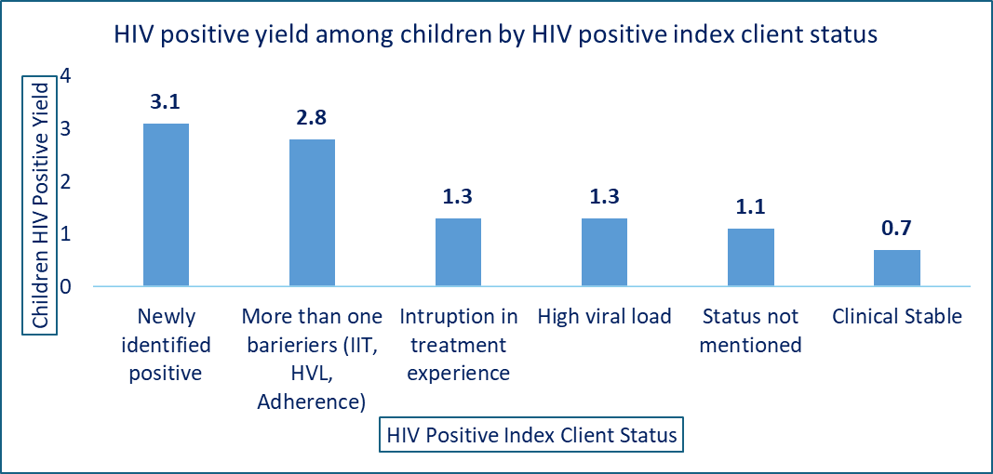
Supplement Figure 2: HIV Children HIV positivity rate by HIV positive Index case status in Ethiopia (n=563).

Supplement Figure 3: Children HIV positivity rate by HIV positive Index case status and children age in Ethiopia (n=563).

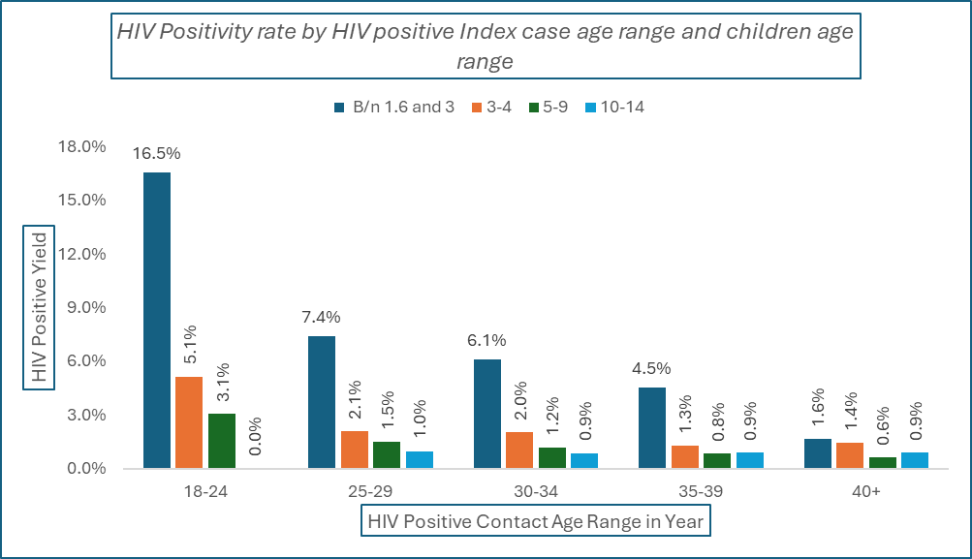
Supplement Figure 4: Children HIV positivity rat by HIV positive Index case age and children age in Ethiopia (n=563).

