Figure7 Cloning of TaAP2-34 gene in Wheat
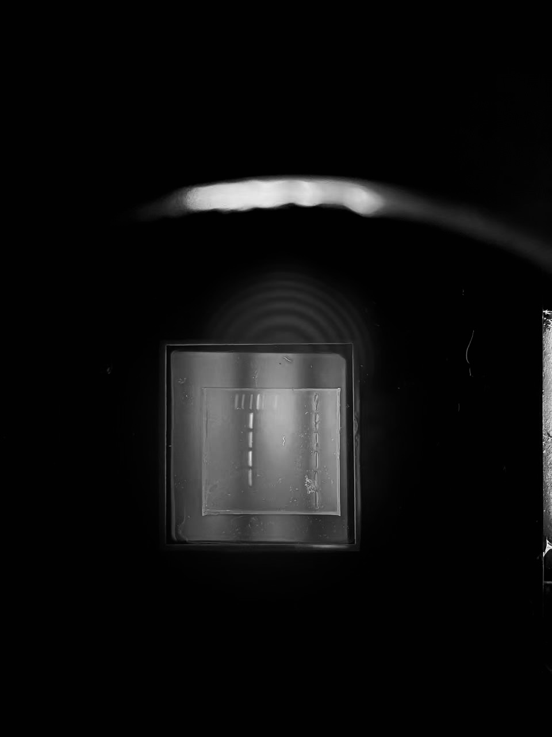

Figure8 Amplification results of bacterial liquid of TaAP2-34 gene cloning vector
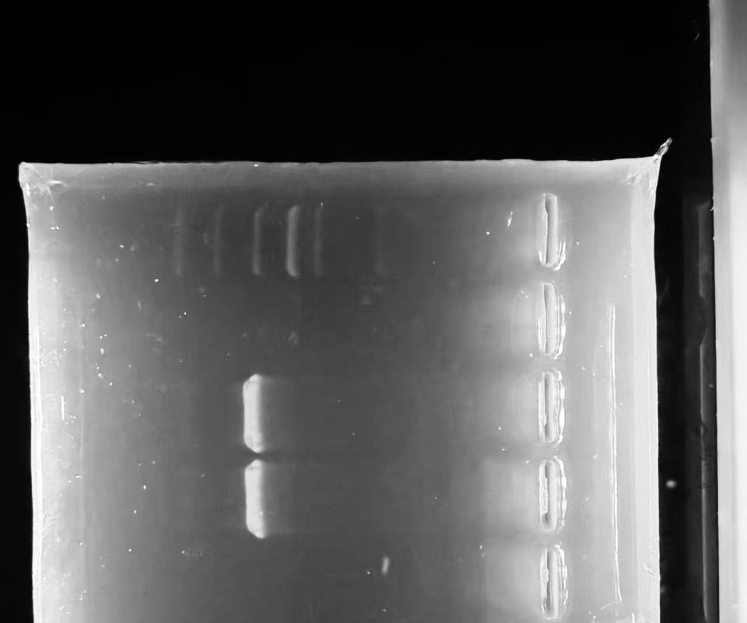
Figure12 Amplification results of bacterial solution of TaAP2-34 gene cloning vector
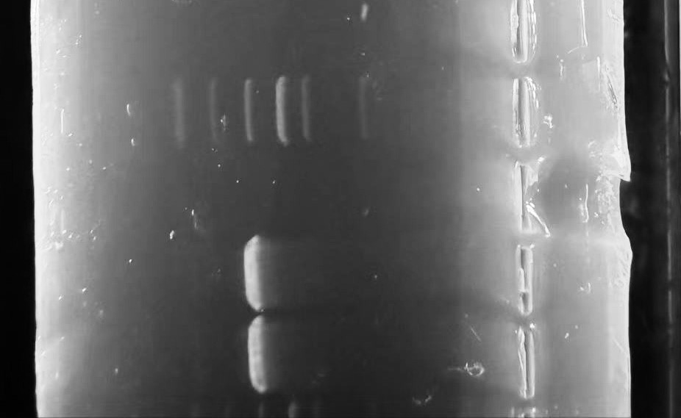

The original image of Figure 7 before color adjustment.

The original images of Figure 8 and Figure 12 are on the same picture, and these are before color adjustment.
