- Supplementary Information
Suppl. Fig. 1. 14-3-3s exert a dose-dependent effect on in vitro α-Syn Fibril Formation
Kinetic curves of α-Syn aggregation measured by RT-QuIC in the presence of different α-Syn:14-3-3γ ratios; Panel A, B and C refer to the effects of 14-3-3γ WT, 14-3-3γ S59D or 14-3-3η, respectively, on α-Syn aggregation. Aggregation of α-Syn in the absence or presence of PFFs (gray dots and black lines, respectively) are reported as reference. Representative images of α-Syn fibrils obtained in the presence of two different α-Syn:14-3-3η ratios (2:1 and 40:1) at the end of the aggregation protocol, as visualized by TEM (D) and AFM (E). (F) Minimum Circumcircle analysis of α-Syn aggregates derived from AFM images in the presence of the two different α-Syn:14-3-3η ratios. Crosses and lines within bars represent the mean and median values, respectively; whiskers represent the 2.5th and 97.5th percentile of the data; individual points outside this range are shown as outliers.
Suppl. Fig. 2. Schematic representation of 14-3-3γ immunoprecipitation from mouse brain lysates
The schematic representation outlines the main steps of the immunoprecipitation workflow. HEK293T cells were transfected with either YFP–14-3-3γ WT or the phosphomimetic mutant YFP–14-3-3γ S59D, while untransfected cells were used as controls. Following overexpression, complexes consisting of 14-3-3γ and its client proteins were isolated using a GFP-Trap approach. The efficiency and quality of the immunoprecipitation were validated by Western blotting. Samples were then subjected to mass spectrometry analysis to identify 14-3-3γ interactors. All experiments were performed in triplicate.
Suppl. Fig. 3. Overlap between our dataset and published 14-3-3 interactors
Venn diagram comparing our dataset with 14-3-3γ interactors reported in BioGRID and 14-3-3Θ interactors from Pair et al. study. Our dataset shares 17 proteins with Pair et al. and 24 proteins with BioGRID. Notably, 9 proteins are common to all three datasets.

Suppl. Fig. 1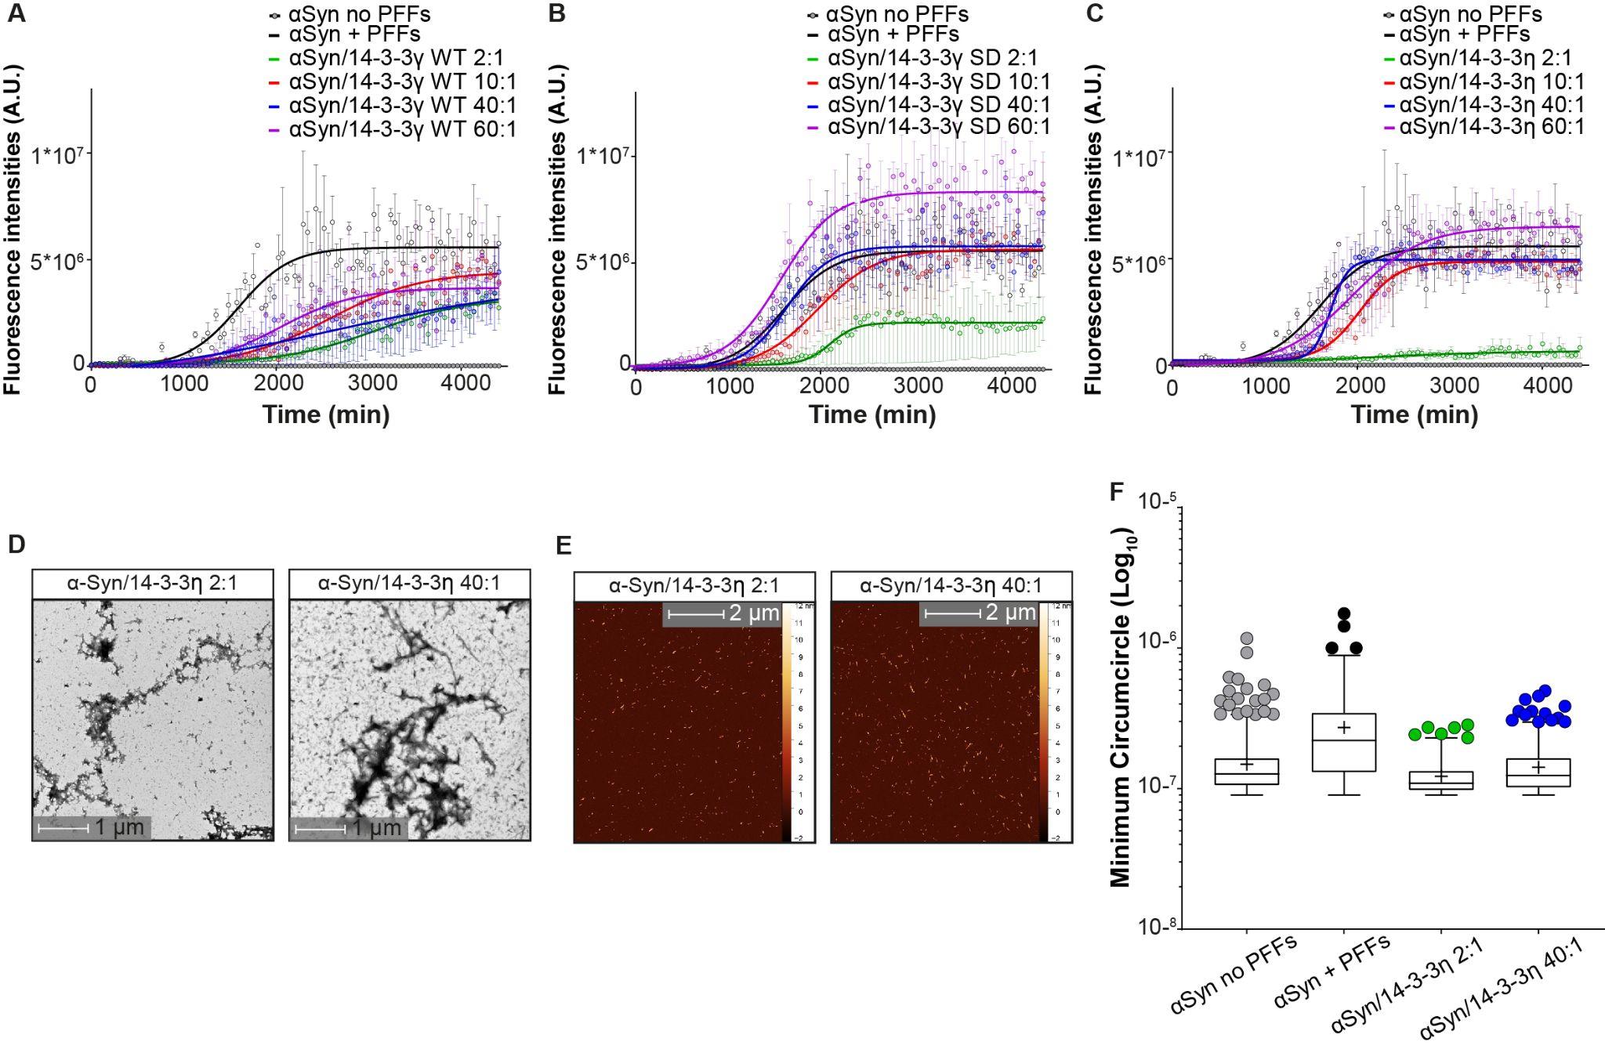
Suppl. Fig.2
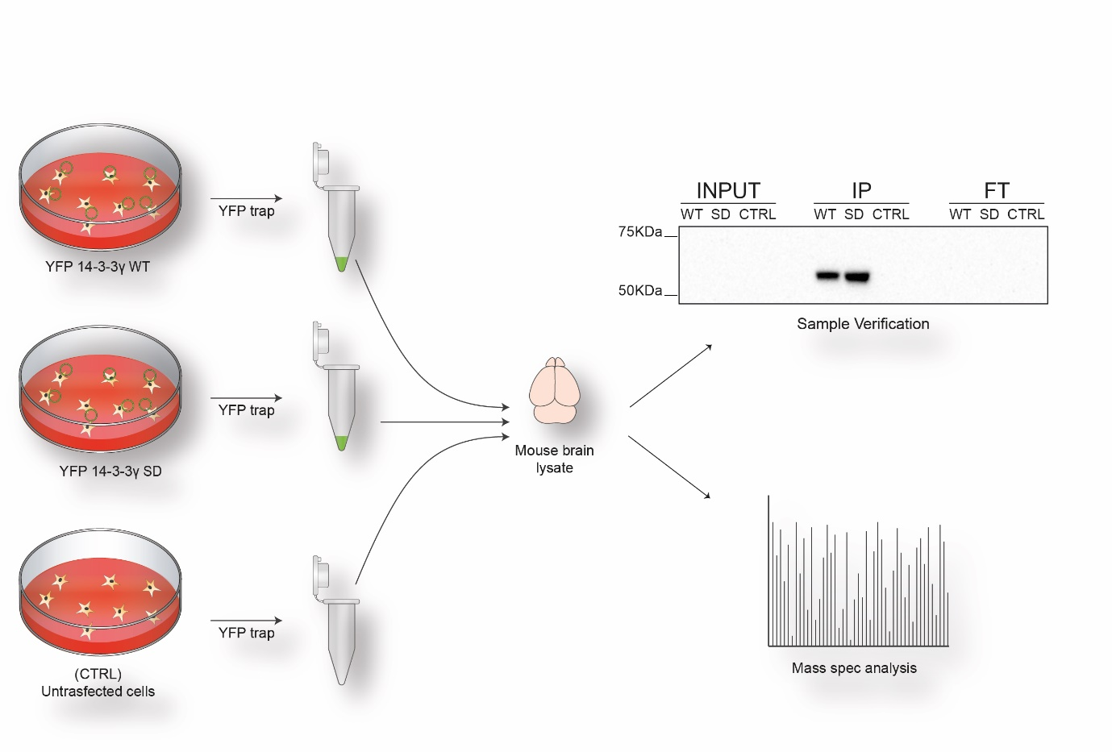
Suppl. Fig. 3
