Supplementary Material
Statistical Formulas for Occupational Injury Indicators

This document provides the detailed mathematical expressions used to calculate the epidemiological indicators for disabling occupational injuries among female workers in Ecuador.

(1) Age-Standardized Incidence Rate (ASIR)
The ASIR was calculated using the direct standardization method to adjust for differences in the age structure of the female workforce across sectors:

$$ASIR=\frac{\sum_{i=1}^{n}{({r_{i} × P}_{std,i})} }{\sum_{i=1}^{n}{P_{std,i}}}×100,000$$

Where r_{i} represents the age-specific incidence rate for each age group i (15-24, 25-34, 35-44, 45-64, and 65+ years), and P_{std,i} is the number of individuals in the corresponding age group of the standard population used as the reference for that specific year.

(2) Relative Percentage Change (PC)
To quantify the variation in injury rates between the initial (t₀ and t₁) years of each analyzed period:

$$PC=\left(\frac{{ASIR}_{t_{1}}-{ASIR}_{t_{0}}}{{ASIR}_{t_{0}}}\right)×100$$

Where t0 and t1 represent the initial and final years of each analyzed period, respectively.

(3) 95% Confidence Interval for the PC
To determine the statistical significance of the PC, 95% confidence intervals (95% CI) were calculated. Since the PC is derived from the ratio of two independent rates (ASIR_{t 1} / ASIR_{t 0}), the confidence limits were estimated using the following formula based on the error of the natural logarithm of the ASIR:

$$95\% CI=\left[exp\left(ln\left(\frac{{ASIR}_{t_{1}}}{{ASIR}_{t_{0}}}\right)±1.96\sqrt{\frac{1}{d_{t_{1}}}+\frac{1}{d_{t_{0}}}}\right)-1\right]×100$$

Where d_{t1} and d_{t0} represent the number of observed disabling injury cases in the final and initial years of each period, respectively.

(4) Z-test for Statistical Significance
To evaluate the statistical significance of the observed variations across the analyzed periods:

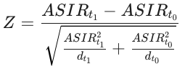

A p-value < 0.05 derived from the standard normal distribution was considered significant.

(5) Incidence Rate Ratio (IRR)
Used to assess the relative risk between economic sectors, with Manufacturing as the reference group (IRR=1.0):

$${IRR}_{i}=\frac{{ASIR}_{i}}{{ASIR}_{ref}}$$

ASIR_{i}: Age-standardized rate of the comparison sector (Agriculture or Construction). ASIR_{ref}: Age-standardized rate of the reference sector (Manufacturing).

(6) 95% Confidence Interval for the IRR
Estimated based on the standard error of the log-transformed IRR to ensure a robust comparison of the risk burden:

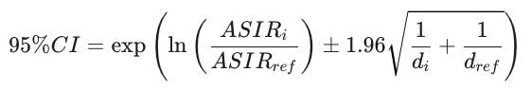

Where, d_{i} and d_{ref} is the number of observed disabling injury cases in the comparison sector and the reference sector, respectively.

