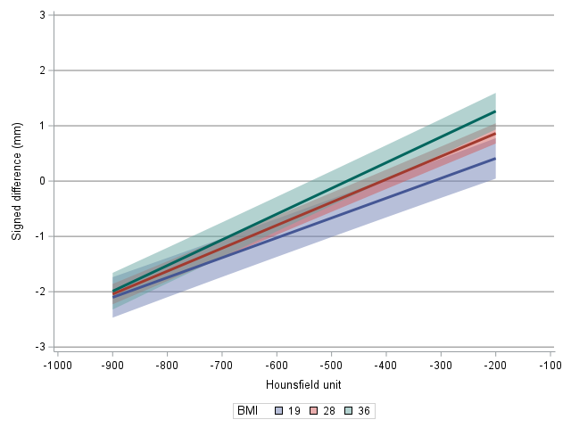
Supplemental Figure 1. Trachea: Hounsfield unit threshold by body mass index (BMI) interaction effect. Lines represent the linear regression estimate for BMI at the 5th, 50th, and 95th percentile. Shaded region represents the 95% CI.

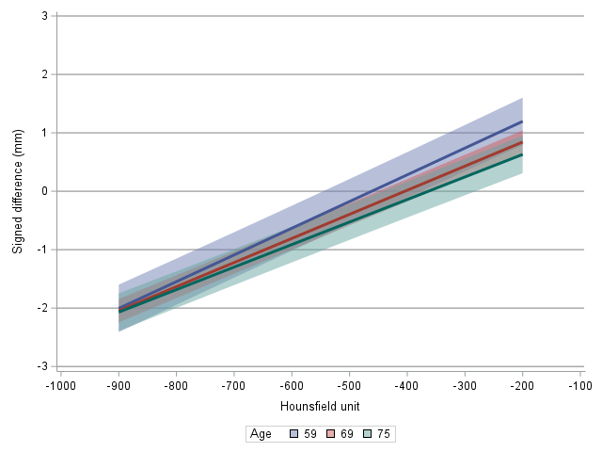
Supplemental Figure 2. Trachea: Hounsfield unit threshold-by-age interaction effect. Lines represent the linear regression estimate for ages at the 5th, 50th, and 95th percentile. Shaded region represents the 95% CI.

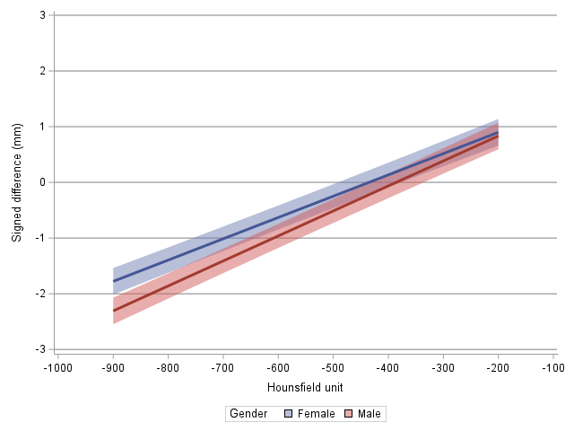
Supplemental Figure 3. Trachea: Hounsfield unit threshold-by gender interaction effect. Lines represent the linear regression estimate for each gender. Shaded region represents the 95% CI.

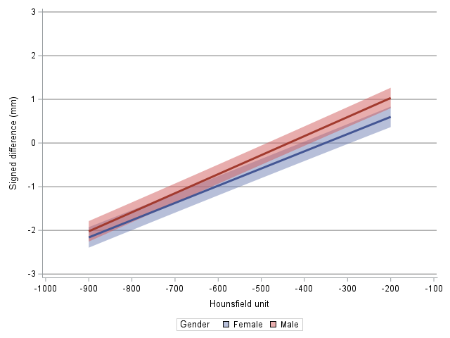
Supplemental Figure 4. Bronchus Intermedius: Hounsfield unit threshold-by-gender interaction effect. Lines represent the linear regression estimate for each gender. Shaded region represents the 95% CI.
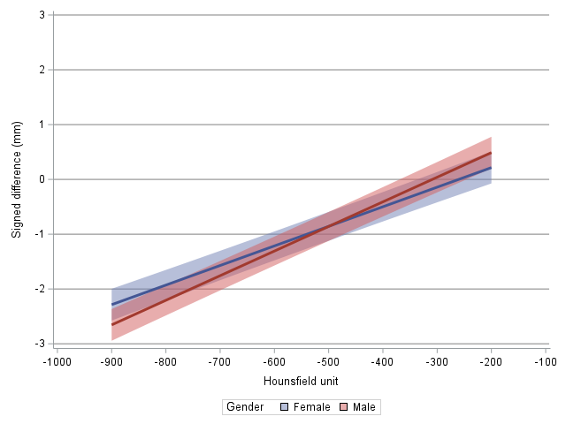
Supplemental Figure 5. Lower Left Lobe Segmental: Hounsfield unit threshold-by-gender interaction effect. Lines represent the linear regression estimate for each gender. Shaded region represents the 95% CI.

