Supplementary Figures

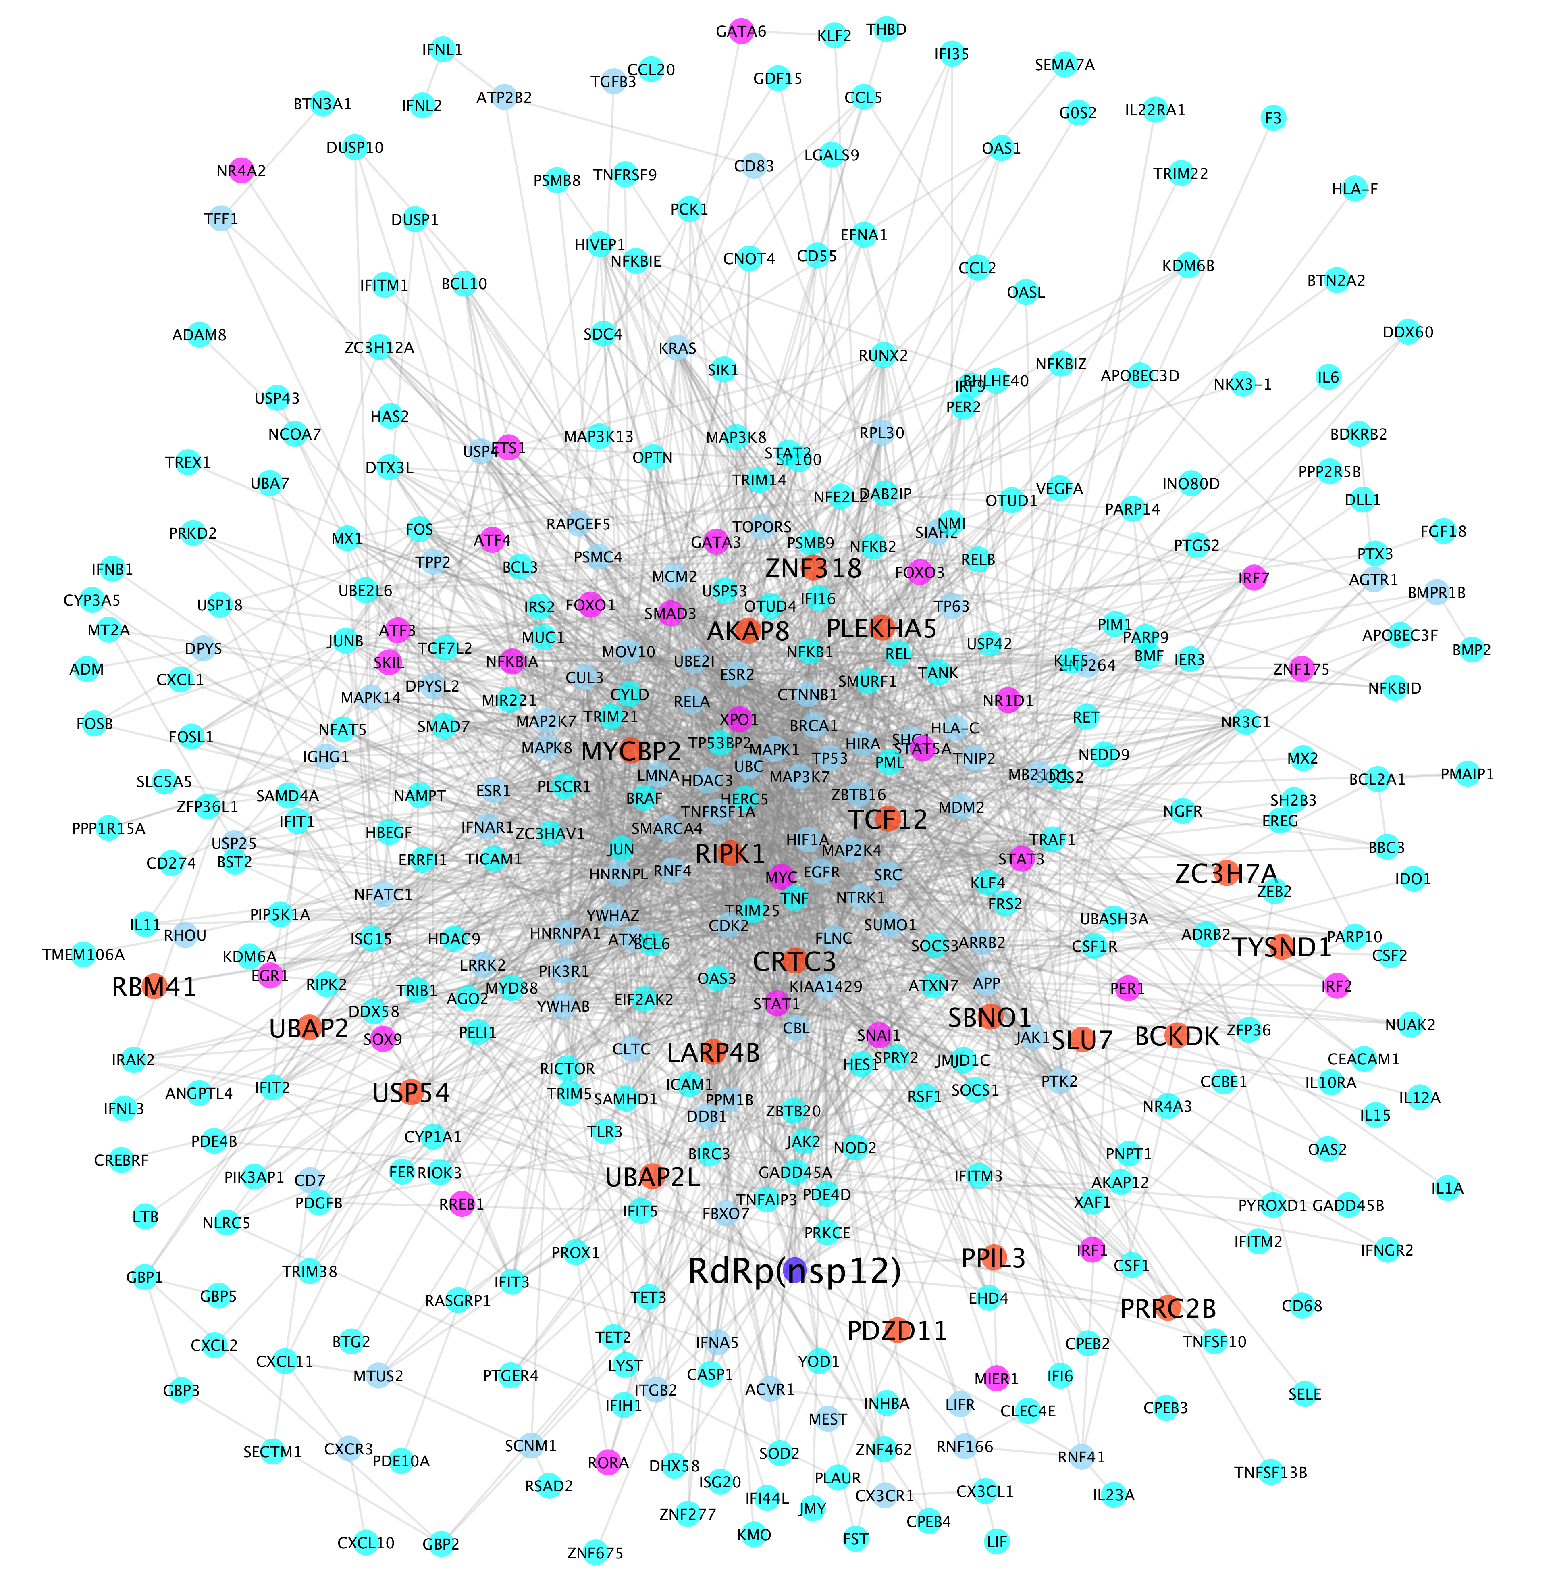
Supplementary Figure 1: Nsp12-host interaction signaling network (with 2,266 protein-protein interactions among 405 proteins). Blue, red, purple, cyan and light blue nodes represent the RdRp(nsp12), prey proteins interacting with nsp12, transcription factors, up-regulated genes, and proteins linking the prey proteins and up-regulated genes.
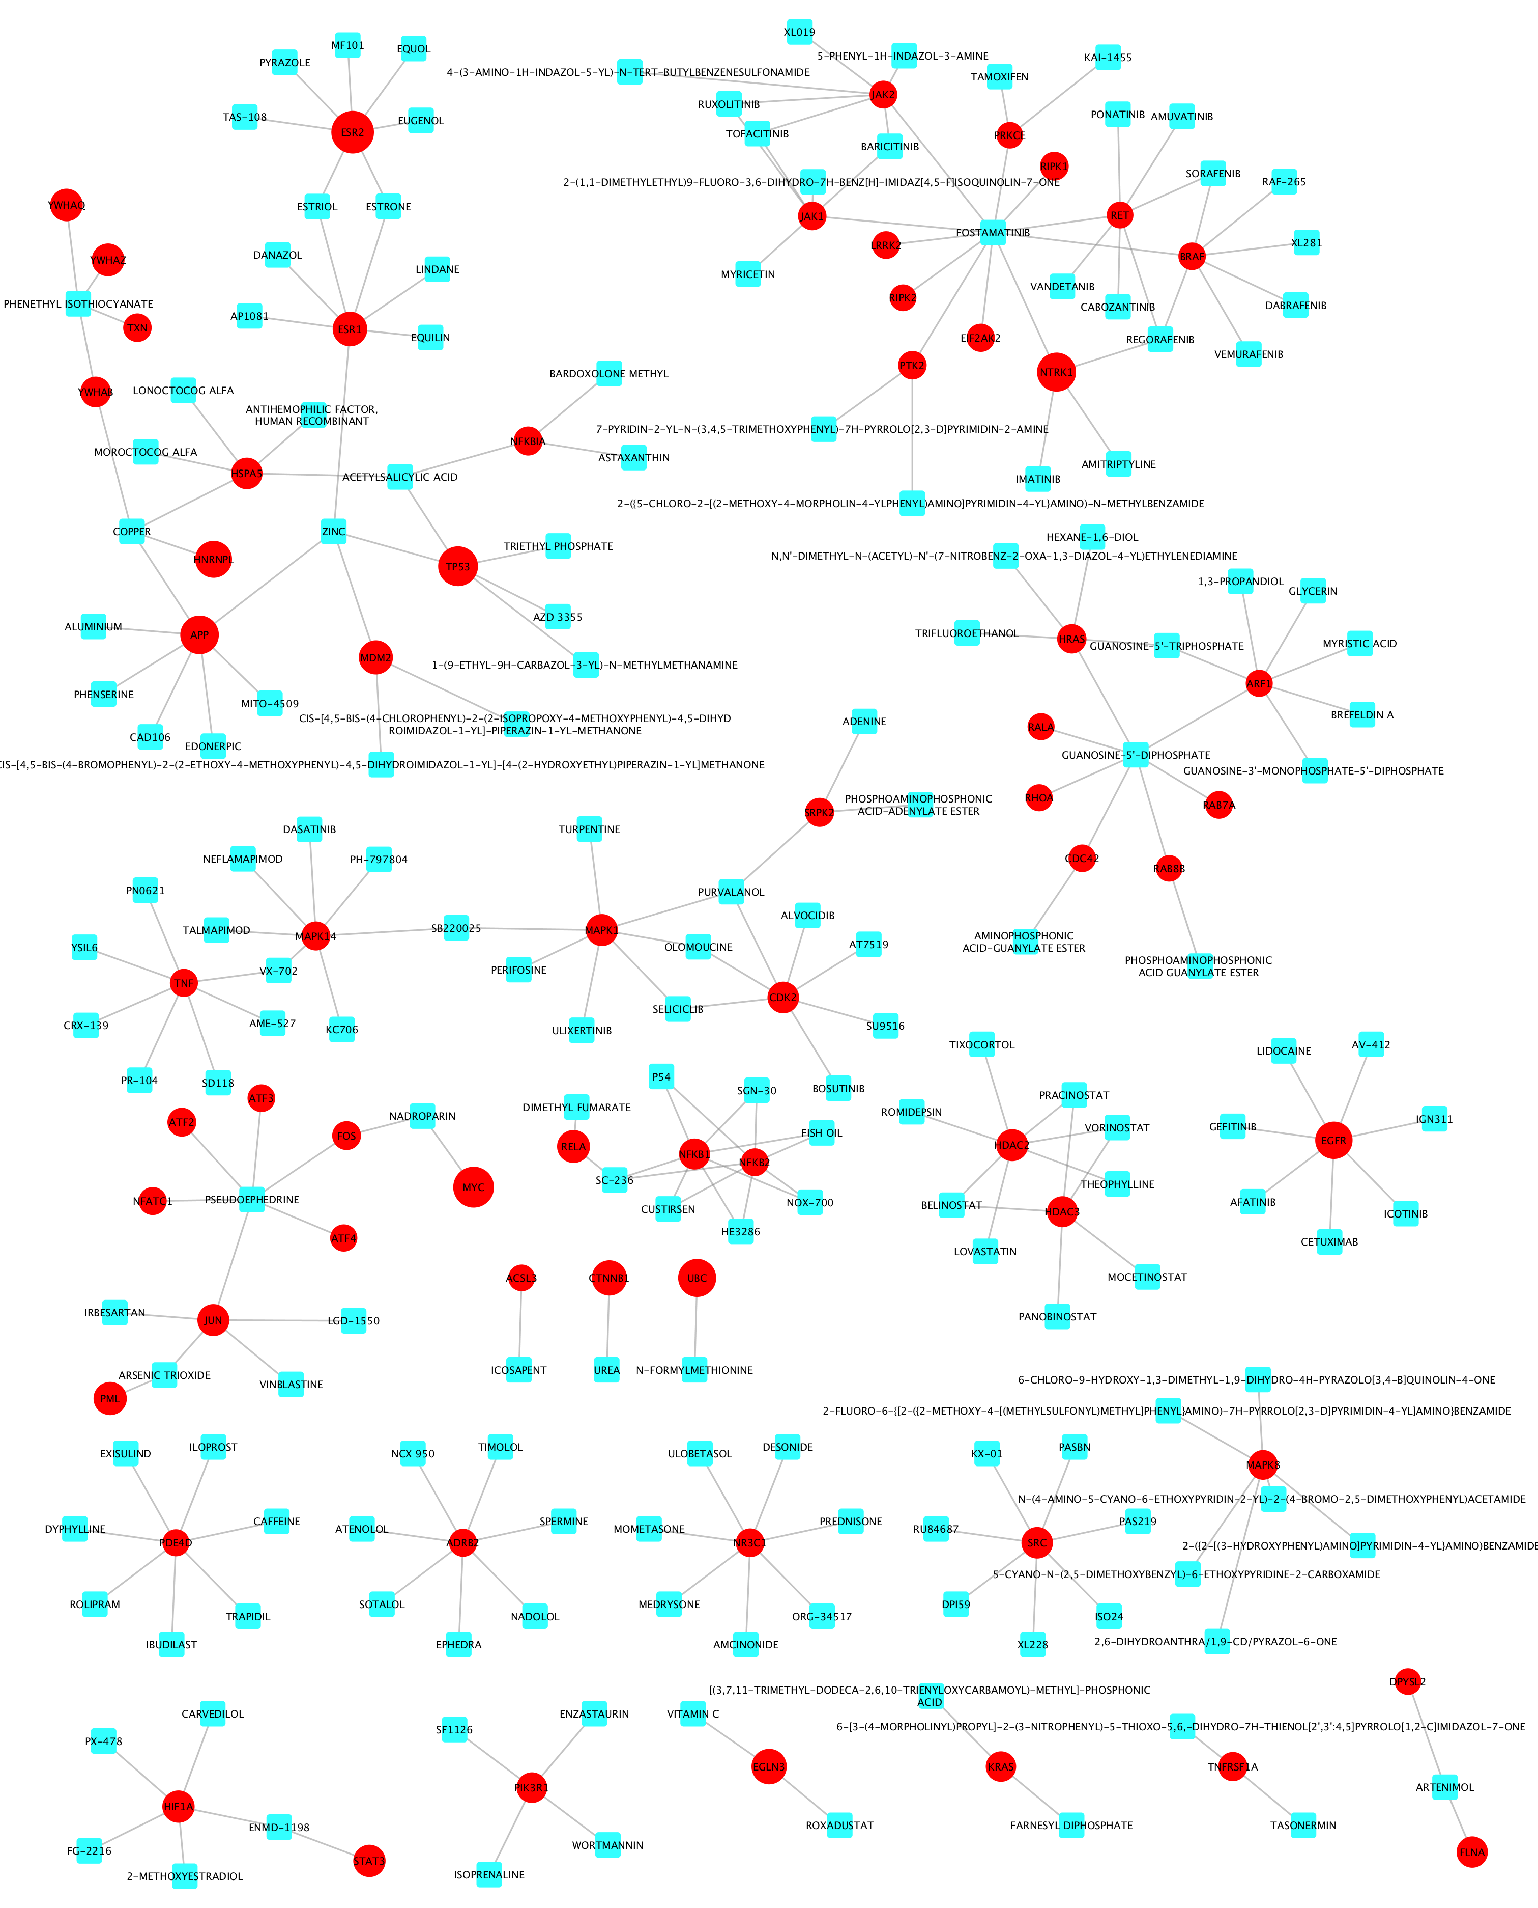
Supplementary Figure 2: Selected drugs perturbing the 65 signaling targets on the RdRP-host interaction signaling networks. Red and Cyan nodes represent targets and drugs respectively.

