Supplementary Information for

Revealing filler-matrix structure of hydrogel-inorganic nanocomposite
across multiple length scales by direct observation

Maradhana Agung Marsudi¹, Masahiro Yoshida², Shinji Noguchi^{2,3,4}, Masato Suzuki^{5,6}, Yasuhiko Igarashi⁵, Ryuji Kiyama^{2,7}, Takayuki Nonoyama^{2,8}*

¹Graduate School of Life Science, Hokkaido University, Kita-21 Nishi-11, Kita-ku, Sapporo 001-0021, Japan
²Faculty of Advanced Life Science, Hokkaido University, Kita-21 Nishi-11, Kita-ku, Sapporo 001-0021, Japan
³John A. Paulson School of Engineering and Applied Sciences, Harvard University, 9 Oxford Street, Cambridge, MA, 02138, USA
⁴Institute for Integrated Innovations, Hokkaido University, Kita-21 Nishi-11, Kita-ku, Sapporo 001-0021, Japan
⁵Faculty of Engineering, Information and Systems, University of Tsukuba, Tennōdai1-1-1, Tsukuba 305-8573, Japan
⁶The Yokohama Rubber Co. Ltd, Oiwake2-1, Hiratsuka 254-8601, Japan
⁷Laboratoire de Sciences et Ingénierie de la Matière Molle, CNRS, ESPCI Paris, PSL Research University, 10 rue Vauquelin, 75005 Paris, France
⁸Co-Creation Core for Soft Materials Aspiring Research & Translation (C³-SMART), Hokkaido University, Kita-21 Nishi-11, Kita-ku, Sapporo 001-0021, Japan
E-mail: nonoyama@sci.hokudai.ac.jp (T. Nonoyama)

Contents

Supplementary text 1 – Theoretical silane coverage calculation‥‥‥‥‥‥‥‥‥‥‥‥3
Supplementary text 2 – Projection effect in length measurements under TEM‥‥‥‥‥‥3
Supplementary text 3 – Energy dissipation value‥‥‥‥‥‥‥‥‥‥‥‥‥‥‥‥‥‥4
Fig. S1‥‥‥‥‥‥‥‥‥‥‥‥‥‥‥‥‥‥‥‥‥‥‥‥‥‥‥‥‥‥‥‥‥‥‥‥6
Fig. S2‥‥‥‥‥‥‥‥‥‥‥‥‥‥‥‥‥‥‥‥‥‥‥‥‥‥‥‥‥‥‥‥‥‥‥‥7
Fig. S3‥‥‥‥‥‥‥‥‥‥‥‥‥‥‥‥‥‥‥‥‥‥‥‥‥‥‥‥‥‥‥‥‥‥‥‥8
Fig. S4‥‥‥‥‥‥‥‥‥‥‥‥‥‥‥‥‥‥‥‥‥‥‥‥‥‥‥‥‥‥‥‥‥‥‥‥9
Fig. S5‥‥‥‥‥‥‥‥‥‥‥‥‥‥‥‥‥‥‥‥‥‥‥‥‥‥‥‥‥‥‥‥‥‥‥‥10
Fig. S6‥‥‥‥‥‥‥‥‥‥‥‥‥‥‥‥‥‥‥‥‥‥‥‥‥‥‥‥‥‥‥‥‥‥‥‥11
Fig. S7‥‥‥‥‥‥‥‥‥‥‥‥‥‥‥‥‥‥‥‥‥‥‥‥‥‥‥‥‥‥‥‥‥‥‥‥12
Fig. S8‥‥‥‥‥‥‥‥‥‥‥‥‥‥‥‥‥‥‥‥‥‥‥‥‥‥‥‥‥‥‥‥‥‥‥‥13
Fig. S9‥‥‥‥‥‥‥‥‥‥‥‥‥‥‥‥‥‥‥‥‥‥‥‥‥‥‥‥‥‥‥‥‥‥‥‥14

Supplementary text 1 – Theoretical silane coverage calculation
The theoretical number of surfaces silanol groups (Si–OH) was estimated from the specific surface area of 100 nm spherical silica (~30 m² g⁻¹) and an assumed surface hydroxyl density of 4.6 OH nm⁻² according to the Zhuravlev model¹, corresponding to 0.229 mmol Si–OH per gram of silica. Thus, the theoretical stoichiometric amount of APTES for full coverage (100%) was 0.229 mmol (0.0507 g).
Based on the aforementioned calculation, OH sample (0% coverage) received no silane addition. For 0.2NH₂ (20% coverage), 0.0458 mmol (0.0101 g) of APTES was employed towards 1 g of silica. For 1.0NH₂ (100% coverage), while the theoretical loading should be 0.229 mmol (0.0507 g), in reality, a non-negligible amount of APTES will be lost due to attachment towards the glass vessel reactor & hydrolysis. Thus, to ensure perfect silane coverage, excess amount of silanization were done (5× the theoretical stoichiometric amount: 1.145 mmol, or 0.2535 g of APTES towards 1 g of silica).

Supplementary text 2 – Projection effect in length measurements under TEM
In TEM observation, three-dimensional objects are imaged as two-dimensional projections along the electron beam direction. As a result, the length of elongated polymer strands measured under TEM generally represents a projected length and may differ from the true three-dimensional length depending on the object orientation within the specimen thickness. To quantify this effect, we consider a straight strand of true length $L_{true}$ embedded in a specimen of finite thickness T. $θ$ denotes the angle between the strand axis and the image plane. The projected length observed in the TEM image, $L_{proj}$, is given by
$$L_{proj}=L_{true}\cos{θ}$$
At the same time, the component of the strand length along the beam direction is $L_{true}\sin{θ}$, which must be smaller than or equal to the specimen thickness T. This constraint limits the maximum allowable tilt angle to
$$θ_{max}=\arctan\left(\frac{T}{L_{proj}}\right)$$
Under this condition, the minimum possible true length corresponds to $θ=0°$, yielding
$$L_{true, min}=L_{proj}$$
whereas the maximum possible true length is obtained at $θ=θ_{max}$,
$$L_{true, max}=\frac{L_{proj}}{\cos{θ_{max}}}$$
For a specimen thickness of $T\sim 150 nm$ and an observed projected length of $L_{proj}\sim 200 nm$, this results in a maximum true length of approximately 250 nm.
To estimate the average true length, we assume that strand orientations are isotropically distributed in three dimensions within the thickness-limited angular range $0°≤θ≤θ_{max}$. For an isotropic distribution, the probability density of the tilt angle is proportional to $\sin{θ}$. The average true length corresponding to a given projected length is then
$$〈L_{true}〉=L_{proj}〈\frac{1}{\cos{θ}}〉=L_{proj}\frac{\int_{0}^{θ_{max}}{\frac{\sin{θ}}{\cos{θ}}dθ}}{\int_{0}^{θ_{max}}{\sin{θ}dθ}}$$
Evaluating this expression for the parameters above yields
$$〈L_{true}〉≈1.1L_{proj}$$
corresponding to an average increase of approximately 10% relative to the projected length. These results indicate that, for specimen thicknesses comparable to but smaller than the observed strand length, projection effects introduce a modest systematic underestimation of the true three-dimensional length. In the present study, the experimentally measured lengths should therefore be interpreted as lower bounds, with the true lengths expected to be on average approximately 10% larger.

Supplementary text 3 – Energy dissipation value
$$tanδ=\frac{G"}{G'}$$
Since G’ is the elastic (energy-storing) component, and G” is the viscous (energy-dissipating) component, the dissipated energy relative to total energy can be estimated by:
$$Fraction of energy dissipated \sim \frac{G"}{G^{'}+G"}\sim \frac{tanδ}{1+tanδ}$$

By inserting the value of tan δ at maximum (~0.2 and ~0.25 for 1.0NH₂^{30wt%} and 1.0NH₂^{40wt%}, respectively) to the equation, these correspond to energy dissipation of 17~20%, hinting breakdown of percolation structure. Note that this value is much higher than the non-percolated systems, having energy dissipation of only ~5%.

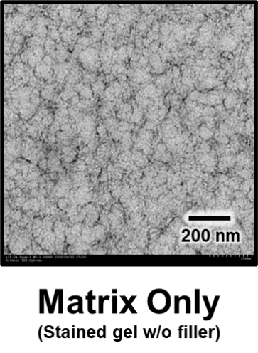
Fig. S1. TEM images of mineral-stained pristine PAMPS/PDMAAm double network hydrogel, showing regular & unperturbed network structure due to absence of filler.

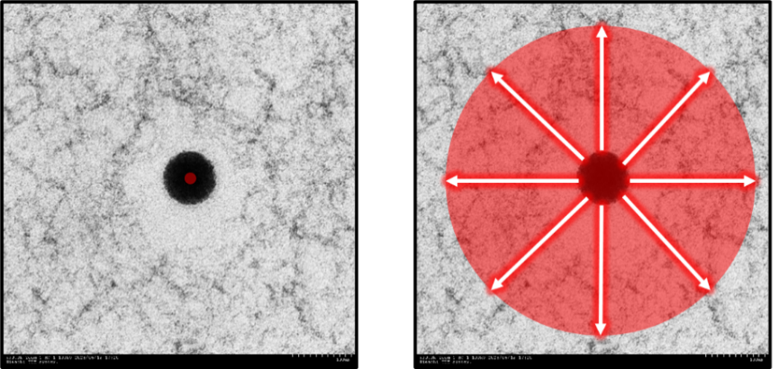
Fig S2. Radial brightness analysis, with filler particle as the center, radiating outwards as shown in the right image. “Radial profile” plugin from Fiji was used in ImageJ in order to facilitate this analysis.

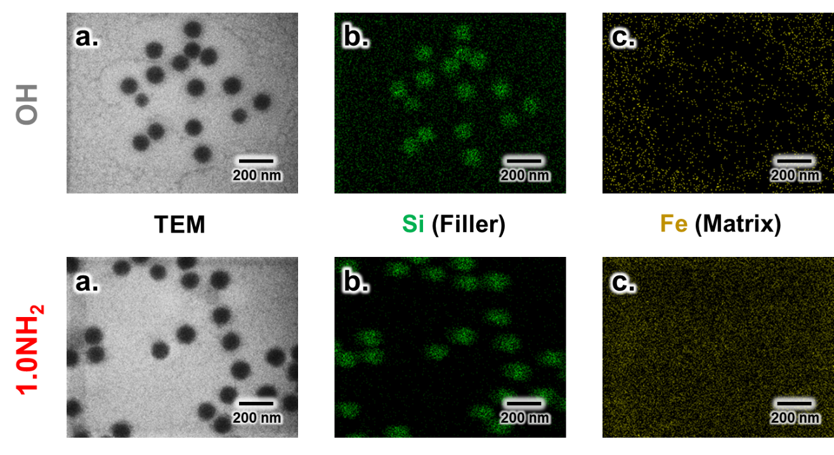
Fig S3. Elemental mapping of bare & completely silanized silica filler in PAMPS hydrogel system. (a) Corresponding TEM image. Energy dispersive X-ray spectroscopy (EDS) mapping result of (b) Si, corresponding to filler position, and (c) Fe, corresponding to matrix position. Bare system shows notable lack of Fe in void area.

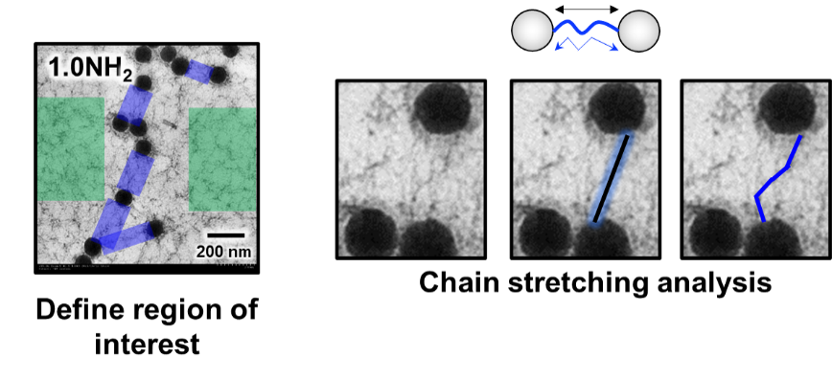
Fig S4. Chain stretching degree analysis. Area between fillers (perturbed network) is marked in blue rectangles, and unperturbed network is marked in green rectangles. Closest straight line is marked in black line with blue glow for visibility. Actual observed chain is marked in blue line.

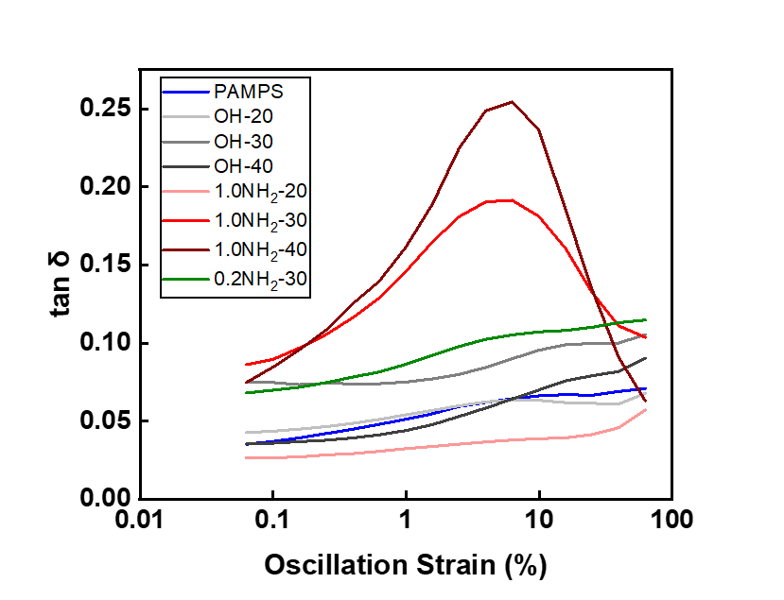
Fig S5. Tan δ of all the nanocomposite systems. Only 1.0NH₂ samples of 30-40 wt% filler loading shows peaking profile at 10% oscillation strain, displaying tan δ 0.2~0.25.

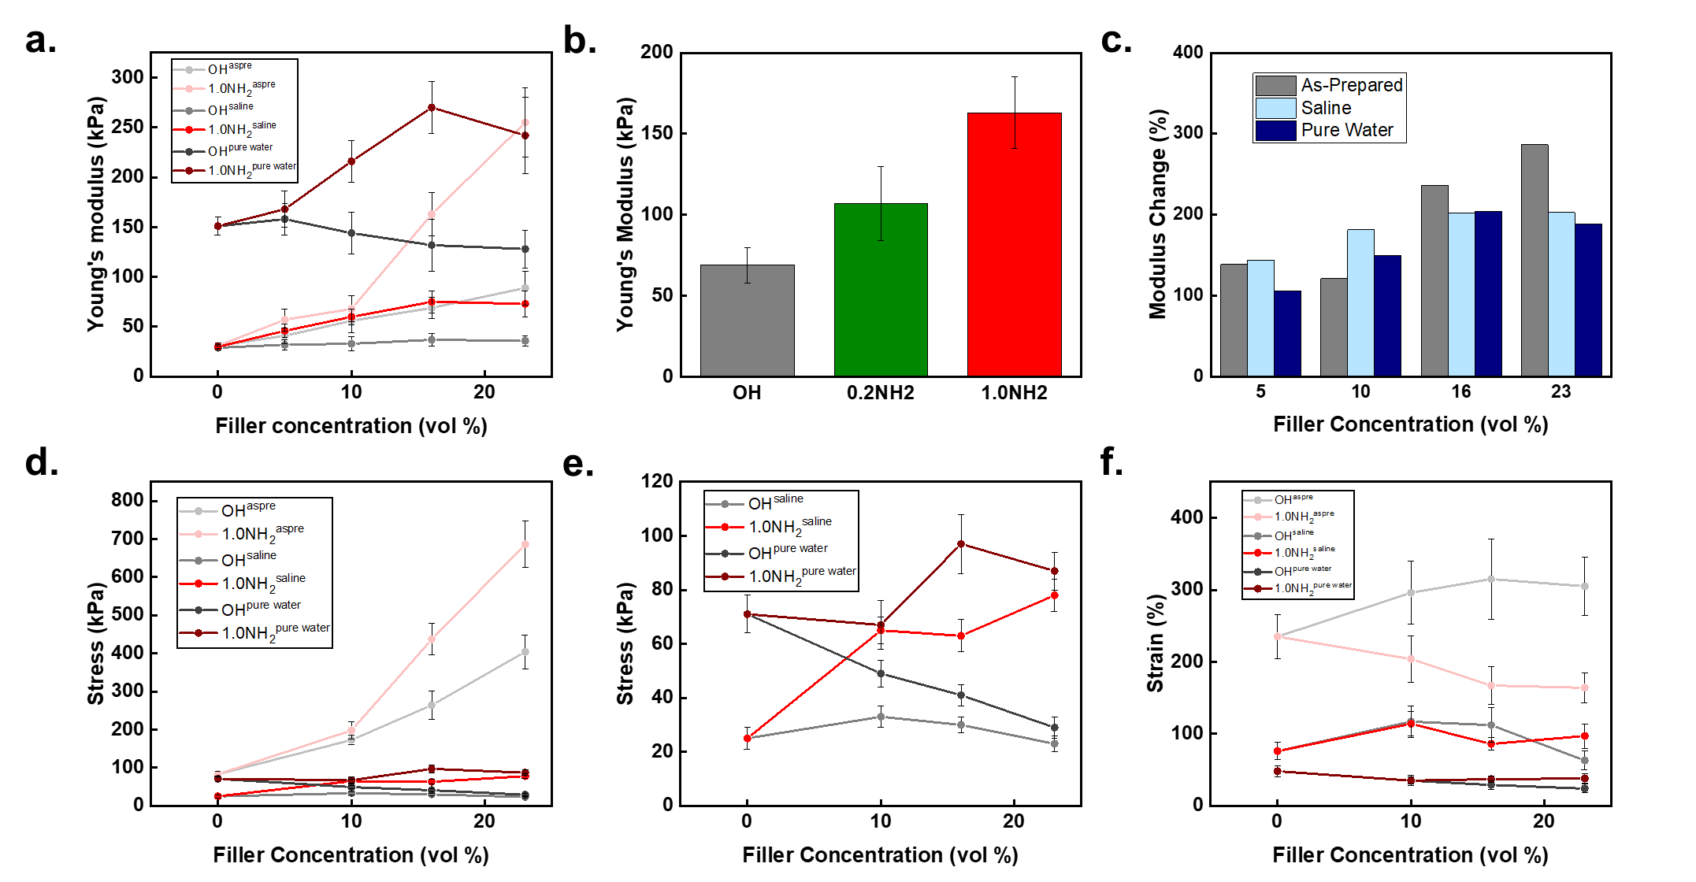
Fig S6. Mechanical properties of each hydrogel-nanocomposite system measured by tensile mode. Young’s modulus as a function of (a) filler loading, (b) amination degree. (c) Improvement of Young’s modulus due to amination (1.0NH₂ relative to OH) at different swelling degree and filler loading. (d) Tensile stress, (e) magnified version of (d) showing only saline and pure water swelling condition. (f) Maximum tensile strain. All tensile tests were done to dog bone-shaped (ISO 37) samples, with 5 times repetition.

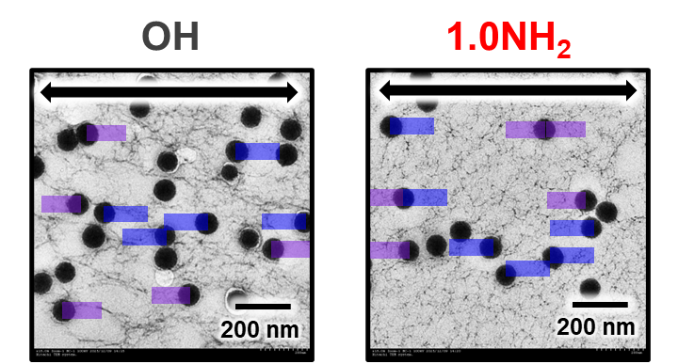
Fig S7. Directional brightness analysis to elucidate local damage mechanism in hydrogel-inorganic nanocomposite. We define the two regions of interests as follows: (1) parallel to tensile direction but away from nearby filler (purple), and (2) parallel to tensile direction and located between two fillers (blue). Brightness analyses were done using ImageJ.

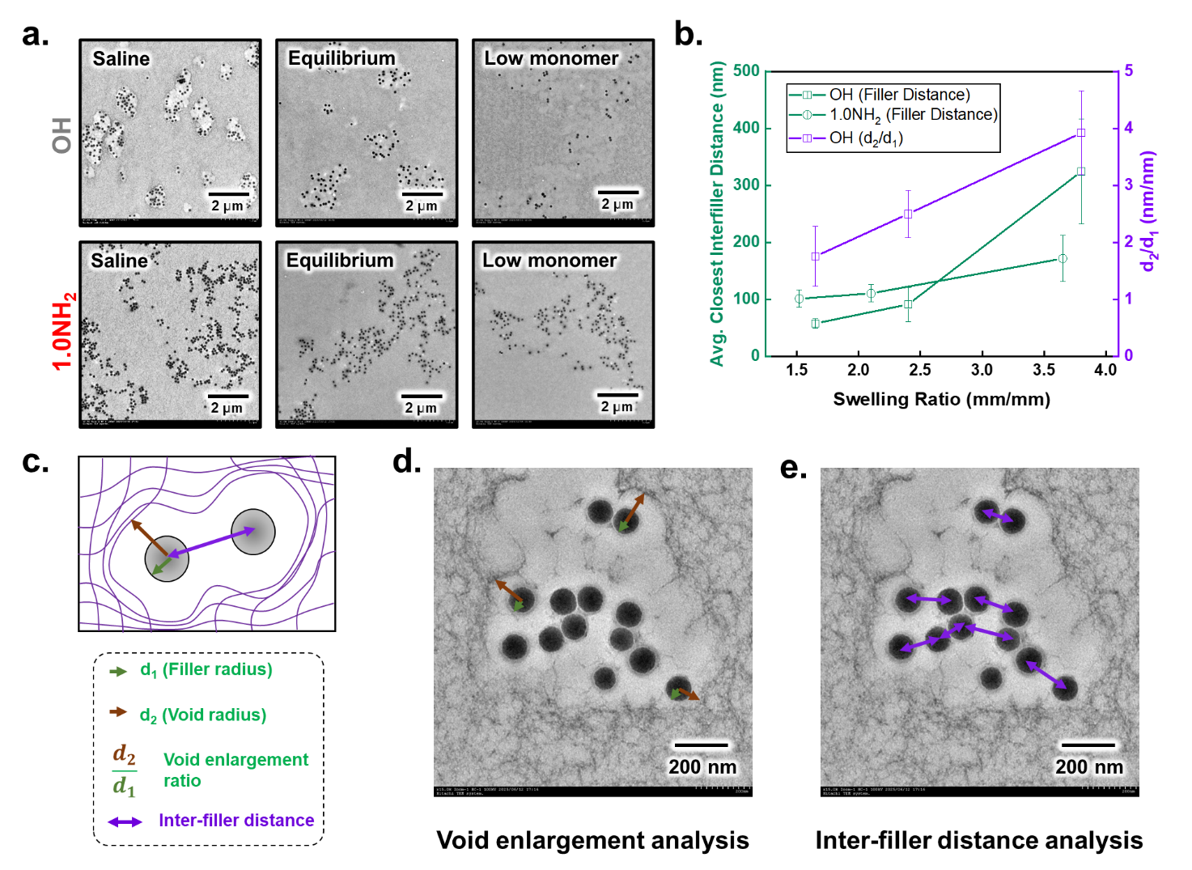
Fig S8. (a) TEM image showing the different swelling state of all samples. Low monomer sample indicates composite made with 1 M PAMPS concentration instead of 1.5 M. This composite shows massively increase swelling due to lower monomer concentration (λ ~ 3.80). (b) Absolute value of inter-filler distance and void enlargement before normalization with the initial value as seen in Fig. 5d. Normalization in Fig. 5d is done by dividing the obtained absolute value at a certain swelling state with the initial value obtained in the saline-swollen state. This is done for the inter-filler distance, the void enlargement, and the macroscale swelling ratio. As such, saline-swollen condition will always start at a value of 1. (c) Illustration of image analysis, showing how to calculate void enlargement ratio and inter-filler distance. Representative real TEM images are shown in (d) and (e), respectively.

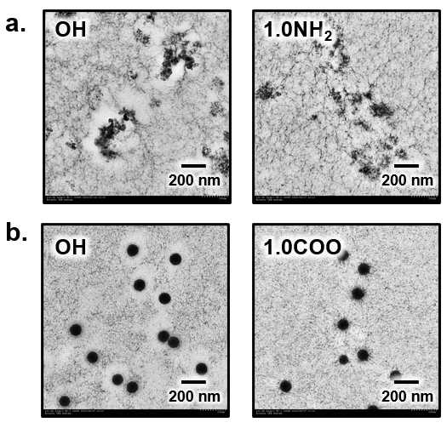
Fig S9. Universality demonstration of the hydrogel nanocomposite filler-matrix observation approach. (a) TEM images of PAMPS/non-spherical silica filler (amorphous silica, Sigma Aldrich), showing irregular filler shape. The void shape around OH filler shows corresponding shape towards the filler shape, while the 1.0NH₂ filler remains connected. (b) TEM images of PMPTC (cationic network)/spherical silica filler, using TBALDH instead of FeCl₃ as mineral staining agent, and TESPSA (negative charged COO⁻) as the silane agent instead of APTES.

References
1. Zhuravlev, L. T. The surface chemistry of amorphous silica. Zhuravlev model. Colloids Surf. A Physicochem. Eng. Asp. 173, 1–38 (2000).

