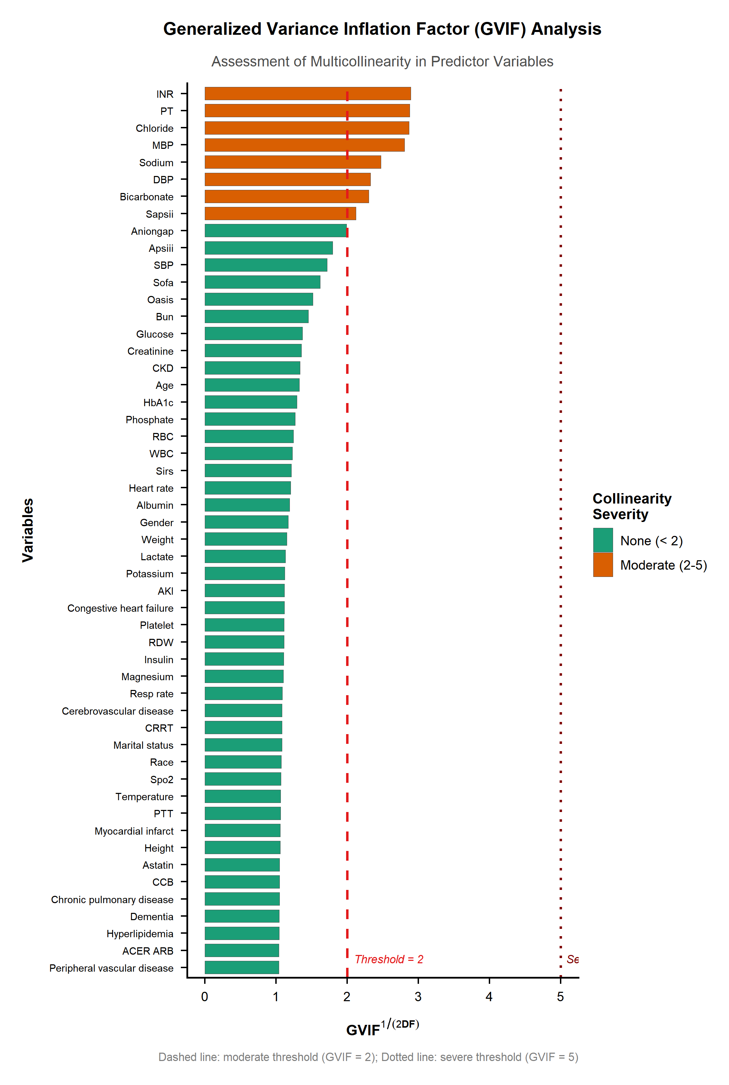
Supplementary Fig 1 Generalized Variance Inflation Factor (GVIF) analysis for the assessment of multicollinearity among predictor variables.

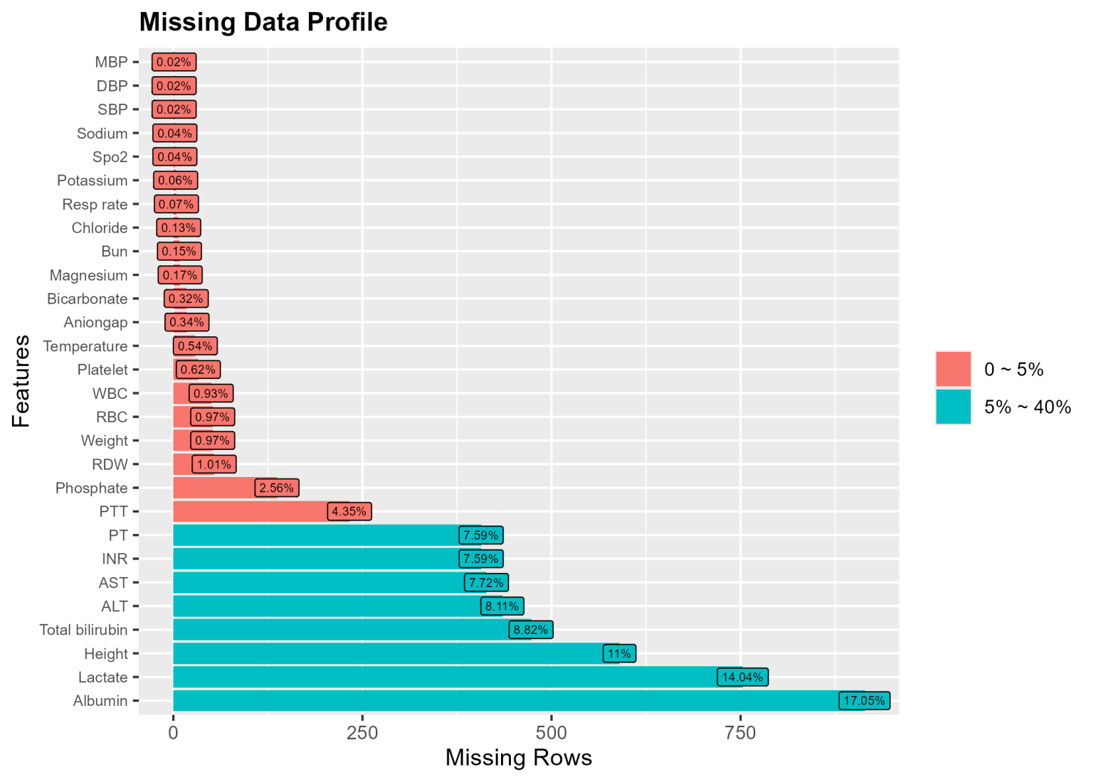
Supplementary Fig 2 Missing data profile of the study cohort
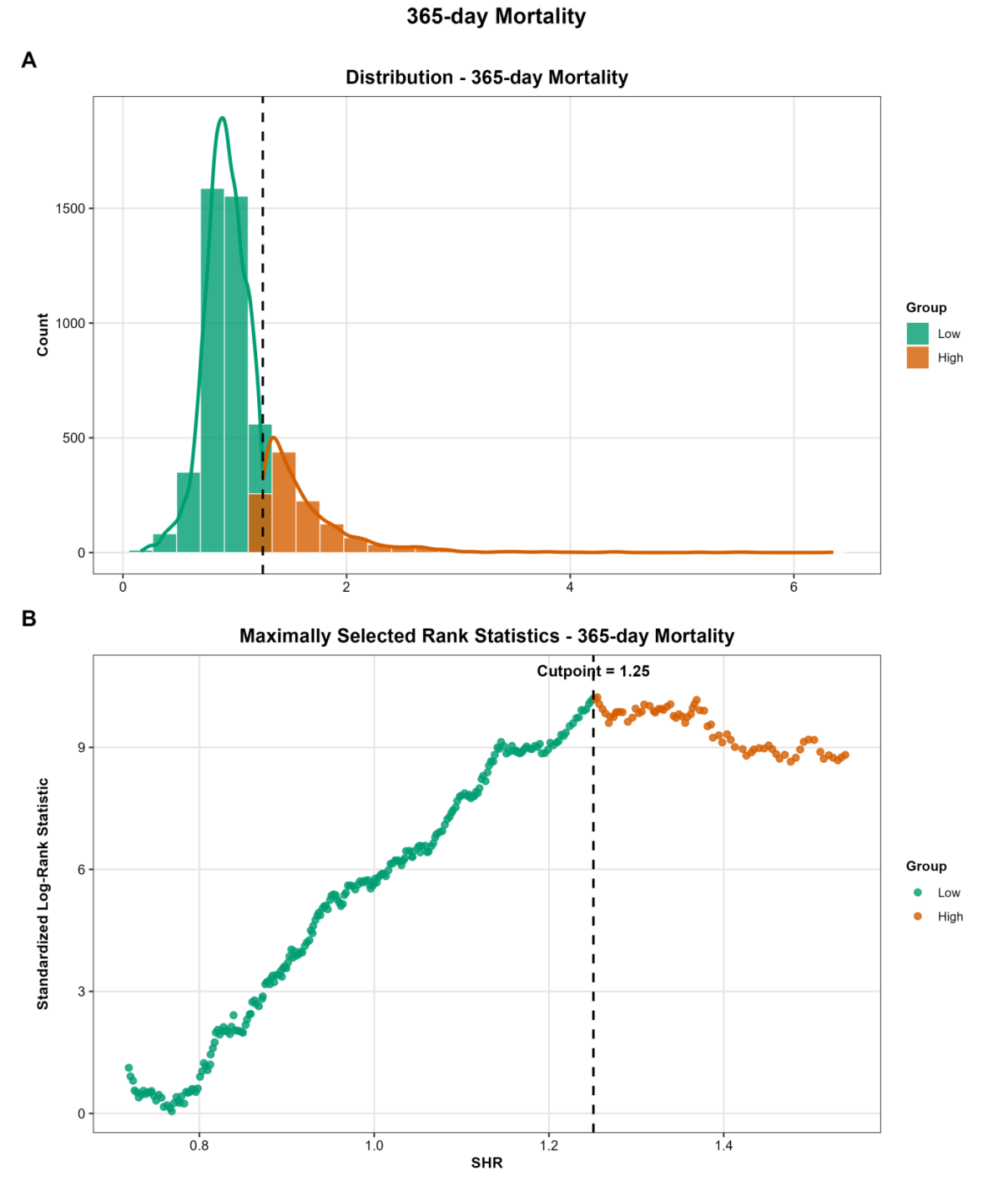
Supplementary Fig 3 (A) Distribution of SHR values stratified by the optimal binary cutpoint (SHR.25), with low (green) and high (orange) groups separated by the dashed vertical line.(B) Maximally selected rank statistics across candidate SHR cutpoints; the dashed vertical line marks the optimal cutpoint (SHR.25) at the maximum standardized log-rank statistic.

Supplementary Table 1 Mediation analysis of the effect of SHR on in-hospital,30-day,and 365-day mortality mediated by lactate
Outcome | Statistic | TE | PNDE | PNIE | PM(%)
In-hospital Mortality | HR(95%CI) | 1.357 (1.218, 1.499) | 1.323 (1.179, 1.452) | 1.033 (1.016, 1.061) | 9.4 (4.7, 20.0)
 | P value | < 0.001 | < 0.001 | < 0.001 | < 0.001
30-day Mortality | HR(95%CI) | 1.285 (1.158, 1.399) | 1.251 (1.130, 1.368) | 1.033 (1.018, 1.063) | 11.9 (6.7, 23.0)
 | P value | < 0.001 | < 0.001 | < 0.001 | < 0.001
365-day Mortality | HR(95%CI) | 1.130 (1.040, 1.210) | 1.111 (1.027, 1.195) | 1.022 (1.010, 1.039) | 14.9 (7.0, 53.2)
 | P value | 0.004 | 0.016 | < 0.001 | 0.004
TE,total effect;PNDE,pure natural direct effect;PNIE,pure natural indirect effect;PM,proportion mediated.HR,hazard ratio;CI,confidence interval.

Supplementary Table 2 Cox proportional hazards models of the association between SHR and in-hospital,30-day,and 365-day all-cause mortality in patients after excluding those with diabetic ketoacidosis(DKA)or hyperosmolar hyperglycemic state(HHS)
 | Crude model |  | Model I |  | Model II |  | Model III
 | HR(95%CI) | P-value | HR(95%CI) | P-value | HR(95%CI) | P-value | HR(95%CI) | P-value
In-hospital Mortality
SHR,per 1 SD | 1.35 (1.26, 1.44) | <0.001 | 1.40 (1.30, 1.50) | <0.001 | 1.32 (1.21, 1.43) | <0.001 | 1.27 (1.16, 1.39) | <0.001
SHR tertiles
T1 | Reference |  | Reference |  | Reference |  | Reference
T2 | 1.51 (1.06, 2.14) | 0.022 | 1.53 (1.07, 2.17) | 0.019 | 1.47 (1.03, 2.11) | 0.035 | 1.39 (0.97, 2.00) | 0.072
T3 | 2.54 (1.85, 3.49) | <0.001 | 2.52 (1.84, 3.47) | <0.001 | 2.18 (1.57, 3.02) | <0.001 | 1.94 (1.39, 2.70) | <0.001
P for trend |  | <0.001 |  | <0.001 |  | <0.001 |  | <0.001
30 day all cause Mortality
SHR,per 1 SD | 1.33 (1.26, 1.40) | <0.001 | 1.39 (1.30, 1.47) | <0.001 | 1.25 (1.16, 1.35) | <0.001 | 1.21 (1.11, 1.31) | <0.001
SHR tertiles
T1 | Reference |  | Reference |  | Reference |  | Reference
T2 | 1.22 (0.89, 1.67) | 0.212 | 1.21 (0.88, 1.65) | 0.242 | 1.08 (0.78, 1.48) | 0.640 | 1.11 (0.81, 1.53) | 0.522
T3 | 2.51 (1.90, 3.31) | <0.001 | 2.41 (1.83, 3.18) | <0.001 | 1.81 (1.36, 2.41) | <0.001 | 1.73 (1.30, 2.31) | <0.001
P for trend |  | <0.001 |  | <0.001 |  | <0.001 |  | <0.001
365 day all cause Mortality
SHR,per 1 SD | 1.24 (1.19, 1.30) | <0.001 | 1.27 (1.21, 1.34) | <0.001 | 1.14 (1.08, 1.22) | <0.001 | 1.11 (1.04, 1.18) | 0.001
SHR tertiles
T1 | Reference |  | Reference |  | Reference |  | Reference
T2 | 0.94 (0.77, 1.14) | 0.516 | 0.94 (0.77, 1.14) | 0.515 | 0.87 (0.71, 1.06) | 0.160 | 0.86 (0.70, 1.04) | 0.125
T3 | 1.67 (1.40, 1.98) | <0.001 | 1.62 (1.37, 1.93) | <0.001 | 1.27 (1.06, 1.52) | 0.008 | 1.21 (1.01, 1.45) | 0.036
P for trend |  | <0.001 |  | <0.001 |  | 0.004 |  | 0.018
Crude model:no covariates adjusted.Model I:Adjusted for Age,Gender,and Race.Model II:Adjusted for Model I+Hypertension,Diabetes mellitus,Atrial fibrillation,Chronic kidney disease,Myocardial infarct,Cerebrovascular disease,Chronic pulmonary disease,Paraplegia,CRRT,Ventilations,BMI,SBP,Urea nitrogen,Platelet,Hemoglobin,Aniongap,Heart rate,Albumin,Creatinine,and SOFA.Model III:Adjusted for Model II+ACE inhibitors/ARB,antiplatelet agents,statins,and beta-blockers.HR,hazard ratio;CI,confidence interval

Supplementary Table 3 Cox proportional hazards models of the association between SHR and in-hospital,30-day,and 365-day all-cause mortality in patients after excluding those with prior use of oral hypoglycemic agents or insulin
 | Crude model |  | Model I |  | Model II |  | Model III
 | HR(95%CI) | P-value | HR(95%CI) | P-value | HR(95%CI) | P-value | HR(95%CI) | P-value
In-hospital Mortality
SHR,per 1 SD | 1.37 (1.28, 1.45) | <0.001 | 1.41 (1.31, 1.50) | <0.001 | 1.31 (1.21, 1.41) | <0.001 | 1.29 (1.19, 1.41) | <0.001
SHR tertiles
T1 | Reference |  | Reference |  | Reference |  | Reference
T2 | 1.69 (1.14, 2.49) | 0.009 | 1.74 (1.17, 2.58) | 0.006 | 1.84 (1.23, 2.76) | 0.003 | 1.75 (1.17, 2.62) | 0.007
T3 | 2.96 (2.08, 4.21) | <0.001 | 2.97 (2.09, 4.23) | <0.001 | 2.48 (1.72, 3.58) | <0.001 | 2.25 (1.55, 3.26) | <0.001
P for trend |  | <0.001 |  | <0.001 |  | <0.001 |  | <0.001
30 day all cause Mortality
SHR,per 1 SD | 1.36 (1.29, 1.43) | <0.001 | 1.40 (1.32, 1.48) | <0.001 | 1.26 (1.17, 1.36) | <0.001 | 1.25 (1.16, 1.35) | <0.001
SHR tertiles
T1 | Reference |  | Reference |  | Reference |  | Reference
T2 | 1.34 (0.94, 1.90) | 0.104 | 1.33 (0.94, 1.89) | 0.110 | 1.30 (0.91, 1.86) | 0.142 | 1.37 (0.96, 1.96) | 0.084
T3 | 2.97 (2.19, 4.04) | <0.001 | 2.84 (2.09, 3.87) | <0.001 | 2.06 (1.50, 2.84) | <0.001 | 2.06 (1.49, 2.85) | <0.001
P for trend |  | <0.001 |  | <0.001 |  | <0.001 |  | <0.001
365 day all cause Mortality
SHR,per 1 SD | 1.26 (1.21, 1.33) | <0.001 | 1.28 (1.22, 1.35) | <0.001 | 1.16 (1.09, 1.23) | <0.001 | 1.13 (1.06, 1.20) | <0.001
SHR tertiles
T1 | Reference |  | Reference |  | Reference |  | Reference
T2 | 0.93 (0.75, 1.16) | 0.533 | 0.95 (0.76, 1.18) | 0.627 | 0.91 (0.73, 1.14) | 0.421 | 0.93 (0.75, 1.16) | 0.538
T3 | 1.75 (1.44, 2.12) | <0.001 | 1.71 (1.41, 2.07) | <0.001 | 1.29 (1.06, 1.58) | 0.012 | 1.27 (1.04, 1.55) | 0.021
P for trend |  | <0.001 |  | <0.001 |  | 0.007 |  | 0.014
Crude model:no covariates adjusted.Model I:Adjusted for Age,Gender,and Race.Model II:Adjusted for Model I+Hypertension,Diabetes mellitus,Atrial fibrillation,Chronic kidney disease,Myocardial infarct,Cerebrovascular disease,Chronic pulmonary disease,Paraplegia,CRRT,Ventilations,BMI,SBP,Urea nitrogen,Platelet,Hemoglobin,Aniongap,Heart rate,Albumin,Creatinine,and SOFA.Model III:Adjusted for Model II+ACE inhibitors/ARB,antiplatelet agents,statins,and beta-blockers.HR,hazard ratio;CI,confidence interval

Supplementary Table 4 Cox proportional hazards models of the association between SHR and in-hospital,30-day,and 365-day all-cause mortality in patients after excluding those who received corticosteroids prior
 | Crude model |  | Model I |  | Model II |  | Model III
 | HR(95%CI) | P-value | HR(95%CI) | P-value | HR(95%CI) | P-value | HR(95%CI) | P-value
In-hospital Mortality
SHR,per 1 SD | 1.37 (1.29, 1.46) | <0.001 | 1.42 (1.33, 1.52) | <0.001 | 1.35 (1.24, 1.46) | <0.001 | 1.30 (1.19, 1.42) | <0.001
SHR tertiles
T1 | Reference |  | Reference |  | Reference |  | Reference
T2 | 1.43 (1.01, 2.02) | 0.046 | 1.42 (1.00, 2.02) | 0.047 | 1.36 (0.95, 1.94) | 0.088 | 1.31 (0.92, 1.88) | 0.139
T3 | 2.59 (1.90, 3.52) | <0.001 | 2.58 (1.89, 3.51) | <0.001 | 2.22 (1.61, 3.06) | <0.001 | 1.98 (1.43, 2.74) | <0.001
P for trend |  | <0.001 |  | <0.001 |  | <0.001 |  | <0.001
30 day all cause Mortality
SHR,per 1 SD | 1.34 (1.27, 1.41) | <0.001 | 1.39 (1.32, 1.48) | <0.001 | 1.27 (1.18, 1.37) | <0.001 | 1.24 (1.14, 1.34) | <0.001
SHR tertiles
T1 | Reference |  | Reference |  | Reference |  | Reference
T2 | 1.14 (0.83, 1.55) | 0.416 | 1.12 (0.82, 1.52) | 0.492 | 0.98 (0.72, 1.34) | 0.906 | 1.02 (0.74, 1.40) | 0.908
T3 | 2.51 (1.92, 3.29) | <0.001 | 2.43 (1.85, 3.18) | <0.001 | 1.80 (1.36, 2.37) | <0.001 | 1.71 (1.29, 2.26) | <0.001
P for trend |  | <0.001 |  | <0.001 |  | <0.001 |  | <0.001
365 day all cause Mortality
SHR,per 1 SD | 1.25 (1.19, 1.31) | <0.001 | 1.28 (1.22, 1.34) | <0.001 | 1.14 (1.08, 1.21) | <0.001 | 1.11 (1.05, 1.18) | <0.001
SHR tertiles
T1 | Reference |  | Reference |  | Reference |  | Reference
T2 | 0.92 (0.76, 1.12) | 0.400 | 0.92 (0.76, 1.11) | 0.382 | 0.84 (0.69, 1.02) | 0.072 | 0.83 (0.68, 1.01) | 0.059
T3 | 1.69 (1.42, 2.00) | <0.001 | 1.65 (1.39, 1.96) | <0.001 | 1.27 (1.07, 1.52) | 0.007 | 1.20 (1.01, 1.44) | 0.039
P for trend |  | <0.001 |  | <0.001 |  | 0.003 |  | 0.018
Crude model:no covariates adjusted.Model I:Adjusted for Age,Gender,and Race.Model II:Adjusted for Model I+Hypertension,Diabetes mellitus,Atrial fibrillation,Chronic kidney disease,Myocardial infarct,Cerebrovascular disease,Chronic pulmonary disease,Paraplegia,CRRT,Ventilations,BMI,SBP,Urea nitrogen,Platelet,Hemoglobin,Aniongap,Heart rate,Albumin,Creatinine,and SOFA.Model III:Adjusted for Model II+ACE inhibitors/ARB,antiplatelet agents,statins,and beta-blockers.HR,hazard ratio;CI,confidence interval

Supplementary Table 5 Cox proportional hazards models of the association between SHR and in-hospital,30-day,and 365-day all-cause mortality in the complete-case dataset excluding patients with any missing analytical variables
 | Crude model |  | Model I |  | Model II |  | Model III
 | HR(95%CI) | P-value | HR(95%CI) | P-value | HR(95%CI) | P-value | HR(95%CI) | P-value
In-hospital Mortality
SHR,per 1 SD | 1.38 (1.29, 1.47) | <0.001 | 1.43 (1.33, 1.53) | <0.001 | 1.36 (1.24, 1.50) | <0.001 | 1.28 (1.15, 1.42) | <0.001
SHR tertiles
T1 | Reference |  | Reference |  | Reference |  | Reference
T2 | 1.45 (1.03, 2.06) | 0.034 | 1.45 (1.02, 2.05) | 0.038 | 1.65 (1.10, 2.48) | 0.016 | 1.62 (1.04, 2.52) | 0.031
T3 | 2.61 (1.92, 3.56) | <0.001 | 2.60 (1.91, 3.54) | <0.001 | 2.38 (1.63, 3.46) | <0.001 | 2.03 (1.36, 3.04) | <0.001
P for trend |  | <0.001 |  | <0.001 |  | <0.001 |  | <0.001
30 day all cause Mortality
SHR,per 1 SD | 1.34 (1.27, 1.42) | <0.001 | 1.40 (1.32, 1.48) | <0.001 | 1.32 (1.21, 1.44) | <0.001 | 1.25 (1.12, 1.38) | <0.001
SHR tertiles
T1 | Reference |  | Reference |  | Reference |  | Reference
T2 | 1.16 (0.85, 1.58) | 0.359 | 1.13 (0.83, 1.54) | 0.442 | 1.20 (0.83, 1.73) | 0.329 | 1.24 (0.82, 1.87) | 0.304
T3 | 2.53 (1.94, 3.32) | <0.001 | 2.44 (1.87, 3.20) | <0.001 | 2.06 (1.48, 2.88) | <0.001 | 1.84 (1.27, 2.66) | 0.001
P for trend |  | <0.001 |  | <0.001 |  | <0.001 |  | <0.001
365 day all cause Mortality
SHR,per 1 SD | 1.25 (1.19, 1.31) | <0.001 | 1.28 (1.22, 1.34) | <0.001 | 1.18 (1.10, 1.26) | <0.001 | 1.11 (1.03, 1.20) | 0.009
SHR tertiles
T1 | Reference |  | Reference |  | Reference |  | Reference
T2 | 0.93 (0.76, 1.12) | 0.429 | 0.92 (0.76, 1.11) | 0.387 | 0.87 (0.70, 1.09) | 0.227 | 0.90 (0.70, 1.15) | 0.398
T3 | 1.70 (1.44, 2.01) | <0.001 | 1.66 (1.40, 1.97) | <0.001 | 1.33 (1.09, 1.63) | 0.006 | 1.24 (0.99, 1.55) | 0.064
P for trend |  | <0.001 |  | <0.001 |  | 0.003 |  | 0.043
Crude model:no covariates adjusted.Model I:Adjusted for Age,Gender,and Race.Model II:Adjusted for Model I+Hypertension,Diabetes mellitus,Atrial fibrillation,Chronic kidney disease,Myocardial infarct,Cerebrovascular disease,Chronic pulmonary disease,Paraplegia,CRRT,Ventilations,BMI,SBP,Urea nitrogen,Platelet,Hemoglobin,Aniongap,Heart rate,Albumin,Creatinine,and SOFA.Model III:Adjusted for Model II+ACE inhibitors/ARB,antiplatelet agents,statins,and beta-blockers.HR,hazard ratio;CI,confidence interval

Supplementary Table 6 Cox proportional hazards models of the association between SHR and in-hospital,30-day,and 365-day all-cause mortality after winsorizing SHR
 | Crude model |  | Model I |  | Model II |  | Model III
 | HR(95%CI) | P-value | HR(95%CI) | P-value | HR(95%CI) | P-value | HR(95%CI) | P-value
In-hospital Mortality
SHR,per 1 SD | 1.46 (1.34, 1.58) | <0.001 | 1.51 (1.38, 1.64) | <0.001 | 1.38 (1.25, 1.51) | <0.001 | 1.29 (1.17, 1.42) | <0.001
SHR tertiles
T1 | Reference |  | Reference |  | Reference |  | Reference
T2 | 1.45 (1.03, 2.06) | 0.034 | 1.44 (1.02, 2.04) | 0.039 | 1.43 (1.01, 2.04) | 0.046 | 1.36 (0.95, 1.94) | 0.096
T3 | 2.61 (1.92, 3.56) | <0.001 | 2.60 (1.91, 3.55) | <0.001 | 2.20 (1.60, 3.03) | <0.001 | 1.94 (1.41, 2.68) | <0.001
P for trend |  | <0.001 |  | <0.001 |  | <0.001 |  | <0.001
30 day all cause Mortality
SHR,per 1 SD | 1.51 (1.39, 1.63) | <0.001 | 1.53 (1.41, 1.66) | <0.001 | 1.32 (1.21, 1.44) | <0.001 | 1.24 (1.14, 1.36) | <0.001
SHR tertiles
T1 | Reference |  | Reference |  | Reference |  | Reference
T2 | 1.16 (0.85, 1.58) | 0.359 | 1.13 (0.83, 1.54) | 0.447 | 1.06 (0.77, 1.45) | 0.725 | 1.05 (0.77, 1.44) | 0.755
T3 | 2.53 (1.94, 3.32) | <0.001 | 2.45 (1.87, 3.20) | <0.001 | 1.81 (1.37, 2.39) | <0.001 | 1.70 (1.28, 2.24) | <0.001
P for trend |  | <0.001 |  | <0.001 |  | <0.001 |  | <0.001
365 day all cause Mortality
SHR,per 1 SD | 1.32 (1.25, 1.40) | <0.001 | 1.33 (1.25, 1.41) | <0.001 | 1.15 (1.08, 1.23) | <0.001 | 1.11 (1.04, 1.18) | 0.001
SHR tertiles
T1 | Reference |  | Reference |  | Reference |  | Reference
T2 | 0.93 (0.76, 1.12) | 0.429 | 0.92 (0.76, 1.11) | 0.382 | 0.89 (0.73, 1.08) | 0.240 | 0.86 (0.71, 1.05) | 0.131
T3 | 1.70 (1.44, 2.01) | <0.001 | 1.66 (1.40, 1.97) | <0.001 | 1.31 (1.10, 1.56) | 0.003 | 1.21 (1.02, 1.45) | 0.030
P for trend |  | <0.001 |  | <0.001 |  | 0.001 |  | 0.014
Crude model:no covariates adjusted.Model I:Adjusted for Age,Gender,and Race.Model II:Adjusted for Model I+Hypertension,Diabetes mellitus,Atrial fibrillation,Chronic kidney disease,Myocardial infarct,Cerebrovascular disease,Chronic pulmonary disease,Paraplegia,CRRT,Ventilations,BMI,SBP,Urea nitrogen,Platelet,Hemoglobin,Aniongap,Heart rate,Albumin,Creatinine,and SOFA.Model III:Adjusted for Model II+ACE inhibitors/ARB,antiplatelet agents,statins,and beta-blockers.HR,hazard ratio;CI,confidence interval

Supplementary Table 7 Baseline Characteristics by Group
Variable | Overall | Low (<1.25) | High (>=1.25) | P | SMD  Before | SMD  After
n | 5362 | 4137 | 1225
Age,yesrs | 69.98 ± 11.30 | 69.77 ± 11.38 | 70.70 ± 10.99 | 0.010 | 0.083 | <0.001
Male,n(%) | 3800 (70.9%) | 2987 (72.2%) | 813 (66.4%) | <0.001 | 0.127 | <0.001
White,n(%) | 3406 (63.5%) | 2626 (63.5%) | 780 (63.7%) | 0.820 | 0.041 | <0.001
BMI,kg/m² | 29.80 ± 6.43 | 29.82 ± 6.42 | 29.76 ± 6.45 | 0.783 | 0.009 | <0.001
Heart rate,beats/min | 81.84 ± 14.94 | 80.79 ± 13.96 | 85.40 ± 17.38 | <0.001 | 0.293 | <0.001
SBP,mmHg | 119.73 ± 22.43 | 118.94 ± 21.85 | 122.41 ± 24.08 | <0.001 | 0.151 | <0.001
DBP,mmHg | 64.37 ± 15.98 | 63.84 ± 15.34 | 66.17 ± 17.86 | <0.001 | 0.140 | 0.023
MBP,mmHg | 81.65 ± 16.67 | 81.16 ± 16.14 | 83.29 ± 18.28 | <0.001 | 0.124 | 0.008
Resp rate,times/min | 16.00 [14.00, 19.00] | 16.00 [13.00, 19.00] | 17.00 [14.00, 21.00] | <0.001 | 0.306 | <0.001
Temperature,°C | 36.42 ± 1.80 | 36.42 ± 1.54 | 36.40 ± 2.48 | 0.788 | 0.010 | 0.064
Spo2,% | 97.99 ± 3.04 | 98.19 ± 2.80 | 97.31 ± 3.67 | <0.001 | 0.270 | 0.056
Aniongap,mmol/L | 14.11 ± 3.36 | 13.74 ± 3.06 | 15.37 ± 3.97 | <0.001 | 0.459 | 0.019
Bicarbonate,mmol/L | 24.37 ± 3.77 | 24.80 ± 3.48 | 22.94 ± 4.32 | <0.001 | 0.475 | <0.001
Chloride,mEq/L | 102.42 ± 4.48 | 102.76 ± 4.17 | 101.27 ± 5.25 | <0.001 | 0.314 | <0.001
Sodium,mEq/L | 138.66 ± 3.71 | 139.07 ± 3.43 | 137.26 ± 4.23 | <0.001 | 0.471 | 0.072
Potassium,mEq/L | 4.20 ± 0.57 | 4.16 ± 0.52 | 4.32 ± 0.70 | <0.001 | 0.261 | 0.048
Magnesium,mEq/L | 2.01 ± 0.32 | 2.02 ± 0.31 | 1.98 ± 0.33 | <0.001 | 0.132 | 0.061
Urea nitrogen,mg/dl | 19.00 [15.00, 27.00] | 18.00 [14.00, 25.00] | 22.00 [17.00, 35.00] | <0.001 | 0.369 | <0.001
Creatinine,mg/dL | 0.80 [0.60, 1.00] | 0.80 [0.60, 1.00] | 0.80 [0.60, 1.10] | <0.001 | 0.134 | 0.069
eGFR,mL/min/1.73m² | 104.73 [79.18, 128.73] | 105.91 [80.99, 129.09] | 96.35 [70.36, 128.38] | <0.001 | 0.075 | 0.026
INR, | 1.10 [1.10, 1.20] | 1.10 [1.10, 1.20] | 1.20 [1.10, 1.30] | <0.001 | 0.158 | <0.001
PT,s | 12.50 [11.70, 13.80] | 12.40 [11.60, 13.60] | 12.80 [11.90, 14.50] | <0.001 | 0.159 | 0.008
PTT,s | 32.10 [28.40, 44.18] | 32.00 [28.50, 43.30] | 32.20 [28.10, 49.20] | 0.425 | 0.171 | <0.001
ALT,IU/L | 23.00 [16.00, 35.00] | 22.00 [16.00, 33.00] | 25.00 [17.00, 45.00] | <0.001 | 0.170 | 0.048
AST,IU/L | 26.00 [19.00, 42.00] | 25.00 [19.00, 38.00] | 31.00 [20.00, 72.00] | <0.001 | 0.193 | 0.063
Albumin,g/dL | 3.74 ± 0.56 | 3.80 ± 0.53 | 3.55 ± 0.60 | <0.001 | 0.437 | <0.001
Total bilirubin,mg/dL | 0.50 [0.40, 0.80] | 0.50 [0.40, 0.70] | 0.50 [0.40, 0.80] | 0.761 | 0.091 | 0.010
Hemoglobin, g/dL | 12.43 ± 2.10 | 12.57 ± 2.02 | 11.97 ± 2.27 | <0.001 | 0.281 | <0.001
Platelet,K/µL | 209.00 [171.00, 257.00] | 209.00 [171.00, 254.00] | 213.00 [171.00, 266.00] | 0.031 | 0.095 | <0.001
RDW,% | 14.09 ± 1.67 | 14.04 ± 1.63 | 14.26 ± 1.77 | <0.001 | 0.132 | 0.070
WBC,K/µL | 8.40 [6.70, 11.10] | 8.10 [6.60, 10.30] | 10.40 [7.60, 14.40] | <0.001 | 0.593 | 0.276
Lactate,mmol/L | 1.40 [1.10, 1.80] | 1.30 [1.00, 1.70] | 1.50 [1.10, 2.20] | <0.001 | 0.402 | 0.171
SOFA | 4.00 [3.00, 7.00] | 4.00 [2.00, 6.00] | 5.00 [3.00, 7.00] | <0.001 | 0.151 | <0.001
Apsiii | 36.00 [28.00, 48.00] | 34.00 [27.00, 46.00] | 41.00 [32.00, 54.00] | <0.001 | 0.336 | 0.027
SIRS | 3.00 [2.00, 3.00] | 3.00 [2.00, 3.00] | 3.00 [2.00, 3.00] | <0.001 | 0.154 | 0.084
SAPS-II | 37.02 ± 11.96 | 36.46 ± 11.66 | 38.89 ± 12.77 | <0.001 | 0.199 | <0.001
OASIS | 31.69 ± 7.76 | 31.43 ± 7.61 | 32.58 ± 8.17 | <0.001 | 0.146 | 0.009
Hypertension,n(%) | 4415 (82.3%) | 3387 (81.9%) | 1028 (83.9%) | 0.108 | 0.054 | <0.001
Diabetes mellitus,n(%) | 2436 (45.4%) | 1733 (41.9%) | 703 (57.4%) | <0.001 | 0.314 | <0.001
Myocardial infarct, n(%) | 2884 (53.8%) | 2101 (50.8%) | 783 (63.9%) | <0.001 | 0.268 | <0.001
Congestive heart failure, n(%) | 2202 (41.1%) | 1524 (36.8%) | 678 (55.3%) | <0.001 | 0.378 | <0.001
Atrial fibrillation, n(%) | 1947 (36.3%) | 1504 (36.4%) | 443 (36.2%) | 0.929 | 0.004 | <0.001
Hyperlipidemia, n(%) | 3056 (57.0%) | 2429 (58.7%) | 627 (51.2%) | <0.001 | 0.152 | 0.045
Peripheral vascular disease, n(%) | 823 (15.3%) | 613 (14.8%) | 210 (17.1%) | 0.053 | 0.063 | 0.011
Cerebrovascular disease, n(%) | 1121 (20.9%) | 854 (20.6%) | 267 (21.8%) | 0.406 | 0.028 | 0.007
Dementia, n(%) | 114 (2.1%) | 81 (2.0%) | 33 (2.7%) | 0.145 | 0.049 | 0.010
Chronic pulmonary disease, n(%) | 1205 (22.5%) | 914 (22.1%) | 291 (23.8%) | 0.236 | 0.040 | 0.048
Mild liver disease, n(%) | 195 (3.6%) | 136 (3.3%) | 59 (4.8%) | 0.015 | 0.078 | 0.037
Paraplegia, n(%) | 361 (6.7%) | 263 (6.4%) | 98 (8.0%) | 0.051 | 0.064 | 0.040
Acute kidney injury, n(%) | 1890 (35.2%) | 1374 (33.2%) | 516 (42.1%) | <0.001 | 0.185 | <0.001
Chronic kidney Disease, n(%) | 1334 (24.9%) | 941 (22.7%) | 393 (32.1%) | <0.001 | 0.210 | 0.031
CRRT, n(%) | 137 (2.6%) | 76 (1.8%) | 61 (5.0%) | <0.001 | 0.174 | 0.014
Ventilations, n(%) | 247 (4.6%) | 161 (3.9%) | 86 (7.0%) | <0.001 | 0.138 | 0.032
ACER/ARB, n(%) | 3370 (62.8%) | 2544 (61.5%) | 826 (67.4%) | <0.001 | 0.124 | 0.014
Beta blockers, n(%) | 4928 (91.9%) | 3848 (93.0%) | 1080 (88.2%) | <0.001 | 0.167 | 0.032
CCB, n(%) | 1104 (20.6%) | 866 (20.9%) | 238 (19.4%) | 0.270 | 0.037 | 0.021
Astatin, n(%) | 4815 (89.8%) | 3777 (91.3%) | 1038 (84.7%) | <0.001 | 0.203 | 0.185
Antiplatelet drugs, n(%) | 5002 (93.3%) | 3896 (94.2%) | 1106 (90.3%) | <0.001 | 0.146 | 0.076

Supplementary Table 8 Causal inference estimates of the association between high SHR(>1.25)and 365-day mortality using four estimators
Method | Effect(95%CI) | P value
RA | 1.193(1.015–1.402) | 0.032
IPW | 1.242(1.044–1.476) | 0.014
IPWRA | 1.219(1.025–1.450) | 0.025
AIPW | 1.237(1.051–1.457) | 0.011
Effects are expressed as risk ratios.All models target the average treatment effect(ATE).IPWRA and AIPW are doubly robust estimators.Abbreviations:RA,regression adjustment;IPW,inverse probability weighting;IPWRA,inverse probability weighted regression adjustment;AIPW,augmented inverse probability weighting;ATE,average treatment effect;CI,confidence interval.

