Supplementary information: Gouy phase engineering space-time singularities in second harmonic generation
Xuechen Gao¹, Jintao Fan^{1, *}, Youjian Yi², Xiuyu Yao², Wei Chen^{3, *}, Ping Zhu^{2, *}, Günter Steinmeyer^{4,5}, Yanqing Lu³, Minglie Hu^{1, *}
¹ Ultrafast Laser Laboratory, Key Laboratory of Opto-electronic Information Science and Technology of Ministry of Education, School of Precision Instruments and Opto-electronics Engineering, Tianjin University, 300072 Tianjin, China
² Shanghai Institute of Optics and Fine Mechanics, Chinese Academy of Sciences, 201800 Shanghai, China
³ Nanjing University, Key Laboratory of Intelligent Optical Sensing and Manipulation, College of Engineering and Applied Sciences, and Collaborative Innovation Center of Advanced Microstructures, National Laboratory of Solid State Microstructures, 210093, Nanjing, China
⁴ Max Born Institute for Nonlinear Optics and Short Pulse Spectroscopy, 12489 Berlin, Germany
⁵ Physics Department, Humboldt University, 12489 Berlin, Germany
* Jintao Fan, E-mail: fanjintao@tju.edu.cn;
Wei Chen, E-mail: wchen@nju.edu.cn;
Ping Zhu, Email: zhp1990@siom.ac.cn;
Minglie Hu, E-mail: huminglie@tju.edu.cn
Content
S1. Full analytical derivation of spatiotemporal optical vortices (STOVs) 3
S2. Conversion between STOVs and SSOVs ($l=1→2$) 4
S3. Singularity evolution of SH STOVs ($l=2$) 6
S4. Conversion between STOVs and SSOVs ($l=2→4$) 8
S5. Singularity evolution of SH STOVs ($l=4$) 10
S6. Temporal and spectral characterization 12
S7. Validity of the thin-crystal approximation 14
S8. Spatiotemporal information reconstruction 15
S9. Experimentally generated fundamental STOVs 16
S10. Influence of the Initial Phase on SH STOV Singularity Evolution 17
References 21

Full analytical derivation of spatiotemporal optical vortices (STOVs)
To determine the spatial and temporal evolution of the optical field, we begin with the paraxial wave equation for its slowly varying amplitude $E\left(x,y,ξ,z\right)$ [S1]:
$$\begin{aligned}\frac{1}{2k_{0}}∇_{⊥}^{2}E-β_{2}\frac{∂^{2}E}{∂ξ^{2}}+i\frac{∂E}{∂z}=0,\#\left(S1\right)\end{aligned}$$
where $∇_{⊥}=e_{x}\frac{∂}{∂x}+e_{y}\frac{∂}{∂y}$ is the transverse Laplacian, and $k_{0}$ is the wave number of the center wavelength $λ$. In this model, we neglect third- and higher-order dispersion terms. The second-order dispersion, i.e., the group velocity dispersion, is represented by the normalized group velocity dispersion $β_{2}={v_{g}}^{2}k_{0}k_{0}''$, where $k_{0}''$ is the group velocity dispersion. The first-order dispersion (i.e., the inverse group velocity $1/{v_{g}}$) has been accounted for by the coordinate transformation $ξ=v_{g}t-z$ into the co-moving frame of the group velocity. Assuming that the coordinates $x,y,ξ$ can be separated, i.e., $E(x,y,ξ,z)=u^{x}(x,z)u^{y}(y,z)u^{ξ}(ξ,z)$, the general Hermite-Gaussian (HG) mode solutions are
$$\begin{aligned}u_{m}^{x}\left(x,z\right)=\frac{C_{m}}{\sqrt{w_{x}}}H_{m}\left(\frac{\sqrt{2}x}{w_{x}}\right)e^{-\frac{x^{2}}{{w_{x}}^{2}}}e^{i\frac{k_{0}x^{2}}{2R_{x}}}e^{-i\left(m+\frac{1}{2}\right)ϕ_{x}}\#\left(S2\right)\end{aligned}$$
$$\begin{aligned}u_{n}^{y}\left(y,z\right)=\frac{C_{n}}{\sqrt{w_{y}}}H_{n}\left(\frac{\sqrt{2}y}{w_{y}}\right)e^{-\frac{y^{2}}{{w_{y}}^{2}}}e^{i\frac{k_{0}y^{2}}{2R_{y}}}e^{-i\left(n+\frac{1}{2}\right)ϕ_{y}}\#\left(S3\right)\end{aligned}$$
$$\begin{aligned}u_{q}^{ξ}\left(ξ,z\right)=\frac{C_{q}}{\sqrt{w_{ξ}}}H_{q}\left(\frac{\sqrt{2}ξ}{w_{ξ}}\right)e^{-\frac{ξ^{2}}{{w_{ξ}}^{2}}}e^{-i\frac{k_{0}ξ^{2}}{2β_{2}R_{ξ}}}e^{i\left(n+\frac{1}{2}\right)ϕ_{ξ}},\#\left(S4\right)\end{aligned}$$
where $C_{m}={(2/π)}^{1/4}{\left(2^{m}m!\right)}^{-1/2}$; $H_{m}$ is the Hermite polynomial of order m; $w_{x},w_{y}, w_{ξ}$ are the half widths ($w_{x}=w_{x0}\sqrt{1+{(z/z_{Rx})}^{2}}$, $w_{y}=w_{y0}\sqrt{1+{(z/z_{Ry})}^{2}}$, $w_{ξ}=w_{ξ0}\sqrt{1+{(z/z_{Rξ})}^{2}}$); $R_{x}$, $R_{y}$, $R_{ξ}$ are the spatial and temporal radii of curvature; and $ϕ_{x}$, $ϕ_{y}$, $ϕ_{ξ}$ are the Gouy phase shifts $\left[ϕ_{x}=\tan^{-1}\left(\frac{z}{z_{Rx}}\right), ϕ_{y}=\tan^{-1}\left(\frac{z}{z_{Ry}}\right),ϕ_{ξ}=β_{2 }\tan^{-1}\left(\frac{z}{z_{Rξ}}\right)\right]$. In vacuum or air, $β_{2}=0$ and $v_{g}=c$. Therefore, Eq. (S4) can be simplified into $u_{q}^{ξ}(ξ,z)=\frac{C_{q}}{\sqrt{w_{ξ}}}H_{q}\left(\frac{\sqrt{2}ξ}{w_{ξ}}\right)e^{-\frac{ξ^{2}}{{w_{ξ}}^{2}}}$. By linearly superimposing distinct HG modes, the expression for elliptical STOVs with arbitrary topological charge $l$ takes the form
$$\begin{aligned}E^{l}\left(x,ξ,z\right)=\sum_{m=0}^{l}{\frac{\left(\begin{matrix}\left|l\right| \\ m\end{matrix}\right){\left[sgn\left(l\right) i\right]}^{m}}{C_{m}C_{l-m}}u_{m}^{x}\left(x,z\right)u_{l-m}^{ξ}\left(ξ,z\right)}.\#\left(S5\right)\end{aligned}$$

Conversion between STOVs and SSOVs ($l=1→2$)
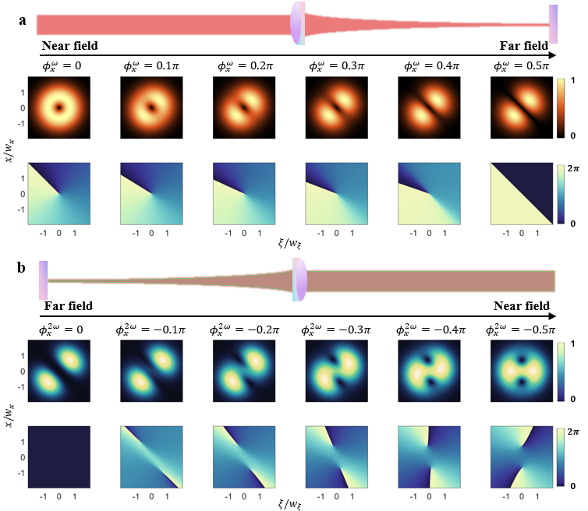
Figure S1 Conversion between STOVs and SSOVs with $∆ϕ=0$. We analyze the case where focused $l=1$ fundamental STOVs are frequency-doubled into $l=2$ SH STOVs. a, Evolution from fundamental STOVs to SSOVs. The variation of phase $ϕ_{x}^{ω}$ from 0 to 0.5π corresponds to the propagation of the optical field from the near field to the far field. b, Evolution from SH SSOVs to SH STOVs. Here, the collimating lens acts as an inverse spatial Fourier transform, corresponding to the evolution of phase $ϕ_{x}^{2ω}$ from 0 to -0.5π.
From Eq. (S5), the STOVs for $l=1$ propagate according to
$$\begin{aligned}E_{STOV}^{ω l=1}\left(x,ξ,ϕ_{x}^{ω}\right)=\left(\frac{ξ}{w_{ξ}}+i\frac{x}{w_{x}}e^{-iϕ_{x}^{ω}}\right)E_{G}^{ω}\left(x,ξ,z\right),\#\left(S6\right)\end{aligned}$$
where $E_{G}^{ω}\left(x,ξ,z\right)$ is the Gaussian envelope, and $ϕ_{x}^{ω}=\tan^{-1}\left(\frac{z}{z_{R}}\right)$ is the spatial Gouy phase shift. Under the thin-lens approximation and neglecting aberrations, by introducing a focusing lens, a quadratic focusing phase factor, $e^{-ik_{0}\frac{x^{2}}{2f}}$ (where f is the focal length), is imparted to the spatial mode solutions in Eqs. (S2) and (S3). This phase modulation effectively shifts the far-field diffraction pattern, which would naturally form at infinity, to the focal plane, mapping the beam propagation to a spatial Fourier transform. Moreover, this propagation from the near-field input plane to the far-field Fourier plane corresponds to a continuous evolution of the spatial Gouy phase shift $ϕ_{x}^{ω}$ from 0 to $π/2$, transforming the elliptical fundamental STOVs into spatiospectral optical vortices (SSOVs) with tilted lobes (Fig. S1). Therefore, when adjusting the nonlinear crystal position $Δz$ towards the Fourier plane, $ϕ_{x}^{ω}=\frac{π}{2}+Δϕ$ and the fundamental SSOVs before SHG can be expressed as
$$\begin{aligned}E_{SSOV}^{ω l=1}\left(x,ξ\right)=\left(\frac{ξ}{w_{ξ}^{ω,f}}+\frac{x}{w_{x}^{ω,f}}e^{-iΔϕ}\right)E_{G}^{ω}\left(x,ξ\right),\#\left(S7\right)\end{aligned}$$
where $Δϕ=\tan^{-1}\left(\frac{Δz}{z_{R}^{FP}}\right)$ is the accumulated spatial Gouy phase shift relative to the Fourier plane, with $z_{R}^{FP}$ being the Rayleigh length at the Fourier plane. Because the thin crystal can minimize mismatch and diffraction effects during SHG (see Supplementary Section S7), the envelope of SH SSOVs can be expressed as the doubling of that of fundamental SSOVs:
$$\begin{aligned}E_{SSOV}^{2ω l=2}\left(x,ξ,Δϕ\right)={\left(\frac{ξ}{w_{ξ}^{2ω,f}}+\frac{x}{w_{x}^{2ω,f}}e^{-iΔϕ}\right)}^{2}E_{G}^{2ω}\left(x,ξ\right).\#\left(S8\right)\end{aligned}$$
Eq. (S8) illustrates that after SHG, SH SSOVs preserve the Gouy phase of fundamental SSOVs. When the generated SH SSOVs subsequently propagate through the collimating lens toward the output plane, the evolution is formally analogous to propagating the original field back from the Fourier plane toward the near field corresponding to an inverse spatial Fourier transform, except for the carrier wavenumber scaling from $k_{ω}$ to $k_{2ω}$. Notably, the propagation to the output plane is governed by a new Gouy phase shift accumulation $ϕ_{x}^{2ω}=-ϕ_{x}^{ω}=-\left(\frac{π}{2}+Δϕ\right)$, leading to tilted-lobes SH SSOVS, which transform into elliptical SH STOVs (Fig. S1b). By decomposing the initial SH SSOV field [Eq. (S8)] into the Hermite-Gaussian basis defined in Eqs. (S1-S4) and incorporating their respective propagation phase factors, the analytical expression for the propagated SH STOVs can be derived as:
 | $$E_{SSOV}^{2ω l=2}\left(x,ξ,ϕ_{x}^{2ω}\right)=\frac{u_{0}^{x}\left(x,ϕ_{x}^{2ω}\right)u_{2}^{ξ}\left(ξ,ϕ_{x}^{2ω}\right)+u_{2}^{x}(x,ϕ_{x}^{2ω})u_{0}^{ξ}(ξ,ϕ_{x}^{2ω})e^{-2iΔϕ}}{C_{0}C_{2}}+\frac{2u_{1}^{x}(x,ϕ_{x}^{2ω})u_{1}^{ξ}(ξ,ϕ_{x}^{2ω})e^{-iΔϕ}}{C_{1}C_{1}}+2\left(1+e^{-2iΔϕ}\right)\frac{u_{0}^{x}(x,ϕ_{x}^{2ω})u_{0}^{ξ}(ξ,ϕ_{x}^{2ω})}{C_{0}C_{0}}=8\left[\frac{ξ^{2}}{{w_{ξ}}^{2}}-\frac{1}{4}+2\frac{xξ}{w_{x}w_{ξ}}e^{-i\left(Δϕ+ϕ_{x}^{2ω}\right)}+\left(\frac{x^{2}}{{w_{x}}^{2}}-\frac{1}{4}\right)e^{-2i\left(Δϕ+ϕ_{x}^{2ω}\right)}+\frac{1}{4}\left(1+e^{-2iΔϕ}\right)\right]u_{G}^{2ω}\left(x,ξ,ϕ_{x}^{2ω}\right).$$ | $$(S9)$$

Singularity evolution of SH STOVs ($l=2$)
The resulting SH STOVs at the output plane can be expressed as:
$$\begin{aligned}E_{STOV}^{2ω l=2}\left(x,ξ\right)=\left[{\left(\frac{ξ}{w_{ξ}^{2ω}}+i\frac{x}{w_{x}^{2ω}}\right)}^{2}+\frac{1}{4}\left(1+e^{-2iΔϕ}\right)\right]E_{G}^{2ω}\left(x,ξ\right).\#\left(S10\right)\end{aligned}$$
Eq. (S10) reflects the coupling connection between SSOVs and STOVs. By tuning$Δϕ$, the rotation and separation of the SH STOV singularities can be achieved. Fig. S2 illustrates this condition; as $Δϕ$ moves from $-π/4$ to $π/4$, the two singularities symmetrically rotate clockwise, and the singularity separation is maximized at $Δϕ=0$.
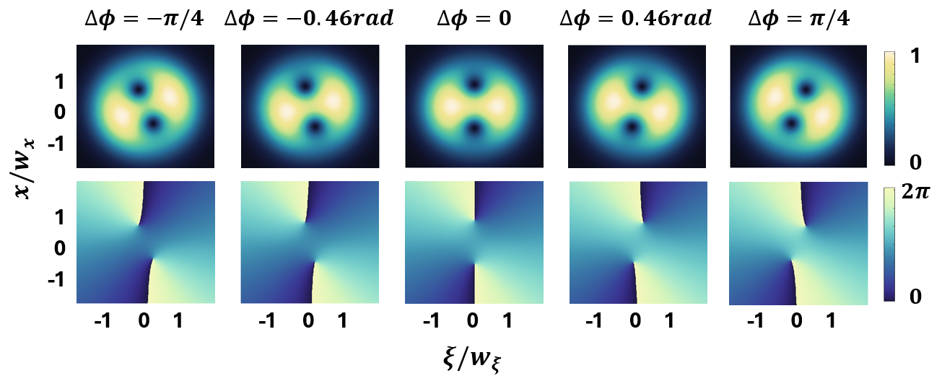
Figure S2 Gouy phase controlled evolution of SH STOVs ($l=2$). The top row displays the normalized spatiotemporal intensity profiles, while the bottom row exhibits the corresponding phase distributions. The columns, from left to right, represent the continuous dynamic evolution of the optical field for different spatial Gouy phase shifts $Δϕ$.
The zeros of the polynomial prefactor define the position of space time sigularities, yielding the analytical solutions presented in Eq. (S11):
$$\left(\begin{matrix}x_{1}^{2ω l=2} \\ ξ_{1}^{2ω l=2}\end{matrix}\right)=\frac{\sqrt{2\cos\left(∆ϕ\right)}}{2}\left[\begin{matrix}\cos\left(\frac{∆ϕ}{2}\right)w_{x}^{2ω} \\ \sin\left(\frac{∆ϕ}{2}\right)w_{ξ}^{2ω}\end{matrix}\right],$$  $$\left(\begin{matrix}x_{2}^{2ω l=2} \\ ξ_{2}^{2ω l=2}\end{matrix}\right)=-\left(\begin{matrix}x_{1}^{2ω l=2} \\ ξ_{1}^{2ω l=2}\end{matrix}\right).$$ | $$(S11)$$
As the definitions of the singularity rotation angle $θ$ and singularity separation $S$ are provided in the main text, the corresponding $θ$ and $S$ of the $l=2$ SH STOVs in this case can be expressed as:
$$θ^{2ω l=2}=\frac{∆ϕ}{2},$$  $$S^{2ω l=2}=\sqrt{2\cos\left(∆ϕ\right)}.$$ | $$(S12)$$

Conversion between STOVs and SSOVs ($l=2→4$)
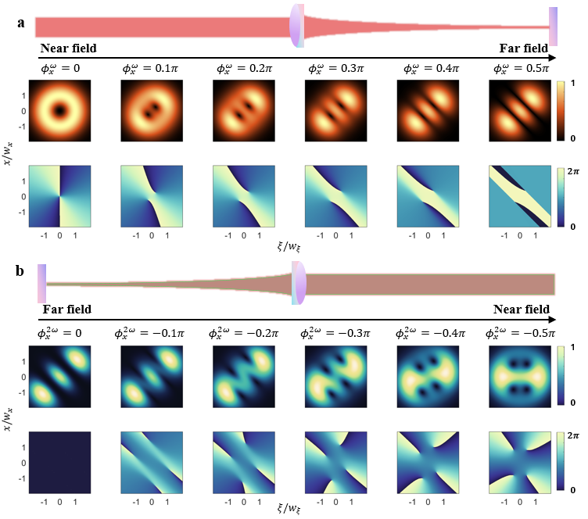
Figure S3 Conversion between higher-order STOVs and SSOVs. a, Evolution from fundamental STOVs to SSOVs. The variation of phase $ϕ_{x}^{ω}$ from 0 to 0.5π corresponds to the propagation of the optical field from the near field to the far field. b, Evolution from SH SSOVs to SH STOVs. The collimating lens here acts as an inverse spatial Fourier transform, corresponding to the evolution of phase $ϕ_{x}^{2ω}$ from 0 to -0.5π.
Additionally, we consider a more complex case in which $l=2$ fundamental STOVs are frequency-doubled into $l=4$ SH STOVs. Fig. S3a shows the propagation process of fundamental STOVs with $l=2$. In this process, the fundamental SSOVs for $l=2$ can be derived from Eq. (S5) as:
$$\begin{aligned}E_{SSOV}^{ω l=2}\left(x,ξ,Δϕ\right)=\left[{\left(\frac{ξ}{w_{ξ}^{ω,f}}+\frac{x}{w_{x}^{ω,f}}e^{-iΔϕ}\right)}^{2}-\frac{\left(1+e^{-2iΔϕ}\right)}{4}\right]E_{G}^{ω}\left(x,ξ\right).\#\left(S13\right)\end{aligned}$$
After SHG, due to $E_{G}^{2ω}\left(x,ξ\right)=e^{-2\frac{x^{2}}{{w_{x}}^{2}}-2\frac{ξ^{2}}{{w_{ξ}}^{2}}}$, the Gaussian envelope is modified to $w_{ξ}^{2ω,f}=\frac{w_{ξ}^{ω,f}}{\sqrt{2}}$, $w_{x}^{2ω,f}=\frac{w_{x}^{ω,f}}{\sqrt{2}}$ [2]. Therefore, the SH SSOVs can be expressed as
$$\begin{aligned}E_{SSOV}^{2ω l=4}\left(x,ξ,Δϕ\right)={\left[{\left(\frac{ξ}{w_{ξ}^{2ω,f}}+\frac{x}{w_{x}^{2ω,f}}e^{-iΔϕ}\right)}^{2}-\frac{\left(1+e^{-2iΔϕ}\right)}{2}\right]}^{2}E_{G}^{2ω}\left(x,ξ\right).\#\left(S14\right)\end{aligned}$$
Similar to the $l=2$ case (Eq. (S9)), the propagated SH SSOVs are solved by decomposing the initial SH SSOV field [Eq. (S14)] into the Hermite-Gaussian basis defined in Eqs. (S1-S4) and incorporating their respective propagation phase factors:
 | $$E_{SSOV}^{2ω l=4}\left(x,ξ,ϕ_{x}^{2ω}\right)=\frac{u_{0}^{x}\left(x,ϕ_{x}^{2ω}\right)u_{4}^{ξ}\left(ξ,ϕ_{x}^{2ω}\right)+u_{4}^{x}(x,ϕ_{x}^{2ω})u_{0}^{ξ}(ξ,ϕ_{x}^{2ω})e^{-4i∆ϕ}}{64C_{0}C_{4}}+\frac{u_{1}^{x}\left(x,ϕ_{x}^{2ω}\right)u_{3}^{ξ}\left(ξ,ϕ_{x}^{2ω}\right)e^{-i∆ϕ}+u_{3}^{x}(x,ϕ_{x}^{2ω})u_{1}^{ξ}(ξ,ϕ_{x}^{2ω})e^{-3i∆ϕ}}{16C_{1}C_{3}}+\frac{3u_{2}^{x}\left(x,ϕ_{x}^{2ω}\right)u_{2}^{ξ}\left(ξ,ϕ_{x}^{2ω}\right)e^{-2i∆ϕ}}{32C_{2}C_{2}}+\frac{u_{2}^{x}\left(x,ϕ_{x}^{2ω}\right)u_{0}^{ξ}\left(ξ,ϕ_{x}^{2ω}\right)e^{-2i∆ϕ}\left(1+e^{-2i∆ϕ}\right)}{16C_{2}C_{0}}+\frac{u_{0}^{x}\left(x,ϕ_{x}^{2ω}\right)u_{2}^{ξ}\left(ξ,ϕ_{x}^{2ω}\right)\left(1+e^{-2i∆ϕ}\right)}{16C_{2}C_{0}}+\frac{u_{1}^{x}\left(x,ϕ_{x}^{2ω}\right)u_{1}^{ξ}\left(ξ,ϕ_{x}^{2ω}\right)e^{-i∆ϕ}\left(1+e^{-2i∆ϕ}\right)}{8C_{1}C_{1}}+\frac{3u_{0}^{x}\left(x,ϕ_{x}^{2ω}\right)u_{0}^{ξ}\left(ξ,ϕ_{x}^{2ω}\right){\left(1+e^{-2i∆ϕ}\right)}^{2}}{16C_{0}C_{0}}.$$ | $$\left(S15\right)$$
Fig. S3b shows the propagation process from tilted-lobe SH SSOVs to elliptical SH STOVs with $l=4$.

Singularity evolution of SH STOVs ($l=4$)
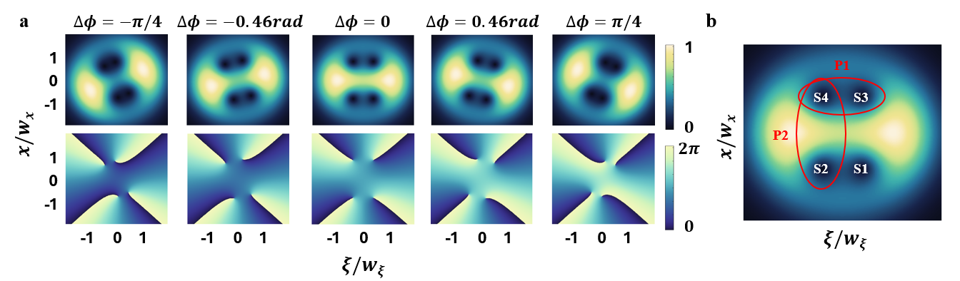
Figure S4 Gouy phase controlled evolution of SH STOVs ($l=4$). a, The top row displays the normalized spatiotemporal intensity profiles, while the bottom row exhibits the corresponding phase distributions. The columns from left to right represent the optical field under different spatial Gouy phase shifts $Δϕ$. b, Schematic defining the four singularities (S1-S4) and the designated singularity pairs (P1 and P2) at $Δϕ=0$. The spatial coordinates of S1–S4 correspond to the analytical roots derived in Eq. (S17), while the red ovals denote pairs P1 and P2 used to evaluate the rotation angle $θ$ and separation distance $S$ in Eq. (S18).
During the inverse Fourier transform for the case $ϕ_{x}^{2ω}=\frac{π}{2}+Δϕ$, we can derive a concise equation for $l=4$ SH STOVs as follows:
$$\begin{aligned}E_{STOV}^{2ω l=4}\left(x,ξ\right)=\left[\begin{aligned}{\left(\frac{ξ}{w_{ξ}^{2ω}}+i\frac{x}{w_{x}^{2ω}}\right)}^{4}+\frac{\left(e^{-i2∆ϕ}+1\right)}{2}{\left(\frac{ξ}{w_{ξ}^{2ω}}+i\frac{x}{w_{x}^{2ω}}\right)}^{2} \\ +\frac{3}{16}{\left(e^{-i2∆ϕ}+1\right)}^{2}\end{aligned}\right]E_{G}^{2ω}\left(x,ξ\right).\#\left(S16\right)\end{aligned}$$
The spatial and temporal coordinates of the vortex cores are defined by the zeros of the complex polynomial prefactor in Eq. (S16). By solving this prefactor, we can analytically determine the trajectories of the four space-time singularities, which directly correspond to the points labeled S1–S4 in Fig. S4b. The exact analytical solutions for these coordinates are expressed as:
$$\left(\begin{matrix}x_{1}^{2ω l=4} \\ ξ_{1}^{2ω l=4}\end{matrix}\right)=\frac{\sqrt{2\cos\left(∆ϕ_{x}^{ω}\right)}}{2}\left\{\begin{matrix}\left[-\sqrt{\frac{\sqrt{3}+1}{2}}\cos\left(\frac{∆ϕ}{2}\right)-\sqrt{\frac{\sqrt{3}-1}{2}}\sin\left(\frac{∆ϕ}{2}\right)\right]w_{x}^{2ω} \\ \left[\sqrt{\frac{\sqrt{3}-1}{2}}\cos\left(\frac{∆ϕ}{2}\right)-\sqrt{\frac{\sqrt{3}+1}{2}}\sin\left(\frac{∆ϕ}{2}\right)\right]w_{ξ}^{2ω}\end{matrix}\right\},$$  $$\left(\begin{matrix}x_{2}^{2ω l=4} \\ ξ_{2}^{2ω l=4}\end{matrix}\right)=\frac{\sqrt{2\cos\left(∆ϕ_{x}^{ω}\right)}}{2}\left\{\begin{matrix}\left[-\sqrt{\frac{\sqrt{3}+1}{2}}\cos\left(\frac{∆ϕ}{2}\right)+\sqrt{\frac{\sqrt{3}-1}{2}}\sin\left(\frac{∆ϕ}{2}\right)\right]w_{x}^{2ω} \\ \left[-\sqrt{\frac{\sqrt{3}-1}{2}}\cos\left(\frac{∆ϕ}{2}\right)-\sqrt{\frac{\sqrt{3}+1}{2}}\sin\left(\frac{∆ϕ}{2}\right)\right]w_{ξ}^{2ω}\end{matrix}\right\},$$  $$\left(\begin{matrix}x_{3}^{2ω l=4} \\ ξ_{3}^{2ω l=4}\end{matrix}\right)=\left(\begin{matrix}-x_{1}^{2ω l=4} \\ ξ_{1}^{2ω l=4}\end{matrix}\right),$$  $$\left(\begin{matrix}x_{4}^{2ω l=4} \\ ξ_{4}^{2ω l=4}\end{matrix}\right)=\left(\begin{matrix}-x_{2}^{2ω l=4} \\ ξ_{2}^{2ω l=4}\end{matrix}\right).$$ | $$(S17)$$
Geometrically, the four singularities derived from Eq. (S17) form a highly symmetric structure centered at the origin. During the continuous evolution, the segments connecting near singularities (i.e., S1-S2 and S4-S3, as well as S1-S4 and S2-S3) remain strictly parallel, defining a rotating parallelogram. They map to two singularity pairs: P1 (comprising S1 and S3) and P2 (comprising S2 and S4). As subsequently derived, $θ$ and $S$ of P1 and P2 can be expressed as:
$$θ_{P1}^{2ω l=4}=\frac{∆ϕ}{2}+\frac{π}{2},$$  $$θ_{P2}^{2ω l=4}=\frac{∆ϕ}{2},$$  $$S_{P1}^{2ω l=4}=\sqrt{\left(\sqrt{3}-1\right)\cos\left(∆ϕ\right)},$$  $$S_{P2}^{2ω l=4}=\sqrt{\left(\sqrt{3}+1\right)\cos\left(∆ϕ\right)}.$$ | $$(S18)$$
As shown in Eq. (S18), the angular difference between $θ_{P1}^{2ω l=4}$ and $θ_{P2}^{2ω l=4}$ is exactly $π/2$. This analytical result demonstrates that the two singularity pairs, P1 and P2, remain strictly orthogonal to each other throughout their entire dynamic motion (Fig. S4).

Temporal and spectral characterization
The temporal and spectral characteristics of the fundamental mode-locked Yb:fiber laser and the generated STOVs have been characterized via intensity autocorrelation and optical spectrum analysis, as shown in Figs. S5a and S5b. Fig. S5a shows the normalized intensity autocorrelation trace of the fundamental laser output (blue solid line), together with its Gaussian fit (red dashed line). This fit yields a pulse duration of 808 fs, consistent with the ~800 fs pulse duration reported in the main text. Owing to the intrinsic dispersion properties of the Yb-doped gain fiber, the output pulse from the laser oscillator carries positive group delay dispersion at 1034 nm wavelength. The optical spectrum of the fundamental laser is shown in Fig. S5b, with a central wavelength of 1034 nm and a full width at half-maximum (FWHM) bandwidth of 30 nm.
After passing through the 4f pulse shaper, the fundamental STOVs are characterized by intensity autocorrelation, as shown in Fig. S5c. The fitted pulse duration is 849 fs. The slight pulse broadening compared to the fundamental Gaussian output is attributed to a residual spatiotemporal chirp introduced by the 4f pulse shaper. As shown in Fig. S5d, in the reference arm of the experimental setup, the fundamental Gaussian pulse is compressed to a pulse duration of 92 fs via the diffraction grating pair. The measured pulse duration is slightly longer than the Fourier-transform limit of 79 fs, calculated from the measured optical spectrum in Fig. S5b. This deviation from the transform limit arises from intrinsic higher-order dispersion contributions in the laser system, which cannot be compensated by the grating pair alone.
Figure S5 Pulse characterization results for the light sources, STOVs, and reference Gaussian pulses. a, Normalized intensity autocorrelation trace of the home-built mode-locked Yb fiber laser output (blue line) and its Gaussian fit (red dashed line). b, Optical spectrum of the fundamental mode-locked Yb fiber laser, with a central wavelength of 1034 nm and a FWHM bandwidth of 30 nm. c, Normalized intensity autocorrelation trace of the generated fundamental STOVs. d, Normalized intensity autocorrelation trace of the fundamental Gaussian reference pulse in the probe arm, which is compressed by the diffraction grating pair. e, Normalized intensity trace of the Gaussian envelope of the SH STOVs generated in the object arm. The delay-scanned interferometric characterization is utilized to reconstruct the temporal information of SH STOVs. f, Normalized intensity autocorrelation trace of the SH Gaussian reference pulse in the probe arm.
For the SHG process in both the reference and object arms, the temporal characteristics of the frequency-doubled pulses are systematically characterized via intensity autocorrelation, as presented in Figs. S5e and S5f. Fig. S5f shows the normalized intensity autocorrelation trace of the SH Gaussian reference pulse in the probe arm. The fitting result yields a pulse duration of 75 fs, which serves as the reference pulse for the subsequent delay-scanned interferometric characterization of the complex spatiotemporal field of SH STOVs.
Due to the low SH conversion efficiency, it is difficult to characterize the temporal pulse duration of STOVs using the autocorrelator. To overcome this limitation, we remove the helical phase modulation in the STOV generation scheme, retaining only the Gaussian term $E_{G}^{2ω}\left(x,ξ\right)$, and reconstruct the temporal waveform via a delay-scanned interferometer. The reconstructed temporal intensity of this SH Gaussian envelope is shown in Fig. S5e, and the corresponding measurement indicates a pulse duration of 570 fs. In particular, one ideally expects the SH pulse to be compressed to $1/\sqrt{2}$​ of the fundamental pulse duration, i.e., ~600 fs, which is in good agreement with the measured pulse duration.

Validity of the thin-crystal approximation
Negligible internal diffraction
In our 4f-assisted focusing geometry, the nonlinear crystal is positioned close to the Fourier plane to impart a spatial Gouy phase shift. In the focal region, the Rayleigh length of the pulse $z_{R}^{FP}$ is ~1.6 mm, i.e., substantially longer than the crystal thickness of $L=30 μm$. Consequently, the fundamental beam undergoes negligible divergence or diffraction as it propagates through the nonlinear medium, allowing the spatial profile to be treated as longitudinally invariant within the crystal.
Calculation of spatial walk-off and group-velocity mismatch
Birefringent phase matching inherently introduces spatial walk-off between the fundamental and SH beams, as well as temporal walk-off driven by group velocity mismatch. In our experiment, the temporal width of the SH STOVs is about 570 fs (as shown in Section S6). The spatial half-width of the SH STOV at the Fourier plane is approximately 15 µm in the x direction, respectively. The temporal walk-off (group velocity mismatch) $η$ is about 93.3 fs/mm, and the spatial walk-off angle $α$ is calculated to be $5.7mrad$. Therefore, the impact of walk-off on spatiotemporal astigmatism can be neglected, given that $\frac{αL}{w_{x}}≈3.4×{10}^{-4},\frac{ηL}{w_{ξ}}≈4.9×{10}^{-3}$ in the Fourier plane [S3,S4].

Spatiotemporal information reconstruction
To obtain spatiotemporal intensity and phase information for STOV pulses, we have established a delay-scanned spatiotemporal interferometric measurement setup based on a Mach-Zehnder interferometer. The interferograms at each time delay $τ$, $I\left(x,y,t;τ\right)$ as shown in Eq. (S19), were recorded to obtain the full information of the light field to be measured via the spatiotemporal pulse reconstruction process:
$$\begin{aligned}I\left(x,y,t;τ\right)={\left|E_{STOV}\left(x,y,t\right)\right|}^{2}+{\left|E_{ref}\left(x,y,t-τ\right)\right|}^{2}+E_{STOV}\left(x,y,t\right)E_{ref}^{*}\left(x,y,t-τ\right)e^{-ikψ}+c.c. ,(S19)\end{aligned}$$
where $E_{STOV}(x,y,t)$ is the light field of the STOV pulse, $E_{ref}(x,y,t)$ is that of the reference pulse, and $ψ$ is the angle between the two beams.
The detailed flowchart of the spatiotemporal pulse reconstruction process is depicted in Fig. S6. Three sets of experimental data were utilized, namely the STOV interferograms, the reference interferograms, and the full-time domain characteristics of the reference pulse in the time domain, retrieved by a Phase and Intensity from Correlation and Spectrum Only (PICASO) algorithm. The STOV interferograms were obtained using this delay-scanned spatiotemporal measurement setup, and the reference interferogram was acquired with a zeroed phase mask of the spatial light modulator.
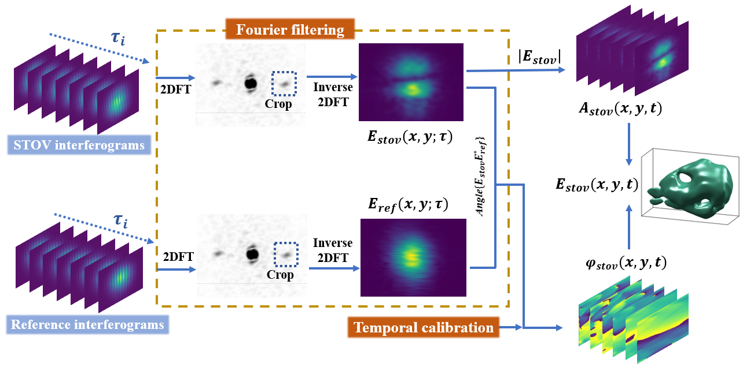
Figure S6: Flowchart of the spatiotemporal pulse reconstruction.
The time-sliced light field at time delay $τ$, i.e., $E\left(x,y;τ\right)$ can be extracted from the interferograms using a Fourier filtering approach, which yields the STOV light field at time delay $τ$, $E_{STOV}\left(x,y;τ\right)$. The same method can be applied to the reference light field at time delay $τ$, i.e., $E_{ref}(x,y;τ)$. In turn, the spatiotemporal amplitude of the STOV light field, $A_{STOV}\left(x,y,t\right)$, can be directly obtained from Eq. (S20):
$$\begin{aligned}A_{STOV}\left(x,y,t\right)=\left|E_{STOV}\left(x,y;τ\right)\right|.\#\left(S20\right)\end{aligned}$$
The phase of the STOV light field at time delay $τ$, $φ_{STOV}\left(x,y;τ\right)$, is calculated by Eq. (S21):
$$\begin{aligned}φ_{STOV}\left(x,y;τ\right)=arg\left\{E_{STOV}\left(x,y;τ\right)E_{ref}^{*}\left(x,y;τ\right)\right\},\#\left(S21\right)\end{aligned}$$
where $arg\{\}$ extracts the phase information from the light field. The spatiotemporal phase of the STOV light field $φ_{STOV}\left(x,y,t\right)$ is derived from Eq. (S22), in which the previously extracted phase information at each time slice $τ$, $φ_{STOV}\left(x,y;τ\right)$, is stitched, and the measured temporal phase at the given point $(x_{0},y_{0})$ of the reference pulse $φ_{time}\left(τ\right)$ is used for calibration. Consequently,
$$\begin{aligned}φ_{STOV}\left(x,y,t\right)=φ_{STOV}\left(x,y;τ\right)-φ_{STOV}\left(x_{0},y_{0};τ\right)+φ_{time}\left(τ\right),\#\left(S22\right)\end{aligned}$$
where $φ_{STOV}\left(x_{0},y_{0};τ\right)$ is the previously extracted phase at the given point $(x_{0},y_{0})$ and time delay $τ$. Finally, the full spatiotemporal light field of the STOV pulses is reconstructed from Eq. (S23):
$$\begin{aligned}E_{STOV}\left(x,y,t\right)=A_{STOV}\left(x,y,t\right)∙e^{-ikφ_{STOV}\left(x,y,t\right)}.\#\left(S23\right)\end{aligned}$$

Experimentally generated fundamental STOVs
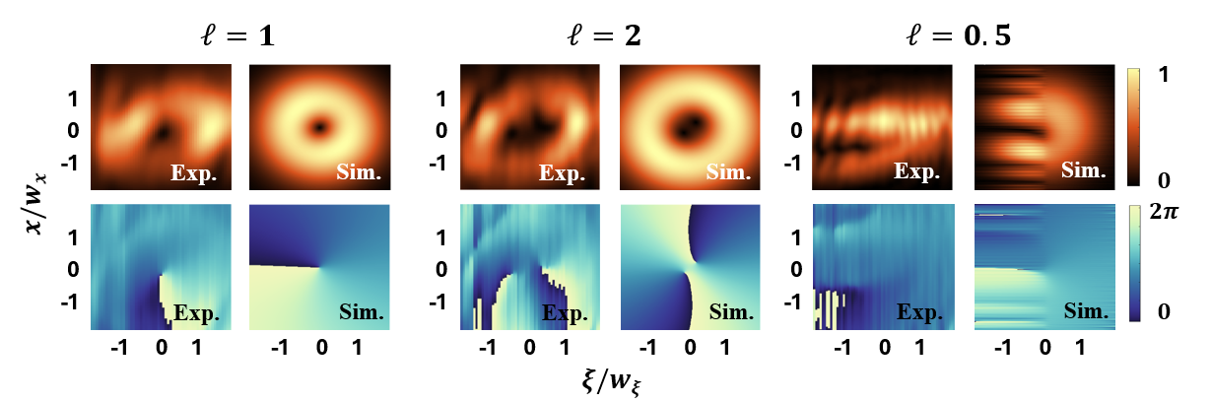
Figure S7 Experimental generated fundamental STOVs with corrected intrinsic Gouy phase shift.

Influence of the Initial Phase on SH STOV Singularity Evolution
The 4f pulse shaper and beam propagation in the experiment inevitably introduce a slight initial phase offset to the spatiotemporal field. This minor experimental imperfection means that the generated fundamental STOV is not an exact eigenmode of the paraxial wave equation, necessitating the slight phase correction factor $ϕ_{i}=-0.045π$ to accurately model the symmetry-breaking dynamics observed in the generated SH field.
The $l=2$ SH STOVs case
Following the established procedure, the corrected fundamental SSOVs from Eq. (S8) can now be expressed as
$$\begin{aligned}E_{STOV}^{ω (1)}\left(x,ξ\right)=\left(\frac{ξ}{w_{ξ}}+i\frac{x}{w_{x}}e^{-iΔϕ-iϕ_{i}}\right)E_{G}^{ω}\left(x,ξ,z\right), \#\left(S24\right)\end{aligned}$$
where $ϕ_{i}$ is the corrected intrinsic Gouy phase shift. Therefore, after SHG, the propagated SH SSOVs can be corrected by $ϕ_{i}$ as
$$E_{SSOV}^{2ω \left(2\right)}\left(x,ξ,ϕ_{x}^{2ω}\right)=8\left[\frac{ξ^{2}}{{w_{ξ}}^{2}}-\frac{1}{4}+2\frac{xξ}{w_{x}w_{ξ}}e^{-i\left(Δϕ+ϕ_{i}+ϕ_{x}^{2ω}\right)}+\left(\frac{x^{2}}{{w_{x}}^{2}}-\frac{1}{4}\right)e^{-2i\left(Δϕ+ϕ_{i}+ϕ_{x}^{2ω}\right)}+\frac{1}{4}\left(1+e^{-2iΔϕ-2iϕ_{i}}\right)\right]u_{G}^{2ω}\left(x,ξ,ϕ_{x}^{2ω}\right),$$ | $$(S25)$$
which should be compared to the case of $ϕ_{x}^{2ω}=-ϕ_{x}^{ω}=-\left(\frac{π}{2}+Δϕ\right)$ in Section S1. Therefore, SH STOVs can be expressed as
$$\begin{aligned}E_{STOV}^{2ω \left(2\right)}\left(x,ξ\right)=\left[{\left(\frac{ξ}{w_{ξ}^{2ω}}+i\frac{x}{w_{x}^{2ω}}e^{-iϕ_{i}}\right)}^{2}+\frac{1}{4}e^{-2iϕ_{i}}\left(1+e^{-2iΔϕ}\right)\right]E_{G}^{2ω}\left(x,ξ\right).\#\left(S26\right)\end{aligned}$$
A notable feature of Eq. (S26) is that the fundamental correction to $ϕ_{i}$ not only manifests itself in the evolution of the vortex term in the spatiotemporal phase, which is equivalent to the square of the corrected fundamental-frequency vortex term, but also exerts an influence on the constant term. This leads to the asymmetry of the singularity motion, as shown in Fig. 3 of the main text. Therefore, the fixed singularity positions, rotation angle, and separation distance can be expressed as follows:
$$\left(\begin{matrix}x_{1}^{2ω,\left(2\right)} \\ ξ_{1}^{2ω,\left(2\right)}\end{matrix}\right)=\frac{\sqrt{2\cos\left(∆ϕ\right)}}{2}\left\{\begin{matrix}\left[\cos\left(\frac{∆ϕ}{2}\right)-\sin\left(\frac{∆ϕ}{2}\right)\tan\left(ϕ_{i}\right)\right]w_{x}^{2ω} \\ \frac{\sin\left(\frac{∆ϕ}{2}\right)}{\cos\left(ϕ_{i}\right)}w_{ξ}^{2ω}\end{matrix}\right\},$$  $$\left(\begin{matrix}x_{2}^{2ω,\left(2\right)} \\ ξ_{2}^{2ω,\left(2\right)}\end{matrix}\right)=-\left(\begin{matrix}x_{1}^{2ω,\left(2\right)} \\ ξ_{1}^{2ω,\left(2\right)}\end{matrix}\right).$$ | $$(S27)$$
$$θ^{2ω,\left(2\right)}=\tan^{-1}\left[\frac{\sin\left(\frac{∆ϕ}{2}\right)}{\cos\left(\frac{∆ϕ}{2}+ϕ_{i}\right)}\right],$$  $$S^{2ω,\left(2\right)}=\sqrt{2\cos\left(∆ϕ\right)}\sqrt{\frac{\cos^{2}\left(\frac{∆ϕ}{2}+ϕ_{i}\right)+\sin^{2}\left(\frac{∆ϕ}{2}\right)}{\cos^{2}\left(ϕ_{i}\right)}}.$$ | $$(S28)$$
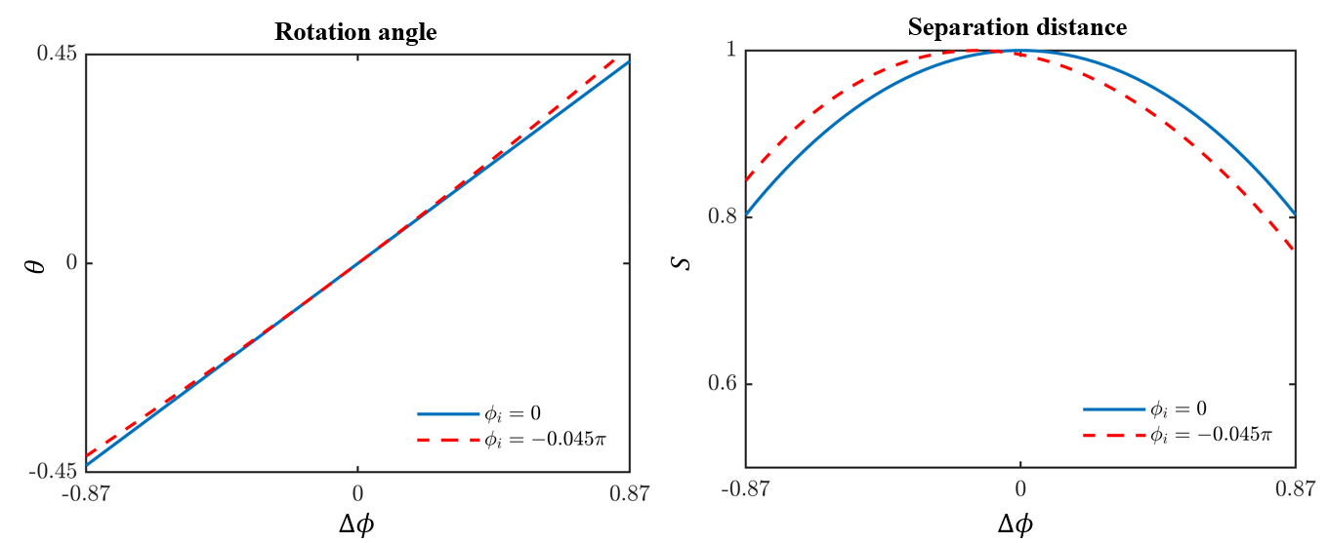
Figure S8 Singularity rotation angle and separation distance with different initial Gouy phase shift $Δϕ$.
To further elucidate the theoretical framework established by Eqs. (S15) and (S16), Fig. S8 presents a comprehensive visualization of the singularity dynamics under varying corrected intrinsic Gouy phase shifts $ϕ_{i}$. As depicted in the left panel of Fig. S8, the intrinsic phase offset dictates the rotational behavior of the split singularities. When $ϕ_{i}=0$, $θ$ exhibits a purely linear dependence on $Δϕ$. However, as it shifts to $-0.045π$, the nonlinear modulation introduced by the cosine term in the denominator of the expression becomes pronounced, leading to significant trajectory deviations.
The right panel of Fig. S8 illustrates the evolution of the separation S distance between the split singularities. The curves clearly demonstrate that $ϕ_{i}$ actively breaks the symmetry of the singularity splitting process. For $ϕ_{i}=0$, the maximum separation occurs exactly at $Δϕ=0$, implying a symmetric spatiotemporal evolution of the SH-STOV singularities.
It is worth noting the apparent visual difference between the calculated singularity evolution curves presented here and those in Fig. 3 of the main text. In this Supplementary Information, the theoretical analysis utilizes the spatial Gouy phase shift $Δϕ$ as the independent variable to fundamentally elucidate the intrinsic singularity dynamics. However, the experimental measurements in the main text are naturally plotted against the normalized physical crystal displacement $Δz/z_{R}^{FP}$. The mapping between these two domains is governed by the nonlinear relationship $Δϕ=\tan^{-1}\left(\frac{Δz}{z_{R}^{FP}}\right)$ as defined in Eq. (S7). Therefore, the specific geometric profiles of those curves accurately reflect this rigorous physical mapping rather than any computational discrepancy, ensuring perfect consistency between our theoretical framework and the laboratory frame.
The $l=4$ SH STOVs case
For $l=4$ SH STOVs, the introduction of the initial Gouy phase shift makes the singular point motion more complex. For this condition, Eq. (S14) can be modified into:
$$E_{img}^{2ω,\left(4\right)}\left(x,ξ\right)=\left\{{\left(\frac{ξ}{w_{ξ}^{2ω}}+i\frac{x}{w_{x}^{2ω}}e^{-iϕ_{i}}\right)}^{4}+\frac{\left[3e^{-i2ϕ_{i}}+e^{-i2\left(∆ϕ+ϕ_{i}\right)}-2\right]}{2}{\left(\frac{ξ}{w_{ξ}^{2ω}}+i\frac{x}{w_{x}^{2ω}}e^{-iϕ_{i}}\right)}^{2}+\frac{1}{16}\left[3{\left(1-e^{-i2ϕ_{i}}\right)}^{2}-2\left(1-e^{-i2ϕ_{i}}\right)\left(e^{-i2\left(∆ϕ+ϕ_{i}\right)}+1\right)+3{\left(e^{-i2\left(∆ϕ+ϕ_{i}\right)}+1\right)}^{2}\right]\right\}E_{G}^{2ω}\left(x,ξ\right).$$ | $$(S29)$$
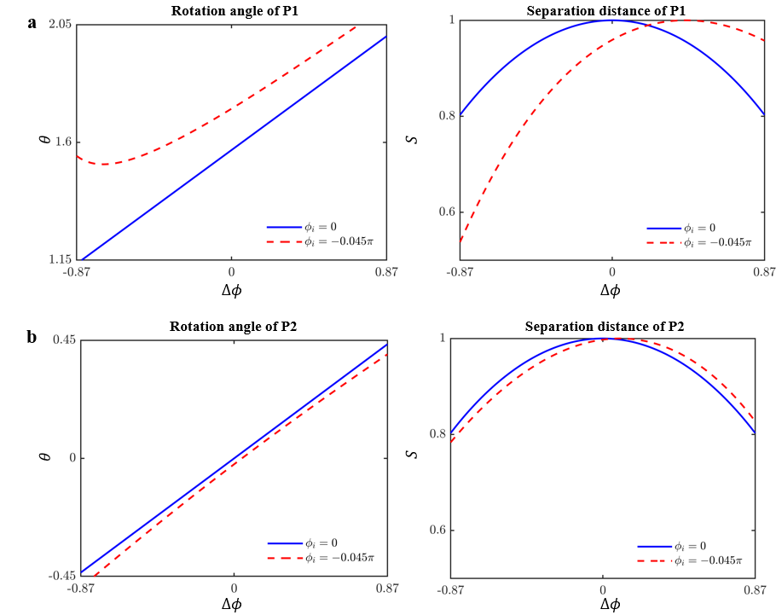
Figure S9 Influence of the initial Gouy phase shift on the singularity dynamics of $l=4$ SH STOVs. a,b. Rotation angle $θ$ and separation distance $S$ for singularity pair P1 and P2, respectively.
As previously established, the vortex cores are defined by the zeros of the complex polynomial prefactor. To analytically determine the singularity positions of the $l=4$ SH STOVs described by Eq. (S29), we define a dimensionless complex spatial variable $Y=\frac{ξ}{w_{ξ}^{2ω}}+i\frac{x}{w_{x}^{2ω}}e^{-iϕ_{i}}$. By setting the polynomial prefactor in Eq. (S29) to zero, the equation is reduced to a biquadratic form with respect to Y. We then yield exact analytical solutions for the four complex roots corresponding to the four splitting singularities as
$$Y_{1}=\frac{1}{2}\sqrt{\left(2-3α-β\right)+\sqrt{-2(4-3α+β)(α+β)}},$$  $$Y_{2}=\frac{1}{2}\sqrt{\left(2-3α-β\right)-\sqrt{-2(4-3α+β)(α+β)}},$$  $$Y_{3}=-Y_{1}, Y_{4}=-Y_{2},$$ | $$(S30)$$
where $α=e^{-i2ϕ_{i}}$ and $β=e^{-i2\left(∆ϕ+ϕ_{i}\right)}$. Figure S9 demonstrates that the intrinsic phase offset actively breaks the symmetry of the singularity evolution for the $l=4$ case. As depicted in Fig. S9, both singularity pairs (P1 and P2) experience notable deviations in their $θ$ and separation distances S when a non-zero phase shift ($ϕ_{i}=-0.045π$) is introduced, compared to the ideal symmetric case ($ϕ_{i}=0$). Specifically, the peak separation distances for both P1 and P2 shift asymmetrically away from the center point $ϕ_{i}=0$. Finally, by decoupling the real and imaginary components of $Y_{m}$, the exact coordinates of the four singularities in the physical domain can be straightforwardly mapped as
$$\begin{aligned}\left(\begin{matrix}x_{m}^{2ω,\left(4\right)} \\ ξ_{m}^{2ω,\left(4\right)}\end{matrix}\right)=\left\{\begin{matrix}\frac{Im\left(Y_{m}\right)}{\cos{ϕ_{i}}}w_{x}^{2ω} \\ \left[Re\left(Y_{m}\right)-Im\left(Y_{m}\right)\tan{ϕ_{i}}\right]w_{ξ}^{2ω}\end{matrix}\right\},\#\left(S31\right)\end{aligned}$$
$$θ_{Pn}^{2ω,\left(4\right)}=\tan^{-1}\left\{\cot\left[arg\left({∆Y}_{n}\right)\right]\cos{ϕ_{i}}-\sin{ϕ_{i}}\right\},$$  $$S_{Pn}^{2ω,\left(4\right)}=\frac{\left|{∆Y}_{n}\right|}{\cos{ϕ_{i}}}\sqrt{\cos^{2}\left[arg\left({∆Y}_{n}\right)+ϕ_{i}\right]+\sin^{2}\left[arg\left({∆Y}_{n}\right)\right]}.$$ | $$(S32)$$
where $Pn$ is the singularity pair of SH STOVs, $m=1,2,3,4$, $n=1,2$, and ${∆Y}_{1}=Y_{1}-Y_{4}$, ${∆Y}_{2}=Y_{1}-Y_{2}$.

References
[S1] Hancock, S. W., Zahedpour, S. & Milchberg, H. M. Mode structure and orbital angular momentum of spatiotemporal optical vortex pulses. Phys. Rev. Lett. 127, 193901 (2021).
[S2] Boyd, R. W., Gaeta, A. L. & Giese, E. Nonlinear optics. In Springer Handbook of Atomic, Molecular, and Optical Physics 1097–1110 (Springer, 2008).
[S3] M. Hanna et al. Second harmonic generation in the presence of walk-off and group velocity mismatch. J. Opt. Soc. Am. B 40(5), 930–938 (2023).
[S4] Gao, X. et al. Space-time singularity dynamics for second harmonic spatiotemporal optical vortices. Adv. Photon. Nexus 4, 036003 (2025).

