Supplementary Information for:

Mutual complementarity maximization in multi-view proteomics enables robust biomarker prediction
Hui Peng^{1,^}, Hexin Cai ¹, Shifu Luo¹, Jinyan Li^{1*}, Wilson Wen Bin Goh^{2,3,4,5,6,7*}
1. School of Computer Science and Control Engineering, Shenzhen University of Advanced Technology, Shenzhen, China
2. Lee Kong Chian School of Medicine, Nanyang Technological University, Singapore
3. School of Biological Sciences, Nanyang Technological University, Singapore
4. Center for Biomedical Informatics, Nanyang Technological University, Singapore
5. Center of AI in Medicine, Nanyang Technological University, Singapore
6. Division of Neurology, Department of Brain Sciences, Faculty of Medicine, Imperial College London
7. Institute of Mental Health, Singapore

^ First Author
*Corresponding Author: Jinyan Li, lijinyan@suat-sz.edu.cn; Wilson Wen Bin Goh, wilsongoh@ntu.edu.sg

Supplementary Figures

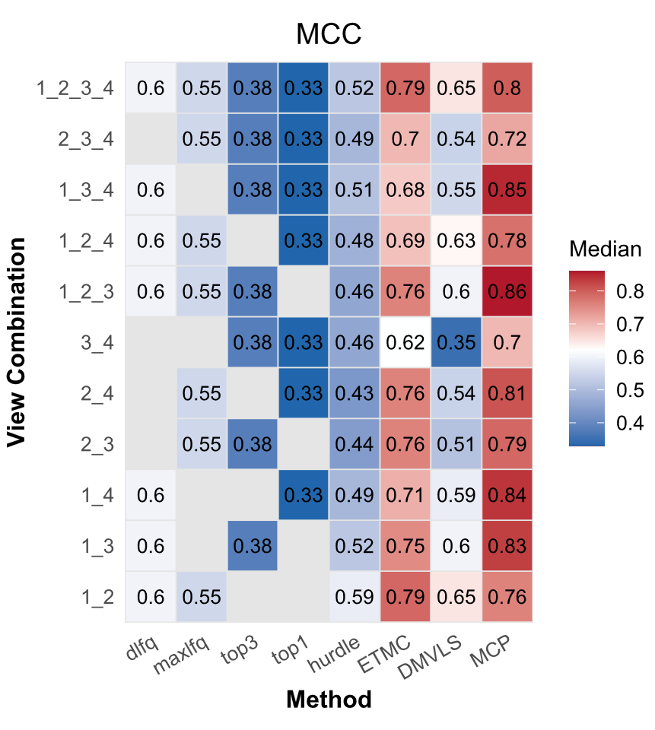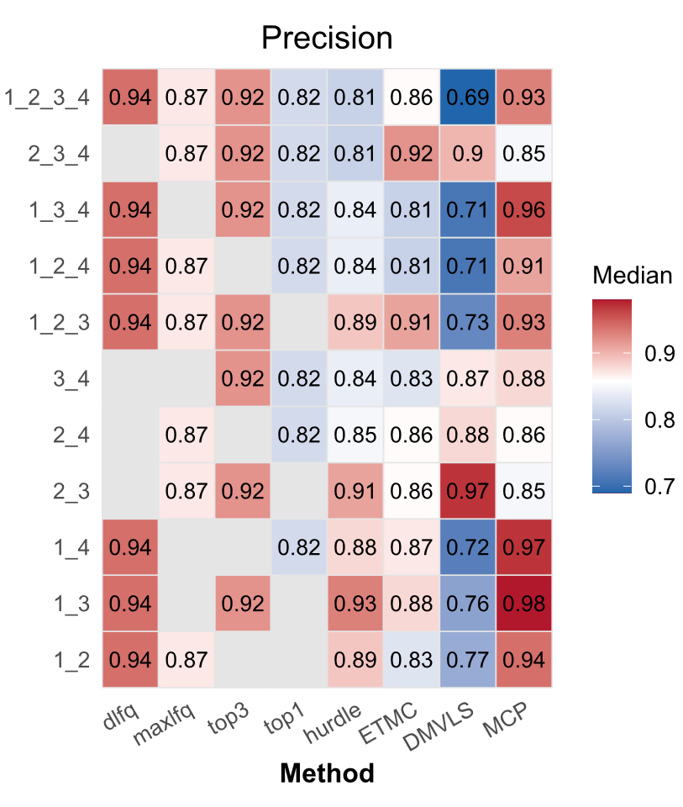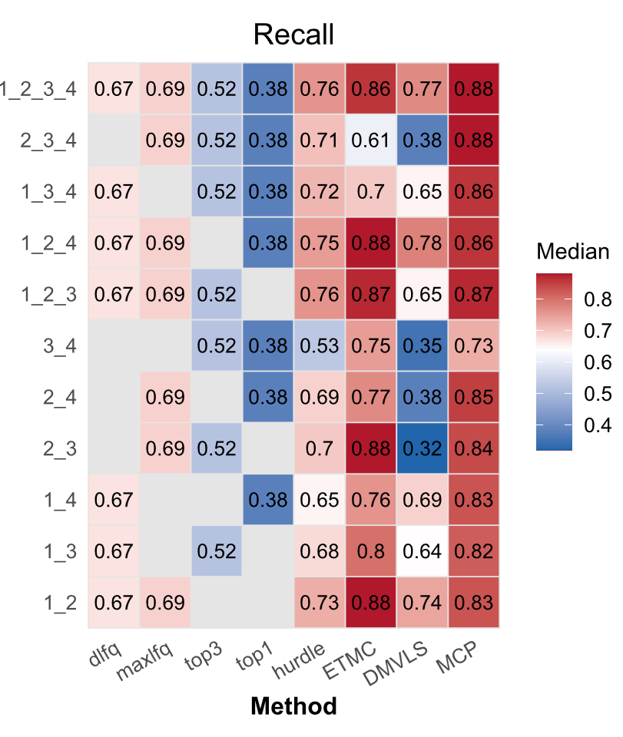

Supp. Fig. 1. Differential Expression Analysis (DEA) Benchmarking on Spectronaut. The median MCC (left), Recall (middle) and Precision (right) scores achieved by different methods (x axis) on different views or combinations of views (y axis, where numbers 1, 2, 3, 4 in the label refers to the views dlfq, maxlfq, top3 and top1 respectively) were shown.

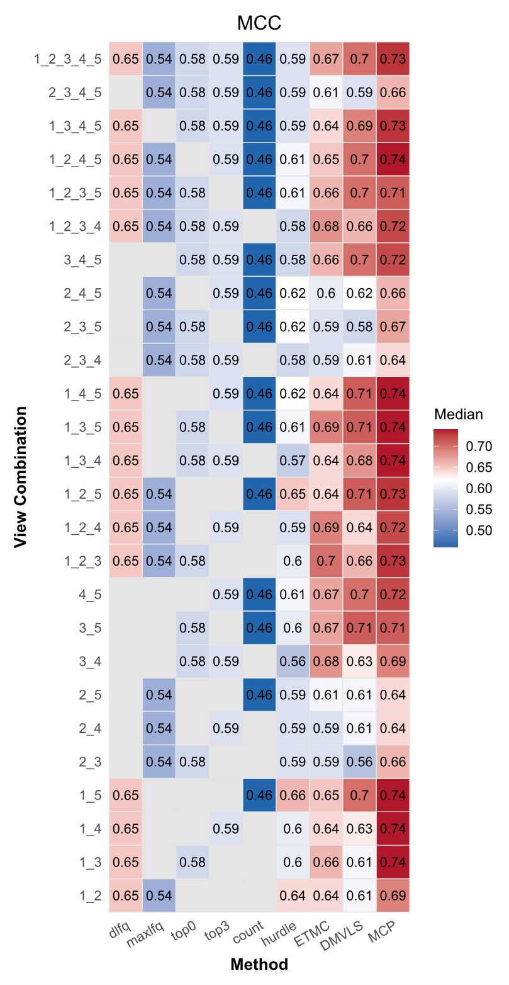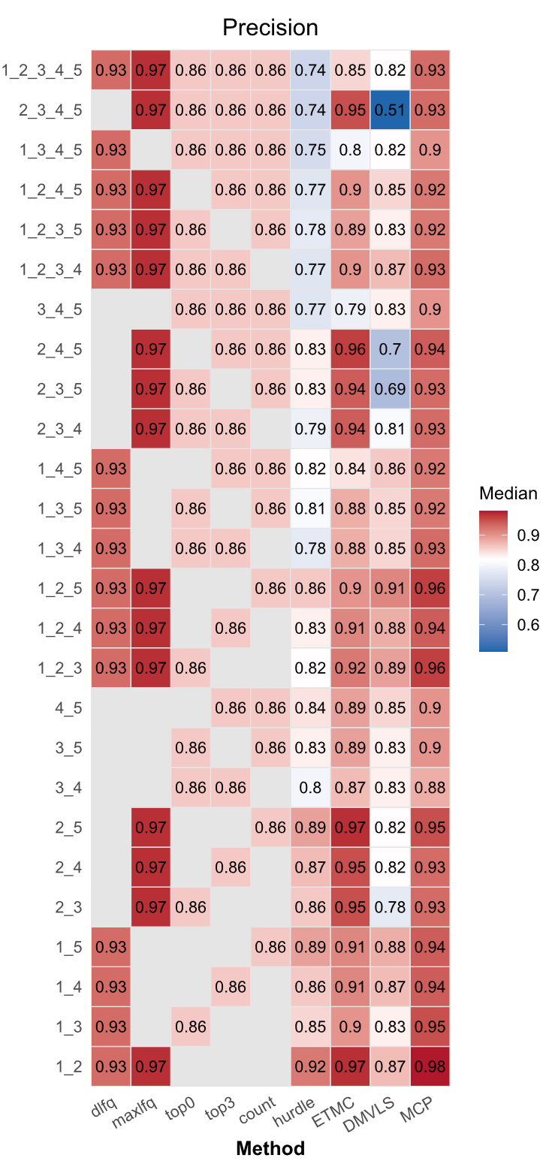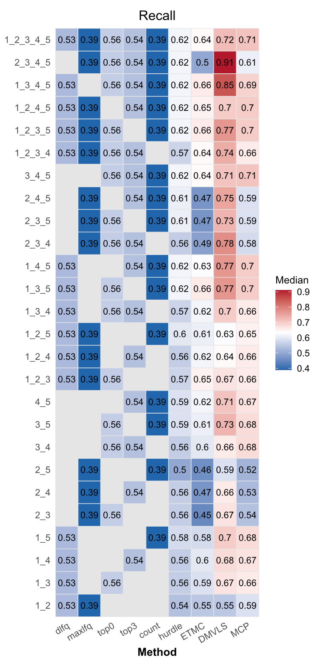

Supp. Fig. 2. Differential Expression Analysis (DEA) Benchmarking on FragPipe. The median MCC (left), Recall (middle) and Precision (right) scores achieved by different methods (x axis) on different views or combinations of views (y axis, where numbers 1, 2, 3, 4, 5 in the label refers to the views dlfq, maxlfq, top0, top3 and count respectively) were shown.

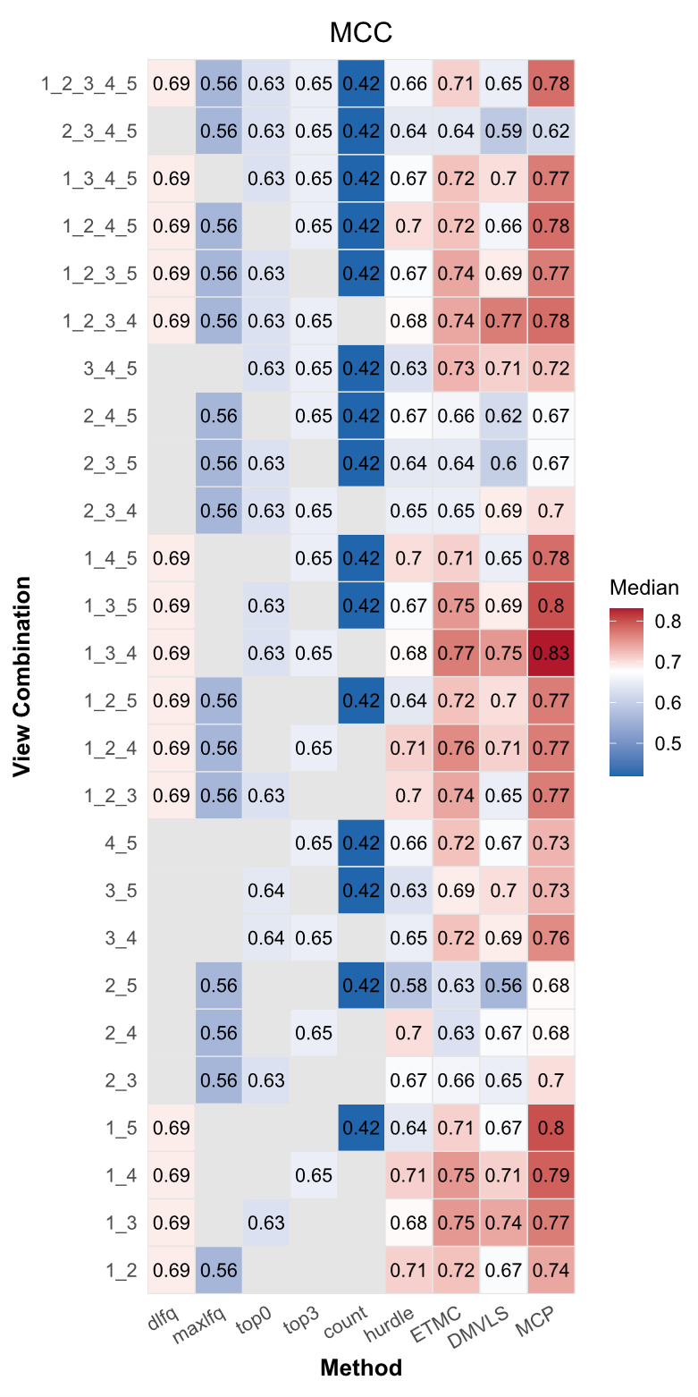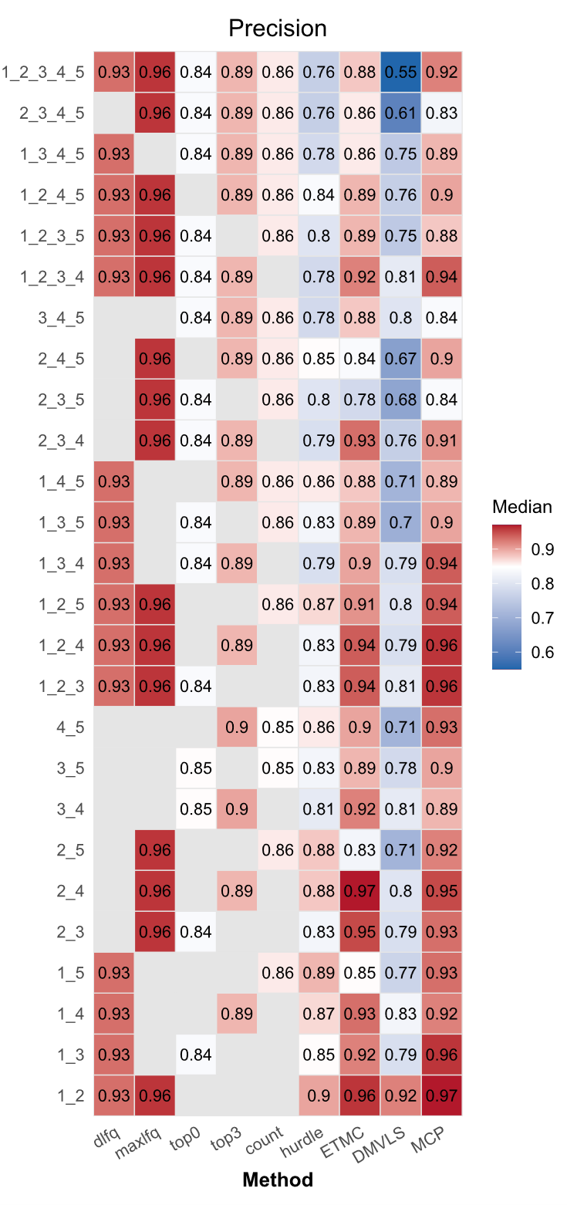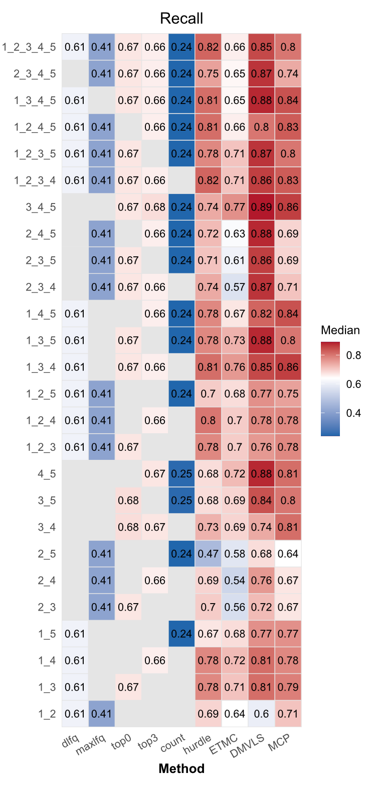

Supp. Fig. 3. Differential Expression Analysis (DEA) Benchmarking on Maxquant. The median MCC (left), Recall (middle) and Precision (right) scores achieved by different methods (x axis) on different views or combinations of views (y axis, where numbers 1, 2, 3, 4, 5 in the label refers to the views dlfq, maxlfq, top0, top3 and count respectively) were shown.

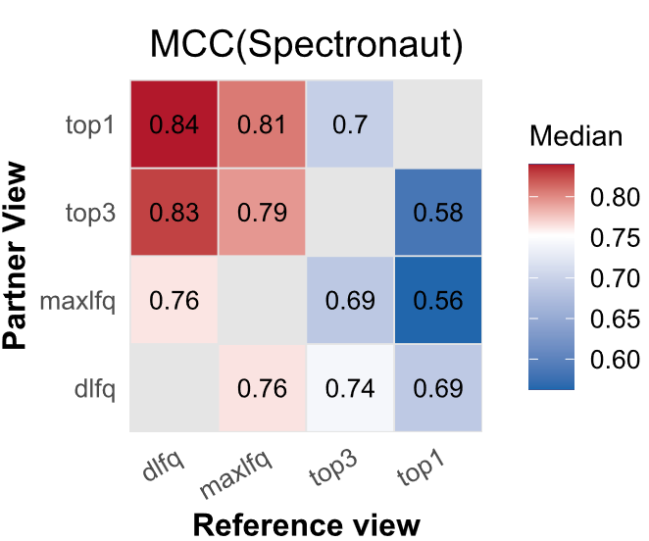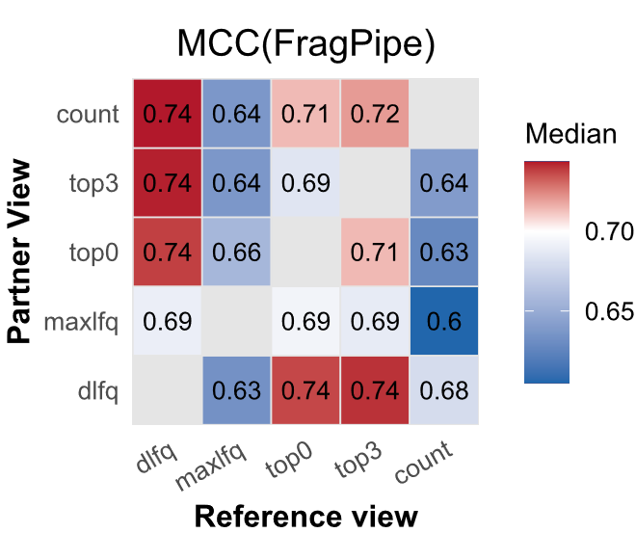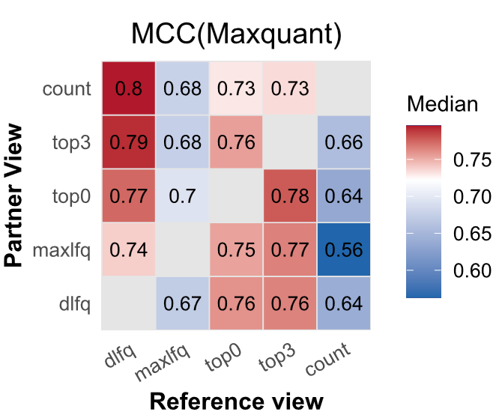

Supp. Fig. 4 The affection of reference view on the DEA performance of MCP working on Spectronaut, FragPipe and Maxquant views. Similar to Fig. 2d, the affection of the selection of reference view was also tested under the other three platforms including Spectronaut, FragPipe and Maxquant.

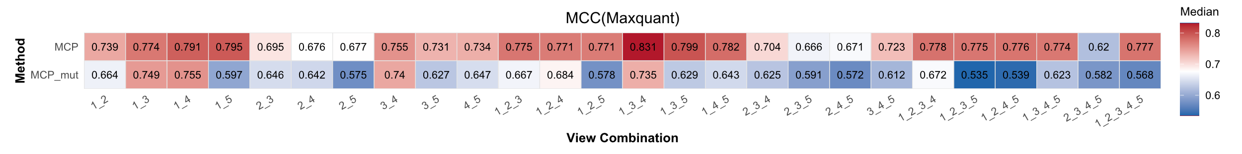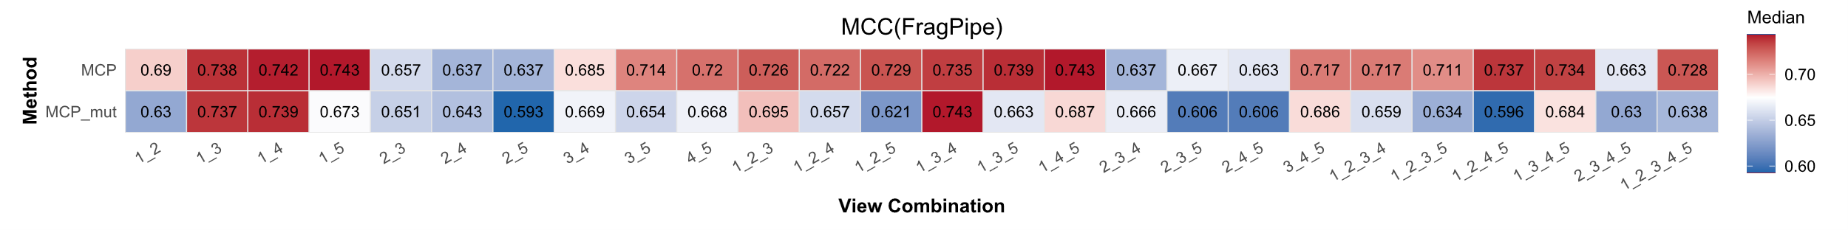
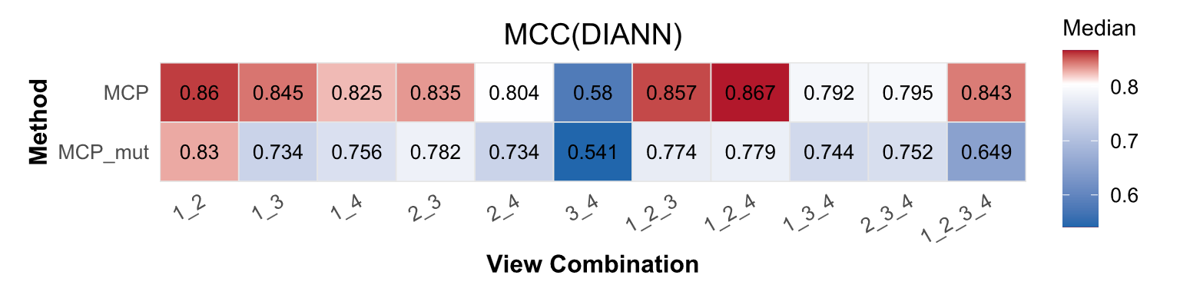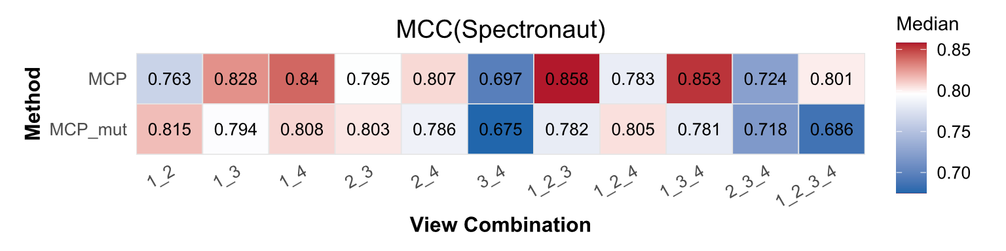

Supp. Fig. 5 The comparison of two approaches for labeling proteins. For MCP, label assignment is guided by concordance between the reference view (i.e., the outputs from a known high-quality view) and the hurdle-based ensemble inference (hurdle is a well-established p-value integration approach. Proteins with inconsistent labels by two methods are initialized to be non-labeled (not known), otherwise will be labeled as DEP or non-DEP. Alternatively, MCP_mut assigns labels for given proteins by the concordance of all the views.

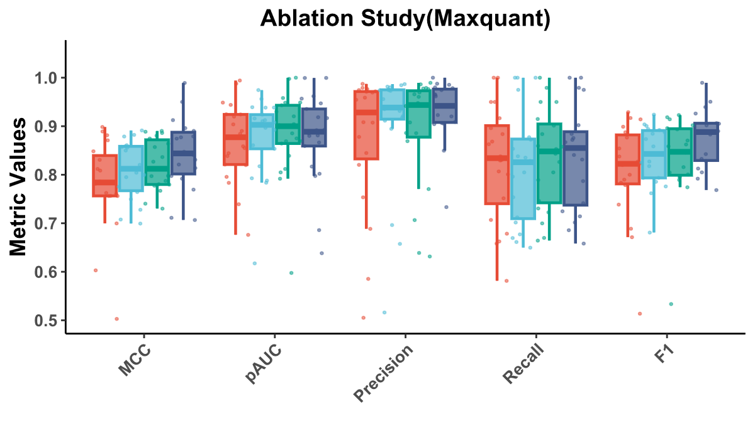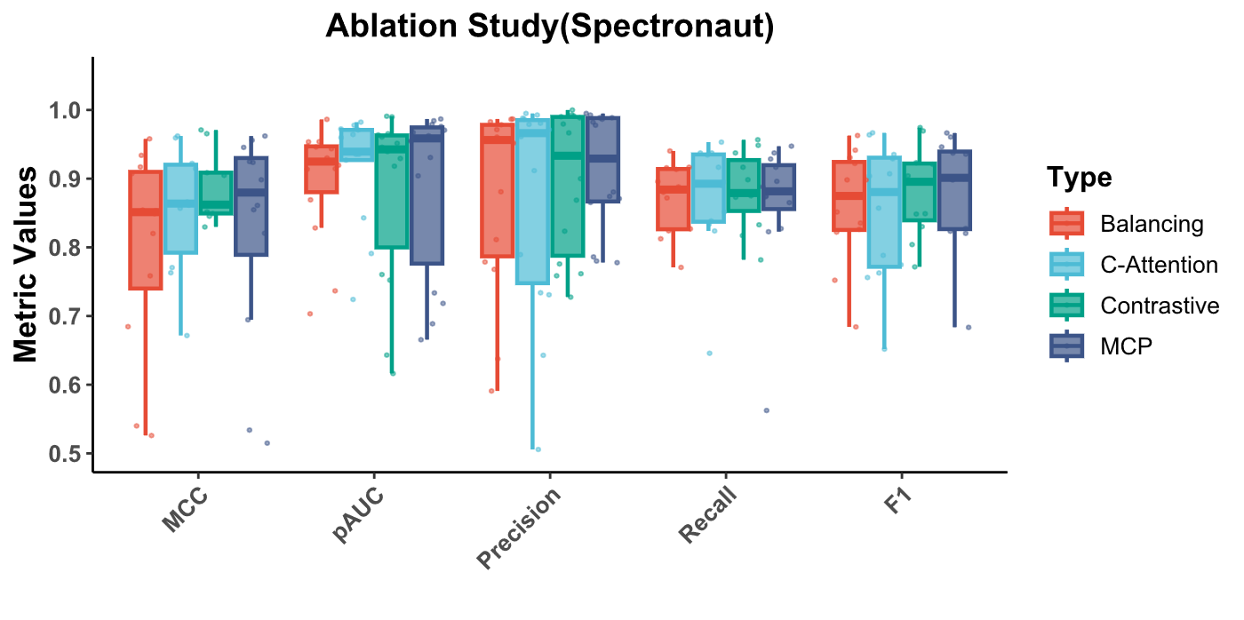

Supp. Fig. 6 Abation Studies on MCP with datasets from Maxquant and Spectronaut. The two subfigures present the ablation studies performed on MCP to observe the contributions of different model structures. For the ablation study under Maxquant, the view combination of dlfq+top0+top3 was used, as MCP achieved the highest median MCC (0.83, see Supp. Fig. 3). For the ablation study under Spectronaut, the view combination of dlfq+maxlfq+top3 was used (with highest median MCC of 0.86, see Supp. Fig. 1). The centerline of the box denotes the median. Box limits indicate upper and lower quartiles while the whiskers indicate the 1.5 interquartile range.

Supplementary Tables
Supp. Tab. 1 Datasets used to benchmark DEA methods.
dataset | ID | acqusition | used contrasts | replicates | instrument | mixture | PMID | Year
HYE5600735_DDA | PXD028735 | DDA | B-A | A:9, B:9 | SCIEX Triple TOF5600 | human+yeast+ecoli | 35354825 | 2022
HYE6600735_DDA | PXD028735 | DDA | B-A | A:9, B:9 | SCIEX Triple TOF6600 | human+yeast+ecoli | 35354825 | 2022
HYEqe735_DDA | PXD028735 | DDA | B-A | A:12, B:12 | Orbitrap QE-HFX | human+yeast+ecoli | 35354825 | 2022
HYEtims735_DDA | PXD028735 | DDA | B-A | A:7, B:7 | TimsToF pro | human+yeast+ecoli | 35354825 | 2022
HYtims134_DDA | PXD036134 | DDA | D-B | B:3,D:3 | TimsToF pro | human+yeast | 36541440 | 2023
HEtims425_DDA | PXD021425 | DDA | C-A | A:3,C:3 | TimsToF pro | human+ecoli | 34373457 | 2021
YUltq006_DDA | PDC000006 | DDA | E-C | C:3,E:3 | LTQ-Orbitrap | yeast+UPS1 | 19858499 | 2010
YUltq099_DDA | PXD002099 | DDA | E-C | C:3,E:3 | LTQ Orbitrap Velos | yeast+UPS1 | 26321463 | 2015
HEqe408_DDA | PXD018408 | DDA | B-A | A:8,B:8 | Q Exactive | human+ecoli | 33553868 | 2021
HYqfl683_DDA | PXD007683 | DDA | C-A | A:3,C:4 | Orbitrap Fusion Lumos | human+yeast | 29635916 | 2018
HYEtims777_DDA | PXD014777 | DDA | B-A | A:3,B:3 | TimsToF pro | human+yeast+ecoli | 32156793 | 2020
HYEtims735_DIA | PXD028735 | DIA | B-A | A:9, B:9 | TimsToFpro | human+yeast+ecoli | 35354825 | 2022
MYtims709_DIA | PXD034709 | DIA | C-A | A:5,C:10 | timsTOF Pro | mouse+yeast | 36609502 | 2023
HEof_n600_DIA | PXD026600 | DIA | E-B | B:3,E:3 | Orbitrap Fusion ETD | UPS1 + E.coli | 34472865 | 2021
HEof_w600_DIA | PXD026600 | DIA | E-B | B:3,E:3 | Orbitrap Fusion ETD | UPS1 + E.coli | 34472865 | 2021
HYtims134_DIA | PXD036134 | DIA | D-B | B:3,D:3 | TimsToF pro | human+yeast | 36541440 | 2023
HEqe777_DIA | PXD019777 | DIA | C-A | A:3,C:3 | Q Exactive HF | human+ecoli | 34373457 | 2021
HEqe408_DIA | PXD018408 | DIA | B-A | A:8,B:8 | Q Exactive | human+ecoli | 33553868 | 2021

Supp. Tab. 2 The spearman correlations between predicted MCC values and ground truth in the nest-cv tests of optimal view combination selection.
dataset | Spearman | dataset | Spearman | dataset | Spearman | dataset | Spearman
DIANN_0 | 0.543 | FragPipe_10 | 0.686 | Maxquant_0 | 0.816 | Maxquant_7 | 0.487
DIANN_1 | -0.405 | FragPipe_11 | 0.831 | Maxquant_1 | 0.847 | Maxquant_9 | 0.827
DIANN_2 | 0.348 | FragPipe_2 | 0.523 | Maxquant_10 | 0.652 | Spectronaut_0 | 0.414
DIANN_3 | 0.110 | FragPipe_3 | 0.787 | Maxquant_11 | 0.537 | Spectronaut_1 | -0.220
DIANN_4 | 0.191 | FragPipe_4 | 0.404 | Maxquant_2 | 0.805 | Spectronaut_2 | 0.146
DIANN_5 | 0.284 | FragPipe_5 | 0.366 | Maxquant_3 | 0.661 | Spectronaut_3 | 0.607
DIANN_6 | -0.025 | FragPipe_6 | -0.121 | Maxquant_4 | -0.164 | Spectronaut_4 | 0.133
FragPipe_0 | 0.797 | FragPipe_7 | -0.408 | Maxquant_5 | 0.253 | Spectronaut_5 | 0.068
FragPipe_1 | 0.567 | FragPipe_9 | 0.719 | Maxquant_6 | -0.040 | Spectronaut_6 | 0.551

Supp. Tab. 3 Feature importances for prediction of performance of the view combination
Feature | Importance | Feature Name
f14 | 8.616990089 | dlfq_mr
f3 | 2.199779272 | v_pca
f11 | 1.796999812 | d_mi
f19 | 1.753269076 | comb_mr
f8 | 1.132291079 | d_miss
f6 | 1.049297214 | v_entropy
f5 | 0.896839976 | v_mi
f20 | 0.885877788 | mr_reduce
f7 | 0.872025549 | d_cr
f4 | 0.8441329 | v_mmd
f2 | 0.790243685 | v_HSIC
f1 | 0.759693205 | v_miss
f9 | 0.505915225 | d_HSIC
f0 | 0.479544312 | v_cr_pro
f10 | 0.38207525 | d_mmd

Supp. Tab. 4 The predicted MCC value of each view combination for the case study on the TPD discovery set. The highest performance is highlighted in red.
view_combination | platform | predicted MCC
DIA_dlfq_maxlfq | DIA-NN | 0.73049086
DIA_dlfq_top3 | DIA-NN | 0.72322017
DIA_dlfq_top1 | DIA-NN | 0.67473376
DIA_maxlfq_top3 | DIA-NN | 0.58878696
DIA_maxlfq_top1 | DIA-NN | 0.45546973
DIA_top3_top1 | DIA-NN | 0.32785887
DIA_dlfq_maxlfq_top3 | DIA-NN | 0.7330906
DIA_dlfq_maxlfq_top1 | DIA-NN | 0.7198455
DIA_dlfq_top3_top1 | DIA-NN | 0.71177876
DIA_maxlfq_top3_top1 | DIA-NN | 0.5047633
DIA_dlfq_maxlfq_top3_top1 | DIA-NN | 0.6330841

Supp. Tab. 5 The predicted MCC value of each view combination for the case study on the CRC data. The highest performance is highlighted in red.
view_combination | platform | predicted MCC
DIA_dlfq_maxlfq | Spectronaut | 0.80210024
DIA_dlfq_top3 | Spectronaut | 0.7829054
DIA_dlfq_top1 | Spectronaut | 0.7751796
DIA_maxlfq_top3 | Spectronaut | 0.50131154
DIA_maxlfq_top1 | Spectronaut | 0.46789557
DIA_top3_top1 | Spectronaut | 0.32785887
DIA_dlfq_maxlfq_top3 | Spectronaut | 0.8095157
DIA_dlfq_maxlfq_top1 | Spectronaut | 0.7792176
DIA_dlfq_top3_top1 | Spectronaut | 0.7558101
DIA_maxlfq_top3_top1 | Spectronaut | 0.31383747
DIA_dlfq_maxlfq_top3_top1 | Spectronaut | 0.7876485

Supp. Tab. 6 The predicted MCC value of each view combination for the case study on the IFN-γ bulk data. The highest performance is highlighted in red. Though dlfq_top0 (orange) obtained the same predicted MCC as dlfq_top0_top3 in this case study, dlfq_top0 achieved worse median performance in above benchmarking of Maxquant datasets (0.77 vs. 0.83, see Supp. Fig. 3), thus dlfq_top0_top3 was finally selected as the optimal view combination.
view_combination | platform | predicted MCC | view_combination2 | platform | predicted MCC
DDA_dlfq_maxlfq | Maxquant | 0.552235 | DDA_dlfq_top0_top3 | Maxquant | 0.72366166
DDA_dlfq_top0 | Maxquant | 0.72366166 | DDA_dlfq_top0_count | Maxquant | 0.66946626
DDA_dlfq_top3 | Maxquant | 0.71229535 | DDA_dlfq_top3_count | Maxquant | 0.66946626
DDA_dlfq_count | Maxquant | 0.6373825 | DDA_maxlfq_top0_top3 | Maxquant | 0.40886432
DDA_maxlfq_top0 | Maxquant | 0.38006657 | DDA_maxlfq_top0_count | Maxquant | 0.30013344
DDA_maxlfq_top3 | Maxquant | 0.37901777 | DDA_maxlfq_top3_count | Maxquant | 0.30013344
DDA_maxlfq_count | Maxquant | 0.35869235 | DDA_top0_top3_count | Maxquant | 0.50559497
DDA_top0_top3 | Maxquant | 0.5337102 | DDA_dlfq_maxlfq_top0_top3 | Maxquant | 0.7150756
DDA_top0_count | Maxquant | 0.48715264 | DDA_dlfq_maxlfq_top0_count | Maxquant | 0.68626183
DDA_top3_count | Maxquant | 0.47794753 | DDA_dlfq_maxlfq_top3_count | Maxquant | 0.6854138
DDA_dlfq_maxlfq_top0 | Maxquant | 0.68958503 | DDA_dlfq_top0_top3_count | Maxquant | 0.6944355
DDA_dlfq_maxlfq_top3 | Maxquant | 0.68958503 | DDA_maxlfq_top0_top3_count | Maxquant | 0.3477442
DDA_dlfq_maxlfq_count | Maxquant | 0.6122001 | DDA_dlfq_maxlfq_top0_top3_count | Maxquant | 0.6629838

Supp. Tab. 7 The predicted MCC value of each view combination for the case study on the IFN-γ single cell data. The highest performance is highlighted in red.
view_combination | platform | predicted MCC
DIA_dlfq_maxlfq | DIA-NN | 0.75362545
DIA_dlfq_top3 | DIA-NN | 0.7214382
DIA_dlfq_top1 | DIA-NN | 0.6546823
DIA_maxlfq_top3 | DIA-NN | 0.56869626
DIA_maxlfq_top1 | DIA-NN | 0.44067737
DIA_top3_top1 | DIA-NN | 0.33098677
DIA_dlfq_maxlfq_top3 | DIA-NN | 0.7446816
DIA_dlfq_maxlfq_top1 | DIA-NN | 0.7198455
DIA_dlfq_top3_top1 | DIA-NN | 0.6538058
DIA_maxlfq_top3_top1 | DIA-NN | 0.4845599
DIA_dlfq_maxlfq_top3_top1 | DIA-NN | 0.6945839

Supp. Tab. 8 Running time comparison.
Task | Dataset | Protein number | Sample size | Method | Time(s)
DEA | HYEtims735_DIA | 11550 | 18 | baseline(dlfq) | 19.0675
DEA | HYEtims735_DIA | 11550 | 18 | baseline(maxlfq) | 18.65467
DEA | HYEtims735_DIA | 11550 | 18 | baseline(top3) | 37.74711
DEA | HYEtims735_DIA | 11550 | 18 | baseline(top1) | 38.8165
DEA | HYEtims735_DIA | 11550 | 18 | baseline(hurdle) | 58.54173
DEA | HYEtims735_DIA | 11550 | 18 | ETMC | 4151.5383
DEA | HYEtims735_DIA | 11550 | 18 | DMVLS | 4971.1624
DEA | HYEtims735_DIA | 11550 | 18 | MCP | 4357.9329

Supplementary Note 1
Datasets used to benchmark DEA methods

In our previous OpDEA work ¹, we collected 12 label-free DDA datasets, 5 TMT datasets, and 7 label-free DIA datasets for assessing DEA workflows. We also observed that the integration of top-ranked workflows for label-free DDA and label-free DIA data can improve the DEA performance. However, for TMT data, miner improvement was achieved. In addition, less views can be extracted from quantification results of TMT data. Thus, this work eschews testing MCP and other multi-view learning methods on TMT data. Among the 12 DDA datasets, from the dataset “YUltq819_LFQ”, we are not always able to find sufficient reliable training samples, e.g., no DEPs were consistently detected by the reference view-based DEA and by the hurdle model. Thus, we removed this dataset for DEA method benchmarking. The remain 11 DDA datasets and 7 DIA datasets were finally used to evaluate the performances of different DEA methods, detailed information of these datasets are shown in above Supp. Tab. 1. and in supp.data1. Tab.1 of Supplementary Data 1.

For the quantification of DDA and DIA data, we used default parameter settings including:
DDA data quantification. FragPipe v20.0 was used with its default quantification parameters. MSFragger-3.8 ² was adopted for database search (using default parameters), in which contaminants and decoy (sequence reverse) protein sequences were added to corresponding libraries by Philosopher v5.0.0 ³, e.g., 48 human UPS1 proteins + reviewed UP000002311 Saccharomyces cerevisiae proteome from uniport database ⁴ for YUltq099_LFQ, YUltq819_LFQ and YUltq006_LFQ datasets. MSBooster-1.1.11⁵, Percolator v3.06 ⁶ and ProteinProphet ⁷ were used for peptide identification and protein inference. For quantification, IonQuant-1.9.8 ⁸ with match between runs (ion FDR of 0.01) ⁹, normalize intensity across runs and MaxLFQ (minimum ions of 2) ¹⁰ were used. For label-free DDA data, we ran the quantification twice with the parameter of “Top N ions” set as 0 and 3 respectively to obtain the top0 (all precursors are considered) and top3 (only top3 most intense precursors are considered) quantification intensities. The quantification results are stored in files containing identified peptides or proteins with their spectral counts or intensities and other annotation information. We extracted expression levels of identified proteins in the form of spectral counts or intensities and organized them as a matrix by setting proteins as rows and samples as columns. The cells hold the expression levels. This data structure is referred to as an expression matrix, and it holds varied expression information. Four types of expression matrixes are obtainable from FragPipe including spectral counting (count), top0 intensities (top0), top3 intensities (top3) and MaxLFQ intensities calculated by MaxLFQ algorithm ¹⁰ (maxlfq). In addition, the directLFQ intensities were extracted with the directLFQ algorithm ¹¹ (with the published directlfq tool: https://github.com/MannLabs/directlfq) (dlfq). These five types of quantification results are regarded as 5 views of protein quantification.

MaxQuant v2.1.0.0 was used as an alternative quantification platform for label-free DDA data ¹². Andromeda ¹³ was applied for database search. We kept most parameters default and used the same reference library as FragPipe. Similarly, match-between runs and MaxLFQ label-free quantification algorithm was used. Again, spectral count, protein top0 and top3 (set the Top N peptides as 0 and check the Top3 option of “Advanced site intensities”) intensities, and MaxLFQ intensities can be acquired directly from Maxquant’s “proteinGroups.txt” file for DEA. The directLFQ intensities were also extracted with the directLFQ algorithm ¹¹ (so we also obtained 5 quantification views for each sample processed by MaxQuant).

DIA data quantification. For DIA data, DIA-NN v1.8.1 was used for quantification under its default parameters and libraries were predicted from corresponding databases ¹⁴. Match between runs was checked and we ran DIA-NN under “Optimal results” mode. The top1 (most intense precursor-based quantification), top3 and MaxLFQ intensities were extracted by the “iq” R package ¹⁵ (https://github.com/tvpham/iq) and the directLFQ intensities were extracted by the directLFQ algorithm from the report file of DIA-NN (so for DIA data, 4 quantification views can be obtained).

Spectronaut 18 ¹⁶ was used as an alternative platform for DIA data quantification. We used the same sequence databases as DIA-NN used and predicted libraries by Spectronaut 18 (used the directDIA ¹⁶ workflow for quantification). Similar to DIA-NN, we extracted top1, top3, MaxLFQ intensities with the “iq” package and extracted directLFQ intensities with the directlfq tool from the report file of Spectronaut 18. More detailed settings are referred to our previous publication ¹.

As for each DDA dataset or DIA dataset, both limma ¹⁷ and ROTS ¹⁸ were used as the statistical tool for DEA, thus two different DEA results were obtainable for each compared DEA method on a same dataset.

Batch data balancing setting
To address class imbalance in labeled proteomics datasets, we adopted a minority-class–aware data augmentation strategy that synthetically expands samples from the under-represented class during training. Let $D=\{(x_{i},y_{i})\}_{i=1}^{N}$ denote the labeled training set, where $x_{i}∈R^{P}$represents a protein expression vector with $P$quantified proteins and $y_{i}∈\{1,…,C\}$denotes the class label. Samples with missing labels ($y_{i}=-1$) were excluded from class balancing.
At each training epoch, class frequencies were computed as
$$n_{c}=\sum_{i=1}^{N}{I(}y_{i}=c),$$
and the minority class was identified as
$$c_{min}=arg⁡\underset{c}{min⁡}n_{c}.$$
To achieve balanced class distributions, the number of synthetic samples to be generated was set to
$$N_{\text{aug}}=\underset{c}{max⁡}n_{c}-n_{c_{min}}.$$
Stochastic augmentation of minority-class samples
Synthetic samples were generated by randomly resampling expression profiles from the minority class with replacement and applying a composite stochastic augmentation operator. For a resampled minority-class expression vector $x$, the augmented profile $\tilde{x}$was obtained as
$$\tilde{x}=S\left(D\left(P\left(x + ϵ\right)\right)\right),$$
where each operator corresponds to a biologically motivated perturbation:
(i) Additive Gaussian noise.
Measurement noise was modeled as
$$ϵ∼N(0,σ^{2}I),$$
with the noise standard deviation fixed to
$$σ=0.01.$$
(ii) Feature-wise random permutation.
With probability $p_{\text{perm}}=1.0$, protein features were randomly permuted:
$$P(x)=x_{π},$$
where $π$denotes a random permutation of the protein indices. This operation captures local uncertainty and instability in protein-level quantification.
(iii) Random dropout.
Missingness commonly observed in mass spectrometry–based proteomics was simulated by element-wise masking:
$$D(x)=x⊙m,m_{j}∼\text{Bernoulli}(1-p_{\text{drop}}),$$
with dropout probability $p_{\text{drop}}=0.05.$

Global intensity scaling
To further model systematic intensity variation arising from technical factors such as sample loading or batch effects, a global multiplicative scaling was applied to each augmented sample with probability $p_{\text{scale}}=0.4$. Specifically,
$$S(x)=\left\{\begin{matrix}αx, & \text{with probability }p_{\text{scale}}, \\ x, & \text{otherwise},\end{matrix}\right.$$
where the scaling factor $α$was drawn from a uniform distribution: $α∼U\left(0.8,1.2\right).$
Following augmentation, expression values were clipped to the interval [0, 1] to ensure numerical stability and biological plausibility.

Training with augmented samples
The generated synthetic samples $\left\{{\tilde{x}}_{k}\}_{k=1}^{N_{\text{aug}}}\right.$, together with their assigned minority-class labels $c_{min}$, were concatenated with the original training data at each epoch. The resulting balanced dataset was then used for model optimization in an end-to-end manner. This on-the-fly augmentation strategy enables effective mitigation of class imbalance while preserving realistic sources of variability inherent to quantitative proteomics data.

Complementarity evaluation between paired views
To prove that proteomic quantification is an inherent multi-view system, we evaluated the complementarity between paired views via calculating three types of metrics, including the Pearson’s correlation (view_pearson), the missingness complementarity (missing_complementary) and the DEA cross-view consistency (DEA_pearson) (see Fig. 1a and Fig. 1b, and see Supplementary Data 2 for detail metric values).
view_pearson. Let $\{X^{\left(v\right)}\}_{v=1}^{k}$ denote a selected set of 𝑘 proteomics views, where each view is represented by an expression matrix $X^{\left(v\right)}∈R^{N×P}$ represents the protein expression matrix with N samples and P proteins. Missing values are encoded as NaNs. For a given protein p, the Pearson correlation between views $v_{i}$ and $v_{j}$ was computed using samples with observed measurements in both views. Let
$Ω_{ij}^{\left(p\right)}=\left\{n | X_{n,p}^{\left(v_{i}\right)} \text{and} X_{n,p}^{\left(v_{j}\right)} \text{are observed}\right\}, \left|Ω_{ij}^{\left(p\right)}\right|>τN,$ (1)
where $τN$ denotes the minimum fraction of valid samples required for correlation estimation. Under this condition, the protein-wise Pearson’s correlation coefficient is defined as
$r_{ij}^{\left(p\right)}=\text{corr}\left(\{X_{n,p}^{\left(v_{i}\right)}\}_{n∈Ω_{ij}^{\left(p\right)}},\{X_{n,p}^{\left(v_{j}\right)}\}_{n∈Ω_{ij}^{\left(p\right)}}\right).$ (2)
The expression correlation complementarity between views $v_{i}$ and $v_{j}$ for protein p was defined as
$C_{ij}^{\left(p\right)}=1-\left|r_{ij}^{\left(p\right)}\right|.$ (3)
The protein-level complementarity score was obtained by averaging across all unordered view pairs satisfying the valid-sample criterion,
$C^{\left(p\right)}=\frac{1}{\left|P_{p}\right|}\sum_{\left(i,j\right)∈P_{p}}{\left(1-\left|r_{ij}^{\left(p\right)}\right|\right)},$ (4)
where $P_{p}=\{\left(i,j\right)∣1≤i<j≤k, \left|Ω_{ij}^{\left(p\right)}\right|>τN\}$.
Finally, the overall expression correlation complementarity score was computed as
$C_{\text{ep}}=\frac{1}{P}\sum_{p=1}^{P}{C^{\left(p\right)}}.$ (5)

A higher value of $C_{\text{ep}}$ indicates lower expression similarity and stronger complementarity across views.

In our complementarity evaluation, for each possible view pair [V1, V2], we set $τN$= 0.8 and define view_pearson(V1, V2) = $1 - C_{\text{ep}}$. Then, higher view_pearson score means weaker complementarity between V1and V2.

missing_complementary. Let $\{X^{\left(v\right)}\}_{v=1}^{k}$ denote a selected set of k proteomics views, where each view is represented by an expression matrix $X^{\left(v\right)}∈R^{N×P}$, with N samples and P proteins. Missing entries are encoded as NaN values.

For each protein $p ∈\{1, …, P\}$, we extracted its expression vectors across all selected views. For every unordered pair of views $\left(v_{i},v_{j}\right)$, we computed the proportion of samples in which protein p is missing in one view while being observed in the other. Specifically, the directed complementarity from view $v_{i}$ to view $v_{j}$ was defined as:
$C_{i→j}^{\left(p\right)}=\frac{1}{N}\sum_{n=1}^{N}{oI\backslash big\left(X_{n,p}^{\left(v_{i}\right)} \text{is missing} ∧ X_{n,p}^{\left(v_{j}\right)} \text{is observed}\backslash big\right)},$ (6)
where $I\left(⋅\right)$ denotes the indicator function.

To obtain a symmetric measure of pairwise complementarity, we averaged the two directed terms:
$C_{ij}^{\left(p\right)}=\frac{1}{2}\left(C_{i→j}^{\left(p\right)}+C_{j→i}^{\left(p\right)}\right).$ (7)
The protein-specific missingness complementarity score was then computed by averaging $C_{ij}^{\left(p\right)}$ across all $\left({k \atop 2}\right)$ unordered pairs of selected views:
$C^{\left(p\right)}=\frac{1}{\left({k \atop 2}\right)}\sum_{1≤i<j≤k}{C_{ij}^{\left(p\right)}}.$ (8)
Finally, the overall missingness complementarity score (missing_complementary) for the selected set of views was calculated as the mean of protein-level scores across all proteins:
$C=\frac{1}{P}\sum_{p=1}^{P}{C^{\left(p\right)}}.$ (9)
By construction, $C∈\left[0,1\right]$, with higher values indicating stronger complementarity, i.e., a greater tendency for missing protein measurements in one view to be compensated by observed measurements in other views. This metric was used to assess the potential benefit of integrating multiple proteomics views under heterogeneous missingness patterns.

DEA_pearson. The DEA_pearson is calculated similar to above $C_{\text{ep}}$ via formula (1)-(5). The main difference is that we replace the expression matrix $X^{\left(v\right)}∈R^{N×P}$ with a DEA output matrix $D^{\left(v\right)}∈R^{2×P}$, where the first column is the logFC value and the second column is the adjust p-value corresponding to each query protein p. We calculate a DEA correlation complementarity score $C_{\text{dea}}$. For each possible view pair [V1, V2], we set $τN$= 0.2 and the DEA_pearson(V1, V2) = 1-$C_{\text{dea}}$ where higher score means lower DEA similarity and stronger complementarity across views.

Protein labeling strategy comparison
In the multi-view data preparation module, MCP constructs a unified protein list with partially labeled training data, where label assignment is guided by concordance between the reference view (i.e., the outputs from a known high-quality view) and the hurdle-based ensemble inference (hurdle is a well-established p-value integration approach, see Methods). Proteins with inconsistent labels by two methods are initialized to be non-labeled (not known), otherwise will be labeled as DEP or non-DEP. The affection of the choice of the reference view on performance of MCP under DIA-NN has been presented in Fig. 2d, while when views are from Spectronaut, FragPipe and Maxquant, the comparisons are shown in above Supp. Fig. 4 (all the 18 benchmark datasets were tested and median MCC scores were calculated as performance the indicator).
We can see, the view with better DEA accuracy is preferred to be used as the reference view. Under DIA-NN, the performance of single views can be ranked as dlfq>maxlfq>top3>top1. From Fig. 2d, using dlfq as reference view works the best, followed by maxlfq, top3 and at last top1. Similarly, under Spectronaut, the DEP performance of the four views can be ranked as dlfq>maxlfq>top3>top1 (Supp. Fig. 1), we also can find that dlfq is preferred to be reference view, followed by maxlfq, then top3 and top1 from Supp. Fig. 4. For FragPipe (Supp. Fig. 2) and Maxquant (Supp. Fig. 3), the performance of the single views can be ranked as dlfq>top3>top0>maxlfq>count, we again can observe the phenomenon that the preference of reference view is consistent the DEA performance ranks (Supp. Fig. 4).
Alternative to label proteins by concordance between the reference view and the hurdle-based ensemble inference, we can label proteins per full cross-view consistency. However, under this high stringent requirement, the labeling accuracy would be limited by the least sensitive view. The performance comparison of MCP and the MCP coupled with the alternative labeling strategy (refer to MCP_mut) is shown in Supp. Fig. 5. We can see, no matter under each quantification platform, MCP works better than MCP_mut, with higher median MCC score across all the benchmark data and with different view combinations.

Feature sets used to train XGBoost regressor for DEP detection performance prediction
To train a XGBoost regressor to predict DEP detection performance (MCC score), each view combination is represented by following 3 groups of features including: (i) view-specific attributes, such as missing rate; (ii) cross-view complementarity metrics; and (iii) view-specific differential expression complementarity indices.
view-specific attributes. The view-specific attributes include "count_mr", "dlfq_mr", "maxlfq_mr", "top0_mr", "top1_mr", "top3_mr", "comb_mr", "mr_reduce". The attributes "count_mr", "dlfq_mr", "maxlfq_mr", "top0_mr", "top1_mr", "top3_mr" are numeric values indicating the missing rates of the corresponding views, if a view is absence, then we fill it with 1.
"comb_mr" and "mr_reduce" are calculated via: Let $X^{\left(v\right)}∈R^{N×P}$denote the protein expression matrix of view $v$, where missing values are represented as NaNs. For computational consistency, missing entries are first imputed as zeros. The missing rate of view $v$is defined as the proportion of missing entries:
${MR}^{\left(v\right)}=\frac{1}{NP}\sum_{i=1}^{N}{\sum_{j=1}^{P}{I}}\left(X_{ij}^{\left(v\right)} = 0\right)$(10)
where $I(⋅)$is the indicator function.
Let $V$ denote the set of selected views. The minimum missing rate among individual views is then:
${MR}_{min}=\underset{v∈V}{min⁡}{MR}^{\left(v\right)}$ (11)
The combined view $X^{\left(V\right)}$is then constructed by element-wise summation across all views:
$X_{ij}^{\left(V\right)}=\sum_{v=1}^{K}{{\tilde{X}}_{ij}^{\left(v\right)}}$ (12)
Its missing rate ("comb_mr") is defined analogously as:
${MR}^{\left(V\right)}=\frac{1}{∣X^{\left(V\right)}∣}\sum_{x∈X^{\left(V\right)}}{I\left(x=0\right)}$ (13)
$T$he missing-rate reduction ("mr_reduce") achieved by multi-view integration is quantified as:
${mr}_{reduce}={MR}_{min}-{MR}^{\left(V\right)}$ (14)
${mr}_{reduce}>0$indicates that multi-view integration reduces missingness compared with the best single view. Larger values reflect stronger cross-view complementarity in coverage, demonstrating that missing values in one view can be compensated by observed values in others. ${mr}_{reduce}≤0$suggests no benefit (or degradation) in missing-rate reduction from view combination.
cross-view complementarity metrics. The cross-view complementarity metrics include 'v_cr_pro', 'v_miss', 'v_HSIC', 'v_pca', 'v_mmd', 'v_mi' and 'v_entropy'. They are defined as:
a. 'v_cr_pro' is calculated by above formula (1)-(5), higher means stronger complementarity;
b. 'v_miss' is calculated by above formula (6)-(9), higher means stronger complementarity;
c. 'v_HSIC' uses the Hilbert–Schmidt Independence Criterion to assess nonlinear dependence between views. Let $\left\{X^{\left(v\right)}\}_{v=1}^{K}\right.$denote $K$aligned proteomics views, where each view is represented as a matrix $X^{\left(v\right)}∈R^{N×P}$. Missing values were replaced with zeros prior to kernel computation. For any pair of views $\left(i , j\right)$, nonlinear dependence was measured using the Hilbert–Schmidt Independence Criterion (HSIC):
$HSIC\left(X^{\left(i\right)} , X^{\left(j\right)}\right)=\frac{1}{\left(N − 1)^{2}\right.}tr\left(HK^{\left(i\right)}HK^{\left(j\right)}H\right),$ (15)
where $K^{\left(i\right)}$and $K^{\left(j\right)}$are radial basis function kernel matrices computed from $X^{\left(i\right)}$and $X^{\left(j\right)}$, respectively, and $H=I-\frac{1}{N}{11}^{⊤}$is the centering matrix.
Pairwise complementarity between views $i$and $j$was then defined as
$C_{ij}^{HSIC}=1-HSIC\left(X^{\left(i\right)} , X^{\left(j\right)}\right)$ (16)
such that lower nonlinear dependence corresponds to higher complementarity.
For a selected set of $k$views $V⊆\{1,…,K\}$, the multi-view HSIC complementarity score was computed by averaging across all unordered view pairs:
$C^{HSIC}(V)=\frac{1}{\left({k \atop 2}\right)}\sum_{\begin{aligned}i,j∈V \\ i<j\end{aligned}}{C_{ij}^{HSIC}}$ (17)
Finally, the reported HSIC complementarity score was obtained by averaging $C^{HSIC}(V)$across all view combinations of size $k$(with $k$fixed to the maximal number of integrated views):
$C_{HSIC}=E_{V}\left[C^{HSIC}(V)\right]$ (18)
By construction, higher values of $C_{HSIC}$indicate weaker nonlinear dependence and stronger statistical complementarity among integrated proteomics views.
d. 'v_pca' quantifies structural complementarity among multiple proteomics views using principal component analysis (PCA). Let $\left\{X^{\left(v\right)}\}_{v=1}^{K}\right.$denote $K$aligned views, where each view $X^{\left(v\right)}∈R^{P×N}$represents protein-wise profiles across $N$samples. Missing values were replaced with zeros prior to PCA.
For each view $v$, PCA with $d$components was fitted to $X^{\left(v\right)}$, yielding a reconstructed matrix ${\hat{X}}^{\left(v\right)}$. The single-view reconstruction error was defined as
$ε^{\left(v\right)}=\frac{1}{PN}{∥X^{\left(v\right)}-{\hat{X}}^{\left(v\right)}∥}_{F}^{2}$(19)
where $∥⋅∥_{F}$denotes the Frobenius norm.
For a selected subset of views $V⊆\{1,…,K\}$with $∣V∣=k$, views were concatenated along the feature dimension:
$X^{\left(V\right)}=\left[X^{\left(v_{1}\right)} ∥ X^{\left(v_{2}\right)} ∥ ⋯ ∥ X^{\left(v_{k}\right)}\right]$ (20)
PCA with the same number of components $d$was applied to $X^{\left(V\right)}$, producing the reconstruction ${\hat{X}}^{\left(V\right)}$. The joint reconstruction error was defined as
$ε^{\left(V\right)}=\frac{1}{∣X^{\left(V\right)}∣}{∥X^{\left(V\right)}-{\hat{X}}^{\left(V\right)}∥}_{F}^{2}$ (21)
The reconstruction complementarity of the view set $V$was quantified as
$C^{PCA}(V)=ε^{\left(V\right)}-\frac{1}{k}\sum_{v∈V}{ε^{\left(v\right)}}$ (22)
This score measures the excess reconstruction error introduced by jointly embedding multiple views relative to the average single-view reconstructions.
The final PCA-based complementarity score was obtained by averaging $C^{PCA}(V)$ across all view combinations of size $k$(with $k$fixed to the maximal number of integrated views):
$C_{PCA}=E_{V}\left[C^{PCA}(V)\right]$ (23)
Higher values of $C_{PCA}$indicate that joint low-dimensional reconstruction is less efficient than single-view reconstructions, suggesting that the integrated views encode non-redundant and complementary structural information.
e. 'v_mmd' quantifies distributional complementarity between views. Let $\left\{X^{\left(v\right)}\}_{v=1}^{K}\right.$denote $K$quantitative proteomics views, where $X^{\left(v\right)}∈R^{P×N}$represents the protein-by-sample matrix of view $v$. Missing values are imputed as zero prior to kernel computation, consistent with the implementation. Then, we adopt Maximum Mean Discrepancy (MMD) with a Gaussian radial basis function (RBF) kernel to quantifies distributional complementarity between views.
For two views $X^{\left(i\right)}$and $X^{\left(j\right)}$, MMD is defined as:
$MMD\left(X^{\left(i\right)} , X^{\left(j\right)}\right)=\frac{1}{n_{i}^{2}}\sum_{a,a^{'}}{k(}x_{a}^{\left(i\right)},x_{a^{'}}^{\left(i\right)})+\frac{1}{n_{j}^{2}}\sum_{b,b^{'}}{k(}x_{b}^{\left(j\right)},x_{b^{'}}^{\left(j\right)})-\frac{2}{n_{i}n_{j}}\sum_{a,b}{k(}x_{a}^{\left(i\right)},x_{b}^{\left(j\right)})$ (24)
where $x_{a}^{\left(i\right)}$denotes the $a$-th sample (protein profile) in view $i$, and $k(⋅,⋅)$is the RBF kernel:
$k(x,y)=exp\left(-\frac{∥x-y∥^{2}}{2σ^{2}}\right)$ (25)
For a subset of views $S⊆\{1,…,K\}$with cardinality $∣S∣=k$, we define the MMD-based complementarity as the average pairwise MMD across all view pairs:
$C_{MMD}(S)=\frac{1}{\left({k \atop 2}\right)}\sum_{\begin{aligned}i,j∈S \\ i<j\end{aligned}}{MMD}\left(X^{\left(i\right)} , X^{\left(j\right)}\right)$ (26)
Following the implementation, the final reported score is obtained by averaging over all considered $k$-view combinations (with $k=K$in our experiments):
$v_{MMD}=E_{S, ∣S∣=k}\left[C_{MMD}(S)\right]$ (27)
A higher value of $v_{MMD}$indicates larger distributional discrepancies between views, reflecting lower redundancy and stronger cross-view complementarity in the underlying proteomic measurements.
f. 'v_m' measures the mutual information (MI) between discretized expression profiles. Let $\left\{X^{\left(v\right)}\}_{v∈S}\right.$denote a selected set of $k$proteomics views, where $X^{\left(v\right)}∈R^{N×P}$represents sample-by-protein expression matrices. For protein $p$, its expression profile in view $v$is denoted by $x_{p}^{\left(v\right)}∈R^{N}$. To quantify view complementarity at the protein level, we estimate pairwise mutual information (MI) between discretized expression profiles. Continuous expression values are discretized into $B$bins using histogram-based binning.
For a valid sample subset $Ω_{ij,p}$shared by views $i$and $j$, the mutual information is defined as:
$MI\left(x_{p}^{\left(i\right)} , x_{p}^{\left(j\right)}\right)=\sum_{u=1}^{B}{\sum_{v=1}^{B}{p_{uv}}}log⁡\frac{p_{uv}}{p_{u}p_{v}}$(28)
where $p_{uv}$is the joint empirical probability of binned values $\left(u , v\right)$, and $p_{u}$, $p_{v}$are the corresponding marginals.
To emphasize complementarity rather than redundancy, MI is normalized and inverted:
$C_{MI}^{\left(p\right)}(i,j)=1-\frac{MI\left(x_{p}^{\left(i\right)} , x_{p}^{\left(j\right)}\right)}{\log{B}},C_{MI}^{\left(p\right)}∈[0,1]$(29)
For proteins with insufficient shared observations ($<60\%$), a neutral score of $0.5$is assigned, consistent with the implementation.
The protein-level complementarity across a view subset $S$is then:
$C_{MI}^{\left(p\right)}(S)=\frac{1}{\left({k \atop 2}\right)}\sum_{\begin{aligned}i,j∈S \\ i<j\end{aligned}}{C_{MI}^{\left(p\right)}}(i,j)$ (30)
Finally, the overall MI-based complementarity score is obtained by averaging across all proteins:
$v_{MI}=\frac{1}{P}\sum_{p=1}^{P}{C_{MI}^{\left(p\right)}}(S)$ (31)
Higher $v_{MI}$values indicate lower expression redundancy and stronger cross-view complementarity at the protein level.
g. 'v_entropy' is a multi-view entropy–based complementarity metric that captures global distributional diversity across views. Given a set of views $S$, expression values from each view are discretized into $B$bins after imputing missing values as zero. For each view $v$, let $h^{\left(v\right)}∈R^{B}$denote its empirical histogram:
$h_{b}^{\left(v\right)}=\#\{x∈X^{\left(v\right)}:x∈\text{bin }b\}$ (32)
The joint histogram across views is constructed multiplicatively:
$h^{\left(S\right)}=\prod_{v∈S}{h^{\left(v\right)}}$(33)
and the corresponding joint entropy is computed as:
$H(S)=-\sum_{b}{p_{b}}log⁡p_{b},p_{b}=\frac{h_{b}^{\left(S\right)}}{\sum_{b}{h_{b}^{\left(S\right)}}}$ (34)
To obtain a normalized complementarity score, the joint entropy is compared to the maximum possible entropy under a uniform distribution:
$v_{Entropy}=\frac{H_{max}-H(S)}{H_{max}},H_{max}=H(1)$ (35)
where $1$denotes a uniform histogram.
Higher $v_{Entropy}$values indicate stronger multi-view complementarity, reflecting greater structural diversity and reduced redundancy across views.
view-specific differential expression complementarity indices. The view-specific differential expression complementarity indices include "d_cr", "d_miss", "d_HSIC", "d_mmd", "d_mi", "d_entropy".
"d_cr" is calculated via the above formula (1)-(5) while replace the $X^{\left(v\right)}∈R^{N×P}$ with DEA output matrix $D^{\left(v\right)}∈R^{2×P}$, where the first column is the logFC value and the second column is the adjust p-value corresponding to each query protein p. Similarly, "d_miss", "d_HSIC", "d_mmd", "d_mi", "d_entropy" are calculated by replacing the expression matrix with DEA output matrix in above 'v_miss', 'v_HSIC', 'v_mmd', 'v_mi' and 'v_entropy'.
Finally, each view combination is represented by a 21-d feature vector. The feature values were normalized to the range [0, 1] and used as the input of the XGBoost. The nest-cv results on the 11 DDA dataset and 7 DIA datasets are shown in above Supp. Tab. 2
The final feature importances are shown in above Supp. Tab. 3.
Combination selection in case studies
In the case studies of DEPs detection from TPD, CRC and IFN-γ datasets, we first extracted and normalized view combinations features (see above section), and applied our trained XGBoost regressor (see the section of XGBoost for view combination performance regression and for patient classification in Methods of our manuscript) to predict DEA performances corresponding to the adoption of different view combinations. Then, the view combinations will be ranked and the view combination with the highest predicted performance will be used to in following DEP detection with MCP. The detailed predicted performances of each dataset were shown in above Supp. Tab. 4-7. Those recommended optimal view combinations are highlighted in red. We note that in the case study on the IFN-γ bulk data (Supp. Tab. 6), though dlfq_top0 (orange) obtained the same predicted MCC as dlfq_top0_top3 in this case study, dlfq_top0 achieved worse median performance in above benchmarking of Maxquant datasets (0.77 vs. 0.83, see Supp. Fig. 3), thus dlfq_top0_top3 was finally selected as the optimal view combination.

Hardware environment
The benchmarking, case studies, and following running time comparison were implemented under the following hardware environment:
OS: Ubuntu 20.04.6 LTS (GNU/Linux 5.15.0-139-generic x86_64)
Memory: 128G
Processor: AMD EPYC 7H12 64-Core Processor; CPU MHz: 1500.000; CPU max MHz: 2600.0000; CPU min MHz: 1500.0000
GPU: NVIDIA RTX A6000 48GB * 2; Driver Version: 560.35.05; CUDA Version: 12.6
The optimal combination recommendation model and the remain data analysis were implemented under the hardware environment of:
OS: Windows 11 25H2 26200.7840
Memory: 16G
Processor: 13th Gen Intel(R) Core(TM) i9-13900HX (2.20 GHz) * 24
Other computing environment including the python and R packages see github:
Running time comparison
MCP is an end-to-end DEP detection method based on deep multi-view contrastive learning. Due to the training and hyperparameter optimization (with default 30 rounds) process, its running time will be increased a lot. We tested the running time of single-view conventional statistical methods, the hurdle and MCP on the HYEtims735_DIA dataset. Detailed running times of different methods are listed in Supp. Tab. 8.

Two existing multi-view learning methods
ETMC: Trusted Multi-View Classification with Dynamic Evidential Fusion (ETMC) builds upon evidential deep learning to model prediction uncertainty in multi-view classification ¹⁹. The method assigns each view an evidence distribution and dynamically fuses these evidences using Dempster–Shafer theory, allowing the model to weight views according to their reliability. This design enables ETMC to handle view conflict and noise while producing calibrated predictions with quantified uncertainty.

DMVLS: Dynamic Multi-view Labeling Strategy (DMVLS) adopts a decouple-then-classify paradigm to exploit both shared and view-specific information across multiple views ²⁰. The method dynamically generates pseudo-labels by separating common representations from view-specific components and iteratively refining label assignments during training. This strategy improves multi-view consistency while preserving complementary information, leading to more robust classification performance.

Reference
1. Peng, H., Wang, H., Kong, W., Li, J. & Goh, W. W. B. Optimizing differential expression analysis for proteomics data via high-performing rules and ensemble inference. Nat. Commun. 15, 3922 (2024).
2. Kong, A. T., Leprevost, F. V., Avtonomov, D. M., Mellacheruvu, D. & Nesvizhskii, A. I. MSFragger: ultrafast and comprehensive peptide identification in mass spectrometry–based proteomics. Nat. Methods 14, 513–520 (2017).
3. da Veiga Leprevost, F. et al. Philosopher: a versatile toolkit for shotgun proteomics data analysis. Nat. Methods 17, 869–870 (2020).
4. UniProt Consortium. UniProt: the Universal Protein Knowledgebase in 2023. Nucleic Acids Res. 51, D523–D531 (2023).
5. Yang, K. L. et al. MSBooster: improving peptide identification rates using deep learning-based features. Nat. Commun. 14, 4539 (2023).
6. Käll, L., Canterbury, J. D., Weston, J., Noble, W. S. & MacCoss, M. J. Semi-supervised learning for peptide identification from shotgun proteomics datasets. Nat. Methods 4, 923–925 (2007).
7. Nesvizhskii, A. I., Keller, A., Kolker, E. & Aebersold, R. A statistical model for identifying proteins by tandem mass spectrometry. Anal. Chem. 75, 4646–4658 (2003).
8. Yu, F., Haynes, S. E. & Nesvizhskii, A. I. IonQuant Enables Accurate and Sensitive Label-Free Quantification With FDR-Controlled Match-Between-Runs. Mol. Cell. Proteomics MCP 20, 100077 (2021).
9. Yu, S.-H., Kyriakidou, P. & Cox, J. Isobaric Matching between Runs and Novel PSM-Level Normalization in MaxQuant Strongly Improve Reporter Ion-Based Quantification. J. Proteome Res. 19, 3945–3954 (2020).
10. Cox, J. et al. Accurate proteome-wide label-free quantification by delayed normalization and maximal peptide ratio extraction, termed MaxLFQ. Mol. Cell. Proteomics MCP 13, 2513–2526 (2014).
11. Ammar, C., Schessner, J. P., Willems, S., Michaelis, A. C. & Mann, M. Accurate Label-Free Quantification by directLFQ to Compare Unlimited Numbers of Proteomes. Mol. Cell. Proteomics 22, 100581 (2023).
12. Prianichnikov, N. et al. MaxQuant Software for Ion Mobility Enhanced Shotgun Proteomics *. Mol. Cell. Proteomics 19, 1058–1069 (2020).
13. Cox, J. et al. Andromeda: a peptide search engine integrated into the MaxQuant environment. J. Proteome Res. 10, 1794–1805 (2011).
14. Demichev, V., Messner, C. B., Vernardis, S. I., Lilley, K. S. & Ralser, M. DIA-NN: neural networks and interference correction enable deep proteome coverage in high throughput. Nat. Methods 17, 41–44 (2020).
15. Pham, T. V., Henneman, A. A. & Jimenez, C. R. iq: an R package to estimate relative protein abundances from ion quantification in DIA-MS-based proteomics. Bioinforma. Oxf. Engl. 36, 2611–2613 (2020).
16. Martinez-Val, A., Bekker-Jensen, D. B., Hogrebe, A. & Olsen, J. V. Data Processing and Analysis for DIA-Based PhosphoproteomicsPhosphoproteomics Using SpectronautSpectronaut. in Proteomics Data Analysis (ed. Cecconi, D.) 95–107 (Springer US, New York, NY, 2021). doi:10.1007/978-1-0716-1641-3_6.
17. Smyth, G. K. limma: Linear Models for Microarray Data. in Bioinformatics and Computational Biology Solutions Using R and Bioconductor (eds Gentleman, R., Carey, V. J., Huber, W., Irizarry, R. A. & Dudoit, S.) 397–420 (Springer, New York, NY, 2005). doi:10.1007/0-387-29362-0_23.
18. Suomi, T., Seyednasrollah, F., Jaakkola, M. K., Faux, T. & Elo, L. L. ROTS: An R package for reproducibility-optimized statistical testing. PLOS Comput. Biol. 13, e1005562 (2017).
19. Han, Z., Zhang, C., Fu, H. & Zhou, J. T. Trusted Multi-View Classification With Dynamic Evidential Fusion. IEEE Trans. Pattern Anal. Mach. Intell. 45, 2551–2566 (2023).
20. Wan, X. et al. Decouple then Classify: A Dynamic Multi-view Labeling Strategy with Shared and Specific Information. in Proceedings of the 41st International Conference on Machine Learning 49941–49956 (PMLR, 2024).

