Supplementary Information for
Decoupled infiltration and isotope signals reveal hidden East Asian monsoon megadroughts
Hartland et al.
This supplement provides detailed derivations, estimation procedures, sensitivity analyses, and supporting data/code for the kinetic proxy model. All code is available at Github [https://github.com/waikatosci/paleodriprates.git]. For persistent access, code and data are archived at Zenodo [DOI: 10.5281/zenodo.16392750]. Key scripts include model.py (dissociation kinetics) and drip_rate_util.py (Bayesian inversion).
Dependencies and Reproducibility To reanalyse/reproduce our data and results requires Python 3.12 with numpy, pandas, matplotlib, scipy (integrate, optimize, interpolate, stats), openpyxl, Pillow (PIL), progressbar (for _progressbar), and BayProx (custom Bayesian library). No additional installs needed beyond standard imports in the scripts. Full execution requires the xlsx data files. An executable version of the source code with a graphical interface will be published at the repositories upon publication of the main research paper.

Supplementary Methods 1: Derivation of the Kinetic Proxy Model Equations
This section provides a step-by-step derivation of the equations used in the kinetic proxy framework for reconstructing drip rates from stalagmite trace metals (Co, Ni). The model exploits the dissociation kinetics of organic metal complexes (OMCs) in cave dripwater, where transition metals (e.g., X = Co or Ni) bind to heterogeneous organic ligands (L_{i}), influencing their availability for incorporation into calcite during speleothem growth. We assume a log-normal distribution of dissociation rate constants (k_{d}) for the complexes, reflecting the heterogeneity of dissolved organic matter (DOM).

S1.1 Equilibrium Binding of Metals to Ligands
Transition metals (M) in dripwater form complexes with organic ligands (L_{i}):
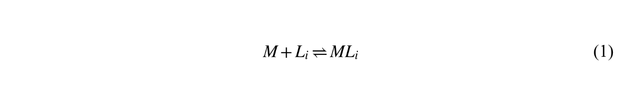
The stability constant for each complex is: $k = \frac{{[ML}_{i}]}{[M][L_{i}]}$, where brackets denote concentrations. The forward (association) rate constant is k_{f,i}, and the reverse (dissociation) rate constant is k_{d,i}:
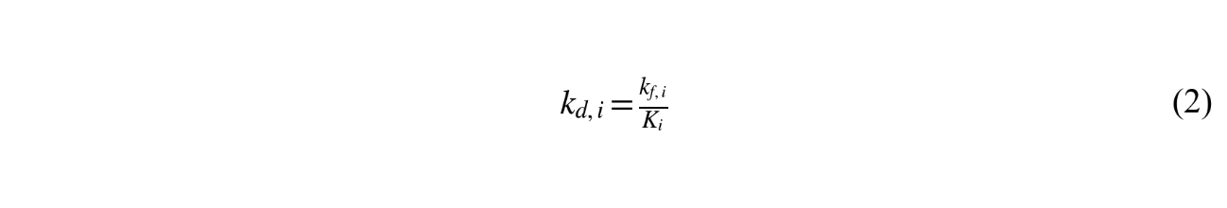
In natural systems, ligands exhibit a continuum of binding strengths, leading to a distribution of k_{d} values. We model this as a log-normal probability density function f(ln k_{d}), with mean μ and standard deviation σ (optimized via calibration).

S1.2. Dissociation in a Distributed System
For a single complex, the concentration of labile (free or rapidly dissociating) metal at time t is governed by first-order dissociation kinetics: $\frac{d[ML]}{dt}={-k}_{d}[ML]$, yielding ${[ML]}_{t}={[ML]}_{0}e^{{-k}_{d}t}$.
In the presence of a suitable sink (such as calcite), the remaining bound metal decreases exponentially, so the dissociated (labile) fraction increases as $1-e^{-k_{d}t}$. For the full distribution, the total concentration of dissociated metal C_{t} from an initial bound concentration C₀ is:
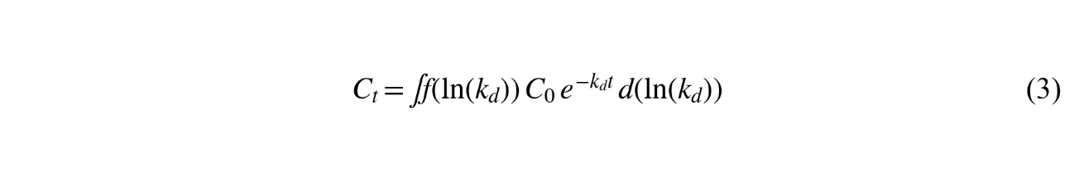
However, in dripwater, a small "fast" fraction (λ_{F} ≈ 0.001–0.01) of metals is inherently labile (e.g., free ions or very weak complexes), dissociating instantaneously; and a larger inert fraction (λ_{I} ≈ 0.4 for Co, λ_{I} ≈ 0.15 for Ni) ensures that labile concentrations asymptote as drip rates approach zero. Accordingly, the slow fraction is (1 – λ_{I} - λ_{F}). Thus, the total labile aqueous metal ${[X]}_{aq}^{la}$ at time t is:
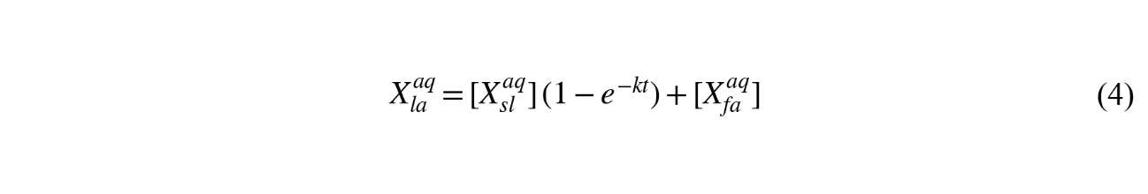where ${[X]}_{aq}^{sl}$is the slow (bound) fraction and ${[X]}_{fa}^{aq}$ is the fast fraction. Substituting the fractions in terms of total aqueous metal ${[X]}_{tot}^{aq}$:
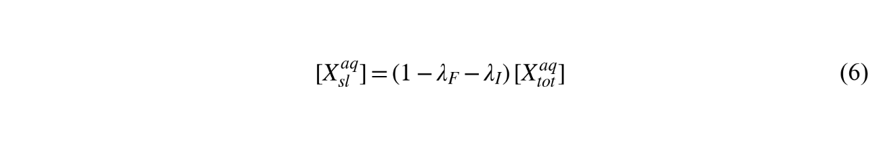
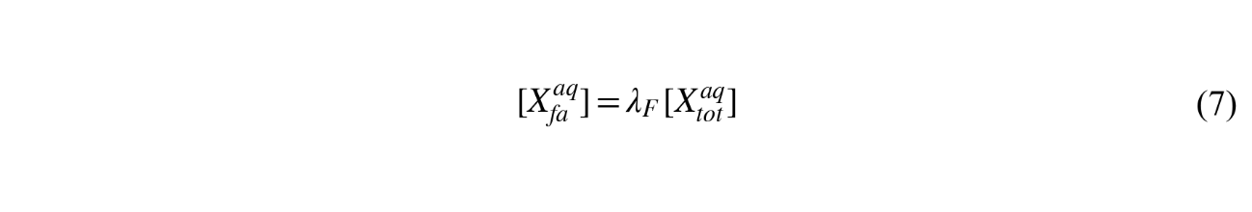
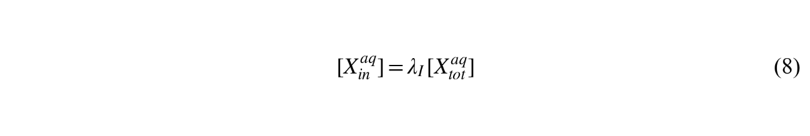
yields:
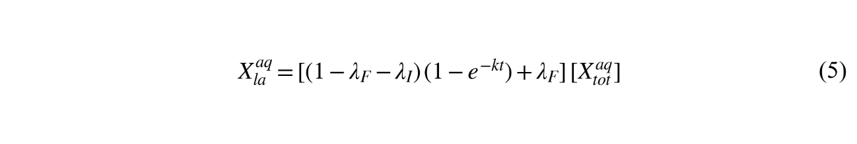
For the distributed case, replace the single exponential with the integral over the distribution.
S1.3. Linking to Drip Rate and Residence Time
In the thin water film on a growing stalagmite, the kinetic window for dissociation is approximated by the residence time τ in seconds (60/d, where d = drips per minute). If N drips occur over time t:
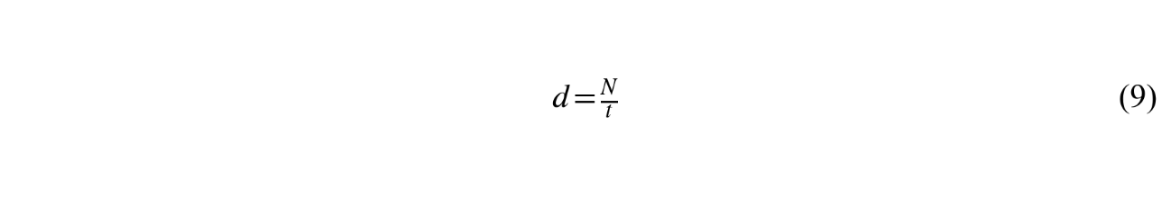
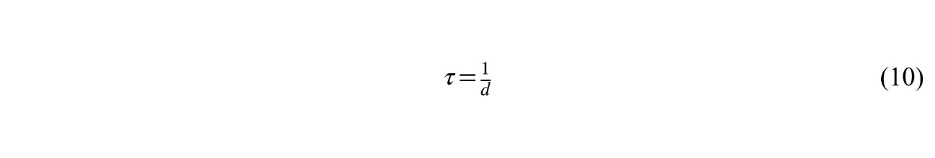
Substituting τ (x 60 s/min to have consistent units with k) for t in the labile equation:
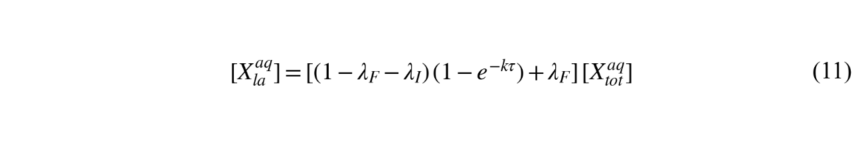
S1.4. Incorporation into Calcite
Labile metals partition into calcite with coefficient K_{p}:
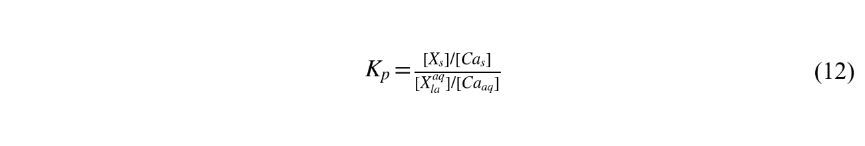where subscripts s and aq denote solid (stalagmite) and aqueous phases. Assuming [X_{aq}] ≈ ${[X]}_{la}^{aq}$ (labile fractions dominate incorporation) and constant [Ca_{s}] ≈ 1 (calcite CaCO₃ matrix), the stalagmite concentration [X_{s}] is:
This shows [X_{s}] as an inverse function of drip rate (via τ), sensitive at lower drip rates (τ large). The assumption that labile fractions dominate [X_{s}] holds if drip rates remain > 0.2 drips min⁻¹, as shown in Fig. 3 (drip rate sensitivity, main text). As rates approach zero, τ expands exponentially, and inert metal fractions become increasingly important but are assumed to have negligible relevance in this treatment, due to the much higher baseflow (median of 17 drips min⁻¹, 2004-2014) to HS4 (Fig. 2, main text).
S1.5. Inversion for Drip Rate
To reconstruct τ (or d = 1/τ) from measured [X_{s}], we invert Eq. (13) using Bayesian methods (detailed in Supp. Methods 2), yielding posteriors p(τ | [X_{s}]):
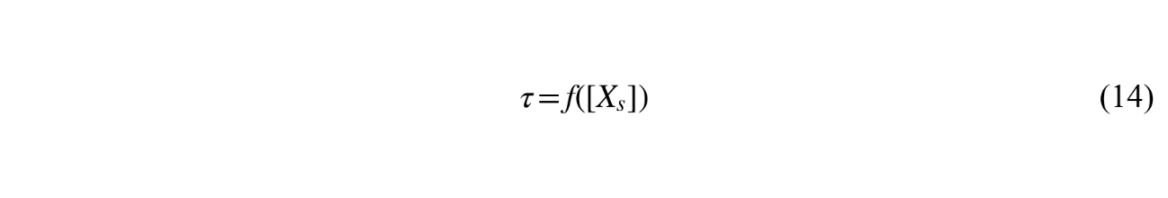
Assumptions include constant ${[X]}_{aq}^{tot}$, [Ca_{aq}], and K_{p}; sensitivities are tested in Supp. Methods 3.

Supplementary Methods 2: Numerical Integration of Dissociated Fraction
The integral in Eq. (13) represents the expected dissociated fraction over the log-normal distribution of dissociation rates:

The expectation E1 for dissociation is computed by numerical quadrature over the log-normal distribution of rate constants (see model.py, functions integrand_1 and expectation_1).
The full labile concentration computation adds λ_{I} and λ_{F}: f_{la} = λ_{F} + (1 - λ_{F} – λ_{I}) * f_{diss} (τ, m, s)
Infinite limits are handled by quad's adaptive algorithm; truncation (e.g., μ ± 5σ) yields similar results for efficiency.

Supplementary Methods 3: Data Filtering and Estimation (From drip_rate_util.py)
S3.1 Outlier detection and removal
Prior to Bayesian inversion, trace metal concentration series (Co, Ni) were screened for outliers using an adaptive modified Hampel filter with Pareto-based tail detection, implemented in the detect_outliers function of drip_rate_util.py. The procedure comprises four steps:
(1) Local anomaly scoring. For each data point, the absolute deviation from the local median is computed within a sliding window of size W (set by OUTLIER_WINDOW_SIZE in params.py) and scaled by the window’s median absolute deviation (MAD), yielding a dimensionless anomaly score. Where MAD falls below a zero-tolerance threshold (zero_tol = 10⁻³), the score is set to zero to avoid division by near-zero values. This step is implemented in the __like_hampel helper function.
(2) Distribution fitting. The anomaly scores are shifted by +1 (to permit logarithmic transformation), binned on a logarithmic scale using Doane’s formula for optimal bin count (__doane function), and a generalised Pareto distribution is fitted to the resulting sample via scipy.stats.pareto.fit.
(3) Tail detection. Histogram bins where the observed density exceeds the fitted Pareto probability density function by a factor ≥ pdf_tol (default = 10) are flagged as anomalous. This criterion identifies concentrations of data points in the distributional tails that are not explained by the expected heavy-tailed behaviour of the anomaly score distribution.
(4) Outlier identification. All data points whose anomaly scores fall within the flagged bins are returned as outlier indices and excluded from subsequent analysis. For the HS4 record, this procedure identified two outliers (Supplementary Fig. 4), which exhibited anomalous Co or Ni concentrations relative to their local neighbourhood and deviated from the expected exponential Co–Ni covariance relationship.
The approach is adaptive in two respects: the Hampel step adjusts to local variance structure along the record (avoiding fixed-threshold artefacts in non-stationary series), and the Pareto tail test uses the data’s own distributional properties to define the outlier criterion rather than an arbitrary cut-off. The window size W and tolerance parameters pdf_tol and zero_tol are configurable in params.py.
S3.2 Bayesian estimation of drip rates
Drip rates are estimated probabilistically from trace metal posteriors using Bayesian inversion. Proxy records (Co and Ni concentrations), after outlier removal (S3.1), are processed for age-depth uncertainties via BayProx, yielding PDFs at unified depths. Inversion solves the model equation for τ given observed [X_{s}], sampling from priors on parameters (μ, σ, λ_{F}).
The estimation algorithm (implemented in drip_rate_util.py, functions driprates and get_proxy_percentile) proceeds as follows: for each age horizon, the proxy posterior PDF is transformed through the inverse of the forward model to yield a drip rate posterior, sampled across the full parameter uncertainty space.

Supplementary Methods 4: Sensitivity (Varying λ_{F} in model.dr_pdfseries)
To assess robustness, we varied λ_{F} (fast fraction, base 0.001) from 0.0001 to 0.01 in the model (dr_pdfseries function), recomputing drip rate PDFs for HS4. Lower λ_{F} increases sensitivity at slow drips (d < 5 min⁻¹), amplifying aridity signals (e.g., the 5.2 kyr pulse deepens ~10%). Higher λ_{F} dampens response, widening uncertainties in wet periods. Speciation analysis on transition metal DOM complexes (Hartland & Zitoun, 2018) demonstrate the dominant binding of trace-level transition metal ions in dripwater, such that an assumed λ_{F =} 0.01 is likely very conservative.
Supplementary Figure 1 shows the impact of these variations on the labile fraction and Holocene drip rate reconstruction.
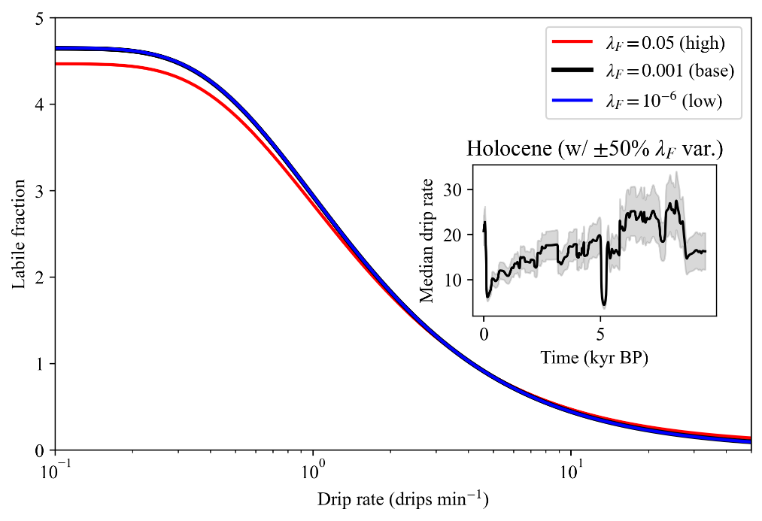
Supplementary Figure 1 | Sensitivity of the labile fraction to λ_{F} variation. Main plot: Labile fraction (y-axis, 0–5) versus drip rate (drips min⁻¹, x-axis, log scale 0.1–50) for λ_{F} = 0.001 (base, black), λ_{F} = 10⁻⁶ (low, blue), and λ_{F} = 0.05 (high, red), showing increased sensitivity at low drip rates for lower λ_{F} and dampened response for higher λ_{F}. Inset: Holocene median drip rate (drips min⁻¹) over time (kyr BP), with gray shading indicating ±50% λ_{F} variation (widening ~15–25% at minima), derived from HS4 data in ProxyRecordPlot.xlsx.
Supplementary Methods 5: Precipitation Reconstruction via Chained Regressions and Monte Carlo Propagation
This section details the chained regression approach to derive quantitative annual precipitation (P, in mm yr⁻¹) from reconstructed drip rates, incorporating temperature (T) estimates and propagating uncertainties via Monte Carlo sampling. Drip rates are first linked to P/T ratios using site-specific (Heshang Cave) and regional (Yichang meteorological) regressions, then multiplied by T (from bacterial 3-hydroxy fatty acids in stalagmite HS4, with a RMSE = 2.6°C) and annualized (×365.25). Uncertainties arise from i) drip rate posteriors (log-normal distributions fitted to medians and 25–75th percentiles); ii) regression coefficients and residuals (normal distributions based on fit statistics); and iii) T (normal distribution with SD = 2.6°C). For each age horizon (73–8807 BP, interpolated to RAN-15 T ages), N = 10,000 samples are drawn to compute posteriors, yielding medians and 25–75th percentiles for P.
Regression parameters (optimized from 2005–2015 cave monitoring / Yichang data) are provided in Supp. Table S2; with means and SDs for Monte Carlo sampling. The process interpolates drip rates to T ages, fits log-normal distributions to drip medians/quartiles, samples parameters, and computes:
P/T_{h} = a_{h} * drip + b_{h} + resid_{h} (clipped ≥0),
P/T_{y} = a_{y} * P/T_{h} + b_{y} + resid_{y}, then P_{daily} = P/T_{y} * T, and
P_{annual} = P_{daily} * 365.25.
Outputs are stored as CSV (e.g., p_reconstruction.csv) with age, P_{med}, P_{pc25}, P_{pc75}.
The full implementation, including Monte Carlo sampling and interpolation, is provided in P_quantification_Holocene.ipynb in the repository.

Supplementary Methods 6: Recurrence Quantification Analysis
S6.1 Conceptual approach
Recurrence Quantification Analysis (RQA) characterises the recurrence structure of dynamical systems from time series data. Here, RQA is applied to two proxy records from stalagmite HS4: the oxygen isotope (δ¹⁸O) series from Hu et al.² and the drip rate series derived from our kinetic proxy (based on trace metals Co and Ni). By examining repeating patterns in these records, RQA helps identify stable climate periods, abrupt changes, or transitions in the East Asian Summer Monsoon (EASM) over the Holocene. This approach reveals the underlying dynamics of the climate system, such as whether monsoon rainfall followed regular cycles or experienced sudden disruptions, providing insights into past climate stability and variability.
S6.2 Methodology
The δ¹⁸O and drip rate time series were normalised and embedded in phase space using a time delay τ = 1 and embedding dimension m = 5, both estimated globally from each proxy's full median time series via the average mutual information function³ and Cao’s method⁴, respectively. A recurrence threshold was set by fixing the recurrence rate at RR = 0.05 ⁵, ensuring comparability across windows independent of signal amplitude. A Theiler window of w = τ(m−1) = 4 excluded autocorrelated neighbours along the line of identity ⁶. Two metrics were derived: Determinism (DET), measuring the fraction of recurrence points on diagonal lines of length ≥ 2; and Transitivity (TRANS), the recurrence network clustering coefficient ⁷. RQA was computed in a sliding window of 100 points (step 5 points) over 1,000 Monte Carlo proxy realisations; ensemble medians and 5th/95th percentile envelopes are reported. Gaussian smoothing (σ = 2 window steps) was applied to ensemble statistics for display.
S6.3 Determinism (DET)
This measures the fraction of recurring points that form diagonal lines of two or more points in the recurrence plot, relative to all recurring points (excluding the main diagonal). DET indicates how predictable the climate system is. High DET values (close to 1) suggest stable, repeating climate patterns, such as consistent monsoon rainfall cycles driven by predictable forcings like orbital changes. Low DET values (close to 0) indicate irregular or chaotic climate behaviour, often linked to abrupt events like droughts or monsoon weakenings, such as the 5.2 ka aridity pulse.
S6.4 Transitivity (TRANS)
This measures the connectedness of recurring climate states, calculated as three times the number of triangle shapes formed by connected points in the recurrence plot, divided by the total number of point triplets. In paleoclimate terms, TRANS reflects how tightly linked climate states are over time. High TRANS values indicate a climate system with strong, consistent connections, such as stable monsoon dynamics. Low TRANS values suggest fragmented or rapidly shifting climate states, often associated with disruptions like volcanic events or teleconnections affecting monsoon intensity.
Dashed vertical lines in Extended Data Fig. 2 mark positive TRANS excursions above 0.5 in the drip rate record, placed at the peak age within each excursion. A dotted horizontal line shows the ensemble mean TRANS for reference. DET remains persistently elevated (~0.75) throughout both proxy records, reflecting stable orbital-scale forcing. Positive TRANS excursions — most prominently at ~5.2 ka — are absent from the δ¹⁸O record, confirming a dynamical signature specific to the directly hydrological kinetic proxy. The full ensemble RQA metrics (DET and TRANS with 5th–95th percentile uncertainty envelopes) and normalised probability density functions for both proxy records are presented in Extended Data Fig. 2.

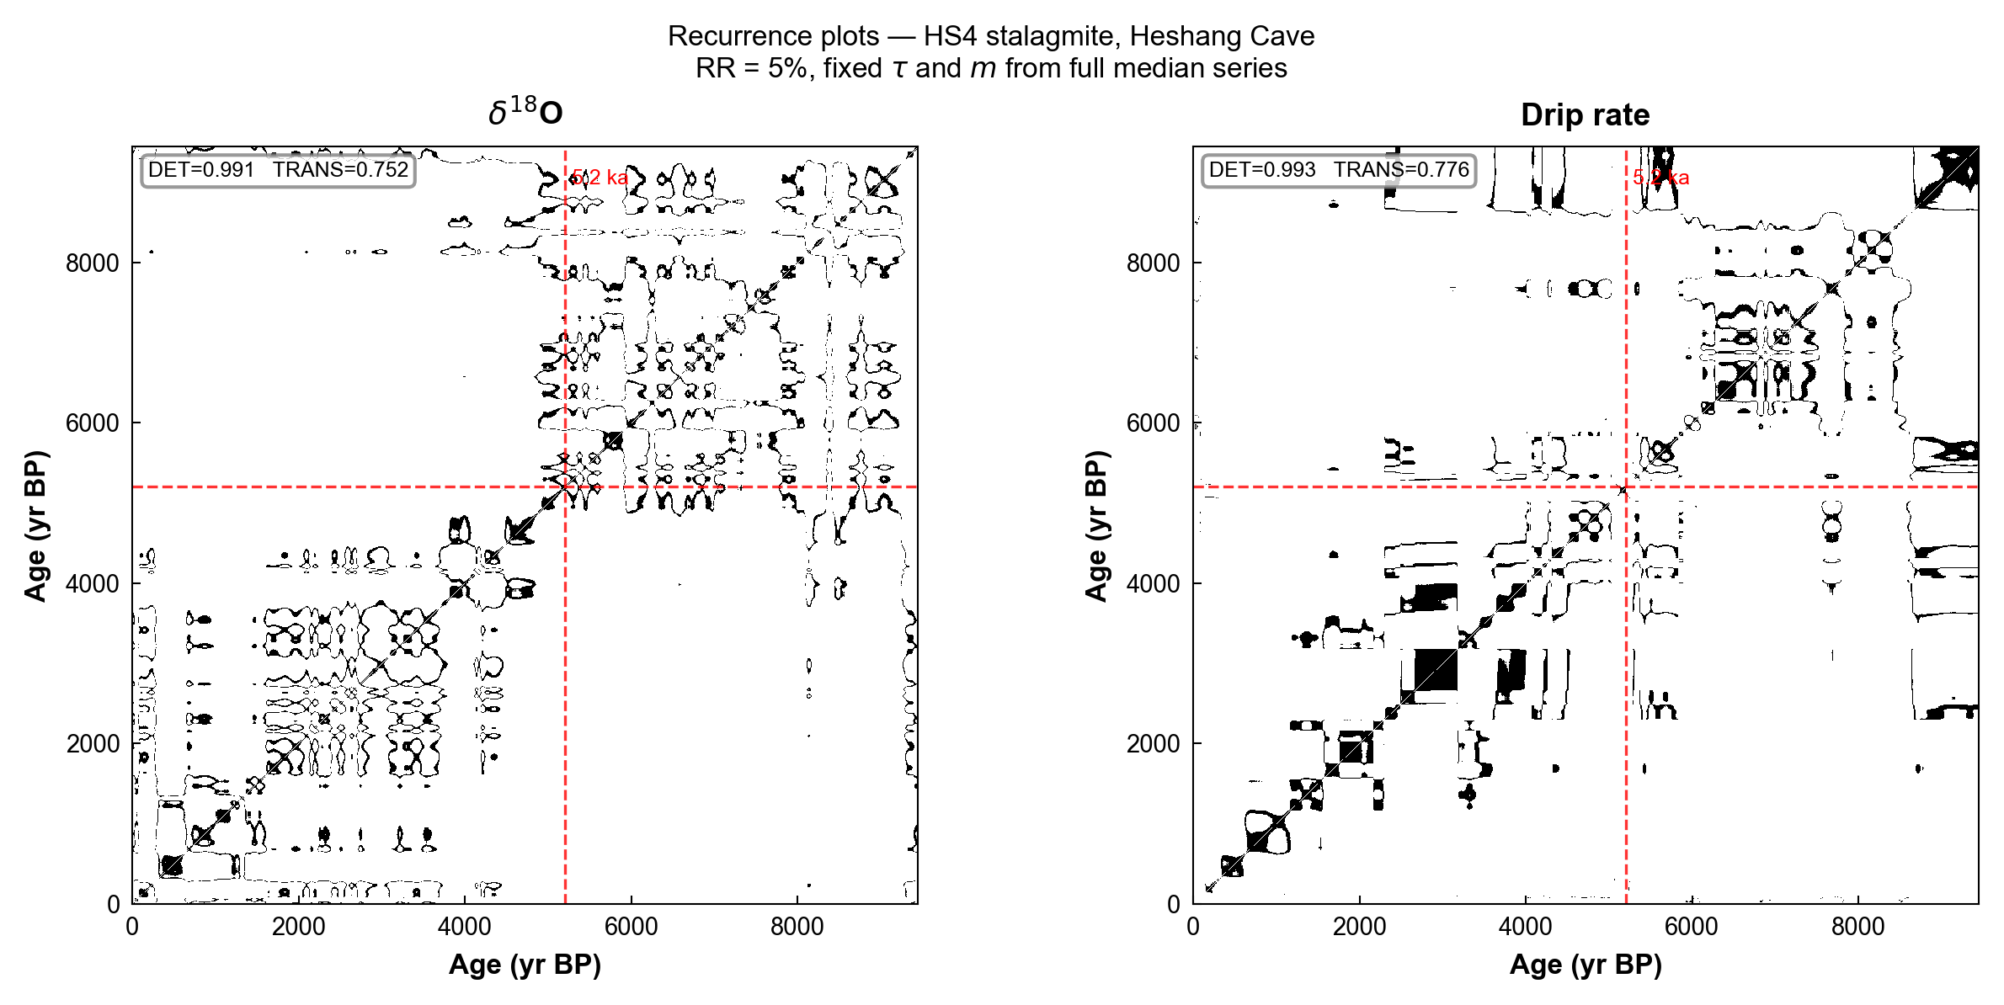
Supplementary Figure 2 | Recurrence plots for the HS4 stalagmite, Heshang Cave. Recurrence matrices are generated from the median series of the δ¹⁸O (left panel) and drip rate (right panel) realisations. The plots are constructed using a fixed time delay (τ) and embedding dimension (m) derived from the full median series, with a target recurrence rate (RR) threshold of 5%. The red dashed lines highlight a specific age marker at 5200 yr BP (5.2 ka). Overall Determinism (DET) and Transitivity (TRANS) values calculated for each complete series are annotated in the top left corner of their respective panels.

Supplementary Methods 7: Statistical Tests for Event Significance and Holocene Stationarity
S7.1 Overview
Five statistical tests were applied to the HS4 drip rate reconstruction to formalise event significance and assess Holocene stationarity. All tests were performed on 1,000 Monte Carlo age-model realisations (9,551 age points, −51 to 9,499 yr BP) as well as on the full-posterior summary (median, 25th and 75th percentiles). Two-sample tests pool all realisation values within each age window; per-realisation Mann–Whitney U (MWU) tests are additionally run across all 1,000 realisations individually to assess robustness to age-model uncertainty. Effect sizes are reported as rank-biserial r (|r| > 0.3 moderate, > 0.5 large). Bootstrap 95% confidence intervals on the difference in medians (10,000 iterations, subsampled to n = 50,000 per group where pool sizes exceed this threshold) are provided for each comparison. All code is available at the repository listed above (drip_rate_stationarity_tests.py).
S7.2 Test 1: 5.2 ka Aridity Pulse
The pre-event background (5,500–6,500 BP; n = 1,001 full-posterior points) has a median of 21.18 drips min⁻¹ (IQR 19.66–22.41). The event minimum window (4,600–4,700 BP) has a full-posterior IQR of 17.52–19.60 drips min⁻¹, lying entirely below the background IQR (event p75 is 0.06 drips min⁻¹ below background p25), confirming strong separation without IQR overlap. Pooling all realisation values, MWU and KS tests comparing the background (5,500–6,500 BP) with the broader event window (4,500–5,200 BP) yield U = 5.03 × 10¹¹, p < 0.001, KS D = 0.459, p < 0.001, rank-biserial r = −0.434 (moderate-to-large effect), and a bootstrap median difference of −3.02 drips min⁻¹ (95% CI −3.10 to −2.88). All 1,000 per-realisation MWU tests return p < 0.05 (fraction = 1.00), confirming that the event minimum is robustly below the background across the full age-model ensemble.
S7.3 Test 2: 8.2 ka Anomaly
Contrary to a null expectation of stationarity, the 8.2 ka event window (8,000–8,500 BP) shows a large positive drip-rate anomaly relative to the pre-event reference period (9,000–9,500 BP). The pre-event median is 16.19 drips min⁻¹ (IQR 15.66–16.63) and the event median is 25.44 drips min⁻¹ (IQR 24.42–26.41); the full-posterior IQRs are entirely non-overlapping, with a separation of 12.32 drips min⁻¹ between event p25 and pre-event p75. Pooled MWU and KS tests confirm complete distributional separation (KS D = 1.000, p < 0.001; rank-biserial r = 1.000), with a bootstrap median difference of +9.00 drips min⁻¹ (95% CI 8.98–9.02). The post-event window (7,500–8,000 BP; median 22.02 drips min⁻¹) also differs significantly from the event window (KS D = 0.472, p < 0.001; r = 0.545), indicating that drip rates were elevated during and immediately after the canonical 8.2 ka interval relative to both the preceding baseline and subsequent levels. All 1,000 per-realisation MWU tests (pre-event vs. event) return p < 0.05 (fraction = 1.00).
On the best-estimate (depth-only) chronology using native analytical resolution (n = 82 points in the 7,500–9,500 yr BP range; median spacing 20.8 yr), a local flanking-baseline test yields a non-significant difference: event core (8,100–8,250 yr BP; n = 6, median = 20.67 drips min⁻¹) versus combined pre- and post-event flanks (8,280–8,500 and 7,900–8,100 yr BP; n = 21, median = 21.10 drips min⁻¹), Δ = −0.44 drips min⁻¹ (−2.1%), Mann–Whitney U p = 0.59, rank-biserial r = −0.16. The broader positive anomaly relative to the early-Holocene baseline (8,800–9,300 yr BP) is attributable to the secular insolation-driven trend (0.94 drips min⁻¹ kyr⁻¹, r² = 0.18) rather than an event-specific perturbation.
S7.4 Test 3: Post-1800 CE Precipitation Surge
The late-Holocene baseline (500–2,000 BP) has a median of 12.78 drips min⁻¹ (IQR 11.74–13.37). The post-1800 CE window (−400 to 50 BP; n = 102 full-posterior points) has a median of 20.39 drips min⁻¹ and a full-posterior IQR of 8.31–32.56, which overlaps the baseline IQR due to wide uncertainty in the most recent interval. Nonetheless, pooled MWU and KS tests strongly reject the null of equal distributions (KS D = 0.726, p < 0.001; rank-biserial r = 0.599, large effect), with a bootstrap median difference of +7.54 drips min⁻¹ (95% CI 7.41–7.63). All 1,000 per-realisation MWU tests return p < 0.05 (fraction = 1.00).

S7.5 Test 4: Long-term Holocene Trend
Mann–Kendall trend analysis of the full-posterior median series (n = 9,551; −51 to 9,499 yr BP) yields τ = 0.505, Z = 74.05, p < 0.001, confirming a significant positive trend (older ages = higher drip rates, consistent with Holocene drying). The Theil–Sen median slope is +1.386 drips min⁻¹ kyr⁻¹, implying a total decline of 13.24 drips min⁻¹ over the 9,550-year record. Per-realisation Mann–Kendall tests (n = 1,000 realisations) return a median τ = 0.505 and a median p < 0.001, with 100% of realisations yielding p < 0.05. Early Holocene (5,500–6,500 BP) versus late Holocene (0–2,000 BP) comparison confirms the magnitude: MWU p < 0.001, KS p < 0.001, bootstrap median difference = −8.40 drips min⁻¹.
S7.6 Test 5: Augmented Dickey–Fuller Stationarity
An Augmented Dickey–Fuller (ADF) test was applied to the full-posterior median series to assess whether drip rates exhibit a random-walk (stochastic) unit root or are instead trend-stationary. The ADF tests for a unit root null hypothesis; rejection indicates the series does not follow a random walk. Given the orbitally forced Holocene decline evident in both the drip rate and Mann–Kendall results, the series is expected to be trend-stationary rather than difference-stationary. ADF results are reported with lag selection via AIC; critical values at the 1%, 5%, and 10% levels are provided. A p-value < 0.05 supports rejection of the unit-root null, consistent with a trend-stationary series physically expected for an orbitally forced climate record.
S7.7 Effect of age-model uncertainty on event amplitude
To assess the degree to which age-model uncertainty attenuates abrupt events in the reconstruction, we re-ran the kinetic proxy inversion without propagating age-model error — that is, using the single best-estimate age–depth function rather than the full 1,000-realisation Monte Carlo ensemble. The resulting record (Extended Data Fig. 3) reveals that the 5.2 ka aridity pulse is far more extreme than the age-propagated reconstruction indicates. Without age smoothing, median drip rates collapse to ~1.7 drips min⁻¹ at 5.134 ka — a 94% reduction from the mid-Holocene mean (26.6 drips min⁻¹) — with an extraordinarily tight interquartile range (1.63–1.71 drips min⁻¹), indicating high model confidence in a near-complete cessation of drip flow. The event is confined to approximately two sampling points (~60 years), with full recovery to ~21 drips min⁻¹ within one additional sample. The ~40% departure reported in the main text (Section 3, Fig. 5) is therefore an age-smoothed lower bound on the true event amplitude: the underlying signal approaches total monsoon failure at this site.
This finding has two implications. First, it substantially widens the discrepancy between observed and modelled event amplitudes: PMIP4 simulations capture only ~10% drying at 6 ka, whereas the underlying proxy signal implies ~94% — an order-of-magnitude mismatch that reinforces the case for missing feedback mechanisms (dust–vegetation, land-surface) in current Earth system models. Second, it demonstrates that age-model uncertainty is the dominant smoothing agent for abrupt events in this reconstruction, not proxy insensitivity or model inadequacy. The kinetic proxy itself resolves the event at full amplitude; it is the convolution with age uncertainty that attenuates it. This suggests that paired analyses — with and without age propagation — should be reported routinely for speleothem proxy reconstructions to distinguish genuine signal attenuation from methodological smoothing.
The 8.2 ka positive anomaly is also amplified without age smoothing, reaching 30.7 drips min⁻¹ (1.4× the pre-event baseline of 21.4 drips min⁻¹), compared with ~25 drips min⁻¹ in the age-propagated version. The post-1800 surge peaks at 38.7 drips min⁻¹ (2.4× the late-Holocene baseline), consistent with the age-propagated result (~2.5×) but with tighter uncertainty bounds.
A further feature resolved by the no-age-error reconstruction is a sustained drought immediately preceding the post-1800 intensification. Drip rates fell to ~4.5 drips min⁻¹ at approximately 1737 CE (213 yr BP) and remained suppressed (~4.6 drips min⁻¹ at 180 yr BP / ~1770 CE), representing a 72% reduction from the late-Holocene baseline (16.4 drips min⁻¹) sustained across two consecutive sampling points (~60 years). This event coincides with the 1720–1740 severe drought period identified by Zheng et al.⁸ as one of six major drought episodes in the Qing dynasty, and with the extreme 1784–1787 drought that affected Hubei and the middle and lower Yangtze basin (He et al.⁹; Yin et al.¹⁰). Hanjiang River Basin reconstructions note a conspicuous absence of extreme flood events during 1750–1810 (Yin et al.¹⁰), consistent with the sustained aridity recorded by the kinetic proxy. The recovery from this drought is explosive: drip rates surge to 38.7 drips min⁻¹ (~1803 CE), the highest sustained value in the Holocene record, marking the onset of the post-1800 anthropogenic intensification. The drought-to-surge transition spans a single sampling interval, reinforcing the interpretation that the post-1800 signal is not a gradual orbital or natural recovery but a forced step-change in the hydrological regime (Extended Data Fig. 3C). The full no-age-error reconstruction is shown in Extended Data Fig. 3.

Supplementary Methods 8: Framework for Extension and Verification of the Kinetic Proxy
The kinetic proxy framework is extensible to trace elements beyond Co and Ni (e.g., Cu, Zn) through reconstructed drip rates, multi-element Bayesian inference, and stable isotope systems. The following approaches draw on established geochemical techniques for parameter estimation and stable isotope analysis.
S8.1 Drip Rate Reconstructions for Additional Metals with Unknown Parameters
Drip residence times (τ) reconstructed from calibrated metals (e.g., Co or Ni with known dissociation rate distributions f(ln k_{d}), fast/inert fractions λ_{F}/λ_{I}, and partition coefficients K_{p}) can be used to derive parameters for additional metals where k_{d} or K_{p} are unknown. Assuming total aqueous concentrations [$X_{tot}^{aq}$] and [Ca_{aq}] are constrained (e.g., from monitoring), Eq. 13 can be rearranged.
For unknown K_{p} (assuming k_{d} distribution known):
where k is the mean dissociation rate from the log-normal distribution.
For unknown k (mean k_{d}, assuming K_{p} known):
These enable parameter estimation for elements like Cu or Zn, which form organic complexes with log-normal k_{d} distributions similar to Co/Ni ¹¹.
Verification involves comparing derived values against laboratory kinetics measured by competitive ligand exchange (CLE¹¹), CLE-adsorptive cathodic stripping voltammetry (CLE-AdCSV) or diffusive gradients in thin films (DGT). Modern cave monitoring with paired drip rate and multi-element data can test consistency across metals.
S8.2 Constraining Reconstructions via Multi-Element Bayesian Inference
Incorporating multiple metals refines τ estimates by computing joint posterior probabilities, reducing uncertainty from individual proxies. In the Bayesian inversion (as in drip_rate_util.py), the likelihood becomes the product over n metals:
where P(X_{i} | τ) is Gaussian around predicted [X_{s}] from Eq. 13 for each metal i, with priors P(τ) from monitoring or models. This joint approach, implemented in libraries like PyMC, leverages complementary k_{d} ranges (e.g., slower for Cu than Ni;¹¹) for robust constraints, as shown in multi-proxy speleothem hydrology studies ¹².
S8.3 Evaluating Kinetic Isotope Fractionation Using Stable Metal Isotopes
Stable isotopes of metals, such as nickel (δ⁶⁰Ni) or copper (δ⁶⁵Cu), are suitable targets for the study of non-equilibrium fractionation during the dissociation of organic-metal complexes (OMCs) or incorporation into calcite. Mass-dependent kinetic effects enrich lighter isotopes in the labile (free or loosely bound) pool, influenced by the residence time (τ) of dripwater at the stalagmite surface. A simplified model for the isotopic evolution of the labile pool is:
where:
- $δ_{labile}^{M}$: Isotopic composition of the labile pool for metal (M) (e.g., Ni or Cu, in per mil, (‰)).
- $δ_{0}^{M}$: Initial isotopic composition of the metal in the system.
- e: Equilibrium fractionation offset (in (‰)), accounting for isotopic differences between phases at equilibrium (e.g., during calcite incorporation).
- (a_{k}): Kinetic fractionation factor (a_{k} < 1), defined as the ratio of rate constants for lighter to heavier isotopes during OMC dissociation.
- (f): Fraction of the metal dissociated from OMC into the labile pool.
- (ln (1 - f)): Natural logarithm of the remaining (undissociated) fraction, reflecting the progress of dissociation.
High-precision measurements using multi-collector inductively coupled plasma mass spectrometry (MC-ICP-MS) on stalagmite samples are expected to enable correlation of the isotopic composition (dM) with reconstructed residence time (t) to quantify kinetic fractionation biases (Supp. Fig. 4). These measurements would help distinguish kinetic effects (favoring lighter isotopes in the labile pool) from equilibrium processes, providing insights into paleoenvironmental conditions or mineral formation dynamics.
S8.4 Prior Carbonate Precipitation Effects on Metal Signatures
Prior carbonate precipitation (PCP) affects trace metals during carbonate precipitation, but is counteracted by OMC formation, which limits the labile metal pool for co-precipitation in the carbonate. However, this process preferentially removes calcium and trace metals with high distribution coefficients (K_{p}), altering the metal/Ca ratios in the remaining solution. For metals with high K_{p} values in calcite, such as copper (K_{p} ≈ 44¹³), PCP results in pronounced depletion in the dripwater metal concentration under inorganic conditions, as these metals are readily incorporated into the precipitating calcite, although this effect is ameliorated where OMC are present¹³.
However, the PCP overprint can mask or confound signals related to OMC dissociation, where organic ligands stabilize metals in solution and modulate their availability for incorporation. Consequently, metals with high K_{p} in each CaCO₃ polymorph likely have limited applicability as direct proxies for drip rate or hydrological variability, as their concentrations and isotopic signatures (e.g., δ⁶⁵Cu) in speleothems may primarily reflect PCP intensity rather than dissociation kinetics. This rationale explains the choice of metals for drip rate reconstruction in the present study (Co and Ni K_{p} ≈4 and 1, respectively), with Ni having the ideal characteristics for a drip rate proxy given its tendency to form OMC and identical partitioning behavior to Ca²⁺ in the calcitic HS4 stalagmite. Furthermore, nickel’s comparative abundance (low ppb range) in dripwater and availability of stable isotopes make it an ideal target for further study in calcite speleothems.
For metals with high partition coefficients and stable isotopes such as Cu, to accurately interpret concentration and isotopic signals in speleothems, integrated modelling of both OMC dissociation (which controls metal release and complexation) and PCP effects is essential, particularly for metals like Cu, where high K_{p} in calcite likely amplifies the influence of PCP on final speleothem compositions. This dual-process approach would allow for disentanglement of hydrological drivers from PCP-driven fractionation, enhancing the reliability of paleoclimate reconstructions from speleothem archives.
S8.5 Implications for Clumped Isotope Signals in Stalagmites
Additionally, kinetic disequilibria may indirectly influence carbonate clumped isotopes (Δ₄₇), as growth rate (linked to τ) modulates deviations from equilibrium via DIC speciation or pH gradients^{14,15}. Empirical studies show Δ₄₇ decreases with faster chemical rates¹⁶ but higher drip rates may limit the degree of isotopic distillation and CaCO₃-DIC fractionation. Via dissociation kinetics as a proxy of thin-film residence time it may be possible to correct negative offsets in Δ47 or targeted sampling for periods of higher dripping, though direct tests via paired Δ₄₇ and trace metal analyses will be required¹⁷.
These recommended methods provide a framework for multi-proxy integration, validation and expansion.

Supplementary Methods 9: Reconstructing Trace Metal Stoichiometry from Metal Pairs
Trace metal stoichiometry in speleothem calcite, particularly ratios of metals originating from OMCs (e.g., Co/Ni, Cu/Ni), can potentially serve as proxies for dissolved organic matter (DOM) quality and flux, reflecting variations in organic ligand composition and transport modes in karst systems¹⁸. This approach leverages the differential binding affinities of metals to heterogeneous DOM, where stronger binders like Cu or Pb preferentially associate with high molecular weight, aromatic DOM, being mobilised during soil flushing events, while weaker binders (e.g., Ni, Co) may show greater consistency via their association with lower molecular weight, hydrophilic DOM (Hartland¹⁹). In shallow caves or sites dominated by fracture flow, rapid infiltration may mobilise aromatic, hydrophobic DOM, altering metal ratios as indicators of hydrological intensity and soil disturbance, with potential to be captured by speleothems.
To reconstruct aqueous stoichiometry ($[X_{tot}^{aq}$] ratios), it is necessary to combine kinetic drip rate (τ) estimates with speleothem metal concentrations ([X_{s}]). Rearrange Eq. 13 for each metal:
where the bracketed term is the labile fraction. For a metal pair (e.g., Cu/Zn), the aqueous stoichiometry is:

assuming constant [Ca_{aq}] (e.g., from monitoring; Table S1) and metal-specific parameters (k_{d}, K_{p}, λ_{F}/λ_{I}) for generic metals M₁ and M₂. Deviations from binding ratios characteristic of humic/fulvic acids and empirical data from soil extractions may be a useful indicator of soil processes or surface disturbances. This method, may enable paleoenvironmental insights into DOM fluxes, complementing biomarker studies (Blyth et al.¹⁸) or assist in characterising OMC characteristics over time¹².
To avoid circularity in the reconstruction of aqueous metal stoichiometry, drip rates (τ) must be derived from an independent pair of metals (e.g., use Co/Ni-derived τ to reconstruct Cu/Zn stoichiometry, or vice versa). This ensures the kinetic window (τ) is decoupled from the target pair, leveraging complementary dissociation kinetics across metals for more robust, non-interdependent estimates.
Supplementary Methods 10: Generalisation Beyond Stalagmite Drip Rates
Although demonstrated here for stalagmite drip rates, the OMC dissociation framework is applicable wherever organic ligands form kinetically restricted complexes with trace metals in aqueous solution and a mineral phase records the resulting labile metal pool. This section outlines the broader scope of potential applications.
S10.1 Carbonate depositional settings
Within speleothem science, the residence time τ takes different physical forms depending on the depositional geometry. For stalagmites, τ is the drip interval (seconds between successive drips onto the growth surface). For stalactites (soda-straws and curtains), τ corresponds to the film migration time along the outer surface. For flowstones, τ is the sheet-flow residence time across the precipitation surface. In each case, the forward model (Eq. 13) applies directly with τ redefined accordingly. Beyond vadose cave carbonates, the framework extends to sub-aqueous settings: lacustrine tufas, pool deposits, and submarine cements, where τ corresponds to the boundary-layer equilibration time between the bulk fluid and the growing mineral surface. At still longer timescales, bulk fluid residence time in a cave pool or lake provides a volumetric flow proxy (e.g. m³ yr⁻¹ via a calibrated reservoir volume).
Importantly, the OMC dissociation kinetics that underpin the proxy are aqueous-phase processes: the rate at which metal–organic complexes release labile metal ions is governed by the thin-film residence time τ, not by the mineralogy of the precipitating phase. The forward model (Eq. 13) therefore applies equally to calcite and aragonite speleothems. What does differ between polymorphs is the partition coefficient K_{p}: the 9-fold Ca coordination in aragonite versus 6-fold in calcite produces systematically different trace metal substitution behaviour, so that K_{p} values for Co and Ni will require polymorph-specific experimental calibration before the proxy can be applied to aragonitic archives. For mixed-mineralogy stalagmites, XRD characterisation of the precipitating phase at each sampling interval would be needed to assign appropriate K_{p} values. HS4 is calcite throughout, so this consideration does not affect the present reconstruction. We also note that prior carbonate precipitation (PCP) effects on trace metal signatures will differ between calcite and aragonite due to contrasting crystal-chemical controls on cation substitution; any extension of the framework to aragonitic or mixed-mineralogy stalagmites should account for polymorph-specific PCP behaviour.
S10.2 Beyond carbonates
Organic ligands forming kinetically inert metal complexes are present in virtually all natural waters, not only in organic-rich settings. Even at dissolved organic carbon concentrations of 1–2 mg L⁻¹, the carboxyl site density of aquatic DOM (~5–10 meq g⁻¹ C for fulvic acids) provides micromolar complexation capacity — orders of magnitude above the nanomolar concentrations typical of dissolved transition metals. OMC formation is therefore expected across rivers, lakes, estuaries, groundwater, soils, ocean margins, and hydrothermal systems. Any mineral phase incorporating trace metals from such waters is a potential recorder of fluid residence time, provided that OMC dissociation is slow enough relative to fluid turnover to produce a measurable kinetic signal. Where dissociation reaches secular equilibrium (i.e. all labile metal is released before the next fluid replacement), the method still resolves a minimum τ (maximum flow rate), providing a one-sided bound analogous to radiocarbon beyond its dating range. The only fundamental requirement is a mineral archive that records the labile metal fraction with a known or calibratable partition coefficient.
S10.3 Toward absolute paleohydrology
More broadly, the OMC dissociation framework extends paleohydrology from relative proxy interpretation into the domain of absolute physical measurement. The analogy with geochronology is instructive: radiometric decay provides an absolute clock because it rests on a rate law with known parameters operating over a measurable timescale, recorded in a datable mineral archive. OMC dissociation kinetics provide an absolute flowmeter on the same basis — a first-order rate law with independently measurable parameters (dissociation rate constants, partition coefficients, speciation fractions), operating over a residence time recorded in a datable mineral. Both methods yield unit-bearing quantities (years; drips min⁻¹ or mL min⁻¹) rather than dimensionless indices, enabling direct comparison across archives, sites, and models. An open-source web application implementing the full forward and inverse model is provided at the code repository (see Data Availability) to facilitate adoption and testing of this framework across depositional settings.

Supplementary Methods 11: Sensitivity to Aqueous Concentration Uncertainty
S11.1 Covariance structure of monitored aqueous concentrations
From n = 92 paired dripwater analyses spanning 2007–2016 (~10.8 samples yr⁻¹), we computed the Pearson correlation matrix for Ca, Co, and Ni. Ca is effectively uncorrelated with both trace metals: r(Ca, Co) = +0.08; r(Ca, Ni) = −0.09. This is expected: Ca is buffered by the carbonate dissolution–precipitation equilibrium, while Co and Ni variability is governed by organic complexation dynamics and redox. The moderate Co–Ni correlation (r = +0.60) reflects their shared OMC speciation. Because r(Ca, TE) ≈ 0, independent Monte Carlo sampling correctly represents the covariance structure. Paired bootstrap resampling of actual (Ca, TE) measurement pairs produces essentially identical K₀ variance: CV(Co/Ca) = 15.8% paired vs 17.4% independent; CV(Ni/Ca) = 27.7% vs 28.8%.
S11.2 Integration time and effective concentration uncertainty
Each milled powder ICP-MS measurement integrates all calcite deposited within the sampling interval. At the HS4 growth rate (~26 µm yr⁻¹ from 260 mm over ~10,000 years), each sample integrates approximately 25 years of deposition. During this interval, the drip water chemistry cycles through ~270 independent observations (25 yr × 10.8 samples yr⁻¹). By the central limit theorem, the effective standard deviation of the time-averaged concentration is: σ_{eff} = σ_{monitoring} / √(T × f_{s}), where T is the integration time (yr) and f_{s} is the monitoring sampling frequency (yr⁻¹).
For T = 25 yr: Ca effective SD = 0.24 ppm (CV 0.36%, vs monitoring 6.0%); Co effective SD = 0.005 ppb (CV 0.97%, vs 16.0%); Ni effective SD = 0.072 ppb (CV 1.67%, vs 27.4%). At these effective CVs, the corresponding log-normal prior widths are σ_{ln} < 0.02 for all components — the priors are effectively delta functions, and stochastic marginalisation produces results indistinguishable from the fixed-concentration baseline.
S11.3 Demonstration: effect of naive monitoring-scale standard deviations
To illustrate the consequences of neglecting the integration-time correction, we ran four reconstructions using the raw monitoring standard deviations as if they represented the uncertainty of each speleothem measurement: (1) all concentrations fixed at means (baseline); (2) Ca stochastic (σ = 3.98 ppm, CV 6%); (3) Ca and Co stochastic; (4) all three stochastic. The Ca-only treatment tripled the mean median drip rate (20.7 → 61.7 drips min⁻¹), inflated the IQR by 24×, and reduced temporal signal correlation to r = 0.23 versus the fixed baseline. The full stochastic treatment yielded 21× IQR inflation and r = 0.44. These results are not artefacts of ignoring Ca–TE covariance (Section S11.1 confirms the independent treatment is structurally correct), but reflect the genuine sensitivity of the nonlinear PDF inversion to K₀ uncertainty when that uncertainty is inappropriately inflated by monitoring-scale variance that the archive has already averaged out.
S11.4 Ratio stability and robustness to non-stationary water chemistry
The preceding sections address the propagation of monitoring-scale variability. A distinct question is whether the mean aqueous concentrations themselves may have changed over the Holocene, rendering the fixed modern values unrepresentative. The critical observation is that the model does not depend on absolute concentrations of Ca or TE independently, but on their molar ratio. The equilibrium ceiling is K₀ = K_{p} × Y_{s} × (X_{a}/Y_{a}) × K_{e}, where X_{a}/Y_{a} is the molar ratio [TE]_{aq}/[Ca]_{aq}. Any process that changes both concentrations proportionally — notably hydrological dilution, which is the dominant driver of dripwater concentration variability and the very signal the proxy reconstructs — cancels through this ratio and does not affect K₀.
Mechanisms that could shift the ratio on Holocene timescales include: (i) changes in soil organic matter character or accumulation, which would increase [TE]_{aq} (more OMC) while [Ca]_{aq} remains buffered by carbonate equilibrium, raising the ratio; and (ii) changes in soil pCO₂, which could increase Ca dissolution without affecting TE, lowering the ratio. Both are slow, monotonic, secular trends — they do not generate the centennial-scale variability that the proxy resolves, and any systematic bias they introduce would be a smooth drift in K₀ rather than a noise source. Furthermore, [Ca]_{aq} in limestone cave dripwaters is strongly buffered by carbonate dissolution equilibrium, with a monitoring CV of only 6% at Heshang. On Holocene timescales, the carbonate system has even longer to equilibrate, so Ca variability contributes negligibly to ratio uncertainty. The monitoring data confirm this: the CV of the Co/Ca molar ratio (15.9%) is essentially identical to the CV of [Co]_{aq} alone (15.9%), demonstrating that Ca contributes no additional variance to K₀.
The proxy is therefore inherently robust to the dominant mode of Holocene water chemistry change: the signal it reconstructs (hydrological dilution/concentration) is precisely the process that cancels through the ratio on which K₀ depends. Only processes that differentially affect TE and Ca — such as changes in DOM character or soil development — could introduce a secular bias, and these would manifest as a smooth trend in the reconstruction rather than spurious high-frequency variability. The semi-quantitative mode of the web application, which back-calculates [TE]_{aq} from the observed proxy data at the monitored drip rate, provides a complementary approach for records where secular changes in water chemistry are suspected.
The Holocene drip rate reconstruction itself provides an empirical falsification of the hypothesis that secular changes in aqueous TE concentration could dominate the speleothem signal. Soil dissolved organic matter (DOM) production tracks temperature ²⁰, predicting increased organic–metal complex mobilisation and higher [TE]_{aq} toward the early Holocene thermal maximum. If this increase in [TE]_{aq} dominated the speleothem trace metal signal, the model would reconstruct lower drip rates toward the early Holocene, because higher [TE]_{aq} at fixed drip rate produces higher calcite TE concentrations, which the kinetic inversion would interpret as slower drip rate. The observed trend is the opposite: reconstructed drip rates increase from ~14 drips min⁻¹ (modern) to ~27 drips min⁻¹ (early–mid Holocene), consistent with insolation-driven precipitation decline rather than secular concentration change (Supplementary Fig. 3). The inversion of the predicted DOM trend confirms that thin-film residence time (drip rate), not aqueous concentration, dominates the kinetic signal throughout the Holocene.
S11.5 Conclusions
Fixed mean aqueous concentrations are appropriate for the HS4 reconstruction. The integration time of each milled powder measurement (~25 yr) averages ~270 independent water chemistry observations, reducing effective concentration CVs to < 2%. The stochastic framework implemented in the web application remains available for sites where integration times are short, aqueous concentrations are poorly constrained, or evidence exists for secular changes in water chemistry. When applying stochastic priors, the appropriate standard deviations should be corrected for integration time: σ_{eff} = σ_{monitoring} / √(T × f_{s}). Using raw monitoring SDs without this correction over-estimates concentration uncertainty by a factor of ~√(T × f_{s}) — approximately 16× for HS4.

Supplementary Data
Table S1: Example Calibration Parameters
(From modern Heshang data; full dataset in Drip_rate.xlsx.)
Parameter | Value | Source
μ(Ni) | -3.91 | Optimised vs. Yichang P/T (2005–2015)
σ(Ni) | 1.39 | Optimised vs. Yichang P/T (2005–2015)
λ_{F} | 0.001 | Assumed base following lab data for Cu¹
[Ca_{aq}] (ppb) | 67,437 | Median monitored
[Ni_{aq}] (ppb) | 4.37 | Median monitored

Table S2: Regression Parameters for P/T Chained Models
Parameter | Mean | Std | Source
a_{h} (Heshang slope) | 0.0102 | 0.0025 | Fit to cave drip vs. P/T
b_{h} (Heshang intercept) | -0.0151 | 0.0393 | Fit to cave drip vs. P/T
resid_{hstd} (Heshang residual std) | - | 0.0217 | Fit residuals
a_{y} (Yichang slope) | 0.4393 | 0.266 | Fit to regional P/T
b_{y} (Yichang intercept) | 0.1074 | 0.041 | Fit to regional P/T
resid_{ystd} (Yichang residual std) | - | 0.0249 | Fit residuals
T_{std} (Temperature uncertainty) | - | 2.6 | RMSE from bacterial fatty acids proxy

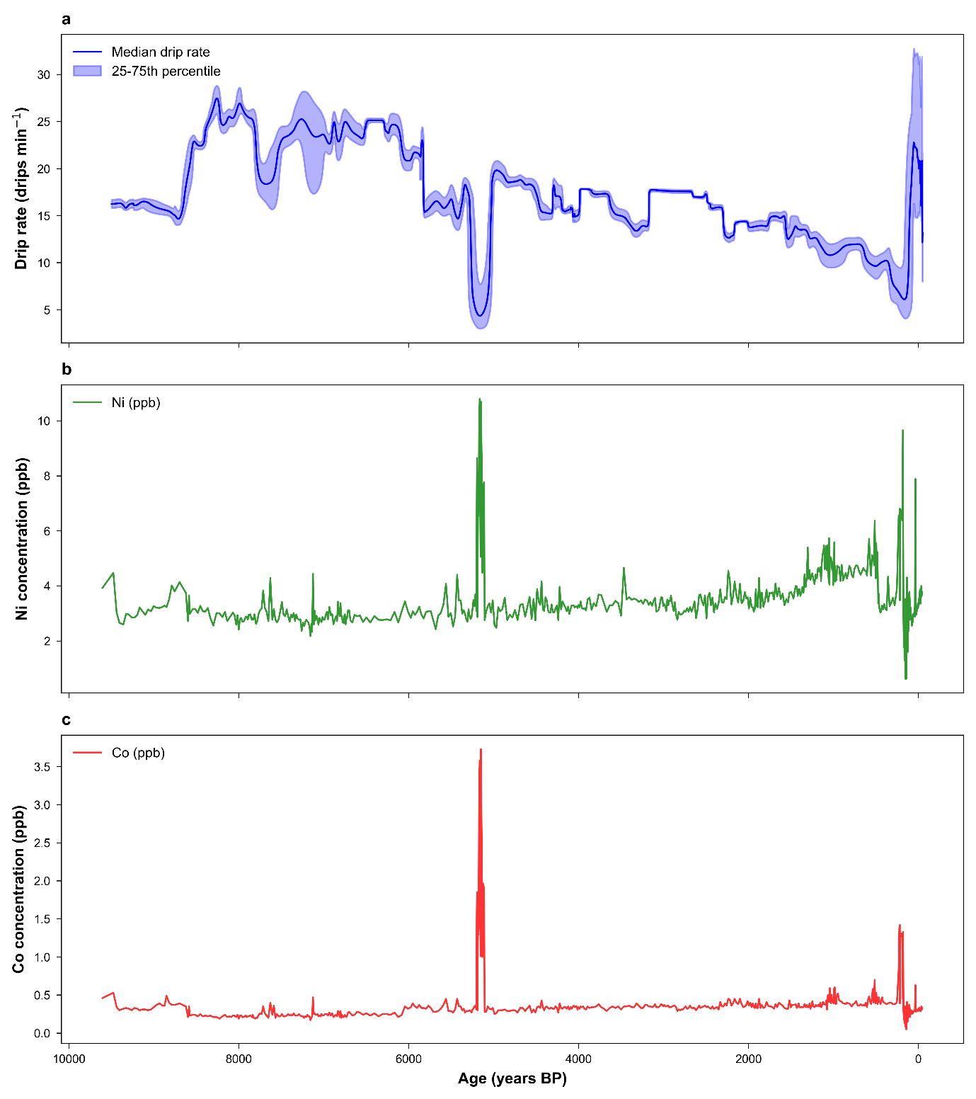
Supplementary Figure 3 | Time series of drip rates and metal concentrations. (a) Median drip rate (blue line) with 25th–75th percentile range (blue shading) in drips per minute as a function of age (years BP). (b) Nickel (Ni) concentration (ppm, green line) versus age. (c) Cobalt (Co) concentration (ppm, red line) versus age.
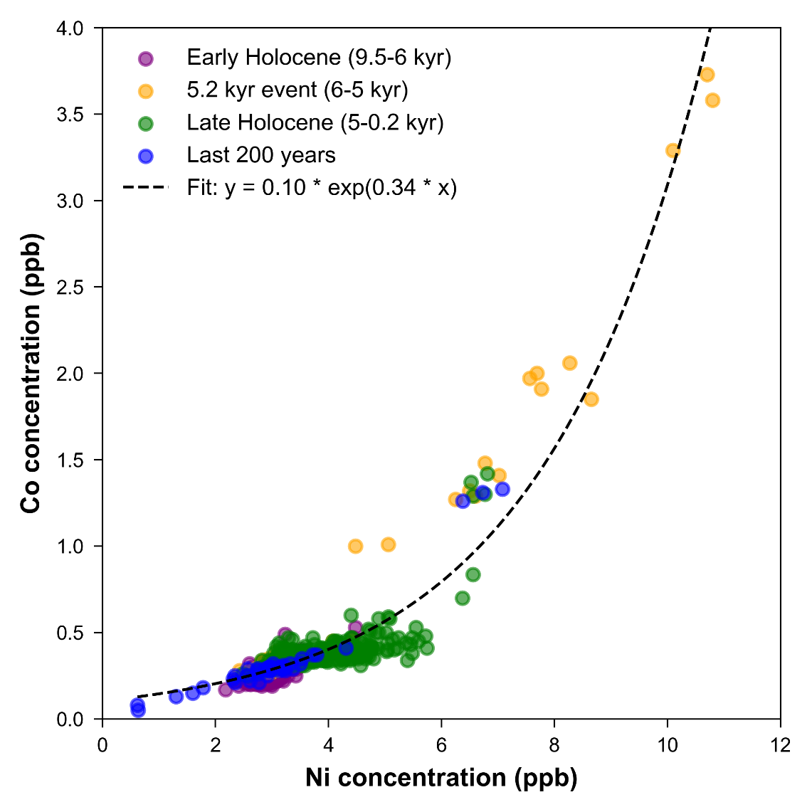
Supplementary Figure 4 | Nickel versus Cobalt concentrations across time periods. Scatter plot of Ni concentration (ppm) versus Co concentration (ppm), with two outliers excluded. Data points are coloured by epoch: Early Holocene (9.5–6 kyr BP, purple), 5.2 kyr event (6–5 kyr BP, orange), Late Holocene (5–0.2 kyr BP, green), and Last 200 years (0.2–0 kyr BP, blue). An exponential fit (black dashed line) highlights the relationship, emphasizing the slower dissociation rate of OMC-Co complexes, which require longer thin film residence times to contribute to the speleothem record.

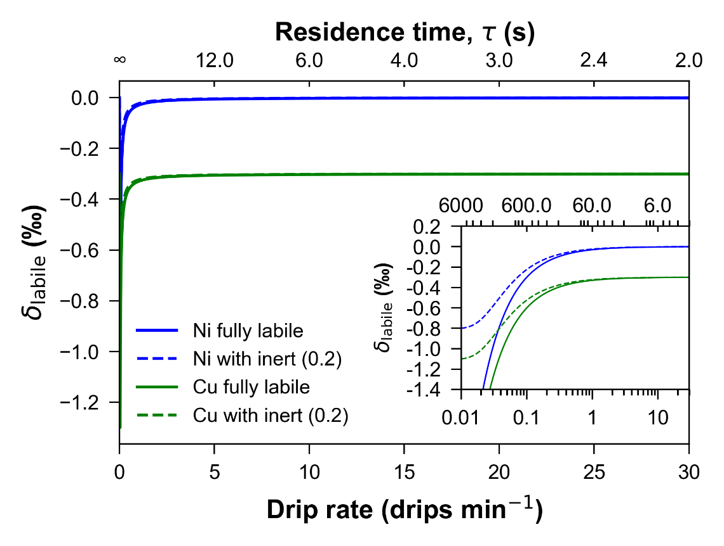
Supplementary Figure 5 | Modelled isotopic composition of the labile pool (d_{labile}) for nickel (d⁶⁰Ni) and copper (d⁶⁵Cu) during organic-metal complex (OMC) dissociation in the stalagmite thin film, modeled with initial isotopic values d⁶⁰Ni = 0.0‰, (d⁶⁵Cu = -0.3‰, and a kinetic fractionation factor a_{k} = 0.9995. The main plot shows d_{labile} versus drip rate (0 to 30 drips min⁻¹, linear scale) with a secondary axis for residence time (t = 60/d, ∞ to 2 s). The inset plot (bottom right) uses a logarithmic drip rate scale (0.01 to 30 drips min⁻¹) with t from 6000 to 2 s for low-rate detail. Solid lines represent fully labile pools; dashed lines include a 0.2 inert fraction.

Supplementary References
1. Hartland, A. & Zitoun, R. Transition metal availability to speleothems controlled by organic binding ligands. Geochem. Persp. Let. 8, 22–25 (2018).
2. Hu, C. et al. Quantification of Holocene Asian monsoon rainfall from spatially separated cave records. Earth Planet. Sci. Lett. 266, 221–232 (2008).
3. Fraser, A. M. & Swinney, H. L. Independent coordinates for strange attractors from mutual information. Phys. Rev. A 33, 1134–1140 (1986).
4. Cao, L. Practical method for determining the minimum embedding dimension of a scalar time series. Physica D: Nonlinear Phenomena 110, 43–50 (1997).
5. Kraemer, K. H., Donner, R. V., Heitzig, J. & Marwan, N. Recurrence threshold selection for obtaining robust recurrence characteristics in different embedding dimensions. Chaos 28, 085720 (2018).
6. Theiler, J. Spurious dimension from correlation algorithms applied to limited time-series data. Phys. Rev. A 34, 2427–2432 (1986).
7. Donner, R. V. et al. Recurrence networks—a novel paradigm for nonlinear time series analysis. New J. Phys. 12, 033025 (2010).
8. Zheng, J. et al. Historical droughts in the Qing dynasty (1644–1911) of China. Clim. Past 16, 911–931 (2020).
9. Hang, X., Sun, Z., He, J. et al. Temporal and spatial effects of extreme drought events on human epidemics over ancient China in 1784–1787 CE. Environ. Health 24, 8 (2025).
10. Yin, Y. X. et al. Extreme historical droughts and floods in the Hanjiang River Basin, China, since 1426. Clim. Past 18, 1775–1791 (2022).
11. Höpker, S. N., Breitenbach, S. F. M., Grainger, M., Stirling, C. H. & Hartland, A. Characterising the decay of organic metal complexes in speleothem-forming cave waters. Geochim. Cosmochim. Acta 373, 98–108 (2024).
12. Brodnax, R. Identifying temporal and spatial variations in the binding properties of transition metal-organic ligand complexes in cave waters using organic inclusions in speleothem calcite: Implications for paleoclimate research. (University of Waikato, Hamilton, New Zealand, 2024).
13. Baker, A. & Fairchild, I. J. Drip Water Hydrology and Speleothems. Nature Education Knowledge 3(10), 16 (2012).
14. Guo, W. & Zhou, C. Patterns and controls of disequilibrium isotope effects in implications for quantitative thermometry. Geochimica et Cosmochimica Acta 267, 196–226 (2019).
15. Sade, Z., Hegyi, S., Hansen, M., Scholz, D. & Halevy, I. The effects of drip rate and geometry on the isotopic composition of speleothems: Evaluation with an advection-diffusion-reaction model. Geochimica et Cosmochimica Acta 317, 409–432 (2022).
16. Bajnai, D. et al. Dual clumped isotope thermometry resolves kinetic biases in carbonate formation temperatures. Nat. Commun. 11, 4005 (2020).
17. Daëron, M. et al. Most Earth-surface calcites precipitate out of isotopic equilibrium. Nat. Commun. 10, 429 (2019).
18. Blyth, A. J., Hartland, A. & Baker, A. Organic proxies in speleothems – New developments, advantages and limitations. Quaternary Science Reviews 149, 1–17 (2016).
19. Hartland, A. Colloidal geochemistry of speleothem-forming groundwaters. PhD thesis (University of Birmingham, 2010).
20. Pearson, A. R. et al. Warming drives dissolved organic carbon export from pristine alpine soils. Nat. Commun. 15, 3522 (2024).

