Supporting Information
Tuning paclitaxel release behavior using dually-responsive nanomicellar assemblies with multiple diselenide/disulfide linkages
Jingwen Xu ^{1#*}, Xiangji Yan^{2,3#}, Yue Zhang ¹, Kangsheng Tu⁴, Wen Shen¹, Guoliang Li¹, Zhaoqing Tian¹, Wei Zhao^{5*} and Mingzhen Zhang^{2,3}

Affiliations:
- School of Food and Biological Engineering, Shaanxi University of Science and Technology, Xi’an 710021, China.

- School of Basic Medical Sciences, Xi’an Key Laboratory of Immune Related Diseases, Xi'an Jiaotong University, Xi’an, Shaanxi, 710061, China

- Key Laboratory of Environment and Genes Related to Diseases, Xi’an Jiaotong University, Ministry of Education, Xi’an, Shaanxi, 710061, China

- Department of Hepatobiliary Surgery, the First Affiliated Hospital of Xi'an Jiaotong University, Xi'an, Shaanxi, 710061, China

- Department of General Surgery, the First Affiliated Hospital of Xi'an Jiaotong University, Xi'an, Shaanxi, 710061, China

# These authors contributed equally to this work

∗ Authors for correspondence

Jingwen Xu
E-mail address: xujingwen@sust.edu.cn (J. Xu)

Wei Zhao
E-mail address: zhaowei9803@126.com (W. Zhao)
Figure S1 ¹H NMR (a) and FTIR (b) spectra of DSeDPA

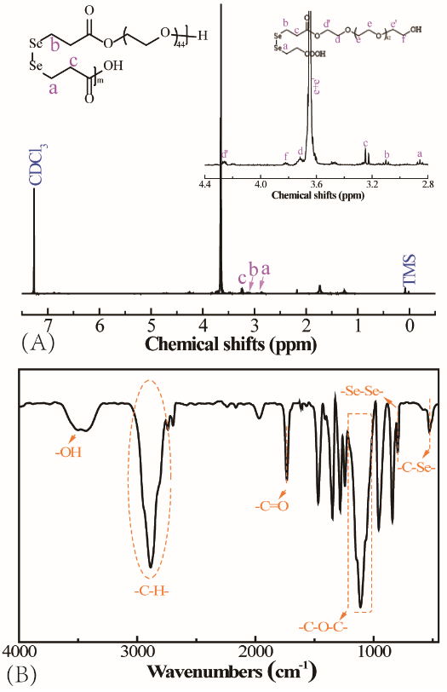
Figure S2 ¹H NMR (A) and FTIR (B) spectra of PEG-alt-DSeDP

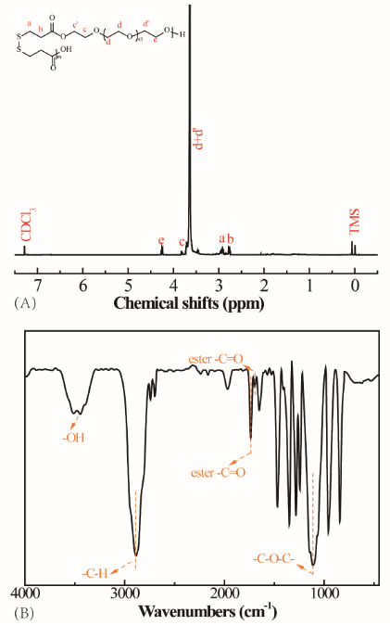
Figure S3 ¹H NMR (a) and FTIR (b) spectra of PEG-alt-DSDP

Figure S4 Plots of fluorescence intensity ratio I₃₈₃/I₃₇₂ from pyrene emission spectrum vs. logarithm of PTX laden nanomicellar concentration.

Figure S5 TEM photographs of P3 blank (A), reduced by 10 mM GSH (B), oxidized by 100 μM H₂O₂ (C) and PTX loaded (D) nanomicelles.

Figure S6 Cell viability of L929 cells treated with free PTX

