Additional file 4. Fig. S1 Burden of disease PPPY (k$) across 24 rare diseases with and without treatment separated by therapeutic area
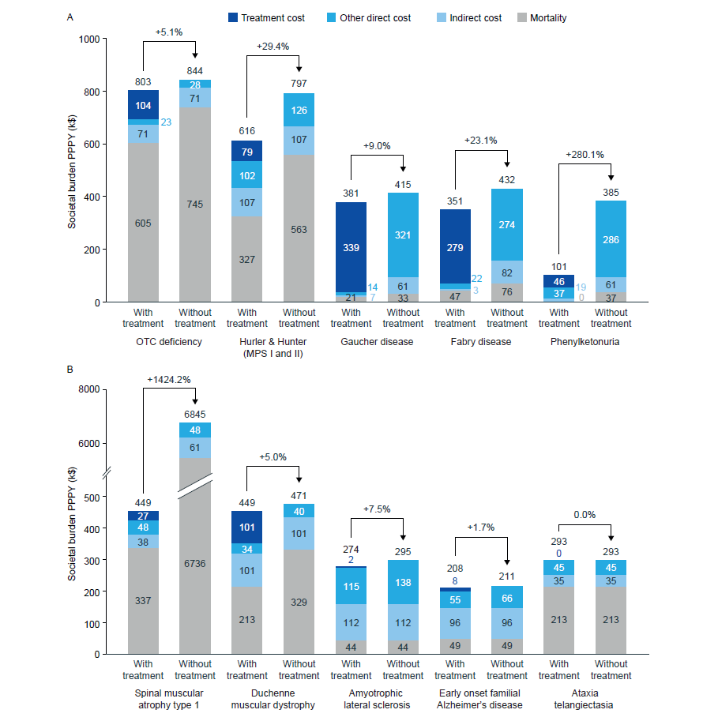
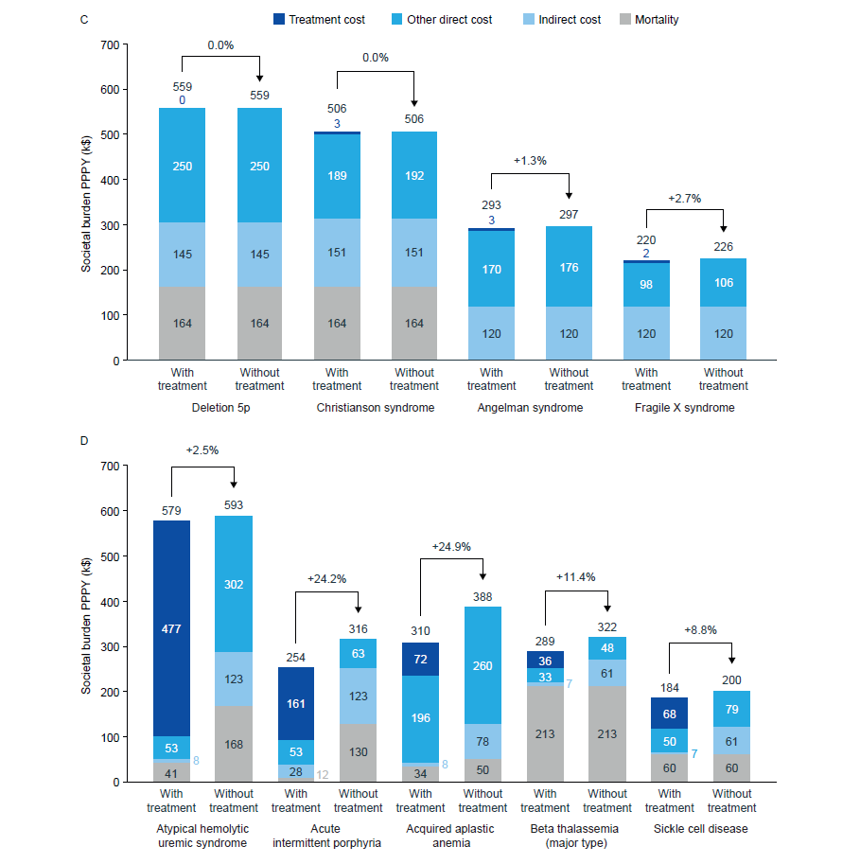
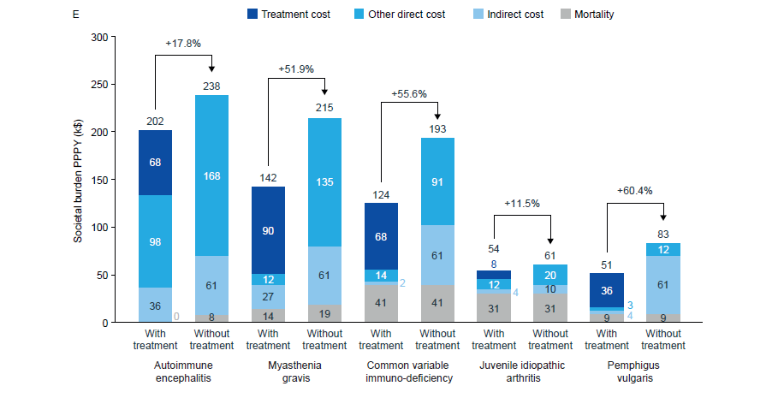
Bars show the average burden PPPY (broken down by cost driver) associated with individual diseases within the metabolic (a), neurological (b), congenital (c), hematological (d) and immunological (e) therapeutic areas.
MPS, mucopolysaccharidoses; OTC, ornithine transcarbamylase; PPPY per patient per year.

