Table S1. Information of oxylipins analyzed in this study
Compound | formal_name | Pubchem ID | PUFA precuror | metabolic pathway
9-HOTrE | 9S-hydroxy-10E,12Z,15Z-octadecatrienoic acid | 47205634 | ALA | LOX
13-HOTrE | 13S-hydroxy-9Z,11E,15Z-octadecatrienoic acid | 16061072 | ALA | LOX
15-oxoETE | 15-oxo-5Z,8Z,11Z,13E-eicosatetraenoic acid | 5280701 | ARA | LOX
12-oxoETE | 12-oxo-5Z,8Z,10E,14Z-eicosatetraenoic acid | 5283162 | ARA | LOX
5-oxoETE | 5-oxo-6E,8Z,11Z,14Z-eicosatetraenoic acid | 5283159 | ARA | LOX
12-HETE | (±)12-hydroxy-5Z,8Z,10E,14Z-eicosatetraenoic acid | 5283155 | ARA | LOX
5-HETE | (±)5-hydroxy-6E,8Z,11Z,14Z-eicosatetraenoic acid | 5280733 | ARA | LOX
15-HETE | (±)15-hydroxy-5Z,8Z,11Z,13E-eicosatetraenoic acid | 5280724 | ARA | LOX
LTB4 | 5S,12R-dihydroxy-6Z,8E,10E,14Z-eicosatetraenoic acid | 5280492 | ARA | LOX
8,15-diHETE | 8S,15S-dihydroxy-5Z,9E,11Z,13E-eicosatetraenoic acid | 53480358 | ARA | LOX
LXA4 | 5S,6R,15S-Trihydroxy-7E,9E,11Z,13E-eicosatetraenoic acid | 5280914 | ARA | LOX
6-trans-LTB4 | 6-trans leukotriene B4 | 5283128 | ARA | LOX
15-HETrE | 15S-hydroxy-8Z,11Z,13E-eicosatrienoic acid | 5283145 | DGLA | LOX
PGA1 | 9-oxo-15S-hydroxy-prosta-10,13E-dien-1-oic acid | 5281912 | DGLA | LOX
Protectin D1 | 10R,17S-dihydroxy-4Z,7Z,11E,13E,15Z,19Z-docosahexaenoic acid | 16042541 | DHA | LOX
RvD2 | 7S,16R,17S-trihydroxy-4Z,8E,10Z,12E,14E,19Z-docosahexaenoic acid | 16061136 | DHA | LOX
14s-HDoHE | (±)14-hydroxy-4Z,7Z,10Z,12E,16Z,19Z-docosahexaenoic acid | 11566378 | DHA | LOX
RvD1 | 7S,8,17S-trihydroxy-docosa-4Z,9E,11E,13Z,15E,19Z-hexaenoic acid | 16061135 | DHA | LOX
RvD5 | resolvin D1 | 16061139 | DHA | LOX
7-HDHA | (±)7-hydroxy-4Z,8E,10Z,13Z,16Z,19Z-docosahexaenoic acid | 53394256 | DHA | LOX
4-HDHA | (±)4-hydroxy-5E,7Z,10Z,13Z,16Z,19Z-docosahexaenoic acid | 53394255 | DHA | LOX
12-HEPE | (±)-12-hydroxy-5Z,8Z,10E,14Z,17Z-eicosapentaenoic acid | 10041593 | EPA | LOX
5-HEPE | (±)-5-hydroxy-6E,8Z,11Z,14Z,17Z-eicosapentaenoic acid | 6439678 | EPA | LOX
15-HEPE | (±)-15-hydroxy-5Z,8Z,11Z,13E,17Z-eicosapentaenoic acid | 53480357 | EPA | LOX
5-HETrE | 5S-hydroxy-6E,8Z,11Z-eicosatrienoic acid | 5283143 | GLA | LOX
9,12,13-TriHOME | 9S,12S,13S-trihydroxy-10E-octadecenoic acid | 9858729 | LA | LOX
13-oxo-ODE | 13-oxo-9Z,11E-octadecadienoic acid | 6446027 | LA | LOX
14, 15-EET | (±)14(15)-epoxy-5Z,8Z,11Z-eicosatrienoic acid | 5283205 | ARA | CYP450
5,6-EET | (±)5,6-epoxy-8Z,11Z,14Z-eicosatrienoic acid | 5283202 | ARA | CYP450
9-HETE | (±)-9-hydroxy-5Z,7E,11Z,14Z-eicosatetraenoic acid | 5312978 | ARA | CYP450
8,9-EET | (±)8,9-epoxy-5Z,11Z,14Z-eicosatrienoic acid | 5283203 | ARA | CYP450
11,12-EET | (±)11,(12)-epoxy-5Z,8Z,14Z-eicosatrienoic acid | 40490664 | ARA | CYP450
5,6-diHETrE | (±)5,6-dihydroxy-8Z,11Z,14Z-eicosatrienoic acid | 5283142 | ARA | CYP450
14,15-DiHET | 14,15-dihydroxy-5Z,8Z,11Z-eicosatrienoic acid | 5283147 | ARA | CYP450
11,12-DiHET | (±)11,12-dihydroxy-5Z,8Z,14Z-eicosatrienoic acid | 11759555 | ARA | CYP450
8,9-DiHET | (±)8,9-dihydroxy-5Z,11Z,14Z-eicosatrienoic acid | 3246873 | ARA | CYP450
19-HETE | 19-hydroxyeicosatetraenoic acid | 20839325 | ARA | CYP450
20-HETE | 20-hydroxy-5Z,8Z,11Z,14Z-eicosatetraenoic acid | 5283157 | ARA | CYP450
14(15)-EET | (±)14,15-epoxy-5Z,8Z,11Z-eicosatrienoic acid | 1431 | ARA | CYP450
19(20)-EpDPE | (±)19,20-epoxy-4Z,7Z,10Z,13Z,16Z-docosapentaenoic acid | 11631565 | DHA | CYP450
16(17)-EpDPE | (±)16,17-epoxy-4Z,7Z,10Z,13Z,19Z-docosapentaenoic acid | 14392758 | DHA | CYP450
19,20-DiHDPA | (±)19,20-dihydroxy-4Z,7Z,10Z,13Z,16Z-docosapentaenoic acid | 16061148 | DHA | CYP450
16,17-DiHDPA | (4z,7z,10z,13z,16r,17r,19z)-16,17-Dihydroxydocosa-4,7,10,13,19-Pentaenoic Acid | 129364499 | DHA | CYP450
13,14-DiHDPA | 13,14-dihydroxy-4Z,7Z,10Z,16Z,19Z-docosapentaenoic acid | 129364495 | DHA | CYP450
10,11-DiHDPA | (±)10,11-dihydroxy-4Z,7Z,13Z,16Z,19Z-docosapentaenoic acid | 129364491 | DHA | CYP450
7,8-DiHDPA | (±)7,8-dihydroxydocosa-4Z,10Z,13Z,16Z,19Z-pentaenoic acid | 16061144 | DHA | CYP450
22-HDHA | 22-hydroxy-4Z,7Z,10Z,13Z,16Z,19Z-docosahexaenoic acid | 72715842 | DHA | CYP450
10(11)-EpDPA | (±)-(4Z,7Z)-9-[3-(2Z,5Z,8Z)-2,5,8-undecatrien-1-yl-2-oxiranyl]-4,7-nonadienoic acid | 124403576 | DHA | CYP450
7(8)-EpDPA | (±)-(4Z)-6-[3-(2Z,5Z,8Z,11Z)-2,5,8,11-tetradecatetraen-1-yl-2-oxiranyl]-4-hexenoic acid | 89861878 | DHA | CYP450
13(14)-EpDPA | (±)-(4Z,7Z,10Z)-12-[3-(2Z,5Z)-2,5-octadien-1-yl-2-oxiranyl]-4,7,10-dodecatrienoic acid | 124407158 | DHA | CYP450
14(15)-EpETE | (±)14,15-epoxy-5Z,8Z,11Z,17Z-eicosatetraenoic acid | 16061088 | EPA | CYP450
5,6-diHETE | (±)5,6-dihydroxy-8Z,11Z,14Z,17Z-eicosatetraenoic acid | 14429105 | EPA | CYP450
RvE1 | 5S,12R,18R-trihydroxy-6Z,8E,10E,14Z,16E-eicosapentaenoic acid | 25063347 | EPA | CYP450
17,18-DiHETE | (±)17,18-dihydroxyeicosatetraenoic acid | 16061120 | EPA | CYP450
14,15-DiHETE | (±)14,15-dihydroxyeicosatetraenoic acid | 16061119 | EPA | CYP450
11,12-DiHETE | (+/-)-11,12-dihydroxy-5Z,8Z,14Z,17Z-eicosatetraenoic acid | 16061121 | EPA | CYP450
8,9-DiHETE | (+/-)-8,9-dihydroxy-5Z,11Z,14Z,17Z-eicosatetraenoic acid | 16061118 | EPA | CYP450
20-HEPE | 20-hydroxy-5Z,8Z,11Z,14Z,17Z-eicosapentaenoic acid | 72551579 | EPA | CYP450
11(12)-EpETE | (±)11,12-epoxy-5Z,8Z,14Z,17Z- eicosatetraenoic acid | 16061087 | EPA | CYP450
8(9)-EpETE | (±)8,9-epoxy-5Z,11Z,14Z,17Z-eicosatetraenoic acid | 53394044 | EPA | CYP450
17(18)-EpETE | (±)17,18-epoxy-5Z,8Z,11Z,14Z-eicosatetraenoic acid | 27076755 | EPA | CYP450
12,13-EpOME | (±)12(13)epoxy-9Z-octadecenoic acid | 5356421 | LA | CYP450
9,10-EpOME | (±)9,10-epoxy-12Z-octadecenoic acid | 6246154 | LA | CYP450
12,13-diHOME | 12,13-dihydroxy-9Z-octadecenoic acid | 10236635 | LA | CYP450
9,10-diHOME | (±)9,10-dihydroxy-12Z-octadecenoic acid | 25320862 | LA | CYP450
15d-PGJ2 | 15-deoxy-delta12,14-prostaglandin J2 | 5311211 | ARA | COX
15d-PGA2 | 15-deoxy-Δ12,14-Prostaglandin A2 | 16061104 | ARA | COX
11-HETE | (±)11-hydroxy-5Z,8Z,12E,14Z-eicosatetraenoic acid | 14123410 | ARA | COX
PGEM | 9,15-dioxo-11α-hydroxy-13,14-dihydro-2,3,4,5-tetranor-prostan-1,20-dioic acid | 161468 | ARA | COX
PGFM | 13,14-dihydro-15-keto Prostaglandin F2α | 5283039 | ARA | COX
PGA2 | 9-oxo-15S-hydroxy-prosta-5Z,10,13E-trien-1-oic acid | 5280880 | ARA | COX
PGJ2 | 11-oxo-15S-hydroxy-prosta-5Z,9,13E-trien-1-oic acid | 5280884 | ARA | COX
15d-PGD2 | 15-deoxy-Δ12,14-Prostaglandin D2 | 5283052 | ARA | COX
PGE2 | 9-oxo-11α,15S-dihydroxy-prosta-5Z,13E-dien-1-oic acid | 5280360 | ARA | COX
PGD2 | 9α,15S-dihydroxy-11-oxo-prosta-5Z,13E-dien-1-oic acid | 448457 | ARA | COX
dhk PGD2 | 13,14-Dihydro-15-keto-PGD2 | 5283036 | ARA | COX
PGF2a | 9α,11α,15S-trihydroxy-prosta-5Z,13E-dien-1-oic acid | 5280363 | ARA | COX
11b PGF2a | 9α,11β,15S-trihydroxy-prosta-5Z,13E-dien-1-oic acid | 5280886 | ARA | COX
TXB2 | 9α,11,15S-trihydroxythromba-5Z,13E-dien-1-oic acid | 5283137 | ARA | COX
PGI2 | 6,9α-epoxy-11α,15S-dihydroxy-prosta-5Z,13E-dien-1-oic acid | 5282411 | ARA | COX
6-keto-PGF1a | 6-oxo-9α,11α,15S-trihydroxy-prost-13E-en-1-oic acid | 5280888 | ARA | COX
PGB2 | 9-oxo-15S-hydroxy-prosta-5Z,8(12),13E-trien-1-oic acid | 5280881 | ARA | COX
20-OH-PGF2a | 20-hydroxy prostaglandin F2α | 472956246 | ARA | COX
20-OH-PGE2 | 20-hydroxy prostaglandin E2 | 5283034 | ARA | COX
2,3-dinor-TXB2 | 2,3-dinor thromboxane B2 | 5283138 | ARA | COX
11-dehydro TXB2 | 11-dehydro thromboxane B2 | 5280891 | ARA | COX
13,14-dihydro-15-keto PGE2 | 13,14-dihydro-15-keto prostaglandin E2 | 5280711 | ARA | COX
13,14-dihydro-15-keto PGD2 | 13,14-dihydro-15-keto prostaglandin D2 | 5283036 | ARA | COX
PGK1 | 9,11-dioxo-15S-hydroxy-prost-13E-en-1-oic acid | 16061102 | DGLA | COX
PGE1 | 9-oxo-11α,15S-dihydroxy-prost-13E-en-1-oic acid | 5280723 | DGLA | COX
PGD1 | 9α,15S-dihydroxy-11-oxo-prost-13E-en-1-oic acid | 5280936 | DGLA | COX
PGF1a | 9α,11α,15S-trihydroxy-prost-13E-en-1-oic acid | 5280939 | DGLA | COX
17-HDoHE | (±)17-hydroxy-4Z,7Z,10Z,13Z,15E,19Z-docosahexaenoic acid | 6439179 | DHA | COX
PGD3 | 9α,15S-dihydroxy-11-oxo-prosta-5Z,13E,17Z-trien-1-oic acid | 5282260 | EPA | COX
PGE3 | 9-oxo-11α,15S-dihydroxy-prosta-5Z,13E,17Z-trien-1-oic acid | 5280937 | EPA | COX
delta 17-6-keto-PGF1a | Δ17-6-keto prostaglandin F1α | 472956090 | EPA | COX
9-HODE | (±)-9-hydroxy-10E,12Z-octadecadienoic acid | 5282944 | LA | COX
13-HODE | (±)-13-hydroxy-9Z,11E-octadecadienoic acid | 5282947 | LA | COX
9-oxo-ODE | 9-oxo-10E,12Z-octadecadienoic acid | 9839084 | LA | COX
ALA | 9Z,12Z,15Z-octadecatrienoic acid | 5280934 | ALA | PUFA
ARA | Arachidonic acid | 444899 | ARA | PUFA
Adrenic acid | 7Z,10Z,13Z,16Z-docosatetraenoic acid | 5497181 | ARA | PUFA
DGLA | 8Z,11Z,14Z-eicosatrienoic acid | 5280581 | DGLA | PUFA
DHA | 4Z,7Z,10Z,13Z,16Z,19Z-docosahexaenoic acid | 445580 | DHA | PUFA
EPA | Eicosapentaenoic acid | 446284 | EPA | PUFA
GLA | 6Z,9Z,12Z-octadecatrienoic acid | 5280933 | GLA | PUFA
LA | 9Z,12Z-octadecadienoic acid | 5280450 | LA | PUFA
10-Nitrooleate | 10-nitro-9E-octadecenoic acid | 24836820 | PUFA | PUFA
9-Nitrooleate | 9-nitro-9E-octadecenoic acid | 11645581 | PUFA | PUFA
13-HDoHE | (±)13-hydroxy-4Z,7Z,10Z,14E,16Z,19Z-docosahexaenoic acid | 11559259 | DHA | non-enzymatic
20-HDHA | (±)20-hydroxy-4Z,7Z,10Z,13Z,16Z,18E-docosahexaenoic acid | 16061143 | DHA | non-enzymatic
16-HDHA | (±)16-hydroxy-4Z,7Z,10Z,13Z,17E,19Z-docosahexaenoic acid | 53394262 | DHA | non-enzymatic
10-HDHA | (±)10-hydroxy-4Z,7Z,11E,13Z,16Z,19Z-docosahexaenoic acid | 53394258 | DHA | non-enzymatic
11-HDHA | (±)11-hydroxy-4Z,7Z,9E,13Z,16Z,19Z-docosahexaenoic acid | 11631564 | DHA | non-enzymatic
8-HDHA | (±)8-hydroxy-4Z,6E,10Z,13Z,16Z,19Z-docosahexaenoic acid | 53394257 | DHA | non-enzymatic
8-HEPE | (±)-8-hydroxy-5Z,9E,11Z,14Z,17Z-eicosapentaenoic acid | 16061128 | EPA | non-enzymatic
18-HEPE | (±)-18-hydroxy-5Z,8Z,11Z,14Z,16E-eicosapentaenoic acid | 16061132 | EPA | non-enzymatic
11-HEPE | (±)-11-hydroxy-5Z,8Z,12E,14Z,17Z-eicosapentaenoic acid | 16061130 | EPA | non-enzymatic
9-HEPE | (±)-9-hydroxy-5Z,7E,11Z,14Z,17Z-eicosapentaenoic acid | 16061129 | EPA | non-enzymatic
EKODE | 9-oxo-11-(3-pentyl-2-oxiranyl)-10E-undecenoic acid | 5283007 | LA | non-enzymatic

Table S2. Demographics characteristics of participants
 | HC | MDD | statistics | p
sex (Male/Female) | 44/90 | 42/112 | 0.81* | 0.37
age | 25.48(7.33) | 25.16(8.44) | -0.34# | 0.74
BMI | 20.89(2.9) | 20.6(3.54) | -0.76# | 0.45
onset age | - | 21.31(8) | - | -
number of episodes | - | 1.67(1.45) | - | -
current disease duration | - | 9.61(14.55) | - | -
Total score of HAMD | - | 21.65(4.67) | - | -
Total score of HAMA | - | 21.75(7.18) | - | -
Note: The data are presented as mean (standard deviation)
# t statistics; * chi-square statistics.

Table S3. Demographics characteristics of participants with follow-up data
 | non-  responder | responder | statistics | p
sex (Male/Female) | 11/28 | 8/27 | 0.067* | 0.8
age | 24.79(7.09) | 25.89(8.4) | 0.61# | 0.55
BMI | 20.8(3.97) | 21.11(3.91) | 0.35# | 0.73
onset age | 20.36(7.14) | 22.71(8.02) | 1.34# | 0.19
number of episodes | 1.53(1.25) | 1.94(2.17) | 1.02# | 0.31
current disease duration | 15.39(20.6) | 9.19(13.73) | -1.5# | 0.14
Total score of HAMD (W0) | 20.97(4.72) | 20.97(5.02) | -0.0026# | 1
Total score of HAMA (W0) | 21.03(7.8) | 21.63(6.94) | 0.35# | 0.73
Total score of HAMD (W8) | 17.23(6.2) | 5.34(4.09) | -9.6# | 1.5e-14
Total score of HAMA (W8) | 18.72(7.41) | 6.76(5.58) | -7.7# | 6.3e-11
Note: The data are presented as mean (standard deviation)
# t statistics; * chi-square statistics.

Table S4. Correlation between total scores/subscales of HAMD/HAMA and oxylipins
 | HAMD |  |  |  |  |  | HAMA
 | total score | somatization | weight | cognitive disturbance | retardationdisturbance | sleep | total score | Somatic anxiety | psychological anxiety
9-HOTrE | 0.17  (0.34) | 0.043  (0.9) | -0.15  (0.58) | 0.12  (0.48) | 0.17  (0.38) | 0.17  (0.72) | -0.063  (0.94) | -0.083  (0.66) | -0.037  (0.98)
13-HOTrE | 0.068  (0.74) | -0.16  (0.9) | -0.052  (0.76) | -0.03  (0.89) | 0.1  (0.52) | 0.2  (0.72) | -0.17  (0.92) | -0.22  (0.63) | -0.09  (0.95)
12-HETE | -0.059  (0.75) | -0.045  (0.9) | -0.01  (0.93) | -0.17  (0.29) | -0.0022  (0.98) | -0.012  (0.95) | -0.031  (0.94) | 0.087  (0.66) | -0.15  (0.95)
5-HETE | 0.056  (0.75) | 0.0017  (1) | -0.13  (0.6) | 0.17  (0.28) | 0.083  (0.54) | 0.017  (0.95) | -0.033  (0.94) | 0.035  (0.85) | -0.091  (0.95)
15-HETE | -0.031  (0.86) | -0.049  (0.9) | -0.027  (0.9) | -0.055  (0.77) | 0.023  (0.9) | -0.019  (0.95) | -0.085  (0.94) | 0.036  (0.85) | -0.19  (0.95)
15-HETrE | 0.1  (0.59) | 0.026  (0.9) | -0.049  (0.76) | 0.11  (0.51) | 0.088  (0.54) | 0.06  (0.8) | -0.0065  (0.97) | 0.099  (0.66) | -0.12  (0.95)
14s-HDoHE | 0.16  (0.34) | 0.088  (0.9) | -0.087  (0.7) | 0.084  (0.62) | 0.16  (0.38) | 0.12  (0.76) | 0.14  (0.94) | 0.21  (0.66) | 0.014  (0.98)
4-HDHA | 0.094  (0.61) | 0.054  (0.9) | -0.17  (0.58) | 0.23  (0.16) | 0.12  (0.42) | -0.0064  (0.95) | 0.025  (0.94) | 0.085  (0.66) | -0.051  (0.98)
12-HEPE | -0.022  (0.92) | -0.13  (0.9) | 0.076  (0.76) | -0.072  (0.77) | 0.0042  (0.98) | -0.045  (0.95) | -0.2  (0.94) | -0.066  (0.83) | -0.27  (0.95)
9,12,13-TriHOME | 0.026  (0.87) | -0.064  (0.9) | -0.078  (0.7) | -0.014  (0.93) | 0.092  (0.54) | -0.0097  (0.95) | -0.061  (0.94) | -0.12  (0.66) | 0.013  (0.98)
13-oxo-ODE | 0.16  (0.42) | 0.035  (0.9) | -0.11  (0.7) | 0.1  (0.62) | 0.17  (0.38) | 0.17  (0.76) | -0.085  (0.94) | -0.13  (0.66) | -0.069  (0.98)
5,6-diHETrE | 0.15  (0.34) | 0.044  (0.9) | -0.12  (0.62) | 0.28  (0.14) | 0.12  (0.42) | 0.0069  (0.95) | 0.038  (0.94) | 0.062  (0.74) | -0.00057  (1)
14,15-DiHET | 0.2  (0.29) | 0.061  (0.9) | -0.11  (0.69) | 0.28  (0.14) | 0.23  (0.38) | 0.086  (0.76) | 0.0038  (0.97) | -0.02  (0.85) | 0.0089  (0.98)
11,12-DiHET | 0.16  (0.34) | 0.055  (0.9) | -0.16  (0.58) | 0.2  (0.21) | 0.14  (0.38) | 0.11  (0.76) | 0.013  (0.94) | 0.096  (0.66) | -0.075  (0.95)
19,20-DiHDPA | 0.21  (0.29) | 0.11  (0.9) | -0.11  (0.69) | 0.19  (0.21) | 0.16  (0.38) | 0.19  (0.72) | 0.15  (0.94) | 0.15  (0.66) | 0.087  (0.95)
16,17-DiHDPA | 0.2  (0.29) | 0.12  (0.9) | -0.13  (0.6) | 0.19  (0.21) | 0.18  (0.38) | 0.17  (0.72) | 0.12  (0.94) | 0.12  (0.66) | 0.084  (0.95)
13,14-DiHDPA | 0.23  (0.29) | 0.15  (0.9) | -0.18  (0.54) | 0.27  (0.14) | 0.16  (0.38) | 0.15  (0.76) | 0.12  (0.94) | 0.16  (0.66) | 0.031  (0.98)
10,11-DiHDPA | 0.2  (0.29) | 0.08  (0.9) | -0.19  (0.54) | 0.26  (0.15) | 0.26  (0.29) | 0.14  (0.76) | 0.072  (0.94) | 0.035  (0.85) | 0.081  (0.95)
22-HDHA | 0.19  (0.29) | 0.12  (0.9) | -0.2  (0.54) | 0.25  (0.15) | 0.23  (0.38) | 0.13  (0.76) | 0.1  (0.94) | 0.098  (0.66) | 0.063  (0.98)
17,18-DiHETE | 0.21  (0.29) | 0.049  (0.9) | -0.018  (0.9) | 0.18  (0.21) | 0.18  (0.38) | 0.064  (0.8) | 0.092  (0.94) | 0.073  (0.69) | 0.072  (0.95)
9,10-EpOME | 0.09  (0.61) | -0.1  (0.9) | -0.064  (0.76) | 0.091  (0.58) | 0.14  (0.38) | 0.14  (0.76) | -0.18  (0.92) | -0.18  (0.66) | -0.16  (0.95)
12,13-diHOME | -0.04  (0.83) | -0.16  (0.9) | -0.092  (0.7) | 0.022  (0.93) | 0.084  (0.54) | 0.093  (0.76) | -0.21  (0.92) | -0.25  (0.63) | -0.11  (0.95)
9,10-diHOME | -0.087  (0.61) | -0.24  (0.9) | -0.014  (0.92) | -0.076  (0.63) | -0.033  (0.89) | 0.17  (0.72) | -0.21  (0.92) | -0.21  (0.63) | -0.15  (0.95)
11-HETE | 0.012  (0.93) | -0.033  (0.9) | -0.054  (0.76) | 0.03  (0.89) | 0.065  (0.65) | 0.014  (0.95) | -0.033  (0.94) | 0.064  (0.74) | -0.14  (0.95)
PGD3 | -0.19  (0.29) | -0.083  (0.9) | 0.019  (0.9) | -0.19  (0.21) | -0.11  (0.48) | -0.078  (0.78) | -0.18  (0.92) | -0.17  (0.66) | -0.1  (0.95)
PGE3 | -0.21  (0.29) | -0.11  (0.9) | 0.056  (0.76) | -0.2  (0.21) | -0.16  (0.38) | -0.073  (0.8) | -0.14  (0.94) | -0.17  (0.66) | -0.0061  (0.98)
9-HODE | 0.16  (0.34) | 0.04  (0.9) | -0.2  (0.54) | 0.11  (0.51) | 0.27  (0.29) | 0.068  (0.8) | -0.082  (0.94) | -0.083  (0.66) | -0.075  (0.95)
13-HODE | 0.12  (0.46) | 0.054  (0.9) | -0.084  (0.7) | 0.1  (0.51) | 0.14  (0.38) | 0.091  (0.76) | -0.099  (0.94) | -0.084  (0.66) | -0.13  (0.95)
9-oxo-ODE | 0.24  (0.29) | 0.032  (0.9) | -0.15  (0.6) | 0.095  (0.62) | 0.15  (0.42) | 0.2  (0.72) | -0.049  (0.94) | -0.031  (0.85) | -0.041  (0.98)
ALA | 0.15  (0.34) | 0.041  (0.9) | -0.071  (0.72) | 0.21  (0.21) | 0.15  (0.38) | 0.081  (0.76) | -0.03  (0.94) | 0.025  (0.85) | -0.094  (0.95)
ARA | 0.041  (0.83) | -0.00026  (1) | -0.18  (0.54) | 0.15  (0.34) | 0.14  (0.38) | -0.058  (0.8) | -0.13  (0.94) | -0.095  (0.66) | -0.14  (0.95)
Adrenic acid | -0.13  (0.44) | -0.092  (0.9) | -0.15  (0.58) | 0.016  (0.93) | 0.085  (0.54) | -0.034  (0.95) | -0.084  (0.94) | -0.087  (0.66) | -0.092  (0.95)
DGLA | 0.15  (0.34) | 0.058  (0.9) | -0.18  (0.54) | 0.19  (0.21) | 0.14  (0.38) | 0.13  (0.76) | 0.018  (0.94) | 0.074  (0.69) | -0.047  (0.98)
DHA | 0.086  (0.61) | 0.094  (0.9) | -0.14  (0.58) | 0.14  (0.4) | 0.11  (0.47) | 0.12  (0.76) | 0.031  (0.94) | 0.04  (0.85) | 0.012  (0.98)
EPA | 0.15  (0.34) | 0.034  (0.9) | -0.084  (0.7) | 0.24  (0.15) | 0.097  (0.52) | 0.016  (0.95) | 0.051  (0.94) | 0.13  (0.66) | -0.029  (0.98)
GLA | 0.19  (0.29) | 0.071  (0.9) | -0.078  (0.7) | 0.24  (0.15) | 0.18  (0.38) | 0.081  (0.76) | -0.022  (0.94) | 0.03  (0.85) | -0.082  (0.95)
LA | 0.16  (0.34) | 0.089  (0.9) | -0.1  (0.7) | 0.22  (0.16) | 0.17  (0.38) | 0.096  (0.76) | -0.014  (0.94) | -0.02  (0.85) | -0.024  (0.98)
CUDA | 0.0019  (0.99) | -0.0028  (1) | 0.056  (0.76) | 0.037  (0.88) | 0.02  (0.9) | 0.12  (0.76) | -0.045  (0.94) | -0.14  (0.66) | 0.05  (0.98)
16-HDHA | 0.1  (0.59) | 0.001  (1) | -0.14  (0.58) | 0.1  (0.51) | 0.2  (0.38) | 0.086  (0.76) | 0.058  (0.94) | 0.12  (0.66) | -0.036  (0.98)
10-HDHA | 0.063  (0.75) | 0.066  (0.9) | -0.053  (0.76) | 0.014  (0.93) | -0.026  (0.9) | 0.2  (0.72) | 0.066  (0.94) | 0.11  (0.66) | -0.013  (0.98)
11-HDHA | 0.065  (0.75) | 0.061  (0.9) | -0.11  (0.69) | -0.0052  (0.96) | 0.17  (0.38) | 0.086  (0.76) | 0.04  (0.94) | 0.086  (0.66) | -0.029  (0.98)
8-HDHA | -0.038  (0.86) | -0.13  (0.9) | -0.3  (0.54) | 0.14  (0.49) | 0.023  (0.9) | -0.039  (0.95) | 0.047  (0.94) | 0.12  (0.66) | -0.043  (0.98)
Note: The data are presented as “r value (p value)”

Figure S1. Comparison of total HAMD/HAMA scores between responders and non-responders
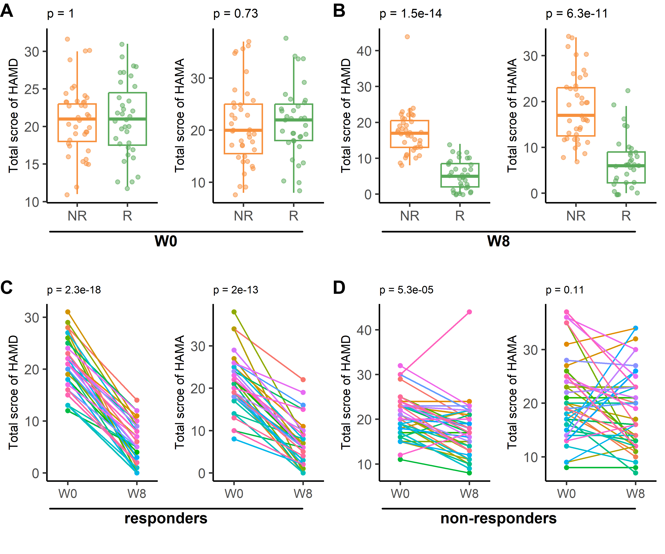

Figure S2. Correlation between plasma oxylipin levels and reduction rate of HAMA
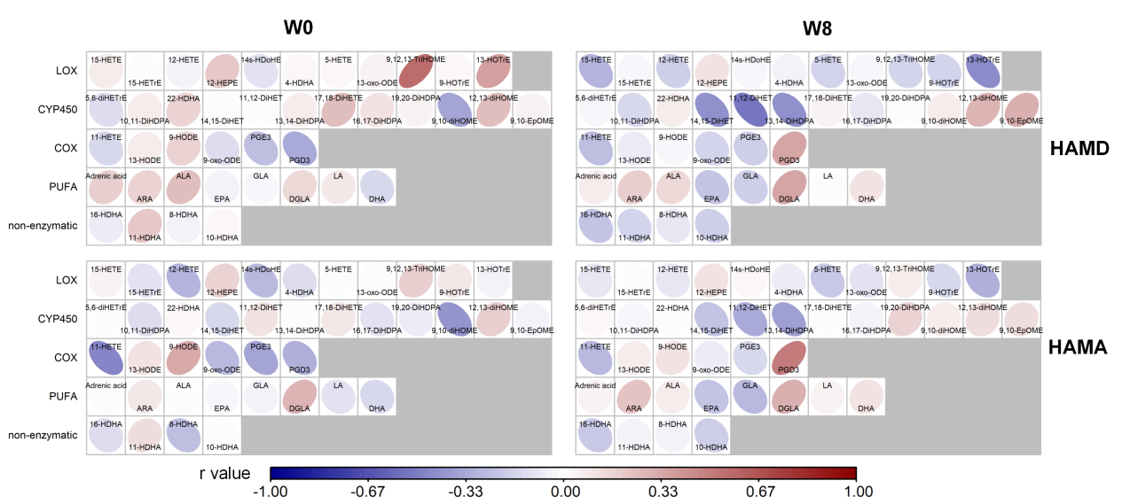
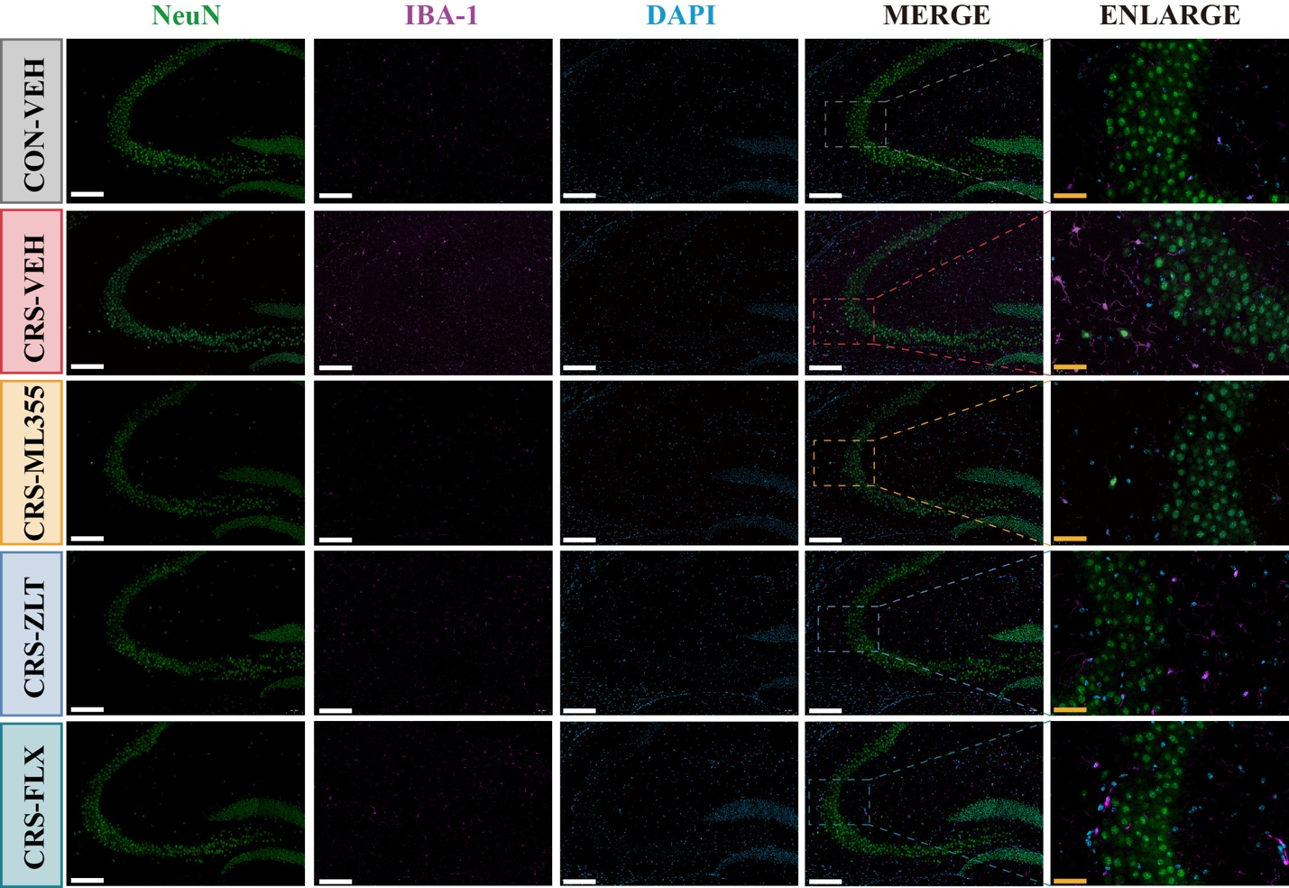
Figure S3 Representative images of microglial activation (Iba-1) in the hippocampal CA3 region across treatment groups. White scale bar=200 μm, yellow scale bar=50 μm.
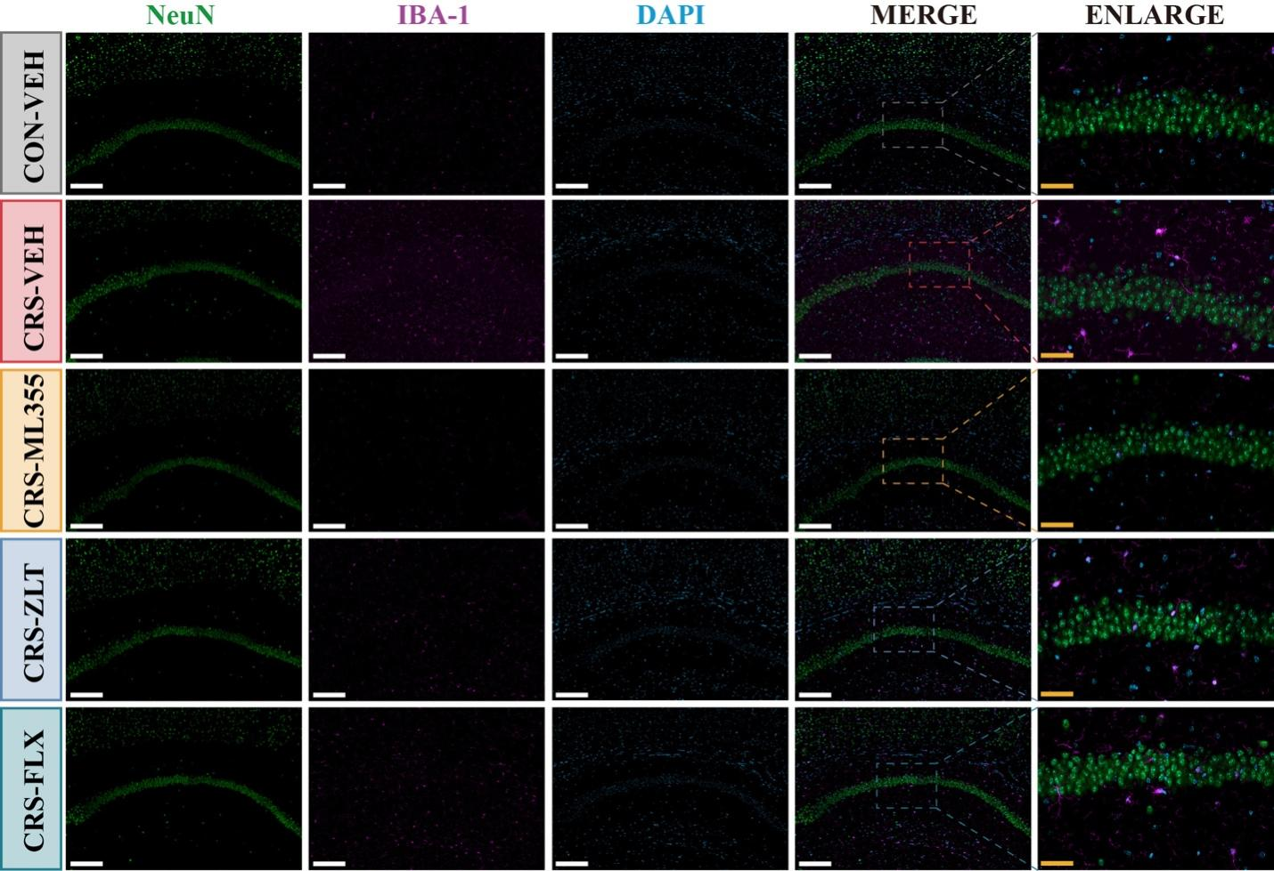
Figure S4 Representative images of microglial activation (Iba-1) in the hippocampal CA1 region across treatment groups. White scale bar=200 μm, yellow scale bar=50 μm.

FigureS5 ML-355 inhibits chronic restraint stress-induced microglial activation (Iba-1) in the prefrontal cortex (PFC).
(A) Schematic diagram of coronal section of the hippocampus with regional segmentation. (B-C) Quantitative analysis of relative fluorescence intensity of Iba-1 (microglial activation) in the Cg1 region and PrL region of PFC among different groups. (D) Representative images of microglial activation (Iba-1) in the Cg1 region of PFC among different groups. (E) Representative images of microglial activation (Iba-1) in the PrL region of PFC among different groups. White scale bar=200 μm, yellow scale bar=75 μm. N=6~8 per group in (B)~(C). Statistical significance: *p<0.05, **p<0.01, ***p<0.001,****p<0.0001. The data are expressed as the means ± SD. Cg1: cingulate cortex, area 1, PrL: prelimbic cortex, M2: secondary motor cortex, M1: primary motor cortex, S1: primary somatosensory cortex, AI: agranular insular cortex, LO: lateral orbital cortex, VO: ventral orbital cortex, MO: medial orbital cortex, fmi: forceps minor of the corpus callosum, cl: claustrum.

