CD137L adjuvanted vaccine increases antigen-specific T-cell responses but impacts antigen-specific humoral responses

Kanin Salao^{1,2,3#}, Ming Xuan Lim^{4#}, Daryl Zhang Wei Lee^{2,3}, Jazz Linn Ng^{2,3}, Jia Le Lin^{1,2,3}, Wanzhen Lu⁴, Estelle Goh⁴, Emily Nickles^{1,2}, Herbert Schwarz^{1,2†}*, Sylvie Alonso^{2,3,5†}*, Guillaume Carissimo^{4,6,7†}*

Supplementary material and methods
Supplementary Material

Table S1. T-cell panel antibodies for flow cytometry (M2e and NP)
Target | Fluorochrome | Dilution | Catalog number | Brand
Cell surface staining
CD3 | BUV421 | 1:100 | 704014 | BD Biosciences
CD4 | APC | 1:100 | 561091 | BD Biosciences
CD8 | RY775 | 1:100 | 571368 | BD Biosciences
CD107a | PE | 1:100 | 558661 | BD Biosciences
Intracellular staining
IFNγ | FITC | 1:100 | 554411 | BD Biosciences
TNFα | RB613 | 1:100 | 571332 | BD Biosciences
IL-2 | RB705 | 1:100 | 570704 | BD Biosciences

Table S2. T-cell panel antibodies for flow cytometry (RBD)
Target | Fluorochrome | Dilution | Catalog number | Brand
Extracellular T-cell staining
PD-1 | APC-R700 | 1:200 | 566876 | BD Biosciences
CD25 | SBUV665 | 1:50 | MCA1260SBUV665 | Bio-Rad
CD4 | BUV496 | 1:200 | 612952 | BD Biosciences
CD185 (CXCR5) | BV785 | 1:80 | 145523 | Biolegend
CD8a | APC-Fire 750 | 1:200 | 100766 | Biolegend
CD69 | BV711 | 1:50 | 104537 | Biolegend
CD3 | PECy7 | 1:200 | 560591 | BD Biosciences
CD103 | APC | 1:80 | 562772 | BD Biosciences
CD45 | BUV805 | 1:200 | 368-0451-82 | Thermo Fisher Scientific
CD19 | Biotinylated | 1:200 | 115504 | Biolegend
CD11b | Biotinylated | 1:400 | 101204 | Biolegend
CD161 (NK1.1) | Biotinylated | 1:400 | 108704 | Biolegend
Intracellular T-cell cytokine staining
IL-10 | BV605 | 1:20 | 505031 | Biolegend
IL-17A | BUV615 | 1:80 | 366-7177-82 | Thermo Fisher Scientific
IL-5 | BV421 | 1:20 | 504311 | Biolegend
IFN-g | PE-CF594 | 1:80 | 562303 | BD Biosciences
IL-4 | AF488 | 1:50 | 504109 | Biolegend
Granzyme B | PerCP-eFluor 710 | 1:100 | 46-8898-82 | Thermo Fisher Scientific

Table S3. B cell panel antibodies for flow cytometry (M2e)
Target | Fluorochrome | Dilution | Catalog number | Brand
Cell surface staining
B220 | BUV395 | 1:200 | 563793 | BD Biosciences
IgD | BV711 | 1:200 | 564275 | BD Biosciences
GL-7 | Alexa Fluor 647 | 1:200 | 561529 | BD Biosciences
CD95 | BV605 | 1:200 | 152612 | Biolegend
Decoy (Sav) | BB515 | 1 μg/mL | 564453 | BD Biosciences

Table S4. B cell panel antibodies for flow cytometry (RBD)
Target | Fluorochrome | Dilution | Catalog number | Brand
B cell staining
IgD[b] | BUV661 | 1:25 | 750656 | BD Biosciences
CD19 | BUV805 | 1:100 | 368-0193-82 | Thermo Fisher Scientific
CD27 | BV421 | 1:100 | 124223 | Biolegend
CD184 (CXCR4) | BV711 | 1:200 | 146517 | Biolegend
CD95 | FITC plus | 1:200 | FITC-9813 | Proteintech
CD138 | PE-Dazzle594 | 1:100 | 142528 | Biolegend
GL7 | PECy7 | 1:200 | 144620 | Biolegend
CD45R (B220) | AlexaFluor700 | 1:200 | 103232 | Biolegend

Figure S1. Gating strategies for flow cytometry.
Gating strategy for M2e specific GC B cells for mRNA format

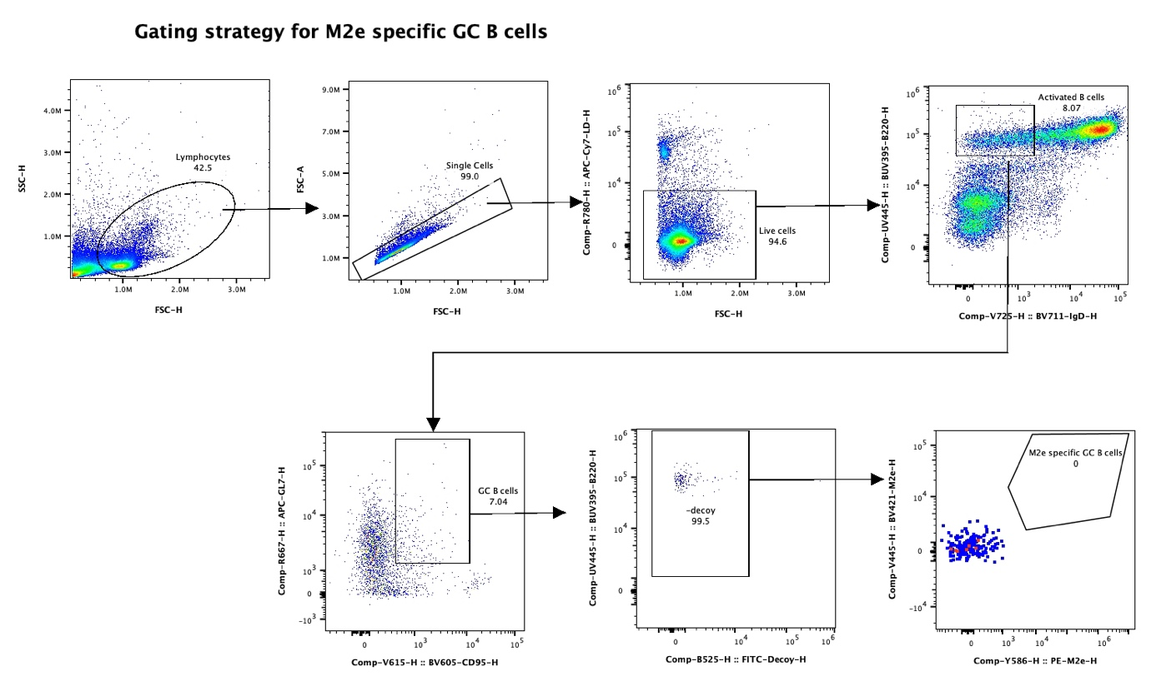

Gating strategy for effector T-cells for mRNA format

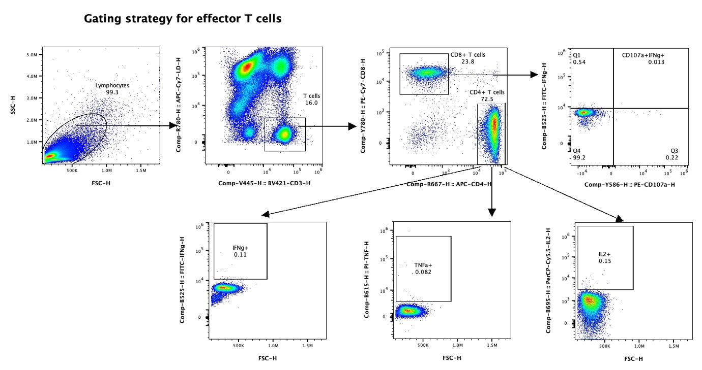

B cell gating strategy for recombinant protein format
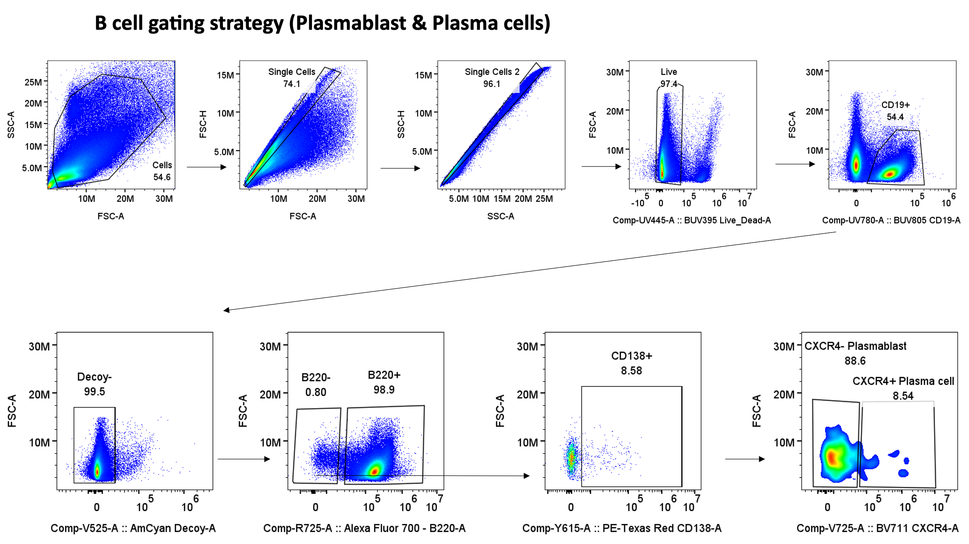
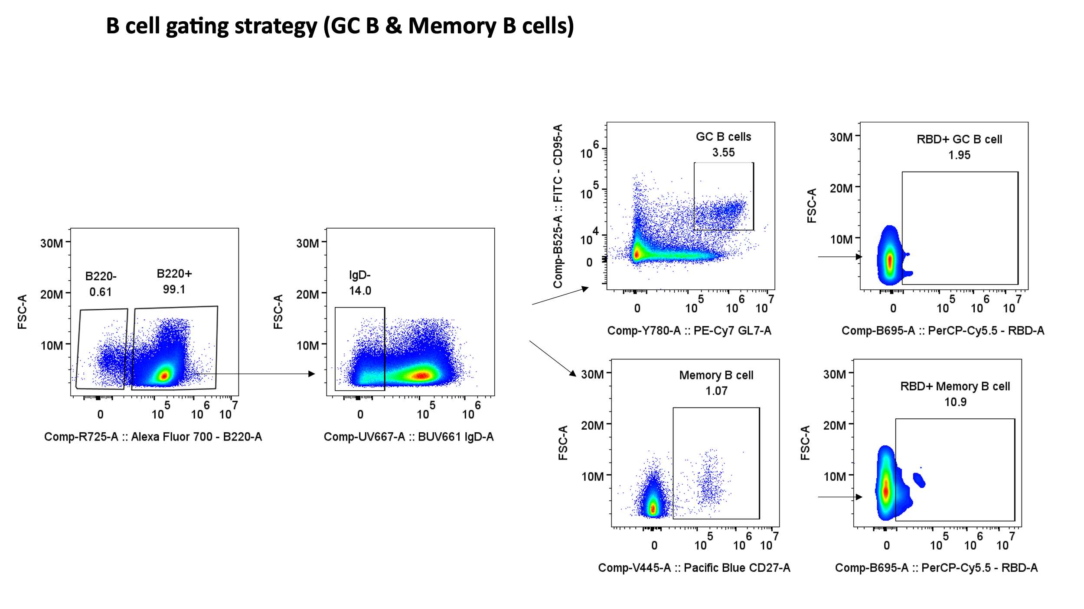

T-cell gating strategy for recombinant protein format
