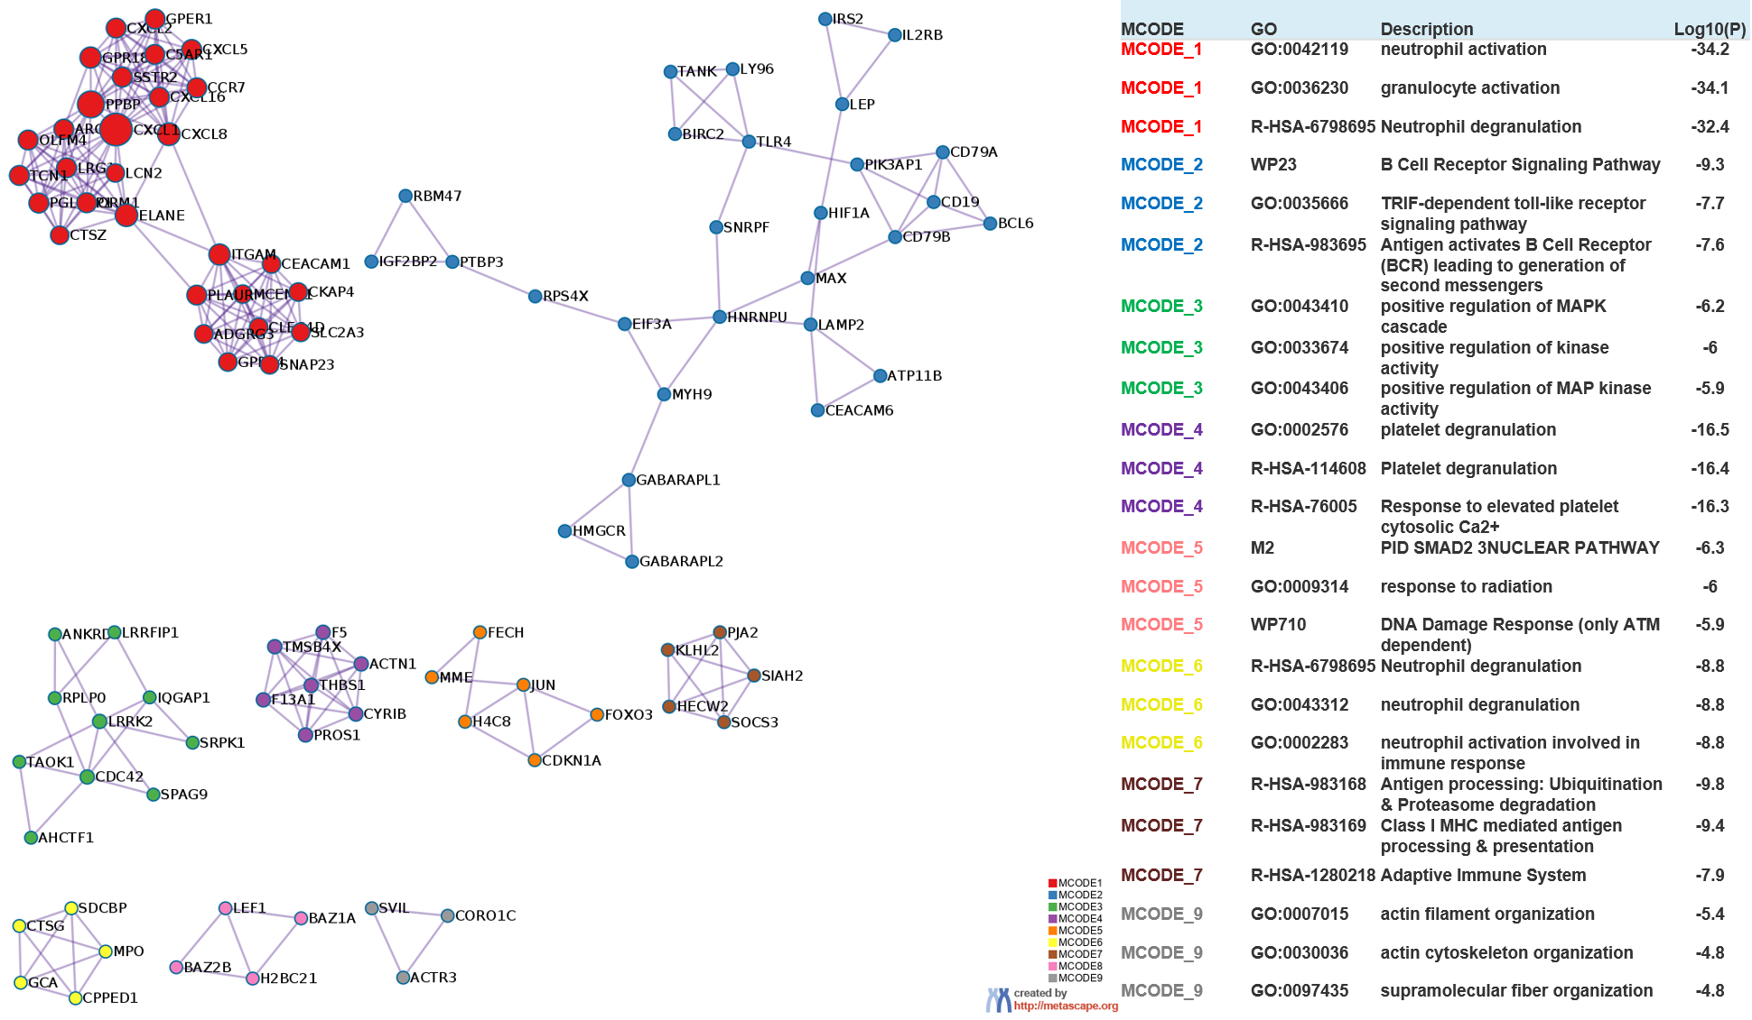
Supplementary Figures
Supplementary Figure 1. Results of PPI network analysis.

