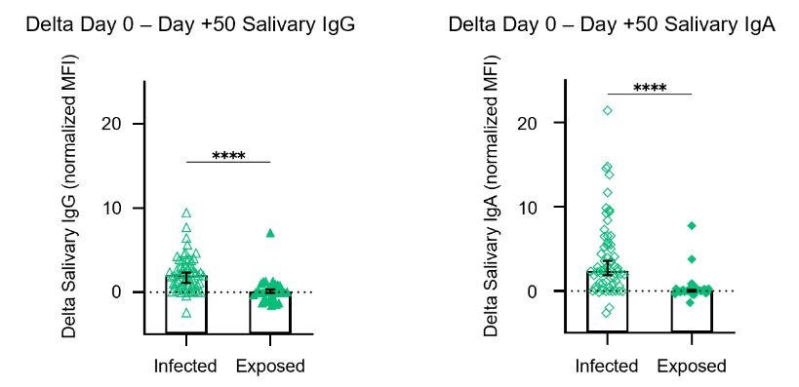
Figure S1. Elevated salivary IgG and IgA dynamics in infected individuals across the 50-day follow-up period. Related to Figure 2.
Change in salivary IgG (left) and salivary IgA (right) levels between Day 0 and Day +50 (Δ, normalized MFI) in infected (n=62) versus exposed (n=33) individuals. Bars indicate the median and 95% confidence interval (CI), with individual data points shown. Statistical analysis was performed using the Mann-Whitney U test (salivary IgG: p < 0.0001; salivary IgA: p < 0.0001). Both salivary IgG and IgA levels increased significantly in the infected group compared to the exposed group (****p < 0.0001).

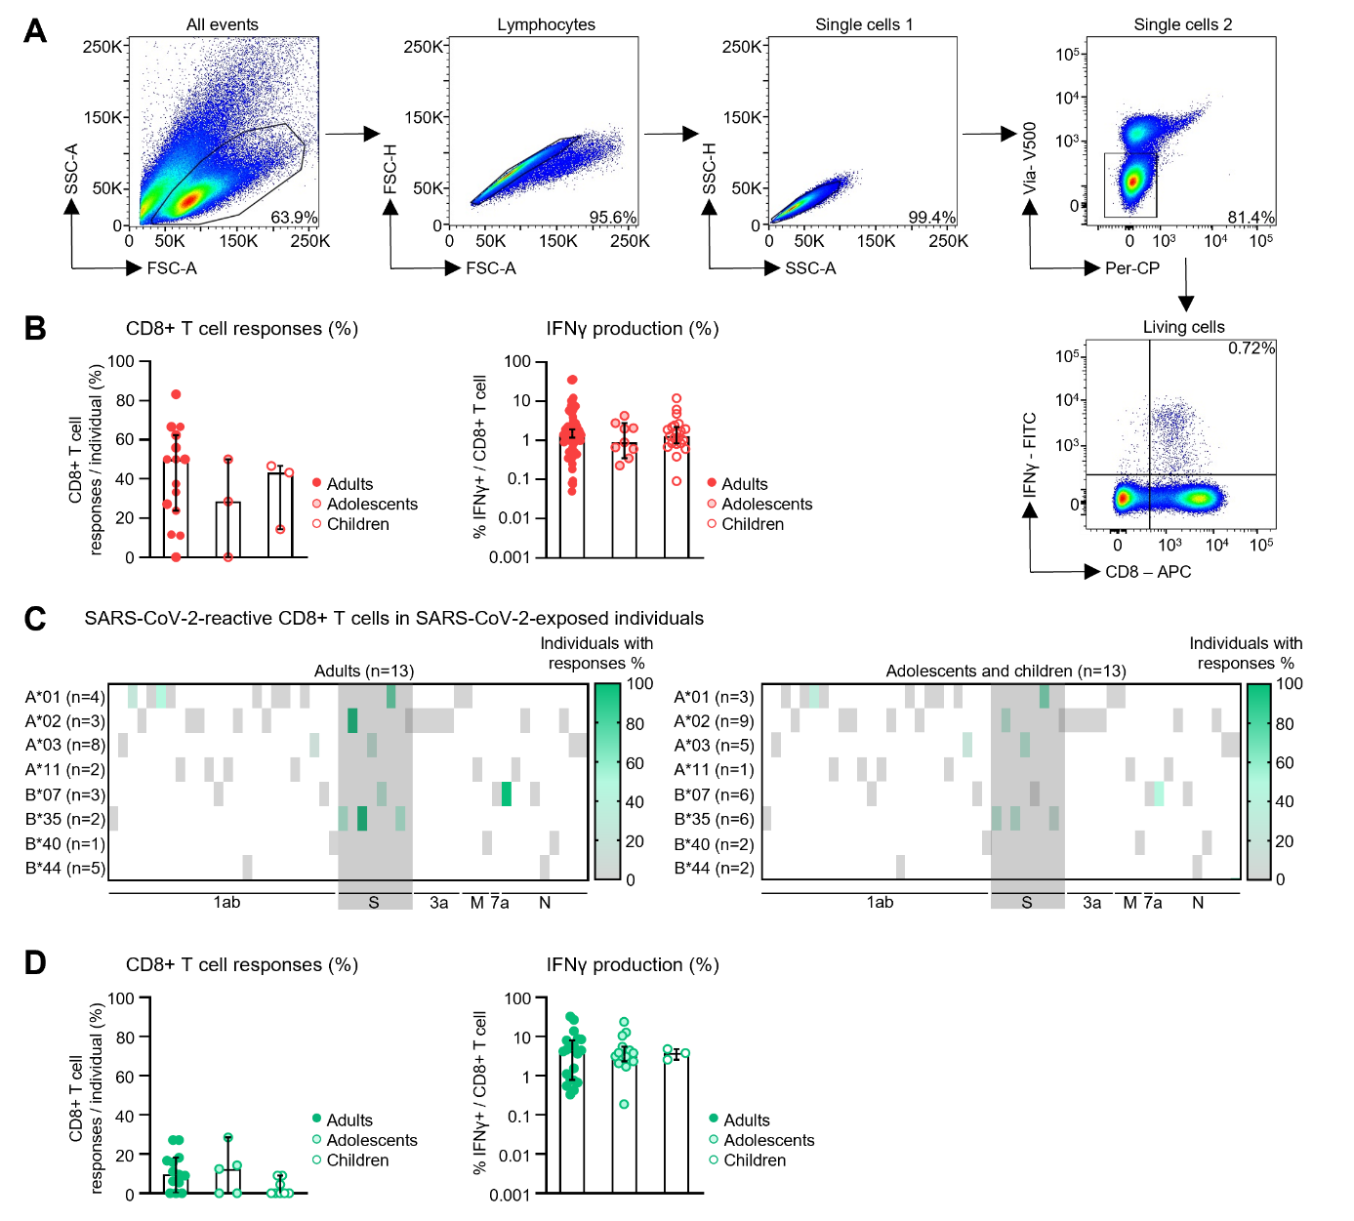
Figure S2. Similar virus-specific CD8+ T cell immunity after hybrid immunization and during abortive infection, regardless of age. Related to Figure 4.
CD8+ T cell responses are shown of adults (≥18 years), adolescents (12-17 years), children (≤11 years).
(A) Gating strategy to analyze the SARS-CoV-2-specific CD8+ T cell repertoire. Lymphocytes were gated on FSC-A and SSC-A, doublet exclusion was applied on FSC-A/ FSC-H and SSC-A/ SSC-H, gating was performed on living cells, followed by gating on IFNγ+ CD8+ T cells.
(B) Percentages of CD8+ T cell responses per individual (left) and IFNγ production (right) to previously described optimal CD8+ T cell epitopes (infected individuals, adults n=15, adolescents n=3, children n=3). Bar charts display the median, with error bars representing the 95% confidence interval. Statistical differences were evaluated using the Kruskal-Wallis test followed by Dunn’s post hoc test for multiple comparisons.
(C) CD8+ T cell responses to previously identified optimal CD8+ T cell epitopes in exposed adults n=13 (left) and adolescents and children n=13 (right). The proportion of positive responses per tested HLA allotype is shown. CD8+ T cell responses to spike-specific CD8+ T cell epitopes are highlighted with a gray box.
(D) Percentages of CD8+ T cell responses per individual (left) and IFNγ production (right) to previously described optimal CD8+ T cell epitopes (exposed individuals, adults n=13, adolescents n=5, children n=8). Bar charts show the median with 95% confidence interval error bars. Statistical significance was assessed by a Kruskal-Wallis test followed by Dunn’s post hoc test for multiple comparisons.

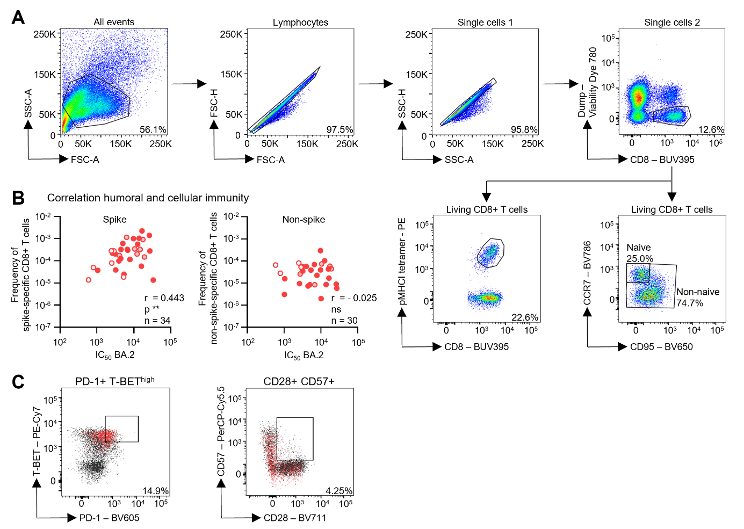
Figure S3. Comparable frequencies of spike- and non-spike-specific CD8+ T cells in adults, adolescents and children. Related to Figure 4.
CD8+ T cell responses are shown of adults (≥18 years), adolescents (12-17 years), children (≤11 years).
(A) Gating strategy to detect SARS-CoV-2-specific CD8+ T cells ex vivo after pMHCI tetramer-based enrichment. Lymphocytes were gated on FSC-A and SSC-A, doublet exclusion was applied on FSC-A/ FSC-H and SSC-A/ SSC-H, gating was performed on living CD8+ cells, followed by gating on SARS-CoV-2-specific CD8+ T cells, and further gating on naïve and non-naïve CD8+ T cells.
(B) The frequency of spike-specific CD8+ T cells (adults n=19, adolescents n=9, children n=6) and the frequency of non-spike-specific CD8+ T cells (adults n=20, adolescents n=6, children=4) is depicted at the IC50 BA.2. Statistical significance was assessed by Spearman’s correlation, **p < 0.01.
(C) Representative dot plots of SARS-CoV-2-specific CD8+ T cells co-expressing PD-1 and T-BEThigh (left) and CD28 and CD57 (right).

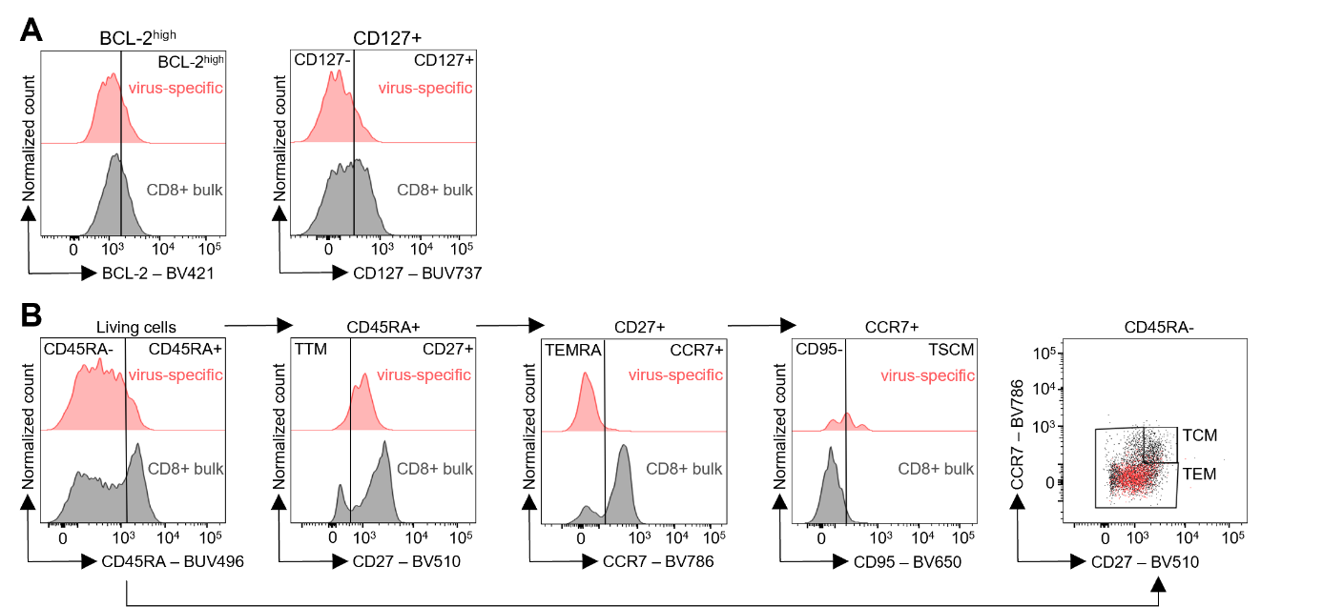
Figure S4. Hybrid immunity induces robust virus-specific CD8+ T-cell memory across all age groups. Related to Figure 5.
CD8+ T cell responses are shown of adults (≥18 years), adolescents (12-17 years), children (≤11 years).
(A) Histograms depicting BCL-2high (left) and CD127 (right) expression levels on virus-specific CD8+ T cells (red) and CD8+ bulk (grey).
(B) Gating strategy used to define CD8+ memory T-cell subsets following ex vivo pMHCI tetramer-based enrichment on virus-specific CD8+ T cells (red) and bulk CD8+ T cells (grey).

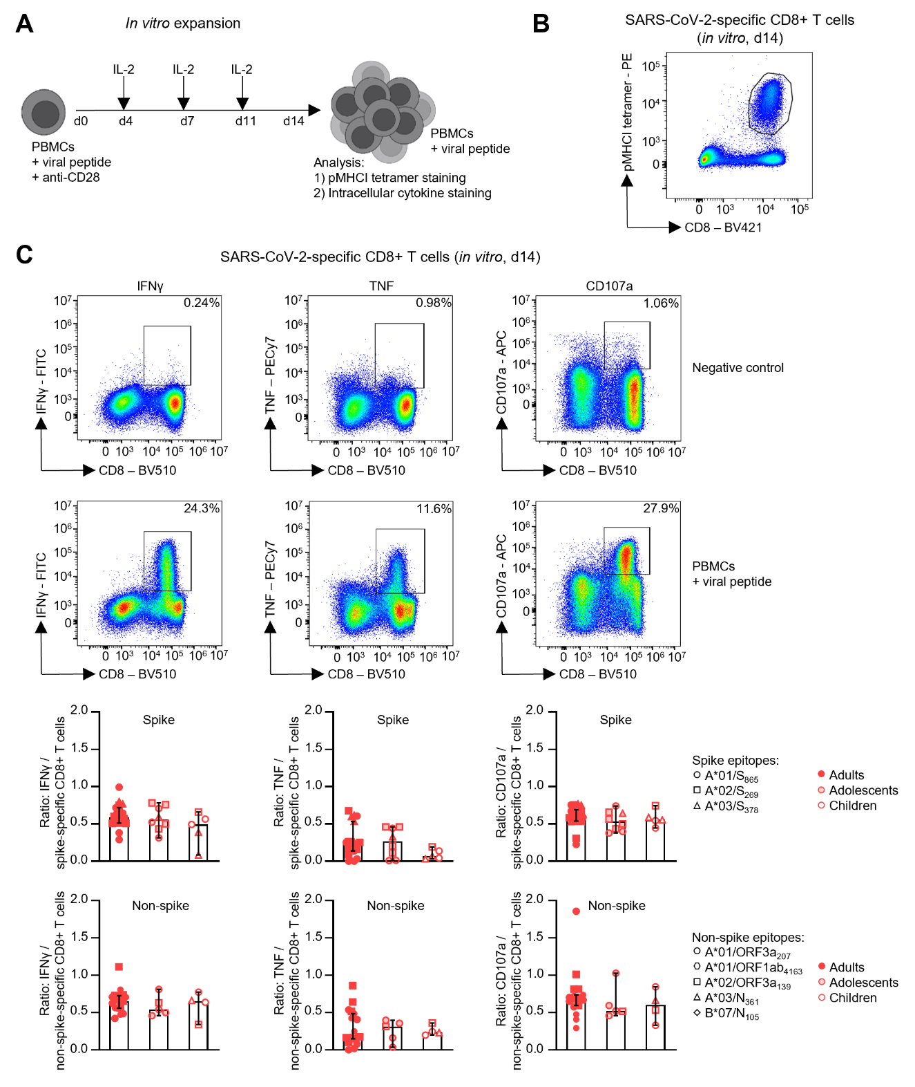
Figure S5. Robust in vitro functionality of virus-specific CD8+ T-cell across all age groups. Related to Figure 5.
CD8+ T cell responses are shown of adults (≥18 years), adolescents (12-17 years), children (≤11 years).
(A) Workflow illustrating peptide-specific in vitro expansion of CD8+ T cells.
(B) Representative dot plot of SARS-CoV-2-specific CD8+ T cells after 14 days in vitro expansion.
(C) Expression of IFNγ, TNF and CD107a/ degranulation in relation to the frequency of spike-specific CD8+ T cells (adults n=19, adolescents n=8, children n=5) and non-spike-specific CD8+ T cells (adults n=17, adolescents n=5, children=4) after 14 days of in vitro expansion. Representative dot plots show the cytokine response to a negative control (top) and to viral peptides (bottom). Bar charts show the median with 95% confidence interval error bars. Statistical significance was assessed by a Kruskal-Wallis test with Dunn’s multiple comparisons test.
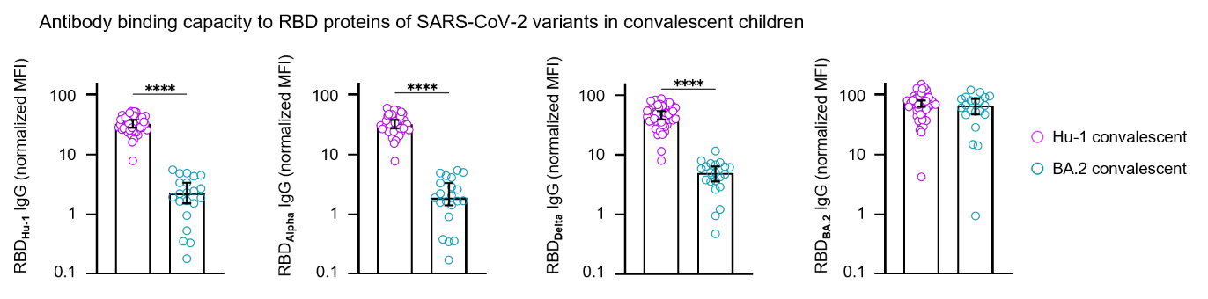
Figure S6. Distinct IgG binding capacities to SARS-CoV-2 RBD variants in unvaccinated children after BA.2 or Hu-1 infection. Related to Figure 6.
Panels illustrating data from the MultiCoV-Ab, lines indicate the median. IgG Antibody Binding (DF 1:400) of RBD isolates from 4 SARS-CoV-2 variants in children following BA.2 (n = 21) or Hu-1 infection (n = 49). Statistical significance was calculated using a Man Whitney U test, with p-values indicated above the groups, ****p < 0.0001.

Detailed statistics related to Figure 3
The following contingency tables and statistical results of Fisher’s exact tests present the evaluation of the potential influence of immunity (S1), sex (S2), and age (S3) on the occurrence of cytokine autoantibodies within the cohort and are related to Figure 3. A cut-off value of MFI = 1500 was applied to classify samples as positive.
Table S1: Distribution of individuals positive for autoantibodies against selected cytokines across hybrid immunity, vaccinated-only, SARS-CoV-2 convalescent (Hu-1 or BA.2), and seronegative cohorts. Related to Figure 3.
Data are shown as number of positive individuals and percentage within each group. P values indicate the association between autoantibody prevalence and immune background, calculated using Fisher’s exact test.
 | Hybrid |  | Vaccinated |  | Hu-1 convalescent |  | BA.2 convalescent |  | Seronegative |  | Fishers exact test (p)
 | (n = 84) |  | (n = 37) |  | (n = 167) |  | (n = 22) |  | (n=50) |  | Fishers exact test (p)
 | n (positive) | % | n (positive) | % | n (positive) | % | n (positive) | % | n (positive) | % | Fishers exact test (p)
IFN-α2a | 2 | 2% | 1 | 3% | 8 | 5% | 3 | 14% | 3 | 6% | 0,151
IFN-β | 0 | 0% | 0 | 0% | 1 | 1% | 0 | 0% | 1 | 2% | >0,999
IFN-ω | 17 | 20% | 7 | 19% | 65 | 39% | 6 | 27% | 8 | 16% | 0,007
IFN-γ | 1 | 1% | 0 | 0% | 23 | 14% | 1 | 5% | 2 | 4% | <0,001
IFN-λ1 | 13 | 15% | 2 | 5% | 39 | 23% | 3 | 14% | 9 | 18% | 0,047
IL6 | 19 | 23% | 7 | 19% | 72 | 43% | 4 | 18% | 10 | 20% | <0,001
IL8 | 0 | 0% | 0 | 0% | 1 | 1% | 0 | 0% | 1 | 2% | >0,999
GM-CSF | 6 | 7% | 2 | 5% | 18 | 11% | 1 | 5% | 3 | 6% | 0,694
TNFα | 5 | 6% | 2 | 5% | 20 | 12% | 0 | 0% | 4 | 8% | 0,180

Table S2: Distribution of individuals positive for autoantibodies against selected cytokines stratified by sex. Related to Figure 3.
Data are shown as number of positive individuals and percentage within each group. P values indicate the association between autoantibody prevalence and immune background, calculated using Fisher’s exact test.
 | Male (n= 189) |  | Female (n=195) |  | Fishers exact test (p)
 | n (positive) | % | n (positive) | % | Fishers exact test (p)
IFN-α2a | 8/189 | 4% | 10/195 | 5% | 0,811
IFN-β | 0/189 | 0% | 2/195 | 1% | 0,499
IFN-ω | 40/189 | 21% | 69/195 | 35% | 0,002
IFN-γ | 14/189 | 7% | 14/195 | 7% | >0,999
IFN-λ1 | 29/189 | 15% | 39/195 | 20% | 0,285
IL6 | 59/189 | 31% | 57/195 | 29% | 0,739
IL8 | 2/189 | 1% | 1/195 | 1% | 0,618
GM-CSF | 17/189 | 9% | 17/195 | 9% | >0,999
TNFα | 14/189 | 7% | 20/195 | 10% | 0,372
Table S3: Distribution of individuals positive for autoantibodies against cytokines across age groups. Related to Figure 3.
Data are shown as number of positive individuals and percentage within each group. P values indicate the association between autoantibody prevalence and sex, calculated using Fisher’s exact test.
 | Children (n = 124) |  | Adolescents (n = 59) |  | Adults (n = 201) |  | Fishers exact test (p)
 | n (positive) | % | n (positive) | % | n (positive) | % | Fishers exact test (p)
IFN-α2a | 10/124 | 8% | 0/59 | 0% | 8/201 | 4% | 0,044
IFN-β | 1/124 | 1% | 0/59 | 0% | 1/201 | 0% | >0,999
IFN-ω | 45/124 | 36% | 19/59 | 32% | 45/201 | 22% | 0,020
IFN-γ | 12/124 | 10% | 5/59 | 8% | 11/201 | 5% | 0,321
IFN-λ1 | 11/124 | 9% | 10/59 | 17% | 47/201 | 23% | 0,003
IL6 | 31/124 | 25% | 15/59 | 25% | 70/201 | 35% | 0,122
IL8 | 2/124 | 2% | 0/59 | 0% | 1/201 | 0% | 0,734
GM-CSF | 16/124 | 13% | 7/59 | 12% | 11/201 | 5% | 0,041
TNFα | 9/124 | 7% | 3/59 | 5% | 22/201 | 11% | 0,394

Table S4. SARS-CoV-2-derived epitopes used for analyses of SARS-CoV-2-specific CD8+ T cell responses. Related to STAR Methods.

Epitope | Amino acid sequence
B*35/ORF1ab₄₄₇₋₄₅₅ | NAAISDYDY
A*03/ORF1ab₈₀₈₋₈₁₆ | VTNNTFTLK
A*01/ORF1ab₁₃₂₁₋₁₃₂₉ | PTDNYITTY
A*02/ORF1ab₁₅₆₆₋₁₅₇₄ | RTIKVFTTV
A*01/ORF1ab₁₆₃₆₋₁₆₄₆ | HTTDPSFLGRY
A*01/ORF1ab₁₆₃₇₋₁₆₄₆ | TTDPSFLGRY
A*01/ORF1ab₁₈₈₉₋₁₈₉₉ | CTEIDPKLDNY
A*11/ORF1ab₂₁₉₂₋₂₂₀₀ | ASMPTTIAK
A*02/ORF1ab₂₂₉₇₋₂₃₀₇ | SLDTYPSLETI
A*02/ORF1ab₂₃₃₂₋₂₃₄₀ | ILFTRFFYV
A*11/ORF1ab₂₆₀₀₋₂₆₀₈ | STFNVPMEK
B*07/ORF1ab₂₇₈₈₋₂₇₉₆ | YLITPVHVM
B*07/ORF1ab₂₉₄₉₋₂₉₅₆ | RPDTRYVL
A*11/ORF1ab₃₆₂₂₋₃₆₃₀ | SAFAMMFVK
A*02/ORF1ab₃₈₈₆₋₃₈₉₄ | KLWAQCVQL
B*44/ORF1ab₃₉₄₆₋₃₉₅₄ | SEFSSLPSY
A*01/ORF1ab₄₀₈₂₋₄₀₉₁ | NTCDGTTFTY
A*02/ORF1ab₄₀₉₄₋₄₁₀₂ | ALWEIQQVV
A*01/ORF1ab₄₁₆₃₋₄₁₇₁ | CTDDNALAY
A*01/ORF1ab₄₁₆₃₋₄₁₇₂ | CTDDNALAYY
A*11/ORF1ab₄₂₁₆₋₄₂₂₄ | VTDTPKGPK
A*01/ORF1ab₅₁₃₀₋₅₁₃₈ | DTDFVNEFY
A*24/ORF1ab₅₁₃₇₋₅₁₄₅ | FYAYLRKHF
A*03/ORF1ab₅₅₃₃₋₅₅₄₂ | VVYRGTTTYK
A*24/ORF1ab₅₇₂₁₋₅₇₂₉ | VYIGDPAQL
B*07/ORF1ab₅₉₁₆₋₅₉₂₄ | IPRRNVATL
B*40/ORF1ab₆₂₁₉₋₆₂₂₈ | IEYPIIGDEL
B*35/S₈₄₋₉₂ | LPFNDGVYF
A*02/S₂₆₉₋₂₇₇ | YLQPRTFLL
B*35/S₃₂₁₋₃₂₉ | QPTESIVRF
A*03/S₃₇₈₋₃₈₆ | KCYGVSPTK
A*24/S₄₄₈₋₄₅₆ | NYNYLYRLF
B*07/S₆₈₀₋₆₈₈ | SPRRARSVA
A*01/S₈₆₅₋₈₇₃ | LTDEMIAQY
B*35/S₈₉₆₋₉₀₄ | IPFAMQMAY
A*02/S₁₀₀₀₋₁₀₀₈ | RLQSLQTYV
A*24/S₁₂₀₈₋₁₂₁₆ | QYIKWPWYI
A*24/S₁₂₁₁₋₁₂₂₀ | KWPWYIWLGF
A*02/ORF3a₇₂₋₈₀ | ALSKGVHFV
A*02/ORF3a₈₂₋₉₀ | NLLLLFVTV
A*02/ORF3a₁₀₇₋₁₁₅ | YLYALVYFL
A*24/ORF3a₁₁₂₋₁₂₀ | VYFLQSINF
A*02/ORF3a₁₃₉₋₁₄₇ | LLYDANYFL
A*01/ORF3a₂₀₇₋₂₁₅ | FTSDYYQLY
B*40/M₁₃₆₋₁₄₅ | SELVIGAVIL
A*01/M₁₇₁₋₁₇₉ | ATSRTLSYY
A*11/M₁₇₁₋₁₈₀ | ATSRTLSYYK
B*07/ORF7a₇₈₋₈₆ | RARSVSPKL
B*27/N₉₋₁₇ | QRNAPRITF
B*07/N₁₀₅₋₁₁₃ | SPRWYFYYL
A*11/N₁₃₄₋₁₄₃ | ATEGALNTPK
A*02/N₂₂₂₋₂₃₀ | LLLDRLNQL
B*07/N₂₅₇₋₂₆₅ | KPRQKRTAT
Epitope | Amino acid sequence
B*15/N₃₀₅₋₃₁₄ | AQFAPSASAF
B*44/N₃₂₂₋₃₃₀ | MEVTPSGTW
B*40/N₃₂₂₋₃₃₁ | MEVTPSGTWL
A*02/N₃₃₈₋₃₄₆ | KLDDKDPNF
A*03/N₃₆₁₋₃₆₉ | KTFPPTEPK
A*03/N₃₆₁₋₃₇₀ | KTFPPTEPKK

Table S5. Characteristics of infected individuals (Omicron cohort 2022). Related to Figure 4, 5.
Vacc. no. = Covid vaccinations count
Donor ID | Family ID | Age group | Age | Sex | Vacc. no. | PCR day 0 | PCR day 10 | Serum N-IgG day 50 | HLA class I type
OI1 | 2 | adults | 39 | m | 3 | positive | positive | 2.20 | A*23:01, A*32:01, B*40:02, B*49:01
OI2 | 2 | adults | 38 | f | 3 | positive | positive | 4.12 | A*31:01, A*68:01, B*40:01, B*55:01
OI3 | 3 | adults | 37 | m | 3 | positive | negative | 1.77 | A*03:01, B*07:02, B*35:01
OI4 | 4 | adults | 45 | f | 3 | positive | positive | 2.39 | A*01:01, A*32:01, B*14:01, B*53:01
OI5 | 4 | adults | 35 | m | 3 | negative | positive | 2.38 | A*01:01, A*03:01, B*08:01, B*13:02
OI6 | 4 | adolescents | 15 | f | 3 | positive | negative | 3.09 | A*01:01, B*53:01, B*57:01
OI7 | 5 | adults | 42 | m | 3 | positive | positive | 2.16 | A*02:01, A*03:01, B*07:02, B*27:05
OI8 | 5 | adults | 41 | f | 3 | positive | negative | 3.46 | A*01:01, A*03:01, B*15:01, B*44:03
OI9 | 6 | adults | 45 | m | 3 | positive | negative | 2.54 | A*01:01, A*03:01, B*07:02, B*08:01
OI10 | 6 | adolescents | 13 | f | 2 | positive | negative | 1.25 | A*02:01, A*03:01, B*07:02, B*57:01
OI11 | 7 | adults | 42 | f | 3 | positive | positive | 0.59 | A*01:01, A*02:01, B*27:05, B*44:27
OI12 | 7 | adults | 48 | m | 3 | positive | negative | 1.44 | A*02:01, A*32:01, B*35:03, B*51:01
OI13 | 7 | adolescents | 14 | m | 3 | negative | positive | 2.43 | A*01:01, A*32:01, B*27:05, B*35:03
OI14 | 7 | children | 8 | m | 2 | positive | negative | 1.88 | A*01:01, A*32:01, B*27:05, B*35:03
OI15 | 8 | adults | 44 | f | 3 | positive | negative | 2.30 | A*03:01, A*24:02, B*35:03, B*39:06
OI16 | 8 | adults | 42 | m | 3 | negative | positive | 2.36 | A*03:01, A*26:01, B*27:02
OI17 | 8 | children | 10 | f | 2 | positive | negative | 2.62 | A*03:01, A*24:02, B*27:05, B*39:06
OI18 | 8 | children | 6 | m | 2 | negative | positive | 2.62 | A*24:02, A*26:01, B*27:05, B*39:06
OI19 | 9 | adolescents | 16 | m | 3 | positive | negative | 3.90 | A*01:01, A*02:01, B*27:05, B*56:01
OI20 | 10 | adults | 19 | f | 2 | negative | negative | 3.17 | A*26:01, A*30:02, B*15:01, B*18:01
OI21 | 12 | adults | 40 | f | 2 | negative | positive | 2.39 | A*01:01, A*02:01, B*08:01, B*44:03
OI22 | 13 | adults | 39 | m | 3 | positive | positive | 1.54 | A*01:01, A*03:01, B*08:01
OI23 | 14 | adults | 34 | f | 3 | positive | negative | 1.73 | A*01:01, A*26:01, B*38:01, B*52:01
OI24 | 15 | adults | 44 | f | 3 | negative | positive | 2.72 | A*01:01, A*33:01, B*08:01, B*35:03
OI25 | 15 | children | 9 | f | 1 | positive | negative | 5.08 | A*01:01, A*23:01, B*08:01, B*27:05
OI26 | 16 | adults | 44 | m | 3 | positive | positive | 3.40 | A*02:01, A*31:01, B*07:02, B*40:01
OI27 | 16 | adolescents | 17 | m | 3 | positive | negative | 3.43 | A*02:01, B*14:02, B*40:01
OI28 | 16 | adolescents | 14 | f | 3 | positive | negative | 4.12 | A*02:01, A*31:01, B*07:02, B*14:02
OI29 | 16 | children | 11 | f | 2 | positive | negative | 2.57 | A*02:01, A*31:01, B*07:02, B*14:02
OI30 | 17 | adults | 46 | m | 3 | positive | negative | 3.24 | A*02:01, A*68:01, B*15:01, B*51:01
OI31 | 18 | adolescents | 12 | m | 2 | positive | negative | 3.27 | A*02:01, A*25:01, B*15:01, B*51:01
OI32 | 19 | adults | 35 | m | 3 | negative | positive | 1.14 | A*01:01, A*02:05, B*08:01, B*49:01
OI33 | 19 | children | 9 | m | 2 | positive | negative | 2.04 | A*01:01, A*02:01, B*07:02, B*08:01
OI34 | 20 | adults | 49 | m | 3 | negative | positive | 1.48 | A*01:01, A*02:02, B*08:01, B*56:01
OI35 | 20 | adolescents | 13 | m | 3 | positive | negative | 3.81 | A*01:01, A*66:01, B*08:01, B*38:01
OI36 | 21 | adolescents | 17 | f | 3 | positive | negative | 3.66 | A*01:01, A*03:01, B*15:01, B*35:01
OI37 | 22 | adults | 31 | m | 3 | positive | negative | 2.38 | A*01:01, A*03:01, B*07:02, B*57:01
OI38 | 22 | children | 10 | f | 2 | positive | negative | 3.31 | A*01:01, A*03:01, B*07:02, B*08:01
OI39 | 25 | adults | 52 | m | 3 | positive | positive | 2.20 | A*01:01, A*11:01, B*08:01, B*49:01
OI40 | 25 | adolescents | 15 | f | 3 | positive | negative | 1.42 | A*11:01, A*24:02, B*07:02, B*49:01
OI41 | 28 | adults | 42 | f | 3 | positive | positive | 2.99 | A*01:01, A*68:02, B*14:02, B*37:01
OI42 | 28 | children | 9 | m | 2 | negative | positive | 3.91 | A*01:01, A*23:01, B*37:01, B*49:01
OI43 | 31 | adults | 36 | f | 3 | negative | negative | 1.39 | A*02:01, A*24:02, B*15:01, B*15:09
OI44 | 31 | children | 7 | m | 2 | positive | negative | 1.68 | A*02:01, A*03:01, B*15:01, B*18:01
OI45 | 33 | adults | 42 | f | 3 | positive | negative | 1.41 | A*01:01, A*29:02, B*08:01, B*45:01
OI46 | 34 | adults | 39 | m | 3 | positive | positive | 2.82 | A*24:02, A*31:01, B*35:01, B*44:03
OI47 | 34 | adults | 38 | f | 3 | positive | negative | 1.67 | A*01:01, A*02:01, B*07:02, B*41:01
OI48 | 36 | adults | 33 | m | 3 | positive | positive | 0.84 | A*01:01, A*02:01, B*27:05, B*57:01
OI49 | 36 | adults | 35 | f | 3 | positive | positive | 1.64 | A*02:01, A*23:01, B*44:02, B*53:01
OI50 | 36 | children | 7 | f | 2 | positive | negative | 1.61 | A*01:01, A*23:01, B*27:05, B*53:01
OI51 | 37 | adults | 54 | m | 3 | positive | negative | 2.79 | A*02:01, B*07:02, B*51:01
OI52 | 38 | adolescents | 16 | m | 3 | positive | negative | 1.74 | A*01:01, A*03:01, B*08:01, B*51:01
OI53 | 38 | adolescents | 16 | f | 3 | negative | negative | 3.17 | A*03:01, A*32:01, B*44:02, B*51:05
OI54 | 41 | adults | 43 | m | 3 | positive | negative | 0.78 | A*01:01, A*02:01, B*08:01, B*39:24

Table S6. Characteristics of exposed individuals (Omicron cohort 2022). Related to Figure 4.
Vacc. no. = Covid vaccinations count
Donor ID | Family ID | Age group | Age | Sex | Vacc. no. | PCR day 0 | PCR day 10 | Serum N-IgG day 50 | HLA class I type
OE1 | 1 | adults | 31 | f | 3 | negative | negative | 0.13 | A*01:01, A*23:01, B*15:01, B*44:03
OE2 | 1 | adults | 31 | m | 3 | negative | negative | 0.15 | A*03:01, A*24:02, B*18:01, B*41:01
OE3 | 9 | adults | 47 | f | 3 | negative | negative | 0.11 | A*02:01, A*32:01, B*27:05, B*44:02
OE4 | 9 | adults | 47 | m | 3 | negative | negative | 0.10 | A*01:01, A*11:01, B*56:01
OE5 | 9 | adolescents | 14 | m | 3 | negative | negative | 0.32 | A*11:01, A*32:01, B*44:02, B*56:01
OE6 | 14 | adults | 35 | m | 3 | negative | negative | 0.11 | A*03:01, A*11:01, B*44:03, B*55:01
OE7 | 17 | adults | 36 | f | 3 | negative | negative | 0.19 | A*03:01, A*29:02, B*15:01, B*35:01
OE8 | 17 | children | 5 | f | 0 | negative | negative | 0.06 | A*02:01, A*03:01, B*35:01, B*51:01
OE9 | 20 | adults | 45 | f | 3 | negative | negative | 0.12 | A*03:01, A*66:01, B*07:02, B*38:01
OE10 | 21 | adults | 48 | m | 3 | negative | negative | 0.10 | A*01:01, A*03:01, B*15:01, B*38:01
OE11 | 26 | adults | 39 | f | 3 | negative | negative | 0.20 | A*02:01, B*07:02, B*44:02
OE12 | 26 | adults | 44 | m | 1 | negative | negative | 0.10 | A*02:01, A*68:01, B*40:01, B*44:05
OE13 | 26 | children | 7 | m | 0 | negative | negative | 0.01 | A*02:01, B*40:01, B*44:02
OE14 | 26 | children | 5 | m | 0 | negative | negative | 0.03 | A*02:01, B*07:02, B*40:01
OE15 | 27 | children | 9 | f | 2 | negative | negative | 0.24 | A*03:01, B*07:02
OE16 | 31 | adults | 40 | m | 3 | negative | negative | 0.09 | A*03:01, B*07:02, B*18:01
OE17 | 33 | children | 6 | f | 2 | negative | negative | 0.07 | A*01:01, A*29:02, B*45:01, B*57:01
OE18 | 34 | children | 7 | f | 2 | negative | negative | 0.10 | A*02:02, A*31:01, B*35:01, B*41:01
OE19 | 34 | children | 4 | m | 0 | negative | negative | 0.12 | A*01:01, B*31:01, B*07:02, B*35:01
OE20 | 37 | adults | 52 | f | 3 | negative | negative | 0.21 | A*03:01, A*68:01, B*35:01, B*40:02
OE21 | 37 | adolescents | 18 | f | 3 | negative | negative | 0.10 | A*02:01, A*03:01, B*07:02, B*35:01
OE22 | 37 | adolescents | 15 | f | 3 | negative | negative | 0.35 | A*02:02, A*03:01, B*07:02, B*35:01
OE23 | 37 | adolescents | 13 | f | 2 | negative | negative | 0.08 | A*02:01, A*03:01, B*07:02, B*35:01
OE24 | 38 | adults | 55 | f | 3 | negative | negative | 0.08 | A*01:01, A*03:01, B*51:05, B*57:01
OE25 | 39 | children | 3 | m | 0 | negative | negative | 0.04 | A*02:01, A*23:01, B*49:01, B*50:01
OE26 | 41 | adolescents | 13 | f | 3 | negative | negative | 0.20 | A*01:01, A*02:01, B*08:01, B*39:42

