Supplementary Materials for
Thermodynamic Optimization of Atomically Thin Iron-Based Compounds for Mid-Infrared Laser Power Scaling

Yunrou Wu^{1, 4}, Weitao Liu^{1, 4}, Tiantian Yun^{2, 4}, Taifeng Liu³, Feng Feng¹, Yanxiang Shi¹, Ruoping Li¹, Xi Wang¹*, Tao Jiang²*, Ke Chen¹*

¹Henan Key Laboratory of Quantum Materials and Quantum Energy, School of Future Technology, School of Physics and Electronics, Henan University, Kaifeng 475004, China.
²MOE Key Laboratory of Advanced Micro-Structured Materials, Shanghai Frontiers Science Center of Digital Optics, Institute of Precision Optical Engineering, and School of Physics Science and Engineering, Tongji University, Shanghai 200092, China.
³National & Local Joint Engineering Research Center for Applied Technology of Hybrid Nanomaterials, Henan University, Kaifeng 475004, China.
⁴These authors contributed equally to this work.
*Corresponding authors. Email: kchen@henu.edu.cn (K.C.); tjiang@tongji.edu.cn (T.J.); wangxi0426@henu.edu.cn (X.W.)

This file includes:
Supplementary Figs. 1 to 14

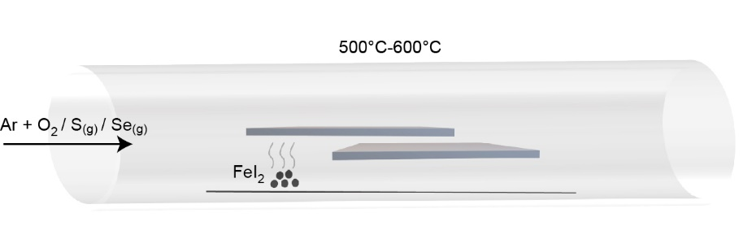
Supplementary Fig. 1 | Schematic illustration of the synthesis process for 2D Fe-based crystals.

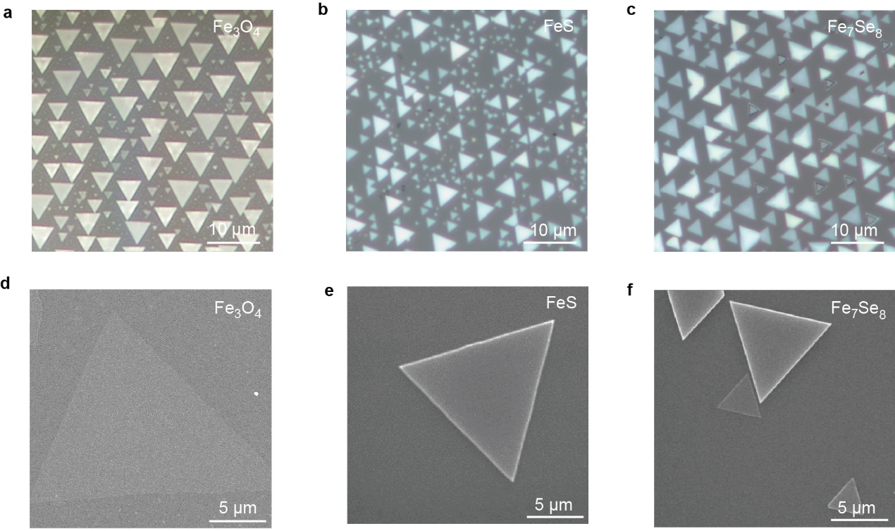
Supplementary Fig. 2 | Morphology of synthesized 2D Fe-based crystals. a-c OM and d-f SEM images of Fe₃O₄, FeS, and Fe₇Se₈, respectively.

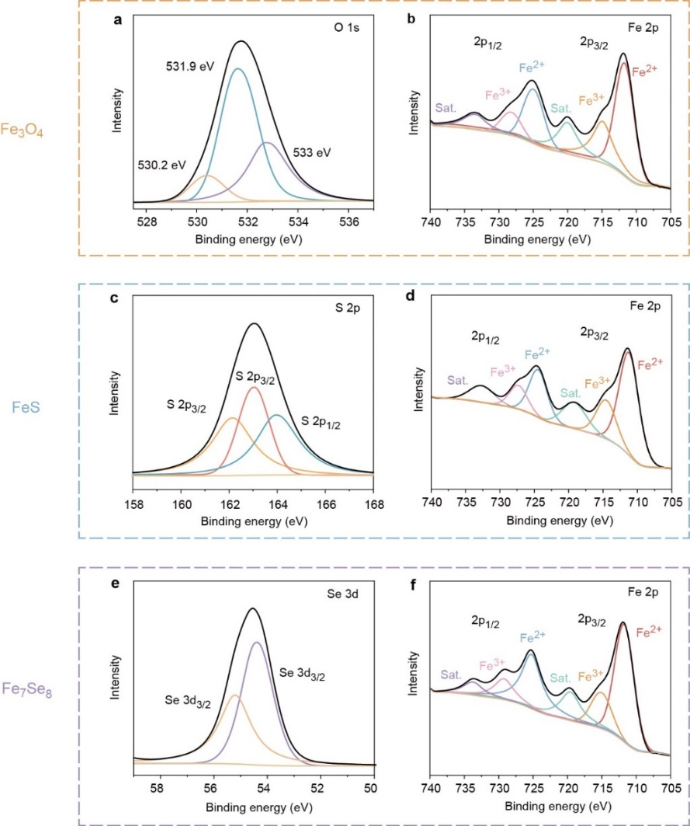
Supplementary Fig. 3 | XPS analysis of 2D Fe-based crystals. a-b Fe 2p and O 1s spectra of Fe₃O₄; c-d Fe 2p and S 2p spectra of FeS; e-f Fe 2p and Se 3d spectra of Fe₇Se₈.
The bonding states and composition of the 2D Fe-based (Fe₃O₄, FeS, Fe₇Se₈) crystals were further confirmed by X-ray photoelectron spectroscopy (XPS), as shown in Figure S3. The binding energies at ~725.9 and ~712.3 eV correspond to Fe³⁺, while the peaks at ~722.9 and ~709.8 eV are assigned to Fe²⁺, consistent with previously reported XPS characteristics of 2D Fe₃O₄, FeS and Fe₇Se₈ crystals. For Fe₃O₄, three distinct peaks located at 530.33, 531.63, and 532.73 eV confirm the presence of O 1s. For FeS, the peaks at 163.95 eV and 162.1 eV in the S 2p orbital are attributed to the S 2p_{1/2} and S 2p_{3/2} states, respectively. In Fe₇Se₈, the peaks at 54.4 eV and 55.2 eV in the Se 3d orbital correspond to the Se 3d_{5/2} and Se 3d_{3/2} states, respectively. These XPS results are consistent with previously reported data for Fe₃O₄, FeS, and Fe₇Se₈, confirming the desired chemical composition and typical bonding states of the as-prepared crystals.

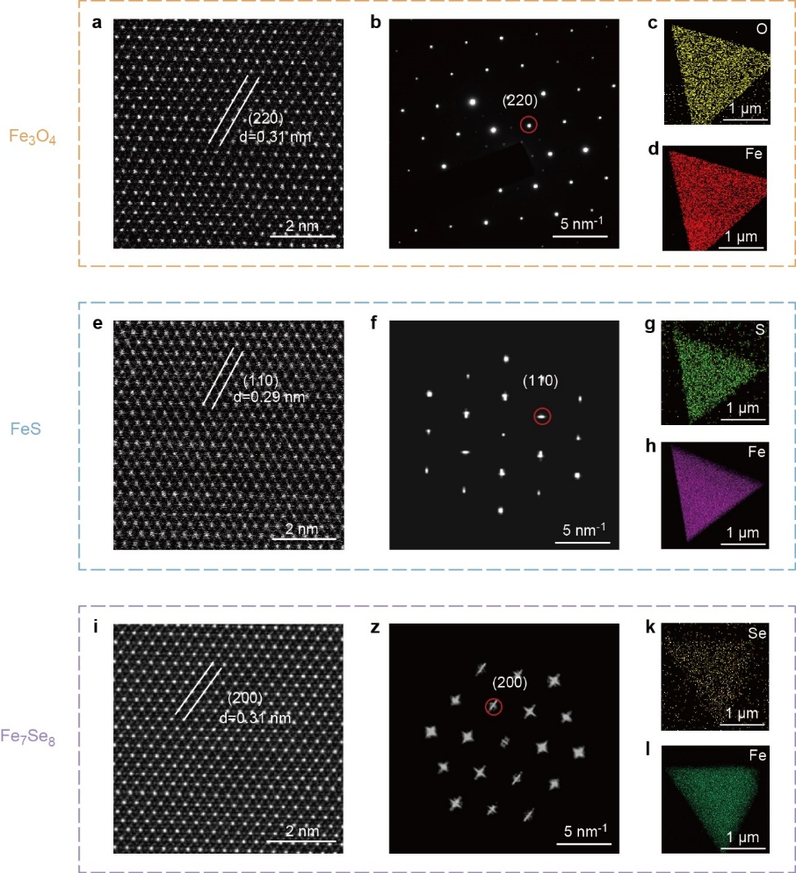
Supplementary Fig. 4 | Composition and structure of 2D Fe-based crystals. a-d HRTEM image, SAED pattern, and TEM-EDS elemental maps of an ultrathin Fe₃O₄ crystals. e-h Corresponding characterization of FeS. i-l Corresponding characterization of Fe₇Se₈.

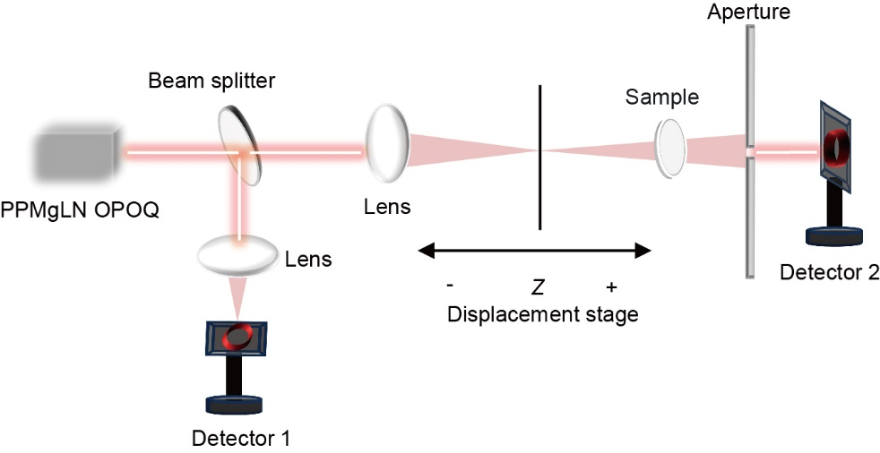
Supplementary Fig. 5 | Schematic of the open-aperture Z-scan setup.

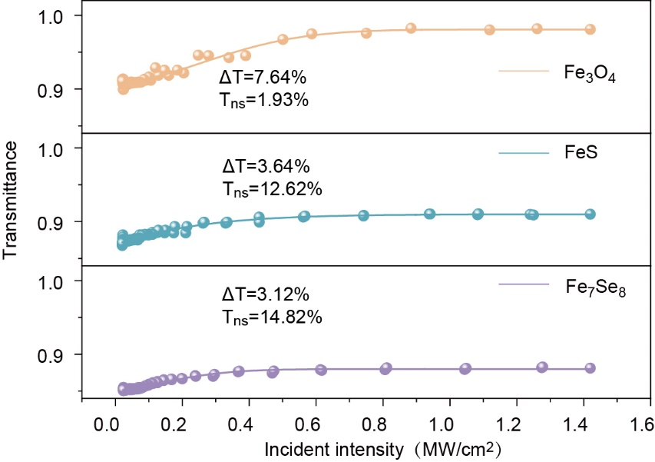
Supplementary Fig. 6 | Normalized transmittance of 2D Fe-based SAs at 2.8 μm.

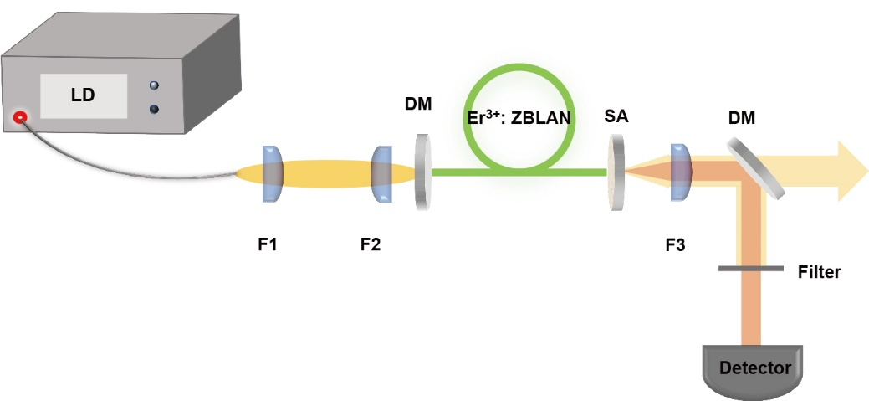
Supplementary Fig. 7 | Schematic of a passively Q-switched Er³⁺: ZBLAN fiber laser using 2D Fe-based SAs.

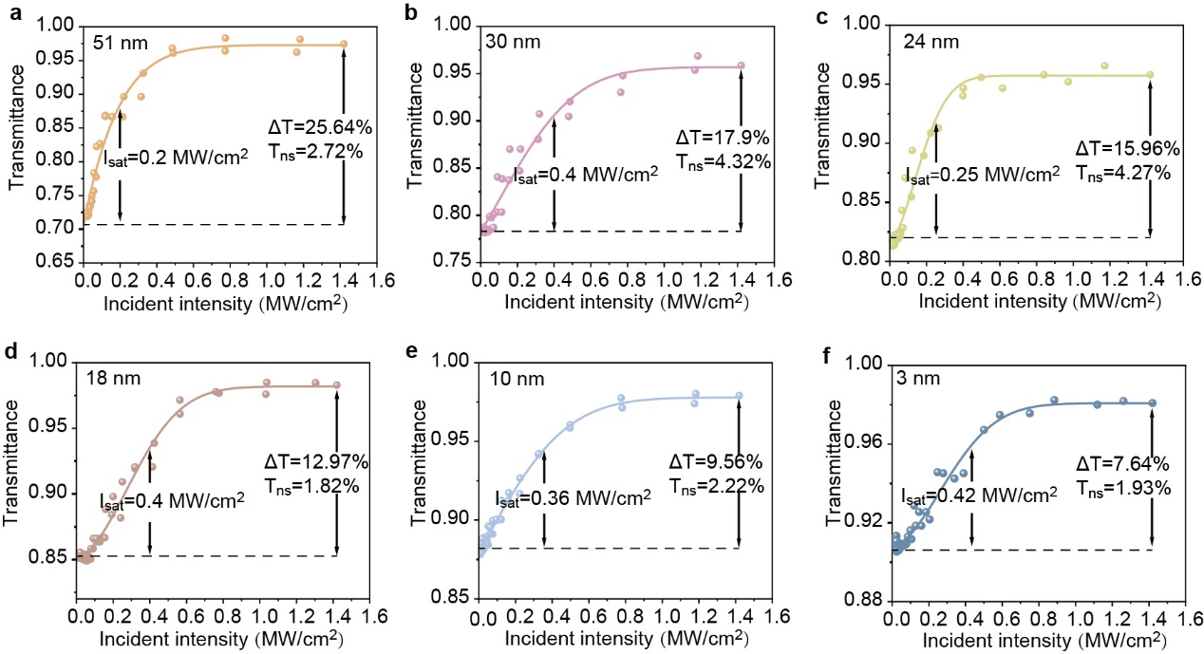
Supplementary Fig. 8 | Nonlinear absorption curves of Fe₃O₄ SA with different thicknesses at 2.8 μm.

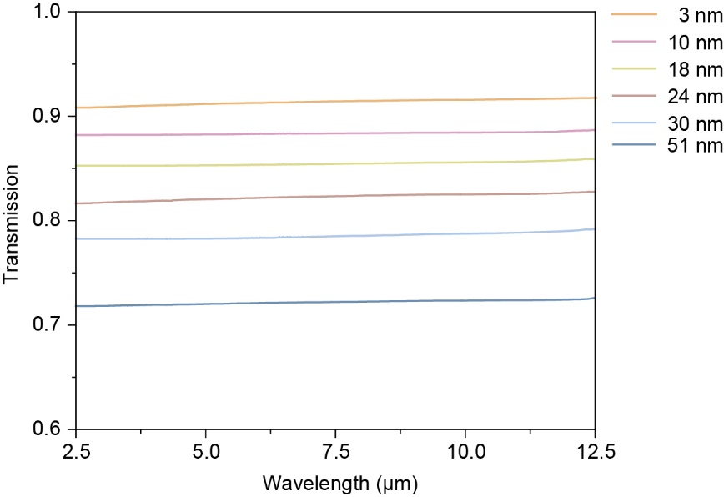
Supplementary Fig. 9 | Mid-infrared transmission spectra of Fe₃O₄ SA with different thicknesses (2.5-12.5 μm).

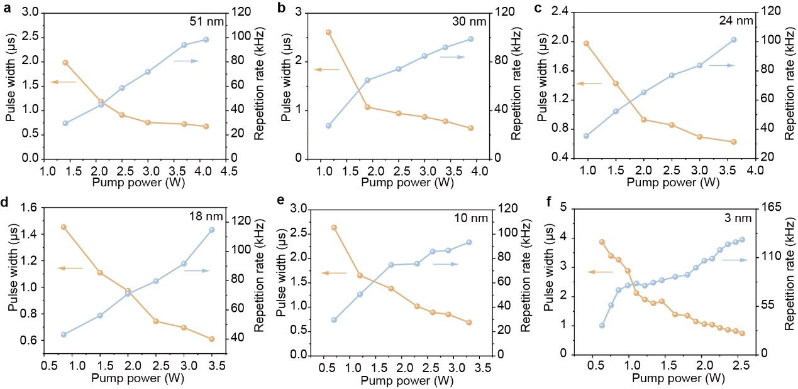
Supplementary Fig. 10 | Thickness-dependent passive Q-switching characteristics (pulse width and repetition rate) of a Fe₃O₄ SA at 2.8 μm.

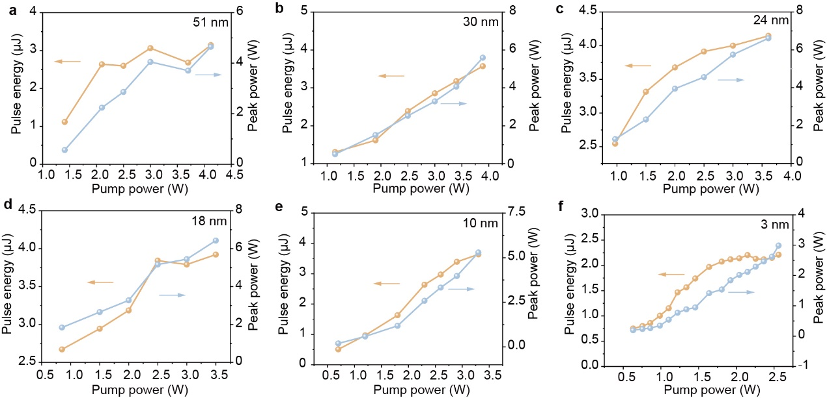
Supplementary Fig. 11 | Thickness-dependent passive Q-switching characteristics (pulse energy and peak power) of a Fe₃O₄ SA at 2.8 μm.

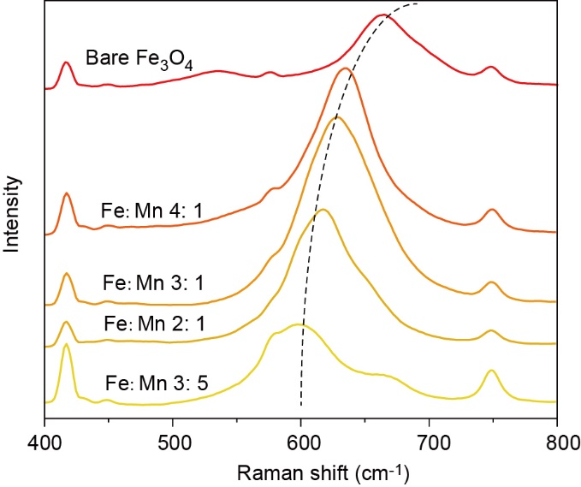
Supplementary Fig. 12 | Redshift of the A_{1g} Raman peak (662 cm⁻¹) of bare Fe₃O₄ as a function of Mn doping concentration.

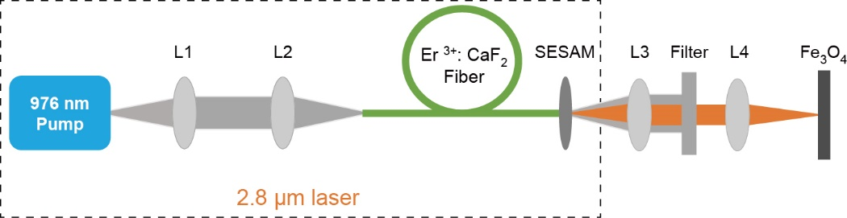
Supplementary Fig. 13 | Schematic of the experimental setup for laser-induced damage threshold test.

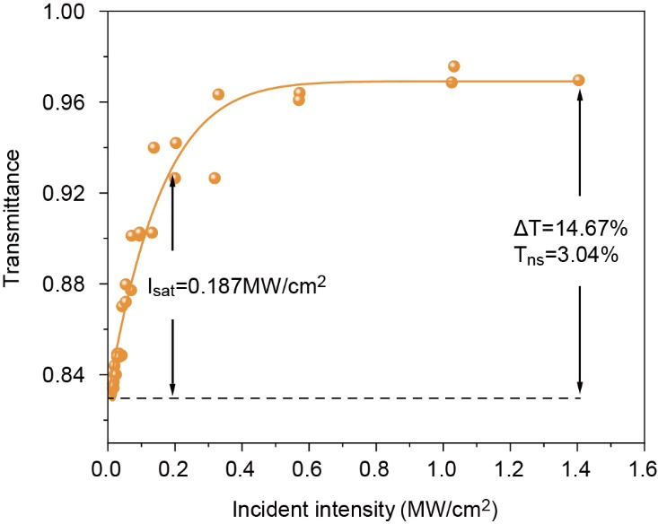
Supplementary Fig. 14 | Nonlinear absorption curves of Mn-Fe₃O₄ at 2.8 μm.

