Model assumptions
The assumption of normality was evaluated by examining the residuals of the structural equations predicting Optimism (T2) and Life Satisfaction (T2). Specifically, Lilliefors tests (Kolmogorov–Smirnov) were applied to the standardized residuals. The results indicated no significant deviations from normality for either equation (path a: D = 0.047, p = .323; path y: D = 0.054, p = .146). Visual inspection of Q–Q plots and histograms also supported the assumption of approximate normality (Figure S1).
Figure S1. Normality diagnostics for residuals of the structural equations predicting Optimism (T2) and Life Satisfaction (T2): Q–Q plots and histograms of standardized residuals.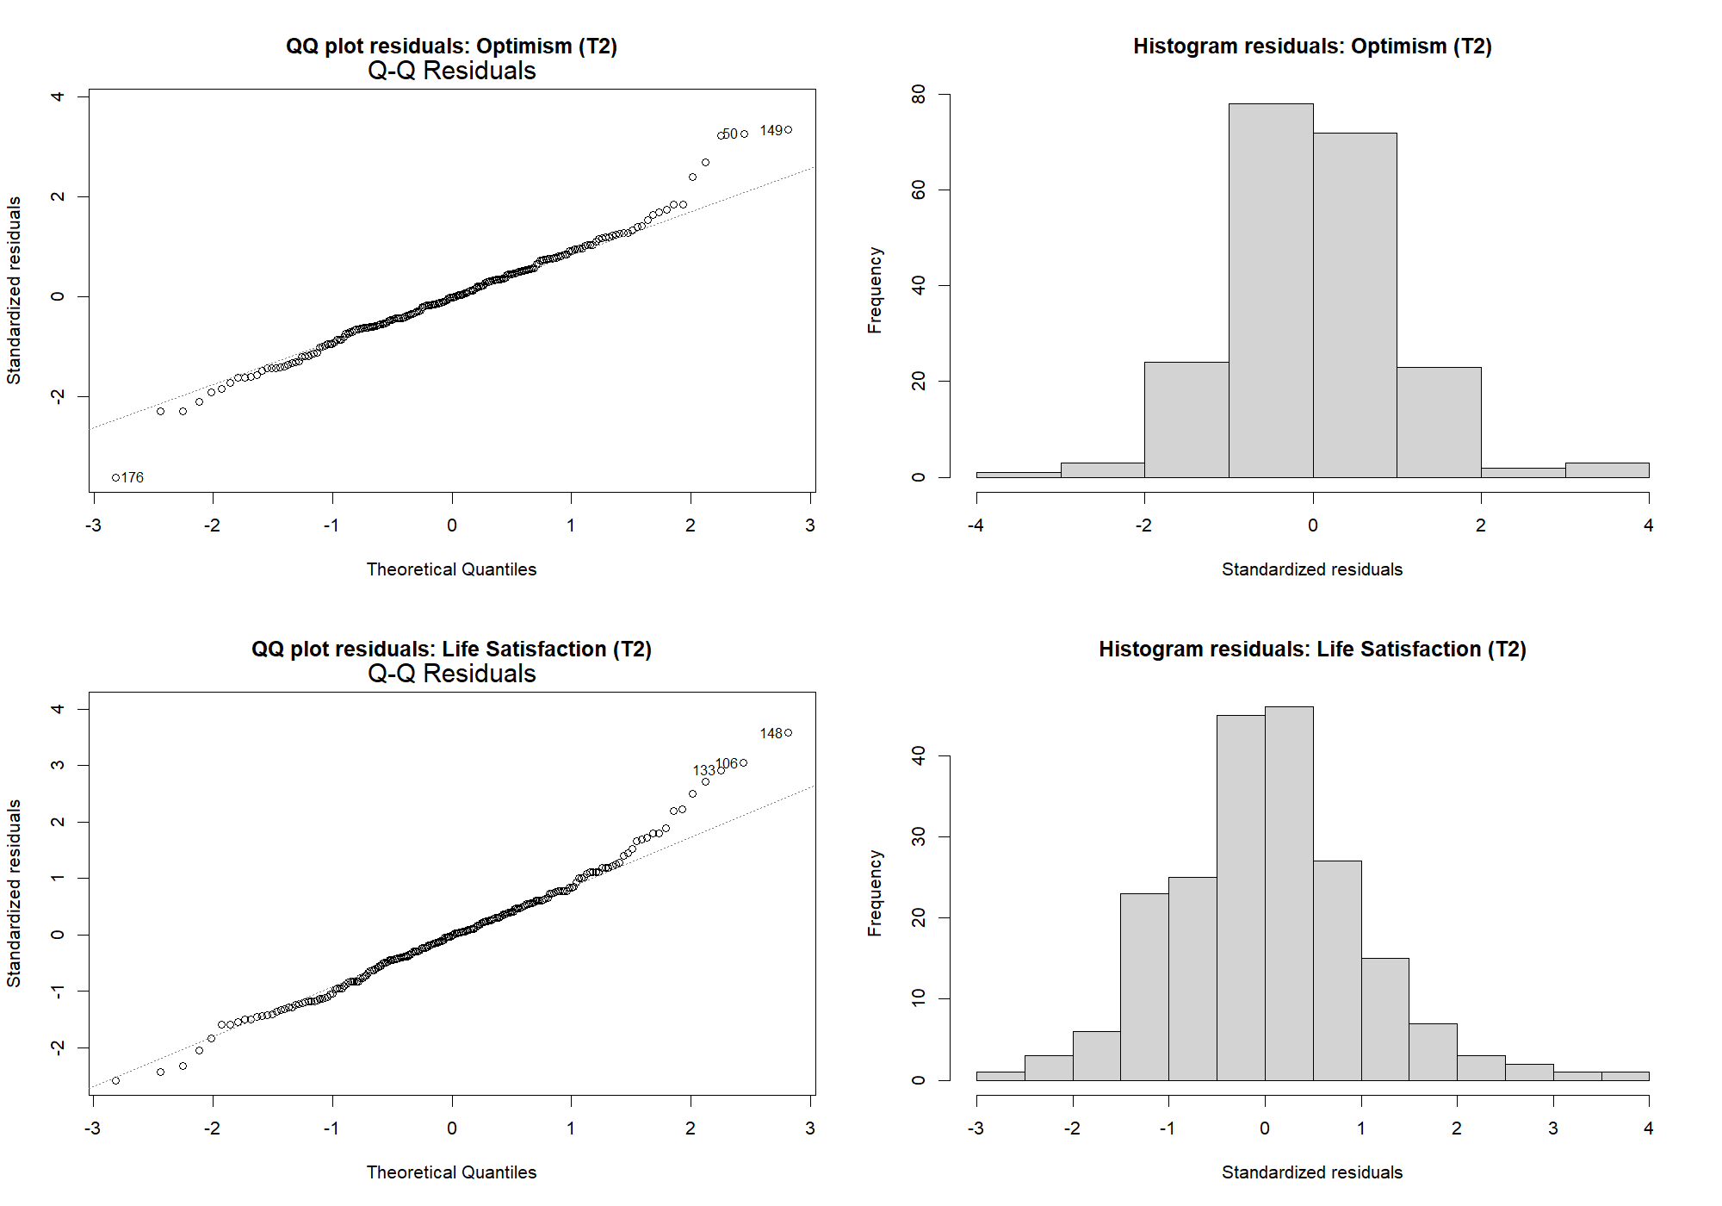

The assumption of linearity was assessed through visual inspection of residuals-versus-fitted plots for the auxiliary regression models corresponding to the structural equations, as well as partial residual plots examining the relationships RAS_{T1} → EAF_{T2}, EAF_{T1} → SWLS_{T2}, and RAS_{T1} → SWLS_{T2}. In all cases, the residuals showed no clear systematic patterns and the smoothed trends were approximately linear, indicating no substantial departures from linearity (see Figures S2–S3).
Figure S2. Assessment of linearity for the structural equations: residuals versus fitted values for the equations predicting Optimism (T2) and Life Satisfaction (T2).
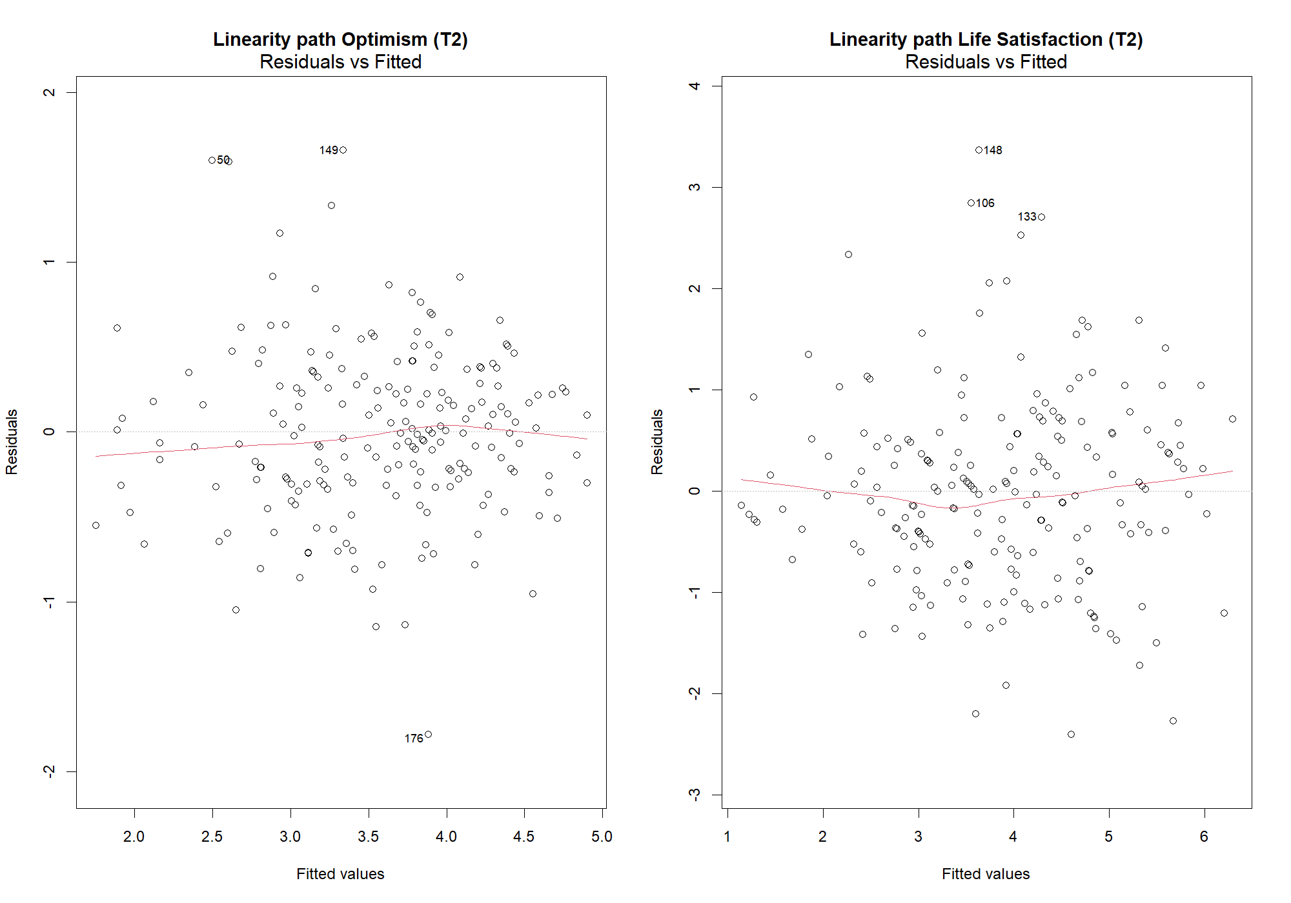

Figure S3. Partial residual plots assessing linearity of the structural paths: Recovery (T1) → Optimism (T2), Optimism (T1) → Life Satisfaction (T2), and Recovery (T1) → Life Satisfaction (T2).
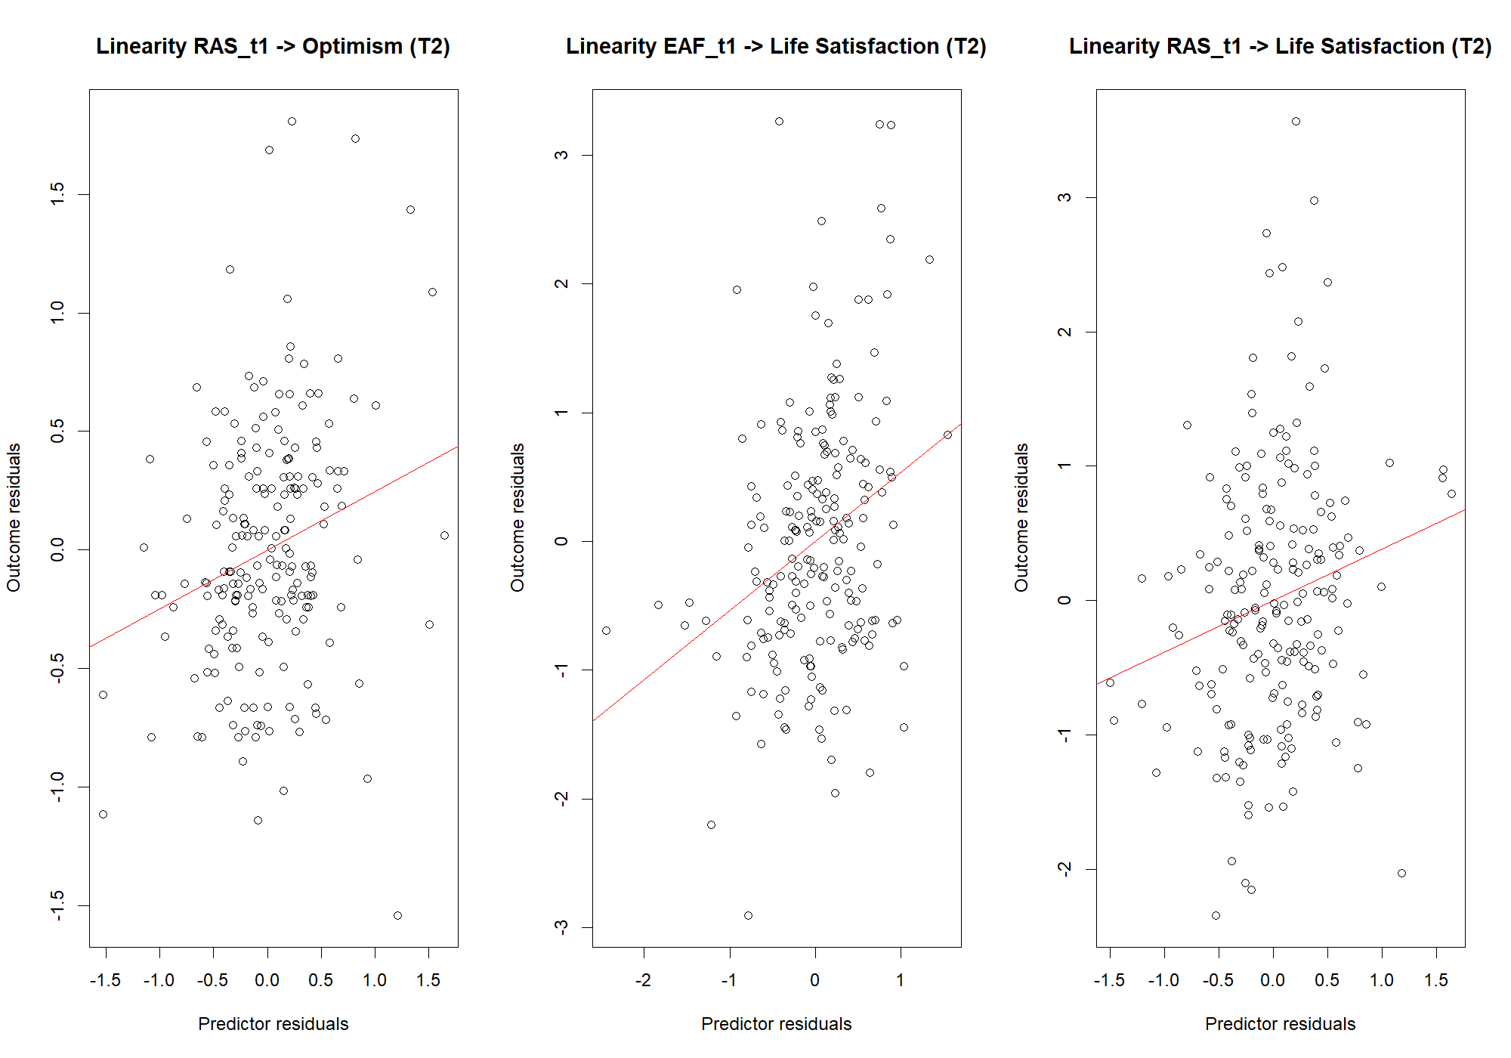
The assumption of independence of residuals was evaluated using the Durbin–Watson statistic and by visually inspecting residuals plotted against case order for the auxiliary regression models corresponding to the structural equations predicting Optimism (T2) and Life Satisfaction (T2). The Durbin–Watson statistics were close to 2 (Optimism T2 equation: DW = 2.08, p = .664; Life Satisfaction T2 equation: DW = 1.90, p = .442), indicating no evidence of residual autocorrelation. Visual inspection of the residual-by-case plots likewise revealed no systematic patterns, supporting the assumption of independent residuals (see Figure S4 in the Supplementary Materials).
Figure S4. Assessment of residual independence: residuals plotted by case order for the equations predicting Optimism (T2) and Life Satisfaction (T2).
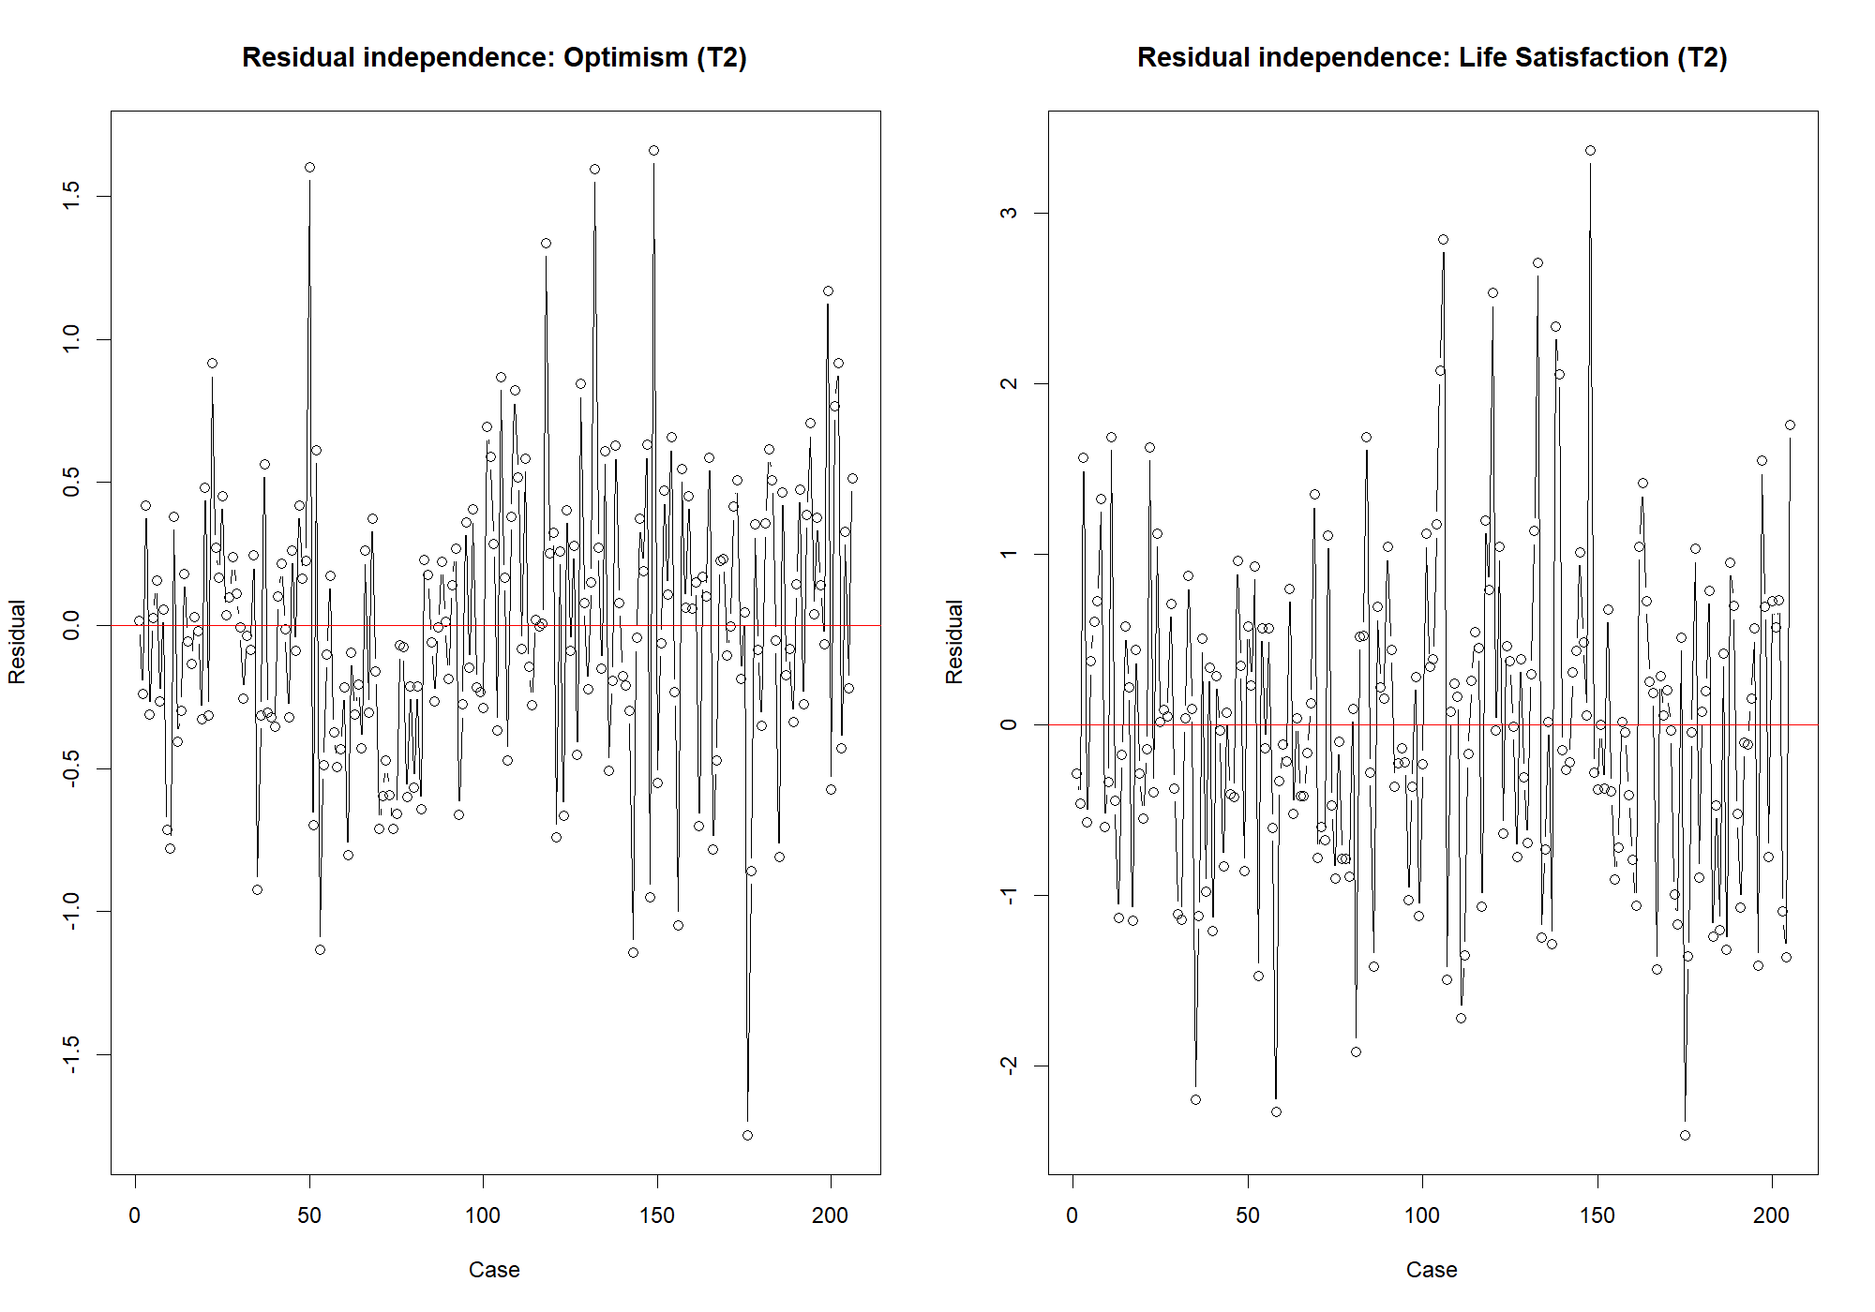
Multicollinearity was assessed using variance inflation factors (VIF). All predictors showed VIF values within acceptable ranges (all VIF < 10), indicating that multicollinearity was not a concern in the auxiliary regression models.

Table S1. Variance Inflation Factor for the regression equations predicting Optimism and Life Satisfaction
Predictor | VIF | VIF 95% CI | Adjusted VIF | Tolerance | Tolerance 95% CI
Regression on Optimism at T2
RAS _{T1} | 1.75 | [1.48, 2.16] | 1.32 | 0.57 | [0.46, 0.68]
EAF_{T1} | 1.75 | [1.48, 2.16] | 1.32 | 0.57 | [0.46, 0.68]
Regression on Life Satisfaction at T2
RAS_{T1} | 1.78 | [1.51, 2.20] | 1.33 | 0.56 | [0.45, 0.66]
EAF_{T1} | 2.50 | [2.06, 3.14] | 1.58 | 0.40 | [0.32, 0.49]
SWLS_{T1} | 2.00 | [1.67, 2.48] | 1.41 | 0.50 | [0.40, 0.60]

Potentially influential observations were examined in the auxiliary regression models corresponding to the structural equations predicting Optimism (T2) and Life Satisfaction (T2) using studentized residuals (|rstudent| > 3) and Cook’s distance (4/n). A small number of observations exceeded these conservative screening thresholds (four and two cases with |rstudent| > 3 in the Optimism and Life Satisfaction equations, respectively), and 11–13 observations exceeded the Cook’s distance screening criterion. However, all Cook’s distance values were far below levels typically considered indicative of strong influence (e.g., Cook’s distance > 1). Visual inspection of Cook’s distance and studentized residual plots likewise suggested the absence of highly influential observations (Figures S5–S6 in the Supplementary Materials).
Figure S5. Influence diagnostics for the structural equations: Cook’s distance for the equations predicting Optimism (T2) and Life Satisfaction (T2).
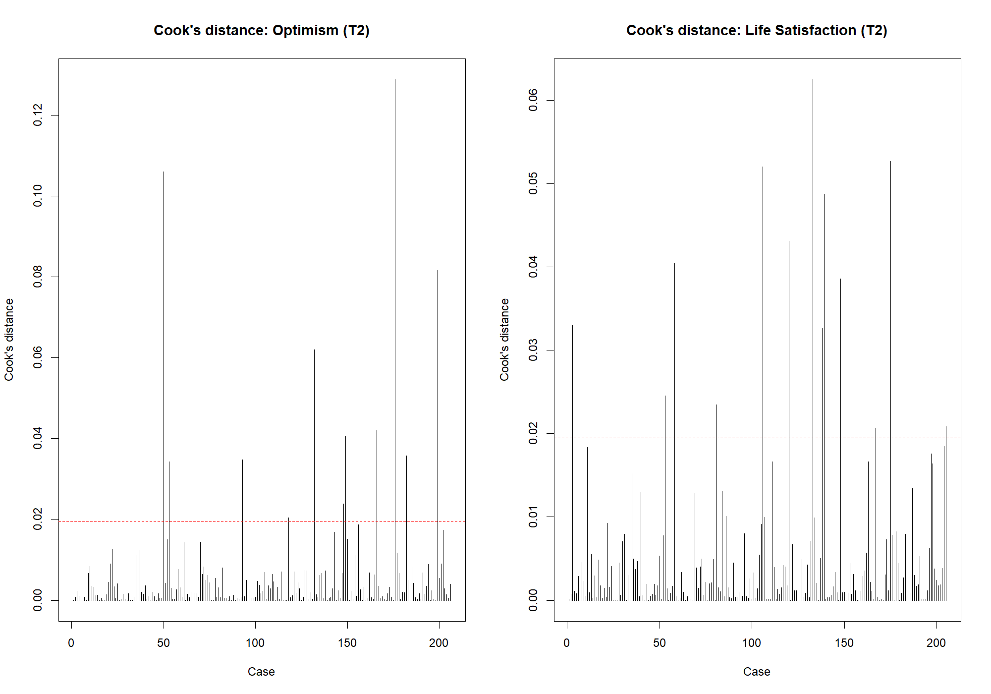

Figure S6. Studentized residuals for the structural equations predicting Optimism (T2) and Life Satisfaction (T2).
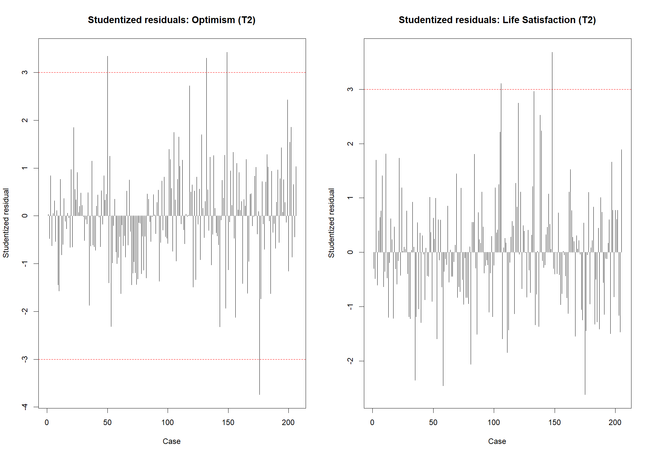

Half-longitudinal mediation models
Table S2. Local fit assessment: residual correlations and means
Residual correlations
 | OFS_{T2} | SWLS_{T2} | OFS_{T1} | SWLS_{T1} | RAS_{T1} | Group
OFS_{T2} | 0.000
SWLS_{T2} | 0.007 | 0.000
OFS_{T1} | -0.002 | -0.007 | 0.000
SWLS_{T1} | 0.042 | 0.015 | 0.000 | 0.000
RAS_{T1} | -0.004 | -0.008 | 0.000 | 0.000 | 0.000
Group | -0.058 | -0.064 | -0.064 | -0.082 | -0.074 |  | 0.000
Residual means
OFS_{T2} | SWLS_{T2} | OFS_{T1} | SWLS_{T1} | RAS_{T1} | SWLS_{T2} |  | Group
-0.001 | -0.001 | 0.000 | 0.000 | 0.000 | 0.000 |  | 0.000

Table S3. Parameter estimates of the mediation model
Path estimate | Unstd. | S.E. | z | p | LowCI | UppCI | Std.
EAF (T1) ↔RAS (T1) | 0.38 | 0.05 | 7.18 | <.001 | 0.28 | 0.48 | 0.66
SWLS (T1) ↔ RAS (T1) | 0.52 | 0.09 | 5.62 | <.001 | 0.34 | 0.70 | 0.52
EAF (T1) ↔ SWLS (T1) | 0.95 | 0.11 | 8.82 | <.001 | 0.74 | 1.16 | 0.70
EAF (T2) ↔ SWLS (T2) | 0.22 | 0.04 | 6.13 | <.001 | 0.15 | 0.28 | 0.46
EAF (T1) → EAF (T2) | 0.64 | 0.07 | 9.05 | <.001 | 0.50 | 0.77 | 0.67
SWLS (T1) → SWLS (T2) | 0.32 | 0.08 | 4.00 | <.001 | 0.16 | 0.47 | 0.34
RAS (T1) → EAF (T2) (a) | 0.25 | 0.09 | 2.71 | .007 | 0.07 | 0.43 | 0.19
EAF (T1) → SWLS (T2) (b) | 0.59 | 0.11 | 5.16 | <.001 | 0.36 | 0.81 | 0.36
RAS (T1) → SWLS (T2) (c') | 0.40 | 0.12 | 3.29 | .001 | 0.16 | 0.64 | 0.18
Group → EAF (T2) | 0.16 | 0.08 | 2.03 | .043 | 0.01 | 0.31 | 0.09
Group → SWLS (T2) | 0.20 | 0.14 | 1.44 | .150 | -0.07 | 0.48 | 0.07
Variance of EAF (T2) | 0.25 | 0.03 | 7.97 | <.001 | 0.19 | 0.31 | 0.34
Variance of SWLS (T2) | 0.88 | 0.10 | 8.72 | <.001 | 0.68 | 1.08 | 0.41
Variance of EAF (T1) | 0.79 | 0.07 | 12.08 | <.001 | 0.66 | 0.92 | 1.00
Variance of SWLS (T1) | 2.37 | 0.17 | 14.10 | <.001 | 2.04 | 2.70 | 1.00
Variance of RAS (T1) | 0.42 | 0.05 | 8.83 | <.001 | 0.33 | 0.51 | 1.00
Variance of Group | 0.25 | 0.00 | - | - | 0.25 | 0.25 | 1.00
Intercept of EAF (T2) | 0.35 | 0.24 | 1.44 | .150 | -0.13 | 0.82 | 0.41
Intercept of SWLS (T2) | -0.90 | 0.35 | -2.56 | .010 | -1.59 | -0.21 | -0.62
Mean of EAF (T1) | 3.48 | 0.07 | 47.19 | <.001 | 3.34 | 3.63 | 3.92
Mean of SWLS (T1) | 3.61 | 0.12 | 29.89 | <.001 | 3.37 | 3.84 | 2.34
Mean of RAS (T1) | 3.69 | 0.06 | 60.33 | <.001 | 3.57 | 3.81 | 5.71
Mean of Group | 0.46 | 0.00 | - | - | 0.46 | 0.46 | 0.93
Indirect effect (a x b) | 0.15 | 0.06 | 2.31 | .021 | 0.02 | 0.27 | 0.07
Total effect (a x b + c') | 0.55 | 0.16 | 3.52 | <.001 | 0.24 | 0.85 | 0.25
Note: Unstd. = Unstandardized coefficient, S.E = Standard error, LowCI/UppCI = Lower and Upper limit of the 95% confidence interval around the unstandardized estimate, Std. = Standardized coefficient, RAS = Recovery Assessment Scale (total score), SWLS = Satisfaction With Life Scale (total score), OFS = Openess to the Future Scale (total score).

Table S4. Multigroup analysis M1. Parameter estimates for females.
Path estimate | Unstd. | S.E. | z | p | LowCI | UppCI | Std.
EAF (T1) ↔RAS (T1) | 0.38 | 0.06 | 6.41 | <.001 | 0.27 | 0.50 | 0.66
SWLS (T1) ↔ RAS (T1) | 0.46 | 0.10 | 4.75 | <.001 | 0.27 | 0.65 | 0.48
EAF (T1) ↔ SWLS (T1) | 1.01 | 0.14 | 7.15 | <.001 | 0.74 | 1.29 | 0.72
EAF (T2) ↔ SWLS (T2) | 0.67 | 0.09 | 7.41 | <.001 | 0.50 | 0.85 | 0.75
EAF (T1) → EAF (T2) | 0.18 | 0.04 | 4.95 | <.001 | 0.11 | 0.24 | 0.39
SWLS (T1) → SWLS (T2) | 0.33 | 0.12 | 2.77 | 0.006 | 0.10 | 0.57 | 0.36
RAS (T1) → EAF (T2) (a) | 0.11 | 0.13 | 0.81 | 0.416 | -0.15 | 0.37 | 0.08
EAF (T1) → SWLS (T2) (b) | 0.55 | 0.17 | 3.32 | 0.001 | 0.23 | 0.88 | 0.36
RAS (T1) → SWLS (T2) (c') | 0.32 | 0.12 | 2.61 | 0.009 | 0.08 | 0.56 | 0.14
Group → EAF (T2) | 0.18 | 0.10 | 1.79 | 0.073 | -0.02 | 0.37 | 0.11
Group → SWLS (T2) | 0.34 | 0.18 | 1.89 | 0.058 | -0.01 | 0.69 | 0.12
Variance of EAF (T2) | 0.24 | 0.03 | 7.78 | <.001 | 0.18 | 0.30 | 0.35
Variance of SWLS (T2) | 0.85 | 0.13 | 6.75 | <.001 | 0.60 | 1.10 | 0.42
Variance of EAF (T1) | 0.85 | 0.09 | 9.29 | <.001 | 0.67 | 1.03 | 1.00
Variance of SWLS (T1) | 2.32 | 0.23 | 10.31 | <.001 | 1.88 | 2.76 | 1.00
Variance of RAS (T1) | 0.40 | 0.04 | 9.70 | <.001 | 0.32 | 0.48 | 1.00
Variance of Group | 0.25 | 0.00 | - | - | 0.25 | 0.25 | 1.00
Intercept of EAF (T2) | 0.74 | 0.34 | 2.18 | 0.029 | 0.08 | 1.41 | 0.89
Intercept of SWLS (T2) | -0.60 | 0.41 | -1.49 | 0.138 | -1.40 | 0.19 | -0.42
Mean of EAF (T1) | 3.47 | 0.09 | 40.31 | <.001 | 3.30 | 3.64 | 3.76
Mean of SWLS (T1) | 3.52 | 0.14 | 24.45 | <.001 | 3.23 | 3.80 | 2.31
Mean of RAS (T1) | 3.70 | 0.07 | 52.29 | <.001 | 3.56 | 3.84 | 5.85
Mean of Group | 0.48 | 0.00 | - | - | 0.48 | 0.48 | 0.95
Note: Unstd. = Unstandardized coefficient, S.E = Standard error, LowCI/UppCI = Lower and Upper limit of the 95% confidence interval around the unstandardized estimate, Std. = Standardized coefficient, RAS = Recovery Assessment Scale (total score), SWLS = Satisfaction With Life Scale (total score), OFS = Openess to the Future Scale (total score).

Table S5. Multigroup analysis M1. Parameter estimates for males.
Path estimate | Unstd. | S.E. | z | p | LowCI | UppCI | Std.
EAF (T1) ↔RAS (T1) | 0.37 | 0.08 | 4.62 | <.001 | 0.21 | 0.53 | 0.67
SWLS (T1) ↔ RAS (T1) | 0.60 | 0.14 | 4.31 | <.001 | 0.33 | 0.88 | 0.58
EAF (T1) ↔ SWLS (T1) | 0.86 | 0.15 | 5.73 | <.001 | 0.56 | 1.15 | 0.66
EAF (T2) ↔ SWLS (T2) | 0.58 | 0.10 | 5.65 | <.001 | 0.38 | 0.79 | 0.56
EAF (T1) → EAF (T2) | 0.26 | 0.08 | 3.17 | 0.002 | 0.10 | 0.42 | 0.57
SWLS (T1) → SWLS (T2) | 0.32 | 0.08 | 3.83 | <.001 | 0.16 | 0.48 | 0.33
RAS (T1) → EAF (T2) (a) | 0.43 | 0.10 | 4.34 | <.001 | 0.24 | 0.62 | 0.33
EAF (T1) → SWLS (T2) (b) | 0.64 | 0.17 | 3.83 | <.001 | 0.31 | 0.96 | 0.35
RAS (T1) → SWLS (T2) (c') | 0.48 | 0.20 | 2.42 | 0.016 | 0.09 | 0.86 | 0.21
Group → EAF (T2) | 0.12 | 0.14 | 0.89 | 0.375 | -0.15 | 0.39 | 0.07
Group → SWLS (T2) | -0.01 | 0.23 | -0.03 | 0.975 | -0.45 | 0.44 | 0.00
Variance of EAF (T2) | 0.24 | 0.05 | 4.48 | <.001 | 0.13 | 0.34 | 0.32
Variance of SWLS (T2) | 0.88 | 0.19 | 4.58 | <.001 | 0.51 | 1.26 | 0.39
Variance of EAF (T1) | 0.69 | 0.09 | 7.82 | <.001 | 0.52 | 0.87 | 1.00
Variance of SWLS (T1) | 2.42 | 0.25 | 9.53 | <.001 | 1.92 | 2.91 | 1.00
Variance of RAS (T1) | 0.45 | 0.09 | 5.22 | <.001 | 0.28 | 0.61 | 1.00
Variance of Group | 0.25 | 0.00 | - | - | 0.25 | 0.25 | 1.00
Intercept of EAF (T2) | -0.13 | 0.23 | -0.54 | 0.588 | -0.58 | 0.33 | -0.15
Intercept of SWLS (T2) | -1.27 | 0.45 | -2.82 | 0.005 | -2.15 | -0.38 | -0.84
Mean of EAF (T1) | 3.50 | 0.09 | 38.11 | <.001 | 3.32 | 3.68 | 4.21
Mean of SWLS (T1) | 3.74 | 0.16 | 22.90 | <.001 | 3.42 | 4.06 | 2.41
Mean of RAS (T1) | 3.68 | 0.07 | 49.52 | <.001 | 3.53 | 3.82 | 5.51
Mean of Group | 0.45 | 0.00 | - | - | 0.45 | 0.45 | 0.90
Note: Unstd. = Unstandardized coefficient, S.E = Standard error, LowCI/UppCI = Lower and Upper limit of the 95% confidence interval around the unstandardized estimate, Std. = Standardized coefficient, RAS = Recovery Assessment Scale (total score), SWLS = Satisfaction With Life Scale (total score), OFS = Openess to the Future Scale (total score).

Table S6. Multigroup analysis M2. Fixed means and intercepts across sex (the remaining parameters are the same as in Table S5).
Path estimate | Unstd. | S.E. | z | p | LowCI | UppCI | Std.
Intercept of EAF (T2) | 0.36 | 0.23 | 1.60 | 0.109 | -0.08 | 0.80 | 0.41
Intercept of SWLS (T2) | -0.81 | 0.32 | -2.55 | 0.011 | -1.44 | -0.19 | -0.56
Mean of EAF (T1) | 3.49 | 0.07 | 53.74 | <.001 | 3.36 | 3.62 | 3.77
Mean of SWLS (T1) | 3.61 | 0.12 | 30.81 | <.001 | 3.38 | 3.84 | 2.37
Mean of RAS (T1) | 3.69 | 0.06 | 67.29 | <.001 | 3.58 | 3.79 | 5.83

Table S7. Multigroup analysis M3. Fixed means, intercepts, and regression paths across sex (the remaining parameters are the same as in Table S5 and S6).
Path estimate | Unstd. | S.E. | z | p | LowCI | UppCI | Std.
EAF (T1) → EAF (T2) | 0.63 | 0.07 | 8.84 | <.001 | 0.49 | 0.77 | 0.64
SWLS (T1) → SWLS (T2) | 0.32 | 0.08 | 4.34 | <.001 | 0.18 | 0.47 | 0.35
RAS (T1) → EAF (T2) (a) | 0.26 | 0.09 | 2.83 | 0.005 | 0.08 | 0.43 | 0.21
EAF (T1) → SWLS (T2) (b) | 0.59 | 0.11 | 5.34 | <.001 | 0.37 | 0.81 | 0.34
RAS (T1) → SWLS (T2) (c') | 0.37 | 0.11 | 3.48 | 0.001 | 0.16 | 0.57 | 0.17
Group → EAF (T2) | 0.17 | 0.08 | 2.15 | 0.032 | 0.01 | 0.32 | 0.10
Group → SWLS (T2) | 0.20 | 0.14 | 1.44 | 0.151 | -0.07 | 0.48 | 0.07

Table S8. Model comparisons by sex.
 | Chi | DF | p | CFI | TLI | RMSEA | RMSEA_low | RMSEA_upp | SRMR | $$Δχ^{2}$$ | $$Δdf$$ | p
M1 | 6.4 | 8 | .60 | 1.0 | 1.0 | <.001 | 0 | 0.093 | 0.032
M2 | 13.1 | 13 | .43 | 1.0 | 1.0 | .009 | 0 | 0.092 | 0.050 | 6.110 | 5 | 0.296
M3 | 17.3 | 20 | .63 | 1.0 | 1.0 | <.001 | 0 | 0.068 | 0.049 | 3.270 | 7 | 0.859

Table S9. Parameter estimates of the mediation model without potentially influential cases
Path estimate | Unstd. | S.E. | z | p | LowCI | UppCI | Std.
EAF (T1) ↔ RAS (T1) | 0.40 | 0.06 | 7.01 | <.001 | 0.29 | 0.51 | 0.71
SWLS (T1) ↔ RAS (T1) | 0.52 | 0.10 | 5.31 | <.001 | 0.33 | 0.71 | 0.55
EAF (T1) ↔ SWLS (T1) | 1.01 | 0.11 | 9.04 | <.001 | 0.79 | 1.23 | 0.76
EAF (T2) ↔ SWLS (T2) | 0.10 | 0.03 | 3.86 | <.001 | 0.05 | 0.15 | 0.33
EAF (T1) → EAF (T2) | 0.71 | 0.05 | 13.70 | <.001 | 0.60 | 0.81 | 0.74
SWLS (T1) → SWLS (T2) | 0.43 | 0.07 | 5.95 | <.001 | 0.29 | 0.58 | 0.46
RAS (T1) → EAF (T2) (a) | 0.24 | 0.06 | 3.92 | <.001 | 0.12 | 0.36 | 0.18
EAF (T1) → SWLS (T2) (b) | 0.52 | 0.13 | 4.19 | <.001 | 0.28 | 0.77 | 0.33
RAS (T1) → SWLS (T2) (c') | 0.34 | 0.11 | 3.16 | 0.002 | 0.13 | 0.55 | 0.15
Group → EAF (T2) | 0.13 | 0.07 | 1.93 | 0.053 | 0.00 | 0.27 | 0.08
Group → SWLS (T2) | 0.07 | 0.10 | 0.67 | 0.504 | -0.13 | 0.26 | 0.02
Variance of EAF (T2) | 0.17 | 0.02 | 9.89 | <.001 | 0.13 | 0.20 | 0.23
Variance of SWLS (T2) | 0.57 | 0.06 | 9.72 | <.001 | 0.46 | 0.69 | 0.28
Variance of EAF (T1) | 0.78 | 0.07 | 11.77 | <.001 | 0.65 | 0.91 | 1.00
Variance of SWLS (T1) | 2.25 | 0.18 | 12.78 | <.001 | 1.91 | 2.60 | 1.00
Variance of RAS (T1) | 0.40 | 0.05 | 8.42 | <.001 | 0.31 | 0.49 | 1.00
Variance of Group | 0.25 | 0.00 | - | - | 0.25 | 0.25 | 1.00
Intercept of EAF (T2) | 0.13 | 0.16 | 0.80 | 0.426 | -0.19 | 0.44 | 0.15
Intercept of SWLS (T2) | -0.91 | 0.33 | -2.73 | 0.006 | -1.55 | -0.26 | -0.64
Mean of EAF (T1) | 3.50 | 0.08 | 45.76 | <.001 | 3.35 | 3.65 | 3.96
Mean of SWLS (T1) | 3.66 | 0.12 | 31.18 | <.001 | 3.43 | 3.89 | 2.44
Mean of RAS (T1) | 3.67 | 0.06 | 59.40 | <.001 | 3.55 | 3.80 | 5.82
Mean of Group | 0.46 | 0.00 | - | - | 0.46 | 0.46 | 0.93
Indirect effect (a x b) | 0.13 | 0.04 | 3.02 | 0.003 | 0.04 | 0.21 | 0.06
Total effect (a x b + c') | 0.47 | 0.11 | 4.15 | <.001 | 0.25 | 0.69 | 0.21
Note: Unstd. = Unstandardized coefficient, S.E = Standard error, LowCI/UppCI = Lower and Upper limit of the 95% confidence interval around the unstandardized estimate, Std. = Standardized coefficient, RAS = Recovery Assessment Scale (total score), SWLS = Satisfaction With Life Scale (total score), OFS = Openess to the Future Scale (total score).

Table S10. Parameter estimates of the mediation model including Depression Symptomatology (DEP) as a covariate.
Path estimate | Unstd. | S.E. | z | p | LowCI | UppCI | Std.
EAF (T1) ↔ RAS (T1) | 0.38 | 0.05 | 7.18 | <.001 | 0.28 | 0.48 | 0.66
SWLS (T1) ↔ RAS (T1) | 0.52 | 0.09 | 5.62 | <.001 | 0.34 | 0.70 | 0.52
EAF (T1) ↔ SWLS (T1) | 0.95 | 0.11 | 8.82 | <.001 | 0.74 | 1.16 | 0.70
DEP (T1) ↔ RAS (T1) | -0.39 | 0.05 | -7.61 | <.001 | -0.49 | -0.29 | -0.53
DEP (T1) ↔ EAF (T1) | -0.63 | 0.09 | -6.91 | <.001 | -0.81 | -0.45 | -0.63
EAF (T2) ↔ SWLS (T2) | -0.82 | 0.16 | -5.22 | <.001 | -1.13 | -0.51 | -0.47
SWLS (T2) ↔ EAF (T2) | 0.21 | 0.04 | 5.92 | <.001 | 0.14 | 0.29 | 0.46
RAS (T1) → EAF (T2) (a) | 0.23 | 0.09 | 2.53 | 0.011 | 0.05 | 0.41 | 0.18
EAF (T1) → EAF (T2) | 0.60 | 0.08 | 7.79 | <.001 | 0.45 | 0.75 | 0.63
Group → EAF (T2) | 0.15 | 0.08 | 1.99 | 0.046 | 0.00 | 0.31 | 0.09
DEP (T1) → EAF (T2) | -0.05 | 0.04 | -1.33 | 0.184 | -0.13 | 0.03 | -0.07
EAF (T1) → SWLS (T2) (b) | 0.57 | 0.14 | 4.22 | <.001 | 0.31 | 0.83 | 0.35
RAS (T1) → SWLS (T2) (c') | 0.39 | 0.13 | 3.07 | 0.002 | 0.14 | 0.64 | 0.17
SWLS (T1) → SWLS (T2) | 0.32 | 0.08 | 4.05 | <.001 | 0.16 | 0.47 | 0.34
Group → SWLS (T2) | 0.20 | 0.14 | 1.41 | 0.158 | -0.08 | 0.48 | 0.07
DEP (T1) → SWLS (T2) | -0.02 | 0.09 | -0.26 | 0.794 | -0.20 | 0.16 | -0.02
Variance of EAF (T2) | 0.25 | 0.03 | 7.88 | <.001 | 0.18 | 0.31 | 0.34
Variance of SWLS (T2) | 0.88 | 0.10 | 8.72 | <.001 | 0.68 | 1.07 | 0.41
Variance of RAS (T1) | 0.42 | 0.05 | 8.83 | <.001 | 0.33 | 0.51 | 1.00
Variance of EAF (T1) | 0.79 | 0.07 | 12.08 | <.001 | 0.66 | 0.92 | 1.00
Variance of DEP (T1) | 1.29 | 0.08 | 16.10 | <.001 | 1.13 | 1.45 | 1.00
Variance of SWLS (T1) | 2.37 | 0.17 | 14.10 | <.001 | 2.04 | 2.70 | 1.00
Variance of CONDITION | 0.25 | 0.00 | - | - | 0.25 | 0.25 | 1.00
Intercept of EAF (T2) | 0.64 | 0.30 | 2.14 | 0.033 | 0.05 | 1.23 | 0.76
Intercept of SWLS (T2) | -0.76 | 0.64 | -1.20 | 0.232 | -2.01 | 0.49 | -0.52
Mean of RAS (T1) | 3.69 | 0.06 | 60.33 | <.001 | 3.57 | 3.81 | 5.71
Mean of EAF (T1) | 3.48 | 0.07 | 47.19 | <.001 | 3.34 | 3.63 | 3.92
Mean of CONDITION | 0.46 | 0.00 | - | - | 0.46 | 0.46 | 0.93
Mean of DEP (T1) | 1.92 | 0.08 | 23.18 | <.001 | 1.76 | 2.08 | 1.69
Mean of SWLS (T1) | 3.61 | 0.12 | 29.88 | <.001 | 3.37 | 3.84 | 2.34
Indirect effect (a x b) | 0.13 | 0.06 | 2.07 | 0.039 | 0.01 | 0.26 | 0.06
Total effect (a x b + c') | 0.52 | 0.17 | 3.15 | 0.002 | 0.20 | 0.85 | 0.24
Note: Unstd. = Unstandardized coefficient, S.E = Standard error, LowCI/UppCI = Lower and Upper limit of the 95% confidence interval around the unstandardized estimate, Std. = Standardized coefficient, RAS = Recovery Assessment Scale (total score), SWLS = Satisfaction With Life Scale (total score), OFS = Openess to the Future Scale (total score), DEP = Depression subscale (total score) from the Symptom Checklist 45.

