Supplemental references list
Figure S1. Sequencing of the homologous rs1421085 T>C variant in human and mouse.
Figure S2. The homologous rs1421085 T>C variant protests HFD-induced obesity but shows no change in body weight under chow diet in KIcas9 mice.
Figure S3. The homologous rs1421085 T>C variant protests HFD-induced obesity but shows no change in body weight under chow diet in KIES mice.
Figure S4. Brown adipocyte-specific knock-in homologous rs1421085 T>C variant enhances thermogenesis resists HFD-induced adiposity.
Figure S5. The mRNA expression of potential downstream effectors of rs1421085 T>C variation.
Figure S6. FTO enhances thermogenic capacity of brown adipocytes and partially medicates the increased thermogenesis in rs1421085 T>C knock-in model. (A) The mRNA expression
Figure S7. Fto deficiency in BAT impairs thermogenesis and resists HFD-induced adiposity.
Figure S8. FTO protein stabilizes Ucp1 mRNA and increase UCP1 protein expression.
Figure S9. Surgical excision of intrascapular BAT largely reverses HFD-resistance phenotype of KI^{cas9} mice.
Figure S10. The association of human FTO rs1421085 T>C variation frequency with BMI.
Figure S11. The FTO and UCP1 were colocalized in human embryonic brown adipose tissue.
Figure S12. The association of human FTO rs1421085 T>C variation frequency with ambient environmental temperature, elevation, and latitude.
Figure S13. Sanger sequencing of the 6 kb DNA region centered on the homologous rs1421085 locus in WT and KIcas9 mice.
Table S1. Top 10 off-target sites prediction.
Table S2. Primers for genotyping/qPCR.
Table S3. Primer sequences for lentivirus construction and validation.
Table S4. Study details included in Meta-anaylsis.
Table S5. Study details included in FTO rs1421085 T>C variant frequency
analysis.
Table S6. Acronym and full name.

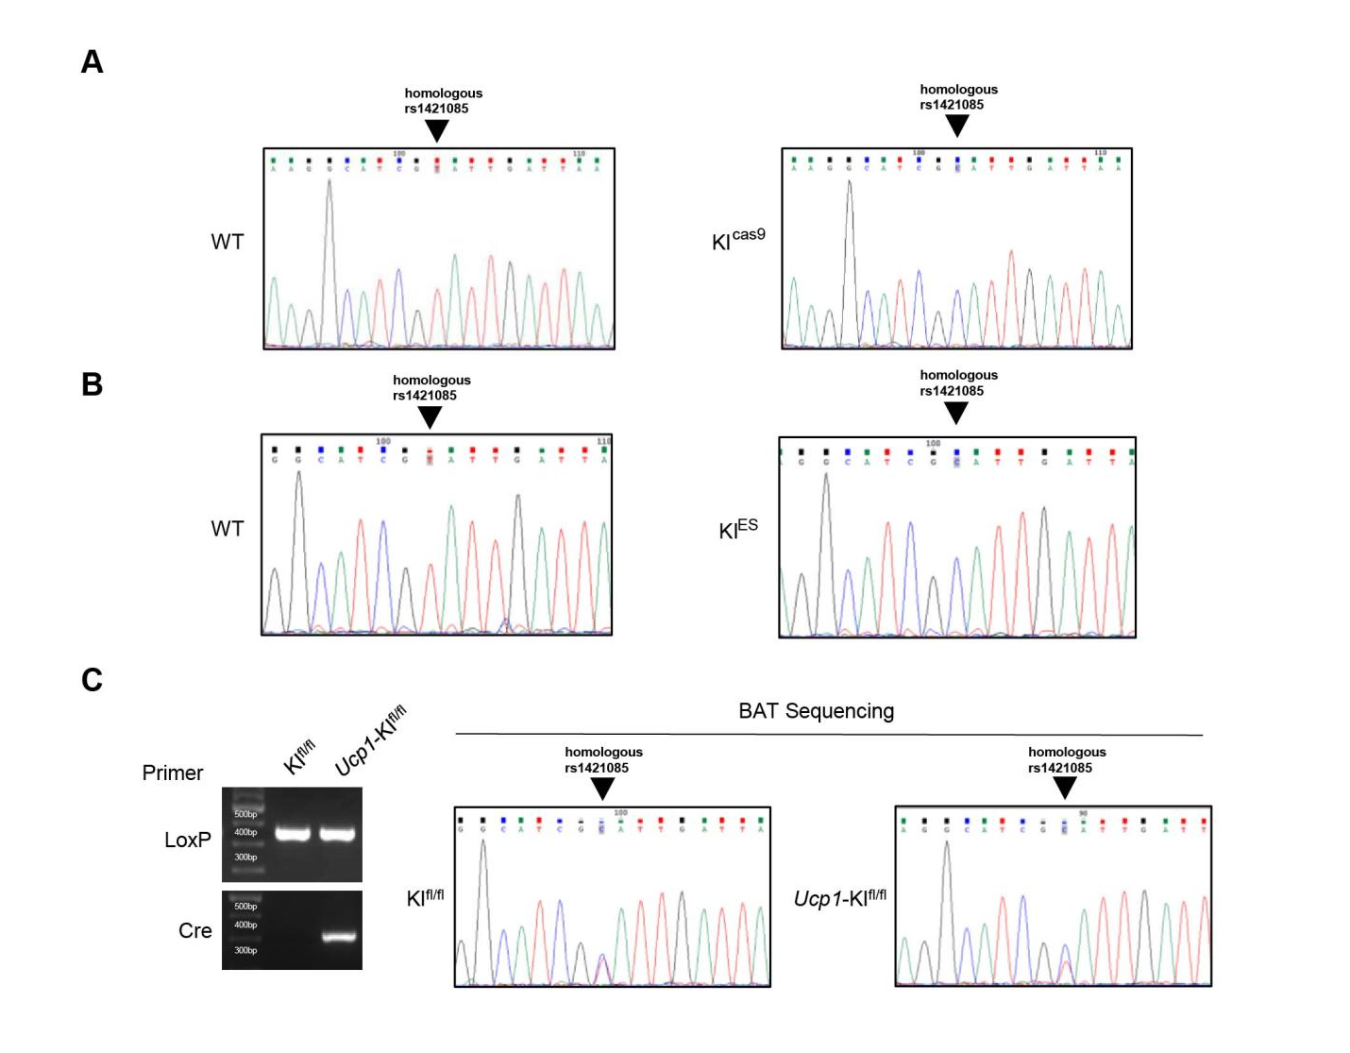
Fig. S1. Sequencing of the homologous rs1421085 T>C variant in human and mouse. (A) Conserved motif module surrounding rs1421085 locus in human and mouse. (B and C), Sanger sequence analysis of KI^{cas9} (B) and KI^{ES} (C) mice, respectively. (D) Floxp (left, top) and Cre expression (left, bottom) and BAT DNA sequence analysis (right) of homologous rs1421085 mutation in KI^{fl/fl} and Ucp1-KI^{fl/fl} mice. Gene sequencing alignment was analyzed with Jalview Version 2 (see Methods).

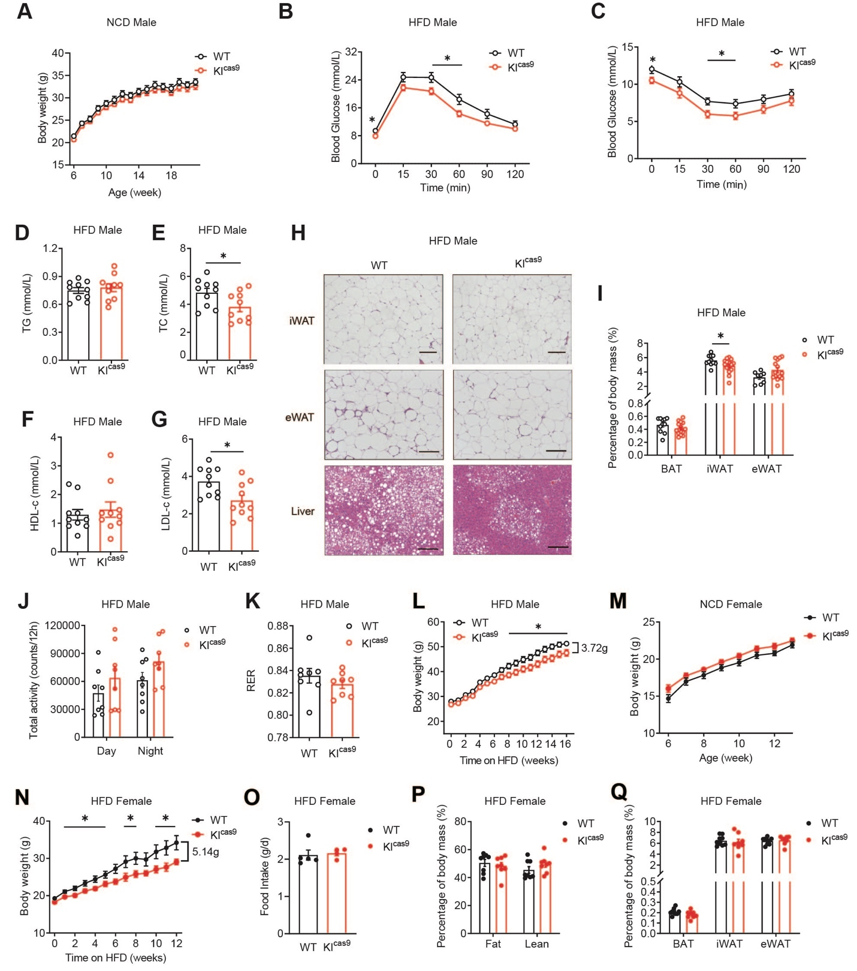
Fig. S2. The homologous rs1421085 T>C variant protests HFD-induced obesity but shows no change in body weight under chow diet in KI^{cas9} mice. (A) Body weight curve of KI^{cas9} mice and WT littermates under normal chow diet (NCD) (n = 10:15). (B to J), IPGTT (B) and ITT(C) tests, plasma triglyceride (D), total cholesterol (TC) (E), HDL-c (F) and LDL-c (G), representative images of H&E staining of iWAT, eWAT and liver (H), BAT, iWAT and eWAT content (I), total physical activities (J) and respiratory exchange ratio (RER) (K) of KI^{cas9} mice and WT littermates under HFD. n = 17:17 in (B) and (C), n = 10:10 in (D) to (G), n = 8:15 in (H). I, Scale bar, 100 μm. n = 8:8 in (J) and (K). (L) The validated diet-induced adiposity phenotype of KI^{cas9} mice (with F3 generation) under HFD challenge initiating from 11-week-old to 27-week-old (n = 18:19 for KI^{cas9} and WT, respectively). (M) Body weight curve of female KI^{cas9} and wild-type littermate mice under NCD (n = 21:20). （N to Q）, Body weight curve (N), average food intake (O), body composition (P), and mass percentage of indicated fat tissue (Q) of female KI^{cas9} and wild-type littermates under HFD challenge initiating from 8-week-old to 20-week-old. n = 9:8 in (N). average food intake per mouse of individual cage in (O), n = 5:4. n = 8:8 in (P) and (Q). Data are mean ± s.e.m. of biologically independent samples; unpaired two-sided Student’s t-test. * P < 0.05.

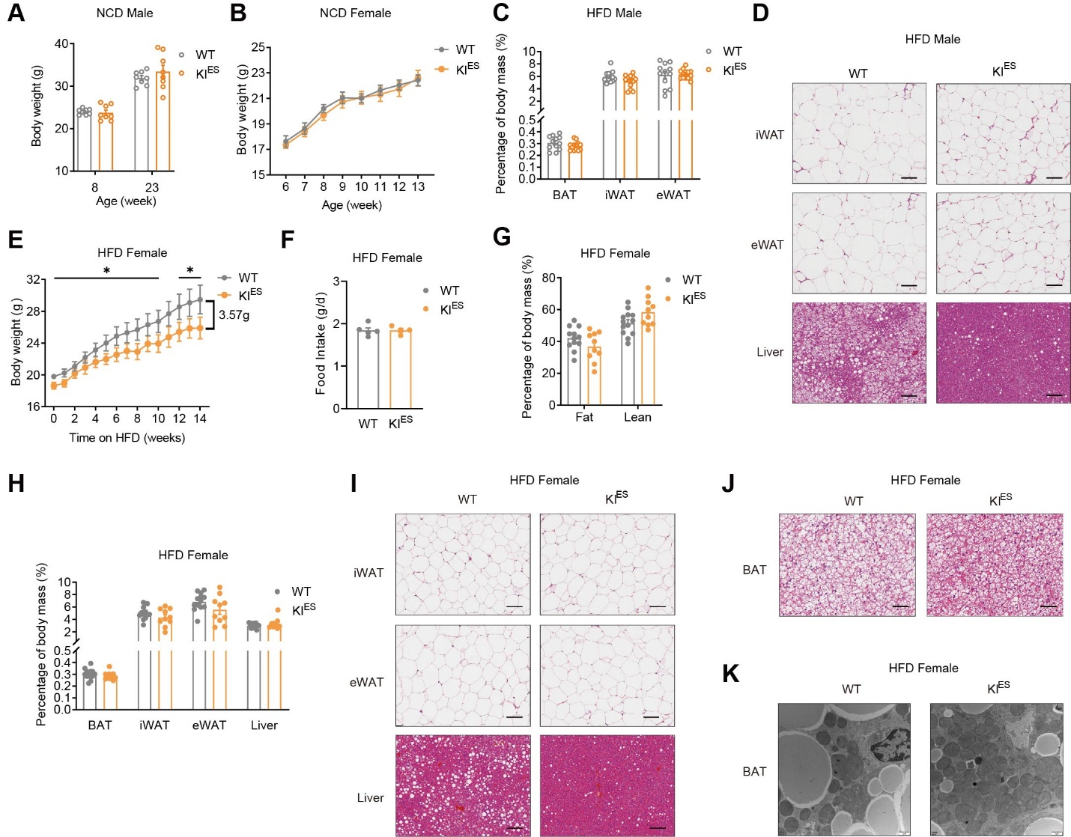Fig. S3. The homologous rs1421085 T>C variant protests HFD-induced obesity but shows no change in body weight under chow diet in KI^{ES} mice. (A) Body weight of male KI^{ES} and WT mice aged 8- and 23-week-old under NCD (n = 13:10). (B) Body weight curve of female KI^{ES} and WT mice under NCD (n = 8:8). (C to D) BAT, iWAT and eWAT content (C), representative images of H&E staining of iWAT, eWAT and liver (D) of male KI^{ES} and wild-type littermates under HFD (C, n = 11:16; D, scale bar, 100 μm). (E to K) Body weight curve (E), average food intake (F), body composition (G) and mass percentage of indicated fat tissues (H), representative images of H&E staining of indicated tissues (I, J) and TEM of BAT (K) of female KI^{ES} and wild-type littermate mice under HFD challenge initiating from 10-week-old to 24-week-old (E, n = 16:13; F, n = 5:4 cages; G, H, n = 10–13; I, J, scale bar, 100 μm; K, scale bar, 1 μm).Data are mean ± s.e.m. of biologically independent samples; unpaired two-sided Student’s t-test. * P < 0.05

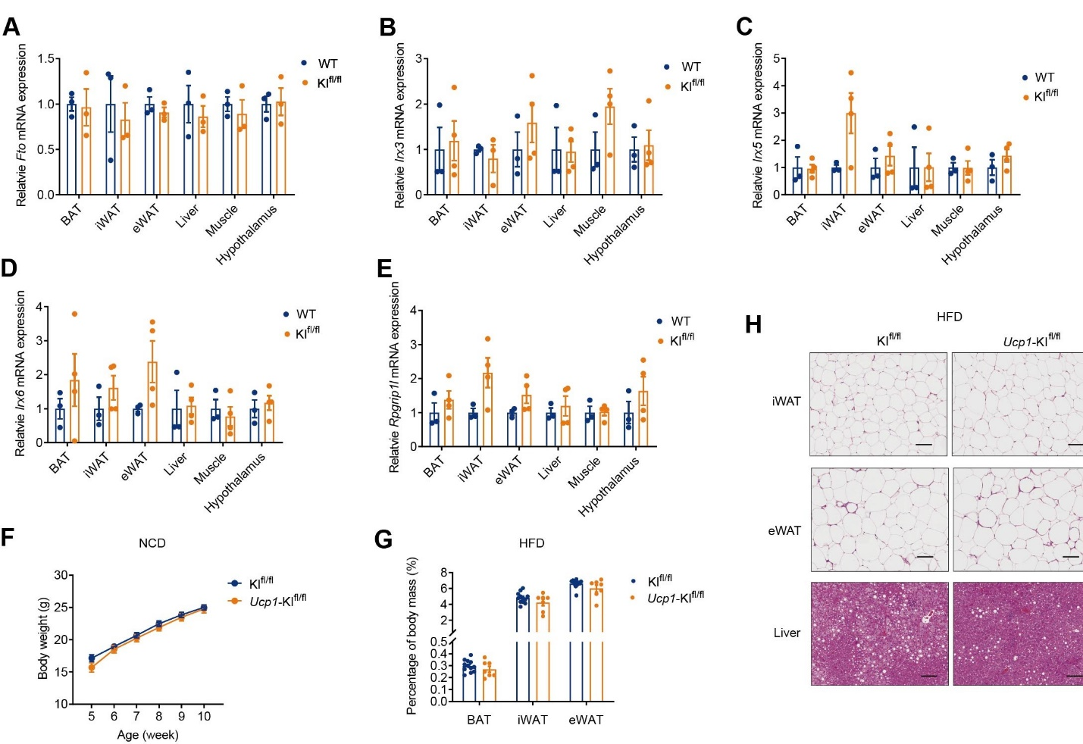
Fig. S4. Brown adipocyte-specific knock-in homologous rs1421085 T>C variant enhances thermogenesis and resists HFD-induced adiposity. (A to E) The mRNA expression of Fto (A), Irx3 (B), Irx5 (C), Irx6 (D), and Rpgrip1l (E) in the key tissues related to energy hemostasis of homologous rs1421085^{fl/fl} (KI^{fl/fl}) and wild-type mice (4-5 weeks old male mice; n = 3:4). (F and G) Body weight curve (F) and mass percentage (G) of Ucp1-KI^{fl/fl} mice and KI^{fl/fl} littermates under NCD (n = 12:7). (H) The representative H&E images of iWAT, eWAT and liver in Ucp1-KI^{fl/fl} mice and KI^{fl/fl} littermates under HFD (Scale bar, 100 μm). Data are mean ± s.e.m. of biologically independent samples.

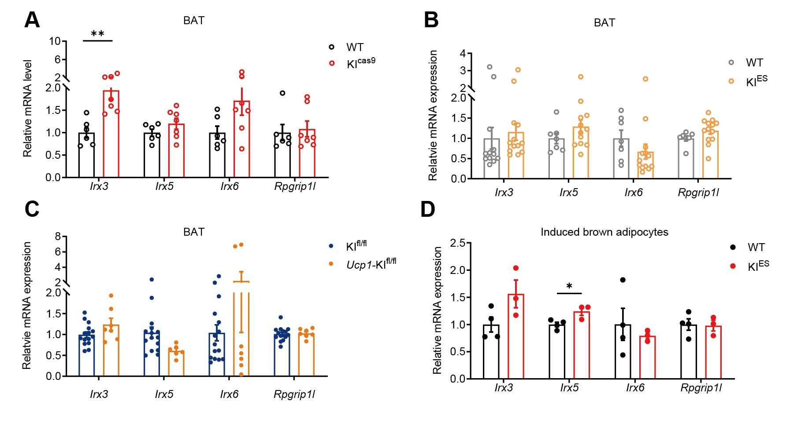
Fig. S5. The mRNA expression of potential downstream effectors of rs1421085 T>C variation. (A to D) The mRNA expression of Irx3, Irx5, Irx6, and Rpgrip1l in BAT tissues and induced mature brown adipocytes of indicated models (KI^{cas9}, n = 6:7; KI^{ES}, n = 7:13; Ucp1-KI^{fl/fl}, n = 15:7; induced brown adipocytes derived from KI^{ES} BAT SVF, n = 4:3). Data are mean ± s.e.m. of biologically independent samples; unpaired two-sided Student’s t-test. * P < 0.05, ** P < 0.01.

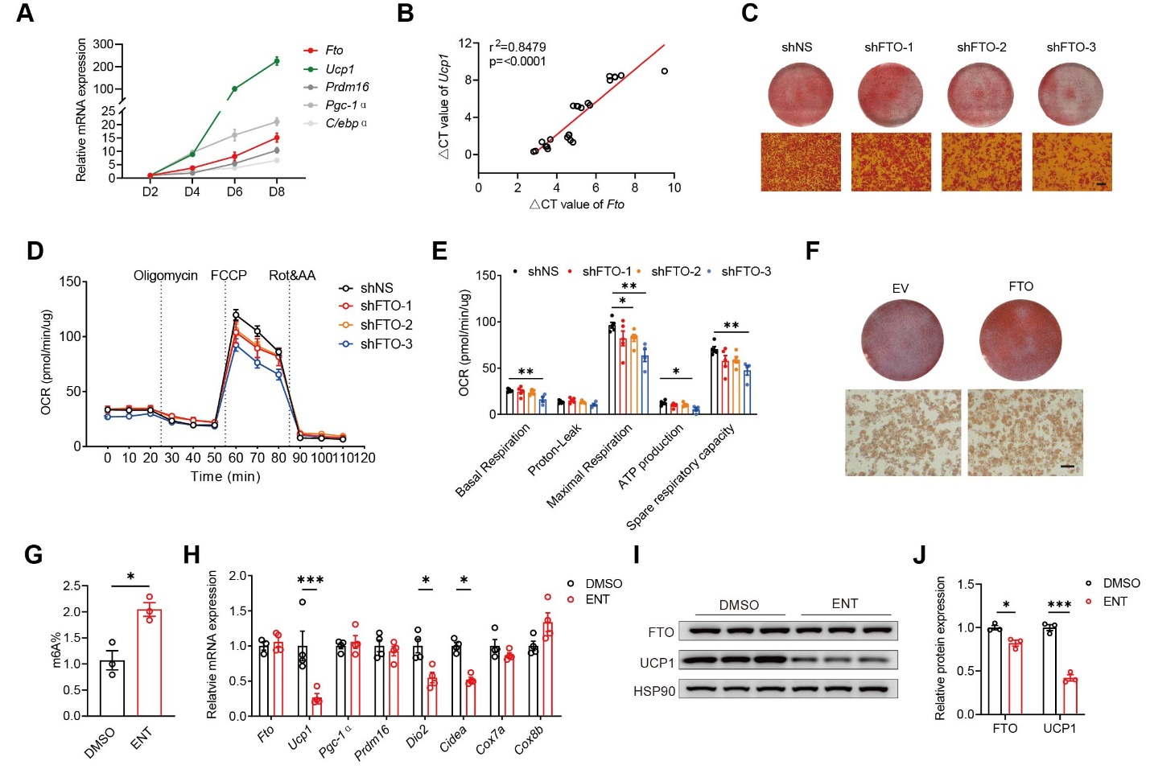
Fig. S6. FTO enhances thermogenic capacity of brown adipocytes and partially medicates the increased thermogenesis in rs1421085 T>C knock-in model. (A) The mRNA expression of Fto and thermogenesis-related genes at different time point during brown adipocyte differentiation derived from BAT SVFs (n = 5). (B) Correlation analysis of the mRNA levels of Fto and Ucp1 in (A). (C to E), Oil Red O staining (C), OCR measurement (D, E) of induced brown adipocytes derived from BAT SVFs with Fto knockdown. (F) Oil Red O staining of induced brown adipocytes derived from BAT SVFs with Fto overexpression. (G) The m6A abundance in induced mature brown adipocytes in the presence of Entacapone (ENT, 50 μM) or vehicle (n = 3). (H) The mRNA expression of thermogenesis-related genes in induced mature brown adipocytes in the presence of ENT or vehicle (n = 4). (I and J) The protein levels (I) and quantification analysis (J) of FTO and UCP1 in induced mature brown adipocytes in the presence of ENT or vehicle (n = 3). (C to F) The SVFs were infected with lentivirus 2 days before induction; MOI = 50; (C) and (F), Scale bar, 100 μm. Data are mean ± s.e.m. of biologically independent samples; unpaired two-sided Student’s t-test. * P < 0.05, ** P < 0.01, *** P < 0.001.

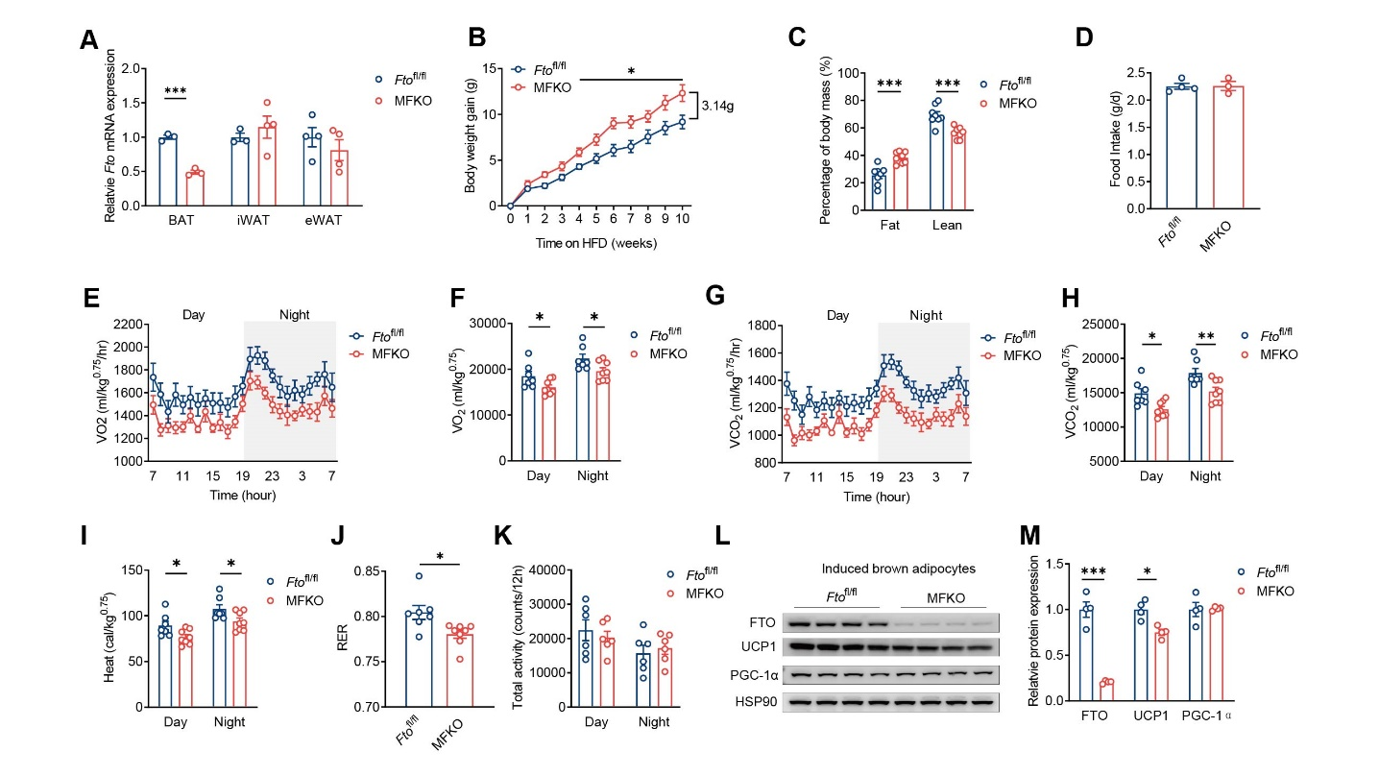
Fig. S7. Fto deficiency in BAT impairs thermogenesis and resists HFD-induced adiposity. (A) The mRNA expression of Fto in indicated adipose tissues in 4-week-old female Fto^{fl/fl}; Myf5-cre (MFKO) mice and Fto^{fl/fl} littermates (n = 4:4). (B to D) Body weight (B), body composition (C) and average food intake (D) of MFKO mice and littermate controls under HFD challenge initiating from 9-week-old to 19-week-old (n = 9:12). (E to K) Whole-day and 12h O₂ consumption (E, F), CO₂ production (G, H), heat generation (I), RER (J) and total physical activities (K) were collected in MFKO mice and littermate controls under HFD challenge (n = 8:8; E-I, normalized to the body weight^{0.75}). (L and M) The protein expression (L) quantification analysis (M) and of FTO, UCP1 and PGC-1α in induced mature brown adipocytes derived from BAT SVFs of MFKO and littermate control mice (n = 4:4). The data were presented as means ± s.e.m.; unpaired two-sided Student’s t-test. * P < 0.05, ** P < 0.01, *** P < 0.001.

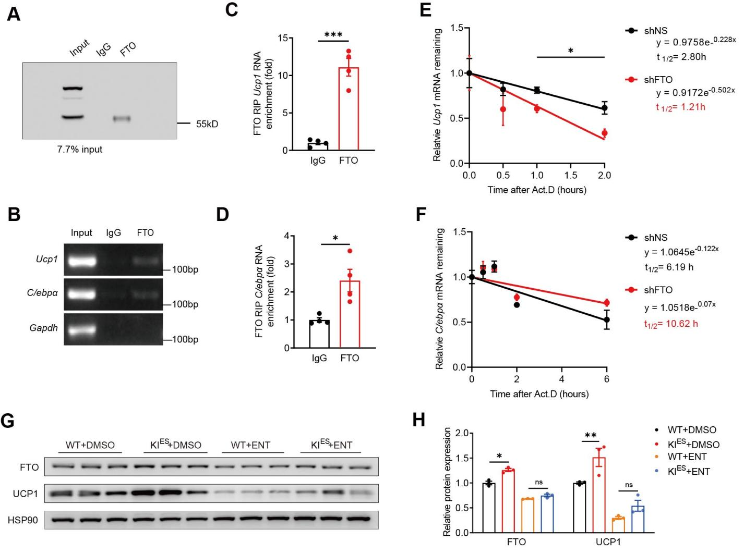
Fig. S8. FTO protein stabilizes Ucp1 mRNA and increase UCP1 protein expression.
(A to D) RIP-qPCR analysis of the interaction of FTO protein and target mRNA in induced mature brown adipocytes. Representative immunoblots showing the products of IP by FTO antibody, with IgG as a negative control (A); AGE (B) and qPCR analysis (C, D) of Ucp1 and C/ebpα mRNA abundance of FTO-IP products (n = 4). The enrichment of Ucp1 and C/ebpα mRNA were normalized to input (7.7%). (E and F) Half-life analysis of Ucp1 (E) and C/ebpα (F) mRNA in induced mature brown adipocytes with Fto knockdown. The BAT SVFs were infected with lentivirus 2 days before induction (MOI = 75); Actinomycin D (5 μg/ml) was added on the eighth day of induction; total RNA was isolated at indicated time points (n = 3-4); Calculated half-times t_{1/2} = In2/K_{decay}. (G and H) The protein expression (G) and quantification analysis (H) of FTO and UCP1 in induced mature brown adipocytes derived from BAT SVFs of KI^{ES} and wild-type littermate mice in the presence of ENT or vehicle (n = 3:3). The data were presented as means ± s.e.m.; unpaired two-sided Student’s t-test. * P < 0.05, ** P < 0.01, *** P < 0.001.

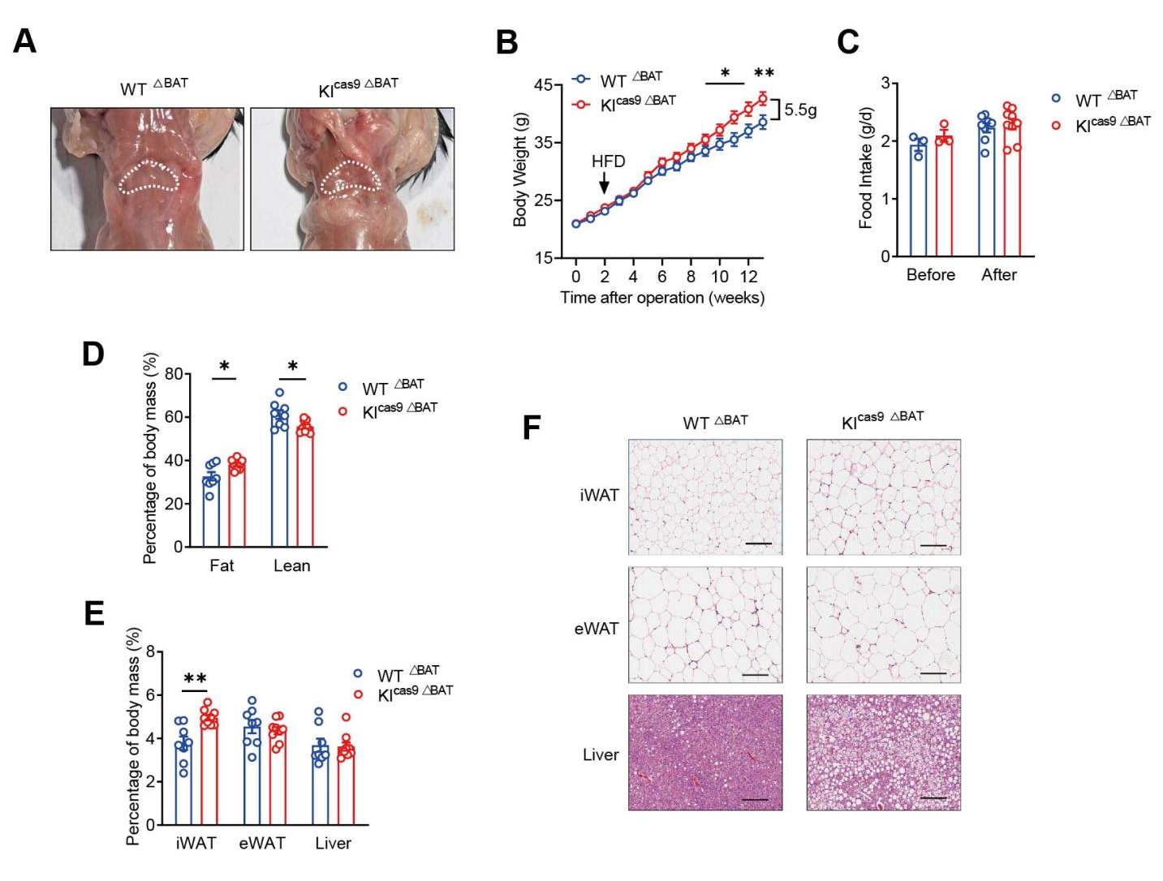
Fig. S9. Surgical excision of intrascapular BAT largely reverses HFD-resistance phenotype of KI^{cas9} mice. (A) Representative anatomy images showed no obvious regeneration of intrascapular BAT 16 weeks after BAT-surgical deletion in KI^{cas9} (KI^{cas9 ΔBAT}) and WT littermate (WT^{ΔBAT}) mice. White dotted circle indicated interscapular BAT (iBAT) region. (B to F) Body weight curve (B), average food intake (C), body composition (D), mass percentage of indicated tissues (E), and representative H&E images of iWAT, eWAT and liver (F) in KI^{cas9 ΔBAT} mice and WT^{ΔBAT} littermates after HFD (Scale bar, 100 μm). BAT-surgical deletion was performed to mice at 6-week-old, and HFD was provided to mice at 8-week-old; n = 7:9. The data were presented as means ± s.e.m.; unpaired two-sided Student’s t-test. * P < 0.05, ** P < 0.01.

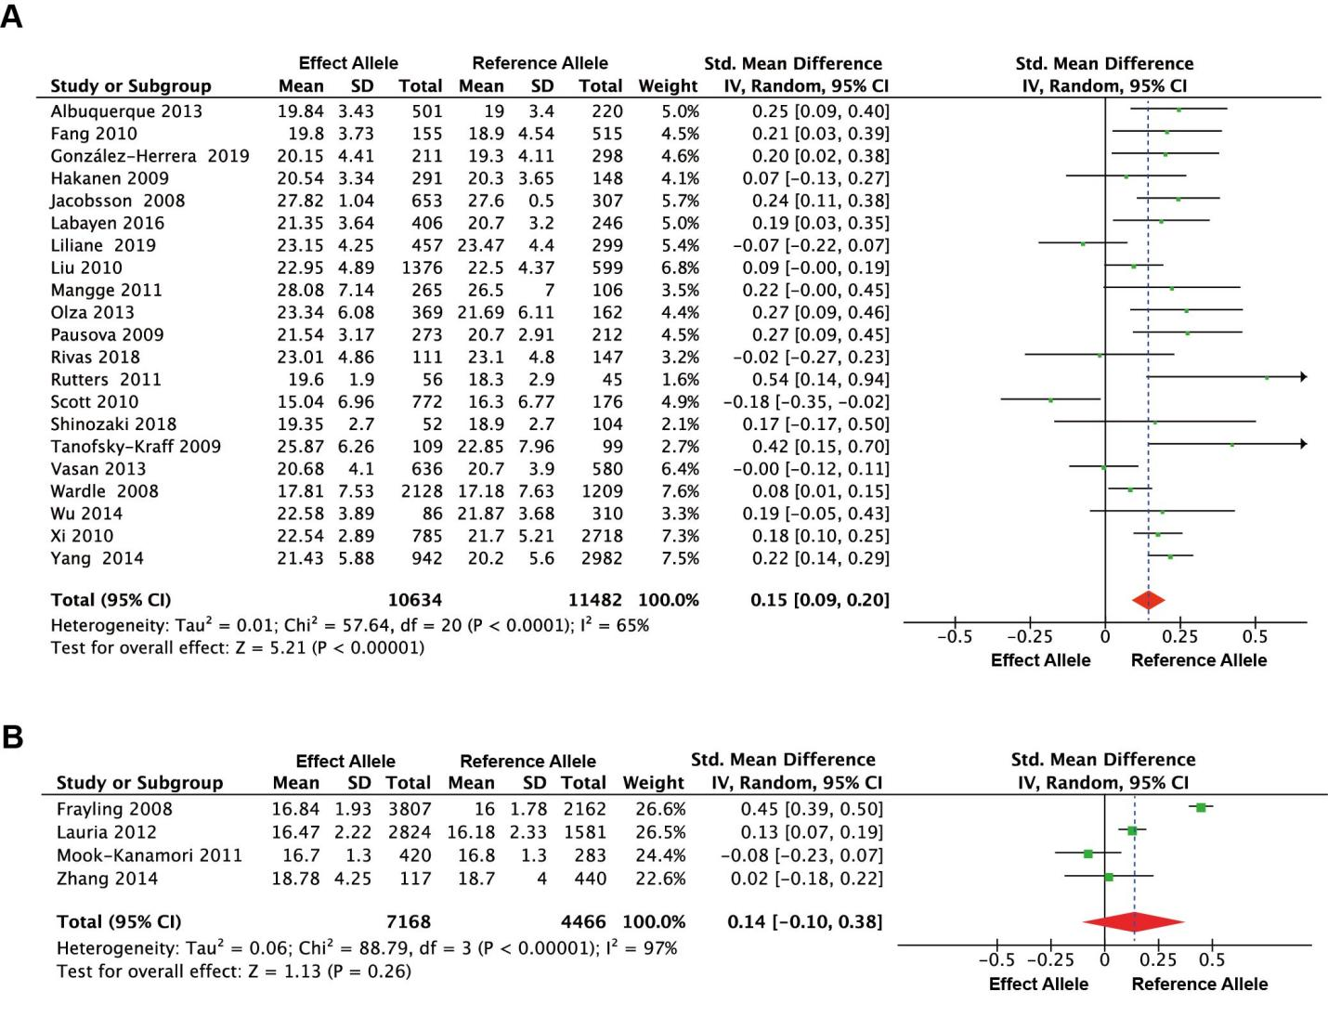
Fig. S10. The association of human FTO rs1421085 T>C variation frequency with BMI. (A and B) The Forest plot of the association between BMI and human FTO rs1421085 polymorphism in populations with ages older than 8 year-old (A) and younger than 8 year-old (B), respectively. Effect allele, rs1421085_C; reference allele, rs1421085_T.

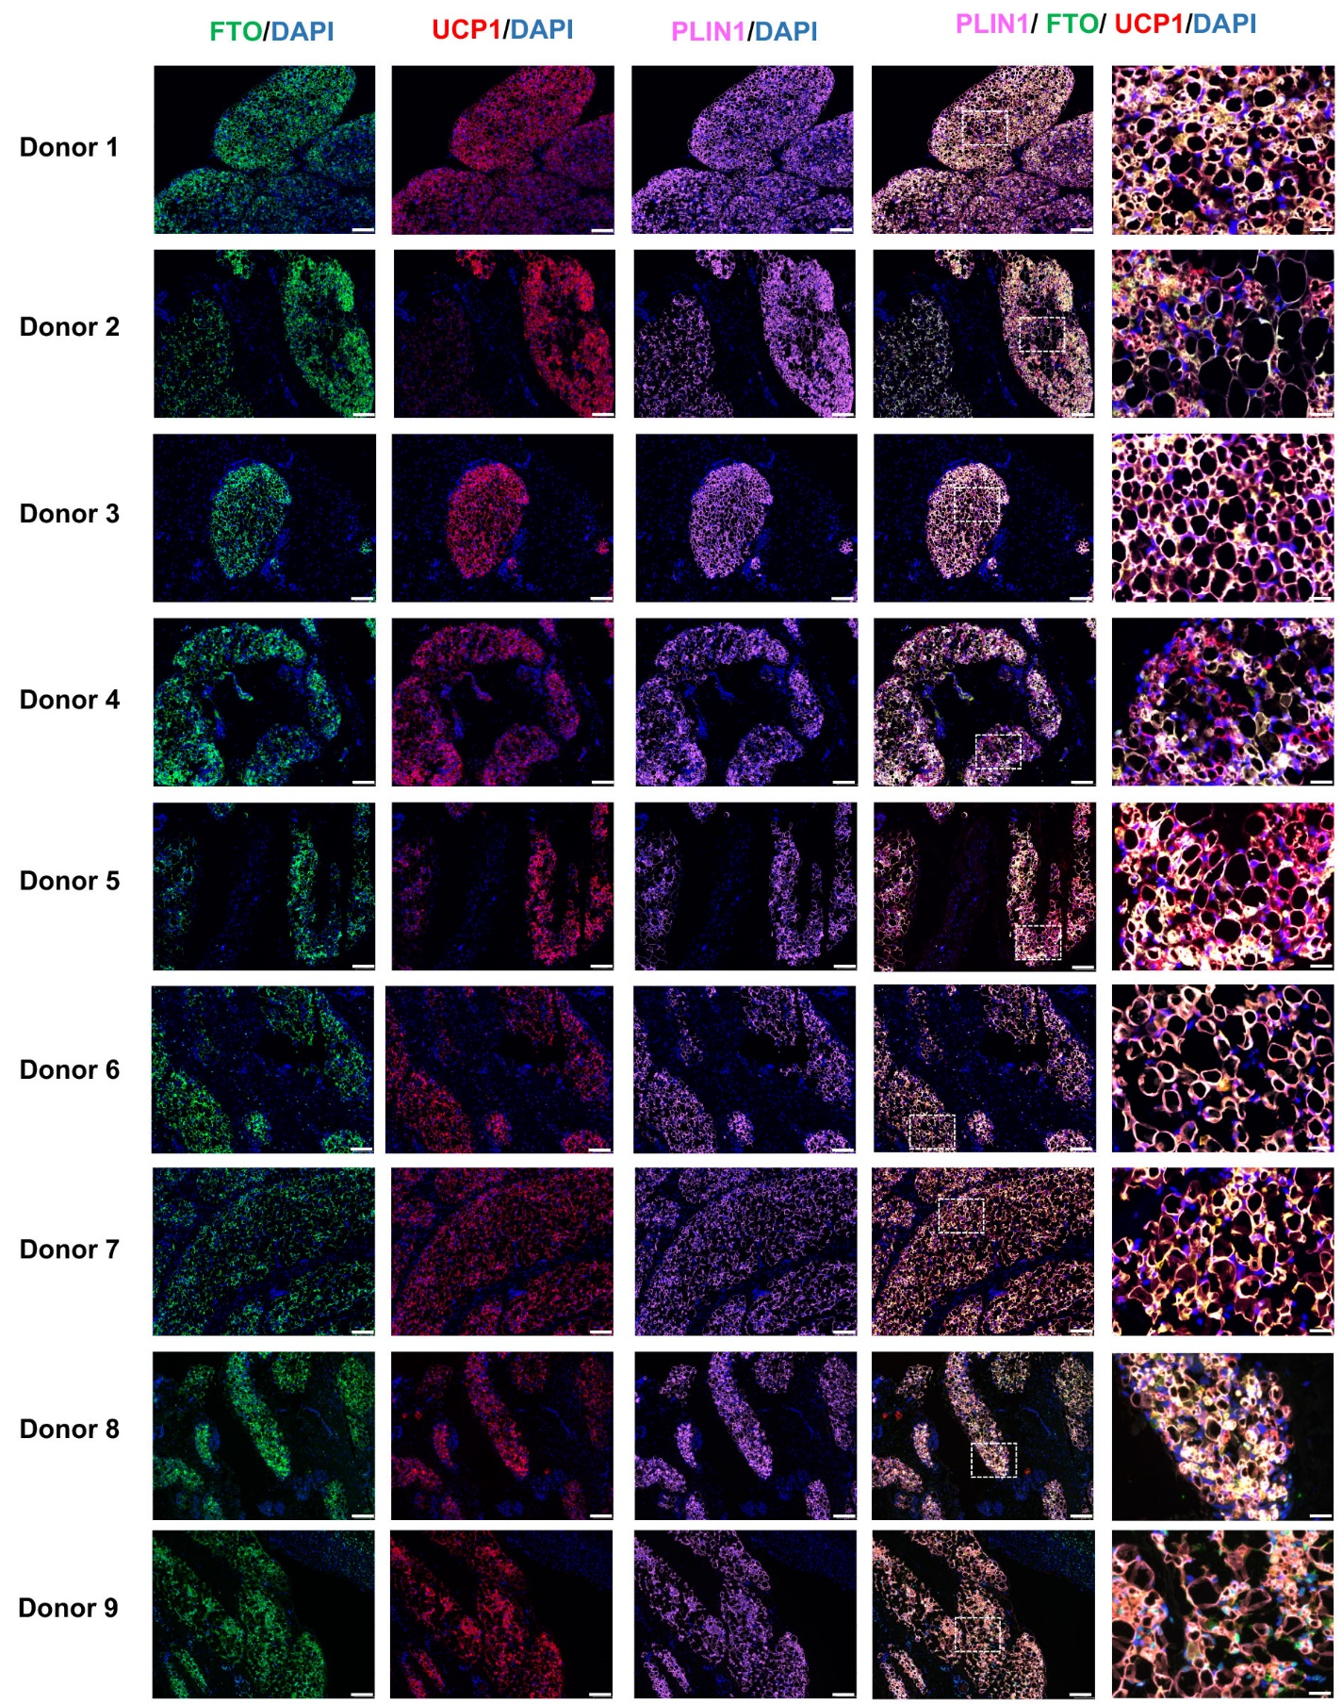
Fig. S11. The FTO and UCP1 were colocalized in human embryonic brown adipose tissue. Representative immunofluorescence (IF) images of FTO (green) and UCP1 (red) in human embryonic brown adipose tissue. The nucleus was stained with DAPI (blue), lipid droplets was
stained with PLIN1 (pink). Left to right: FTO, UCP1, PLIN1, PLIN1/FTO/UCP1/DAPI (scale bar, 100μm), PLIN1/FTO/UCP1/PLIN1(scale bar, 20μm).

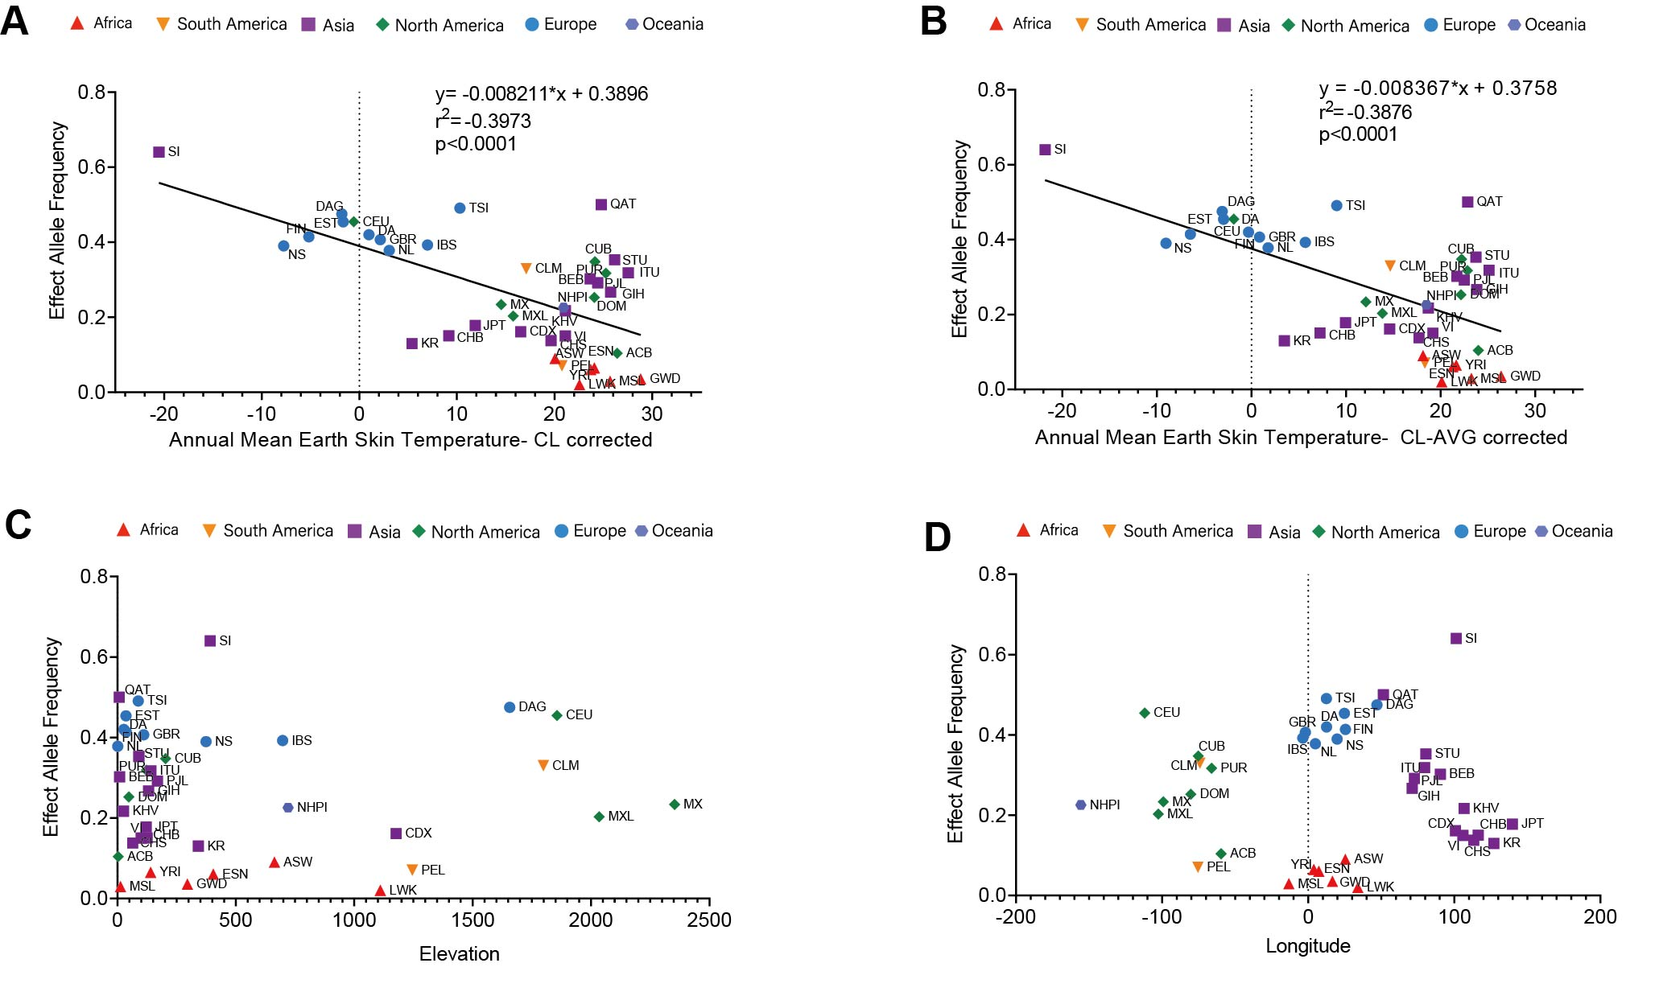
Fig. S12. The association of human FTO rs1421085 T>C variation frequency with ambient environmental temperature, elevation, and latitude. (A and B) The correlation analysis of effect allele frequencies and CL-corrected (A) or CL-AVG corrected (B) annual mean earth skin temperature. (C and D) The correlation analysis of effect allele frequency and elevation (C) or longitude (D). Colors and symbols represented populations of different continents. Details of populations are listed in table S5.

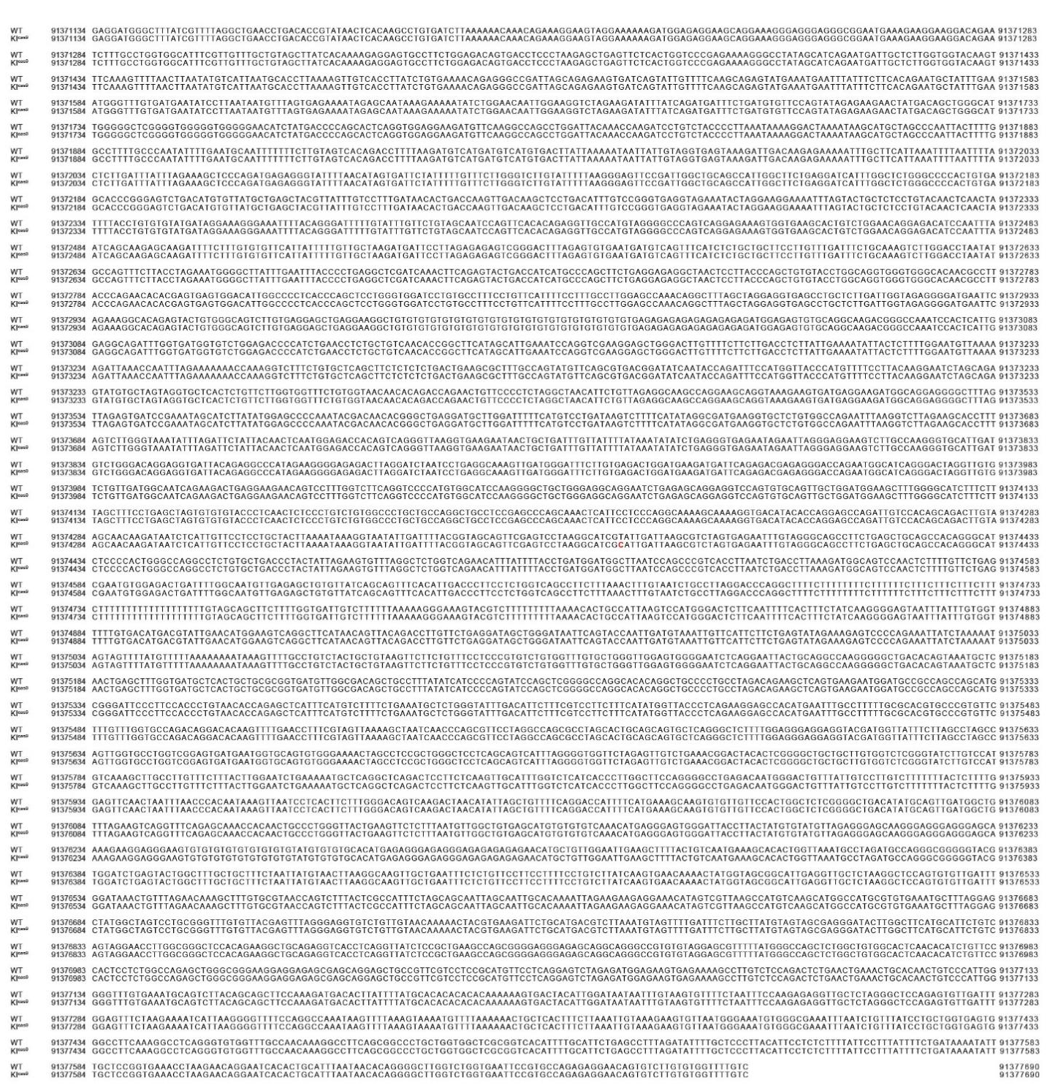
Fig. S13. Sanger sequencing of the 6 kb DNA region centered on the homologous rs1421085 locus in WT and KI^{cas9} mice. The rs1421085 locus was emphasized in bold.

Coordinates | strand | MM* | target_sequence | PAM | distance |  | gene name
chr8:91374360-91374382 | - | 0 | CTTAATCA[ATACGATGCCTT] | AGG | 13354 | I | Fto
chr3:5498973-5498995 | - | 4 | GTTTATAA[ATATGATGCCTT] | AGG | 14000 | - | 4930555M17Rik
chr14:39161796-39161818 | - | 4 | CTAAAACA[TGACGATGCCTT] | TGG | 58253 | I | Gm20642
chr10:50467540-50467562 | - | 4 | ATGAATCC[ATAAGATGCCTT] | TGG | NA | - | NA
chr17:93375023-93375045 | + | 4 | CTGAATAA[TGACGATGCCTT] | CGG | NA | - | NA
chr11:90012399-90012421 | - | 4 | CTCCATCT[ATATGATGCCTT] | GGG | 9505 | - | Pctp
chr7:91069018-91069040 | + | 4 | ATTAAACC[ATATGATGCCTT] | AGG | 21666 | - | Dlg2
chr2:117820099-117820121 | - | 4 | CTTGAGTA[ATATGATGCCTT] | GGG | 1807 | - | 4930412B13Rik
chr15:82106342-82106364 | - | 4 | CTCAAACA[AACCGATGCCTT] | TGG | 666 | I | Mei1
chr10:130452922-130452944 | + | 4 | CTAAACAA[ATACCATGCCTT] | TGG | 0 | E | Vmn2r86

Table S1. Top 10 off-target sites prediction
Notes. MM: Mouse Musculus GRCm38/mm10. Data Analyze: https://cctop.cos.uni-heidelberg.de:8043/.
Referrence: https://cctop.cos.uni-heidelberg.de:8043/help.html

Genotyping Primers | sequence (5'→3'）
mouse Fto-F | AGCCCAGCAAACTCATTCCT
mouse Fto-R | CAGATTAAGGTGACGGGCTGGAT
Fto sequencing | AAGGTGACATACACCAGGAGCC
loxP-F | GCCGATTAGCAGAGAAGTGATCAG
loxP-R | CTTGAACATCTTCCTCCACCTGAG
Cre-F | ATTTGCCTGCATTACCGGTCG
Cre-R | CAGCATTGCTGTCACTTGGTC
qPCR Primers | sequence (5'→3'）
36B4-F | GAAACTGCTGCCTCACATCCG
36B4-R | GCTGGCACAGTGACCTCACACG
Ucp1-F | AGGCTTCCAGTACCATTAGGT
Ucp1-R | CTGAGTGAGGCAAAGCTGATTT
Fto-F | GACACTTGGCTTCCTTACCTG
Fto-R | CTCACCACGTCCCGAAACAA
Cox8b-F | GAACCATGAAGCCAACGACT
Cox8b-R | GCGAAGTTCACAGTGGTTCC
Cox7a-F | CAGCGTCATGGTCAGTCTGT
Cox7a-R | AGAAAACCGTGTGGCAGAGA
Elovl6 F | CCCGAACTAGGTGACACGAT
Elovl6 R | CCAGCGACCATGTCTTTGTA
C/EBPα F | GGTTTCGGGTCGCTGGATCTCTAG
C/EBPα-R | ACGGCCTGACTCCCTCATCTTAGAC
C/ebpβ-F | TTATAAACCTCCCGCTCGGC
C/ebpβ-R | TTCCATGGGTCTAAAGGCGG
Pgc1α-F | AGCCGTGACCACTGACAACGAG
Pgc1α-R | RGCTGCATGGTTCTGAGTGCTAAG
Cidea-F | TGCTCTTCTGTATCGCCCAGT
Cidea-R | GCCGTGTTAAGGAATCTGCTG
Pparγ2-F | GCATGGTGCCTTCGCTGA
Pparγ2-R | TGGCATCTCTGTGTCAACCATG
Dio2-F | AATTATGCCTCGGAGAAGACCG
Dio2-F | GGCAGTTGCCTAGTGAAAGGT
Prdm16-F | TGACGGATACAGAGGTGTCAT
Prdm16-R | ACGCTACACGGATGTACTTGA
Irx3-F | GGCAATGCTTATGGGAGCGA
Irx3-R | CGCTGTCTAAGTTTTCCAAATCG
Irx5-F | GCACGGATGAGCTCGGCCGCTC
Irx5-R | GGGTGATATCCCAAGGAACCTG
Irx6-F | CTCAGTATGAGTTCAAGGATGCTG
Irx6-R | CTCCCTTGTGGCATTCTTCCTG
Fabp4-F | ACACCGAGATTTCCTTCAAACTG
Fabp4-R | CCATCTAGGGTTATGATGCTC
Rpgrip1l-F | ACTGGAAGACAGATTTTTGCGT
Rpgrip1l-R | AACTAGCCGTATTAACTTGGTGG

Table S2. Primers for genotyping/qPCR.

Lentiviruse siRNA
Marker | Gene | Gene ID | TargetSequence | GC%
shFTO-1 | Fto | NM_011936 | GCTTGAAGACACTTGGCTT
shFTO-2 | Fto | NM_011936 | GCATGTCAGACCTTCCTAA
shFTO-3 | Fto | NM_011936 | GCTGAGGCAGTTCTGGTTT
shCtrl | NC |  | TTCTCCGAACGTGTCACGT | 52.6
shRNA and Primers
DNA primers | Sequence
shFTO-1 F | CCGGGCTTGAAGACACTTGGCTTCTCAAGAGAAAGCCAAGTGTCTTCAAGCTTTTTTG
shFTO-1 R | AATTCAAAAAAGCTTGAAGACACTTGGCTTTCTCTTGAGAAGCCAAGTGTCTTCAAGC
shFTO-2 F | CCGGGCATGTCAGACCTTCCTAATTCAAGAGATTAGGAAGGTCTGACATGCTTTTTTG
shFTO-2 R | AATTCAAAAAAGCATGTCAGACCTTCCTAATCTCTTGAATTAGGAAGGTCTGACATGC
shFTO-3 F | CCGGGCTGAGGCAGTTCTGGTTTCTCAAGAGAAAACCAGAACTGCCTCAGCTTTTTTG
shFTO-3 R | AATTCAAAAAAGCTGAGGCAGTTCTGGTTTTCTCTTGAGAAACCAGAACTGCCTCAGC
shCtrl F | CCGGTTCTCCGAACGTGTCACGTTTCAAGAGAACGTGACACGTTCGGAGAATTTTTTG
shCtrl R | AATTCAAAAAATTCTCCGAACGTGTCACGTTCTCTTGAAACGTGACACGTTCGGAGAA
CMV-F | CGCAAATGGGCGGTAGGCGTG

Table S3. Primer sequences for lentivirus construction and validation.

FTO & BMI> 8
Number | Auther | Cohort name | Publication year | Country | Ethnicity | Genotype | DOI
1 | Josefin A. Jacobsson | National Childhood Obesity Centre at Karolinska University Hospital, | 2008 | Sweden | Swedish | rs9939609 | DOI: 10.1016/j.bbrc.2008.01.087
2 | I.Labayen | The HELENA cross- sectional study | 2016 | Vitoria, Spain | European | rs9939609 | DOI: 10.1016/j.numecd.2016.07.010
3 | Liliane dos SantosRodrigues | RPS Cohort of São Luís, Maranhão. | 2019 | Brazil | Brazilian | rs9939609 | DOI: 10.1016/j.jped.2019.05.006
4 | Gaifen Liu | Georgia Cardiovascular Twin study the LACHY study and the APEX study | 2010 | The Netherlands | European whites and African American | rs9939609 | DOI: 10.1186/1471-2350-11-57
5 | Bo Xi | Beijing Child and Adolescent Metabolic Syn- drome (BCAMS) study | 2010 | China | Chinese | rs9939609 | DOI: 10.1186/1471-2350-11-107
6 | Hongyun Fang | NAª | 2010 | China | Chinese | rs9939609 | DOI: 10.1186/1471-2350-11-136
7 | Josune Olza | NA | 2013 | Spain | European descent | rs9939609 | DOI: 10.1186/1471-2350-14-123
8 | Marian Tanofsky-Kraff | NA | 2009 | US | Non-Hispanic white and others | rs9939609 | DOI: 10.3945/ajcn.2009.28439
9 | Lizbeth González-Herrera | NA | 2019 | México | Mayan | rs1421085 | DOI: 10.1002/ajhb.23192
10 | S K Vasan | NA | 2013 | South India | Hiefly Dravidian in origin, with 1.2% being a mixture of Punjabi and Marwari ethnicity | rs9939609 | DOI: 10.1111/j.2047-6310.2013.00118.x
11 | Maarit Hakanen | STRIP study | 2009 | Finland | Finn | rs9939609 | DOI: 10.1210/jc.2008-1199
12 | Femke Rutters | Dutch Caucasian cohort | 2011 | Dutch | Dutch Caucasian | rs9939609 | DOI: 10.1210/jc.2010-2413
13 | David Albuquerque | NA | 2013 | Portuguese | Portuguese | rs9939609 | DOI: 10.1371/journal.pone.0054370
14 | Junqing Wu | NA | 2014 | China | Chinese | rs9939609 | DOI: 10.1371/journal.pone.0098984
15 | Min Yang | NA | 2014 | China | Chinese | rs9939609 | DOI: 10.1371/journal.pone.0104574
16 | Robert A Scott | Growth, Exercise and Nutrition Epidemiological Study in preSchoolers (GENESIS) | 2010 | Greece | Greek | rs17817449 | DOI: 10.1038/ejhg.2010.131
17 | Zdenka Pausova | Saguenay Youth Study | 2009 | United Kingdom | Saguenay-Lac St Jean(French Canadian Founder Population) | rs9939609 | DOI: 10.1161/CIRCGENETICS.109.857359
18 | Ana Maria Obregón Rivas | NA | 2018 | Chile | Chilean | rs9939609 | DOI: 10.1016/j.nut.2018.03.001
19 | Keiko Shinozaki | Shunan Child Health Cohort Study | 2018 | Japan | Japanese | rs1558902 | DOI: 10.1111/ped.13578
20 | Jane Wardle | Twins’ Early Development Study（TEDS ） | 2008 | UK | United Kingdom children | rs9939609 | DOI: 10.1210/jc.2008-0472
21 | Harald Mangge | STYrian Juvenile OBesity Study (STYJOBS) | 2011 | Australia | European | rs9939609 | DOI: 10.1155/2011/186368
ª. Not available.
FTO & BMI ≤ 8
Number | Auther | Cohort name | Publication year | Country | Ethnicity | Genotype | DOI
1 | D O Mook-Kanamori | he Generation R Study | 2011 | Dutch | Dutch ethnicity | rs9939609 | DOI: 10.1007/BF03346689
2 | Meixian Zhang | Beijing Child and Adolescent Metabolic Syndrome (BCAMS) study | 2014 | China | Chinese | rs9939609 | DOI: 10.1371/journal.pone.0097545
3 | Fabio Lauria | IDEFICS | 2012 | Italy | White European descent | rs9939609 | DOI: 10.1371/journal.pone.0048876
4 | Timothy M. Frayling | The Avon Longitudinal Study of Parents and Children (ALSPAC) cohort and the Northern Finland 1966 birth cohort (NFBC1966) | 2008 | England and Finland | English and Finn | rs9939609 | DOI: 10.1126/science.1141634
FTO& Birthweigt
Number | Auther | Cohort name | Publication year | Country | Ethnicity | Genotype | DOI
1 | Abel López-Bermejo | Neonatal Unit of the Obstetrics and Gynecology Department of the Hospital Sant Joan de De ́u, | 2008 | Spain | Spanish | rs9939609 | DOI: 10.1210/jc.2007-2343
2 | Maarit Hakanen | STRIP study | 2009 | Finland | Finn | rs9939609 | DOI: 10.1210/jc.2008-1199
3 | Bo Xi | Beijing Child and Adolescent Metabolic Syn- drome (BCAMS) study | 2010 | China | Chinese | rs9939609 | DOI: 10.1186/1471-2350-11-107
4 | Nuananong Seal | NA | 2011 | America | American Indian | rs9939609 | DOI: 10.1089/gtmb.2010.0188
5 | Tanaka | NA | 2012 | Japan | Japanese | rs1558902 | DOI: 10.5551/jat.11940
6 | Fleur P Velders | Generation R Study | 2012 | The Netherlands | Northern European descent | rs9939609 | DOI: 10.1371/journal.pone.0049131
7 | Olivier S Descamps | NA | 2014 | Belgium | European whites | rs9939609 | DOI: 10.1186/s12863-014-0145-0
8 | Elina Molou | NA | 2015 | Greece | Greek | rs9939609 | DOI: 10.1515/jpem-2014-0320
9 | Eva Gesteiro | NA | 2016 | Spain | Caucasian | rs9939609 | DOI: 10.1007/s13105-016-0467-7
10 | Claudiu Mărginean | Obstetrics Gynecology Tertiary Hospital from Romania | 2016 | Romania | Romanian | rs9939609 | DOI: 10.1097/MD.0000000000005551
11 |  | GOCY^{b} | 2020 | China | Chinese | rs1421085
^{b}. data from the Genetics of Obesity in Chinese Youngs (GOCY) study.

Table S4. Study details included in Meta-anaylsis.

Populations | Study Fullname | Full name
JPT | 1000Genomes | Japanese in Tokyo, Japan
KR | KOREAN population from KRGDB | KOREAN
CHB | 1000Genomes | Han Chinese in Beijing, China
CHS | 1000Genomes | Southern Han Chinese
KHV | 1000Genomes | Kinh in Ho Chi Minh City, Vietnam
VI | Vietnamese | Vietnamese
CDX | 1000Genomes | Chinese Dai in Xishuangbanna, China
BEB | 1000Genomes | Bengali from Bangladesh
SI | Siberian | Siberian
PJL | 1000Genomes | Punjabi from Lahore, Pakistan
QAT | Qatari | Qatari
DAG | Genome-wide autozygosity in Daghestan | Daghestan
LWK | 1000Genomes | Luhya in Webuye, Kenya
FIN | 1000Genomes | Finnish in Finland
EST | Genetic variation in the Estonian population | Estonian
NS | Northern Sweden | Northern Sweden
GWD | 1000Genomes | Gambian in Western Divisions in the Gambia
DA | The Danish reference pan genome | Danish
TSI | 1000Genomes | Toscani in Italia
ESN | 1000Genomes | Esan in Nigeria
NL | Genome of the Netherlands Release 5 | Netherlands
YRI | 1000Genomes | Yoruba in Ibadan, Nigeria
ITU | 1000Genomes | Indian Telugu from the UK
STU | 1000Genomes | Sri Lankan Tamil from the UK
GBR | 1000Genomes | British in England and Scotland
IBS | 1000Genomes | Iberian Population in Spain
MSL | 1000Genomes | Mende in Sierra Leone
ACB | 1000Genomes | African Caribbeans in Barbados
PUR | 1000Genomes | Puerto Ricans from Puerto Rico
CLM | 1000Genomes | Colombians from Medellin, Colombia
PEL | 1000Genomes | Peruvians from Lima, Peru
DOM | The PAGE Study | Dominican
CUB | The PAGE Study | Cuban
GIH | 1000Genomes | Gujarati Indian from Houston, Texas
ASW | 1000Genomes | Americans of African Ancestry in SW USA
MX | The PAGE Study | Mexican
CEU | 1000Genomes | Utah Residents (CEPH) with Northern and Western European Ancestry
MXL | 1000Genomes | Mexican Ancestry from Los Angeles USA
NHPI | The PAGE Study | Native Hawaiian

Table S5. Study details included in FTO rs1421085 T>C variant frequency analysis.

Abbreviation | Full name
AGE | agarose gel electrophoresis
ARID5b | AT-rich interactive domain 5B
ATCC | American type culture collection
BAT | brown adipose tissue
BMI | body mass index
BMR | basal metabolic rate
C/ebpα | CCAAT-enhancer binding protein α
Cidea | cell death-inducing DNA fragmentation factor alpha-like effector A
Cox7a | cytochrome c oxidase subunit 7A1
Cox8b | cytochrome c oxidase subunit 8B
CUX1 | cut like homeobox 1
Dio2 | typeⅡiodothyronine deiodinase
DMEM | Dulbecco's modified eagle medium
DMSO | dimethyl sulphoxide
EGG Consortium | Early Growth Genetics Consortium
Elovl6 | elongase of very long chain fatty acids family member 6
ENT | entacapone
ES cell | embryonic stem cell
eWAT | epididymal white adipose tissues
F12 | Ham's F12 nutrient medium
FBS | fetal bovine serum
FTO/Fto | fat mass and obesity associated
GWAS | genome-wide association studies
H&E | hematoxylin and eosin stain
HDL-c | high-density lipoprotein-cholesterol
HFD | high fat diet
iBAT | interscapular BAT
IBMX | 3-isobutyl-1-methylxanthine
IPGTT | intraperitoneal glucose-tolerance tests
IRX3/Irx3 | iroquois homeobox 3
ITT | insulin tolerance test
iWAT | inguinal white adipose tissue
KI | knock-in
LDL-c | low-density lipoprotein-cholesterol
LGM | Last Glacial Maximum
m6A | N6-methyladenosine
NCD | normal chow diet
OCR | oxygen consumption rate
PBS | phosphate buffer solution
PCR | polymerase chain reaction
Pgc-1α | peroxisome proliferator activated receptor coactivator-1 alpha
PLIN1 | perilipin1
Prdm16 | PR domain containing 16
RER | respiratory exchange ratio
RIP | RNA immunoprecipitation
Rosi | rosiglitazone
SNP | single nucleotide polymorphism
SVF | stromal vascular fraction
T3 | triiodothyronine
TC | total cholesterol
TEM | transmission electron microscopy
TG | triglyceride
UCP1 | uncoupling protein 1
WT | wild-type
△iBAT | excision of interscapular BAT

Table S6. Acronym and full name.

