Supplementary Figure

sFigure 1.
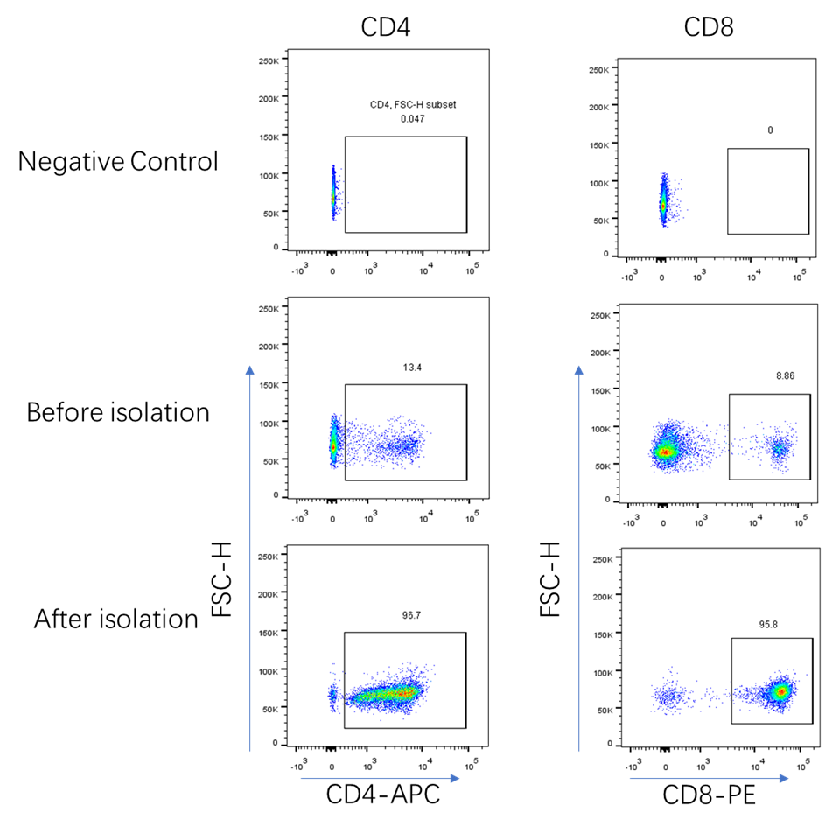
sFigure1. Cell separation and analysis by flow cytometry.
Separation of CD4+ T cells and CD8+ T cells from Balb/c mouse spleen.
Splenocytes were collected from mice immunized with pGX9501 and CD4-positive and CD8-positive T cells were separated by magnetic tag. The splenocytes and T cells were stained with CD4-APC and CD8-PE and detected with LSRFortessa flow cytometry (BD) and analyzed by FlowJo (TreeStar). Gates were set on lymphocytes (FSC/SSC).

