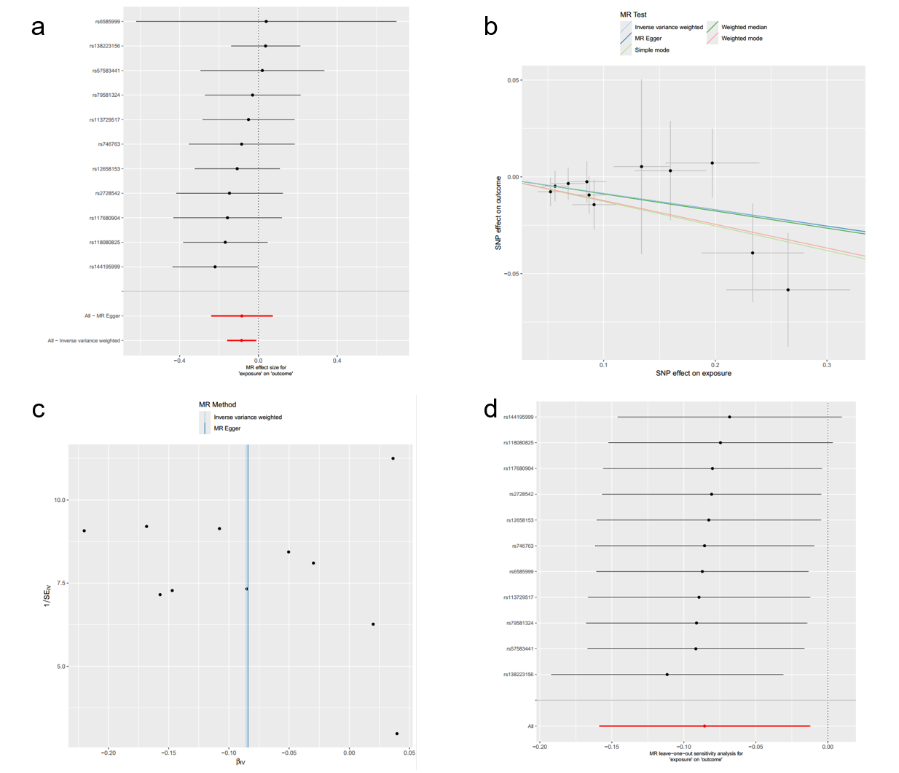
Supplementary Figure S1 Forest plot (a), scatter plot(b), funnel plot (c) and sensitivity analysis (d) of SNPs associated with Gordonibacter pamelaeae on OA.

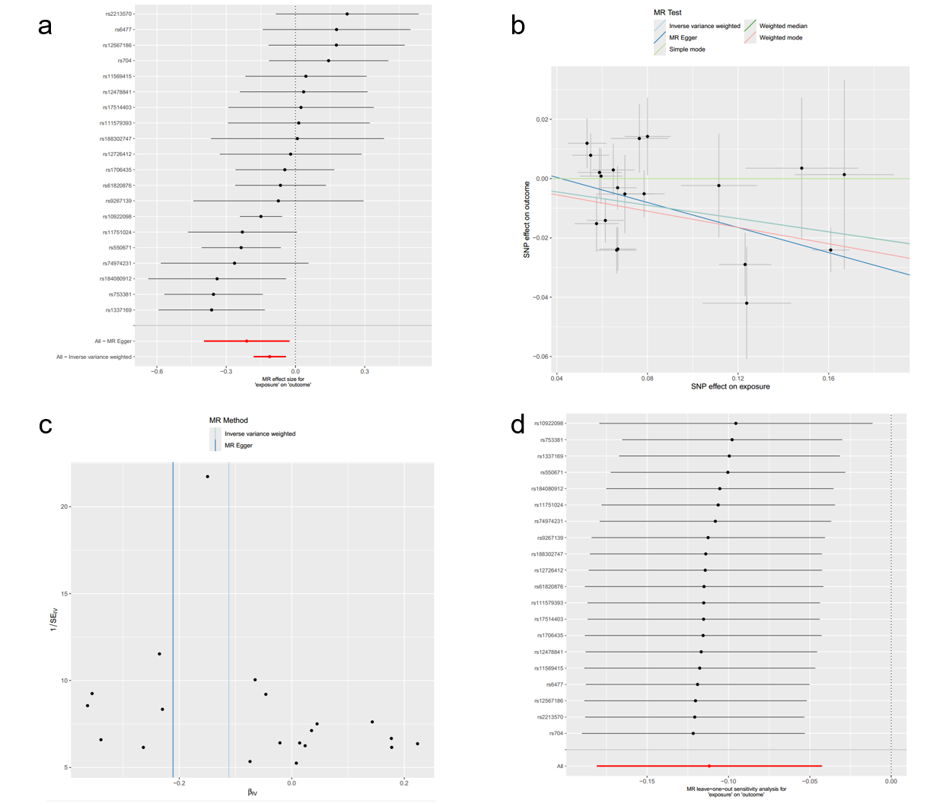
Supplementary Figure S2 Forest plot (a), scatter plot(b), funnel plot (c) and sensitivity analysis (d) of SNPs associated with PLCG1 on OA.

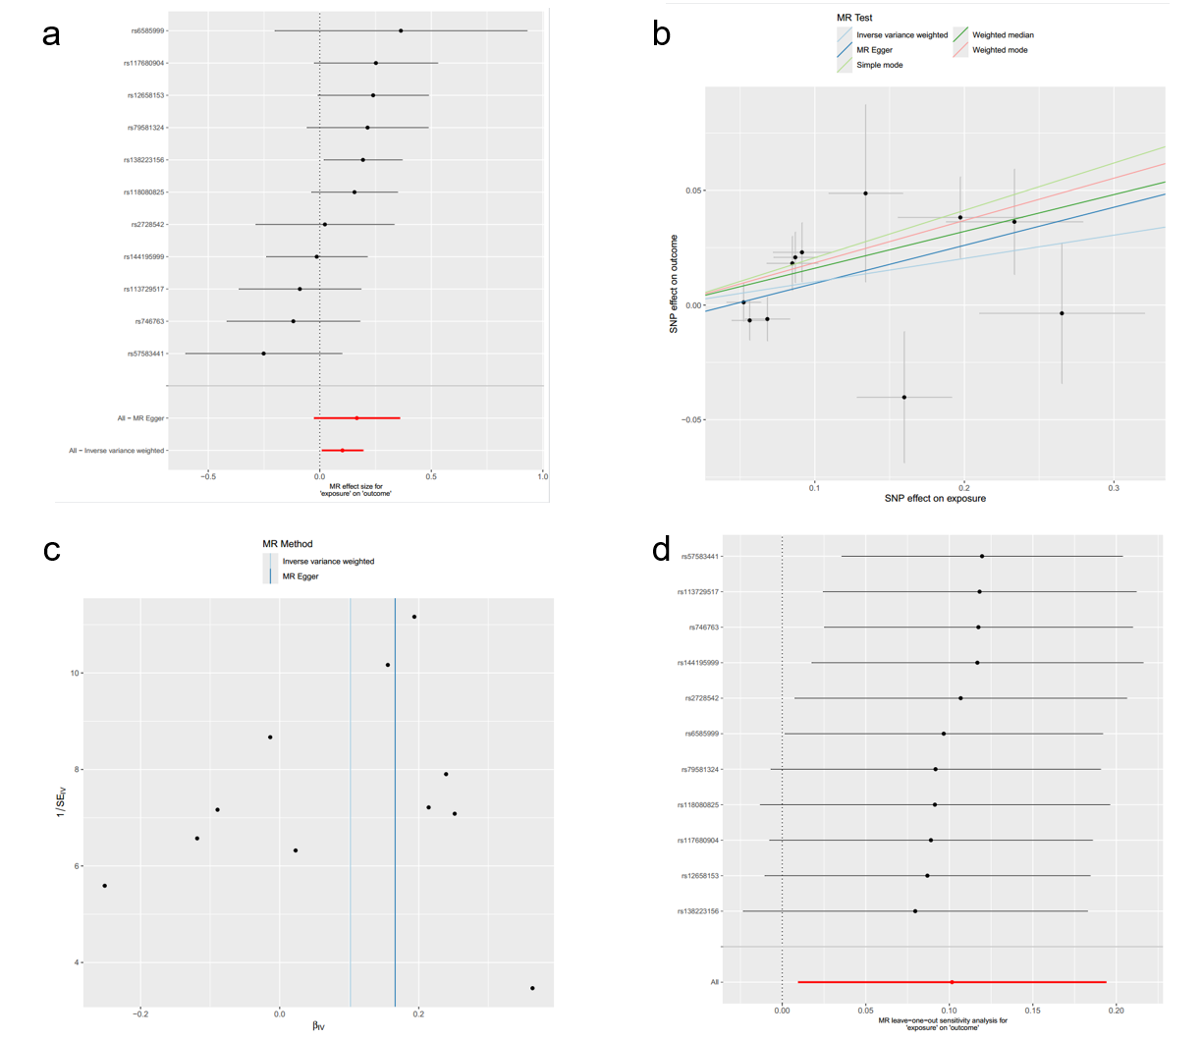
Supplementary Figure S3 Forest plot (a), scatter plot(b), funnel plot (c) and sensitivity analysis (d) of SNPs associated with Gordonibacter pamelaeae on PLCG1.

