Supplementary Information for

The Meissner effect in high-temperature hydrogen-rich superconductors under high pressure

V. S. Minkov, S. L. Bud’ko, F. F. Balakirev, V. B. Prakapenka, S. Chariton, R. J. Husband, H. P. Liermann, M. I. Eremets

Correspondence to: m.eremets@mpic.de; v.minkov@mpic.de

This PDF file includes:

Supplementary Text
Figs. SI1 to SI11

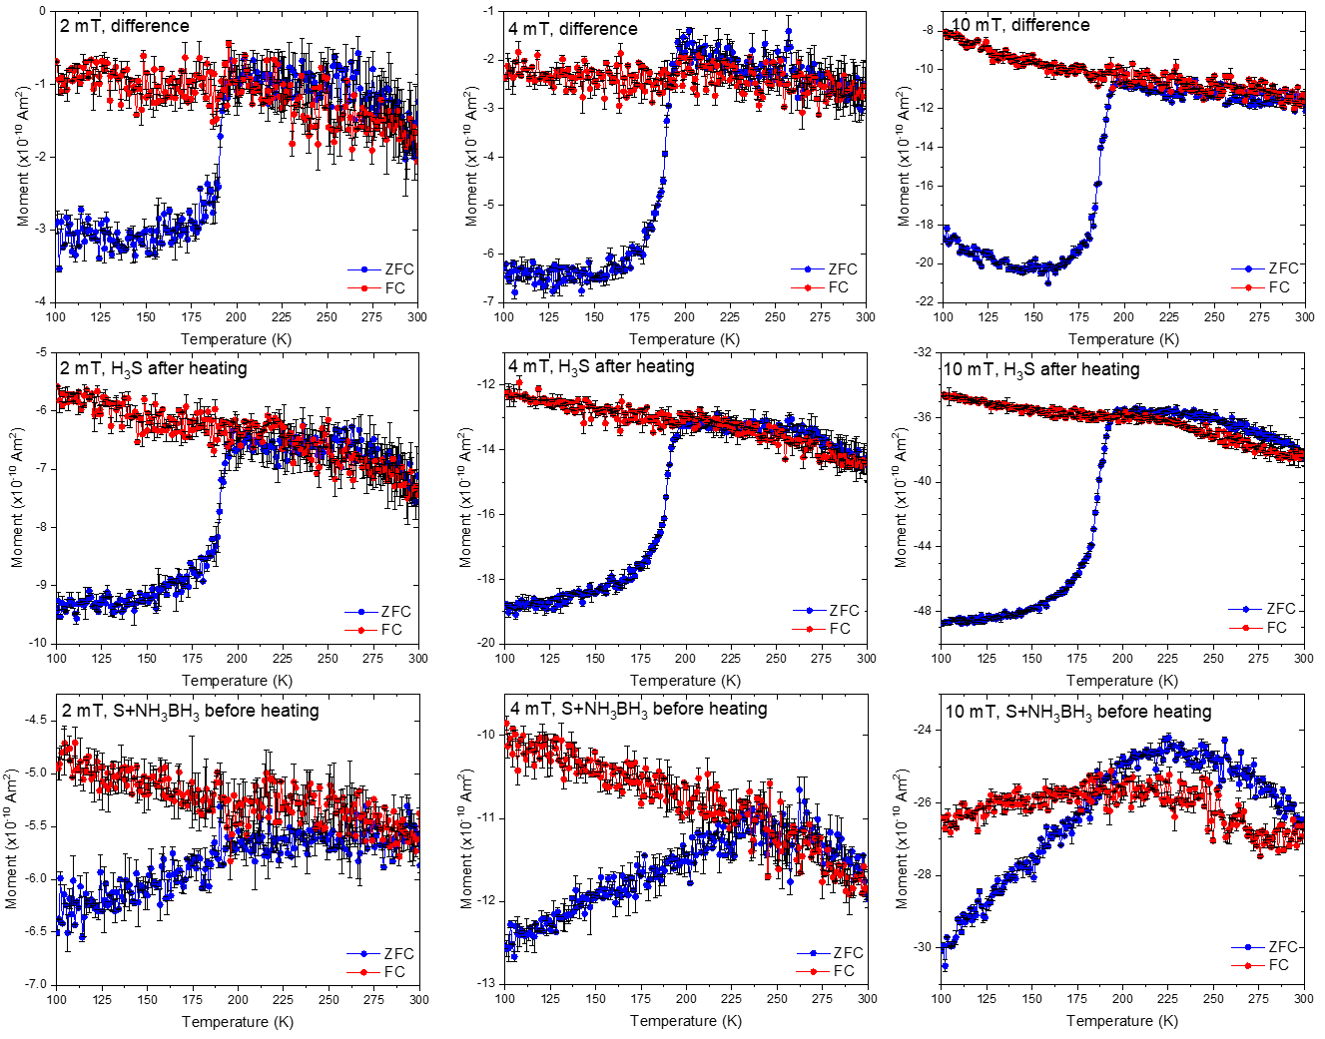

Figure SI1.
M(T) magnetization data of the sandwiched sample with S and NH₃BH₃ pressurized at P_{D} = 167±7 GPa at 2, 4 and 10 mT (lower panel), the heated sample with the superconducting Im-3m-H₃S phase at P_{S} = 155±5 GPa (P_{D} = 162±3 GPa, P_{H} = 155 GPa) at 2, 4, 10 mT (middle panel), and the difference plot (upper panel). The blue and red circles correspond to the zero-field-cooled (ZFC) and filed-cooled (FC) measurements.

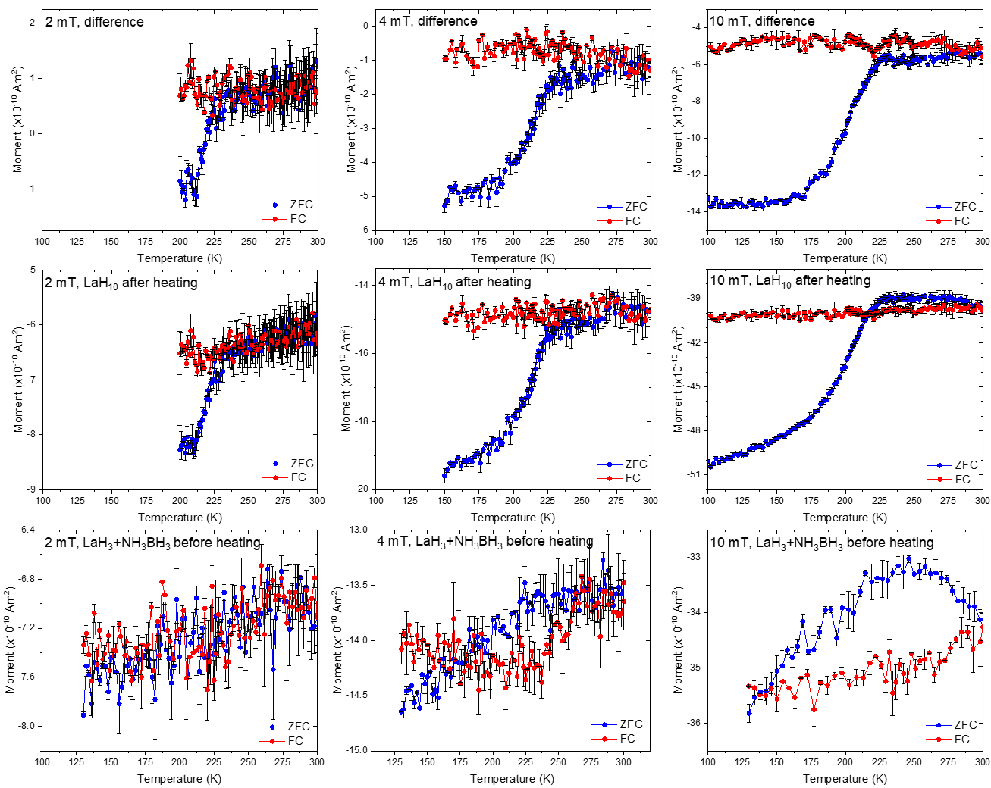

Figure SI2.
M(T) magnetization data of the sandwiched sample with LaH₃ and NH₃BH₃ pressurized at P_{D} = 168±7 GPa at 2, 4 and 10 mT (lower panel), the heated sample with the superconducting Fm-3m-LaH₁₀ phase at P_{S} = 130±8 GPa (P_{D} = 157±3 GPa) at 2, 4, 10 mT (middle panel), and the difference plot (upper panel). The blue and red circles correspond to the zero-field-cooled (ZFC) and filed-cooled (FC) measurements.

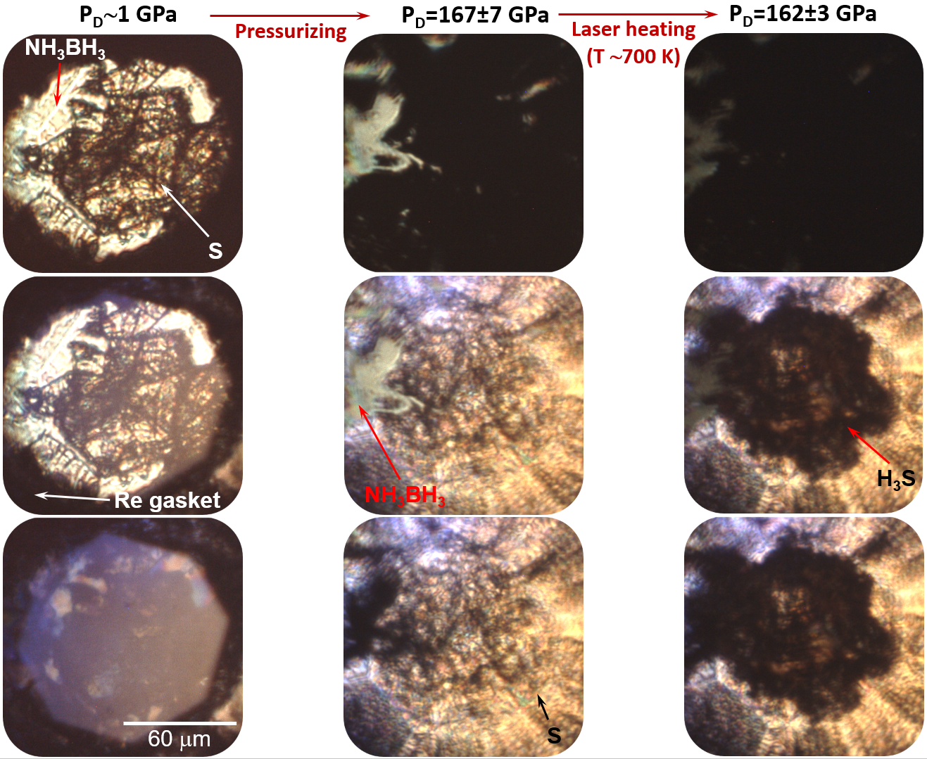

Figure SI3.
Photos of the sandwiched sample with S and NH₃BH₃ after clamping at P_{D} ∼1 GPa (left panel) and pressurizing to P_{D} = 167±7 GPa (central panel), and the heated sample with the superconducting Im-3m-H₃S phase at P_{S} = 155±5 GPa (P_{D} = 162±3 GPa, P_{H} = 155 GPa). The photos are taken in transmitted (top), transmitted and reflected (center), and reflected (bottom) light.

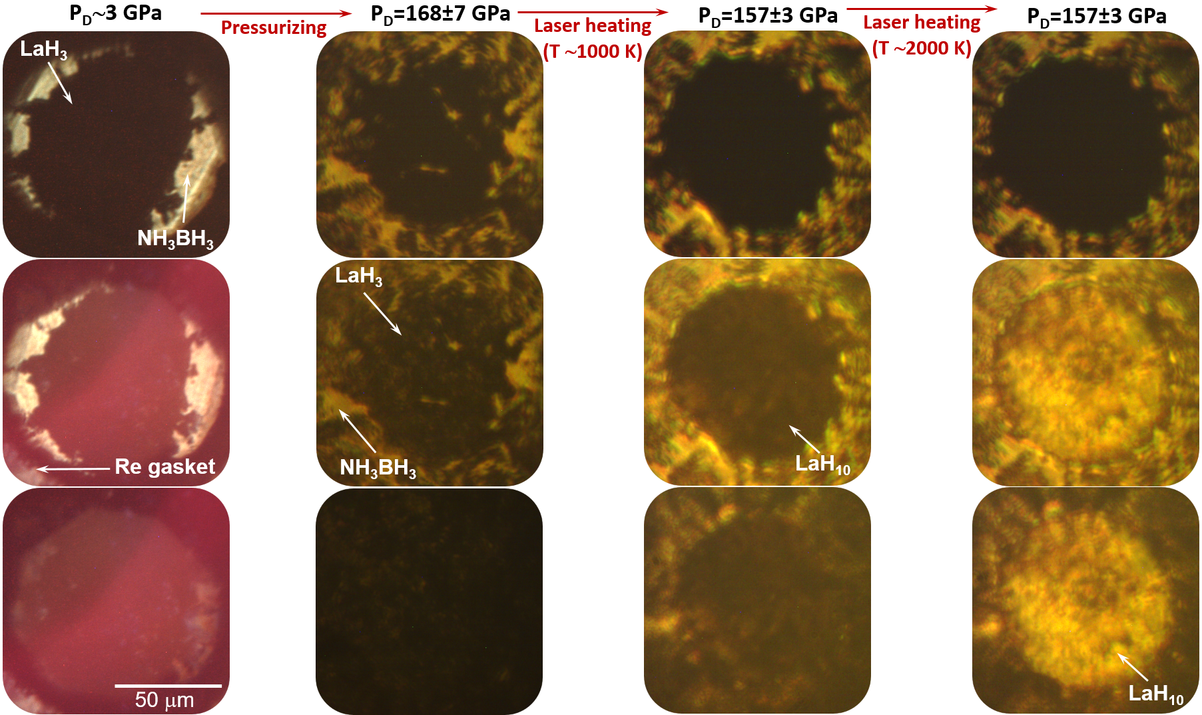

Figure SI4.
Photos of the sandwiched sample with LaH₃ and NH₃BH₃ after clamping at P_{D} ∼3 GPa (left panel) and pressurizing to P_{D} = 168±7 GPa (second panel), and the sample with the superconducting Fm-3m-LaH₁₀ phase at P_{S} = 130±8 GPa (P_{D} = 157±3 GPa) after heating by a pulse laser at ∼1000 K (third panel) and ∼2000 K (right panel). The photos are taken in transmitted (top), transmitted and reflected (center), and reflected (bottom) light.
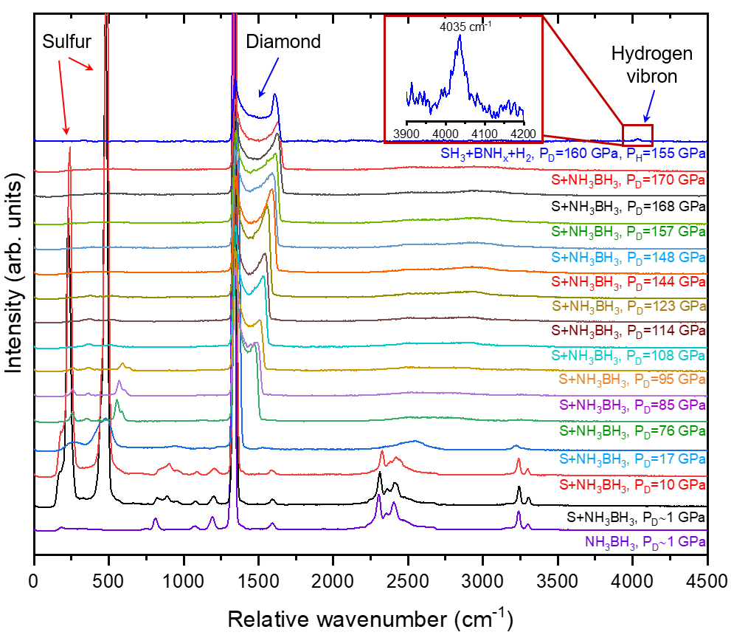

Figure SI5.
Raman spectra of the sandwiched sample with S and NH₃BH₃ upon pressurizing from P_{D} ∼1 GPa (black Raman spectrum) to P_{D} = 167±7 GPa (red Raman spectrum), demonstrating the metallization of sulfur. The blue Raman spectrum on the top corresponds to the sample with the superconducting Im-3m-H₃S phase, which was synthesized after heating at ∼700 K by a pulse laser. The wavenumber of the hydrogen vibron, which was appeared in the Raman spectrum after heating of NH₃BH₃, corresponds to a pressure value of P_{H} = 155 GPa, slightly lower than P_{D} = 162±3 GPa estimated by the diamond scale(37).
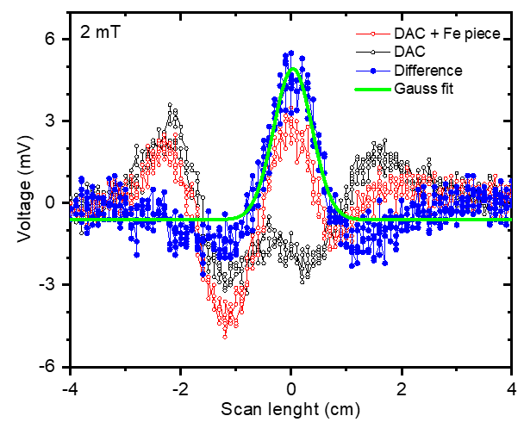

Figure SI6.
Centering of a sample residing in the miniature DAC using a ferromagnetic signal of the steel piece with a size of 140×100×25 μm³ attached to the rhenium gasket. The red, black and blue circles and green curve correspond to the DC scans of the miniature DAC with and without steel piece, the difference, and Gauss fit, respectively. Here is the centering of the sample with the Fm-3m-LaH₁₀ phase in the DAC at 295 K and 2 mT.

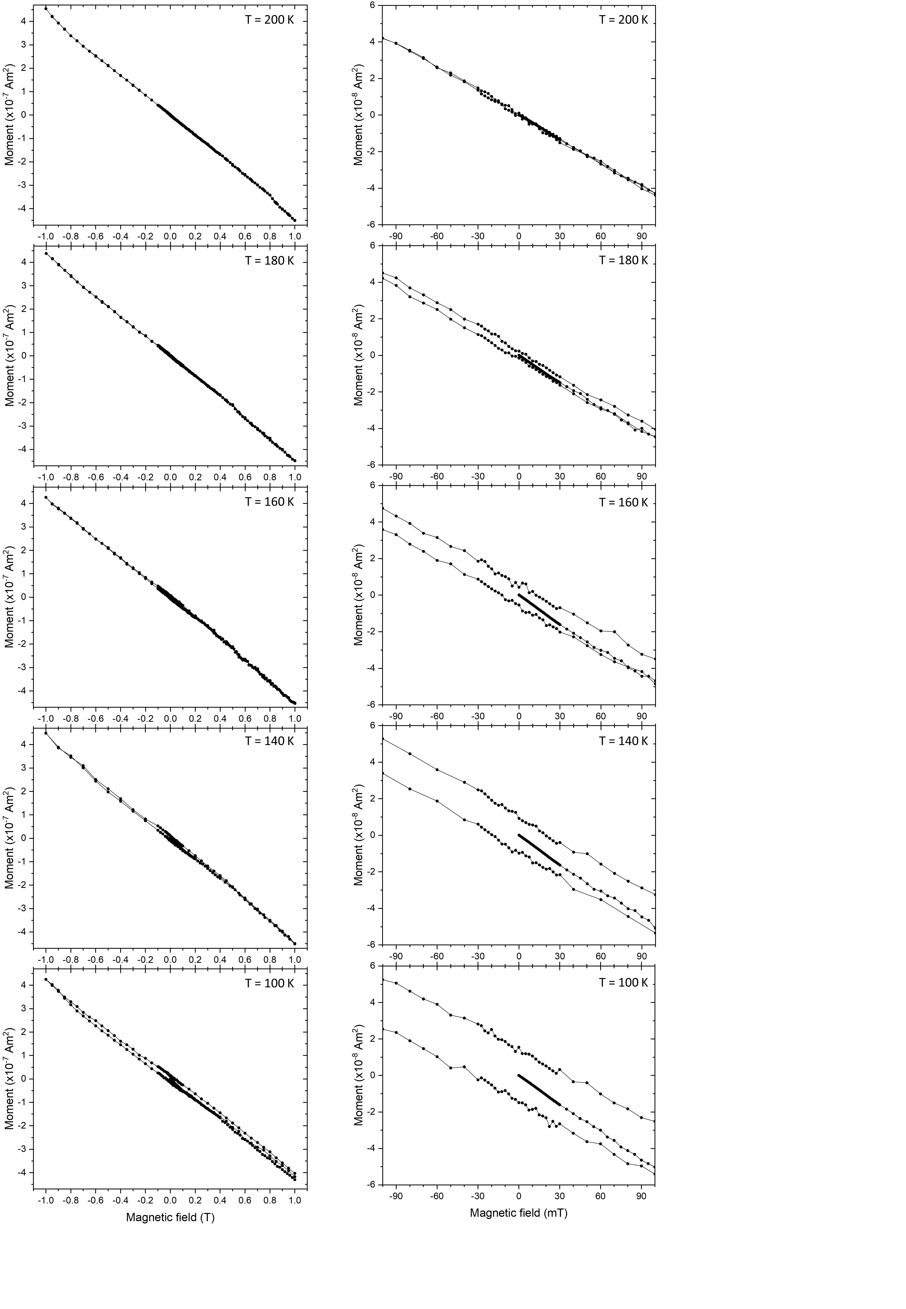

Figure SI7.
M(H) magnetization data of the heated sample with the Im-3m-H₃S at P_{S} = 155±5 GPa (P_{D} = 162±3 GPa, P_{H} = 155 GPa) at several temperatures: in a normal metallic state above T_{c} at 200 K, and in a superconducting state below T_{c} at 180, 140, 100 and 80 K. The left panel shows the full range of hysteresis and the right panel shows the enlarged magnetic field range of -0.1 – 0.1 T.

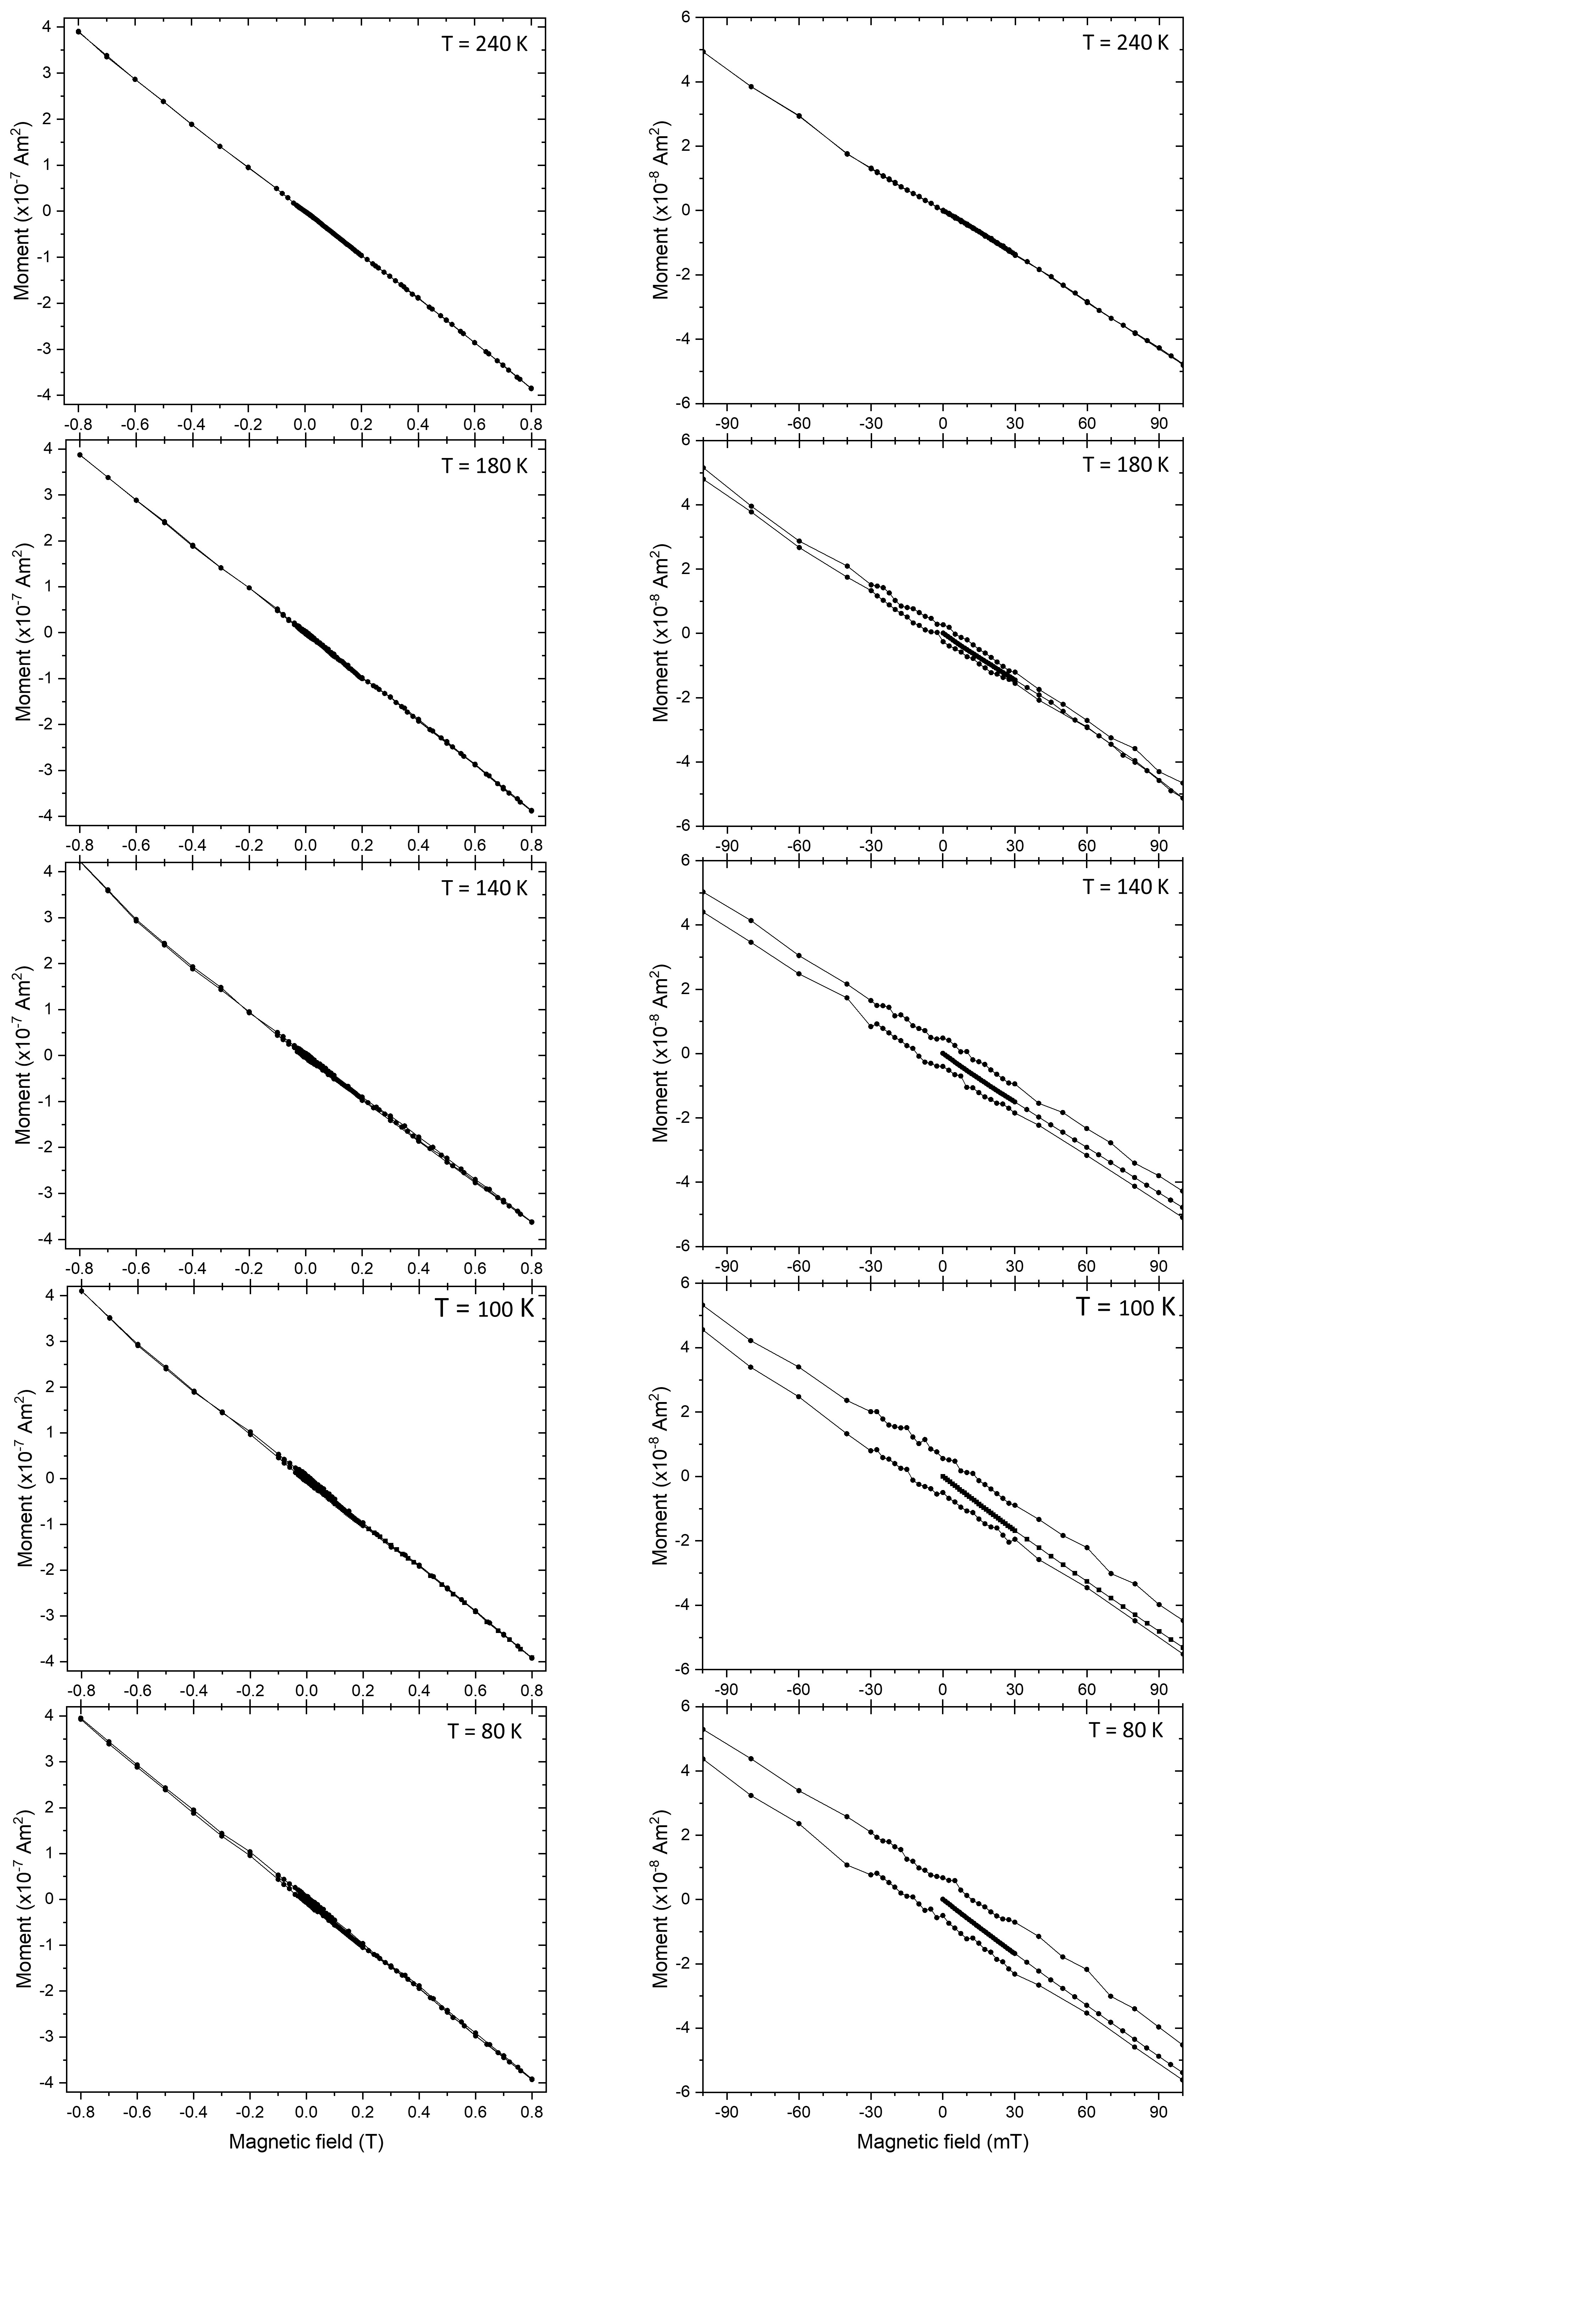

Figure SI8.
M(H) magnetization data of the heated sample with the Fm-3m-LaH₁₀ phase at P_{S} = 130±8 GPa (P_{D} = 157±3 GPa) at several temperatures: in a normal metallic state above T_{c} at 240 K, and in a superconducting state below T_{c} at 180, 140, 100 and 80 K. The left panel shows the full range of hysteresis and the right panel shows the enlarged magnetic field range of -0.1 – 0.1 T.

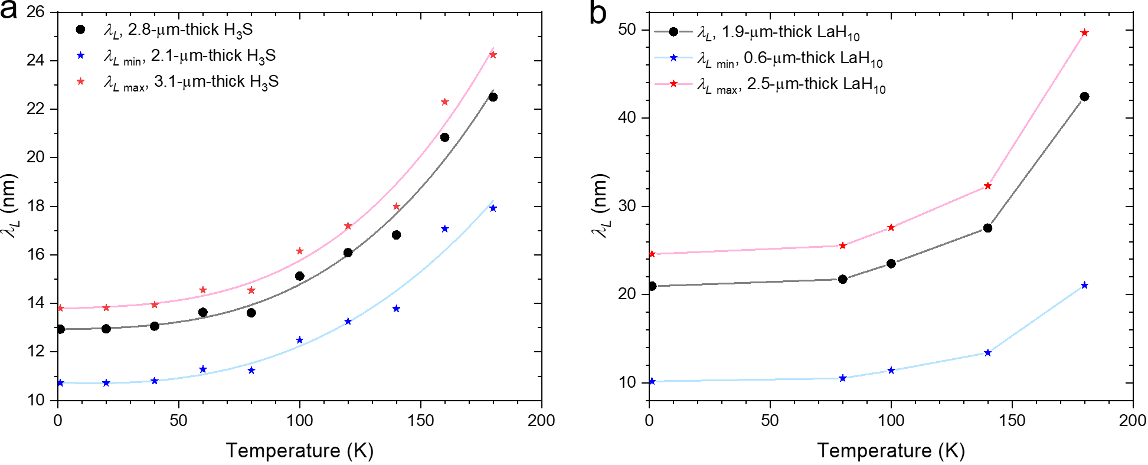

Figure SI9.
Temperature-dependence of the London penetration depth, λ_{L}, of Im-3m-H₃S at P_{S} = 155±5 GPa, a, and Fm-3m-LaH₁₀ at P_{S} = 130±8 GPa, b. The black circles correspond to the λ_{L} values, which were determined using the sample thickness of 2.8 μm for H₃S and 1.9 μm for LaH₁₀ samples estimated from the optical microscopy data. The red and blue stars correspond to maximum and minimum λ_{L} values, which were estimated using the theoretical calculated maximum and minimum values of sample thickness.

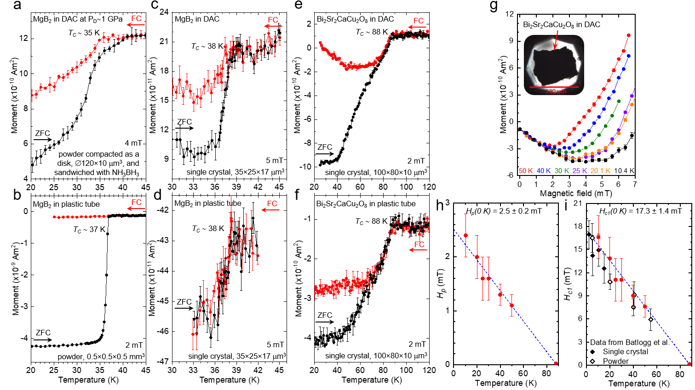

Figure SI10.
Magnetic measurements of the test materials in a SQUID. M(T) magnetization data for powder MgB₂ sample, a and b, single crystal MgB₂ sample, c and d, and single crystal Bi₂Sr₂CaCu₂O₈ sample, e and f, housing in the miniature DACs and the standard nonmagnetic plastic tube. Black and red cycles correspond to ZFC and FC magnetization curves. g, M(H) magnetization data of the single crystal Bi₂Sr₂CaCu₂O₈ sample in the DAC at different temperatures. h and i, H_{p}(T) and H_{c1}(T) plots of the single crystal Bi₂Sr₂CaCu₂O₈ sample in the DAC built from the M(H) data without effective demagnetizing factor N and with the estimated N = 0.8556, respectively. Red circles and black rhombuses are the present data and the data from Ref(48), respectively.

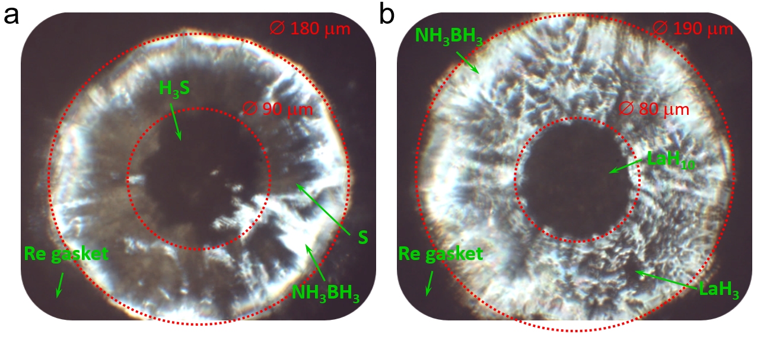

Figure SI11.
Estimation of a thickness of the superconducting samples in the miniature DACs at high pressure. a and b, Expansion of the hole in the rhenium gasket restraining the sandwiched samples with H₃S at P_{S} = 155±5 GPa and LaH₁₀ at P_{S} = 130±8 GPa, respectively. The inner red circles show the starting size of the hole in the rhenium gasket at P_{D} ∼1 and ∼3 GPa. Photos are taken with 90%-transmitting and 10%-reflecting light.

