APPENDICES

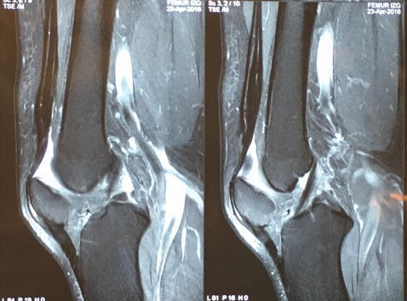

Figure 1. Loss of patellar tendon tension. Patient No. 1.

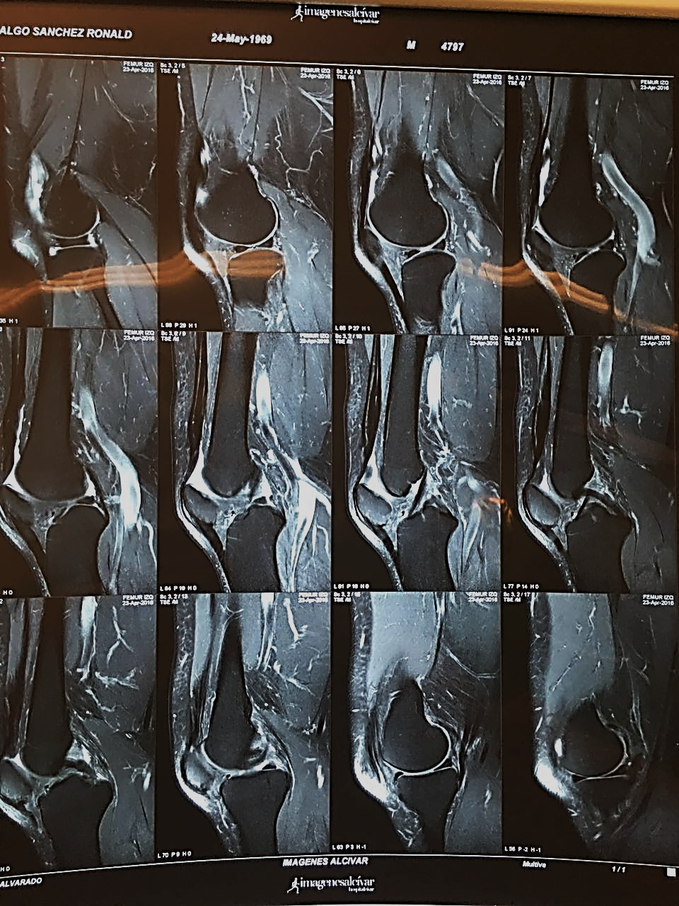
Figure 2. Decreased patellar height. Patient No. 2.

APPENDICES – SURGICAL TECHNIQUE #1

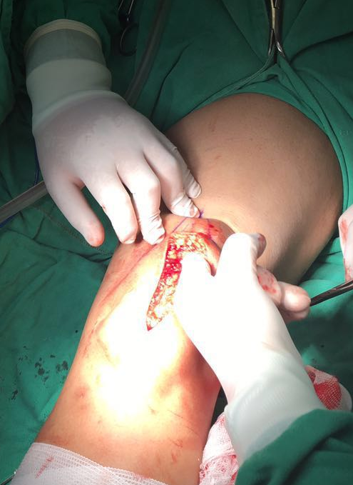
Figure 3. Longitudinal incision with dissection of the subcutaneous cellular tissue.

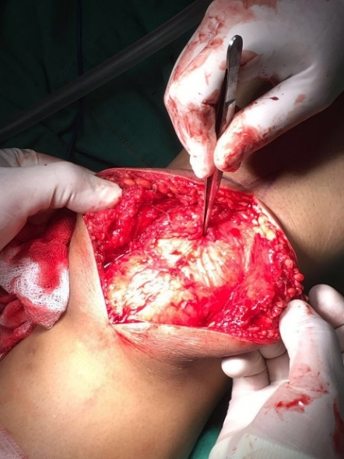
Figure 4. Exposure of the extensor mechanism.

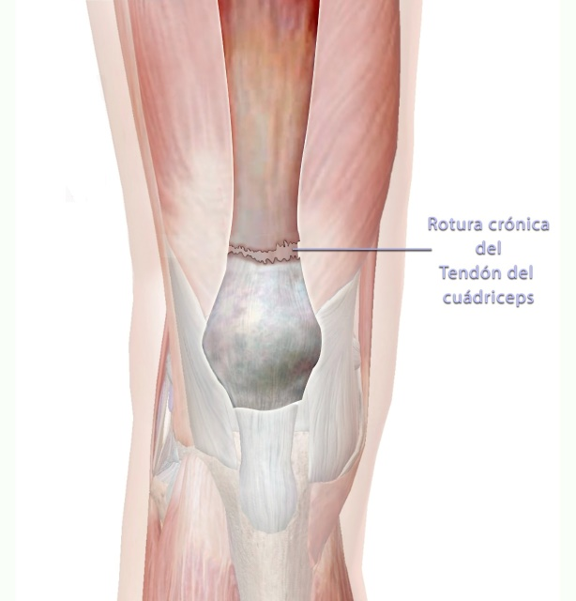
Figure 5. Exposure of the extensor mechanism and the described pathology.
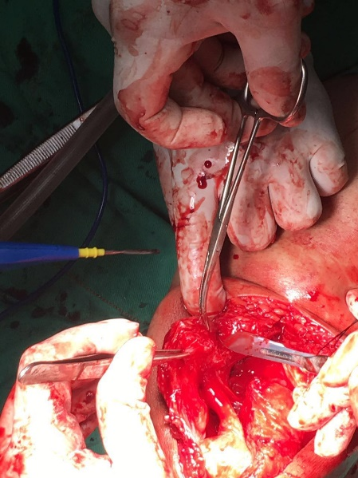
Figure 6. Debridement of nonviable tissue.

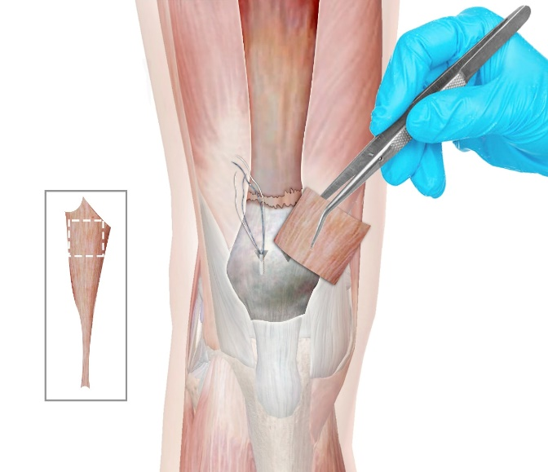
Figure 7. Harvesting of the Achilles tendon allograft.

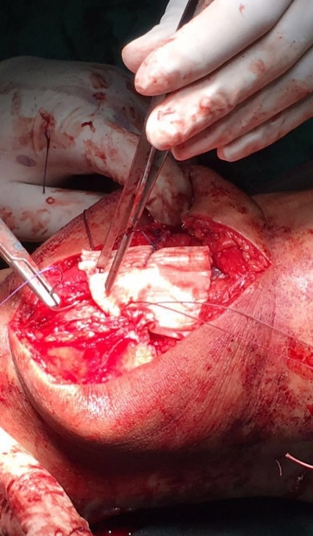
Figure 8. Placement of the Achilles tendon allograft.

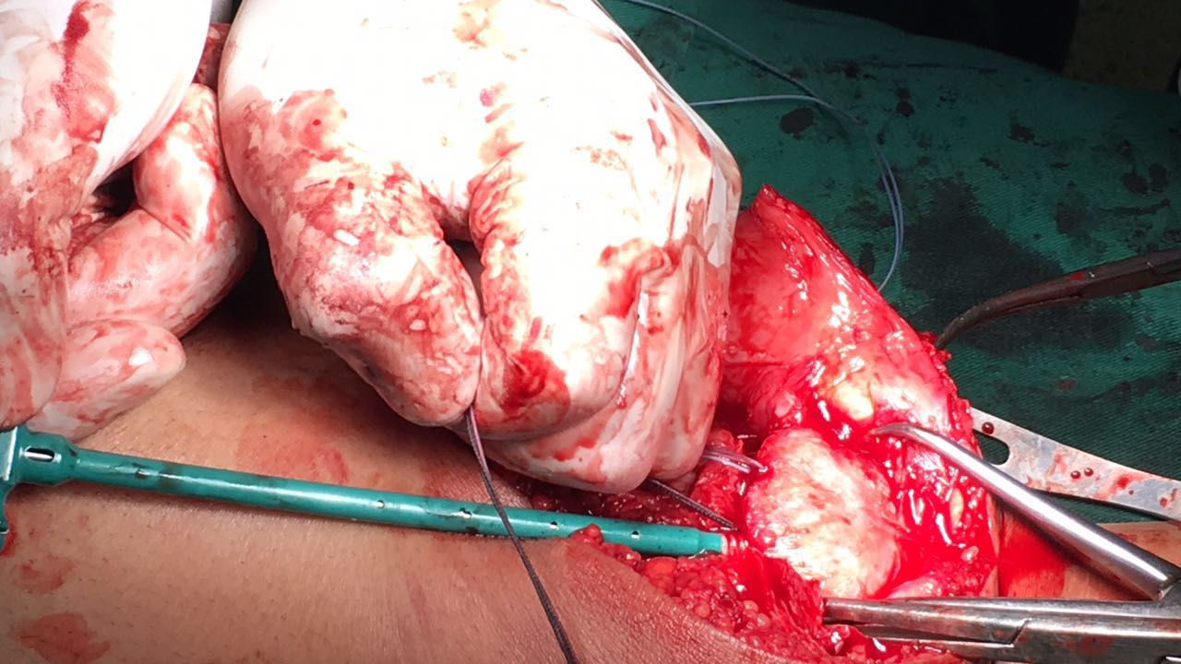
Figure 9. Placement of medial and lateral PEEK anchors.

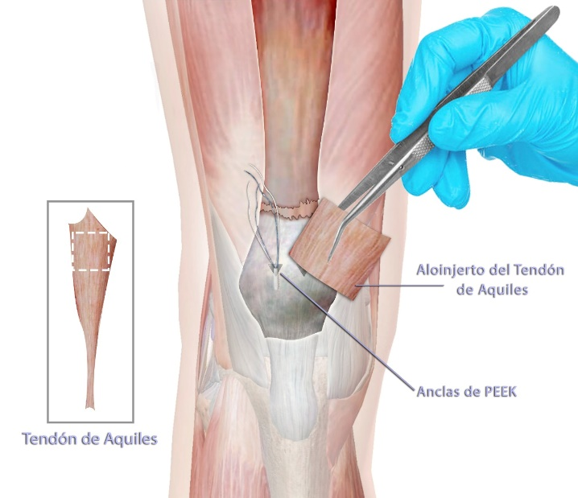
Figure 10. Placement of the Achilles tendon allograft with PEEK anchors.

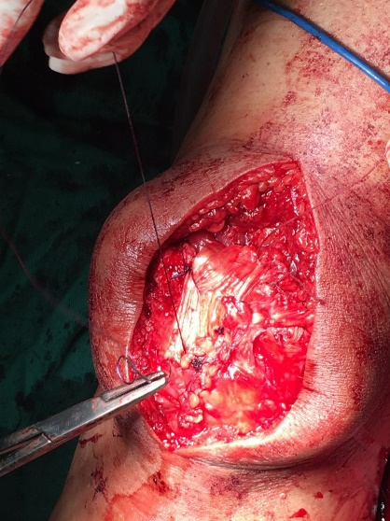
Figure 11. Final suturing of the Achilles tendon allograft.
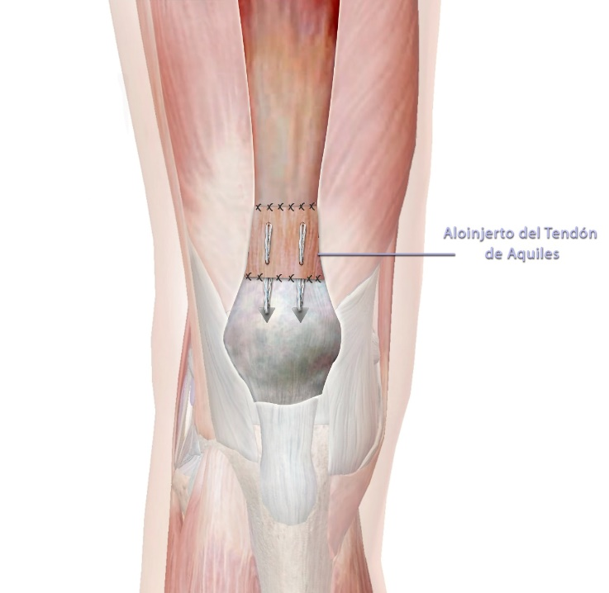
Figure 12. Final suturing of the Achilles tendon allograft.

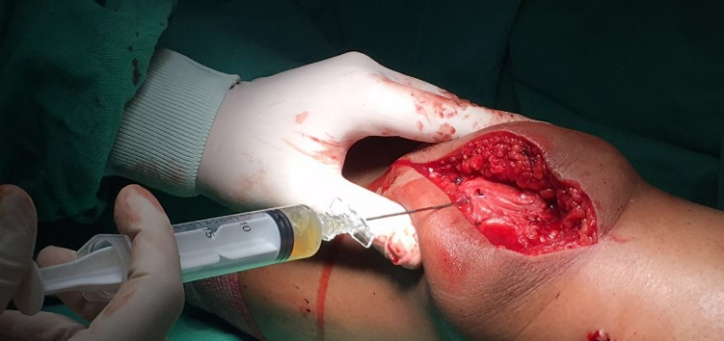
Figure 13. Platelet-rich plasma infiltration.

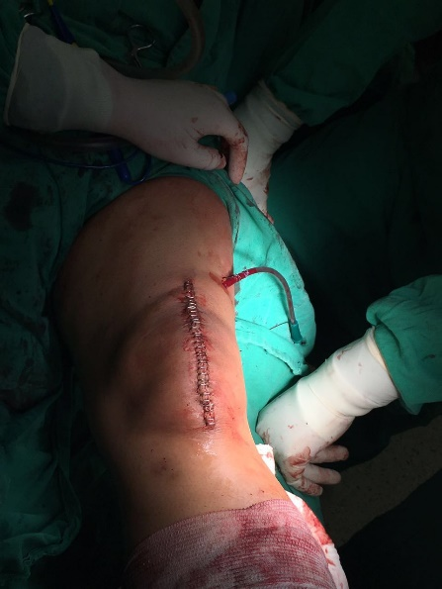
Figure 14. Skin closure.
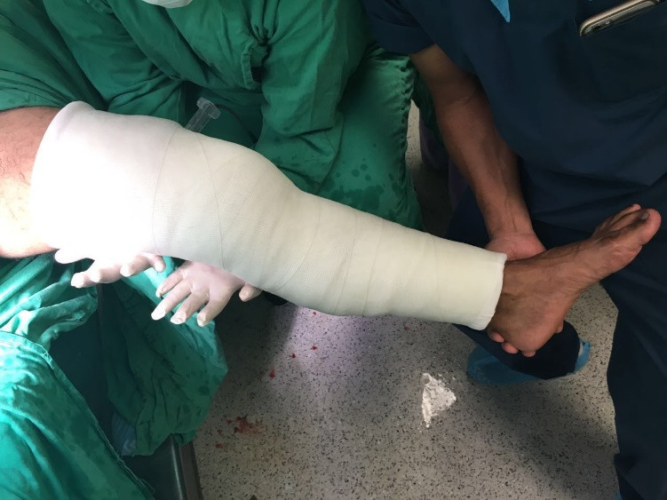
Figure 15. Immobilization of the affected lower limb.

APPENDICES – SURGICAL TECHNIQUE #2

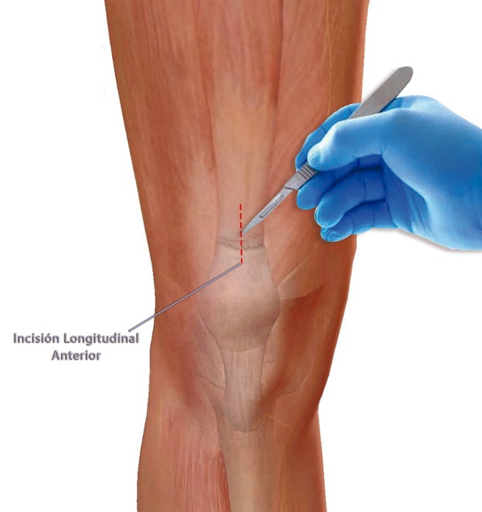
Figure 16. Anterior knee incision.

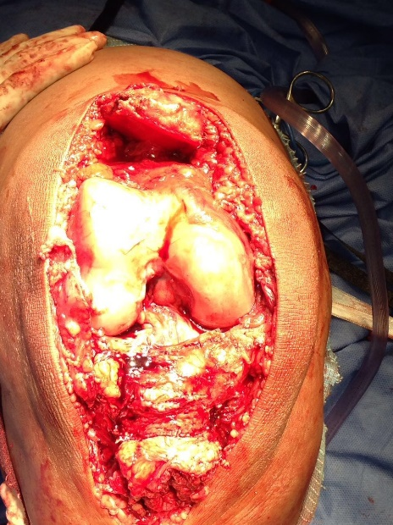
Figure 17. Exposure of the pathologic extensor mechanism.

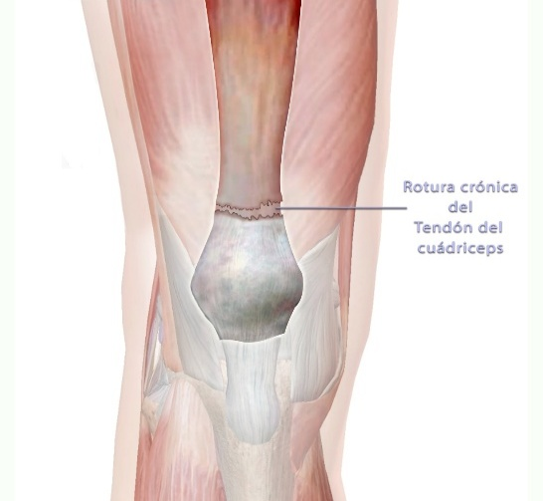
Figure 18. Exposure of the pathologic extensor mechanism.
.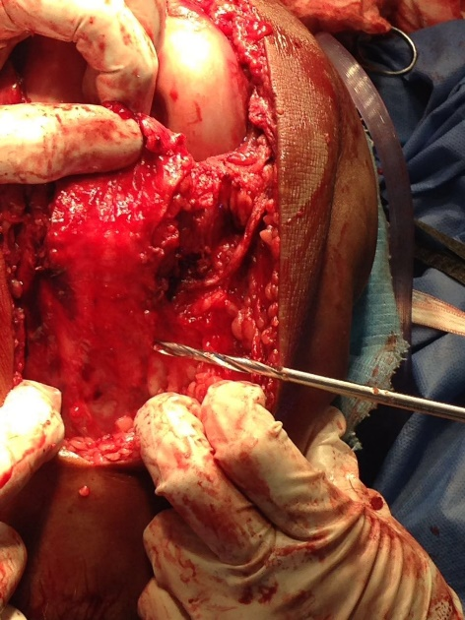
Figure 19. Tunneling at the superior pole of the patella.

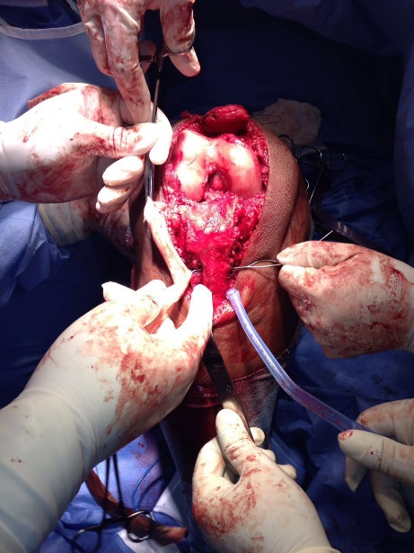
Figure 20. Passage of the allograft through the patellar tunnel.

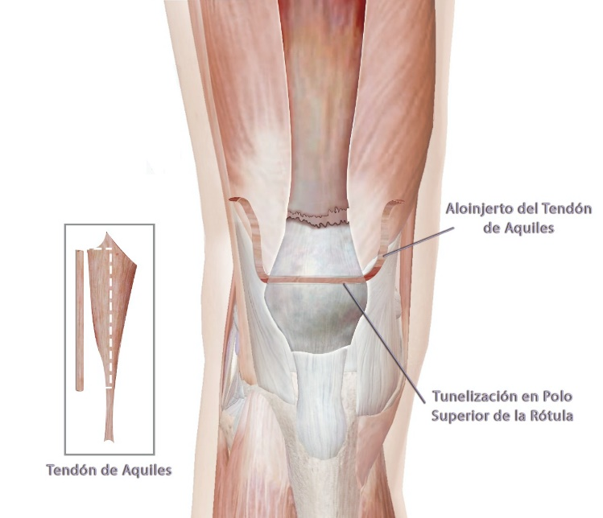
Figure 21. Tunneling at the superior pole of the patella.
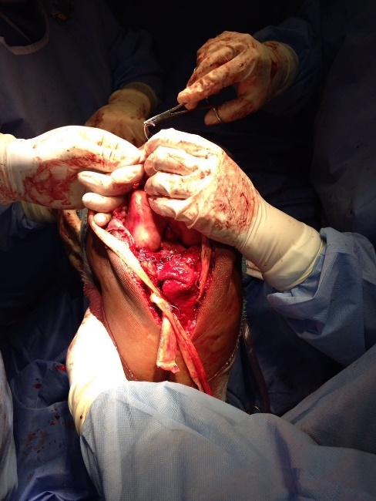
Figure 22. Fixation of the Achilles tendon allograft to the quadriceps tendon tear using suture technique.

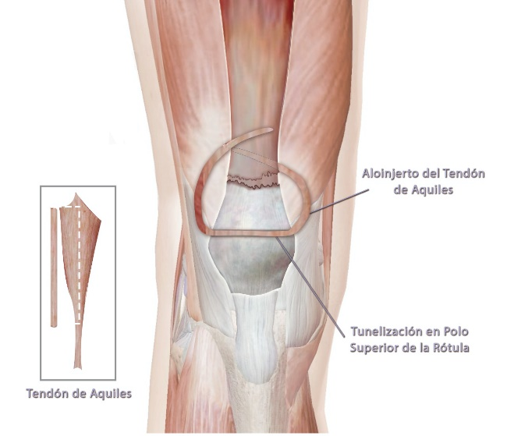
Figure 23. Integration of the Achilles tendon allograft with the quadriceps tendon tear using sutures.

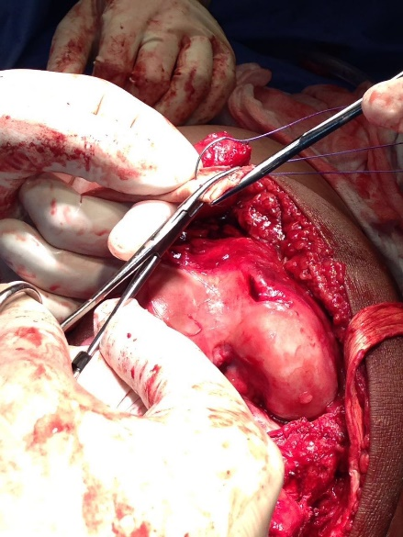
Figure 24. Final construct of the extensor mechanism reconstruction.
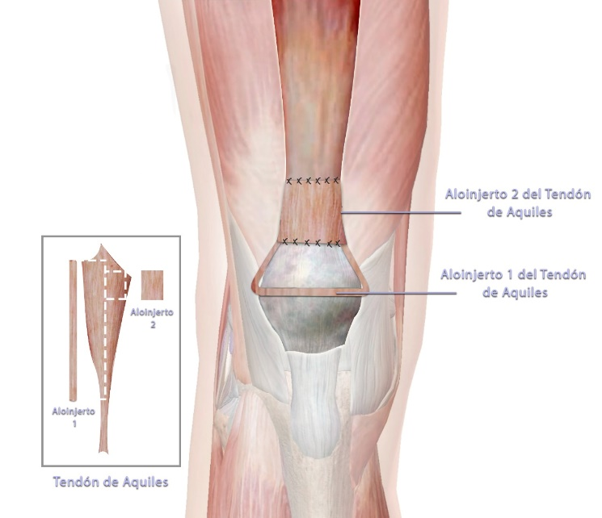
Figure 25. Final construct of the extensor mechanism reconstruction

