Supporting Information
for
Electrodegradation of Acid Red B by N-doped Graphite Cathode in Electro-Peroxone Process
Yu-jia Gao¹, Xu-yan Bai¹, Shuai-cong Huo¹, Bo-lun Yu¹, Ying Yang^{1,2∗}
1 School of Chemistry and Chemical Engineering, Central South University, Changsha 410083, China
2 Key Laboratory of Hunan Province for Water Environment and Agriculture Product Safety, Central South University, Changsha 410083, China
Table of contents
Section 1 Experimental details
TEXT S1 H₂O₂ generation performance test
TEXT S2 Energy consumption analysis
Fig. S1 Electrochemical Modification Setup
Fig. S2 Dye Degradation Performance Testing Apparatus
Fig. S3 H₂O₂ Generation Performance Testing Apparatus

Section 2 Supporting figures
Fig. S4 H₂O₂ generation performance of NEGF electrode materials prepared with varying calcination temperature (a) and holding time (b)
Fig. S5 FT-IR spectra of NEGF, EGF, and GF (a); FT-IR spectra of NEGF electrode materials prepared under different calcination temperatures (b) and holding times (c)
Fig. S6 Energy consumption analysis at 8 min under different initial dye concentrations and electrolyte parameters
Fig. S7 Energy consumption analysis at 8 min under different pH conditions
Fig. S8 Three-dimensional fluorescence spectrum of Deke dyeing tank direct effluent
Fig. S9 Three-dimensional fluorescence spectrum of Deke comprehensive effluent
Fig. S10 Three-dimensional fluorescence spectrum of Deke treated effluent

Section 1 Experimental details
TEXT S1 H₂O₂ generation performance test
The test device for H₂O₂ generation performance is shown in Fig. S3, with an NEGF electrode as the cathode, a graphite plate as the anode, and oxygen uniformly bubbled into a 250 mL beaker containing 200 mL of 0.05 mol/L Na₂SO₄ solution via an aerator. Before the test, oxygen was purged into the solution for 10 min to ensure saturation, and the magnetic stirring speed was set at 100 rpm to minimize the influence of oxygen mass transfer on the experiment. The test conditions were as follows: constant current of 0.1 A, oxygen flow rate of 100 mL/min, and a reaction time of 30 min. Samples were taken at 0, 1, 3, 5, 8, 10, 15, and 30 min to measure the H₂O₂ concentration in the solution.
TEXT S2 Energy consumption analysis
The calculation formula for energy consumption in the degradation of dye wastewater by the electro-peroxone process is shown in Equation S1, where W is the energy required to degrade per gram of dye, in kWh/kg; C_{O3} is the ozone concentration, in mg/L; r is the energy consumed per kilogram of ozone produced, typically 15 kWh/kg in industry; U is the average voltage during the reaction, in V; I is the current during the reaction, in A; t is the reaction time, in h; m is the volume of wastewater, in L; C₀ is the initial dye concentration in the wastewater, in mg/L; and C_{t} is the dye concentration in the wastewater at reaction time t, in mg/L.
$\text{W=}{\text{(r}{\text{C}}_{{\text{O}}_{\text{3}}}\text{+UIt)}}/{\text{m(}{\text{C}}_{\text{0}}\text{−}{\text{C}}_{\text{t}}\text{)}}$ (Equation S1)
To further reflect the efficiency of the electro-peroxone process in degrading dyes, the effective utilization efficiency of ozone per milligram for degrading Acid Red B per milligram is calculated using Equation S2, where M₀ is the initial mass of dye in the wastewater, in mg; M_{t} is the mass of dye in the wastewater at reaction time t, in mg; and the difference in m represents the amount of ozone consumed, in mg.
$\text{η}\text{=}{\text{(}{\text{M}}_{\text{0}}\text{−}{\text{M}}_{\text{t}}\text{)}}/{\text{(}{\text{m}}_{\text{0}}\text{−}{\text{m}}_{\text{t}}\text{)}}$ (Equation S2)

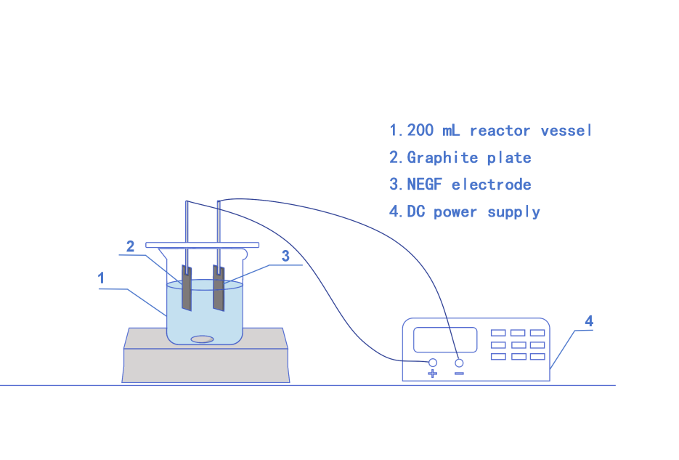
Fig. S1 Electrochemical Modification Setup

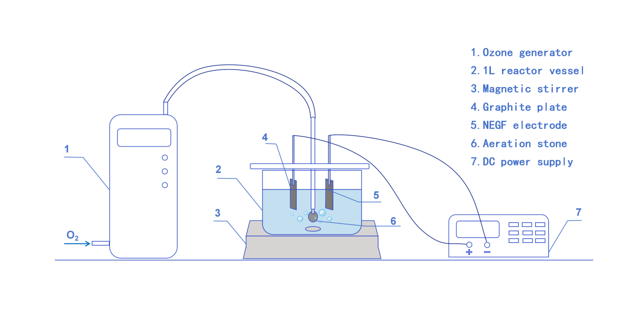Fig. S2 Dye Degradation Performance Testing Apparatus

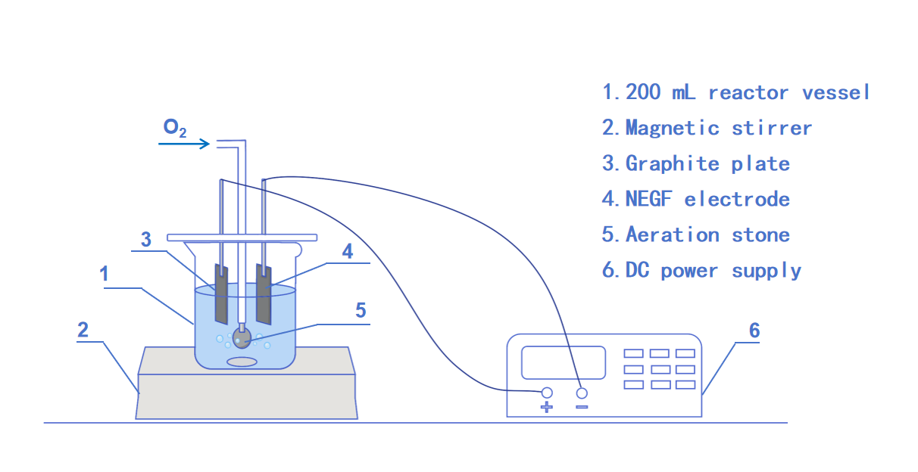
Fig. S3 H₂O₂ Generation Performance Testing Apparatus

Section 2 Supporting figures
(a) (b)
Fig. S4 H₂O₂ generation performance of NEGF electrode materials prepared with varying calcination temperature (a) and holding time (b)

(a) (b)
(c)
Fig. S5 FT-IR spectra of NEGF, EGF, and GF (a); FT-IR spectra of NEGF electrode materials prepared under different calcination temperatures (b) and holding times (c)

(a)
(b)
(c)
Fig. S6 Energy consumption analysis at 8 min under different initial dye concentrations and electrolyte parameters

Fig. S7 Energy consumption analysis at 8 min under different pH conditions

(a) (b)
(c) (d)
(e)
Fig. S8 Three-dimensional fluorescence spectrum of Deke dyeing tank direct effluent

(a) (b)
(c) (d)
(e)
Fig. S9 Three-dimensional fluorescence spectrum of Deke comprehensive effluent

(a) (b)
(c) (d)
(e)
Fig. S10 Three-dimensional fluorescence spectrum of Deke treated effluent

Corresponding author. Email: yangy@csu.edu.cn. ORCID: 0000-0003-4531-8349

