Supplementary Appendix: Table of Contents

Supplementary Table 1……………………………………………………………………………………….……..1
Supplementary Figure 1..…………………………………………………………………………………….……..2
Supplementary Figure 2..…………………………………………………………………………………….……..2
Supplementary Figure 3..…………………………………………………………………………………….……..2
Supplementary Figure 4..…………………………………………………………………………………….……..3
Supplementary Figure 5..…………………………………………………………………………………….……..3
Supplementary Figure 6..…………………………………………………………………………………….……..3
Supplementary Figure 7..…………………………………………………………………………………….……..4
Supplementary Figure 8..…………………………………………………………………………………….……..4
Supplementary Figure 9..…………………………………………………………………………………….……..4
Supplementary Figure 10..………………………………………………………………..………………….……..5
Supplementary Figure 11..………………………………………………………………..………………….……..5
Supplementary Figure 12..………………………………………………………………..………………….……..5
Supplementary Figure 13..………………………………………………………………..………………….……..6
Supplementary Figure 14..………………………………………………………………..………………….……..6
Supplementary Figure 15..………………………………………………………………..………………….……..6
Supplementary Figure 16..………………………………………………………………..………………….……..7
Supplementary Figure 17..………………………………………………………………..………………….……..7
Supplementary Figure 18..………………………………………………………………..………………….……..7
Supplementary Figure 19..………………………………………………………………..………………….……..8
Supplementary Figure 20..………………………………………………………………..………………….……..8
Supplementary Figure 21..………………………………………………………………..………………….……..8
Supplementary Figure 22..………………………………………………………………..………………….……..9
Supplementary Figure 23..………………………………………………………………..………………….……..9
Supplementary Figure 24..………………………………………………………………..………………….……..9
Supplementary Figure 25..………………………………………………………………..………………….……..10
Supplementary Figure 26..………………………………………………………………..………………….……..10
Supplementary Figure 27..………………………………………………………………..………………….……..10
Supplementary Figure 28..………………………………………………………………..………………….……..11
Supplementary Figure 29..………………………………………………………………..………………….……..11
Supplementary Figure 30..………………………………………………………………..………………….……..11
Supplementary Figure 31..………………………………………………………………..………………….……..12
Supplementary Figure 32..………………………………………………………………..………………….……..12
Supplementary Figure 33..………………………………………………………………..………………….……..12
Supplementary Figure 34..………………………………………………………………..………………….……..13
Supplementary Figure 35..………………………………………………………………..………………….……..13
Supplementary Figure 36..………………………………………………………………..………………….……..13
Supplementary Figure 37..………………………………………………………………..………………….……..14
Supplementary Figure 38..………………………………………………………………..………………….……..15
Supplementary Figure 39..………………………………………………………………..………………….……..16
Supplementary Figure 40..………………………………………………………………..………………….……..17
Supplementary Figure 41..………………………………………………………………..………………….……..18
Supplementary Figure 42..………………………………………………………………..………………….……..19
Supplementary Figure 43..………………………………………………………………..………………….……..20

Supplementary Table 1. Complete search strategy for each database

Pubmed (n = 226)
( "Traumatic Brain Injury"[Mesh] OR "Brain Injuries, Traumatic"[Mesh] OR tbi[tiab] OR "traumatic brain injur*"[tiab] OR "head injur*"[tiab] OR "craniocerebral injur*"[tiab] OR "intracranial injur*"[tiab] OR "acute subdural hematoma"[tiab] OR "subdural hematoma"[Mesh] OR "subdural hematoma*"[tiab] OR "chronic subdural hematoma*"[tiab] OR "extra-axial hemorrhage"[tiab] OR "acute intracranial hemorrhage"[tiab] ) AND ( surg*[tiab] OR surgery[tiab] OR surgical[tiab] OR neurosurg*[tiab] OR craniotom*[tiab] OR craniectom*[tiab] OR "decompressive craniectomy"[tiab] OR evacuation[tiab] OR "hematoma evacuation"[tiab] ) AND ( "medical management"[tiab] OR "conservative management"[tiab] OR "nonoperative"[tiab] OR "non-operative"[tiab] OR "non-surgical"[tiab] OR "best medical therapy"[tiab] OR "standard medical care"[tiab] OR "medical treatment"[tiab] ) AND ( "Aged"[Mesh] OR "Aged, 80 and over"[Mesh] OR elderly[tiab] OR elder*[tiab] OR geriatric*[tiab] OR older[tiab] OR "older adult*"[tiab])
Embase (n = 394)
('traumatic brain injury'/exp OR 'brain injuries, traumatic'/exp OR tbi:ti,ab OR 'traumatic brain injur*':ti,ab OR 'head injur*':ti,ab OR 'craniocerebral injur*':ti,ab OR 'intracranial injur*':ti,ab OR 'acute subdural hematoma':ti,ab OR 'subdural hematoma'/exp OR 'subdural hematoma*':ti,ab OR 'chronic subdural hematoma*':ti,ab OR 'extra-axial hemorrhage':ti,ab OR 'acute intracranial hemorrhage':ti,ab) AND (surg*:ti,ab OR surgery:ti,ab OR surgical:ti,ab OR neurosurg*:ti,ab OR craniotom*:ti,ab OR craniectom*:ti,ab OR 'decompressive craniectomy':ti,ab OR evacuation:ti,ab OR 'hematoma evacuation':ti,ab) AND ('medical management':ti,ab OR 'conservative management':ti,ab OR nonoperative:ti,ab OR 'non operative':ti,ab OR 'non surgical':ti,ab OR 'best medical therapy':ti,ab OR 'standard medical care':ti,ab OR 'medical treatment':ti,ab) AND ('aged'/exp OR 'aged, 80 and over'/exp OR elderly:ti,ab OR elder*:ti,ab OR geriatric*:ti,ab OR older:ti,ab OR 'older adult*':ti,ab)
Web of science (n = 305)
(ALL="Traumatic Brain Injury" OR ALL="Brain Injuries, Traumatic" OR (TI=tbi OR AB=tbi) OR (TI="traumatic brain injur*" OR AB="traumatic brain injur*") OR (TI="head injur*" OR AB="head injur*") OR (TI="craniocerebral injur*" OR AB="craniocerebral injur*") OR (TI="intracranial injur*" OR AB="intracranial injur*") OR (TI="acute subdural hematoma" OR AB="acute subdural hematoma") OR ALL="subdural hematoma" OR (TI="subdural hematoma*" OR AB="subdural hematoma*") OR (TI="chronic subdural hematoma*" OR AB="chronic subdural hematoma*") OR (TI="extra-axial hemorrhage" OR AB="extra-axial hemorrhage") OR (TI="acute intracranial hemorrhage" OR AB="acute intracranial hemorrhage")) AND ((TI=surg* OR AB=surg*) OR (TI=surgery OR AB=surgery) OR (TI=surgical OR AB=surgical) OR (TI=neurosurg* OR AB=neurosurg*) OR (TI=craniotom* OR AB=craniotom*) OR (TI=craniectom* OR AB=craniectom*) OR (TI="decompressive craniectomy" OR AB="decompressive craniectomy") OR (TI=evacuation OR AB=evacuation) OR (TI="hematoma evacuation" OR AB="hematoma evacuation")) AND ((TI="medical management" OR AB="medical management") OR (TI="conservative management" OR AB="conservative management") OR (TI=nonoperative OR AB=nonoperative) OR (TI=non-operative OR AB=non-operative) OR (TI=non-surgical OR AB=non-surgical) OR (TI="best medical therapy" OR AB="best medical therapy") OR (TI="standard medical care" OR AB="standard medical care") OR (TI="medical treatment" OR AB="medical treatment")) AND (ALL=Aged OR ALL="Aged, 80 and over" OR (TI=elderly OR AB=elderly) OR (TI=elder* OR AB=elder*) OR (TI=geriatric* OR AB=geriatric*) OR (TI=older OR AB=older) OR (TI="older adult*" OR AB="older adult*"))

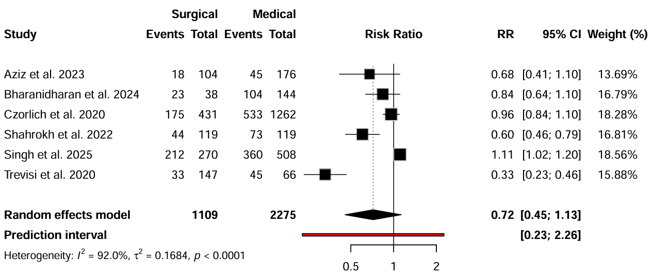
Supplementary Figure 1. Favorable neurological outcome at discharge

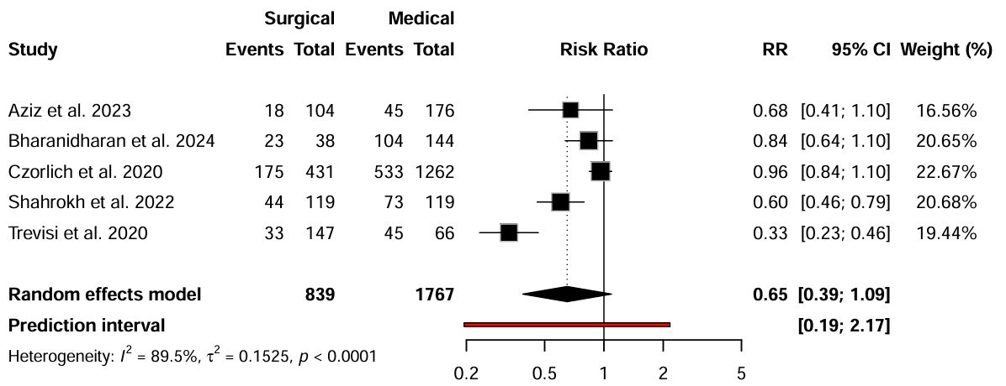
Supplementary Figure 2. Favorable neurological outcome at discharge in older adults aged 65 and over

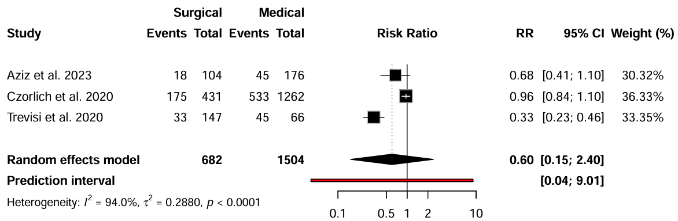
Supplementary Figure 3. Favorable neurological outcome at discharge in older adults aged 70 and over

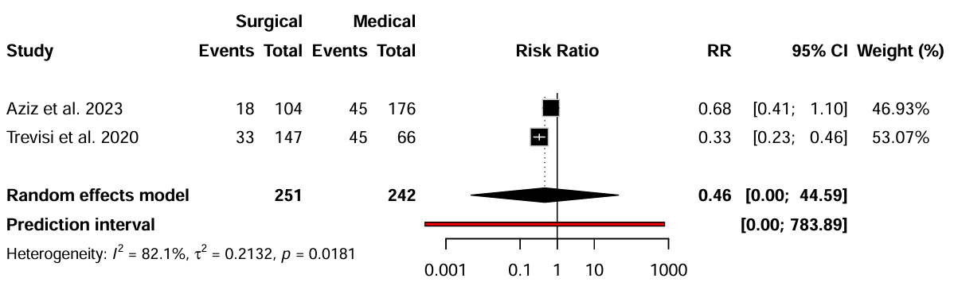
Supplementary Figure 4. Favorable neurological outcome at discharge in older adults with SDH

Supplementary Figure 5. Favorable neurological outcome at discharge in older adults with isolated TBI
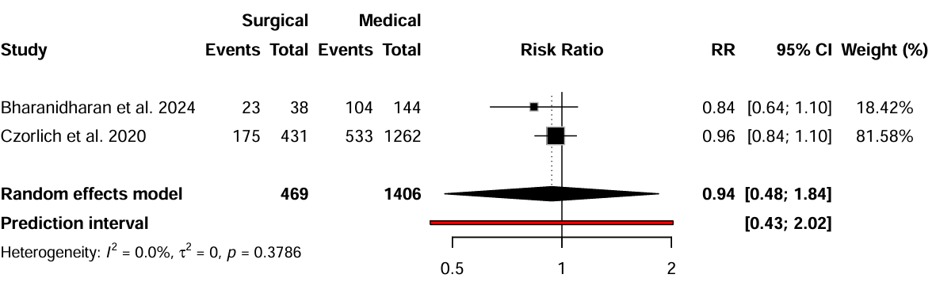

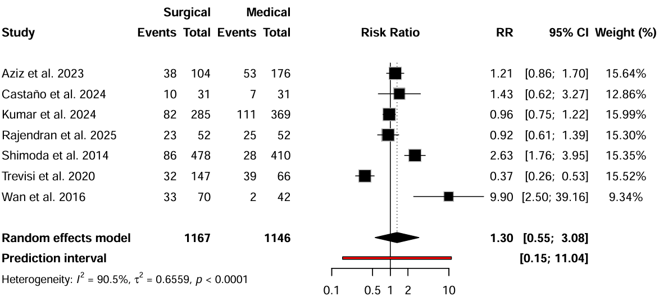
Supplementary Figure 6. Favorable neurological outcome at 6 months

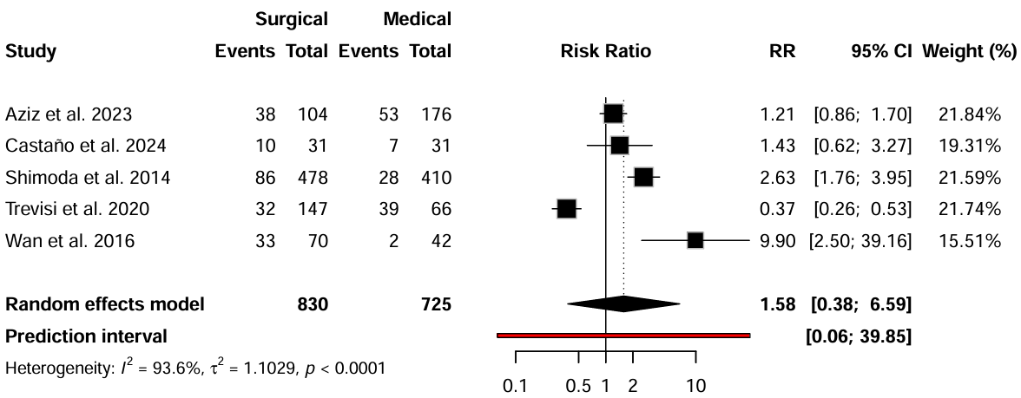
Supplementary Figure 7. Favorable neurological outcome at 6 months in older adults aged 65 and over

Supplementary Figure 8. Favorable neurological outcome at 6 months in older adults aged 70 and over
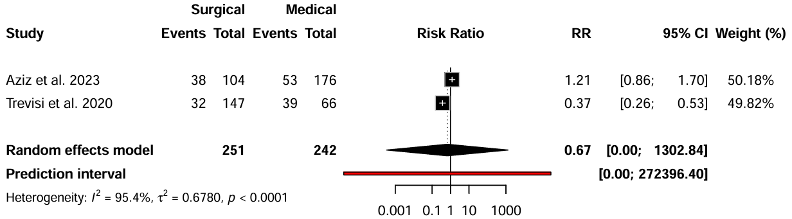

Supplementary Figure 9. Favorable neurological outcome at 6 months in older adults with SDH
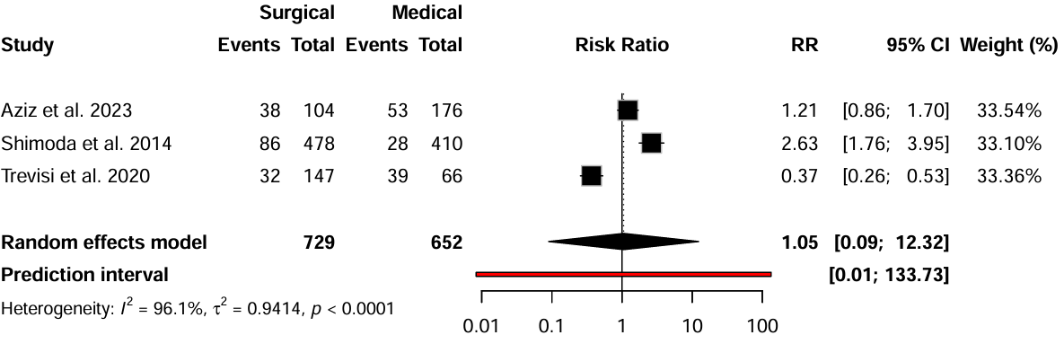

Supplementary Figure 10. Favorable neurological outcome at 6 months in older adults with isolated TBI
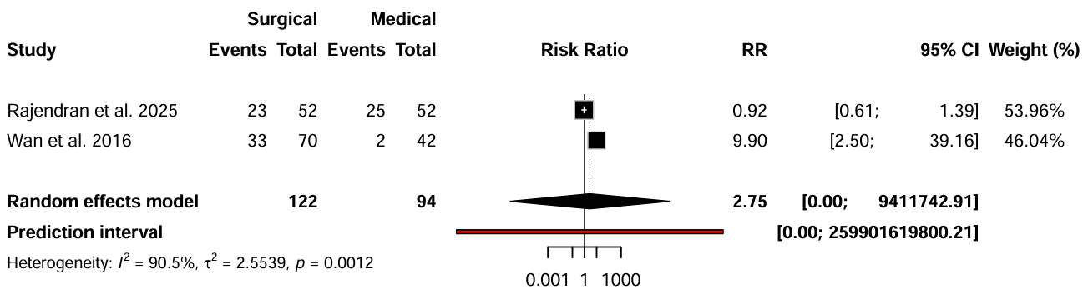

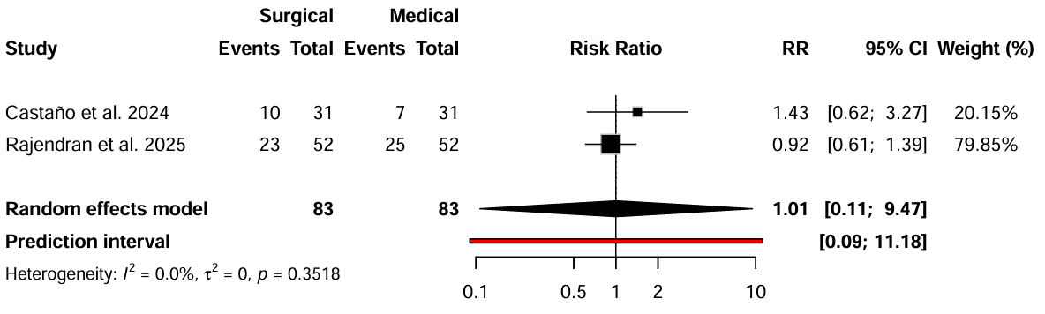
Supplementary Figure 11. Favorable neurological outcome at 6 months in matched studies

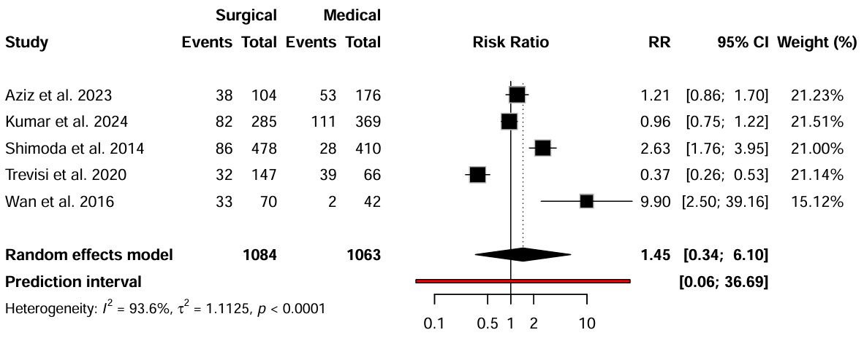
Supplementary Figure 12. Favorable neurological outcome at 6 months in unmatched studies

Supplementary Figure 13. Hospital length of stay

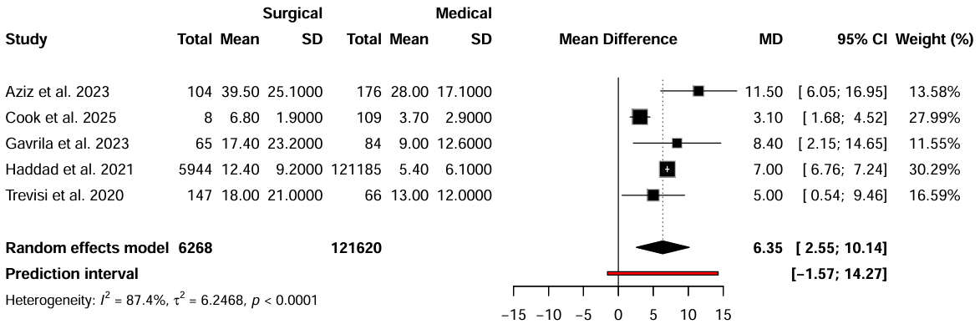

Supplementary Figure 14. Hospital length of stay in older adults aged 70 and over
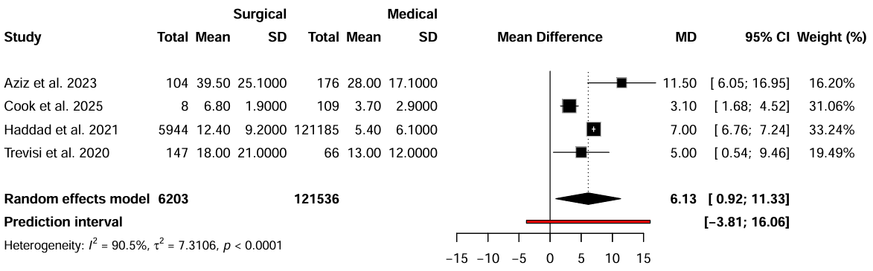

Supplementary Figure 15. Hospital length of stay in older adults aged 80 and over

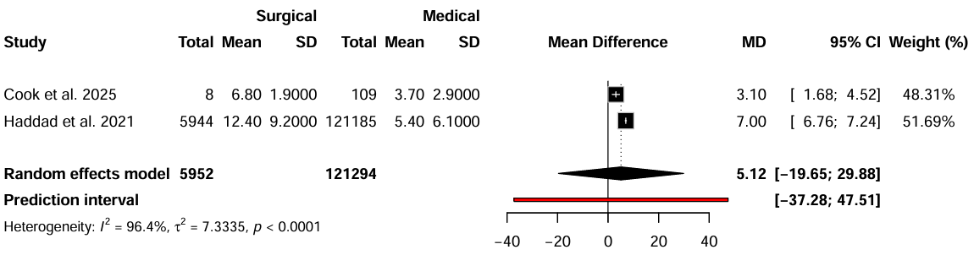

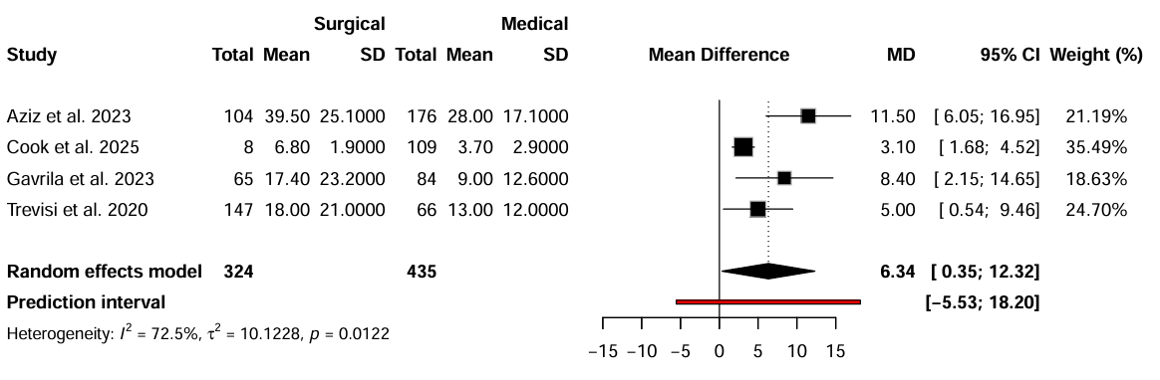
Supplementary Figure 16. Hospital length of stay in older adults with SDH

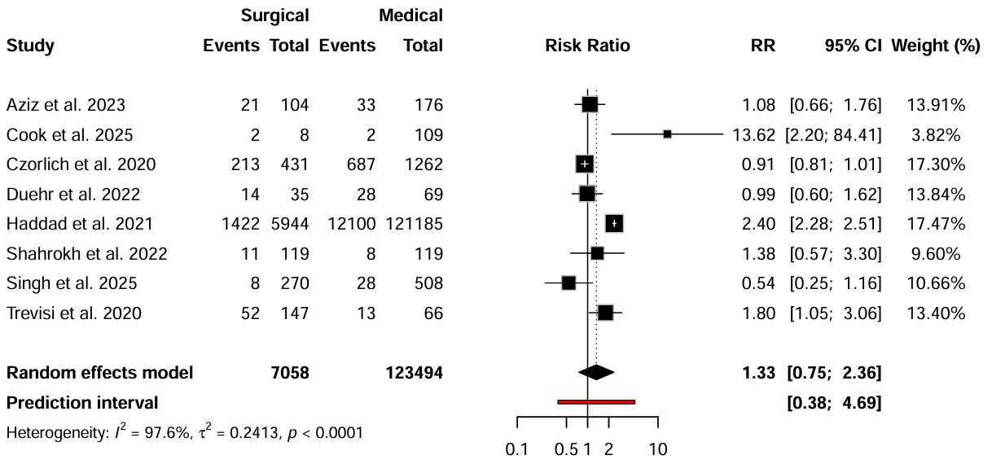
Supplementary Figure 17. In-hospital mortality

Supplementary Figure 18. In-hospital mortality in older adults aged 65 and over
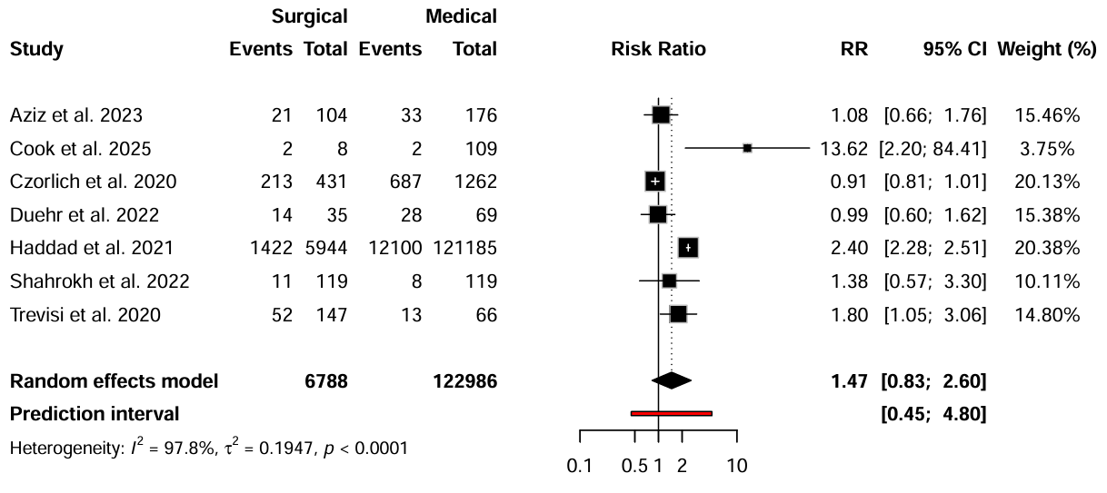

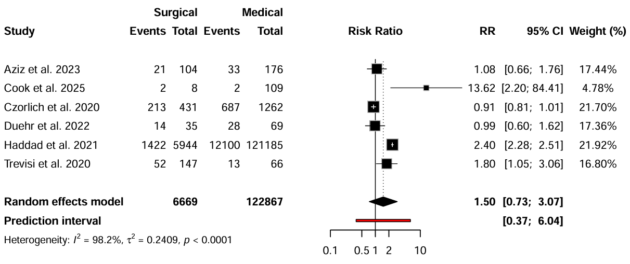
Supplementary Figure 19. In-hospital mortality in older adults aged 70 and over

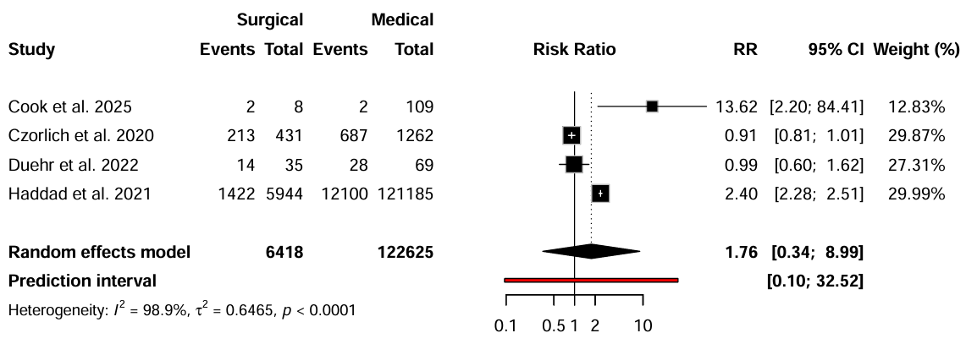
Supplementary Figure 20. In-hospital mortality in older adults aged 80 and over

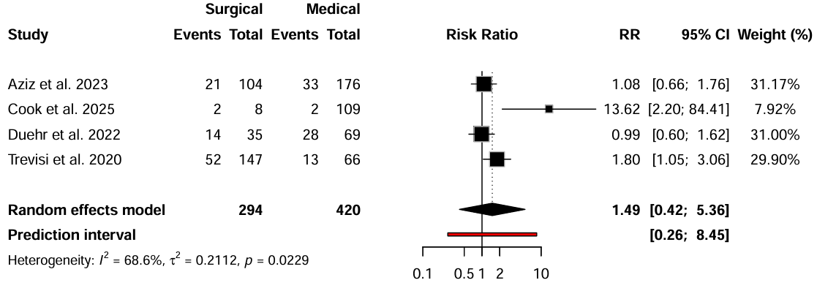
Supplementary Figure 21. In-hospital mortality in older adults with SDH

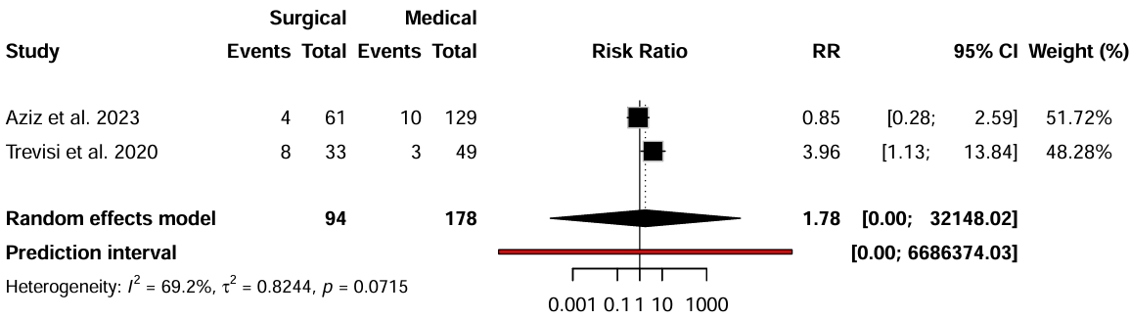
Supplementary Figure 22. In-hospital mortality in older adults with mild TBI

Supplementary Figure 23. In-hospital mortality in older adults with moderate TBI
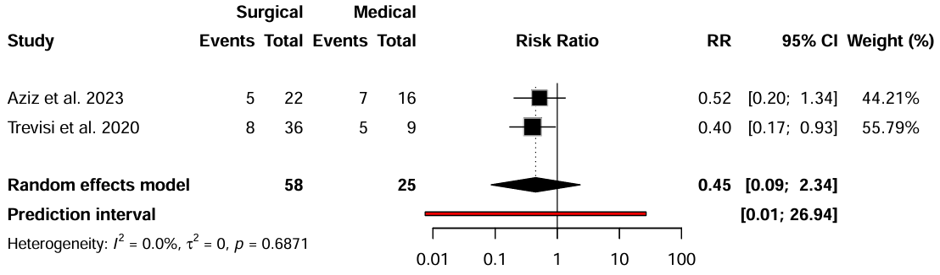

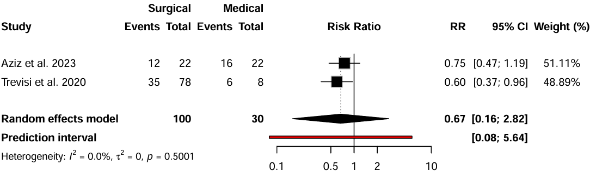
Supplementary Figure 24. In-hospital mortality in older adults with severe TBI

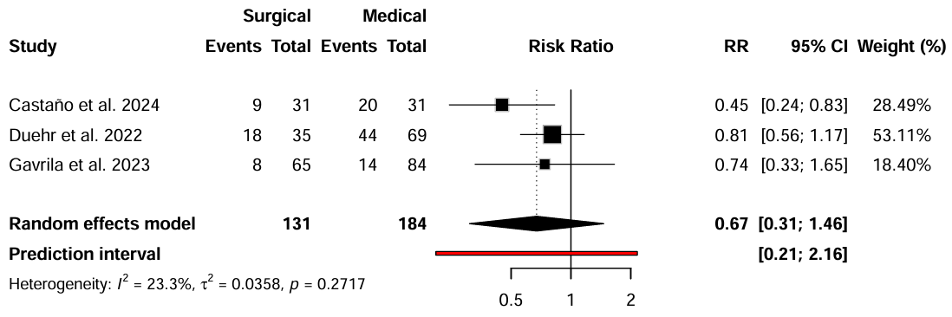
Supplementary Figure 25. 30-day mortality

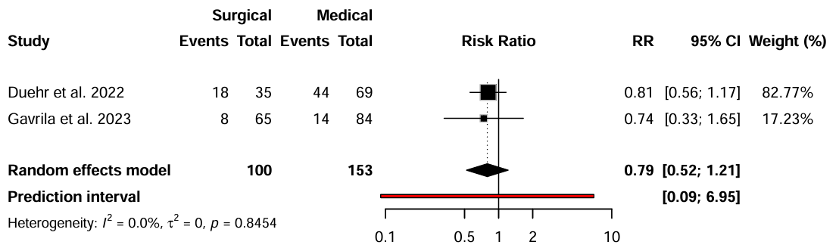
Supplementary Figure 26. 30-day mortality (unmatched studies)

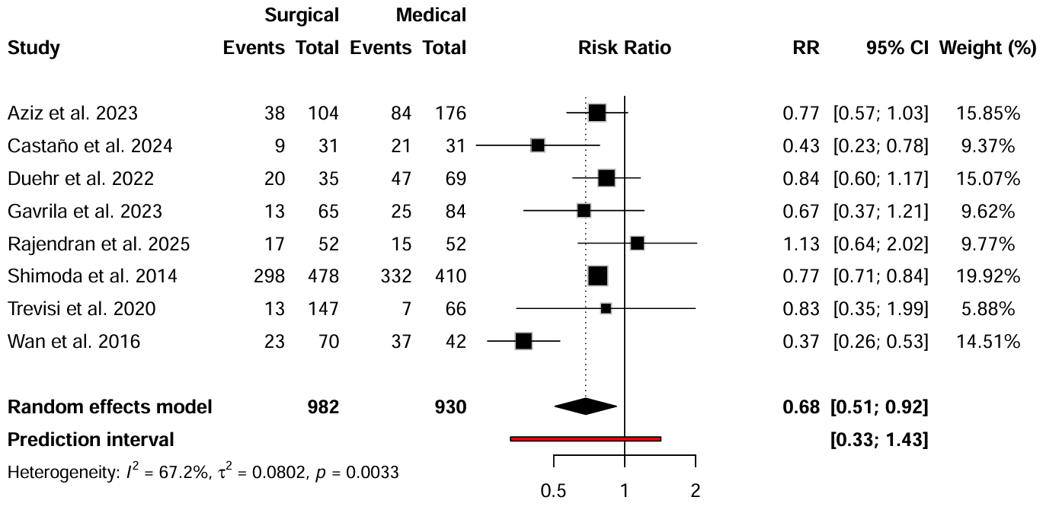
Supplementary Figure 27. 6-month mortality

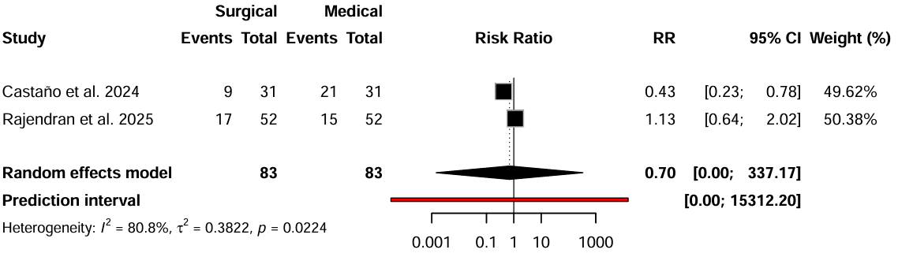
Supplementary Figure 28. 6-month mortality (matched studies)

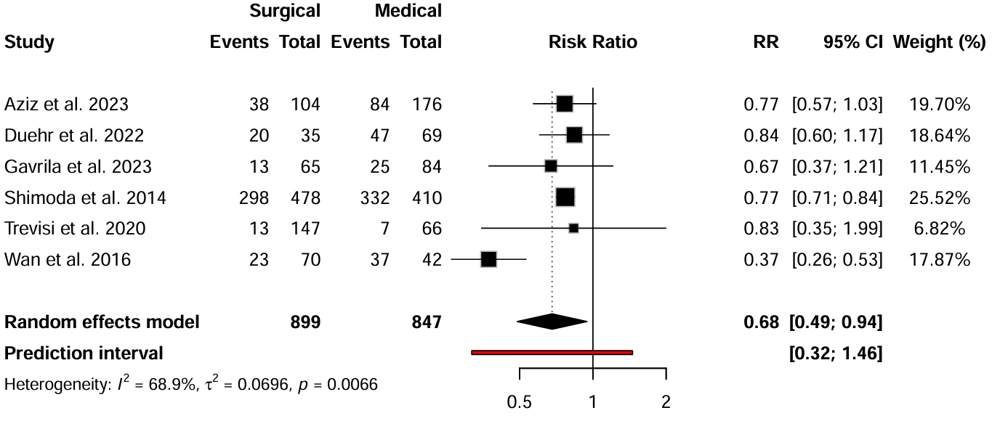
Supplementary Figure 29. 6-month mortality (unmatched studies)

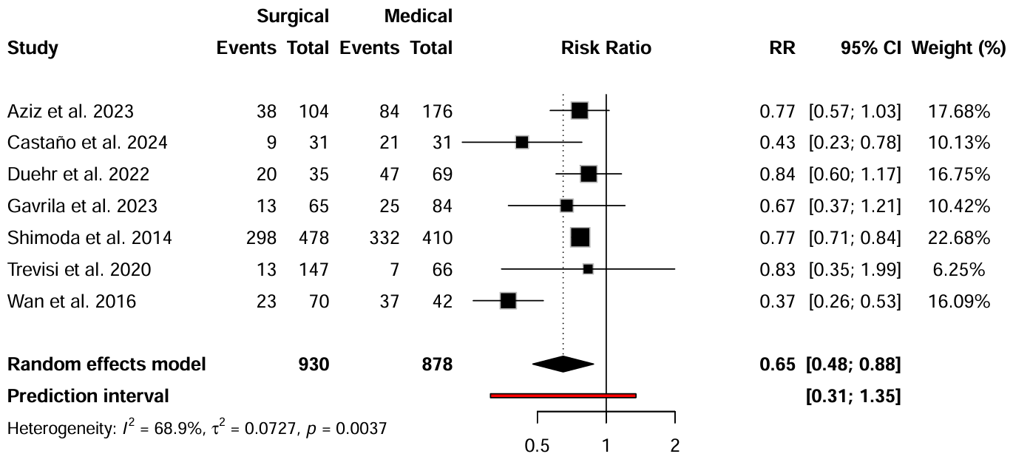
Supplementary Figure 30. 6-month mortality in older adults aged 65 and over

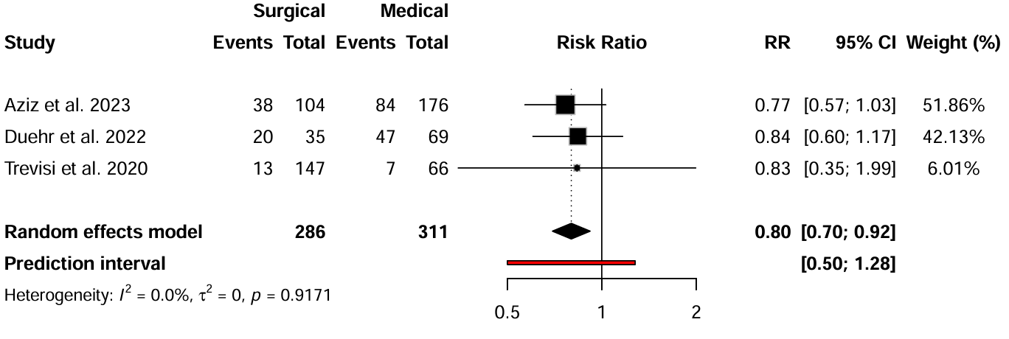
Supplementary Figure 31. 6-month mortality in older adults aged 70 and over

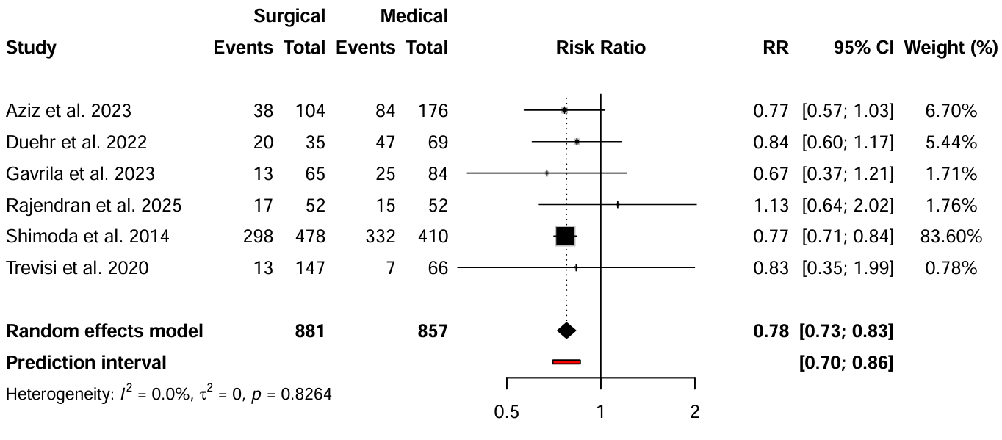
Supplementary Figure 32. 6-month mortality in older adults with SDH

Supplementary Figure 33. 6-month mortality in older adults with isolated TBI
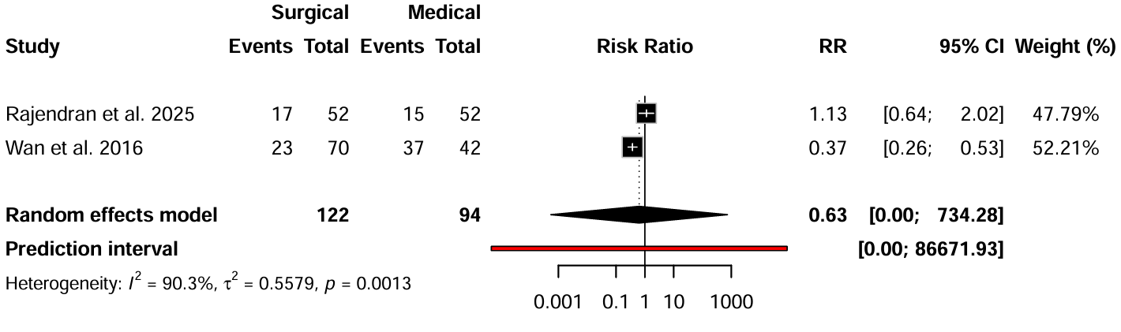

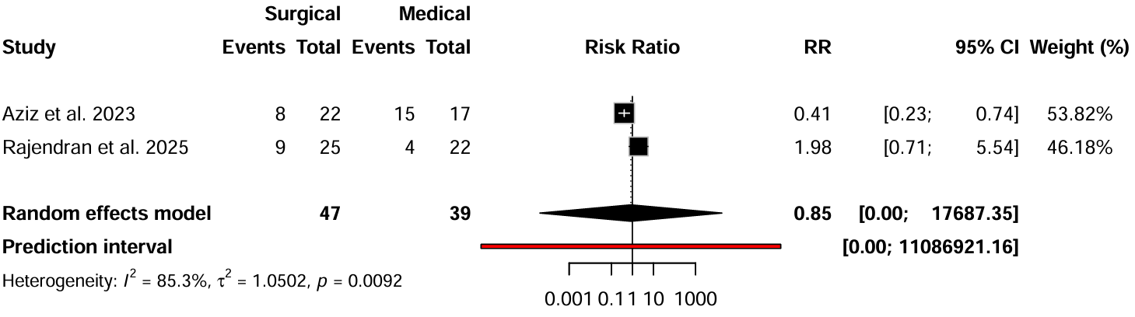
Supplementary Figure 34. 6-month mortality in older adults with moderate TBI

Supplementary Figure 35. 6-month mortality in older adults with severe TBI
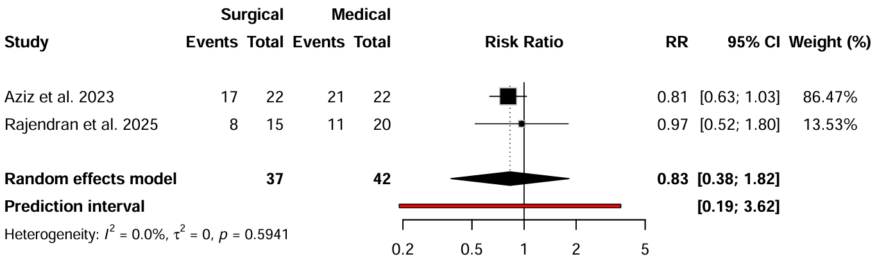

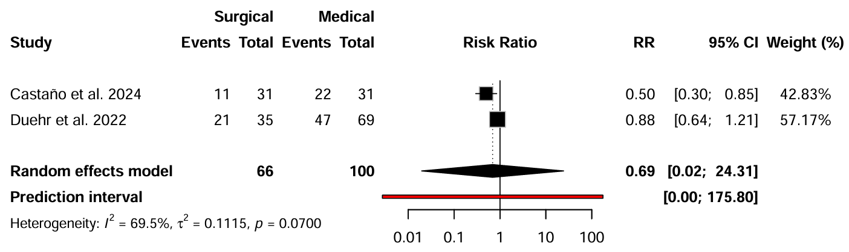
Supplementary Figure 36. 12-month mortality

Supplementary Figure 37. Influence Analysis of favorable neurological outcome at discharge

A.

Study | rstudent | DFFITS | Cook’s d | cov.r | τ² | Q statistic | Hat | Weight | DFBETAS
Aziz et al. 2023 | -0.11 | -0.03 | 0.00 | 1.40 | 0.21 | 60.51 | 0.14 | 13.69 | -0.03
Bharanidharan et al. 2024 | 0.37 | 0.18 | 0.04 | 1.47 | 0.21 | 61.49 | 0.17 | 16.79 | 0.18
Czorlich et al. 2020 | 0.74 | 0.36 | 0.14 | 1.37 | 0.19 | 62.58 | 0.18 | 18.28 | 0.36
Shahrokh et al. 2022 | -0.39 | -0.16 | 0.03 | 1.44 | 0.21 | 50.48 | 0.17 | 16.81 | -0.16
Singh et al. 2025 | 1.22 | 0.58 | 0.30 | 1.13 | 0.15 | 37.94 | 0.19 | 18.56 | 0.58
Trevisi et al. 2020 | -3.10 | -1.53 | 0.95 | 0.42 | 0.05 | 23.14 | 0.16 | 15.88 | -1.62

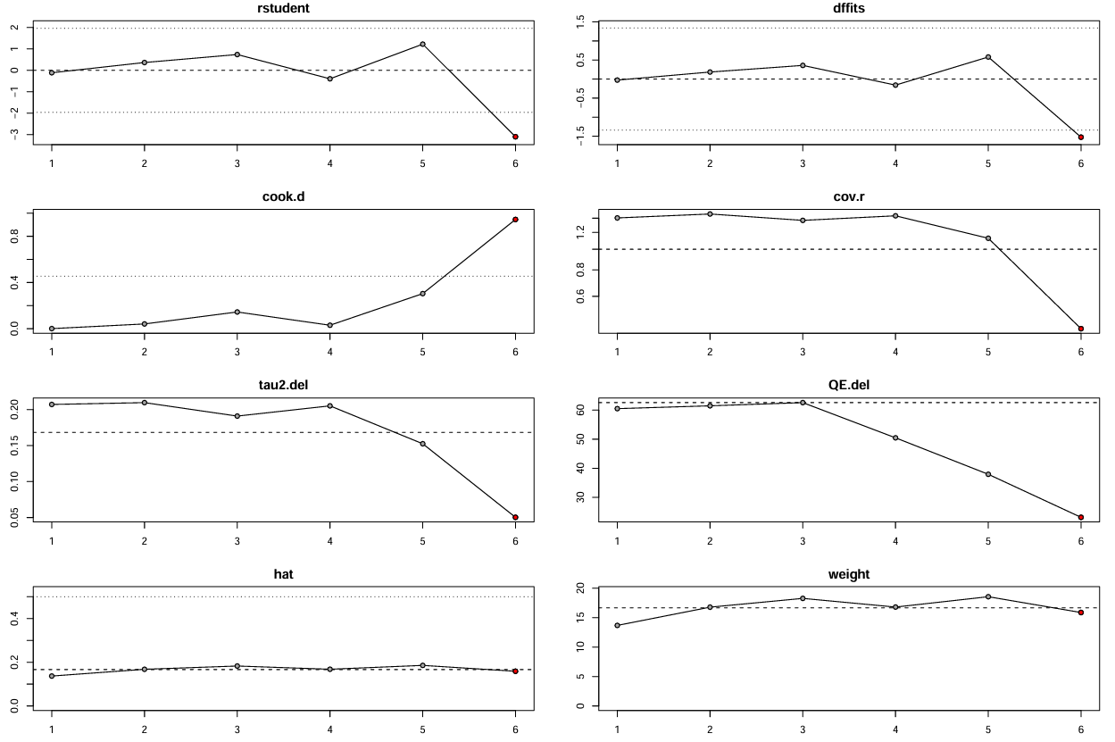
B.

Supplementary Figure 38. Influence Analysis of favorable neurological outcome at 6 months

A.

Study | rstudent | DFFITS | Cook’s d | cov.r | τ² | Q statistic | Hat | Weight | DFBETAS
Aziz et al. 2023 | -0.10 | -0.10 | 0.01 | 1.52 | 0.87 | 62.03 | 0.16 | 15.64 | -0.10
Castaño et al. 2024 | 0.08 | -0.02 | 0.00 | 1.43 | 0.83 | 62.68 | 0.13 | 12.86 | -0.02
Kumar et al. 2024 | -0.38 | -0.21 | 0.06 | 1.50 | 0.85 | 63.01 | 0.16 | 15.99 | -0.22
Rajendran et al. 2025 | -0.42 | -0.23 | 0.06 | 1.47 | 0.84 | 63.13 | 0.15 | 15.30 | -0.23
Shimoda et al. 2014 | 0.93 | 0.40 | 0.16 | 1.16 | 0.64 | 38.88 | 0.15 | 15.35 | 0.40
Trevisi et al. 2020 | -2.21 | -0.75 | 0.29 | 0.64 | 0.32 | 28.61 | 0.16 | 15.52 | -0.73
Wan et al. 2016 | 2.30 | 0.75 | 0.43 | 0.68 | 0.38 | 52.68 | 0.09 | 9.34 | 0.83

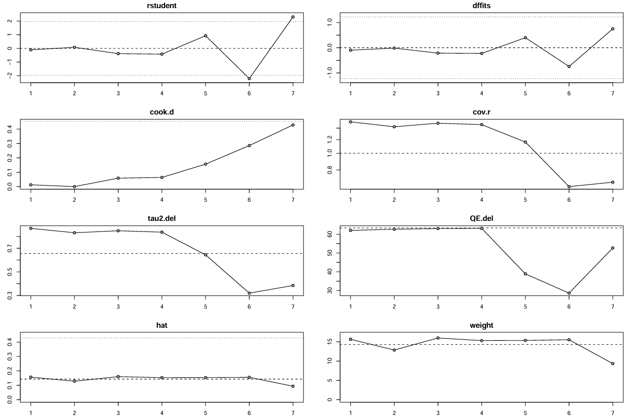
B.

Supplementary Figure 39. Influence Analysis of hospital length of stay

A.

Study | rstudent | DFFITS | Cook’s d | cov.r | τ² | Q statistic | Hat | Weight | DFBETAS
Aziz et al. 2023 | 1.64 | 0.68 | 0.39 | 0.83 | 4.11 | 28.93 | 0.14 | 13.58 | 0.73
Cook et al. 2025 | -5.30 | -1.70 | 0.23 | 0.01 | 0.00 | 3.59 | 0.28 | 27.99 | -5.52
Gavrila et al. 2023 | 0.51 | 0.16 | 0.03 | 1.28 | 7.31 | 31.45 | 0.12 | 11.55 | 0.15
Haddad et al. 2021 | 0.18 | 0.01 | 0.00 | 1.99 | 10.12 | 10.91 | 0.30 | 30.29 | 0.01
Trevisi et al. 2020 | -0.43 | -0.29 | 0.10 | 1.61 | 8.98 | 30.97 | 0.17 | 16.59 | -0.28

B.
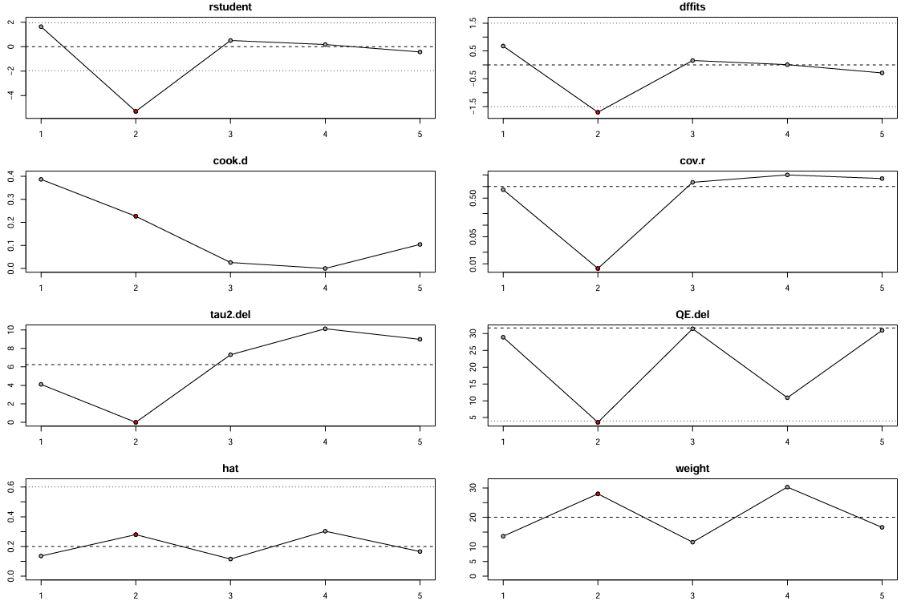

Supplementary Figure 40. Influence Analysis of in-hospital mortality

A.

Study | rstudent | DFFITS | Cook’s d | cov.r | τ² | Q statistic | Hat | Weight | DFBETAS
Aziz et al. 2023 | -0.39 | -0.19 | 0.05 | 1.44 | 0.32 | 282.85 | 0.14 | 13.91 | -0.19
Cook et al. 2025 | 2.30 | 0.43 | 0.17 | 0.87 | 0.19 | 284.83 | 0.04 | 3.82 | 0.46
Czorlich et al. 2020 | -0.80 | -0.38 | 0.16 | 1.34 | 0.28 | 42.10 | 0.17 | 17.30 | -0.38
Duehr et al. 2022 | -0.55 | -0.25 | 0.08 | 1.39 | 0.30 | 281.13 | 0.14 | 13.84 | -0.25
Haddad et al. 2021 | 2.41 | 1.57 | 0.80 | 0.56 | 0.08 | 17.37 | 0.17 | 17.47 | 1.36
Shahrokh et al. 2022 | 0.04 | -0.02 | 0.00 | 1.32 | 0.30 | 288.35 | 0.10 | 9.60 | -0.02
Singh et al. 2025 | -1.61 | -0.51 | 0.23 | 0.94 | 0.19 | 277.85 | 0.11 | 10.66 | -0.52
Trevisi et al. 2020 | 0.52 | 0.18 | 0.04 | 1.33 | 0.29 | 288.91 | 0.13 | 13.40 | 0.18

B.
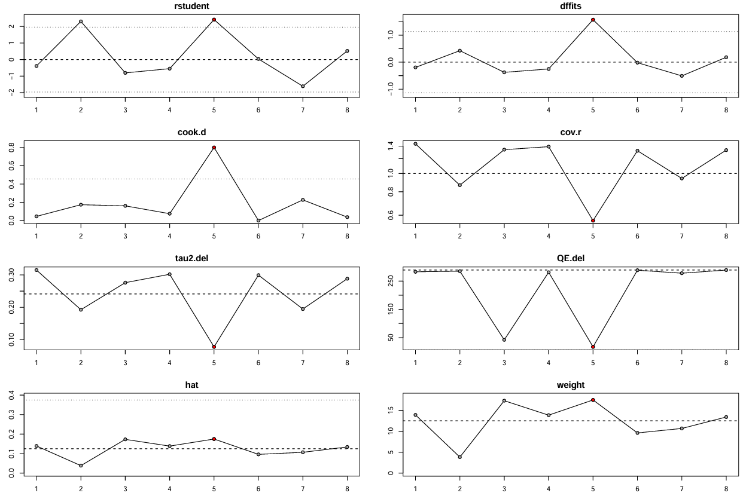

Supplementary Figure 41. Influence Analysis of 30-day mortality

A.

Study | rstudent | DFFITS | Cook’s d | cov.r | τ² | Q statistic | Hat | Weight | DFBETAS
Castaño et al. 2024 | -1.60 | -1.01 | 0.74 | 0.77 | 0.00 | 0.04 | 0.28 | 28.49 | -1.12
Duehr et al. 2022 | 1.30 | 1.62 | 1.29 | 1.63 | 0.00 | 0.92 | 0.53 | 53.11 | 1.48
Gavrila et al. 2023 | 0.25 | 0.25 | 0.09 | 2.18 | 0.10 | 2.58 | 0.18 | 18.40 | 0.23

B.

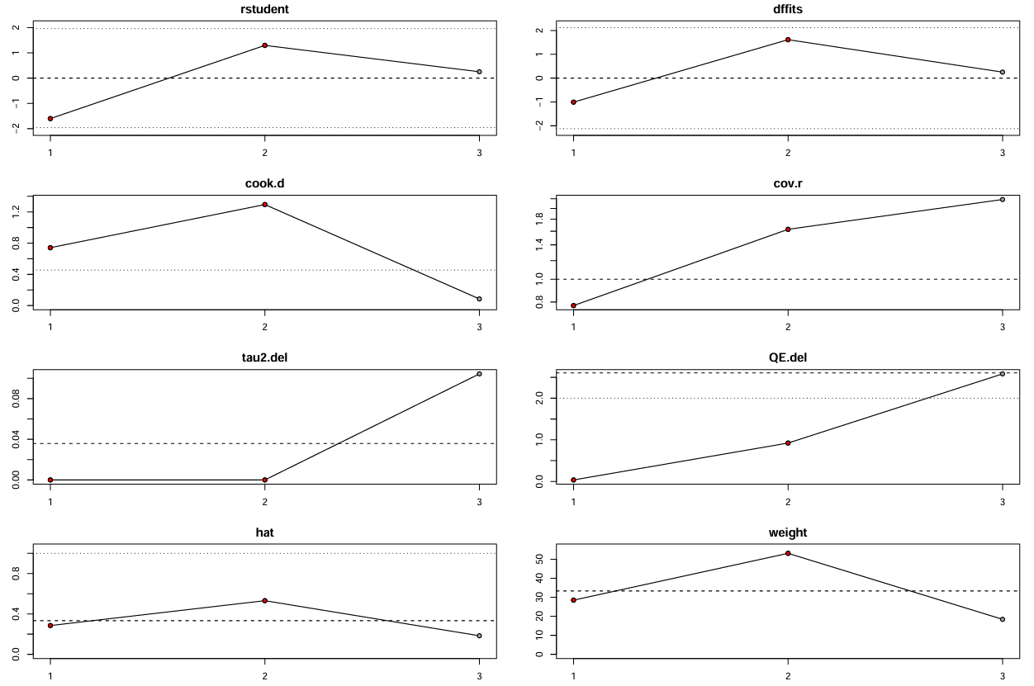

Supplementary Figure 42. Influence Analysis of 6-month mortality

A.

Study | rstudent | DFFITS | Cook’s d | cov.r | τ² | Q statistic | Hat | Weight | DFBETAS
Aziz et al. 2023 | 0.35 | 0.15 | 0.03 | 1.42 | 0.10 | 21.31 | 0.16 | 15.85 | 0.15
Castaño et al. 2024 | -1.19 | -0.38 | 0.14 | 1.06 | 0.08 | 18.04 | 0.09 | 9.37 | -0.38
Duehr et al. 2022 | 0.63 | 0.27 | 0.08 | 1.32 | 0.09 | 20.82 | 0.15 | 15.07 | 0.27
Gavrila et al. 2023 | -0.04 | -0.01 | 0.00 | 1.28 | 0.10 | 21.22 | 0.10 | 9.62 | -0.01
Rajendran et al. 2025 | 1.33 | 0.42 | 0.17 | 1.03 | 0.07 | 19.29 | 0.10 | 9.77 | 0.43
Shimoda et al. 2014 | 0.40 | 0.19 | 0.05 | 1.49 | 0.11 | 18.67 | 0.20 | 19.92 | 0.20
Trevisi et al. 2020 | 0.38 | 0.10 | 0.01 | 1.15 | 0.09 | 21.28 | 0.06 | 5.88 | 0.10
Wan et al. 2016 | -3.93 | -1.73 | 0.86 | 0.09 | 0.00 | 5.86 | 0.15 | 14.51 | -3.12

B.
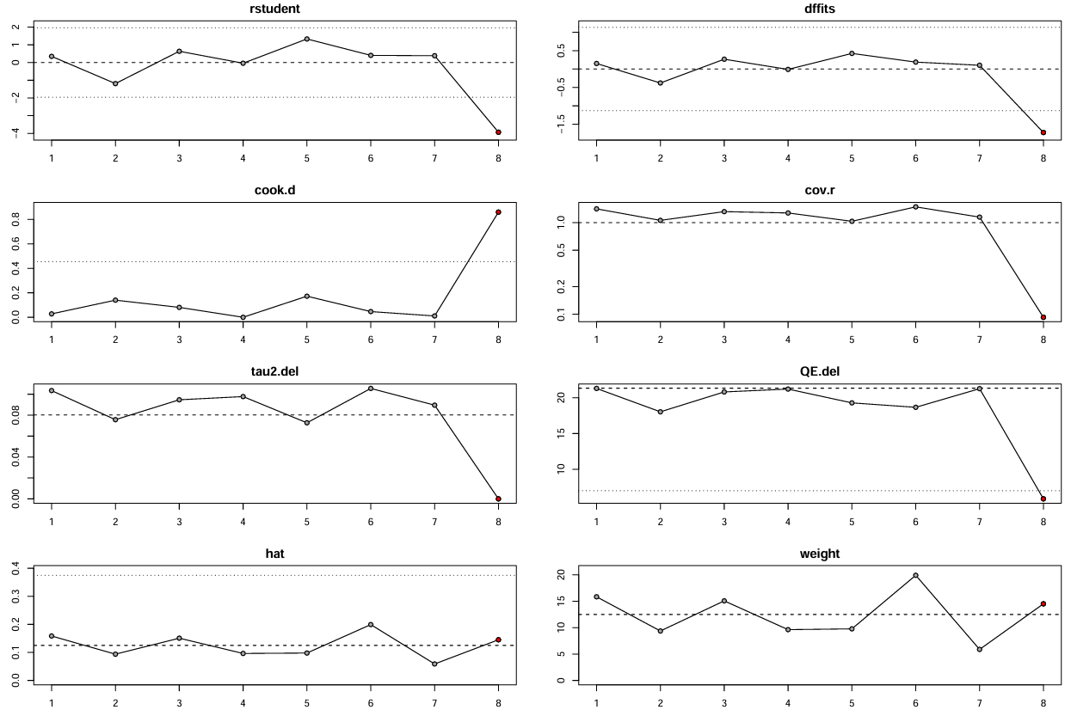

Supplementary Figure 43. Influence Analysis of 12-month mortality

A.

Study | rstudent | DFFITS | Cook’s d | cov.r | τ² | Q statistic | Hat | Weight | DFBETAS
Castaño et al. 2024 | -1.81 | -1.38 | 0.75 | 0.33 | 0.00 | 0.00 | 0.43 | 42.83 | -1.76
Duehr et al. 2022 | 1.81 | 2.66 | 1.34 | 0.92 | 0.00 | 0.00 | 0.57 | 57.17 | 2.35

B.
