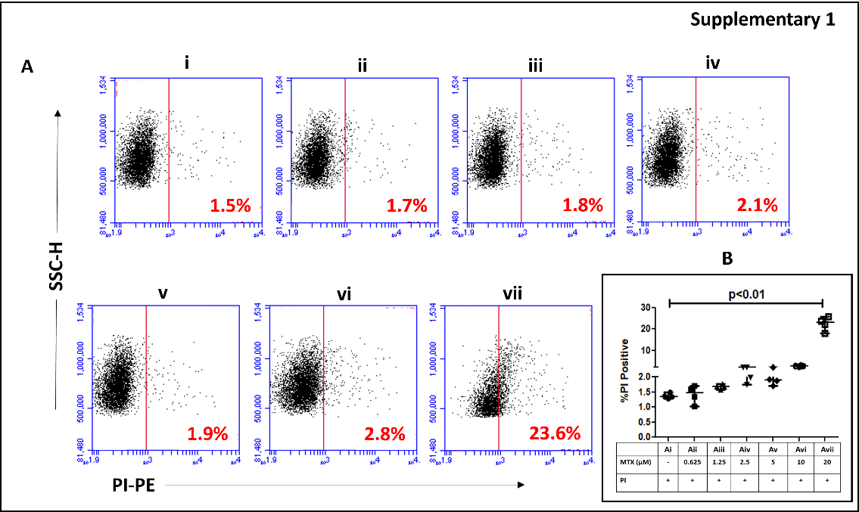
Supplementary 1: Establishment of non-toxic dose of MTX in neutrophils
A i-vii: Representative frequency plots of PI⁺ neutrophils (5x10⁵ cells/ml, n = 4, i) treated with increasing doses of MTX, 0.625 µM (ii), 1.25 µM (iii), 2.5 µM (iv), 5 µM (v), 10 µM (vi) and 20 µM (vii).
B: Scatter plots demonstrating the proportion of PI⁺ neutrophils treated with MTX; data are indicated in median (IQR).

