Supplementary Materials for

TWH19 scaffolds AURKB to phosphorylate C-RAF and activate MAPK signaling

Running title: MAPK activation by TWH19 and AURKB
Yuling Li^{1#}, Yujuan Li^{2#}, Peng Chen^{1#}, Chenhui Wang³, Lu Guo^{1*}, Qingxiang Sun^{1*}
¹Department of Pulmonary and Critical Care Medicine, Sichuan Provincial People's Hospital, School of Medicine, University of Electronic Science and Technology of China, Chengdu, China.
²State Key Laboratory of Biotherapy and Cancer Center, West China Hospital, Sichuan University and Collaborative Innovation Center of Biotherapy, Chengdu 610041, China
³The Key Laboratory for Human Disease Gene Study of Sichuan Province and the Department of Laboratory Medicine, Sichuan Provincial People’s Hospital, School of Medicine, University of Electronic Science and Technology of China, Chengdu, China

*Corresponding authors:
Lu Guo, guoluhx@med.uest.edu.cn
Qingxiang Sun, sunqingxiang@hotmail.com, 0000-0002-9474-8882
# These authors contributed equally to this work.

This file includes:
Fig. S1-S7
Table. S1-S3

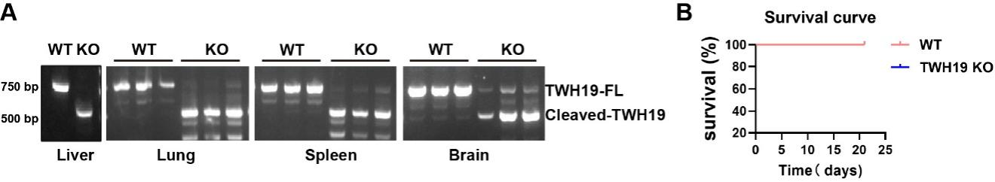
Fig. S1 Validation and survival analysis of inducible TWH19 knockout mice. (A) RT-PCR analysis of TWH19 transcripts in the indicated tissues collected after the tamoxifen induction regimen, confirming systemic deletion of TWH19 in Cre-positive mice relative to littermate controls. (B) Kaplan-Meier survival curves of tamoxifen-induced TWH19 knockout mice and control mice over the indicated observation period, showing no significant difference in survival (n=12 per group).

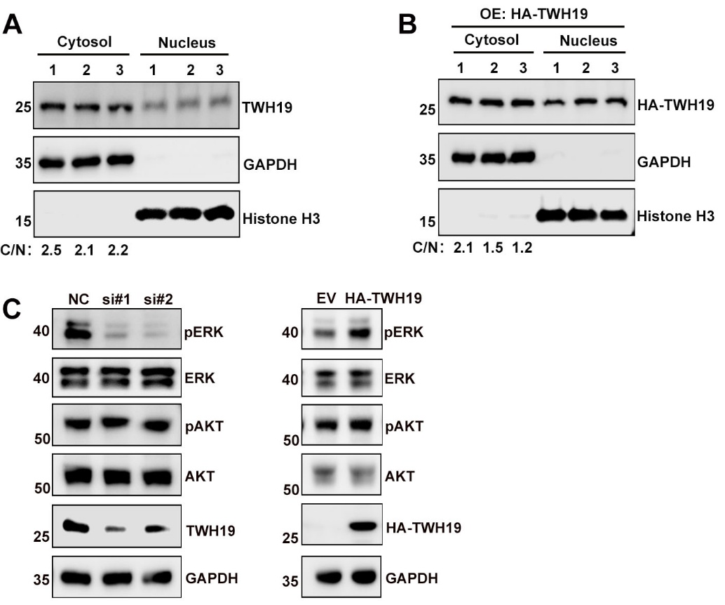
Fig. S2 Subcellular distribution of TWH19 and pathway-selective effects on ERK phosphorylation. (A) Cytoplasmic and nuclear fractionation of 293T cells followed by immunoblotting for endogenous TWH19, showing TWH19 localization in both compartments. GAPDH and Histone H3 served as cytoplasmic and nuclear markers, respectively, with cytosol/nucleus (C/N) ratios indicated below. (B) Cytoplasmic and nuclear fractionation of 293T cells followed by immunoblotting for overexpressed HA-TWH19, confirming similar dual localization of the exogenous protein. (C) Immunoblot analysis of pERK/ERK and pAKT/AKT in HeLa cells after TWH19 knockdown with two independent siRNAs or HA-TWH19 overexpression, showing that TWH19 knockdown reduced pERK levels and overexpression increased pERK levels, whereas pAKT remained unchanged in all conditions.

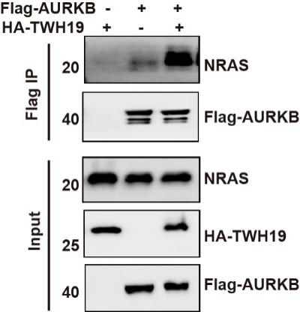
Fig. S3 TWH19 enhances the association between AURKB and NRAS in HeLa cells. Co-immunoprecipitation analysis of Flag-AURKB with endogenous NRAS in HeLa cells in the presence or absence of HA-TWH19, showing that TWH19 overexpression increased AURKB-NRAS complex formation.
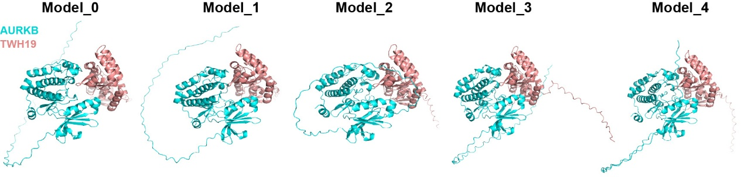
Fig. S4 AlphaFold-predicted binding models of the AURKB-TWH19 complex. Top-ranked AlphaFold models (Models 0-4) of the predicted AURKB-TWH19 interaction. AURKB is shown in cyan and TWH19 in red, showing closely related docking conformations for the two proteins across the five models.

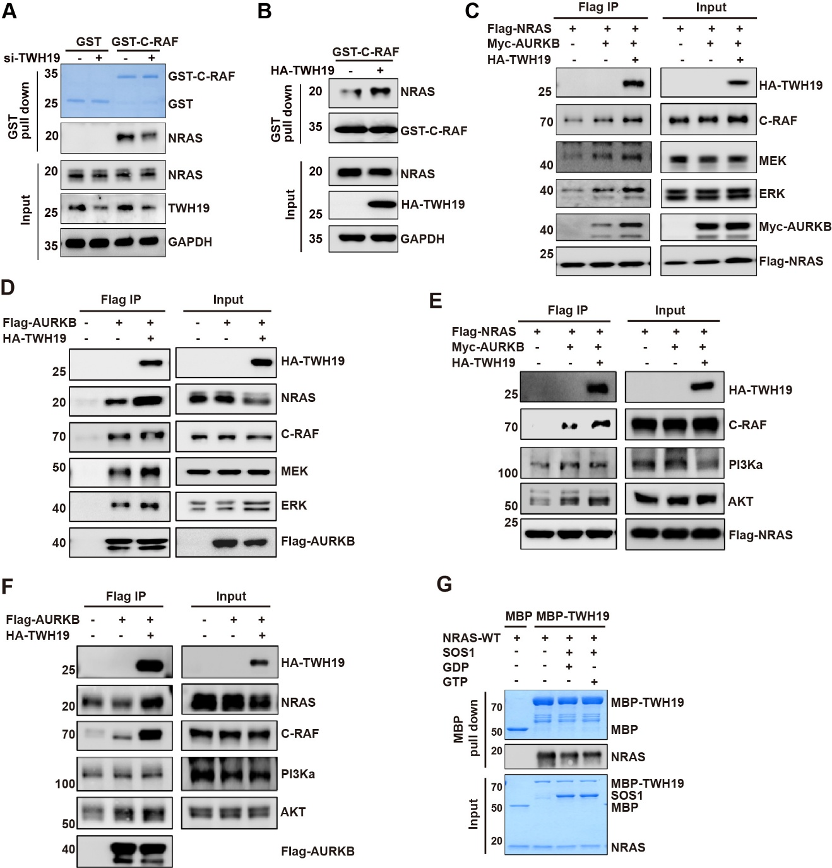
Fig. S5 Additional biochemical analyses of TWH19-dependent assembly of the NRAS-MAPK complex. (A) GST-C-RAF RBD pull-down assay in HeLa cells, showing reduced NRAS-C-RAF association after TWH19 knockdown. GST alone served as a negative control. (B) GST-C-RAF RBD pull-down assay in HeLa cells, showing enhanced NRAS-C-RAF association upon TWH19 overexpression. (C) Co-immunoprecipitation of Flag-NRAS with C-RAF, MEK, and ERK in HeLa cells, showing TWH19-dependent stabilization of MAPK complex assembly. (D) Co-immunoprecipitation of Flag-AURKB with MAPK pathway components in HeLa cells, further showing TWH19-dependent complex formation. (E) Co-immunoprecipitation of Flag-NRAS (Q61R) with PI3Kα and AKT in 293T cells under the indicated conditions, showing no TWH19-dependent enhancement of PI3K-AKT complex assembly. (F) Co-immunoprecipitation of Flag-AURKB with PI3Kα and AKT in 293T cells under the indicated conditions, confirming that TWH19 did not enhance assembly of the PI3K-AKT pathway. (G) In vitro MBP pull-down assay using purified proteins under 1 mM GDP- or GTP-loading conditions as indicated, showing that TWH19 bound NRAS under both nucleotide states.

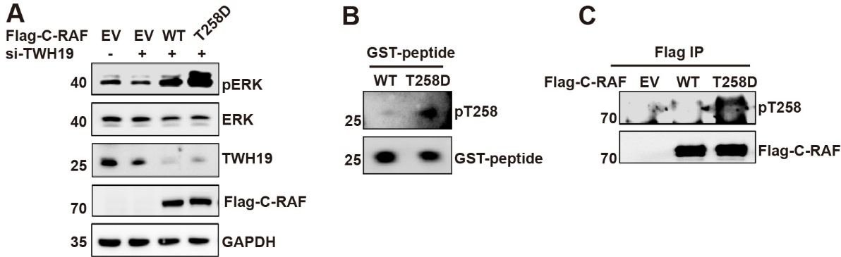
Fig. S6 Functional analysis of C-RAF T258D and validation of the phospho-T258 antibody. (A) Immunoblot analysis of pERK and ERK in TWH19 siRNA-treated 293T cells re-expressing the indicated C-RAF constructs, showing that C-RAF T258D restored ERK phosphorylation more efficiently than wild-type C-RAF. (B) Immunoblot analysis of GST-fused C-RAF peptides corresponding to the wild-type or phosphomimetic T258D sequence probed with the custom anti-pT258 antibody, showing selective recognition of the T258D peptide. (C) Flag immunoprecipitation of wild-type C-RAF or C-RAF T258D followed by immunoblotting with the anti-pT258 antibody, further confirming antibody selectivity for the T258D mutant.

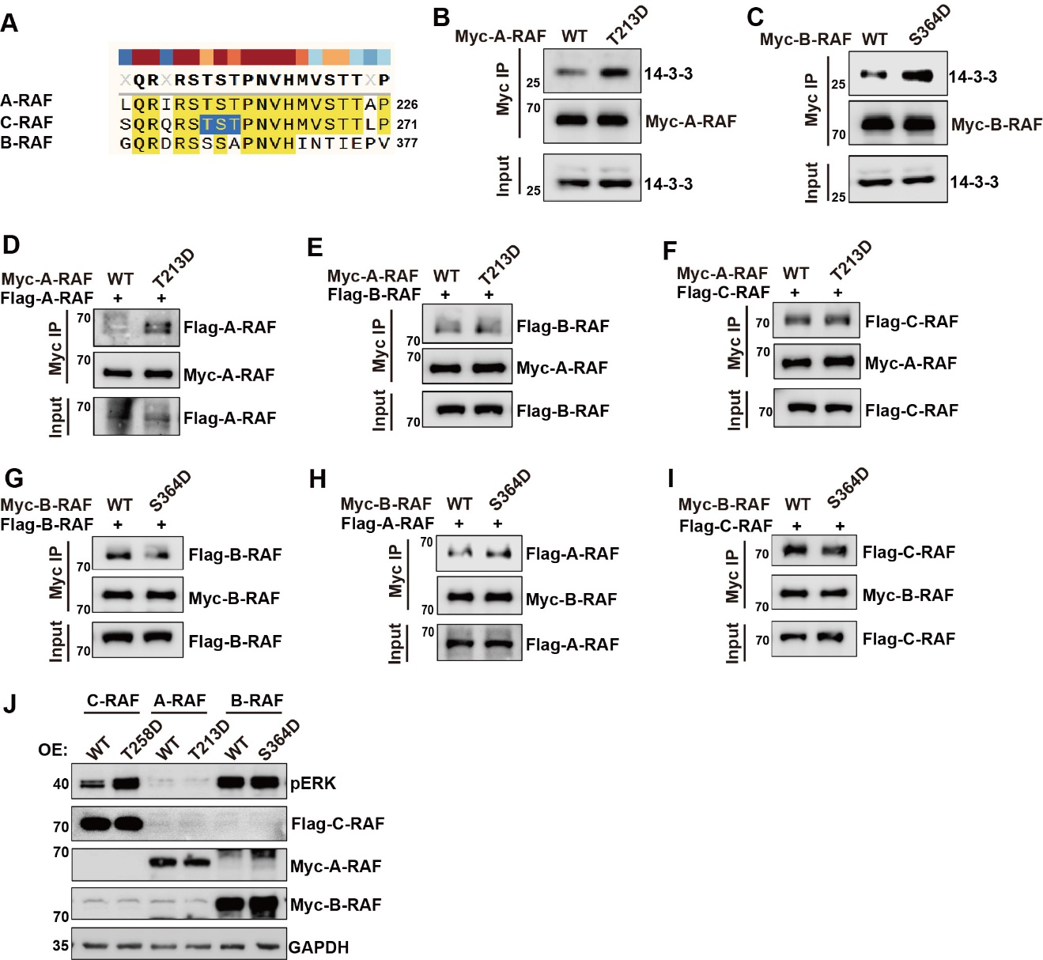
Fig. S7 Phosphomimetic mutations in A-RAF and B-RAF fail to enhance ERK activation, revealing C-RAF-specific regulation of MAPK signaling. (A) Sequence alignment of the region surrounding the C-RAF T258/S259/T260 motif with corresponding regions in A-RAF and B-RAF, showing that T258 is conserved in A-RAF but corresponds to serine in B-RAF. (B) Myc immunoprecipitation assay examining 14-3-3 binding to wild-type and phosphomimetic A-RAF (T213D), showing increased 14-3-3 binding for the T213D mutant. (C) Myc immunoprecipitation assay examining 14-3-3 binding to wild-type and phosphomimetic B-RAF (S364D), showing increased 14-3-3 binding for the S364D mutant. (D-I) Co-immunoprecipitation analyses of homo- and heterodimer formation among A-RAF, B-RAF, and C-RAF carrying the indicated phosphomimetic mutations, showing no clear increase in dimerization for A-RAF T213D or B-RAF S364D. (J) Immunoblot analysis of pERK and ERK in cells expressing the indicated RAF isoforms and mutants, showing that among the tested phosphomimetic variants, only C-RAF T258D robustly enhanced ERK phosphorylation.
Table S1. Mass spec summary of detected phosphorylated C-RAF peptides.

Position | Phospho (STY) peptides | Intensity | Intensity | Fold change
 |  | AURKB | EV | AURKB/EV
T258 | QRSTSTPNVHMVSTTLPVDSR | 1697100 | 8086ª | 209.88
S29 | DAVFDGSSCISPTIVQQFGYQR | 570320 | 8086 | 70.53
S497 | SRWSGSQQVEQPTGSVLWMAPEVIR | 286110 | 8086 | 35.38
S233 | YSTPHAFTFNTSSPSSEGSLSQR | 213970 | 8086 | 26.46
S295 | SHSESASPSALSSSPNNLSPTGWSQPK | 156450 | 8086 | 19.35
S243 | YSTPHAFTFNTSSPSSEGSLSQR | 104420 | 8086 | 12.91
S357 | IGSGSFGTVYK | 292890 | 139010 | 2.11
T260 | STSTPNVHMVSTTLPVDSR | 16400 | 8086 | 2.03
T638 | AAHTEDINACTLTTSPR | 157320 | 104750 | 1.50
S642 | AAHTEDINACTLTTSPR | 662020 | 519300 | 1.27
S296 | SHSESASPSALSSSPNNLSPTGWSQPK | 4620900 | 3792500 | 1.22
S259 | STSTPNVHMVSTTLPVDSR | 9816100 | 9861800 | 1.00
S244 | YSTPHAFTFNTSSPSSEGSLSQR | 1068200 | 1128600 | 0.95
S301 | SHSESASPSALSSSPNNLSPTGWSQPK | 2374000 | 2610700 | 0.91
S289 | SHSESASPSALSSSPNNLSPTGWSQPK | 2900600 | 3399800 | 0.85
S247 | YSTPHAFTFNTSSPSSEGSLSQR | 8086 | 32949 | 0.25
T303 | SHSESASPSALSSSPNNLSPTGWSQPK | 124500 | 766410 | 0.16
T310 | SHSESASPSALSSSPNNLSPTGWSQPKTPVPAQR | 8086 | 50025 | 0.16
T641 | AAHTEDINACTLTTSPR | 8086 | 55269 | 0.15
S43 | ASDDGKLTDPSKTSNTIR | 8086 | 215080 | 0.04
S294 | SHSESASPSALSSSPNNLSPTGWSQPK | 8086 | 766410 | 0.01

ªAn intensity value of 8086 represents the minimum detection threshold for peptides not reliably detected in the EV control sample.
Table S2. List of siRNAs used in this work.

Oligonucleotides | Sense (5'-3') (include overhangs) | Antisense (5'-3') (include overhangs)
si-AURKB | CAUGGAGGAGUUGGCAGAUGCUCUA | UAGAGCAUCUGCCAACUCCUCCAUG
si-PIP5K1A | GCGUGAUGUCCUCAUGCAAGA | UUGCAUGAGGACAUCACGCUC
si-SRPK2 | GAUAUCAUCCAGUGAAAAUUG | AUUUUCACUGGAUGAUAUCCA
si-TWH19-1 | CCGGAGACCUUUGGAGUUATT | UAACUCCAAAGGUCUCCGGTT
si-TWH19-2 | GGAGAUUCAUCAAGUACUUTT | AAGUACUUGAUGAAUCUCCTT
si-NC | UUCUCCGAACGUGUCACGUTT | ACGUGACACGUUCGGAGAATT

Table S3. List of antibodies used in this work.

Antibodies | Source | Identifier
HA-Tag Rabbit mAb | ABclonal | AE115
DDDDK-Tag Rabbit mAb | ABclonal | AE092
GST Tag Mouse McAb | proteintech | 66001-2-Ig
6*His,His-Tag Mouse McAb | proteintech | 66005-1-Ig
TWH19 Rabbit pAb | ABclonal | A7574
Aurora B Rabbit pAb | ZENBIO | 380145
GTPase NRAS Rabbit mAb | ZENBIO | R25553
pan RAS Mouse McAb | proteintech | 60309-1-Ig
C-RAF Rabbit mAb | ZENBIO | R25538
ERK1/2 Rabbit PolyAb | proteintech | 11257-1-AP
Recombinant Rabbit mAb Anti-Phospho-ERK1(T202+Y204)+ERK2(T185+Y187) | HUABIO | ET1610-13
Phospho-MEK1/MEK2-S217/S221 Rabbit mAb | ABclonal | AP1349
Phospho-(ser/Thr) Phe Antibody | Cell Signaling Technology | 9631S
Pan Phospho-Tyrosine Rabbit mAb | ABclonal | AP1316
PIP5K1A Rabbit PolyAb | proteintech | 15713-1-AP
SRPK2 Rabbit PolyAb | proteintech | 25417-1-AP
GNB2 Rabbit mAb | ZENBIO | R383252
Calnexin Mouse McAb | proteintech | 66903-1-Ig
GAPDH Mouse McAb | proteintech | 60004-1-Ig
Histone H3 Rabbit PolyAb | proteintech | 17168-1-AP
Anti-C-RAF pT258 (custom) | This study | N/A (generated as described in Methods)

