Table S1: Multicollinearity analysis in the association analysis between AIP with TyG and CVD
Variable | GVIF | Df | Adj-VIF
TyG+AIP | 2.308 | 3 | 1.150
age | 1.282 | 1 | 1.132
gender | 2.770 | 1 | 1.664
Education level | 1.081 | 1 | 1.040
smoking | 2.002 | 2 | 1.189
drinking | 1.541 | 1 | 1.242
Marriage group | 1.151 | 1 | 1.073
TC | 3.224 | 1 | 1.796
LDL | 3.131 | 1 | 1.769
Scr | 1.730 | 1 | 1.315
BUN | 1.165 | 1 | 1.079
UA | 1.576 | 1 | 1.255
hs_CRP | 1.029 | 1 | 1.014
hypertension | 1.163 | 1 | 1.078
diabetes | 1.128 | 1 | 1.062
dyslipidemia | 2.023 | 1 | 1.422

Table S2: Multicollinearity analysis in the association analysis between AIP with eGDR and CVD
Variable | GVIF | Df | Adj-VIF
eGDR+AIP | 6.096 | 3 | 1.352
age | 1.275 | 1 | 1.129
gender | 2.740 | 1 | 1.655
Education level | 1.080 | 1 | 1.039
smoking | 1.985 | 2 | 1.187
drinking | 1.543 | 1 | 1.242
Marriage group | 1.149 | 1 | 1.072
TC | 3.125 | 1 | 1.768
LDL | 3.086 | 1 | 1.757
Scr | 1.728 | 1 | 1.314
BUN | 1.162 | 1 | 1.078
UA | 1.568 | 1 | 1.252
hs_CRP | 1.028 | 1 | 1.014
hypertension | 2.532 | 1 | 1.591
diabetes | 1.097 | 1 | 1.047
dyslipidemia | 2.013 | 1 | 1.419

Table S3: Multicollinearity analysis in the association analysis between AIP with METS-IR and CVD
Variable | GVIF | Df | Adj-VIF
METS-IR+AIP | 3.017 | 3 | 1.202
age | 1.305 | 1 | 1.142
gender | 2.747 | 1 | 1.657
Education level | 1.087 | 1 | 1.042
smoking | 1.992 | 2 | 1.188
drinking | 1.538 | 1 | 1.240
Marriage group | 1.151 | 1 | 1.073
TC | 3.116 | 1 | 1.765
LDL | 3.040 | 1 | 1.744
Scr | 1.732 | 1 | 1.316
BUN | 1.160 | 1 | 1.077
UA | 1.580 | 1 | 1.257
hs-CRP | 1.030 | 1 | 1.015
hypertension | 1.165 | 1 | 1.080
diabetes | 1.099 | 1 | 1.048
dyslipidemia | 2.034 | 1 | 1.426

Table S4: Threshold effect analysis of eGDR on CVD risk among participants with high AIP
Participants with high AIP | Adjusted HR (95% CI) | P value
eGDR
Total | 0.9 (0.83,0.98) | 0.013
Fitting by two-piecewise Cox proportional risk model
Inflection point | 9.26 | < 0.001
eGDR < 9.26 | 1.52 (1.03, 2.23) | 0.035
eGDR ≥ 9.26 | 0.66 (0.45, 0.97) | < 0.001
P for log-likelihood ratio |  | < 0.001
Abbreviations: AIP, atherogenic index of plasma; CI, confidence interval; CVD, cardiovascular disease; eGDR, estimated glucose disposal rate.

Table S5: Associations of dichotomized AIP and insulin resistance surrogate indices with incident CVD
Subgroups | Incidence rate | Model I | p | Model II | p | Model III HR | p
AIP
Low | 23.03 | Reference | — | Reference | — | Reference | —
High | 30.50 | 1.35 (1.17, 1.57) | < 0.001 | 1.33 (1.15, 1.54) | < 0.001 | 1.31 (1.13, 1.52) | < 0.001
Per 1.0 SD |  | 1.14 (1.06, 1.22) | < 0.001 | 1.14 (1.06, 1.22) | < 0.001 | 1.14 (1.06, 1.22) | < 0.001
TyG
Low | 23.41 | Reference | — | Reference | — | Reference | —
High | 30.11 | 1.31 (1.14, 1.52) | < 0.001 | 1.25 (1.09, 1.45) | 0.002 | 1.24 (1.07, 1.44) | 0.004
Per 1.0 SD |  | 1.16 (1.08, 1.24) | < 0.001 | 1.15 (1.07, 1.23) | < 0.001 | 1.15 (1.07, 1.24) | < 0.001
eGDR
Low | 35.33 | Reference | — | Reference | — | Reference | —
High | 18.36 | 0.50 (0.43, 0.58) | < 0.001 | 0.53 (0.46, 0.62) | < 0.001 | 0.53 (0.45, 0.62) | < 0.001
Per 1.0 SD |  | 0.69 (0.64, 0.74) | < 0.001 | 0.71 (0.66, 0.76) | < 0.001 | 0.70 (0.65, 0.76) | < 0.001
METS-IR
Low | 21.84 | Reference | — | Reference | — | Reference | —
High | 31.69 | 1.49 (1.29, 1.72) | < 0.001 | 1.53 (1.32, 1.78) | < 0.001 | 1.54 (1.32, 1.79) | < 0.001
Per 1.0 SD |  | 1.21 (1.14, 1.29) | < 0.001 | 1.23 (1.16, 1.31) | < 0.001 | 1.24 (1.17, 1.32) | < 0.001
Model I: non-adjusted.
Model II: adjusted for age, sex, smoking status, drinking status, education level, and marital status.
Model III: further adjusted for hs-CRP, UA, Scr, and BUN.
Each index was dichotomized at its median value.
For eGDR, lower values indicate greater insulin resistance. a Incident rate was expressed per 1,000 person-years of follow-up.

Table S6: Sensitivity analyses regarding the joint effects of insulin resistance surrogate indices and atherogenic index of plasma on the risks of developing CVD with respect to missing data.
 | Model I |  |  | Model II |  |  | Model III
Variable | HR | 95% CI | p-value | HR | 95% CI | p-value | HR | 95% CI | p-value
TyG and AIP
Group 1 | Ref | — |  | Ref | — |  | Ref | —
Group 2 | 1.33 | 0.99, 1.79 | 0.055 | 1.40 | 1.04, 1.89 | 0.025 | 1.34 | 1.00, 1.81 | 0.053
Group 3 | 1.13 | 0.83, 1.55 | 0.431 | 1.08 | 0.79, 1.47 | 0.638 | 1.03 | 0.75, 1.41 | 0.843
Group 4 | 1.40 | 1.20, 1.63 | <0.001 | 1.35 | 1.15, 1.57 | <0.001 | 1.24 | 1.05, 1.46 | 0.010
P for trend |  | <0.001 |  |  | <0.001 |  |  | 0.017
eGDR and AIP
Group 1 | Ref | — |  | Ref | — |  | Ref | —
Group 2 | 1.44 | 1.13, 1.84 | 0.003 | 1.36 | 1.07, 1.74 | 0.012 | 1.28 | 0.98, 1.66 | 0.071
Group 3 | 1.69 | 1.34, 2.12 | <0.001 | 1.75 | 1.38, 2.20 | <0.001 | 1.93 | 1.54, 2.42 | <0.001
Group 4 | 1.64 | 1.38, 1.95 | <0.001 | 1.65 | 1.39, 1.97 | <0.001 | 2.24 | 1.78, 2.83 | <0.001
P for trend |  | <0.001 |  |  | <0.001 |  |  | <0.001
METS-IR and AIP
Group 1 | Ref | — |  | Ref | — |  | Ref | —
Group 2 | 1.44 | 1.13, 1.84 | 0.003 | 1.36 | 1.07, 1.74 | 0.012 | 1.33 | 1.04, 1.70 | 0.021
Group 3 | 1.69 | 1.34, 2.12 | <0.001 | 1.75 | 1.38, 2.20 | <0.001 | 1.74 | 1.38, 2.19 | <0.001
Group 4 | 1.64 | 1.38, 1.95 | <0.001 | 1.65 | 1.39, 1.97 | <0.001 | 1.65 | 1.38, 1.97 | <0.001
P for trend |  | <0.001 |  |  | <0.001 |  |  | <0.001
Model I: non-adjusted
Model II: adjusted for age, sex, smoking status, drinking status, education level, marital status
Model III: further adjusted for UA, Scr, hs-CRP, and BUN.
Abbreviations: AIP, atherogenic index of plasma; IR, insulin resistance; CI, confidence interval; CVD, cardiovascular disease; eGDR, estimated glucose disposal rate; METS-IR, metabolic score for insulin resistance; TyG, triglyceride-glucose index; UA, uric acid; Scr, serum creatinine; BUN, Blood Urea Nitrogen; hs-CRP, high-sensitivity C-reactive protein.

Table S7: Index-specific sensitivity analyses of the joint associations of AIP and insulin resistance surrogate indices with incident CVD.
 | Model I |  |  | Model II |  |  | Model III
Variable | HR | 95% CI | p-value | HR | 95% CI | p-value | HR | 95% CI | p-value
TyG and AIP
Group 1 | Ref | — |  | Ref | — |  | Ref | —
Group 2 | 1.33 | 0.99, 1.79 | 0.055 | 1.40 | 1.04, 1.89 | 0.025 | 1.37 | 1.02, 1.85 | 0.036
Group 3 | 1.13 | 0.83, 1.55 | 0.431 | 1.08 | 0.79, 1.47 | 0.638 | 1.07 | 0.79, 1.47 | 0.655
Group 4 | 1.40 | 1.20, 1.63 | <0.001 | 1.35 | 1.15, 1.57 | <0.001 | 1.33 | 1.13, 1.56 | <0.001
P for trend |  | <0.001 |  |  | <0.001 |  |  | 0.001
eGDR and AIP
Group 1 | Ref | — |  | Ref | — |  | Ref | —
Group 2 | 1.28 | 1.00, 1.64 | 0.049 | 1.26 | 0.99, 1.62 | 0.061 | 1.28 | 0.98, 1.66 | 0.071
Group 3 | 2.07 | 1.66, 2.58 | <0.001 | 1.93 | 1.54, 2.41 | <0.001 | 1.93 | 1.54, 2.42 | <0.001
Group 4 | 2.37 | 1.94, 2.89 | <0.001 | 2.20 | 1.80, 2.68 | <0.001 | 2.24 | 1.78, 2.83 | <0.001
P for trend |  | <0.001 |  |  | <0.001 |  |  | <0.001
METS-IR and AIP
Group 1 | Ref | — |  | Ref | — |  | Ref | —
Group 2 | 1.44 | 1.13, 1.84 | 0.003 | 1.36 | 1.07, 1.74 | 0.012 | 1.33 | 1.05, 1.70 | 0.021
Group 3 | 1.69 | 1.34, 2.12 | <0.001 | 1.75 | 1.38, 2.20 | <0.001 | 1.60 | 1.27, 2.03 | <0.001
Group 4 | 1.64 | 1.38, 1.95 | <0.001 | 1.65 | 1.39, 1.97 | <0.001 | 1.48 | 1.23, 1.78 | <0.001
P for trend |  | <0.001 |  |  | <0.001 |  |  | <0.001
Model I: non-adjusted
Model II: adjusted for age, sex, smoking status, drinking status, education level, marital status
Model III: further adjusted for BUN, hs-CRP, UA, Scr, and selected clinical covariates according to the surrogate index evaluated. Specifically, Model III additionally included BMI and hypertension in the TyG-AIP analysis, BMI and dyslipidemia in the eGDR-AIP analysis, and hypertension in the METS-IR-AIP analysis. To reduce potential overadjustment, variables overlapping with the construction of a given surrogate index were not additionally adjusted in the corresponding model.
Abbreviations: AIP, atherogenic index of plasma; IR, insulin resistance; CI, confidence interval; CVD, cardiovascular disease; eGDR, estimated glucose disposal rate; METS-IR, metabolic score for insulin resistance; TyG, triglyceride-glucose index; UA, uric acid; Scr, serum creatinine; BUN, Blood Urea Nitrogen; hs-CRP, high-sensitivity C-reactive protein.

Table S8: Combined effects of IR surrogate indices and AIP on heart disease incidents
 | Model I |  |  | Model II |  |  | Model III
Variable | HR | 95% CI | p-value | HR | 95% CI | p-value | HR | 95% CI | p-value
TyG and AIP
Group 1 | Ref | — |  | Ref | — |  | Ref | —
Group 2 | 1.19 | 0.85, 1.65 | 0.311 | 1.25 | 0.89, 1.74 | 0.196 | 1.18 | 0.84, 1.65 | 0.337
Group 3 | 1.02 | 0.72, 1.46 | 0.892 | 0.97 | 0.68, 1.37 | 0.849 | 0.94 | 0.66, 1.34 | 0.729
Group 4 | 1.25 | 1.06, 1.49 | 0.010 | 1.19 | 1.00, 1.42 | 0.045 | 1.19 | 1.00, 1.42 | 0.045
P for trend |  | <0.001 |  |  | <0.001 |  |  | 0.013
eGDR and AIP
Group 1 | Ref | — |  | Ref | — |  | Ref | —
Group 2 | 1.26 | 0.97, 1.65 | 0.089 | 1.24 | 0.95, 1.62 | 0.119 | 1.22 | 0.93, 1.60 | 0.143
Group 3 | 2.04 | 1.60, 2.59 | <0.001 | 1.91 | 1.50, 2.44 | <0.001 | 1.59 | 1.15, 2.18 | 0.004
Group 4 | 2.05 | 1.64, 2.55 | <0.001 | 1.90 | 1.52, 2.37 | <0.001 | 1.58 | 1.17, 2.13 | 0.003
P for trend |  | <0.001 |  |  | <0.001 |  |  | <0.001
METS-IR and AIP
Group 1 | Ref | — |  | Ref | — |  | Ref | —
Group 2 | 1.29 | 0.98, 1.69 | 0.072 | 1.21 | 0.92, 1.60 | 0.172 | 1.17 | 0.89, 1.55 | 0.256
Group 3 | 1.79 | 1.40, 2.30 | <0.001 | 1.81 | 1.41, 2.33 | <0.001 | 1.63 | 1.26, 2.10 | <0.001
Group 4 | 1.54 | 1.27, 1.87 | <0.001 | 1.52 | 1.25, 1.85 | <0.001 | 1.34 | 1.09, 1.65 | 0.005
P for trend |  | <0.001 |  |  | <0.001 |  |  | <0.001
Model I: non-adjusted
Model II: adjusted for age, sex, smoking status, drinking status, education level, marital status
Model III: further adjusted for UA, Scr, hs-CRP, and BUN.
Abbreviations: AIP, atherogenic index of plasma; IR, insulin resistance; CI, confidence interval; eGDR, estimated glucose disposal rate; METS-IR, metabolic score for insulin resistance; TyG, triglyceride-glucose index; UA, uric acid; Scr, serum creatinine; BUN, Blood Urea Nitrogen; hs-CRP, high-sensitivity C-reactive protein.

Table S9: Combined effects of IR resistance surrogate indices and AIP on incident stroke
 | Model I |  |  | Model II |  |  | Model III
Variable | HR | 95% CI | p-value | HR | 95% CI | p-value | HR | 95% CI | p-value
TyG and AIP
Group 1 | Ref | — |  | Ref | — |  | Ref | —
Group 2 | 1.29 | 0.79, 2.11 | 0.304 | 1.33 | 0.81, 2.17 | 0.263 | 1.24 | 0.75, 2.03 | 0.405
Group 3 | 1.57 | 1.00, 2.47 | 0.051 | 1.56 | 0.99, 2.46 | 0.055 | 1.47 | 0.93, 2.33 | 0.101
Group 4 | 1.87 | 1.47, 2.39 | <0.001 | 1.90 | 1.48, 2.42 | <0.001 | 1.66 | 1.28, 2.15 | <0.001
P for trend |  | <0.001 |  |  | <0.001 |  |  | <0.001
eGDR and AIP
Group 1 | Ref | — |  | Ref | — |  | Ref | —
Group 2 | 1.23 | 0.82, 1.84 | 0.314 | 1.23 | 0.82, 1.84 | 0.314 | 1.23 | 0.82, 1.84 | 0.314
Group 3 | 1.11 | 0.69, 1.79 | 0.664 | 1.11 | 0.69, 1.79 | 0.664 | 1.11 | 0.69, 1.79 | 0.664
Group 4 | 1.74 | 1.12, 2.70 | 0.013 | 1.74 | 1.12, 2.70 | 0.013 | 1.74 | 1.12, 2.70 | 0.013
P for trend |  | <0.001 |  |  | <0.001 |  |  | <0.001
METS-IR and AIP
Group 1 | Ref | — |  | Ref | — |  | Ref | —
Group 2 | 1.58 | 1.08, 2.31 | 0.019 | 1.53 | 1.04, 2.24 | 0.029 | 1.46 | 0.99, 2.14 | 0.055
Group 3 | 1.79 | 1.24, 2.59 | 0.002 | 2.00 | 1.38, 2.90 | <0.001 | 1.75 | 1.20, 2.56 | 0.004
Group 4 | 2.14 | 1.63, 2.80 | <0.001 | 2.30 | 1.75, 3.02 | <0.001 | 1.87 | 1.40, 2.50 | <0.001
P for trend |  | <0.001 |  |  | <0.001 |  |  | 0.002
Model I: non-adjusted
Model II: adjusted for age, sex, smoking status, drinking status, education level, marital status
Model III: further adjusted for UA, Scr, hs-CRP, and BUN.
Abbreviations: AIP, atherogenic index of plasma; IR, insulin resistance; CI, confidence interval; eGDR, estimated glucose disposal rate; METS-IR, metabolic score for insulin resistance; TyG, triglyceride-glucose index; UA, uric acid; Scr, serum creatinine; BUN, Blood Urea Nitrogen; hs-CRP, high-sensitivity C-reactive protein.

Table S10：Interaction of insulin resistance surrogate indices with the atherogenic index of plasma on CVD risk
Interactive indices | Interactive effects (95% CI)
 | Model I | Model II | Model III
AIP & TyG
Additive interaction
RERI | -0.06 (-0.58, 0.46) | -0.13 (-0.65, 0.40) | -0.11 (-0.63, 0.41)
AP | -0.04 (-0.42, 0.33) | -0.10 (-0.49, 0.30) | -0.08 (-0.48, 0.31)
SI | 0.86 (0.28, 2.70) | 0.73 (0.24, 2.24) | 0.74 (0.23, 2.46)
Multiplicative interaction | 0.93 (0.61, 1.42) | 0.89 (0.58, 1.36) | 0.90 (0.59, 1.38)
AIP & eGDR
Additive interaction
RERI | 0.05 (-0.43, 0.53) | 0.05 (-0.41, 0.50) | 0.05 (-0.41, 0.51)
AP | 0.02 (-0.18, 0.23) | 0.02 (-0.19, 0.23) | 0.02 (-0.19, 0.23)
SI | 1.04 (0.71, 1.52) | 1.04 (0.69, 1.57) | 1.04 (0.69, 1.57)
Multiplicative interaction | 0.92 (0.68, 1.25) | 0.93 (0.69, 1.27) | 0.93 (0.69, 1.27)
AIP & METS-IR
Additive interaction
RERI | -0.48 (-0.98, 0.02) | -0.45 (-0.95, 0.05) | -0.42 (-0.91, 0.07)
AP | -0.29 (-0.60, 0.01) | -0.27 (-0.58, 0.03) | -0.26 (-0.56, 0.05)
SI | 0.57 (0.35, 0.91) | 0.59 (0.37, 0.95) | 0.60 (0.37, 0.98)
Multiplicative interaction | 0.68 (0.49, 0.94) | 0.70 (0.51, 0.96) | 0.72 (0.52, 0.99)
Model I was unadjusted.
Model II was adjusted for age, gender, smoking, drinking, education level, and marriage group.
Model III was further adjusted for hs-CRP, UA, Scr, and BUN.
RERI, relative excess risk due to interaction; AP, attributable proportion due to interaction; SI, synergy index; AIP, atherogenic index of plasma; TyG, triglyceride-glucose index; eGDR, estimated glucose disposal rate; METS-IR, metabolic score for insulin resistance.

Fig.S1: Distribution of missing values for variables included in the analysis
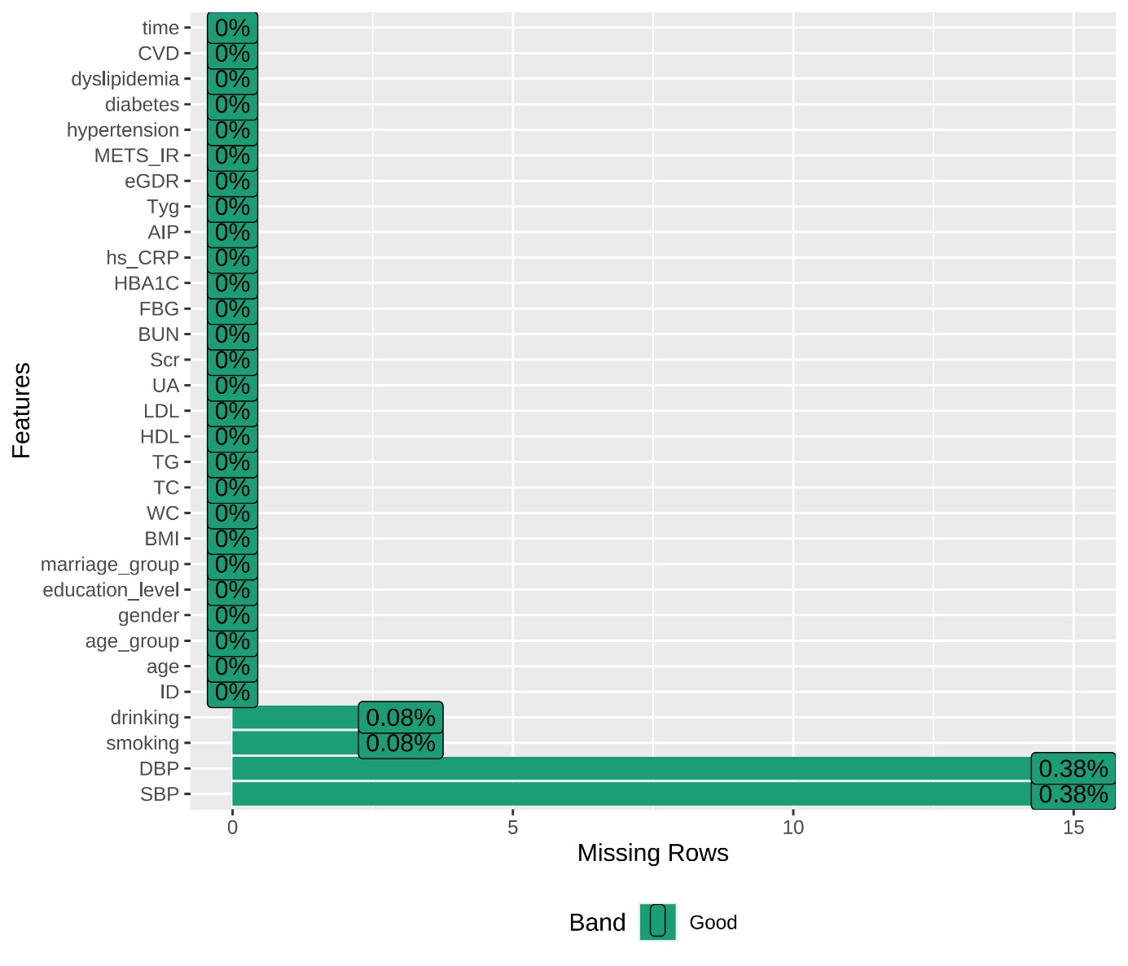

Fig.S2: Subgroup analyses for the association of combined adverse AIP and insulin resistance surrogate profiles with incident CVD.
