Table S1 Commercially cultivated varieties used in this study
No. | Commercially cultivated varieties
1 | Taiyou390
2 | Yuxiangliangyoufuxiangzhan
3 | Quanxiangyou822
4 | Wudayou No.2
5 | Yexiangyoubasi
6 | Chuxiangyou55
7 | Dafengyou101
8 | Fuxiangliangyouxiang99
9 | qingxiangyou19xiang
10 | Sixiangyou908
11 | Teyou3301
12 | Teyou458
13 | Teyou3550xuan
14 | Teyou138
15 | Teyou2068
16 | Shennongdao
17 | Guyou301
18 | Liuxiangyougongsixiang
19 | Jingqiyou
20 | Teyou506
21 | Teyou8009
22 | Teyou8087
23 | GUangliangxingui
24 | Teyou211
25 | Teyou600
26 | Daoxiangyou619
27 | 10Xiangyouyuxiang
28 | Teyou9516
29 | Genxiangyouyinzhan
30 | YLiangyou1173
31 | Fuxiangliangyou19xiang
32 | Lanxiangyouyusi
33 | Jingruanyoudaizhan
34 | Quanxiangyou136
35 | Guinongfeng
36 | Liuxiangyouzhaoxiangsimiao
37 | Guangliangxiangsi
38 | Quanyousimiao
39 | Wushansimiao
40 | Zhenyeyousimiao
41 | Yunliangyou332
42 | Zhenliangyouyuzhan
43 | Jingliangyouhuazhan
44 | Fuxiangsiliuxianger

Table S2 The prime used in this study
Gene | Prime F | Prime R
OsActin1 | TTCCAGCCTTCCTTCATA | AACGATGTTGCCATATAGAT
OsHMA1 | GGGCTAGGACTTATGGTTGC | CACATGAGCTTCCCTGTTGT
OsHMA2 | GGAGGTGTCAGAAGAGCTAC | TTGACGATTTGGGATTGGGA
OsHMA3 | GTCCTTCTTCGAGTGGCTCT | GGTGGTGAAGAGGAAGACGA
OsHMA4 | GTCCCTGTTGATGGTGTTGT | CTTCTGAACTGGAGCCCTTG
OsHMA5 | TGGAAGGCAGCAGCATAGAC | TGATGAGCCGTGGGATAACG
OsHMA6 | TGGCTCAATTGGAATGACTG | ACCTCAGCTCTAACATCCTC
OsHMA7 | GGTATCCAGGCAGACAAGGT | ACCAACACCTCCACCCATAG
OsHMA8 | TTGAAGCTCGCTGTGGATGT | CCCTTTGTTAGCGTCCCTGT
OsHMA9 | GTTGTGATTGCTTGCCCTTG | CCTTGTGTTAGTGTGCCTGT
OsZIP1 | TCTGTTTCCACTCCGTCTTT | GAATATCTTGTGCAGCCCGA
OsZIP2 | CACCGGCATCTTCATCTACG | AGGTGTCCCAGATCATGACG
OsZIP3 | CCAGTTCTTTGAAGGTGTAGG | CGGGTTATTGAAATCTGTTGCT
OsZIP4 | GCGACTTTCTTCTCCCTCAC | GGCAAGCAGAGACATCATCC
OsZIP5 | CAGGCAAAGTTCCGTGTCAG | CGCCATGTAGACGAGTATCC
OsZIP6 | GAGGAGGAAGCAGAAGATGG | GTCACCGAGAACATTACGCA
OsZIP7 | GGACGACAACGACAACAAGG | CATCTCAAGTATCTGCGACACC
OsZIP8 | CCTCAGCACGTCCATCGG | GGCCCTTCATGGATCCCAAA
OsZIP9 | CGCCTACAATGAGAATAGCC | TCAAGCCCAAATACCAAGCA
OsZIP10 | GGGAATTGTATCTCACTCGGTC | TAGCAAAGAAGAAAGCCATCAG
OsZIP11 | CACAACTCAGAAGATACAGCAG | GGAGGAATAAGGTGGTAAATAGAC
OsZIP12 | GAACCGCGTCGTCGTTCAG | CCATCCCCTCGAACATCTGG
OsZIP13 | CGGCATCGTGTCATCTCTCA | CCTCACCTTGAACTTCGCCT
OsZIP14 | CACCACCATCACCATGAACAC | CCTGGAAGAAGATTACTGGGAG
OsZIP15 | CGTTCCACACGCGGGGCAGCAAG | TGCGCCTTGGTGGTGTTACCG
OsZIP16 | ATTGGTGGCCTTAGCACCTC | AAGAAATGCCGCAGTACCCA
OsMTP11 | CACGCTCTGTCCCATGAAAA | GTTTCCTGACGAGCACCAG
OsMTP8.1 | CCAACCATGACCACCAACTT | GCACGTACTGTAGCACATCC
OsMTP9 | AGGCCGAGGTCTGAATTCTC | CACAGGGAAACGATGACTTGT
OsMTP1 | CATTCAGATTGAGCGCGAGT | AGTTGGTCCCATGAGATGAGA
OsMTP5 | ACCTGACCATCCAAACCGAT | ACTGCGAGAGTTTGATCTATCCT
OsMTP6 | TGGGCCAGCAAATTAAGCAA | TCAACCGTGACAGTGTAGCT
OsMTP7 | TGAAGCACACAACCCAGAAG | ACAGCAAGTGAGACCAATCG
OsMTP8 | GCGTGCTTTTGTTCATGTGG | TGCACAAGAGTAAAACTGGAGC
OsMTP11.1 | AGCTTACCTACCTGTGCTGG | ACAAAGTAGTGGGAGCCGAA
OsMTP12 | GGCACTTTTCACCTTCATATCAC | TCTTGAATCCCAGCCTCATGA
OsPCR1 | TGCAACACCTGTTGTATGGC | CGACGATTTCTGCGATCTGG
OsNRAMP1 | CATCGGCATCGTGCTGTTC | TGGCTACCTGTGCTTTCTCG
OsNRAMP5 | AGCAGCAGTAAGAGCAAGATGG | GGGGAGGTCGTTGTGGATG

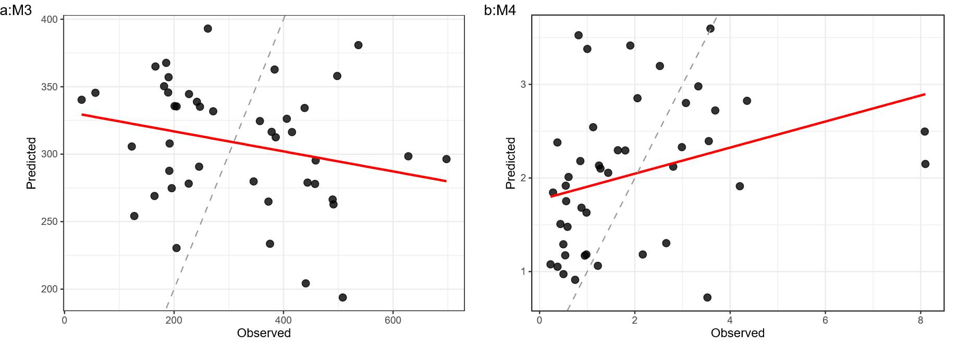
Figure S1. Observed versus predicted values for sensitivity models M1-alt and M2-alt. (a) M1-alt, in which the absolute shoot Cd concentration under Zn treatment (L Cd Conc_Z) was used as the response variable (OOB R² = 0.061, RMSE = 168.1 μg g⁻¹). (b) M2-alt, in which the absolute translocation factor under Zn treatment (TF_Z) was used as the response variable (OOB R² = 0.106, RMSE = 1.706). In both models, predictors were identical to those used in the primary classification models (M1 and M2), comprising baseline metal-status traits and Zn-induced physiological response variables. The lower predictive performance relative to the primary models is consistent with the greater background variance inherent in absolute endpoint values. Red lines indicate fitted regression lines; dashed lines indicate the 1:1 reference.

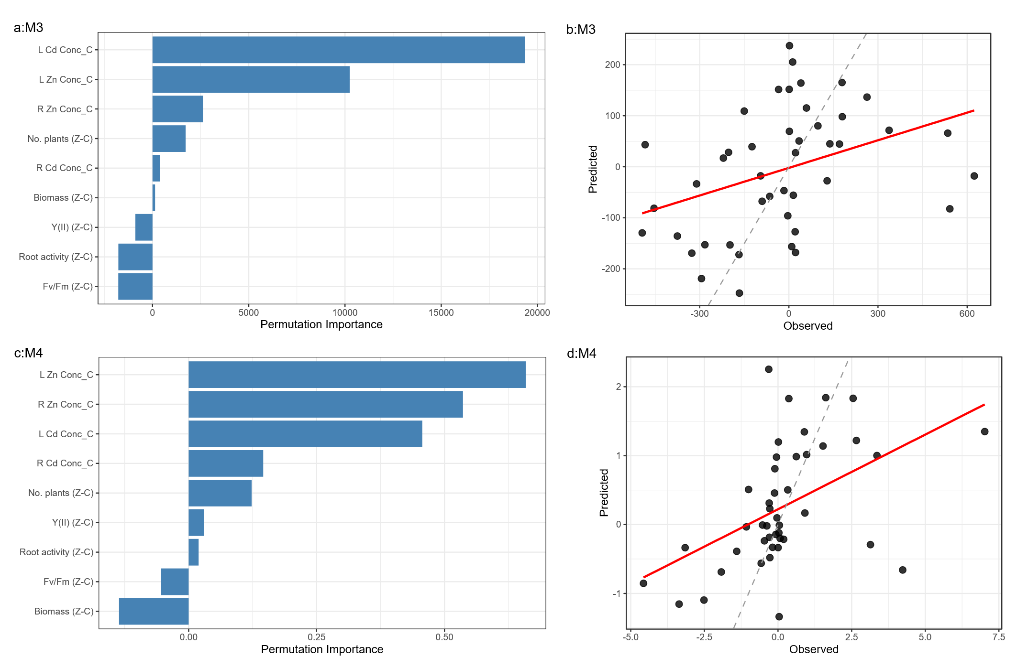
Figure S2. Variable importance and predictive performance of regression models M3 and M4. (a) Permutation importance rankings for M3 (ΔTotal Cd). (b) Observed versus predicted values for M3 (OOB R² = 0.138, RMSE = 233.0). (c) Permutation importance rankings for M4 (ΔTF). (d) Observed versus predicted values for M4 (OOB R² = 0.238, RMSE = 1.702). In both models, predictors comprised baseline metal-status traits and Zn-induced physiological response variables. Negative permutation importance values indicate variables whose inclusion degraded model predictions. Red lines indicate fitted regression lines; dashed lines indicate the 1:1 reference.

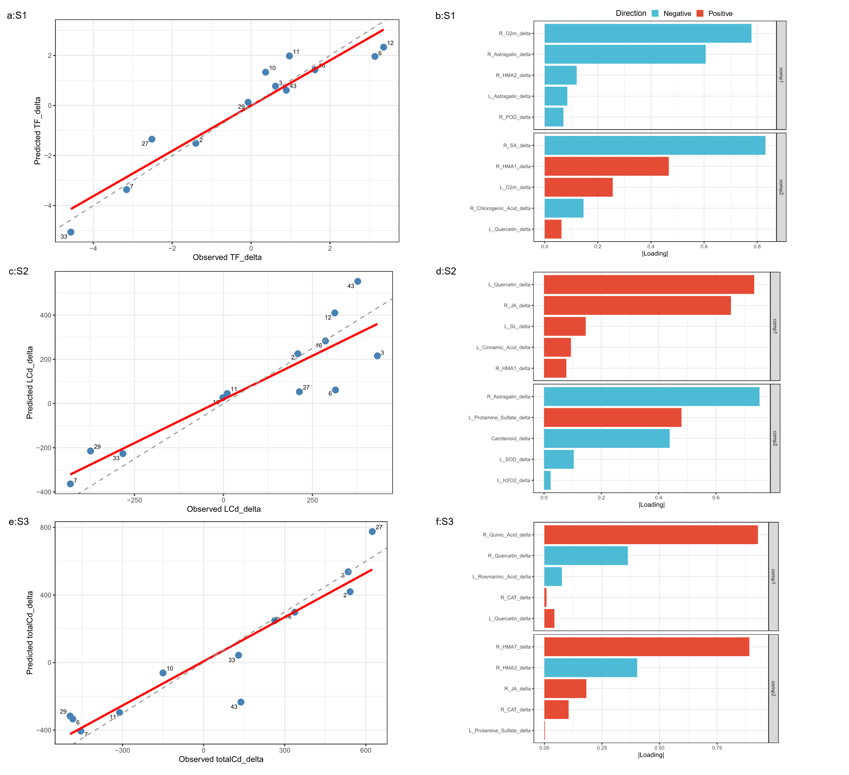
Figure S3. Observed-versus-predicted relationships and comp1 loading structures of the three sPLS models.
(a) Observed versus predicted values for S1 (TF_delta; R² = 0.871, RMSE = 0.836). (b) Non-zero comp1 loadings of the five retained variables in S1. (c) Observed versus predicted values for S2 (LCd_delta; R² = 0.896, RMSE = 93.647). (d) Non-zero comp1 loadings of the five retained variables in S2. (e) Observed versus predicted values for S3 (totalCd_delta; R² = 0.868, RMSE = 146.367). (f) Non-zero comp1 loadings of the five retained variables in S3. All models were fitted using 12 selected cultivars with two latent components.

Table S3. Two-way ANOVA results for selected follow-up traits
Variable | Effect | df | F | p value | q value | Sig.
L Cd Conc | Cultivar | 43 | 68.69 | 2.083e-89 | 2.916e-89 | ***
L Cd Conc | Treatment | 1 | 0.04 | 0.8317 | 0.8317 | ns
L Cd Conc | Cultivar × Treatment | 43 | 40.56 | 4.489e-71 | 7.855e-71 | ***
R Cd Conc | Cultivar | 43 | 218.27 | 9.595e-132 | 6.716e-131 | ***
R Cd Conc | Treatment | 1 | 36.12 | 1.042e-08 | 1.823e-08 | ***
R Cd Conc | Cultivar × Treatment | 43 | 46.86 | 5.226e-76 | 1.219e-75 | ***
L Zn Conc | Cultivar | 43 | 86.40 | 1.256e-97 | 2.198e-97 | ***
L Zn Conc | Treatment | 1 | 7.34 | 0.0074 | 0.0104 | *
L Zn Conc | Cultivar × Treatment | 43 | 54.82 | 1.879e-81 | 1.315e-80 | ***
R Zn Conc | Cultivar | 43 | 104.81 | 1.236e-104 | 4.326e-104 | ***
R Zn Conc | Treatment | 1 | 52.84 | 1.138e-11 | 3.981e-11 | ***
R Zn Conc | Cultivar × Treatment | 43 | 53.44 | 1.465e-80 | 5.126e-80 | ***
Biomass (g) | Cultivar | 43 | 97.31 | 6.187e-102 | 1.444e-101 | ***
Biomass (g) | Treatment | 1 | 72.39 | 7.471e-15 | 5.229e-14 | ***
Biomass (g) | Cultivar × Treatment | 43 | 18.94 | 1.189e-46 | 1.665e-46 | ***
Fv/Fm | Cultivar | 43 | 3.01 | 1.932e-07 | 1.932e-07 | ***
Fv/Fm | Treatment | 1 | 6.63 | 0.0108 | 0.0126 | *
Fv/Fm | Cultivar × Treatment | 43 | 4.42 | 1.318e-12 | 1.318e-12 | ***
Y (II) | Cultivar | 43 | 32.42 | 1.407e-63 | 1.642e-63 | ***
Y (II) | Treatment | 1 | 46.24 | 1.565e-10 | 3.653e-10 | ***
Y (II) | Cultivar × Treatment | 43 | 13.58 | 4.065e-37 | 4.742e-37 | ***
Notes: P values and Benjamini–Hochberg-adjusted q values are shown for Cultivar, Treatment, and Cultivar × Treatment effects.Two-way ANOVA was performed for each variable with Cultivar, Treatment, and Cultivar × Treatment as fixed effects. Q values were obtained by Benjamini–Hochberg correction applied within each effect category.

Table S4

