Graphical Abstract:

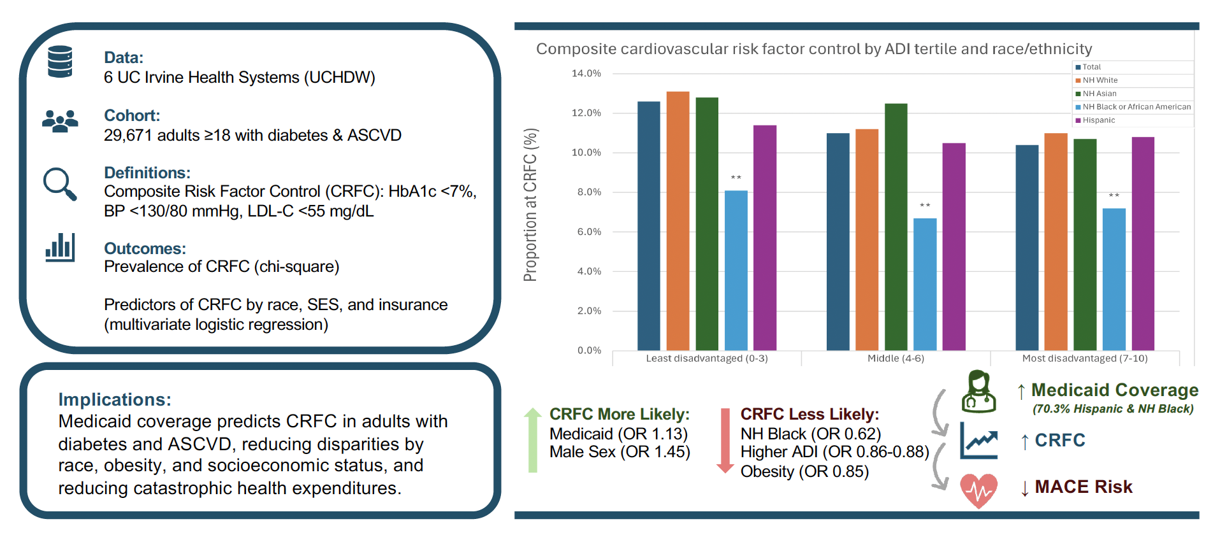
Graphical Abstract Legend:
Graphical Abstract Legend. Abbreviations: ASCVD Atherosclerotic Cardiovascular Disease; HbA1c Hemoglobin A1c; BP Blood Pressure; LDL-C Low Density Lipoprotein Cholesterol; NH Non-Hispanic; MACE Major Adverse Cardiovascular Event

