Supplementary material

Descriptive statistics of the study data
Supplementary table 1. Individual risk factors included in the different risk scores (LIBRA, pPREDICT, ModiCogPD) Numerical variables are reported as mean and SD, together with minimum and maximum values (Min–Max). Categorical and ordinal variables are described by count (n) and percentage. *For these variables we present the percentage of people who present the risk vs those who don't present the risk. Risk Definition appears in table 1.*For these variables we present the percentage of people who present the risk vs those who don't present the risk. Risk Definition appears in table 1.
Risk Factor | Control (n=230) Mean (SD); min-max or n (%) | PD group (n=201) Mean (SD); min-max or n %
age at assessment | 58.02 (11.14); 22–81 | 64.25 (10.38); 38–89
Sex | 1.49 (0.50); 1–2 | 0.29 (0.45); 0–1
Years of education that were completed | 14.40 (3.61); 6–24 | 13.84 (3.63); 6–26
Disease Duration | 4.43 (0.29); 0–4 | 4.59 (4.97); 0–29
Total_MoCA_score | 28.24 (1.46); 22–30 | 25.86 (2.80); 18–30
RBDSQ | 2.53 (2.28); 0–12 | 4.33 (3.06); 0–12
UPDRS- Total Score Part III | 3.05 (4.27); 0–30 | 29.92 (13.69); 3–75
BDI-I Total score | 5.43 (5.02); 0–29 | 8.96 (6.36); 0–45
Anxiety disorder | 0.02 (0.15); 0–1 | 0.16 (0.37); 0–1
BMI | 26.49 (4.73); 12–45 | 27.83 (4.64); 16–50
Vigorous physical activity* | No: 161 (69.87%)  Yes: 69 (30.13%) | No: 147 (73.13%)  Yes: 54 (26.87%)
Moderate physical activity* | No: 201 (87.33%)  Yes: 29 (12.67%) | No: 182 (90.55%)  Yes: 19 (9.45%)
Vascular risk factor* | No: 161 (70%)  Yes: 69 (30%) | No: 107 (53.23%)  Yes: 94 (46.77%)
SAS - Total score | 4.59 (4.40); 0–26 | 12.99 (5.35); 1–33
UPDRS- Total Score for Part I | 0.90 (1.89); 0–15 | 9.54 (6.70); 0–39
UPDRS- Total Score for Part II | 0.00 (0.00); 0–0 | 9.85 (6.62); 0–31
UPDRS- Total Score Part IV | 0.29 (0.45); 0–1 | 1.98 (3.42); 0–16
Family History of Parkinson's Disease | No: 161 (71.24%)  Yes: 65 (28.76%) | No: 140 (69.65%)  Yes: 61 (30.35%)
Family History of Dementia | No: 149 (66.22%)  Yes: 76 (33.78%) | No: 150 (74.63%)  Yes: 51 (25.37%)
Sniffin | 6.47 (2.58); -5.47-13.65 | 3.079 (3.40); -4.41-11.95
Caffeine consumption* | No: 9 (3.91%)  Yes: 221 (96.09%) | No: 20 (9.95%)  Yes: 181 (90.05%)
Alcohol consumption* | No: 27 (11.74%)  Yes: 203 (88.26%) | No: 22 (10.95%)  Yes: 179 (89.05%)
Smoking* | No: 112 (48.70%)  Yes: 118 (51.30%) | No: 92 (45.77%)  Yes: 109 (54.23%)
Contusion* | No: 170 (73.80%)  Yes: 60 (26.20%) | No: 149 (74.13%)  Yes: 52 (25.87%)
Pesticides exposition* | No: 72 (31.30%)  Yes: 158 (68.70%) | No: 133 (66.17%)  Yes: 68 (33.83%)
Toxics expositions* | No: 171 (74.35%)  Yes: 59 (25.65%) | No: 119 (59.20%)  Yes: 82 (40.80%)
Marital status* | No: 170 (73.80%)  Yes: 60 (26.20%) | No: 161 (80.01%)  Yes: 40 (19.99%)
Number of children | 1.71 (1.13); 0–5 | 1.86 (1.18); 0–6
Total number of languages spoken | 3.62 (0.74); 1–4 | 3.01 (1.00); 1–4
Diabetes - Medical History* | No: 222 (96.52%)  Yes: 8 (3.48%) | No: 183 (91.05%)  Yes: 18 (8.96%)
Tremor/PIGD phenotype | 0.46 (0.60); 0–3 | 1.48 1.62); 0–8

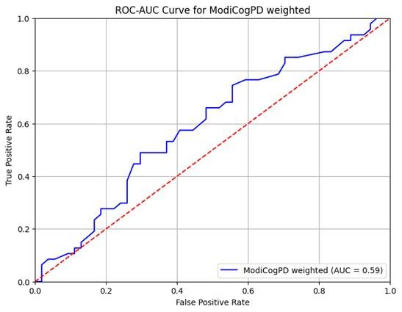
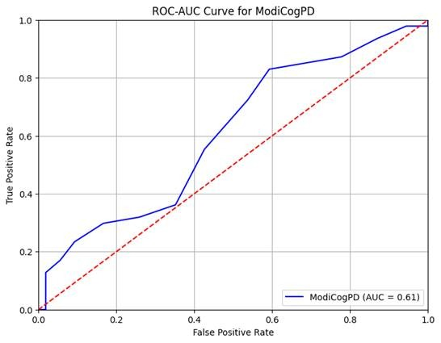
Supplementary Figure 1. Receiver operating characteristic (ROC) curves analysis for the weighting procedure.
ROC curves illustrating the discriminative performance of the two tools. (A) ROC curve for the weighted ModiCogPD. (B) ROC curve for ModiCogP. The area under the curve (AUC) is reported for both cases.
Supplementary Table 2. Results of the multivariable LR analysis used to derive the weighted risk score.
For each subitem of the ModiCogPD risk score, the regression coefficient (β), odds ratio (OR), and the corresponding integer weight assigned to the risk score are presented.
Feature | Coefficient (β) | Odds Ratio (OR) | Weight
Age at assessment | 1.36 | 3.9 | 17
Sex | 0.7 | 2.01 | 9
Years of education that were completed | 0.25 | 1.29 | 3
Disease Duration | 0.13 | 1.14 | 2
RBDSQ | 0.75 | 2.12 | 9
MDS-UPDRS - Total Score Part III | 0.21 | 1.24 | 3
BDI-I - Total score | 0.23 | 1.25 | 3
Anxiety disorder | -0.61 | 0.55 | 8
BMI | -0.35 | 0.7 | 4
Vigorous physical activity | 0.56 | 1.74 | 7
Moderate physical activity | -0.33 | 0.72 | 4
Vascular risk factor | 0.36 | 1.44 | 4
SAS - Total score | 0.58 | 1.79 | 7
MDS-UPDRS - Total Score for Part I | -0.3 | 0.74 | 4
MDS-UPDRS - Total Score for Part II | 0.2 | 1.22 | 2
MDS-UPDRS - Total Score Part IV | -0.03 | 0.97 | 0
Family History of Parkinson's Disease | 0.18 | 1.19 | 2
Family History of Dementia | -0.12 | 0.89 | 2
Sniffin Sticks | 0.97 | 2.63 | 12
Caffeine consumption | -0.39 | 0.68 | 5
Alcohol consumption | 0.92 | 0.4 | 12
Smoking | 0.41 | 1.51 | 5
Concussion | -0.03 | 0.97 | 0
Pesticides exposition | -0.2 | 0.82 | 2
Toxics expositions | 0.02 | 1.02 | 0
Marital status | -0.0 | 1.0 | 0
Number of children | -0.45 | 0.64 | 6
Total number of languages spoken | -0.09 | 0.91 | 1
Diabetes - Medical History | 0.17 | 1.18 | 2
Tremor/PIGD phenotype | -0.08 | 0.92 | 1

Predictive strength on the posterior cognitive decline trajectories

Supplementary Table 3. Hazard ratios for deterioration of CI estimated from Cox proportional-hazards models.

Hazard ratio (HR) estimates with the corresponding 95% confidence intervals and p-values are shown for the association between the baseline risk scores (LIBRA, pPREDICT, and ModiCogPD) and the risk of cognitive decline in two different populations: 1) newly diagnosed PwPD (n = 90) and 2) global PwPD population (n = 192) . Each model was adjusted for age, sex, years of education, and baseline MoCA score. Participants with cognitive performance below the specified threshold at baseline were excluded from the analyses. Highlighted HR showed a statistically significant association with the event (newly diagnosed PwPD: MoCA score < 26 and global PwPD population: MoCA score ≤21).
Variables | LIBRA  HR [95% interval], p-value |  | pPREDICT  HR [95% interval], p-value |  | ModiCogPD  HR [95% interval], p-value
Variables | Newly Diagnosed PwPD | Global PwPD population | Newly Diagnosed PwPD | Global  PwPD population | Newly Diagnosed PwPD | Global  PwPD population
Age | 1.026 [0.996-1.057], 0.086 | 1.02 [0.97-1.088] 0.34 | 1.026  [0.995-1.058]  0.1 | 1.03  [0.97-1.089]  0.31 | 1.024  [0.99-1.056]  0.13 | 1.027  [0.97-1.09]  0.38
Sex | 0.92  [0.49- 1.72] 0.80 | 0.42  [0.15-1.17] 0.096 | 0.90  [0.48-1.71]  0.75 | 0.44  [0.16-1.20]  0.11 | 0.90  [0.48- 1.69]  0.74 | 0.38  [0.13-1.05]  0.062
Years of  Education | 0.98  [0.85- 1.032] 0.19 | 0.65 [0.55-0.77] 0.027 | 0.94  [0.85-1.037]  0.22 | 0.63  [0.74-0.99]  0.043 | 0.93  [0.85- 1.027]  0.16 | 0.60  [0.49-0.72]  0.029
Baseline MoCA | 0.77  [0.69- 0.87] 0.0001 | 0.85 [0.74-0.98] 0.0001 | 0.80  [0.71-0.89]  .0001 | 0.86  [0.53-0.75]  0.0001 | 0.79  [0.71- 0.89] 0.0001 | 0.85  [0.73-0.98]  0.0001
Baseline total risk score | 1.14 [1.005-1.28] 0.042 | 1.03 [0.85-1.25] 0.77 | 1.11  [0.96-1.28]  0.15 | 1.25  [1.0056-1.56] 0.0445 | 1.03  [0.95- 1.12]  0.47 | 1.25  [1.08-1.43]  0.002

