Supplementary Information for
Disentangling feed conversion efficiency and feed sourcing in global livestock water footprint trends, 1972–2023

Content:
Supplementary Methods
Supplementary Fig. S1 and Fig. S2
Supplementary Methods
S1. Water footprint accounting framework
We estimate the water footprint (WF) of livestock products following the Water Footprint Assessment manual (Hoekstra et al., 2011). We consider seven farm animal categories: beef cattle, dairy cattle, pigs, sheep, goats, broiler chickens, and layer chickens.
The WF of a live animal comprises (i) the indirect WF of feed and (ii) the direct WF from drinking and service water (e.g., cleaning the farmyard, washing animals, and other hygiene/maintenance uses) (Chapagain and Hoekstra, 2003; Hoekstra et al., 2011; Mekonnen and Hoekstra, 2012).
We express the WF of animal category a in country c as:
${WF}_{a,c}=WF_{feed,a,c}+WF_{drink,a,c}+WF_{serv,a,c}$ (S1)

where WF_{feed,a,c}, WF_{drink,a,c} and WF_{serv,a,c} denote feed, drinking, and service WFs, respectively.
The feed-related WF equals the sum over all feed ingredients plus the water used to mix feed:

$WF_{feed,a,c}=\sum_{p=1}^{n}{\left({Feed}_{a,c,p}×{WF}_{p,c}^{*}\right)+WF_{mixing,a,c}}$ (S2)

where Feed_{a,c,p} represents the annual quantity of ingredient p consumed per animal of category a in country c (t DM animal⁻¹ yr⁻¹), ${WF}_{p,c}^{*}$ is the unit WF of feed p in country c (m³ t⁻¹), and WF_{mixing,a,c} the water used to mix feed (m³ animal⁻¹ yr⁻¹).
S2. Feed requirements and feed composition
S2.1 Feed conversion ratios
We derived global average FCRs for 2015 by combining livestock feed intake per animal from FAO’s Global Livestock Environmental Assessment Model (GLEAM) (FAO, 2022) and FAOSTAT animal output for the same year (FAO, 2025). Specifically, for each animal category a, we compute FCR_{a,c,y} (t DM per t output):
${FCR}_{a,FAO, 2015}=\frac{\sum{{Feed}_{a,c,2015}}}{\sum{P_{a,c,2015}}}$ (S3)
where Feed_{a,c,2015} is feed use (t DM animal⁻¹ yr⁻¹) and P_{a,c,2015} livestock output (t animal⁻¹ yr⁻¹) per animal of category a in country c for the year 2015. We then extend FCRs to 1972-2023 by scaling the 2015 global average using the ratio of per-animal outputs (country-year vs global-2015):
${FCR}_{a,c,y}=\frac{{PO}_{a,global,2015}}{{PO}_{a,c,y}}×{FCR}_{a,FAO,2015} y ϵ [1972,2023]$ (S4)
Here, PO_{a,c,y} and PO_{a,global,2015} are per-animal outputs (kg meat/milk/egg per animal per year) for animal a in country c, year y, and global average for 2015, respectively. Equation (S4) preserves observed cross-country and temporal variation in per-animal productivity and maps it to FCR trajectories anchored at the 2015 global average. Per-animal outputs were obtained from FAOSTAT (FAO, 2025).
S2.2 Total feed requirements
Annual feed per animal is:
${Feed}_{a,c,y}={FCR}_{a,c,y}×P_{a,c,y}$ (S5)
where P_{a,c,y} is annual animal output (t animal⁻¹ yr⁻¹).
S2.3 Feed composition and FAO FBS reconciliation
The GLEAM dashboard provides 2015 feed composition (Composition_{a,r,y}) per animal and country across categories (e.g., grains, crop residues, grass/leaves, fodder crops, oilseed cakes, by-products, other edible/non-edible feeds). We derived the share of each feed in the total feed basket for 2015 and used this share to allocate the total feed obtained in equation (S5) across ingredients in each country and year:
${Feed}_{p,a,c,y}={Feed}_{a,c,y}×{Composition}_{p,a,c,2015}$ (S6)
where Feed_{p,a,c,y} is ingredient-specific feed (t DM animal⁻¹ yr⁻¹) total and Composition_{p,a,c,2015} is the 2015 share of ingredient p in the feed basket for animal a in country c. We treat the 2015 feed composition shares as the baseline, but update the relative shares of concentrate vs. non‑concentrate components each year using the FAO FBS concentrates reconciliation.
FAO FBS report concentrate feeds by country and year in aggregated groups (e.g., wheat and products, maize and products, soybean, and other crops). To stay consistent with FBS reporting, we replace the grains estimated by equation (S6) with FBS-based concentrate quantities. This can create an imbalance relative to the total feed estimated using equation (S5). We, therefore adjust the non-grain feed proportionally up or down so that the ingredient totals exactly sum to Feed_{a,c,y} in (S5). This ensures mass balance between (i) FCR-based totals and (ii) ingredient-level allocations consistent with FBS aggregates.
S3. Water footprints of feed and livestock products
Because animal feed in a country is sourced from both domestic production and imports, the water footprint of animal feed was calculated as a weighted average based on the relative volumes of domestically produced and imported feed:
${WF}_{p,c}^{*}=\frac{P_{p}×{WF}_{p}+\sum_{e}{{(T}_{i,e,p}}×{WF}_{p,e})}{P_{p}+\sum_{e}{T_{i,e,p}}}$ (S7)
where P_{p} is the production quantity of feed product p in a country (t yr⁻¹); WF_{p} is the WF of feed product p produced domestically (m³ t⁻¹); T_{i,e,p} is the imported quantity of feed product p from exporting country e (t yr⁻¹); and WF_{p,e} is the WF of feed product p as in the exporting country e (m³ t⁻¹).
Feed production and import were obtained from FAOSTAT (FAO, 2025). Crop-specific unit WF of feed products (WF_{p}) were taken from Demeke et al (2026), which provide gridded estimates for the period 1972-2018. To extend these water footprint estimates to 2023, we assumed constant crop evapotranspiration based on the 2014–2018 climatological mean and updated unit water footprints using annual crop yields for 2019–2023 from FAOSTAT, thereby capturing recent productivity changes while preserving the spatial patterns of crop water use.
S4. Partitioning sustainable and unsustainable blue water footprints of feed crops
To estimate sustainable and unsustainable blue water footprints of feed crops, we combined gridded monthly crop-specific blue WF maps (Demeke et al., 2026) with irrigation source attribution from CWatM (Burek et al., 2020; Wolkeba et al., 2024). For each crop, grid cell, and month, the crop’s blue WF was partitioned according to the CWatM fractions of irrigation supplied by surface water and by groundwater, with the groundwater component further separated into sustainable groundwater and groundwater depletion/overdraft. This yields three source-specific components of crop blue WF (surface, sustainable groundwater, and depletion/overdraft groundwater), consistent across space and time.
We then split the surface-water component into sustainable versus unsustainable using the monthly gridded blue water scarcity product from Wolkeba et al. (2024): surface-water blue WF was classified as unsustainable where blue water scarcity > 1, reflecting conditions in which local blue consumptive use exceeds locally available blue water (natural runoff minus environmental flow requirements). Total unsustainable blue WF for each crop is the sum of (i) the surface-water blue WF occurring under blue water scarcity > 1 and (ii) the groundwater depletion/overdraft component; the remaining components constitute sustainable blue WF. These crop-level components were subsequently aggregated to country totals and incorporated into the livestock feed-basket accounting
S5. Attribution of temporal changes
Rationale and Data: To identify the main determinants of the unit water footprint (WF; m³ t⁻¹ product) of livestock commodities, we used a country–year panel (1972–2023) reporting, for each livestock product: (i) weighted average feed water footprints (green and blue; m³ t⁻¹ feed), (ii) unit WFs of livestock products (green and blue), (iii) feed conversion ratios (FCR; t dry matter feed t⁻¹ product), and (iv) the share of concentrates (0–1) in the ration. Weighted feed WFs are already aggregated over all feedstuffs consumed by each livestock type in each country, enabling direct attribution of product WFs to feed efficiency, feed composition, and the water intensity of feed sourcing.
Model Specification: For each livestock product (Dairy, Egg, Cattle, Sheep, Goat, Pig, Chicken), we estimated separate log–linear models for green and blue unit WFs:
$ln⁡({\text{WF}}_{c,t,i})=α_{i}+β_{1}ln⁡({\text{FCR}}_{c,t,i})+β_{2}ln⁡({\text{FeedWF}}_{c,t,i})+β_{3}{\text{Conc}}_{c,t,i}+ε_{c,t,i}$ (S8)
where c indexes countries, t years, and i livestock product codes. Coefficient β₁ captures the elasticity of product WF with respect to feed requirements; β₂ reflects the elasticity with respect to the water intensity of the feed basket; and β₃ is the semi-elasticity associated with the concentrate fraction, controlling for FCR and feed WF. Only complete and positive observations were retained.

SI References

Burek, P., Satoh, Y., Kahil, T., Tang, T., Greve, P., Smilovic, M., Guillaumot, L., Zhao, F., Wada, Y. (2020) Development of the Community Water Model (CWatM v1.04) – a high-resolution hydrological model for global and regional assessment of integrated water resources management. Geosci. Model Dev. 13, 3267-3298.
Chapagain, A.K., Hoekstra, A.Y. (2003) Virtual water flows between nations in relation to trade in livestock and livestock products. Water Res. Rep. Ser. 13.
Demeke, B.W., Mekonnen, M.M., Brauman, K.A., Magliocca, N., Moradkhani, H. (2026) Global spatially detailed water footprint of crop production over five decades (accepted). Scientific Reports.
FAO, (2022) GLEAM 3 Dashboard. In: Shiny Apps. FAO, Rome, Italy.
FAO, (2025) FAOSTAT online database. FAO, Rome.
Hoekstra, A.Y., Chapagain, A.K., Aldaya, M.M., Mekonnen, M.M. (2011) The water footprint assessment manual: Setting the global standard. Earthscan, London, UK.
Mekonnen, M.M., Hoekstra, A.Y. (2012) A Global Assessment of the Water Footprint of Farm Animal Products. Ecosystems 15, 401-415.
Wolkeba, F.T., Mekonnen, M.M., Brauman, K.A., Kumar, M. (2024) Indicator metrics and temporal aggregations introduce ambiguities in water scarcity estimates. Scientific Reports 14, 15182.

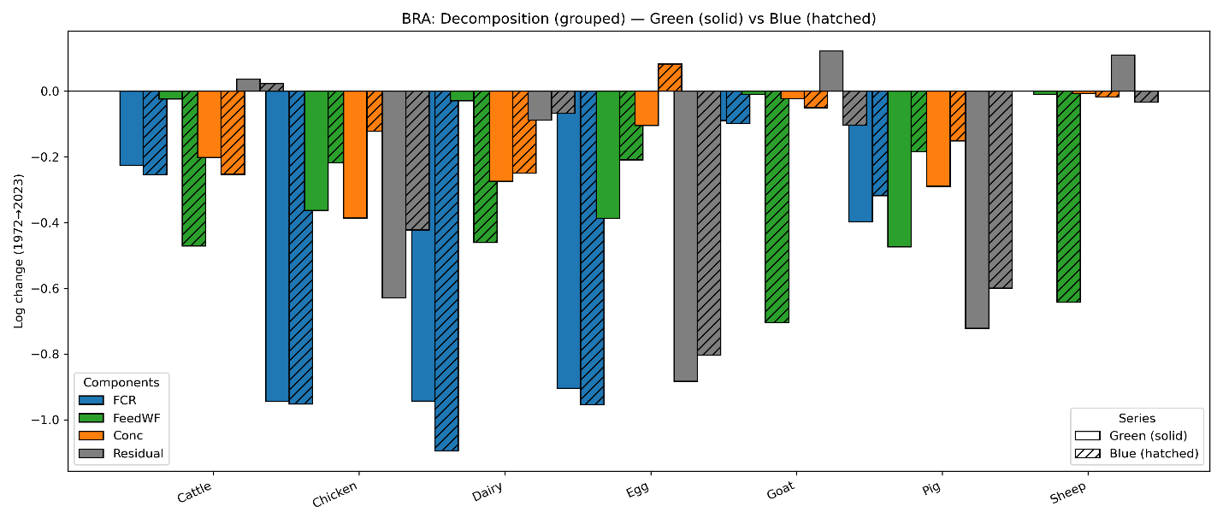
a) Brazil

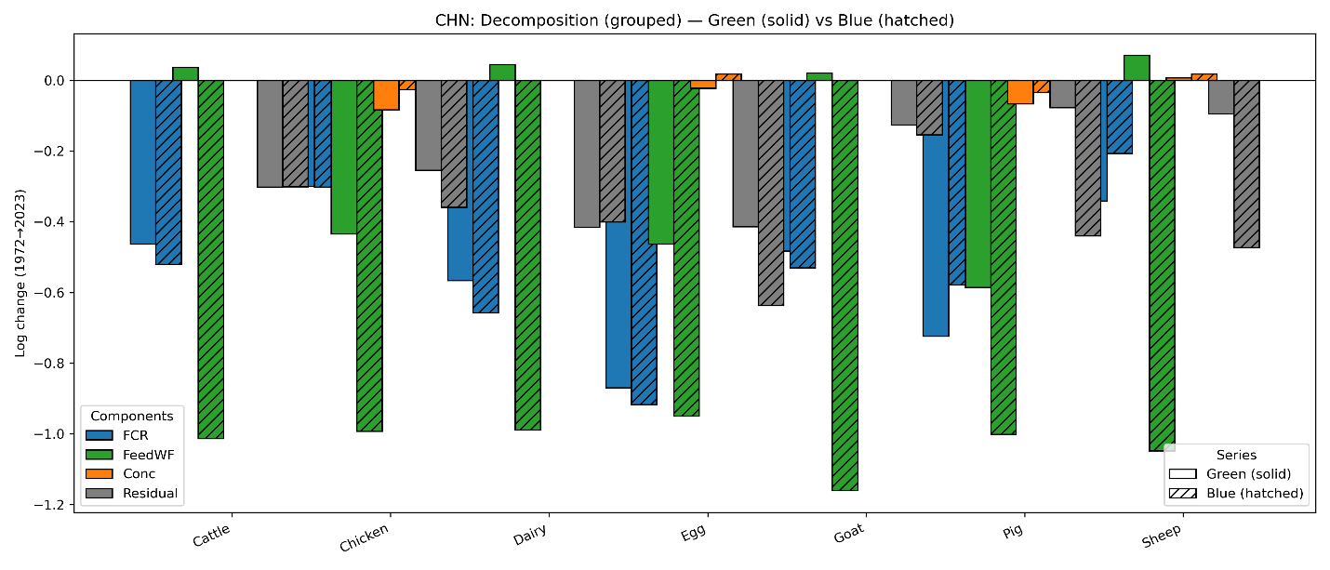
b) China
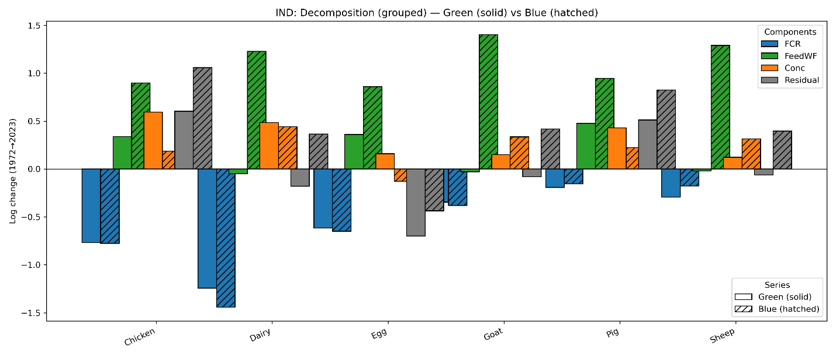
c) India

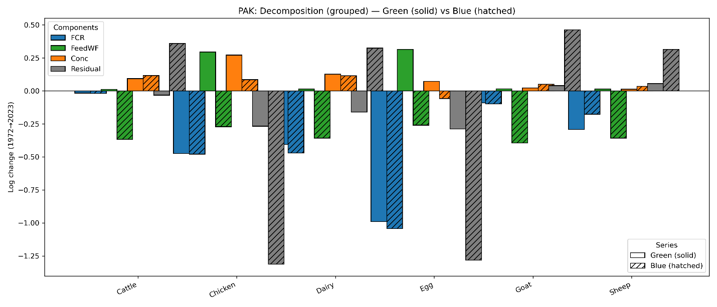
d) Pakistan

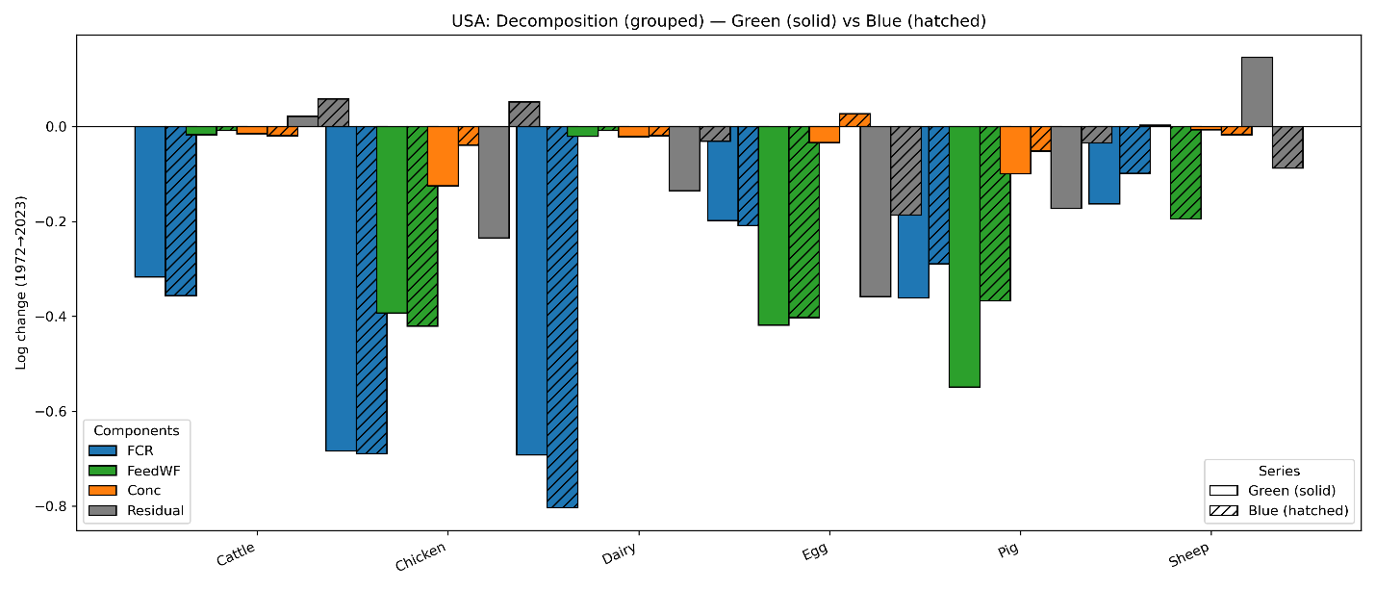
e) USA

Fig. S1: Decomposition of unit water footprint (WF) change from 1972 to 2023 for Brazil (a), China (b), India (c), Pakistan (d), and USA (e) showing contributions from feed conversion ratio (FCR), weighted feed water footprint (FeedWF), concentrate share (Conc), and the residual term. Green WF contributions are shown with solid bars and Blue WF with hatched bars. Exact numerical log‑point contributions corresponding to each bar appear in Table S6.

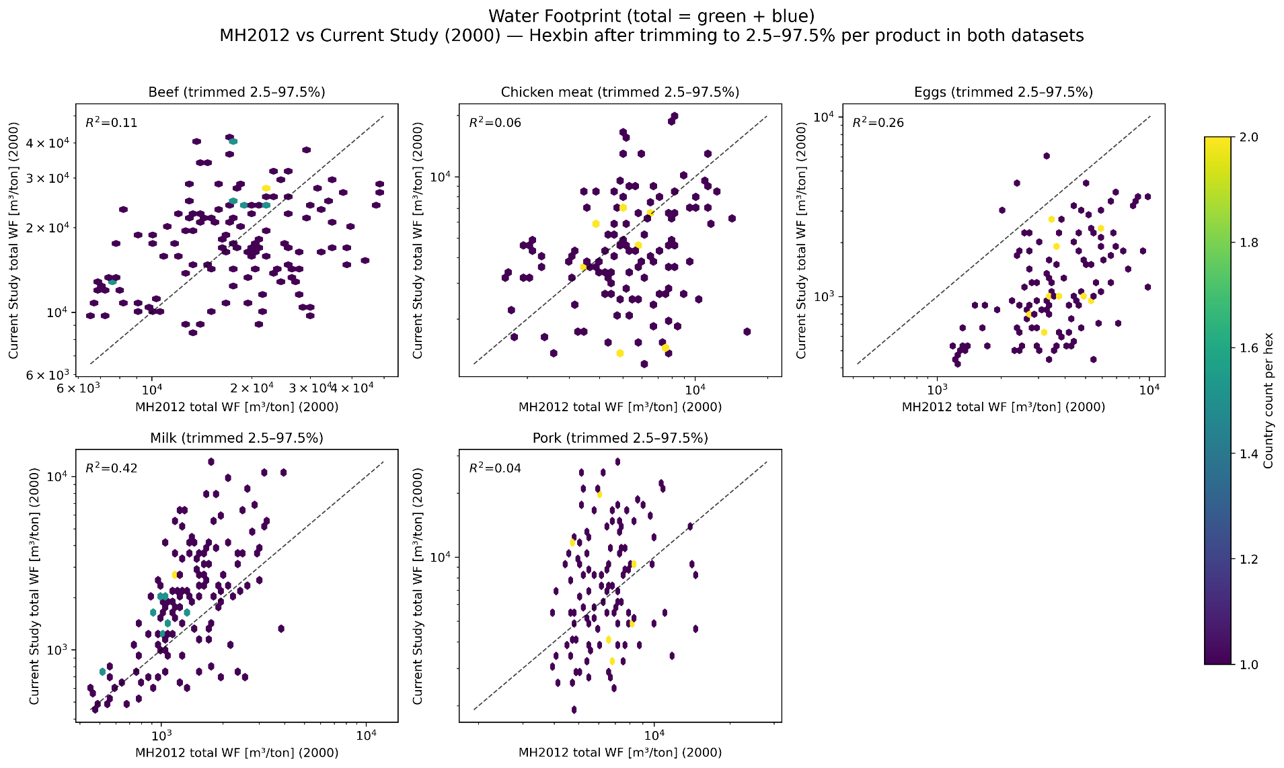
Fig. S2: Country level consumptive water footprint (green + blue, m³ ton⁻¹) of major livestock products, comparing Mekonnen and Hoekstra (2012) with values from the Current Study. Each point represents country data for each livestock product (beef, chicken meat, eggs, milk, pork). The dashed line denotes the 1:1 relationship. Results illustrate the systematic differences between the original global estimates of Mekonnen & Hoekstra and the updated values produced by the Current Study.

