Supplementary File 1: Sample Fabrication
The support insertion and its configuration are shown in Fig. S1.1.

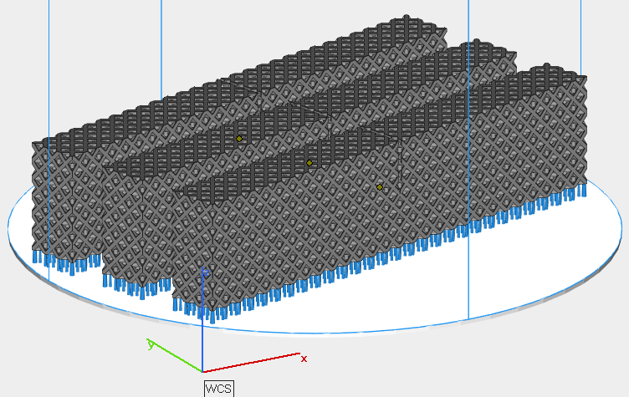
Fig. S1.1. Demonstration of the support structure added when fabricating the specimens.

The gas flow and recoater directions while manufacturing the specimens are shown in Fig. S1.2.

Gas Flow Direction | 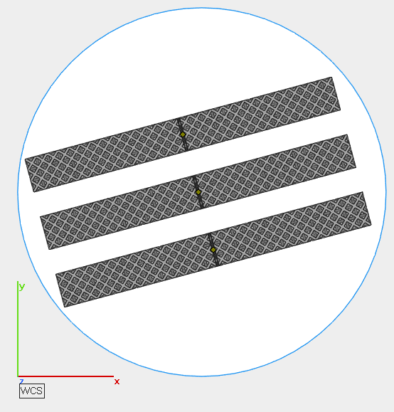
 | Recoater Direction
Fig. S1.2. Demonstration of gas flow and recoater directions while manufacturing the specimens.

The three lattice SENB specimens after fabrication are shown in Fig. S1.3. It can be seen that the support structures have not been removed yet.

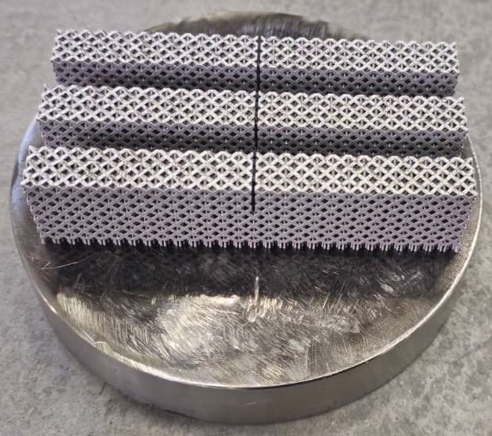
Fig. S1.3. Demonstration of specimens after fabrication, prior to removing the support structures.

