Supplementary Material

Supplementary Figures

Supplementary Figure 1. ALK FISH analysis in STRN::ALK-positive tumors.
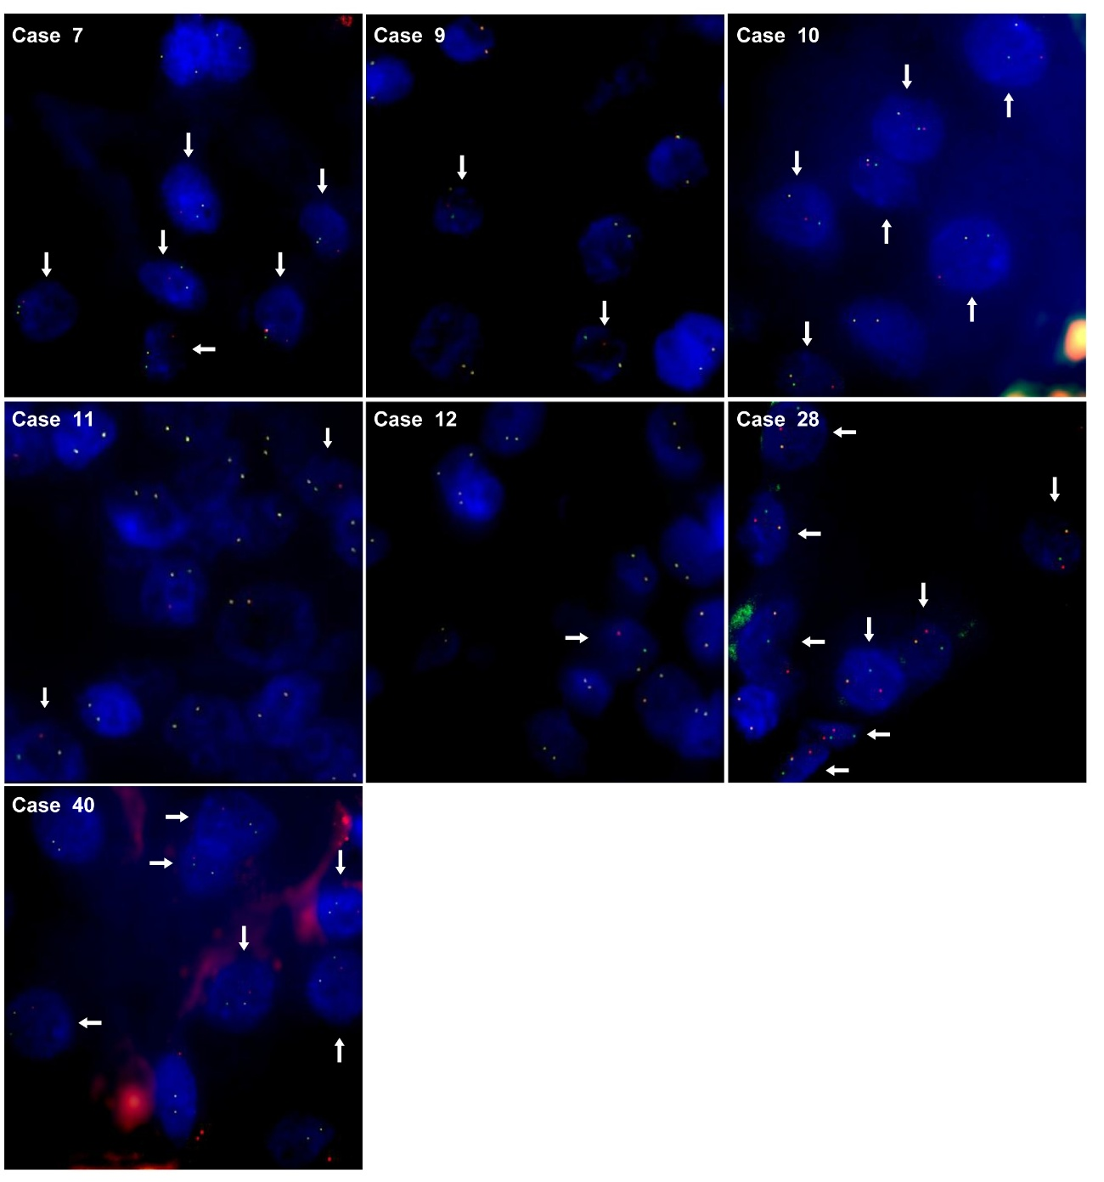
Representative dual-color break-apart FISH images for all STRN::ALK-positive tumors included in this study. Each panel shows tumor nuclei with split red and green signals indicating ALK rearrangement and fused yellow signals corresponding to intact alleles. Case 10 harbors the canonical STRN::ALK fusion, whereas Cases 7, 9, 11, 12, 28, and 40 correspond to out-of-frame variants.
Supplementary Figure 2. ALK immunohistochemistry in STRN::ALK-positive tumors (original magnification ×200).
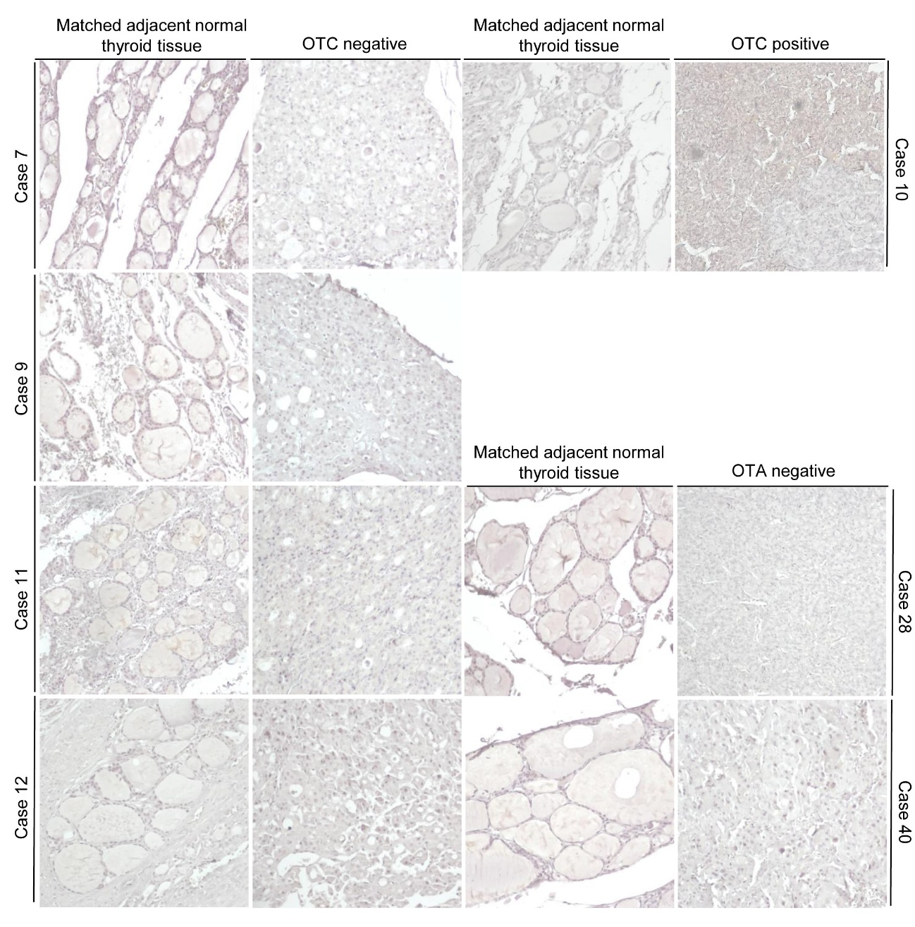
Representative ALK immunohistochemistry images for all STRN::ALK-positive tumors. Positive cytoplasmic staining is observed exclusively in the canonical fusion (Case 10), whereas out-of-frame variants (Cases 7, 9, 11, 12, 28, and 40) show no detectable ALK expression. Adjacent normal thyroid tissue is negative in all cases.
Supplementary Tables
Supplementary Table 1. Physicochemical properties of predicted STRN::ALK protein variants.

 | Canonical | Type I | Type II
Number of amino acids | 700 | 685 | 145
Molecular weight | 77524.51 | 75651.35 | 15951.02
Theoretical pI | 7.87 | 7.23 | 9.17
Total number of negatively charged residues (Asp + Glu) | 78 | 77 | 17
Total number of positively charged residues (Arg + Lys) | 80 | 77 | 21
Formula | C3441H5396N962O1014S33 | C3357H5267N937O992S32 | C702H1103N213O206S4
Total number of atoms | 10846 | 10585 | 2228
The estimated half-life | 30 hours | 30 hours | 30 hours
The instability index | 49.11 | 47.53 | 29.34
Aliphatic index | 73.90 | 74.53 | 70.28
Grand average of hydropathicity (GRAVY) | -0.488 | -0.469 | -0.610
Cases with this protein conformation | 5 and 10 | 4, 9, 11, and 12 | 7, 28, and 40

