Appendices for “Who Are Small Donors?”

Appendix A: Catalist Validation
Most of our analyses comparing non-donors with small and higher-dollar donors rely on survey data collected in the 2010-2024 Cooperative Election Studies (CES). This approach has two limitations. First, the CES sample, while large, does not reflect the population of campaign contributors. Second, surveys rely on respondents self-reporting whether they donated or not (and the amount that they contributed). Such self-reports are subject to misremembering and lying.
To overcome these limitations, we also matched the population of 2020 donors from ActBlue, WinRed, and FEC records – as well as 2018 donors from ActBlue and the FEC – to Catalist, a voter file firm with information on more than 265 million American adults drawn from voter registration records, census data, consumer information, and proprietary models. By matching our near-population-level contribution records with the near-population-level data provided by Catalist, we are able to more accurately study true small and higher-dollar donors at scale. We are also able to explore granular categories of small donors to understand variation within this group (see Appendix B). We carefully removed duplicate contribution records that appeared in both the WinRed or ActBlue records and the FEC candidate records.
The Catalist-donor files match rate in 2018 was 80%, slightly lower than the 2020 match rate of 84%. On the topic of matching, campaign finance records are often plagued by misspelled, abbreviated, or otherwise difficult-to-match names and addresses. The same donor may make multiple contributions and report similar (but slightly different) personal information for each. An exact matching approach would count such a donor as several different people. We are not particularly concerned about this issue on ActBlue and WinRed because donors using those platforms create accounts and enter their personal information once, reducing the likelihood of variation across donations. We find minimal double counting for donors giving large amounts. For these reasons, and because Catalist has its own fuzzy matching algorithm that was applied to our data, we simply cleaned donor name and address information and then matched them based on their first and last names, addresses, and zip codes. This tactic is not the ideal approach, but we note that our findings are consistent with other research on small-donor demographics, though there may be some differences of degree (e.g., Bouton et al. 2024). Unfortunately, we are unable to say much about the sample of unmatched donors.
In our data, about 79% of ActBlue and WinRed donors gave $200 or less, consistent with Pew Research findings from 2016 showing that a majority of contributors gave less than $250 in total (Hughes 2017).
This close approximation of the population of interest is crucial for analyzing political representation (Hersh 2015). Importantly, our data allows for reliable ideological estimates even among small subgroups. Schaffner, Rhodes, and La Raja (2020) highlight Catalist’s ability to measure political representation at the local level, particularly in small and mid-sized communities, where traditional survey data often fall short.
In particular, we take advantage of four Catalist variables/models. First, we use Catalist’s gender variable to identify female donors. Catalist determines gender using a combination of administrative records from states and commercial data purchased from other data vendors. Second, we use Catalist’s Race/Ethnicity predictions to investigate the racial makeup of donors in each category. Catalist employs a model based on names and local demographics to estimate race/ethnicity, validated by Fraga (2016), who matched Catalist predictions with Cooperative Congressional Election Study (CCES) survey responses. The results showed high accuracy: 88% for whites, 86% for Black individuals, and 88% for Hispanics, demonstrating its reliability in racial analysis.
Third, we use Catalist’s Educational Attainment model, which ranges from 0 to 100, with higher scores indicating a higher likelihood that a person has attained a college degree. The scores are developed based on a proprietary method that incorporates survey data, the Catalist voter file, and Census data, with adjustments based on Census tract-level data. We use Catalist’s suggested cutoff in their educational attainment model, which defines those 50 or greater as “likely college educated.”
We again note that these models may not perfectly reflect population statistics because they rely on proxy indicators. For example, while the Catalist estimates suggest about 21-24% of partisans were college educated in 2020, one Pew survey that same year found that 46% of validated Democratic voters and 31% of validated Republican voters had college degrees (see Hartig et al. 2023). This set of findings is not an apples to apples comparison with the Catalist data: the Pew survey focuses on validated voters (who are known to be more educated than non-voting partisans), whereas Catalist focuses on all likely partisans (including those who do not vote). But still, the Catalist estimates we present in Figure 3 are far lower than the Pew ones. For this reason, we are less concerned about the specific percentages within each category and more focused on relative changes across subgroups.
Lastly, we employ Catalist’s Ideology Plus model to estimate the ideological distributions for our subgroups. Catalist generates ideology scores, ranging from 0 to 100, using proprietary linear regression models based on 1.6 million survey responses to questions about values, beliefs, and issues collected between 2016 and 2020. In the model, higher values indicate a greater tendency for a person to endorse progressive positions on a range of issues.
The validity of these scores has been confirmed in multiple academic studies. Schaffner et al. (2020) found that Catalist ideology estimates strongly align with local-level political representation and voter attitudes. Tausanovitch and Warshaw (2013) found that aggregated Catalist ideology measures correlated strongly with municipal ideological estimates based on large-scale surveys (r = .82). A separate validation comparing Catalist ideology scores for 792 state legislators to roll-call-based ideology scores from McCarty and Shor (2015) yielded a correlation of .81, indicating strong predictive power for political behavior. And, in a direct test of individual-level ideology, Warshaw (2019) found a correlation of .67 with issue positions from the CCES, aligning with Catalist's own internal validation.
We define “all partisans” in each party as those identified as likely Democrats/likely Republicans in Catalist’s partisanship model. To measure partisanship, the Catalist model assigns each person a score from 0 to 100, with those assigned a score of 100 most likely to self-identify as Democrats. Catalist has validated the model in states with party registration, finding that a cutoff point of 70 or more is a strong indicator of a Democratic identification and a score of 30 or less is a strong indicator of a Republican party identification. In our own analysis, 97 percent of registered Democrats have a partisanship score of 70 or greater, and 95 percent of Republicans have a score 30 or below. We adopt these same thresholds to identify partisans. Unlike our CES analysis, the comparison here is to all likely partisan identifiers, including those who made a contribution.

References:
Hersh, Eitan D. Hacking the Electorate: How Campaigns Perceive Voters. Cambridge: Cambridge University Press, 2015.
Schaffner, Brian F., Jesse H. Rhodes, and Raymond J. La Raja. Hometown Inequality: Race, Class, and Representation in American Local Politics. Cambridge: Cambridge University Press, 2020.
Fraga, Bernard L. “Candidates or Districts? Reevaluating the Role of Race in Voter Turnout.” American Journal of Political Science 60, no. 1 (2016): 97–122.
Tausanovitch, Chris, and Christopher Warshaw. “Measuring Constituency Preferences Across States, Districts, and Congress.” Journal of Politics 75, no. 2 (2013): 330–342.
McCarty, Nolan, and Boris Shor. “Polarization in American State Legislatures.” American Journal of Political Science 59, no. 3 (2015): 525–541.
Warshaw, Christopher. “Local Representation and Policy Congruence in the United States.” American Journal of Political Science 63, no. 2 (2019): 433–451.

Appendix B: Defining Small Donors
We categorize donors who give $200 or less in total as small donors. Those who give more than $200 are classified as higher-dollar donors. Provisions in the Federal Election Campaign Act (FECA) only require the publication of donation information – contribution amount, date of receipt, and contributor name, occupation and employer – for “each contribution that exceeds $200, either by itself or when added to the contributor’s previous contributions made during the same calendar year”. These detailed records are “itemized”. In contrast, most donations from contributors who give $200 or less appear only as an “unitemized” lump sum for each candidate. This has led to a conventional understanding of small donors as those giving $200 or less. Most existing studies of small donors use this definition.
Still, it is worth exploring – to the extent possible – what effect this cutoff might have on our conclusions regarding small donors. We are not able to systematically examine different cut points below $200, for the reasons noted. But we are able to take advantage of more nuanced reporting from two key conduits, ActBlue and WinRed, in the 2020 election cycle. These intermediary platforms process contributions that are earmarked for other committees and pass them along to the final recipient. Because of this, and unlike other types of committees, these conduits are required to itemize all contributions that pass through them, regardless of the size. By combining these fully itemized records with candidates’ FEC records – including all contributions over $200 as well as those below that threshold that campaigns chose to itemize – we can utilize more granular donor categories. In our analyses using Catalist data we examine differences across 7 different donor bins (based on how much a donor gave in total): less than $25, $25 to $50, $51 to $100, $101 to $200, $201 to $500, $501 to $1,000, and more than $1,000.
Figure B1 shows the share of donors in each of these categories – as well as the share in our binary categories based on the $200 cutoff – using this data from the 2020 election. The bars are shaded based on where the donor’s contributions were reported (ActBlue, WinRed, or campaign records sent to the FEC). A few things stand out. First, relatively few small donors are recorded in campaigns’ FEC records, with most showing up in ActBlue and WinRed reports. As the size of the donation decreases, from $101 to $200 down to less than $25, the proportion of donors tracked via campaign reports declines considerably. Conversely, the share (and aggregate number) of donors reported via the two conduits increases quite substantially. This fact suggests that our use of itemized ActBlue and WinRed contribution records significantly expands the size of the small donor sample we examine and results in a much better approximation of that universe.
Second, there are many more small donors than there are higher-dollar ones, and the bins containing the most donors represent those giving very little ($50 or less). Obviously, these small donations do not add up to as much as the contributions made by larger donors, but it is noteworthy that so many small contributors were mobilized in this cycle, particularly by ActBlue. Indeed, ActBlue processed many more donors – especially small ones – compared to WinRed and candidate campaigns. This may be due to the fact that WinRed was quite new in 2020 (while ActBlue had been around for over a decade) or could reflect a partisan asymmetry (Democratic candidates have tended to benefit more from small donors).
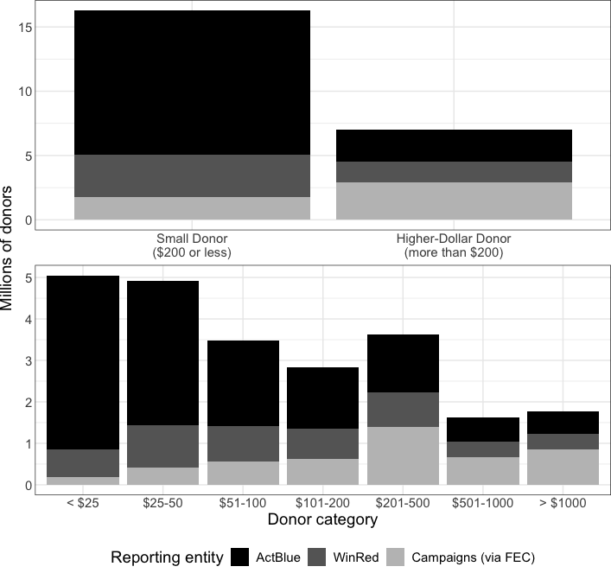

Fig. B1: Small and Higher-Dollar Donors Reported in ActBlue, WinRed, and FEC Records (2020)

The detailed records reported by ActBlue and WinRed also allow us to examine the distribution of contributions for both small and higher-dollar donors and inspect whether our thresholds are reasonable. We should note that the sample we examine is not the same as the full universe of small donors. Some small contributions are made directly to campaigns (e.g. at events) and, if the campaign does not itemize them, would appear as unitemized contributions. But ActBlue and WinRed are fairly ubiquitous, with the vast majority of candidates in both parties using these platforms to raise most of their funds (especially from small donors). There may be systematic differences between small donors who contribute via these online platforms and those who give directly to campaigns, but we do not expect these differences to drastically affect our conclusions.
With these caveats in mind, Figure B2 shows the density distributions for total contributions by those giving $200 or less (small donors) and those giving more than $200 (higher-dollar donors). For visual clarity, we group all donors who give more than $4,000 together at the right side of the higher-dollar donor plot. The distributions for both donor categories are right-skewed, suggesting a greater propensity to give lower amounts (e.g. less than $50 for small donors and less than $1,000 for larger ones). Most importantly, the figure also shows that contribution totals for both small and higher-dollar donors clearly cluster around common numbers like $25, $50, $100, $500, and $1,000. This provides prima facie evidence that our cutpoints capture large, distinctive clusters of donors who give similar amounts. It is clear that there is some variation within the small donor category but also that $200 is a reasonable cutpoint. Similarly, there is strong evidence that our more nuanced cutpoints of $25, $50, $100, $200, $500, and $1,000 are reasonable.

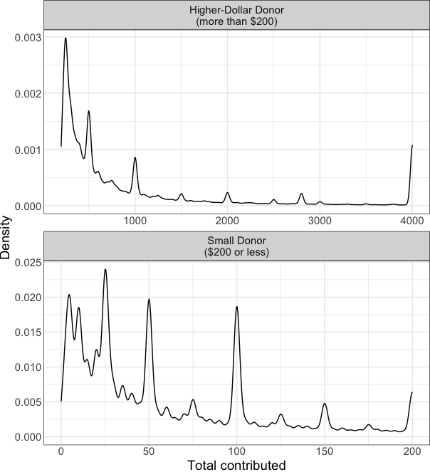
Fig. B2: Distributions of Total Contributions for Small and Higher-Dollar Donors (2020)

Our empirical findings also lend credence to the idea that these are responsible bins. The most notable support for our coding scheme is the fact that there are often key differences between the characteristics of the donors in each bin. For example, we find evidence that many donor demographic characteristics – like gender, education, and race – increase or decrease in a linear fashion as we move across donor categories (see Appendix C and Figure 3), indicating that our results are not sensitive to the specific choice of the $200 cutoff. We also examined differences in terms of other factors not presented here. For example, in 2020, donors giving $200 or less were roughly five times more likely to make just one contribution compared to those giving more than $200. Similarly, roughly half of higher-dollar donors made eight or more contributions, compared to about 10% for small donors.

Appendix C: Additional Descriptive Analyses of Donor Demographics and Politics
In the main text, we present evidence about donor/non-donor demographics and politics using pooled data from the 2008 to 2024 Cooperative Election Surveys (see Figures 1 and 2). Here, we present the same data for each year of the CES to document over-time changes in our subgroups. Figure C1 displays trends in donor and non-donor demographics while Figure C2 shows trends in political identities and behaviors.
Education levels include no high school diploma, high school graduate, some college, two-year degree, four-year degree, and postgraduate degree. The family income levels are: less than $10,000; $10,000 to $19,999; $20,000 to $29,999; $30,000 to $39,999; $40,000 to $49,999; $50,000 to $59,999; $60,000 to $69,999; $70,000 to $79,999; $80,000 to $99,999; $100,000 to $119,999; $120,000 to $149,999; $150,000 to $199,999; $200,000 to $249,999; $250,000 to $349,999; $350,000 to $499,999; and $500,000 or more. The church attendance variable includes ordered options that start at “almost never or never” attend church, then attend “a few times a year,” “a few times a month,” and “once a week or more.”

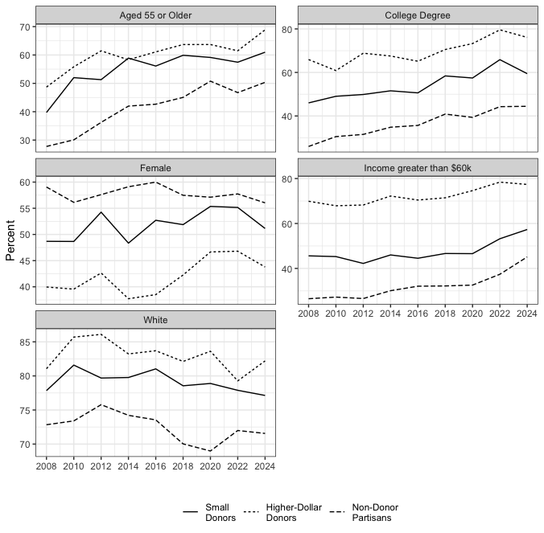
Fig. C1: Demographic Characteristics of Non-Donating Partisans, Small Donors, and Higher-Dollar Donors by Year
Figure C1 shows relatively comparable changes in the demographics of all three subgroups over this period. Donors and non-donors have become progressively (and roughly equally) older, more educated, and wealthier from 2008 to 2024. Over this same period, gender gaps between higher-dollar donors and non-donors have narrowed somewhat.

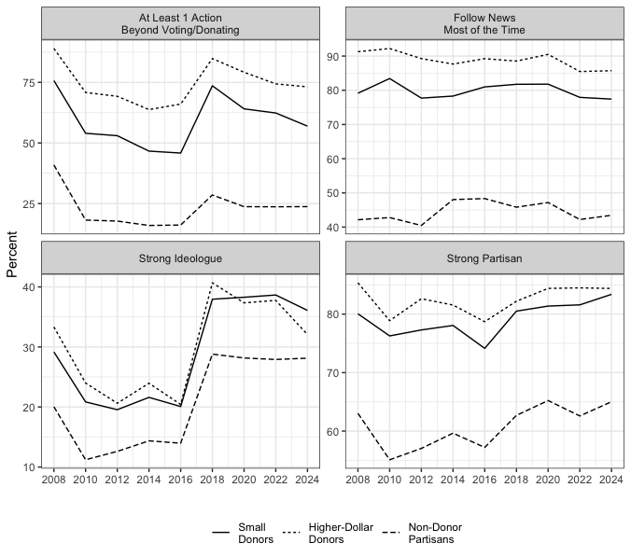
Fig. C2: Political Characteristics of Non-Donating Partisans, Small Donors, and Higher-Dollar Donors by Year

Figure C2 shows that the political characteristics of non-donors, small donors, and higher-dollar tend to move together over time. Importantly, the gaps between donors and non-donors – and, within the donor category, between small donors and higher-dollar donors – are consistent across the 2008-2024 period. Two characteristics – political activism and strong ideologies – experienced a widespread increase in 2018, consistent with broader mobilization in that midterm election cycle. In additional analyses (not shown), we found that ideologues are not only more likely to donate at all, but also to donate to multiple candidates within a given election cycle and to contribute in midterm (rather than just presidential) elections.
We also explore demographic and political differences within the donorate in a single election cycle based on more granular donor categories. Taking advantage of our nuanced donor categories and Catalist match in the 2020 election, we are able to examine changes in the racial, gender, and ideological makeup of the donorate as total contribution amounts increase. We can also compare each donor subgroup to the Democratic and Republican Party bases (using the Catalist partisanship model) to understand how (un)representative donors are of their part overall. These figures supplement Figure 3 and the broader discussion of donor representativeness in the main text.
Figure C3 shows the racial makeup of the donor pool on ActBlue and WinRed using Catalist’s race and ethnicity model. Donors to Republican candidates (WinRed) are overwhelmingly white, as are all Republican partisans. The racial makeup of the GOP donorate is relatively unchanged regardless of total contribution amount. For Democrats on ActBlue, however, the donorate is much whiter than the party as a whole and becomes less racially representative as donation amounts increase. Nearly three-quarters of the smallest donor category (< $25) is predicted to be white, compared to about half of all Democrats. The share of white donors increases linearly alongside the donation amount. At the largest donor categories (> $500.01) roughly 87% of contributors are modeled as white.
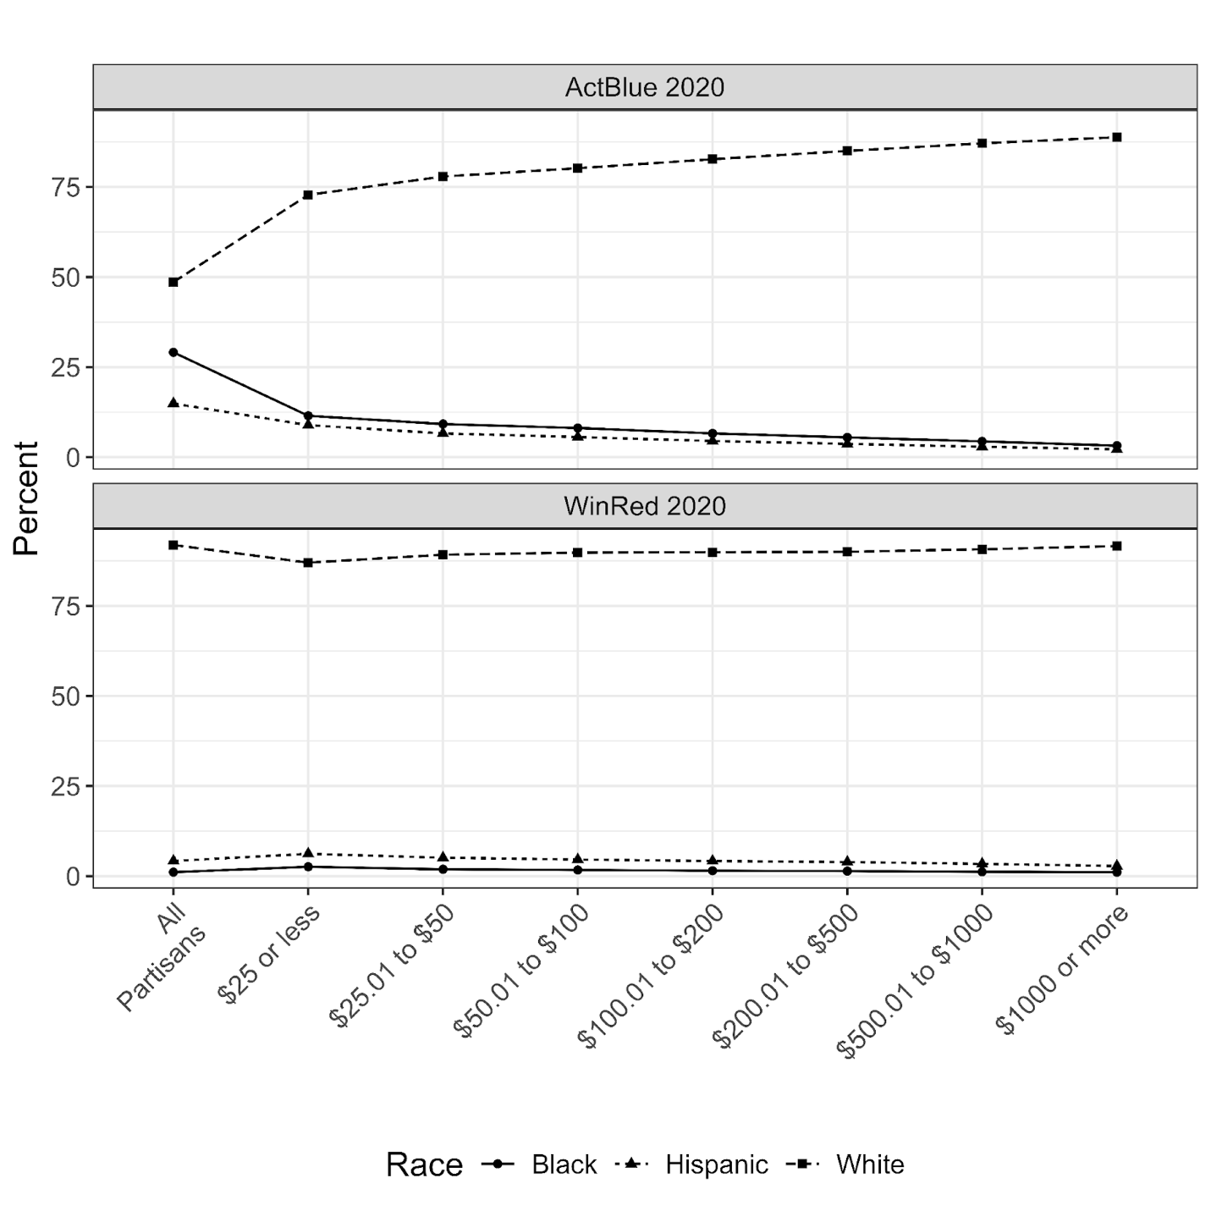
Fig. C3: Percentage of Donors Predicted to Be White, Black and Hispanic by Size of Donation (2020)

Figure C4 presents similar data on the share of female donors and partisans. In both parties, gender representation decreases as the size of the donation grows. But there are important partisan asymmetries. In the GOP, all donor groups are less female than the party overall. The drop-off in representation is significant. About 48% of the Republican Party is female – a share that is fairly similar to the percentage of donors in categories giving $100 or less. But among donors giving more than $500, less than 40% are female. In the largest donor category, just 36% of donors are women.
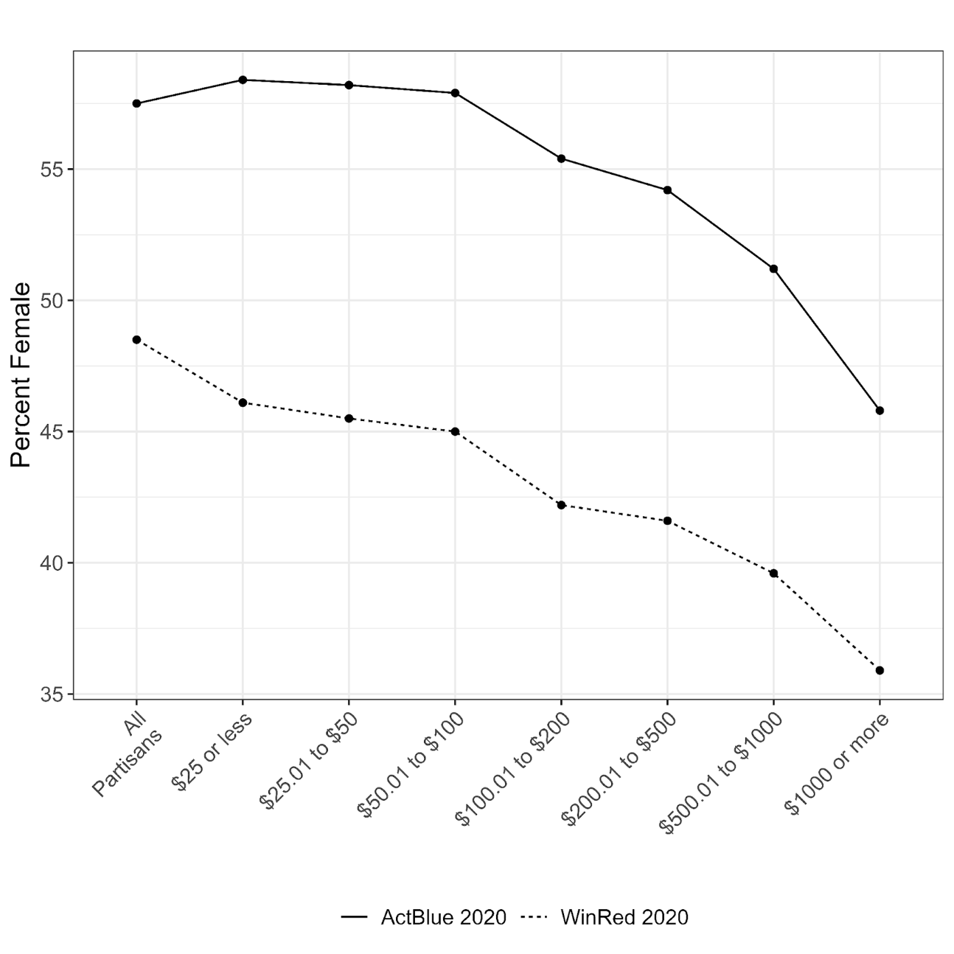
Fig. C4: Percentage of Donors Predicted to Be Female by Size of Donation (2020)

Among Democrats, however, the smallest donors are quite representative of the party overall when it comes to gender. Roughly 57% of Democrats and 58% of donors giving $100 or less are female. Gender representation does not start to drop off until contribution totals exceed $100. The largest donors in the party are particularly unrepresentative: donors giving $1,000 or more are about 11 percentage points less likely to be female than the party overall. This difference is quite similar in size to the gap in the GOP.
Lastly, Figure C5 provides information on the modeled ideology of each subgroup based on the Catalist ideology model. For visual simplicity, the graph shows the share of each category within the most extreme ideological quintile (most liberal 20% for ActBlue and most conservative 20% for WinRed) and within the middle 20% of the ideological distribution (i.e. moderates). We once again observe significant partisan differences. In the Democratic Party, the donorate becomes more ideologically extreme (and less moderate) as the donation amount increases. Overall, donors of all sizes are more extreme and less moderate than the party as a whole. The smallest donors are about twice as likely as partisans overall to be placed in the most liberal quintile, while the largest donors are three times as likely.
In contrast, there are much more muted ideological divides within the Republican Party, and the party overall contains more extreme conservatives (and fewer moderates) than any donor category. Roughly 52 percent of all likely Republicans are in the most conservative 20 percent of the ideology distribution, but only the largest donors come close to that number at 50 percent. We believe this is driven by the fact that a large share of the Republican Party is fairly conservative, potentially obscuring larger differences between donors and non-donors.
But there are important differences that are not captured in this figure, namely that most donor types are more likely than rank-and-file partisans to be in the most extreme bins on the ideology scale. In a separate distribution plot (not shown) we observe that the percentage of rank-and-file in the most conservative decile (i.e., 10 percent rather than 20 percent) of the distribution is just 30 percent, equal to the share of very small donors. But for donors who give more than $25, the share in the most conservative decile jumps to between 42 percent and 65 percent. In a mirror image of the findings for ActBlue, WinRed donors become increasingly conservative as the dollar amount increases, regardless of whether we focus on the top 10 or 20 percent.
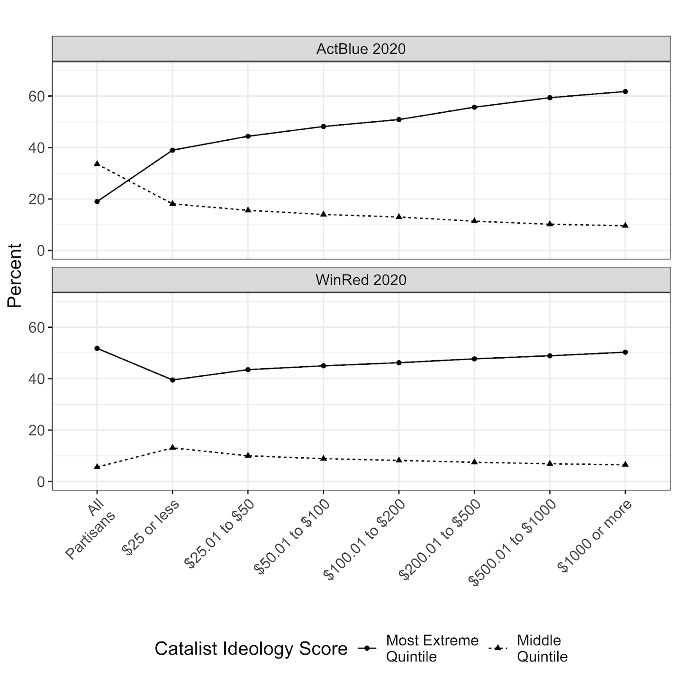
Fig. C5: Ideological Quintiles by Size of Donation (2020)

Appendix D: Donors’ Latent Ideologies
To assess differences in the substance of donors’ ideologies, we created a latent ideological index from thirty-one issue items on the 2024 CES, covering questions on guns, abortion, immigration, taxes, healthcare, and the environment. Using Item Response Theory (IRT), we derived a continuous measure of respondents’ underlying ideological orientation based on whether they held liberal or conservative positions across issues. IRT is used to identify a latent value (here, ideology) from observed binary outcomes (here, having a liberal view or not on each issue). We include these latent ideology measures in our main models. Here, we describe the distribution of this ideology score for each subgroup.
The results, in Figure D1, mirror our findings for self-described ideology but provide a more nuanced and issue-based view. In these box plots, the upper and lower ends of the boxes represent the first and third quartile values, respectively, while the middle line represents the median value. Both small and higher-dollar donors are distinctly more ideological than non-donors. Among Democrats, 75% of small donors and 80% of larger donors hold positions to the left of the median rank-and-file Democrat. Among Republicans, 79% of small donors and 85% of higher-dollar donors fall to the right of the median Republican. In both parties, donors who give more than $200 are slightly more extreme than small ones, though the differences are small. For Democrats, higher-dollar donors had a median score of 0.86 (sd = 0.53) compared to 0.79 (sd = 0.56) for small donors. For Republicans, the median higher-dollar donor scored −1.28 (sd = 0.53) while the median small donor scored −1.18 (sd = 0.54). For non-donor Democrats, the median is 0.44 and the standard deviation is 0.62. For non-donor Republicans, the statistics are –0.74 and 0.55, respectively.
These patterns suggest that donors occupy the ideological edges of their parties’ policy space, while most non-donors cluster nearer the center. The gap between the median Democrat and median Republican is larger than the gap between donors and non-donors within each party – indicating that polarization between the parties exceeds differences within them – but donors nonetheless anchor each party’s ideological poles.
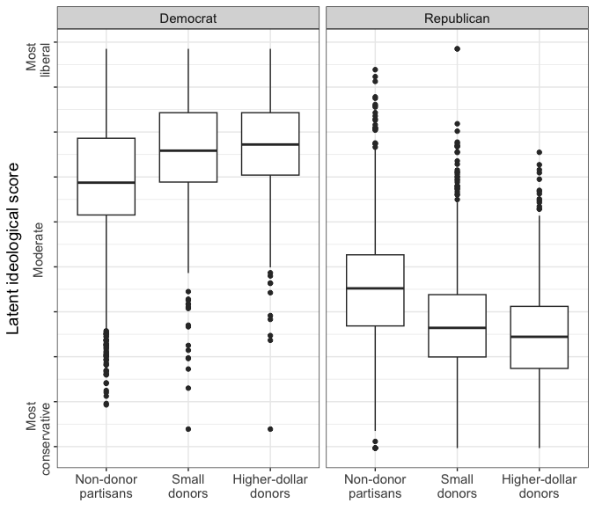
Fig. D1: Latent Ideological Scores by Party and Donor Type (2024)

Appendix E: Affective Polarization
Due to the limited data available, we provide only a brief discussion of affective polarization among the donorate in the main text. Here we provide additional information on this important topic. As noted, we take advantage of a small subsample of 2020 CES respondents who were asked to complete feeling thermometer ratings of the Democratic and Republican Parties (n = 2,358). We use these ratings to measure affective polarization: for Democrats, the difference between their ratings of the Democratic Party and the Republican Party, and for Republicans the difference between Republican and Democratic ratings. Negative values (which are quite rare) indicate a respondent rated the out-party more warmly than their own, while positive values suggest a respondent rated their own party more warmly than the out-party. Values of 0 indicate a respondent rated the two parties equally.
Figure E1 includes the density distributions for non-donors, small donors, and higher-dollar donors in each party. The left-skewed distributions suggest widespread affective polarization among partisans. But one notable difference between subgroups is that Democratic non-donors are less affectively polarized (median = 59) than Democratic small donors (median = 72), and both are less affectively polarized than donors who give more than $200 (median = 78). In the Republican Party, non-donors are more aligned with both donor types (especially higher-dollar donors). This reflects the fact that fewer Republican non-donors hold moderately affectively polarized views (in the 0-50 range) than Democratic non-donors. Among Republicans, small donors are more affectively polarized (median = 77.5) than non-donors (median = 68) or higher-dollar donors (median = 69.5). As noted in the main text, Kruskal-Wallis tests suggest the Democratic distributions are significantly different from one another (p < 0.001) while the Republican distributions are not (p = 0.09).

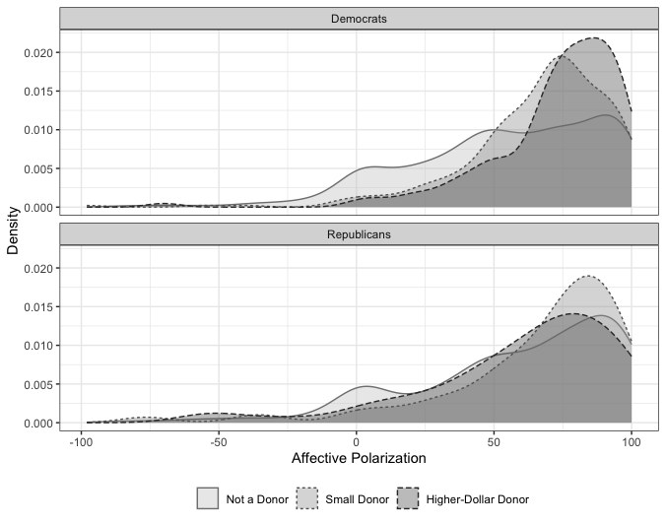
Fig. E1: Distribution of Affective Polarization Scores for Donors and Non-Donors (2020)

To more rigorously assess whether affective polarization is related to giving, we replicated our main regression models using the data from the 2020 CES. In Tables E1 and E2, we recreate our multinomial models predicting donor status (small donor or higher-dollar donor, with non-donor as the baseline) for Democrats and Republicans, respectively. In each table, the first two models include our ideological distance measure (and larger samples), while the latter two models include our affective polarization measure. (Note that these models do not include our latent ideology measure, so they can’t be directly compared to the models presented in the main text and in Appendix F).
The results for Democrats suggest that affective polarization is a statistically significant predictor of being both a small donor (p < 0.05) and a higher-dollar donor (p < 0.01). Substantively, the effects are fairly large. A respondent who rates the parties equally on the feeling thermometers (affective polarization score = 0) has a 17% predicted probability of being a small donor and a 2.5% predicted probability of being a larger donor, all else equal. These probabilities increase to 23% for small donors and 5% for higher-dollar donors when a respondent rates the Democratic Party 50 points warmer than the GOP (affective polarization score = 50). For those who rate the Democratic Party the warmest and the GOP the coldest (affective polarization score = 100), the probabilities increase to 29% for small donors and 9% for higher-dollar donors.
In contrast, the effects for Republicans are statistically insignificant at p < 0.05. This partisan asymmetry reflects the distributions for affective polarization presented in Figure E1. Compared with non-donors, Democratic small and higher-dollar donors are both more affectively polarized. But among Republicans, the distributions for affective polarization are fairly similar regardless of whether one is a non-donor, small donor, or larger donor. The GOP overall is fairly affectively polarized, so this attitudinal measure is less helpful in differentiating donors from non-donors.
We present similar results for our logit models of all donors predicting being a small donor (rather than a higher-dollar one) in Table E3. In both parties, the affective polarization term is statistically insignificant, reflecting the fact that both types of donors tend to be quite affectively polarized. In other words, affective polarization seems to be a similar motivator for both types of donors (at least in the Democratic Party).

 | (1)  Small Donor  (Ideological Distance) | (2)  Higher-Dollar Donor  (Ideological Distance) | (3)  Small Donor  (Affective Polarization) | (4)  Higher-Dollar Donor  (Affective Polarization)
(Intercept) | -4.818*** | -9.179*** | -4.842*** | -8.639***
 | (0.127) | (0.211) | (0.470) | (0.796)
Education Level | 0.284*** | 0.479*** | 0.301*** | 0.337***
 | (0.014) | (0.022) | (0.059) | (0.088)
Family Income | 0.065*** | 0.280*** | 0.116*** | 0.300***
 | (0.006) | (0.010) | (0.026) | (0.042)
Age | 0.232*** | 0.354*** | 0.182** | 0.359***
 | (0.015) | (0.022) | (0.062) | (0.092)
Retired | 0.073 | 0.272*** | 0.245 | -0.046
 | (0.059) | (0.080) | (0.247) | (0.343)
Church Frequency | -0.054** | -0.071** | -0.103 | -0.111
 | (0.018) | (0.025) | (0.072) | (0.107)
Union Member | 0.128** | 0.194*** | -0.043 | 0.270
 | (0.043) | (0.057) | (0.184) | (0.250)
Strong Democrat | 0.565*** | 0.873*** | 0.758*** | 0.774*
 | (0.048) | (0.074) | (0.227) | (0.359)
Lean Democrat | -12.122*** | -6.894*** | 0.802** | 0.728+
 | (0.000) | (0.000) | (0.247) | (0.391)
Very Liberal | -0.085 | -0.155+ | 0.406* | 0.891***
 | (0.057) | (0.082) | (0.186) | (0.257)
Female | -0.071+ | -0.413*** | 0.213 | -0.328
 | (0.040) | (0.054) | (0.165) | (0.231)
Non-White | -0.538*** | -0.729*** | -0.456** | -0.695*
 | (0.043) | (0.066) | (0.173) | (0.272)
Opposing Party Ideological Distance | 0.378*** | 0.464***
 | (0.028) | (0.043)
Affective Polarization |  |  | 0.008** | 0.015**
 |  |  | (0.003) | (0.005)
Observations | 18326 | 18326 | 1100 | 1100
Aikake Inf. Crit. | 27066.5 | 1639.1 | 14293.1 | 859.6
+ p < 0.1, * p < 0.05, ** p < 0.01, *** p < 0.001

Table E1: Multinomial Models Predicting Democratic Respondent Type with Opposing Party Ideological Distance or Affective Polarization Terms (2020)

 | (1)  Small Donor  (Ideological Distance) | (2)  Higher-Dollar Donor  (Ideological Distance) | (3)  Small Donor  (Affective Polarization) | (4)  Higher-Dollar Donor  (Affective Polarization)
(Intercept) | -5.696*** | -9.273*** | -6.077*** | -8.019***
 | (0.189) | (0.307) | (0.753) | (1.107)
Education Level | 0.186*** | 0.291*** | 0.231** | 0.317*
 | (0.020) | (0.029) | (0.088) | (0.123)
Family Income | 0.048*** | 0.252*** | 0.071+ | 0.164**
 | (0.009) | (0.015) | (0.040) | (0.059)
Age | 0.365*** | 0.457*** | 0.373*** | 0.528***
 | (0.023) | (0.035) | (0.096) | (0.138)
Retired | 0.006 | 0.191+ | -0.263 | -0.428
 | (0.073) | (0.103) | (0.313) | (0.433)
Church Frequency | 0.002 | 0.050+ | -0.029 | -0.004
 | (0.020) | (0.029) | (0.087) | (0.123)
Union Member | 0.257*** | 0.222** | 0.720** | 0.081
 | (0.061) | (0.085) | (0.245) | (0.357)
Strong Republican | 0.436*** | 0.629*** | 0.795* | 0.620
 | (0.069) | (0.102) | (0.344) | (0.454)
Lean Republican | -19.894*** | -5.698*** | 0.942** | 0.655
 | (0.000) | (0.000) | (0.347) | (0.464)
Very Conservative | -0.133+ | -0.216+ | -0.128 | -0.277
 | (0.081) | (0.116) | (0.281) | (0.396)
Female | -0.184*** | -0.391*** | -0.055 | -0.906*
 | (0.055) | (0.082) | (0.237) | (0.366)
Non-White | 0.112 | 0.245* | 0.285 | 0.972*
 | (0.084) | (0.115) | (0.350) | (0.422)
Opposing Party Ideological Distance | 0.254*** | 0.227***
 | (0.043) | (0.063)
Affective Polarization |  |  | 0.006 | 0.003
 |  |  | (0.004) | (0.005)
Observations | 18326 | 18326 | 1100 | 1100
Aikake Inf. Crit. | 27066.5 | 1639.1 | 14293.1 | 859.6
+ p < 0.1, * p < 0.05, ** p < 0.01, *** p < 0.001

Table E2: Multinomial Models Predicting Republican Respondent Type with Opposing Party Ideological Distance or Affective Polarization Terms (2020)

 | (1)  Democrats (Ideological Distance) | (2)  Democrats (Affective Polarization) | (3)  Republicans (Ideological Distance) | (4)  Republicans (Affective Polarization)
(Intercept) | 1.322*** | 1.233*** | 1.165*** | 0.873***
 | (0.038) | (0.139) | (0.060) | (0.226)
Education Level | -0.049*** | -0.028+ | -0.036*** | -0.043
 | (0.004) | (0.017) | (0.006) | (0.028)
Family Income | -0.031*** | -0.030*** | -0.026*** | -0.003
 | (0.002) | (0.007) | (0.003) | (0.012)
Age | -0.026*** | -0.040* | -0.024** | -0.032
 | (0.004) | (0.017) | (0.007) | (0.032)
Retired | -0.016 | 0.067 | -0.005 | 0.013
 | (0.015) | (0.063) | (0.022) | (0.097)
Attends Church | 0.002 | 0.015 | -0.003 | 0.012
 | (0.005) | (0.021) | (0.006) | (0.027)
Union Member | -0.015 | -0.093+ | 0.003 | 0.119
 | (0.011) | (0.048) | (0.018) | (0.076)
Strong Democrat | -0.059*** | 0.068
 | (0.015) | (0.071)
Very Liberal | 0.014 | -0.064
 | (0.016) | (0.048)
Strong Republican |  |  | -0.039+ | 0.062
 |  |  | (0.022) | (0.114)
Very Conservative |  |  | -0.003 | -0.036
 |  |  | (0.025) | (0.087)
Female | 0.081*** | 0.110* | 0.059*** | 0.157*
 | (0.011) | (0.045) | (0.017) | (0.075)
Non-White | 0.039** | 0.036 | -0.019 | -0.131
 | (0.013) | (0.051) | (0.025) | (0.099)
Opposing Party Ideological Distance | -0.013 |  | 0.012
 | (0.009) |  | (0.014)
Affective Polarization |  | -0.001 |  | 0.001
 |  | (0.001) |  | (0.001)
Observations | 7210 | 425 | 2968 | 178
AIC | 8702.2 | 522.8 | 3644.0 | 244.1
Log.Lik. | -4338.118 | -247.408 | -1809.007 | -108.069
+ p < 0.1, * p < 0.05, ** p < 0.01, *** p < 0.001
Table E3: Logistic Models Predicting Small Donor Status with Opposing Party Distance or Affective Polarization Terms (2020)

Appendix F: Regression Tables
Here we present the full regression tables for the models predicting whether a respondent is a small or higher-dollar donor (rather than a non-donor; see Figure 7 in the main text) and for the models predicting being a small donor rather than a larger donor (given that one has donated; see Figure 10).
Table F1 contains the results from the multinomial regression models predicting donor status using data from the 2024 CES (Figure 7). This model includes our latent ideology measure alongside a measure of symbolic ideology. We also include results from a pooled analysis using data from the 2010-2024 CES surveys in Table F2. These models do not include the latent ideology measure and have an added term for the survey year. Lastly, Table F3 contains the results from our logistic models predicting small donor status within the donorate (Figure 8).

 | (1)  Democrats: Small Donor | (2)  Democrats: Higher-Dollar Donor | (3)  Republicans: Small Donor | (4)  Republicans: Higher-Dollar Donor
Education Level | 0.192*** | 0.346*** | 0.126*** | 0.271***
 | (0.014) | (0.023) | (0.018) | (0.031)
Family Income | 0.071*** | 0.240*** | 0.040*** | 0.204***
 | (0.005) | (0.009) | (0.008) | (0.014)
Age | 0.341*** | 0.567*** | 0.279*** | 0.456***
 | (0.015) | (0.026) | (0.022) | (0.040)
Retired | 0.045 | 0.240** | 0.114+ | -0.007
 | (0.050) | (0.077) | (0.062) | (0.102)
Church Frequency | 0.008 | 0.001 | 0.001 | 0.015
 | (0.013) | (0.020) | (0.014) | (0.024)
Union Member | 0.190*** | 0.123* | 0.137* | 0.140
 | (0.039) | (0.059) | (0.054) | (0.088)
Strong Democrat | 0.666*** | 0.921***
 | (0.057) | (0.095)
Lean Democrat | 0.345*** | 0.166
 | (0.063) | (0.109)
Very Liberal | -0.164** | -0.238**
 | (0.050) | (0.079)
Strong Republican |  |  | 0.439*** | 0.493***
 |  |  | (0.073) | (0.123)
Lean Republican |  |  | 0.298*** | -0.097
 |  |  | (0.078) | (0.135)
Very Conservative |  |  | -0.095 | -0.001
 |  |  | (0.063) | (0.105)
Latent Ideological Score | 0.612*** | 0.712*** | -0.872*** | -1.103***
 | (0.038) | (0.062) | (0.054) | (0.089)
Female | -0.017 | -0.342*** | 0.005 | -0.291**
 | (0.037) | (0.058) | (0.051) | (0.090)
Non-White | -0.517*** | -0.745*** | -0.057 | 0.128
 | (0.042) | (0.071) | (0.073) | (0.116)
Opposing Party Ideological Distance | 0.148*** | 0.122*** | 0.016 | -0.068
 | (0.018) | (0.031) | (0.027) | (0.047)
Observations | 24065 |  | 17786
Aikake Inf. Crit. | 29212.0 |  | 17029.8
+ p < 0.1, * p < 0.05, ** p < 0.01, *** p < 0.001

Table F1: Multinomial Models Predicting Respondent Type with Latent Ideology Scores (2024)

 | (1)  Democrats: Small Donors | (2)  Democrats: Higher-Dollar Donors | (3)  Republicans: Small Donors | (4)  Republicans: Higher-Dollar Donors
Education Level | 0.265*** | 0.406*** | 0.182*** | 0.263***
 | (0.006) | (0.011) | (0.008) | (0.013)
Family Income | 0.073*** | 0.281*** | 0.075*** | 0.294***
 | (0.003) | (0.005) | (0.004) | (0.007)
Age | 0.273*** | 0.427*** | 0.358*** | 0.453***
 | (0.007) | (0.009) | (0.010) | (0.012)
Retired | 0.068** | 0.194*** | 0.063* | 0.059***
 | (0.022) | (0.007) | (0.027) | (0.008)
Church Frequency | -0.033*** | 0.004 | -0.001 | 0.021
 | (0.007) | (0.011) | (0.008) | (0.013)
Union Member | 0.195*** | 0.227*** | 0.226*** | 0.160***
 | (0.018) | (0.028) | (0.024) | (0.037)
Strong Democrat | 0.639*** | 0.899***
 | (0.021) | (0.004)
Lean Democrat | 0.326*** | 0.912***
 | (0.000) | (0.000)
Very Liberal | 0.006 | -0.016*
 | (0.024) | (0.007)
Strong Republican |  |  | 0.441*** | 0.601***
 |  |  | (0.026) | (0.006)
Lean Republican |  |  | 0.926*** | -5.461***
 |  |  | (0.000) | (0.000)
Very Conservative |  |  | -0.091** | -0.035***
 |  |  | (0.031) | (0.008)
Female | -0.092*** | -0.415*** | -0.208*** | -0.467***
 | (0.017) | (0.027) | (0.023) | (0.037)
Non-White | -0.513*** | -0.682*** | 0.061+ | 0.254***
 | (0.019) | (0.005) | (0.034) | (0.007)
Opposing Party Ideological Distance | 0.342*** | 0.425*** | 0.230*** | 0.219***
 | (0.011) | (0.013) | (0.017) | (0.016)
Year | 0.018*** | 0.059*** | -0.046*** | -0.043***
 | (0.000) | (0.000) | (0.000) | (0.000)
(Intercept) | -40.633*** | -127.856*** | 87.570*** | 76.247***
 | (0.000) | (0.000) | (0.000) | (0.000)
Observations | 101891 | 101891 | 71915 | 71915
Akaike Inf. Crit. | 128367.2 | 128367.2 | 83464.9 | 83464.9
+ p < 0.1, * p < 0.05, ** p < 0.01, *** p < 0.001
Table F2: Multinomial Models Predicting Respondent Type (2010-2024)

 | (1)  Democrats | (2)  Republicans
Education Level | -0.027*** | -0.029***
 | (0.004) | (0.006)
Family Income | -0.030*** | -0.028***
 | (0.002) | (0.003)
Age | -0.038*** | -0.026***
 | (0.005) | (0.007)
Retired | -0.037* | 0.019
 | (0.015) | (0.020)
Attends Church | -0.001 | -0.005
 | (0.004) | (0.005)
Union Member | 0.010 | -0.003
 | (0.011) | (0.017)
Strong Democrat | -0.050**
 | (0.018)
Lean Democrat | 0.022
 | (0.021)
Very Liberal | 0.003
 | (0.015)
Strong Republican |  | -0.025
 |  | (0.024)
Lean Republican |  | 0.056*
 |  | (0.026)
Very Conservative |  | -0.009
 |  | (0.020)
Latent Ideological Score | -0.021+ | 0.052**
 | (0.012) | (0.017)
Female | 0.068*** | 0.056***
 | (0.011) | (0.016)
Non-White | 0.032* | -0.043+
 | (0.013) | (0.023)
Opposing Party Ideological Distance | 0.008 | 0.015+
 | (0.006) | (0.009)
Observations | 6249 | 2919
Akaike Inf. Crit. | 6934.7 | 3130.4
Log Likelihood | -3452.372 | -1550.201
+ p < 0.1, * p < 0.05, ** p < 0.01, *** p < 0.001

Table F3: Logistic Models Predicting Small Donor Status with Latent Ideology Scores (2024)

