Supplemental Methods
Measures

DNA preprocessing in Texas Twin Project

Data collection. Saliva samples were used to collect DNA data during a laboratory visit using Oragene kits (DNA Genotek, Ottawa, ON, Canada). The University of Texas Institutional Review Board granted ethical approval.
Genetic data. The DNA samples were genotyped using the Illumina Infinium PsychArray at the University of Edinburgh, which assays ~590,000 single nucleotide polymorphisms (SNPs), insertions- deletions (indels), copy number variants (CNVs), structural variants, and germline variants across the genome. Genotypes were subjected to quality control. Briefly, samples were excluded when the call rate was <98% and when there was inconsistent reporting between biological and self-reported sex. Variants were excluded if more than 2% of the data was missing. Untyped variants were imputed on the Michigan Imputation Server, with genotypes being phased with Eagle v2.4 and imputed with Minimac4 (v1.5.7), using the 1K Genomes Phase 3 v5 panel as a reference panel (1000 Genomes Project Consortium et al., 2015). Thresholds for minor allele frequency (MAF < 1e-3) and Hardy-Weinberg Equilibrium (HWE p-value < 1e-6) were applied. Imputed genotypes with poor imputation quality (INFO score < .90) were excluded.
Saliva DNA-Methylation data. Methylation profiling was conducted by Edinburgh Clinical Research Facility, using the Infinium MethylationEPIC BeadChip kit (Illumina, Inc., San Diego, CA) to assess methylation levels at 850,000 methylation sites. Briefly, preprocessing was conducted with the ‘minfi’ package in R version 4.0.4 (Aryee et al., 2014). Within-array normalization was performed to address array background correction, red/green dye bias, and probe type I/II correction. To correct for background correction and dye-bias equalization, we applied minfi’s “preprocessNoob” (Triche et al., 2013). CpG probes were excluded if 1) detection p > 0.01, 2) there were fewer than 3 beads in more than 1% of the samples, 3) they were in cross-reactive regions. Samples were excluded if 1) there was mismatch between self-reported and methylation estimated sex, 2) they showed low intensity probes as indicated by the log of average methylation and their detection p was > 0.01 in >10% of their probes. We estimated composition of the immune and epithelial cell types in the samples using “BeadSorted.Saliva.EPIC” within “ewastools” in R, and surrogate variable analyses were used to correct for batch effects (3 batches) using the ComBat function in the SVA package.
DNA preprocessing in Future Families and Child Wellbeing
Data collection. Saliva was collected from children (and mothers at age 9) during in-home assessments at ages 9 and 15 using Oragene® self-collection kits (target volume ≈ 2 mL); samples were shipped to Princeton (Notterman Lab) for extraction and storage following standardized Oragene manual protocols (Ware et al., 2021). Study procedures received institutional review board approval (Princeton University and collaborating institutions), and written informed consent was obtained from participants or their guardians.
Genetic data. Genomic DNA (200 ng) was genotyped on the Illumina PsychChip (v1.0 and v1.1 bead-pools) at the Penn State College of Medicine Genome Sciences Core. Intensities were processed in GenomeStudio v2.0 with TOP-strand allele coding; genotype files were exported in PLINK format (GRCh37). Sample-level QC excluded individuals with >2% missing calls and chromosomal anomalies; SNP-level QC removed markers with >5% missingness (then re-filtered at >2% missingness) and harmonized duplicated/strand-ambiguous variants using the WTCCC strand-correction workflow against 1000 Genomes coordinates. After QC, 3,074 individuals and ~273,800 SNPs remained.
Saliva DNA-Methylation data.
DNA extraction and methylation profiling for FFCWS was conducted by the Notterman Lab of Princeton University and the Pennsylvania State University College of Medicine Genome Sciences Center. Due to the timing of assay completion 40% of the

saliva samples were completed using the Illumina 450K chip and the remaining 60% used the Illumina EPIC chip. Methods for the two chips were standardized as much as possible, but all analyses were run separately for 450 and EPIC and then meta-analyzed. 450K DNAm image data were processed in R statistical software (4.1) using the Enmix package.
The red and green image pairs (n_{samples} = 1811) were read into R and the Enmix preprocessENmix and rcp functions were used to normalize dye bias, apply background correction, and adjust for probe-type bias. The majority of sample filtering was applied using the ewastools packages. We dropped samples using the following criteria: if > 10% of DNA-methylation sites had detection p-value > 0.01 (n_{samples} = 34), if there was sex discordance between DNAm predicted sex and recorded sex (n_{samples} = 11), or if two sequential samples from the same individual exhibited genetic discordance between visits (n_{samples} = 27). ENmix QCinfo function identified samples with outlier methylation values which were cut (n_{samples} = 6). Technical replicates were removed (n_{samples} = 49). This gave us our final analytic sample (n=1684). DNAm sites were removed if they had detection p-value > 0.01 in 5% of samples (n = 33,376). Relative proportions of immune and epithelial cell types were estimated from DNAm measures using a childhood saliva reference panel. EPIC DNAm image data were processed in R statistical software (4.1) using the ENmix package (Xu et al., 2016). The red and green image pairs (n_{samples} = 2558) were read into R and the ENmix preprocessENmix and rcp functions were used to normalize dye bias, apply background correction, and adjust for probe-type bias. The majority of sample filtering was applied using the Ewastools packages. We dropped samples using the following criteria: if > 10% of DNAm sites had detection p-value > 0.05 (n_{samples} = 63), if there was sex discordance between DNA-methylation predicted sex and recorded sex (n = 12), or if two sequential samples from the same individual exhibited genetic discordance between visits (n = 30). ENmix QCinfo function identified samples with outlier methylation values which were cut (n = 1) or samples that failed bisulfite conversion (n_{samples} = 7). Technical replicates were removed (n=168). This gave us our final analytic sample (n_{samples} = 2277). DNAm sites were removed if they had detection p > 0.05 in 5% of samples (n = 127,275). Relative proportions of immune and epithelial cell types were estimated from DNAm measures using a childhood saliva reference panel.
DNA preprocessing in the Generation R Study
Data Collection. Children’s samples were obtained from 30 ml cord blood at birth. Additionally, samples were drawn from venous blood during a visit to the research center at age 6 and 10 years. The Generation R Study is conducted in accordance with the World Medical Association Declaration of Helsinki and has been approved by the Medical Ethics Committee of Erasmus MC, University Medical Center Rotterdam. Informed consent was obtained for all participants.
Genetic data. Child DNA was genotyped using Illumina SNP microarrays (HumanHap 610-Quad for most samples, or 660-Quad for a later subset), assaying 620,901 markers, representing 592,532 SNPs and 28,369 CNV probes. Genotyping followed manufacturer protocols; intensity data were processed with Illumina GenomeStudio and genotypes called using the GenCall algorithm (no-call threshold 0.15). Samples with low genotype call rates (< 97.5%) were excluded as low-quality, and any duplicate participants or sex-mismatches (discordance between genetic sex and reported sex) were removed. Standard variant-level quality control was also applied: markers with high missingness (> 5% missing genotypes), very low minor allele frequency (MAF ≤ 0.1%), or significant deviation from Hardy–Weinberg equilibrium (p < 1×10⁻⁷) were filtered out. After quality control, a two-step imputation pipeline was used to infer untyped variants. Genotypes were first phased into haplotypes (using MACH software) and then imputed with Minimac using the 1000 Genomes Project Phase 3 reference panel. Imputed variants with low imputation quality (MACH R² < 0.3) were excluded from downstream analyses.
Blood DNA-Methylation data. DNA methylation was measured on a genome wide level using the Illumina Infinium MethylationEPIC v1.0 or the Illumina Infinium HumanMethylation450 BeadChip (Illumina Inc., San Diego, USA). EPICv1 was only applied at birth, in cord blood, in 1115 samples. 450K was applied across all ages: we used cord blood samples of 1339 children, blood samples in 469 children aged 6 years and blood samples in 425 children aged 10 years (Kooijman et al., 2016). The EZ-96 DNAm kit (shallow) (Zymo Research Corporation, Irvine, CA) was used for bisulfite conversion on the extracted DNA.
For EPICv1, samples were processed with the Illumina Infinium MethylationEPIC v1.0 BeadChip (Illumina Inc., San Diego, USA). Preparation and normalization of the data were performed according to the CPACOR workflow using the software package R (Lehne et al., 2015; R Core Team, 2024). In detail, the idat files were read using the minfi package. Probes that had a detection p-value above background (based on sum of methylated and unmethylated intensity values) ≥ 1E-16 were set to missing per array. Next, the intensity values were stratified by autosomal and non-autosomal probes and quantile normalized for each of the six probe type categories separately: type II red/green, type I methylated red/green and type I unmethylated red/green. Beta values were calculated as proportion of methylated intensity value on the sum of methylated+unmethylated+100 intensities. Arrays with observed technical problems such as failed bisulfite conversion, hybridization or extension, as well as arrays with a mismatch between sex of the proband and sex determined by the chr X and Y probe intensities were removed from subsequent analyses. Additionally, only arrays with a call rate > 96% per sample were processed further. Probes on the X and Y chromosomes were excluded from the dataset. The final dataset contained information on 808,183 CpGs for 1115 samples at birth.
For 450K, Samples were plated onto 96-well plates in no specific order. Samples were processed with the Illumina Infinium HumanMethylation450 BeadChip (Illumina Inc., San Diego, USA), which analyses methylation at 485,577 CpG sites. Preparation and normalization of the HumanMethylation450 BeadChip array data was performed according to the CPACOR workflow1 using the software package R2. In detail, the idat files were read using the minfi package. Probes that had a detection p-value above background (based on sum of methylated and unmethylated intensity values) ≥ 1E-16 were set to missing per array. Next, the intensity values were stratified by autosomal and non-autosomal probes and quantile normalized for each of the six probe type categories separately: type II red/green, type I methylated red/green and type I unmethylated red/green. Beta values were calculated as proportion of methylated intensity value on the sum of methylated+unmethylated+100 intensities. Arrays with observed technical problems such as failed bisulfite conversion, hybridization or extension, as well as arrays with a mismatch between sex of the proband and sex determined by the chr X and Y probe intensities were removed from subsequent analyses. Additionally, only arrays with a call rate > 95% per sample were processed further. Probes on the X and Y chromosomes were excluded from the dataset. The final dataset contained information on 458,563 CpGs for 1396 samples at birth, 493 samples at age 6 and 464 samples at age 10.
Before analysis, we winsorized extreme outliers beyond 3 times the interquartile range from the quartile limit (i.e., 25th percentile minus 3*IQR and 75th percentile plus 3*IQR). Epigenetic-g was computed using algorithms from previous elastic net analyses. Epigenetic-g was residualized for sample plate, age (gestational age at birth) cell composition (B-cells, CD4-T cells, CD8-T cells, granulocytes, monocytes, natural-killer cells; at age 6 and 10 with (Houseman et al., 2012), and at birth using the IDOL method6 in the minfi package4 in R (Gervin et al., 2019; Salas et al., 2018), and then standardized in the pooled sample (Mean = 0, SD = 1) to ease interpretation.
DNA preprocessing in TwinLife

Data Collection. For a subsample of the TwinLife cohort, saliva samples were collected using Oragene saliva self-collection kits (DNA Genotek, Ottawa, ON, Canada) and DNA was extracted following standard protocols. DNA extraction and genome-wide genotyping were conducted at the Institute of Human Genetics, University Hospital Bonn, Germany. The genotyping was performed using Infinium Global Screening Arrays customized to include additional marker content of relevance to psychiatric disorders (Illumina, San Diego, CA, USA).
Genetic data. Further genomic data processing was performed at the Institute for Genomic Statistics and Bioinformatics, University of Bonn, Germany. Quality control of the genotype data was performed using PLINK 1.9 (Purcell et al., 2007) and R (R Core Team, 2024) . Phasing of the sample genotypes was conducted using Eagle (v. 2.4.1; Loh et al., 2016) and imputation was performed using Minimac (v. 4; Das et al., 2016) and the 1000 Genomes Phase 3 data (Fairley et al., 2020) as a reference panel. Genotype data quality control (QC) comprised sample- and variant-level filtering. Samples were excluded based on the genotyping rate (< 98 %), mismatches between the genetically inferred and the reported sex, family mismatches (KING; Manichaikul et al., 2010) inferred family ID ≠ reported family ID) and if they were genetic outliers (Principal Component deviation of more than 6 standard deviations from the mean of the first 10 PCs). Variant exclusion was based on the SNP call rate (< 98%), Hardy-Weinberg equilibrium (HWE p-value <1 × 10⁻⁶), MAF (< 1e⁻³) and imputation accuracy (R² <= 0.6).

Saliva DNA methylation data. Methylation levels were assessed using the Infinium MethylationEPIC v1.0 BeadChip (Illumina, San Diego, CA, USA). Samples were randomized by age, sex, zygosity, and complete vs single twin pair across 23 plates (266 arrays) using the R package Omixer (Sinke et al., 2021). Family ID was used as a blocking variable to ensure that all samples and timepoints of a twin pair run on the same batch/array.
Preprocessing of all methylation samples (n = 2,128) was conducted following the pipeline by Maksimovic et al. (2017). Scan intensity signals as stored in .idat files were loaded into R and transformed into beta-values within the R package minfi (Aryee et al., 2014). Samples with a mean detection p-value > 0.05 were excluded (n = 3). Additionally, we excluded samples showing sex mismatches between estimated sex from methylation data and confirmed phenotypic sex (n = 14). Beta-values were normalized using stratified quantile normalization (Touleimat & Tost, 2012), followed by BMIQ (Teschendorff et al., 2013). Probes on X or Y chromosomes (n = 16,263), probes containing SNPs (n = 24,038), cross-hybridizing (n = 46,867) and polymorphic probes (n = 297) according to Chen et al. (2013) and McCartney et al. (2016), and probes with a detection p-value of > 0.01 in one or more samples (n = 79,922) were removed. Afterwards beta-values were transformed into M-values, and batch-effects were removed using ComBat (Leek et al., 2012). For this, we computed a principal component analysis (PCA) on the M-values and checked which batches (plate, slide, array) were most strongly associated with the principal components. The strongest batch-effects were iteratively removed. Corrected m-values were re-transformed into beta-values. Lastly, we applied Mixup Mapper (Westra et al., 2011) to the genotype and methylation data to check for possible sample mix-ups and four mix-ups were excluded. The resulting DNA-methylation dataset comprises 2,106 samples of n = 1,059 participants and 698,472 probes. Cell type composition was estimated using EpiDish (Zheng et al., 2018).

Statistical Analyses
Analysis Set 1. Developmental dynamics of genomic Biomarkers.
We modeled developmental change in Epigenetic-g and in repeated cognitive and academic outcomes using cohort-specific longitudinal structural equation models in Mplus Version 8.8 (Muthén & Muthén, 2017). For these time-varying variables in the Texas Twin Project (TTP) and TwinLife, we fit latent growth-curve models (LGCMs) using an accelerated longitudinal (cohort-sequential) specification that leverages overlapping age coverage across participants (Duncan et al., 2006; McArdle & Bell, 2000). These models estimate latent intercepts (baseline level) and latent slopes (rate of within-person change), allowing us to characterize population-level developmental trajectories across childhood and adolescence despite a limited number of repeated assessments per individual. Curvature in age-related change was accommodated by including a within-person quadratic age term in TTP and a logarithmic age function in TwinLife, as these specifications provided the best fit to the observed age trends within each cohort. Age was measured in years (rescaled to decades in TTP to aid model convergence) and centered at the first postnatal DNAm assessment (7.8 years). In GenR, where two postnatal DNAm assessments were available per individual (ages 6 and 10), we estimated latent difference score models (LDSMs) of Epigenetic-g. These models estimate the mean within-person change between measurement occasions as well as interindividual variability in that change. Across all models, missing data were handled using full-information maximum likelihood (FIML). Models were estimated using robust maximum likelihood (MLR) with cluster-robust standard errors to account for family nesting. Sex was included as a between-person covariate. Variances of latent intercepts and slopes (or latent differences) were tested for statistical significance.
Analysis Set 2. Cross-sectional associations.
In TTP and TwinLife, we estimated age-adjusted two-level latent intercept models for each cognitive and academic outcome. On the within-person level, outcomes were regressed on centered age (and a quadratic or logarithmic age term, where applicable) to account for age-related change. On the between-person level, we specified a latent outcome intercept (random intercept; defined by the observed outcome with the residual fixed to zero) and regressed this latent intercept on PGI-Education, PGI-Cognition, and the Epigenetic-g intercept, first in separate models and then jointly to quantify unique versus shared variance. Models included sex as a between-person covariate and were estimated using MLR with cluster-robust standard errors (family and study clustering) and FIML for missing outcome data; observations with missing predictors were excluded. We summarize joint predictive utility as $R_{joint}=\sqrt{R_{full}^{2}-R_{sex}^{2}}$, where $R_{full}^{2}$is the model $R^{2}$ including biomarkers and sex and $R_{sex}^{2}$is the $R^{2}$from sex alone (CIs via the delta method). In FFCWS, cross-sectional associations were estimated by regressing each outcome on Epigenetic-g at the first available DNAm assessment (Year 9). In GenR, we estimated cross-sectional associations of PGI-Education, PGI-Cognition, and Epigenetic-g (birth, and postnatal specifications as described in Supplemental Table 1) with single-time outcomes. Multiple testing was controlled using the Benjamini–Hochberg FDR procedure within outcome domain (cognitive vs. academic) and analysis set. In additional models, PGI-Education and PGI-Cognition were included as predictors of the Epigenetic-g intercept.
Analysis Set 3. Longitudinal prediction of cognitive/academic growth.
In cohorts with repeated outcome assessments (TTP, TwinLife), we fit two-level LGCMs in which within-person change was defined by centered age (scaled to decades) and, where supported by model fit, an additional nonlinear age term (quadratic in TTP; logarithmic in TwinLife). Latent intercepts and latent slopes were specified on the between-person level and were regressed on time-invariant predictors (PGI-Education, PGI-Cognition, and/or the Epigenetic-g intercept), adjusting for sex. Models were estimated using MLR with cluster-robust standard errors and FIML for missing outcome data; observations with missing predictors were excluded.
As an exploratory analysis, we examined cross-sectional associations between genomic/epigenomic markers and adolescent ‘transactional’ correlates of learning (parent and self-reported school-related engagement items). We estimated population-average effects of z-standardized PGI-Education, PGI-Cognition, and Epigenetic-g using probit GLMs for binary outcomes and ordered-probit (POLR) for ordinal outcomes. We applied robust standard errors clustered at the family level (bias-reduced for binary models) to account for within-family dependence without changing the pooled estimand. Models required ≥30 complete cases and ≥2 observed categories; missingness was handled by model-wise listwise deletion. We report probit coefficients per 1 SD in the predictor and controlled the false discovery rate for all behavioral outcomes per predictor using BH-FDR.
Analysis Set 4. Twin Difference Analysis
We implemented three complementary twin-based approaches to (i) evaluate whether biomarker–outcome associations persist after accounting for family-level factors shared by siblings and (ii) decompose variance in Epigenetic-g, as well as Epigenetic-g–outcome covariance, into genetic and environmental components (Neale & Maes, 2004; Rijsdijk & Sham, 2002).
(a) Sibling (twin) difference regressions. We estimated within-family associations by regressing within-pair differences in outcomes (ΔY) on within-pair differences in predictors (ΔX) in dizygotic twin pairs (i.e., twin-difference / sibling fixed-effects models). This specification is algebraically equivalent to pair-demeaned linear models and removes all shared family influences that are constant within twin pairs. Standardized within-family coefficients (β) were contrasted with corresponding between-family estimates from Analysis Set 2 to quantify attenuation, which—particularly for PGIs—has been interpreted as indicating that part of between-family prediction reflects family-level processes correlated with the biomarker (Selzam et al., 2019).
(b) Univariate biometric decomposition of Epigenetic-g. To characterize the etiology of individual differences in Epigenetic-g independent of any outcome associations, we fit classical univariate ACE models using monozygotic and dizygotic twin resemblance to partition variance into additive genetic (h²), shared environmental (c²), and non-shared environmental (e²) components (Neale & Maes, 2004).
(c) Bivariate biometric decomposition with cognition and achievement. To test whether the observed Epigenetic-g–outcome covariance is attributable to genetic and/or environmental sources, we fit bivariate Cholesky ACE models that partitioned covariance into A, C, and E components and yielded genetic and environmental correlations (rA, rC, rE). We evaluated the contribution of specific components via nested likelihood-ratio tests implemented by constraining relevant paths to zero.
Finally, as a complementary within-pair analysis focused on non-shared mechanisms, we examined monozygotic twin-difference associations by correlating MZ within-pair differences in Epigenetic-g with within-pair differences in outcomes. Because MZ twins are genetically identical and share their family environment, these estimates reflect covariation that is independent of additive genetic differences and shared family-level influences, while remaining sensitive to non-shared experiences and measurement error.
Set 5. Socioeconomic context analyses.
These analyses addressed two related questions: whether childhood socioeconomic status (SES) was associated with polygenic and epigenetic biomarkers and whether biomarker–outcome associations were attenuated after accounting for SES. In each cohort, SES was operationalized using available indicators of family socioeconomic context in childhood (e.g., parental education and income; see Table 1 in the main text) and standardized within cohort. We first estimated associations between SES and each biomarker. We then re-estimated the biomarker–outcome models from Analysis Sets 2 with SES indicators included as covariates, treating SES as a family-level (between-family) predictor of both biomarker and outcome. All other model specifications matched Set 2 (standardization; biomarker residualization as specified in the main analyses; FIML for missing data; Benjamini–Hochberg FDR correction across tests).

Supplemental Figures

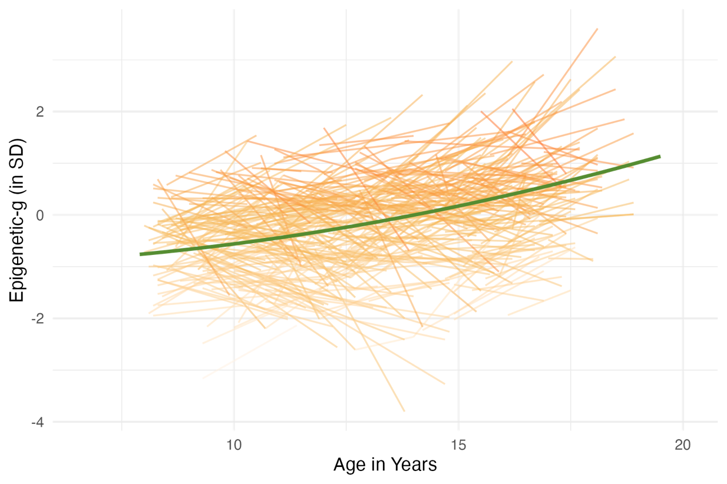
Figure S1. Developmental trajectories of Epigenetic-g across adolescence in the Texas Twin Project. Thin lines depict individual trajectories of standardized Epigenetic-g across age, and the solid line shows the model-implied average trend over time. Epigenetic-g = epigenetic index of general cognitive ability.
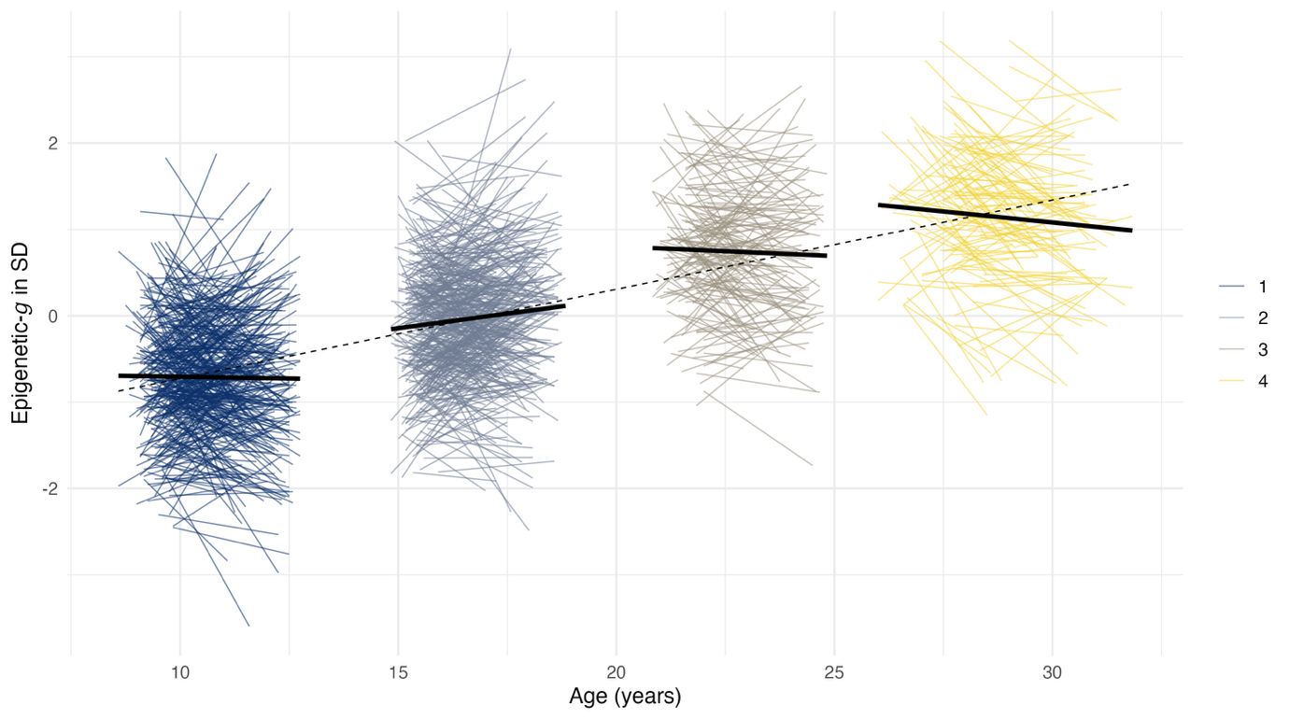

Figure S2. Cohort-specific trajectories of Epigenetic-g across age. Spaghetti lines depict within-person repeated observations of standardized Epigenetic-g plotted against age (in years), colored by cohort. Solid black lines represent cohort-specific linear fits estimated within each cohort, and the dashed black line indicates the overall linear association pooled across cohorts.

References

1000 Genomes Project Consortium, Auton, A., Brooks, L. D., Durbin, R. M., Garrison, E. P., Kang, H. M., Korbel, J. O., Marchini, J. L., McCarthy, S., McVean, G. A., & Abecasis, G. R. (2015). A global reference for human genetic variation. Nature, 526(7571), 68–74. https://doi.org/10.1038/nature15393
Aryee, M. J., Jaffe, A. E., Corrada-Bravo, H., Ladd-Acosta, C., Feinberg, A. P., Hansen, K. D., & Irizarry, R. A. (2014). Minfi: A flexible and comprehensive Bioconductor package for the analysis of Infinium DNA methylation microarrays. Bioinformatics (Oxford, England), 30(10), 1363–1369. https://doi.org/10.1093/bioinformatics/btu049
Chen, Y., Lemire, M., Choufani, S., Butcher, D. T., Grafodatskaya, D., Zanke, B. W., Gallinger, S., Hudson, T. J., & Weksberg, R. (2013). Discovery of cross-reactive probes and polymorphic CpGs in the Illumina Infinium HumanMethylation450 BeadChip. Epigenetics, 8(2), 203–209. https://doi.org/10.4161/epi.23470
Das, S., Forer, L., Schönherr, S., Sidore, C., Locke, A. E., Kwong, A., Vrieze, S. I., Chew, E. Y., Levy, S., McGue, M., & others. (2016). Next-generation genotype imputation service and methods. Nature Genetics, 48(10), 1284–1287. https://doi.org/10.1038/ng.3656
Duncan, T. E., Duncan, S. C., & Strycker, L. A. (2006). An Introduction to Latent Variable Growth Curve Modeling: Concepts, Issues, and Applications (2nd ed.). Lawrence Erlbaum Associates Publishers.
Fairley, S., Lowy-Gallego, E., Perry, E., & Flicek, P. (2020). The 1000 Genomes Project analysis, data use and 21st century medical genetics. Nature Reviews Genetics, 21(4), 241–256. https://doi.org/10.1038/s41576-019-0196-1
Gervin, K., Salas, L. A., Bakulski, K. M., van Zelm, M. C., Koestler, D. C., Wiencke, J. K., Duijts, L., Moll, H. A., Kelsey, K. T., Kobor, M. S., Lyle, R., Christensen, B. C., Felix, J. F., & Jones, M. J. (2019). Systematic evaluation and validation of reference and library selection methods for deconvolution of cord blood DNA methylation data. Clinical Epigenetics, 11(1), 125. https://doi.org/10.1186/s13148-019-0717-y
Houseman, E. A., Accomando, W. P., Koestler, D. C., Christensen, B. C., Marsit, C. J., Nelson, H. H., Wiencke, J. K., & Kelsey, K. T. (2012). DNA methylation arrays as surrogate measures of cell mixture distribution. BMC Bioinformatics, 13(1), 86. https://doi.org/10.1186/1471-2105-13-86
Kooijman, M. N., Kruithof, C. J., van Duijn, C. M., Duijts, L., Franco, O. H., van IJzendoorn, M. H., de Jongste, J. C., Klaver, C. C. W., van der Lugt, A., Mackenbach, J. P., Moll, H. A., Peeters, R. P., Raat, H., Rings, E. H. H. M., Rivadeneira, F., van der Schroeff, M. P., Steegers, E. A. P., Tiemeier, H., Uitterlinden, A. G., … Jaddoe, V. W. V. (2016). The Generation R Study: Design and cohort update 2017. European Journal of Epidemiology, 31(12), 1243–1264. https://doi.org/10.1007/s10654-016-0224-9
Leek, J. T., Johnson, W. E., Parker, H. S., Jaffe, A. E., & Storey, J. D. (2012). The sva package for removing batch effects and other unwanted variation in high-throughput experiments. Bioinformatics, 28(6), 882–883. https://doi.org/10.1093/bioinformatics/bts034
Lehne, B., Drong, A. W., Loh, M., Zhang, W., Scott, W. R., Tan, S.-T., Afzal, U., Scott, J., Jarvelin, M.-R., Elliott, P., McCarthy, M. I., Kooner, J. S., & Chambers, J. C. (2015). A coherent approach for analysis of the Illumina HumanMethylation450 BeadChip improves data quality and performance in epigenome-wide association studies. Genome Biology, 16(1), 37. https://doi.org/10.1186/s13059-015-0600-x
Loh, P.-R., Danecek, P., Palamara, P. F., Fuchsberger, C., Reshef, Y. A., Finucane, H. K., Schoenherr, S., Forer, L., McCarthy, S., Abecasis, G. R., & others. (2016). Reference-based phasing using the Haplotype Reference Consortium panel. Nature Genetics, 48(11), 1443–1448. https://doi.org/10.1038/ng.3679
Maksimovic, J., Phipson, B., & Oshlack, A. (2017). A cross-package Bioconductor workflow for analysing methylation array data. F1000Research, 5, 1281. https://doi.org/10.12688/f1000research.8839.3
Manichaikul, A., Mychaleckyj, J. C., Rich, S. S., Daly, K., Sale, M., & Chen, W.-M. (2010). Robust relationship inference in genome-wide association studies. Bioinformatics, 26(22), 2867–2873. https://doi.org/10.1093/bioinformatics/btq559
McArdle, J. J., & Bell, R. Q. (2000). An introduction to latent growth models for developmental data analysis. Methods in Psychological Research, 5(2), 69–107.
McCartney, D. L., Walker, R. M., Morris, S. W., McIntosh, D. J., Andrew M. Porteous, & Evans, K. L. (2016). Identification of polymorphic and cross-hybridizing probes on the Illumina Infinium MethylationEPIC BeadChip. Genomics Data, 9, 22–24. https://doi.org/10.1016/j.gdata.2016.05.012
Muthén, L. K., & Muthén, B. O. (2017). Mplus User’s Guide (Eighth). Muthén & Muthén.
Neale, M. C., & Maes, H. H. M. (2004). Methodology for Genetic Studies of Twins and Families. Kluwer Academic Publishers.
Purcell, S., Neale, B., Todd-Brown, K., Thomas, L., Ferreira, M. A., Bender, D., Maller, J., Sklar, P., De Bakker, P. I., Daly, M. J., & others. (2007). PLINK: a tool set for whole-genome association and population-based linkage analyses. The American Journal of Human Genetics, 81(3), 559–575. https://doi.org/10.1086/519795
R Core Team. (2024). R: A language and environment for statistical computing. [Computer software]. R Foundation for Statistical Computing. https://www.R-project.org/
Rijsdijk, F. V., & Sham, P. C. (2002). Analytic approaches to twin data using structural equation models. Briefings in Bioinformatics, 3(2), 119–133. https://doi.org/10.1093/bib/3.2.119
Salas, L. A., Koestler, D. C., Butler, R. A., Hansen, H. M., Wiencke, J. K., Kelsey, K. T., & Christensen, B. C. (2018). An optimized library for reference-based deconvolution of whole-blood biospecimens assayed using the Illumina HumanMethylationEPIC BeadArray. Genome Biology, 19(1), 64. https://doi.org/10.1186/s13059-018-1448-7
Selzam, S., Ritchie, S. J., Pingault, J.-B., Reynolds, C. A., O’Reilly, P. F., & Plomin, R. (2019). Comparing Within- and Between-Family Polygenic Score Prediction. American Journal of Human Genetics, 105(2), 351–363. https://doi.org/10.1016/j.ajhg.2019.06.006
Sinke, L., Cats, D., & Heijmans, B. T. (2021). Omixer: Multivariate and reproducible sample randomization to proactively counter batch effects in omics studies. Bioinformatics, 37(18), 3051–3052. https://doi.org/10.1093/bioinformatics/btab159
Teschendorff, A. E., Marabita, F., Lechner, M., Bartlett, T., Tegner, J., Gomez-Cabrero, D., & Beck, S. (2013). A beta-mixture quantile normalization method for correcting probe design bias in Illumina Infinium 450 k DNA methylation data. Bioinformatics, 29(2), 189–196. https://doi.org/10.1093/bioinformatics/bts680
Touleimat, N., & Tost, J. (2012). Complete pipeline for Infinium HumanMethylation450 BeadChip data processing using subset quantile normalization for accurate DNA methylation estimation. Epigenomics, 4(3), 325–341. https://doi.org/10.2217/epi.12.21
Triche, T. J., Weisenberger, D. J., Van Den Berg, D., Laird, P. W., & Siegmund, K. D. (2013). Low-level processing of Illumina Infinium DNA Methylation BeadArrays. Nucleic Acids Research, 41(7), e90. https://doi.org/10.1093/nar/gkt090
Ware, E. B., Fisher, J., Schneper, L., Nottermann, D., & Mitchell, C. (2021). FFCWS Polygenic Scores – Release 1. Genetics.
Westra, H.-J., Jansen, R. C., Fehrmann, R. S., te Meerman, G. J., van Heel, D., Wijmenga, C., & Franke, L. (2011). MixupMapper: Correcting sample mix-ups in genome-wide datasets increases power to detect small genetic effects. Bioinformatics, 27(15), 2104–2111. https://doi.org/10.1093/bioinformatics/btr323
Xu, Z., Niu, L., Li, L., & Taylor, J. A. (2016). ENmix: A novel background correction method for Illumina HumanMethylation450 BeadChip. Nucleic Acids Research, 44(3), e20. https://doi.org/10.1093/nar/gkv907
Zheng, S. C., Breeze, C. E., Beck, S., & Teschendorff, A. E. (2018). EpiDISH: a novel mathematical weights-based algorithm for the estimation of cell-type proportions in a sample from DNA methylation data. Bioinformatics, 36(6), 1950–1951. https://doi.org/10.1093/bioinformatics/btz833

