Supplementary Figure 1: Chart of RA patient selection criteria and outcomes used for this proteomic study cohort.

Supplementary Figure 2: Assessment of optimal number of RA patient clusters. Plots of A) the silhouette statistic tests for number of clusters (k) and B) the consensus of 23 clustering metrics evaluated using baseline proteomic data. Plots of the C) silhouette statistics and D) consensus across clustering metrics assessed using the 12-month serum proteomic profiles. The blue dotted lines or columns represent optimal number of clusters (k).

Supplementary Figure 3: Serology, SDAI, DA and erosion outcome distribution across patient clusters. Overlay of seropositive (RF and/or ACPA) and seronegative RA patients on A) baseline serum proteome PCA plot or B) 12-month serum proteome PCA plot. Clinical assessment of disease activity measured at the 12-month follow-up visit by SDAI scores for patients grouped according to C) baseline or D) 12-month clusters. Horizontal bar correspond to the groups median values. Overlay of 12-month DA outcome of RA patients on E) baseline PCA plot or F) 12-month PCA plot. Overlay of erosion outcome of RA patients on G) baseline PCA plot or H) 12-month PCA plot.

Supplementary Figure 4: KEGG pathway enrichment analyses performed on RA patient clusters. Differently abundant proteins (DAPs) between patient clusters were identified using Mann-Whitney U test with Bonferroni correction. KEGG pathway enrichment using active subnetwork analyses were performed using DAPs (p adjusted ≤0.05). The top 10 KEGG enriched term with at least 2 proteins and a Benjamini-Hochberg adjusted p value ≤0.05 are shown for A) baseline clusters and B) 12-month clusters.

Supplementary Figure 5: Z-scores of complement pathway proteins showing baseline levels distribution across RA patients. The z-scores were calculated using values from baseline serum proteome for each complement proteins from the KEGG pathway hsa04610⁴⁶. Heatmap showing protein z-scores as color gradient for each patient, grouped by baseline clusters.

Supplementary Figure 6: Z-scores of complement pathway proteins showing 12-month levels distribution across RA patients. The z-scores were calculated for each complement proteins from the KEGG pathway hsa04610⁴⁶ using values from 12-month serum proteome. Heatmap showing protein z-scores as color gradient for each patient, grouped by 12-month clusters.

Supplementary Figure 7: Distribution of CRP blood levels in RA patients across clusters. Individual patients CRP blood levels (mg/L) are visualized as color gradient overlay on PCA plots based on A) baseline or B) 12-month proteomic profiles. Patient clusters are indicated by the distinct shapes.

Supplementary Figure 8: Proteins associated with RA disease activity identified by longitudinal proteomic analysis (FDR-corrected). A) Volcano plot of DA-associated proteins identified using GEE models (Figure 2C) with false discovery rate correction using Storey’s q-values ≤0.05. Protein names separated by semicolons indicates that peptides identified by mass spectrometry were common to both. B) KEGG pathway enrichment analysis was conducted using the DA-associated proteins (q-values ≤ 0.05). Plot showing the KEGG enriched terms with at least 2 proteins and a Benjamini-Hochberg adjusted p value ≤0.05.

Supplementary Figure 9: Correlation between CRP and proteins identified as associated with DA outcome. Clinical CRP blood levels (mg/L) were log2-transformed prior to correlation analysis. The Spearman correlation was performed between CRP levels and proteins identified as associated with DA outcomes via GEE analyses. The heatmap displays proteins with Bonferroni-adjusted p-values ≤0.05 at either baseline or 12-month timepoints. Spearman Rho values are visualized using color gradient.

Supplementary Figure 1:

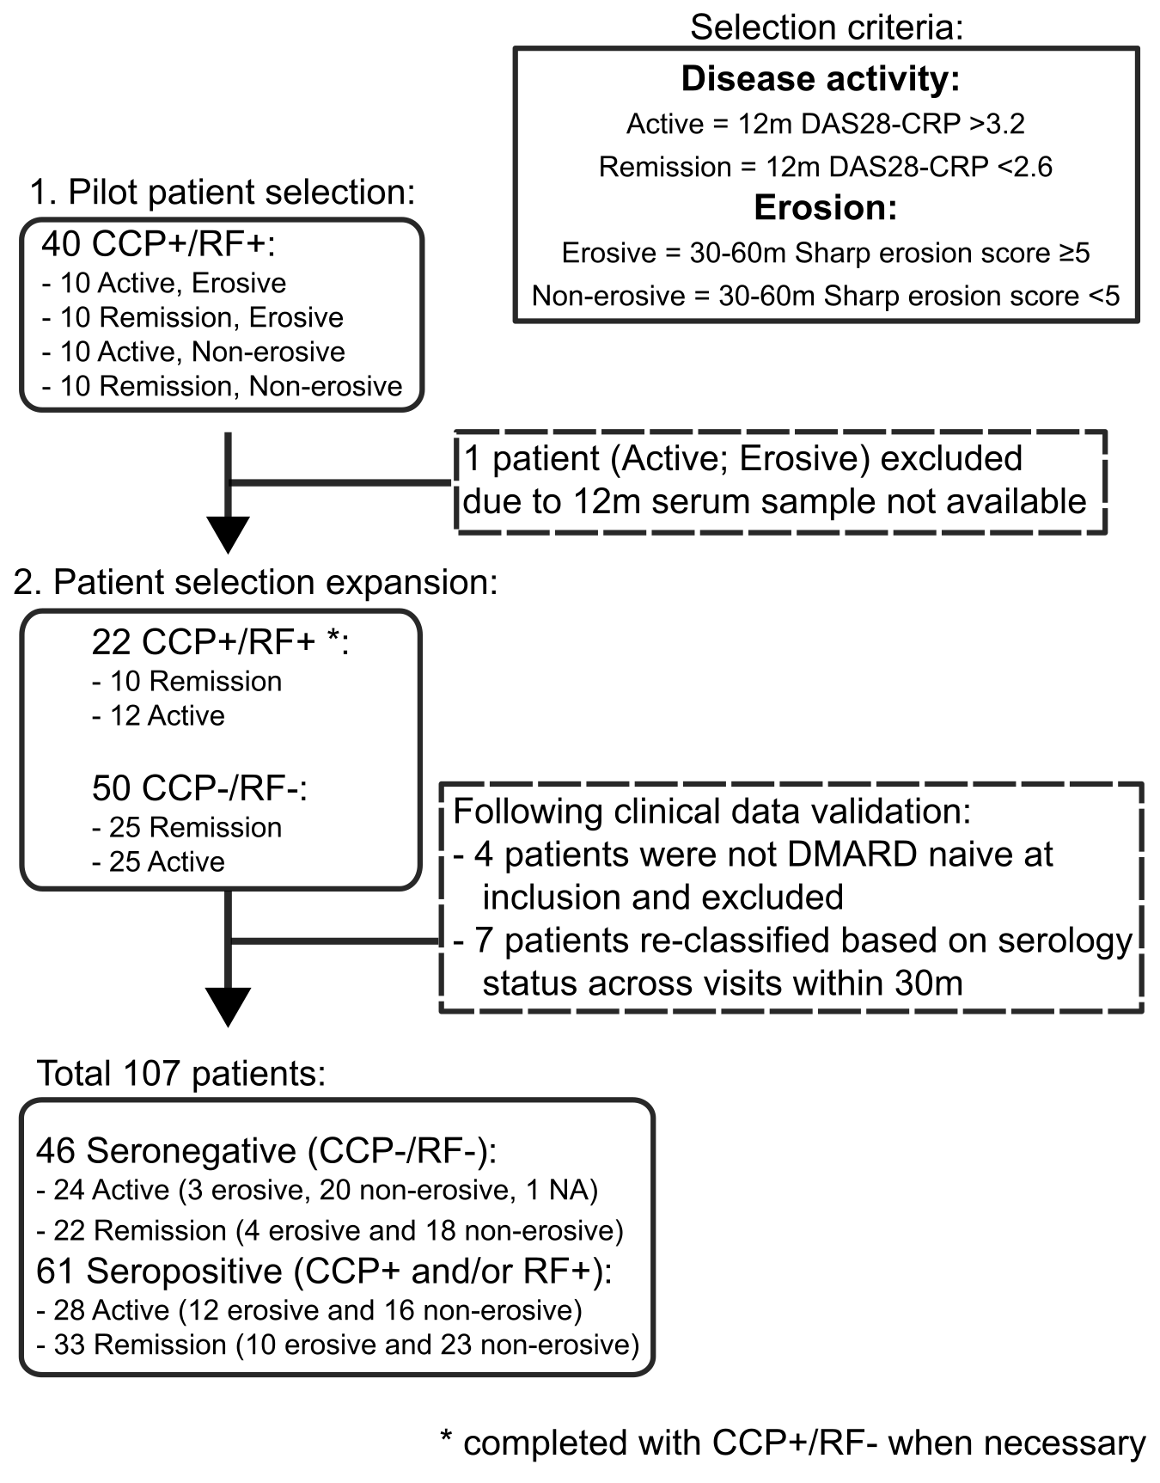

Supplementary Figure 2:

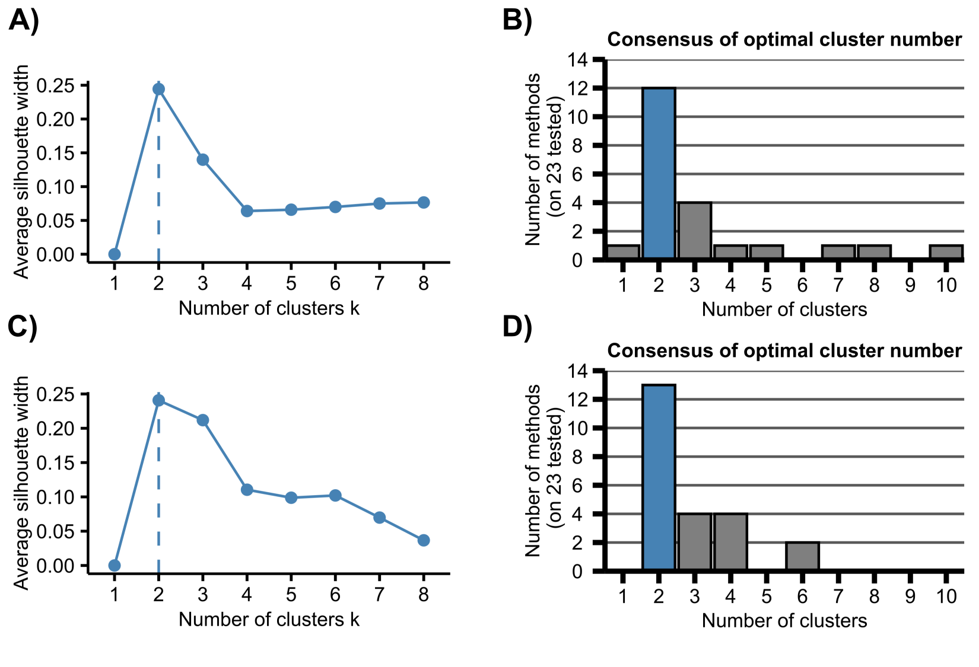

Supplementary Figure 3:

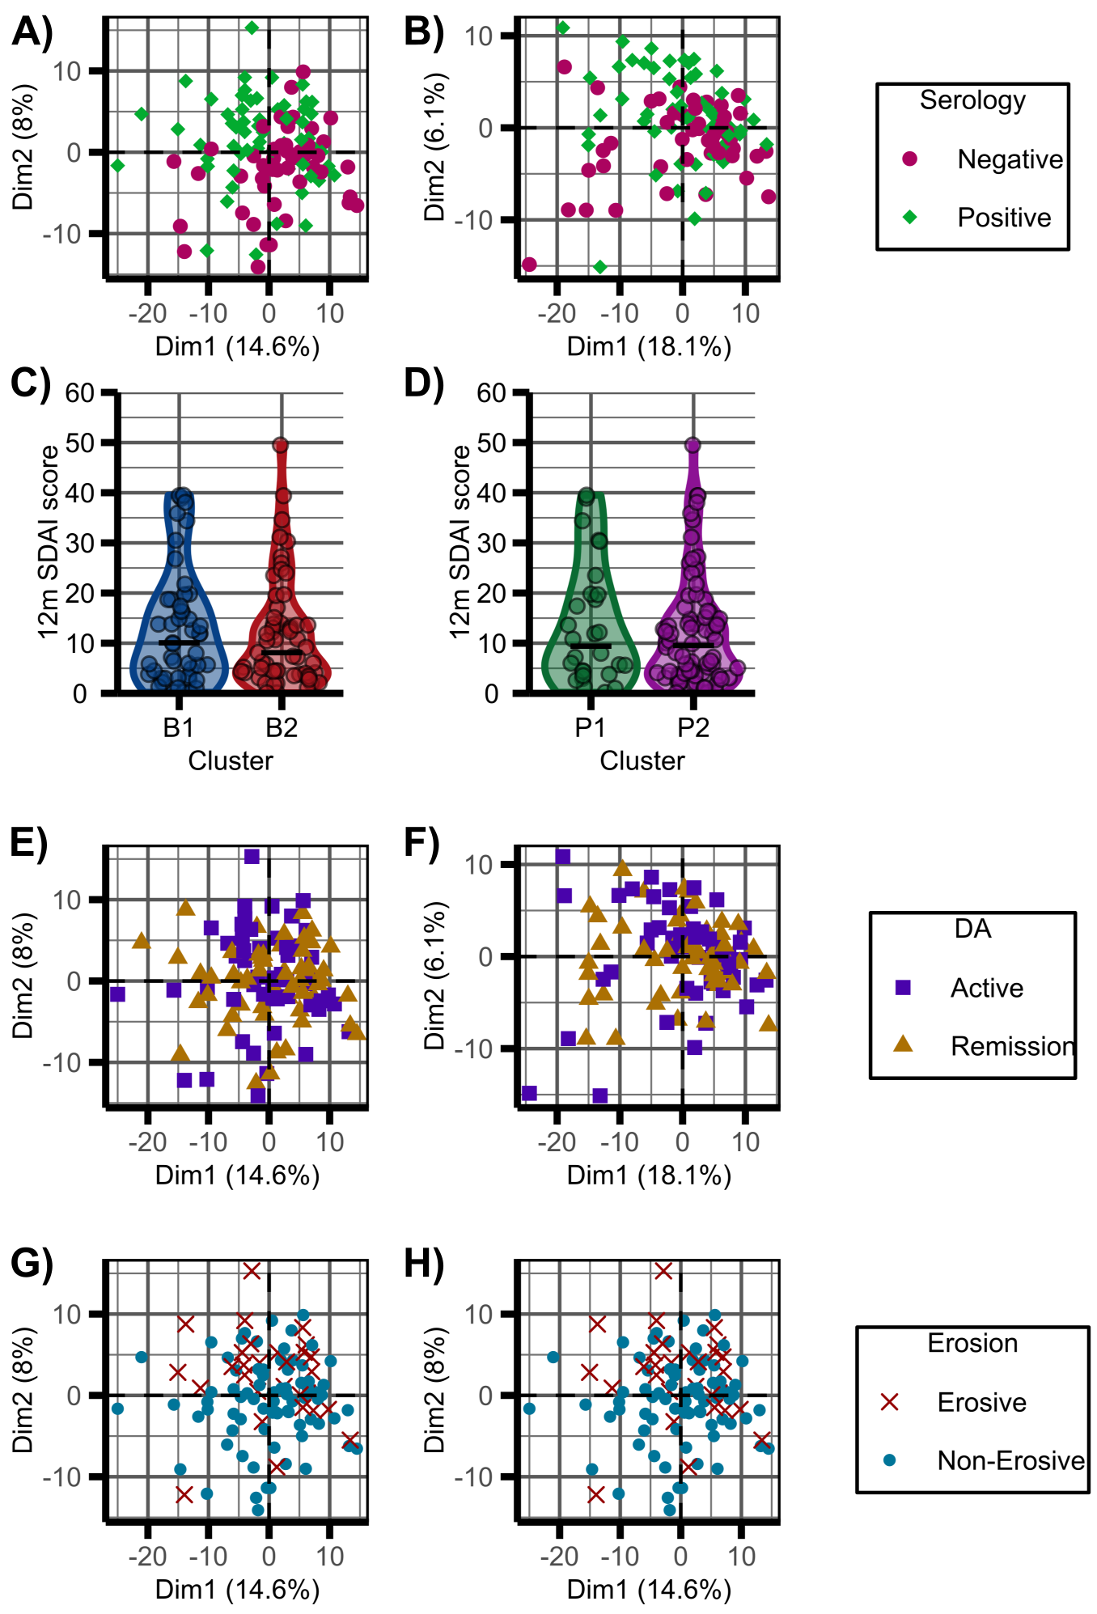

Supplementary Figure 4:

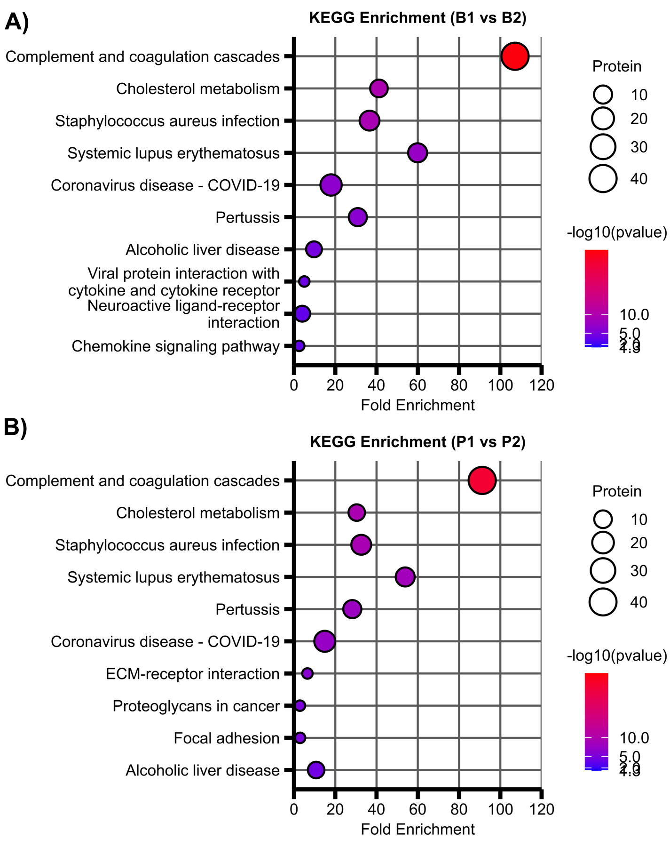
Supplementary Figure 5:

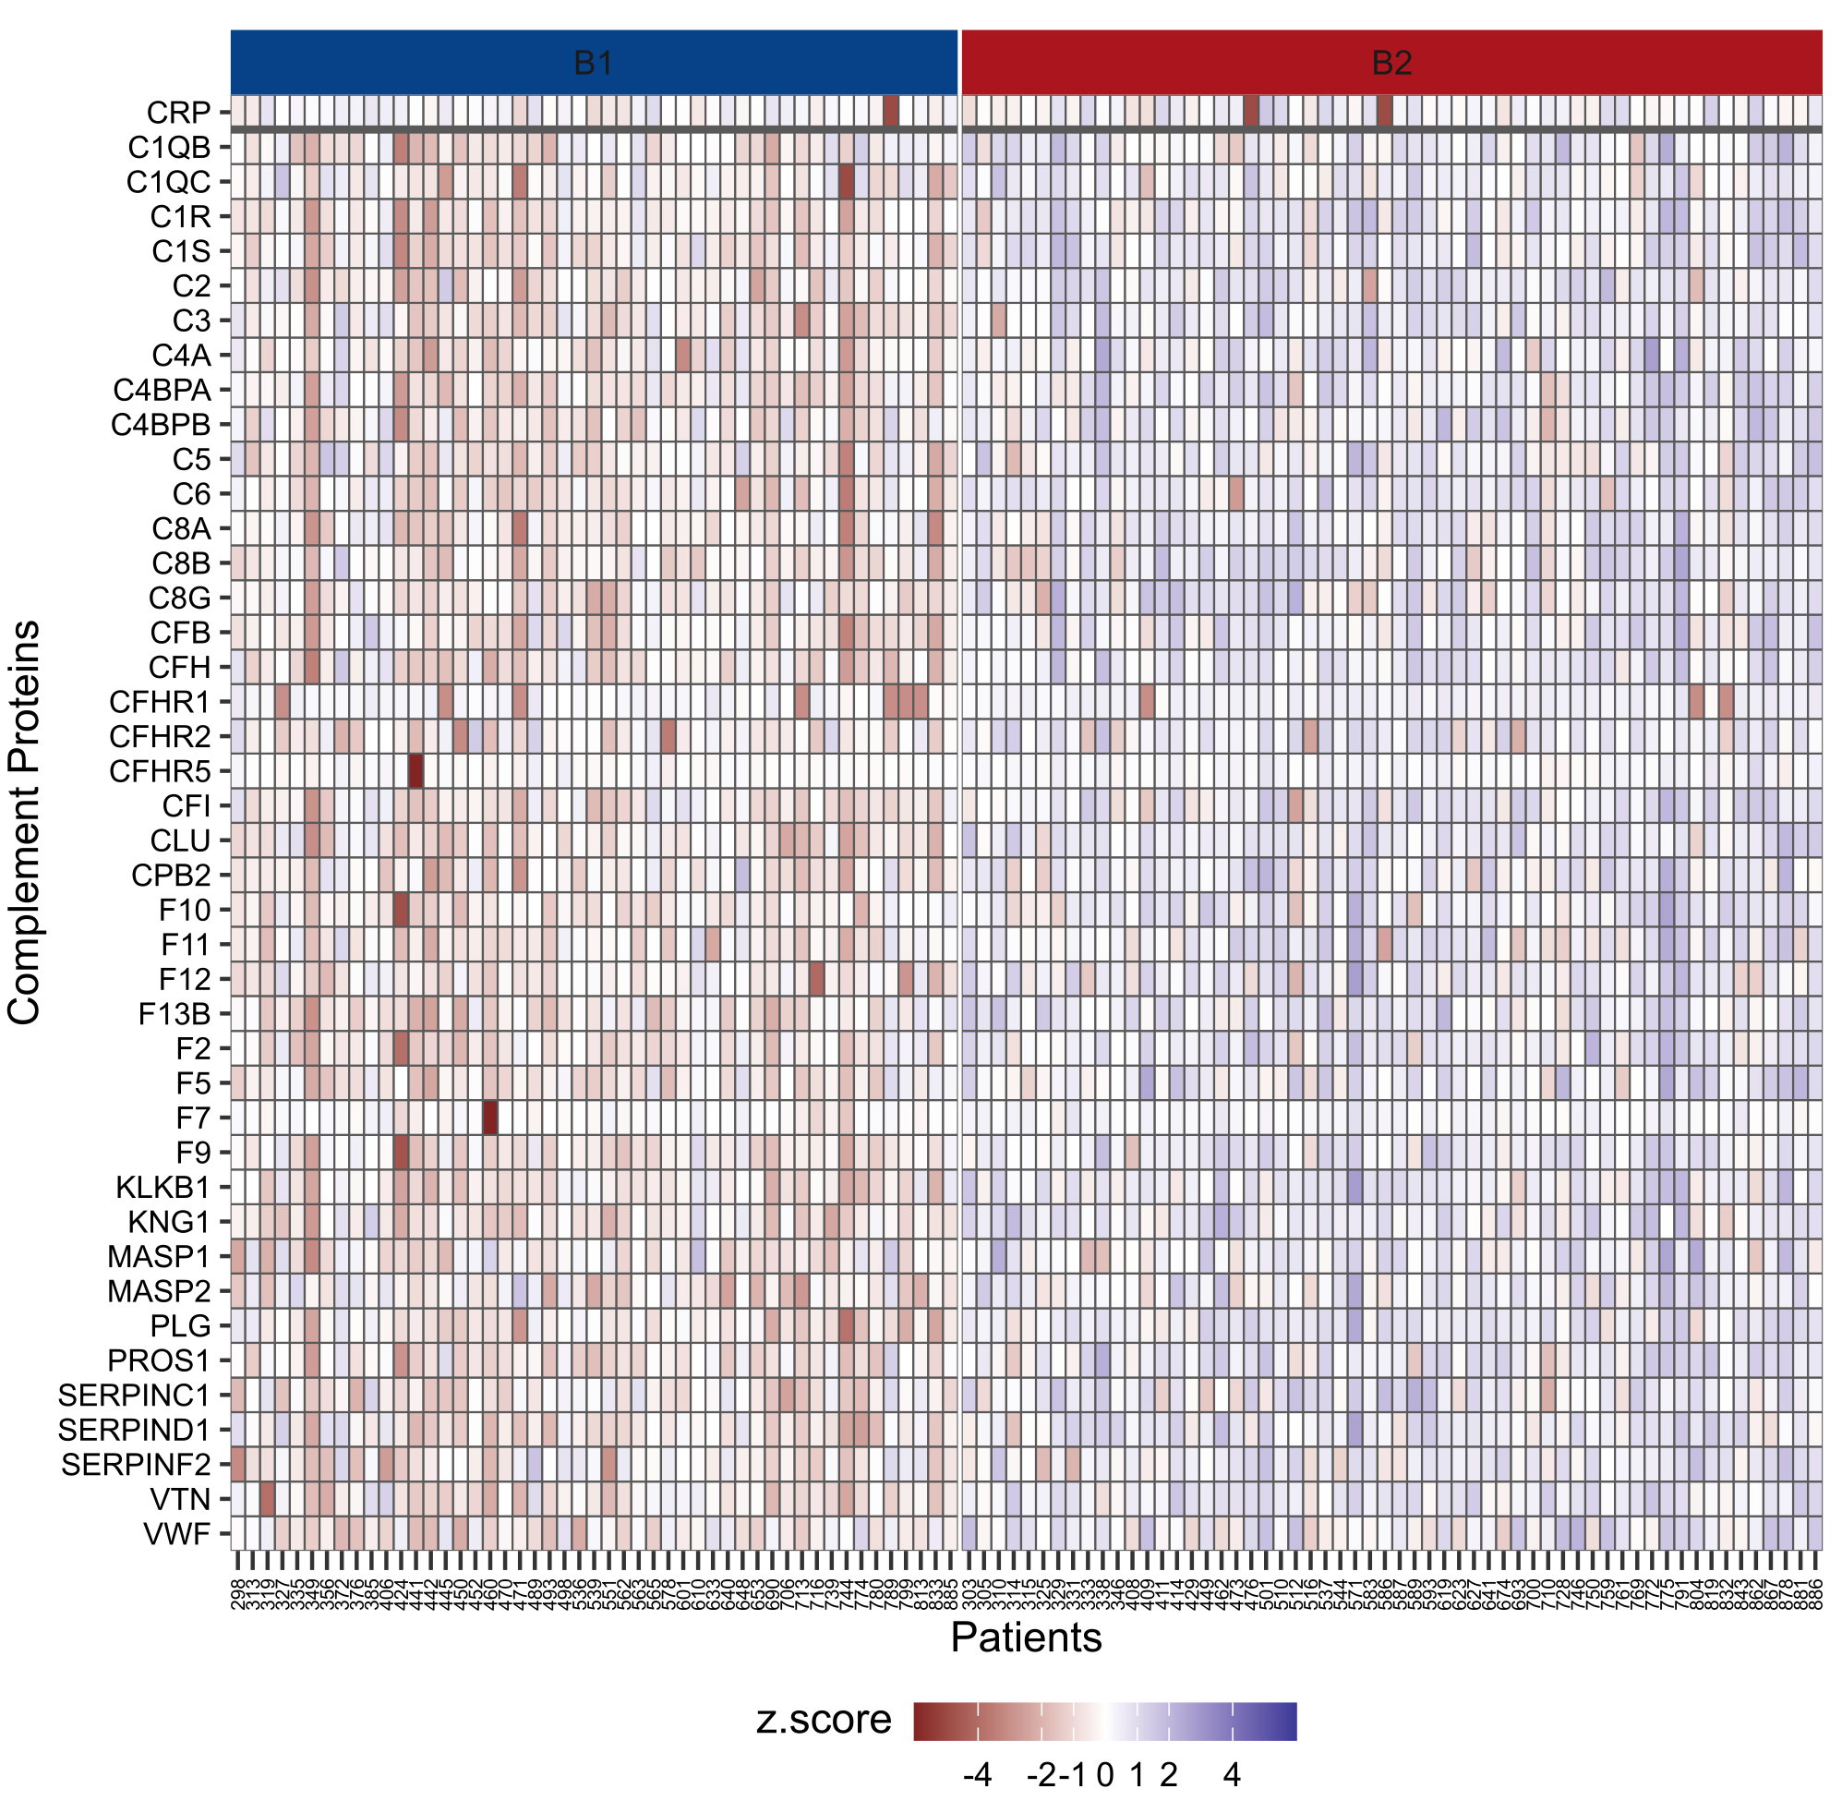

Supplementary Figure 6:

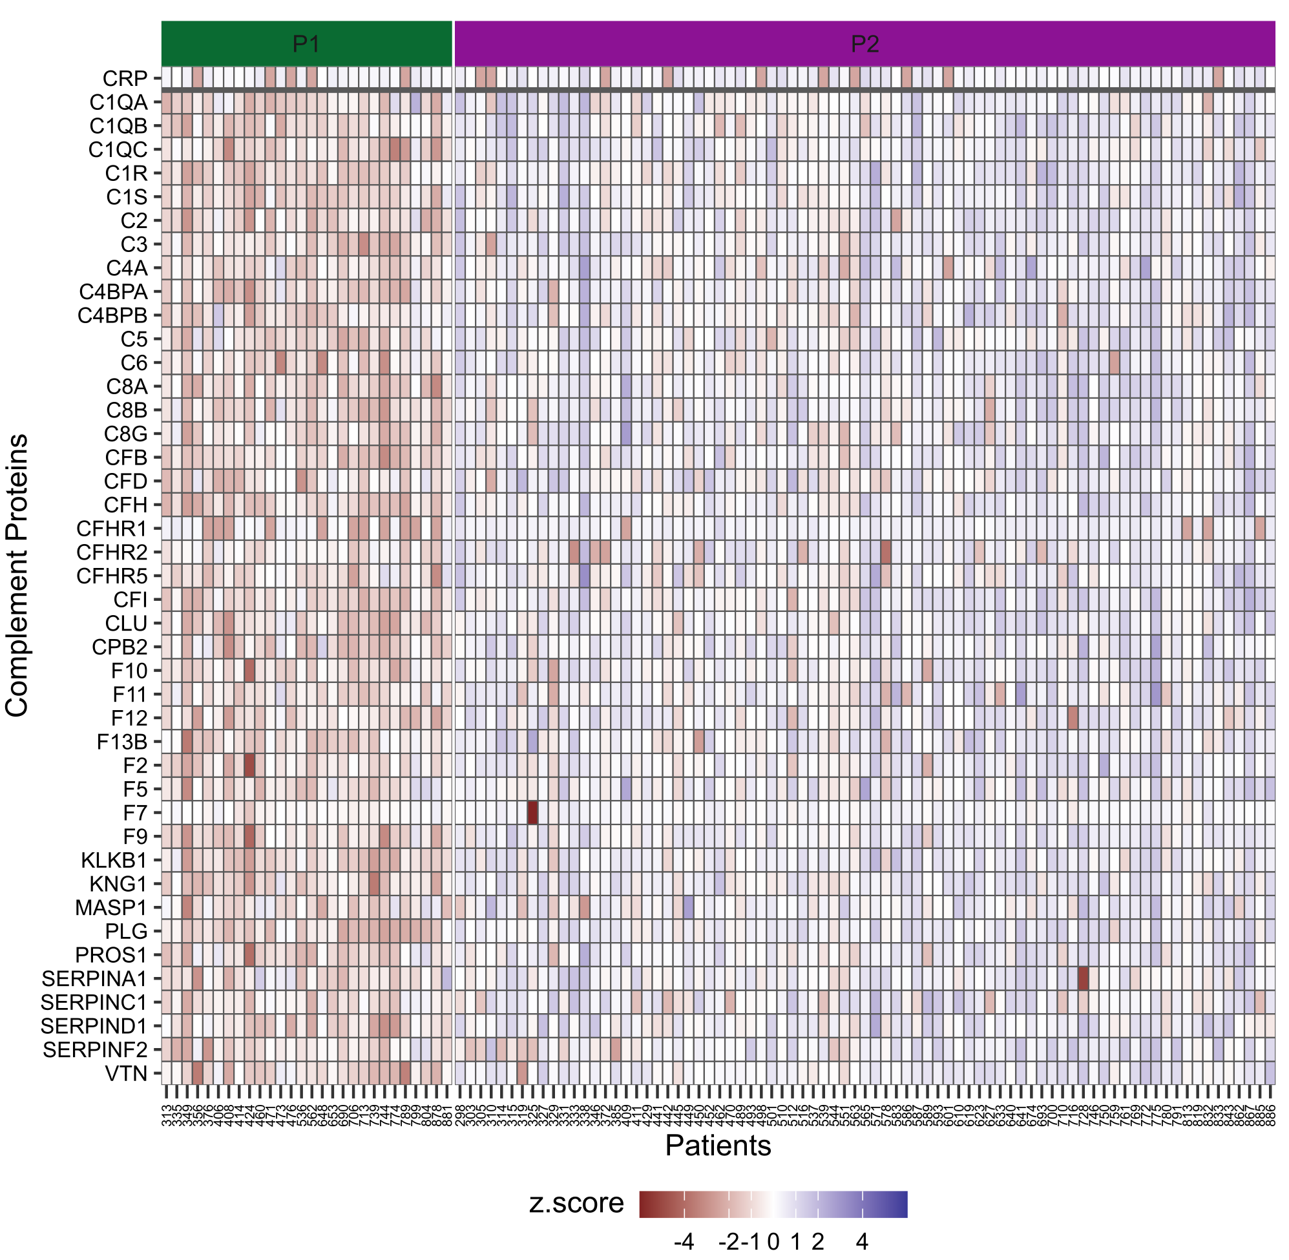
Supplementary Figure 7:

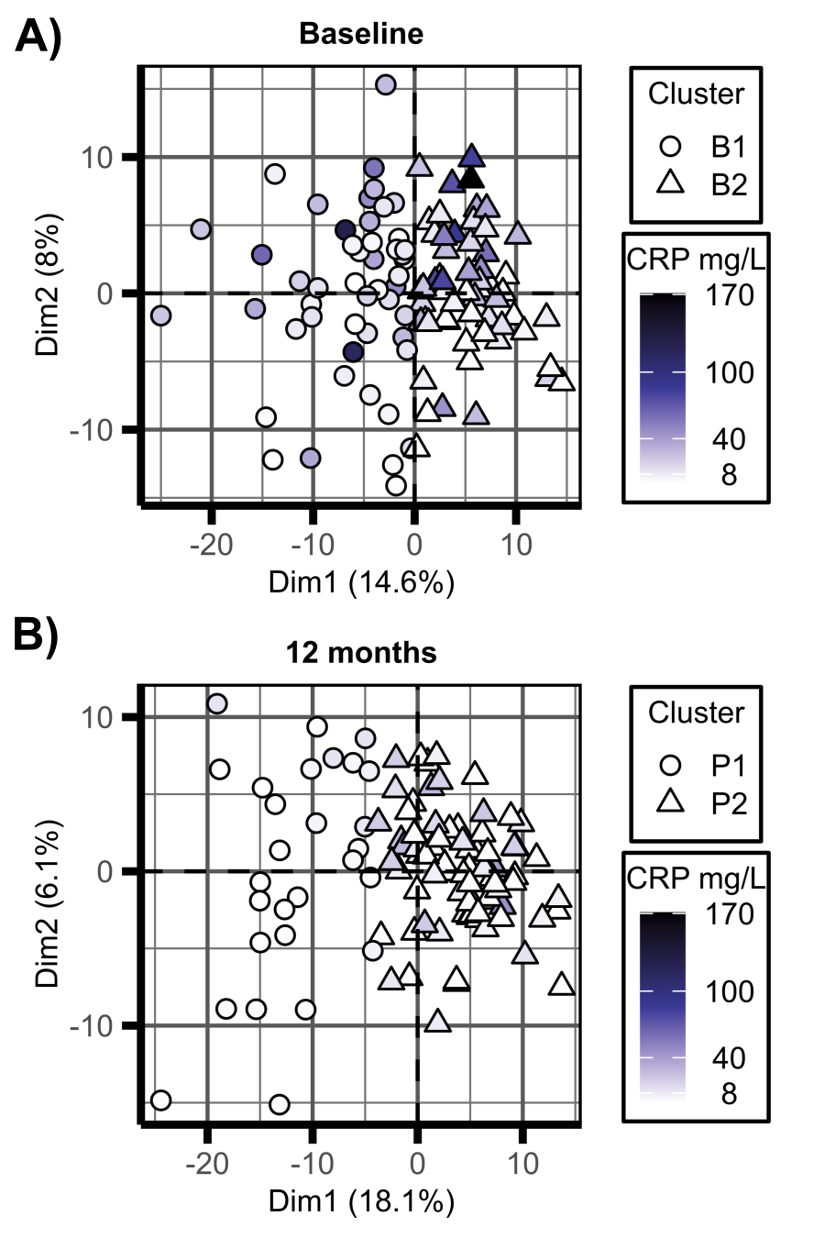

Supplementary Figure 8:

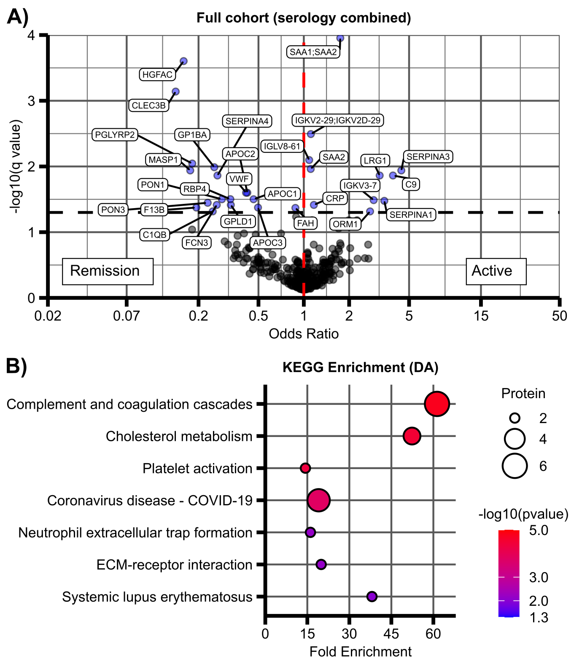
Supplementary Figure 9:

