Supplementary Materials

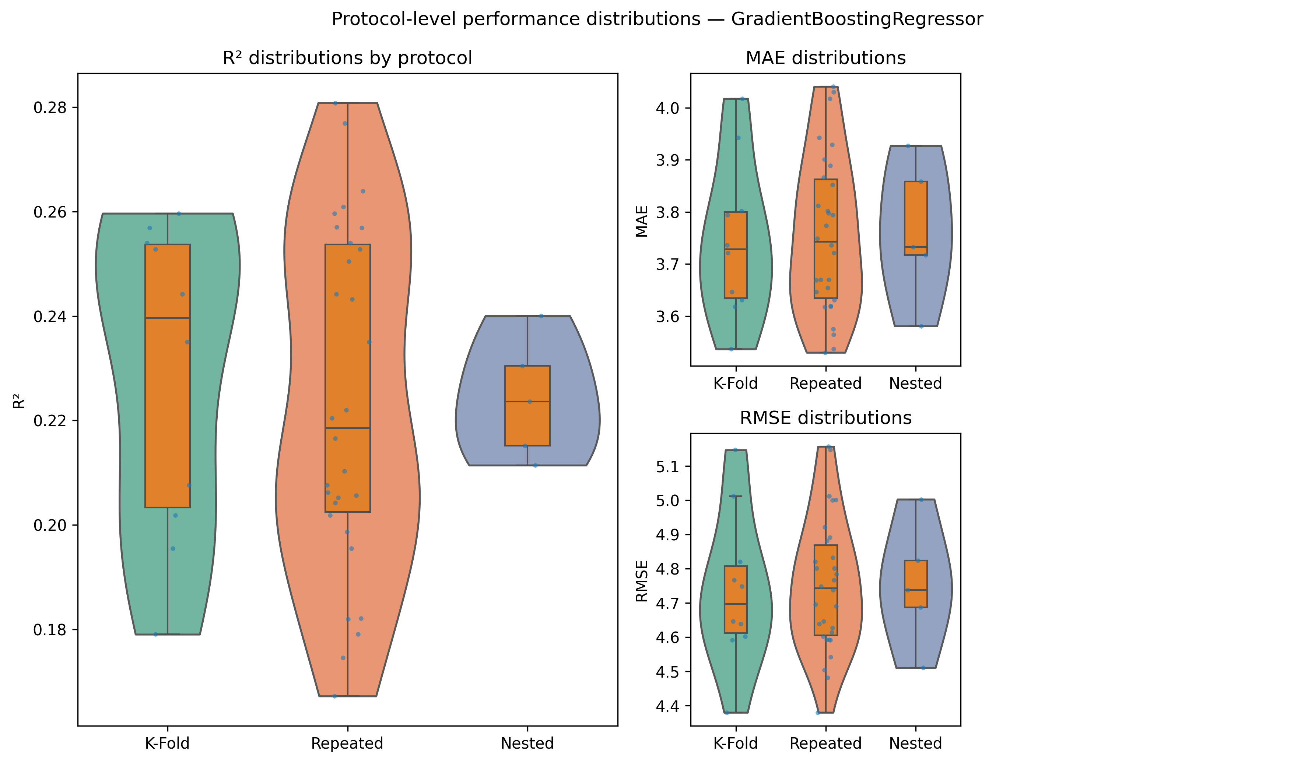
Supplementary Figure S1
Protocol-level performance distributions.
Violin plots display R² (left), MAE (top right), and RMSE (bottom right) for 10-fold K-Fold, Repeated 10-fold CV, and Nested CV. Orange boxplots show medians and IQRs. K-Fold yielded the highest median R², whereas Nested CV exhibited the smallest dispersion; differences were not statistically significant after BH–FDR correction (Supplementary Tables S4–S5). We therefore report 10-fold K-Fold as the primary protocol and use Repeated/Nested CV for sensitivity analyses.
Supplementary Table S1a. Distributional statistics of Happiness Score (mean, SD, quartiles, skewness, kurtosis, Shapiro–Wilk).
Statistic | Value
Mean | 28.564
SD | 5.402
Median | 29.00
Q1 | 25.00
Q3 | 33.00
Min | 9.00
Max | 36.00
Skewness | −0.761
Kurtosis | 0.373
Shapiro–Wilk W | 0.948
p-value | <.001
Supplementary Table S1b. Variable-level missingness in the analytic dataset.
All 20 predictors and the outcome variable exhibited 0% missingness after pre-analysis exclusions (N = 4134 students).
Scope | Variables (n) | Missing (n) | Missing (%)
Predictors | 20 | 0 | 0.0%
Outcome | 1 | 0 | 0.0%
Total | 21 | 0 | 0.0%

Supplementary Table S2. Psychometric properties of the nine-item School Happiness scale (N = 4134).
ITEM | MEAN | SD | FLOOR % | CEILING % | ITEM-TOTAL R | FACTOR LOADING (1F)
M1 | 3.02 | 1.03 | 9 | 45 | 0.64 | 0.73
M2 | 2.7 | 1.08 | 15 | 33 | 0.59 | 0.69
M3 | 2.63 | 1.05 | 15 | 28 | 0.57 | 0.67
M4 | 3.08 | 0.96 | 6 | 44 | 0.54 | 0.65
M5 | 3.45 | 0.76 | 4 | 57 | 0.4 | 0.52
M6 | 3.59 | 0.76 | 4 | 71 | 0.56 | 0.69
M7 | 3.09 | 0.95 | 11 | 39 | 0.53 | 0.65
M8 | 3.49 | 0.84 | 6 | 66 | 0.5 | 0.63
M9 | 3.52 | 0.77 | 4 | 65 | 0.52 | 0.65
CRONBACH’S Α |  |  |  |  |  | 0.8
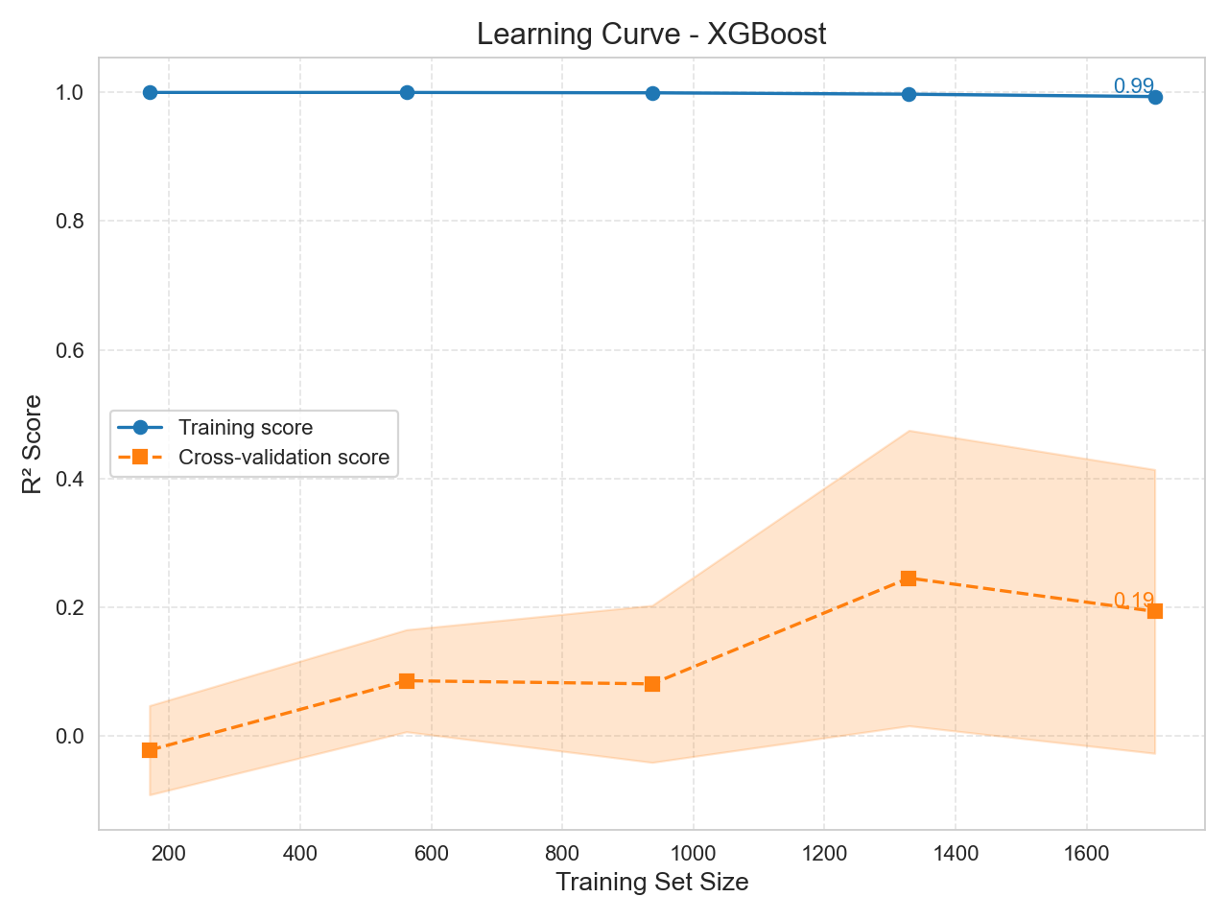
Supplementary Figure S2a. Learning curve of XGBRegressor showing near-saturation of training R². Panel shows training vs. validation performance (R²) across increasing boosting iterations. Curves plateau near R² ≈ 0.99 on training folds, indicating near-saturation and potential overfitting risk.
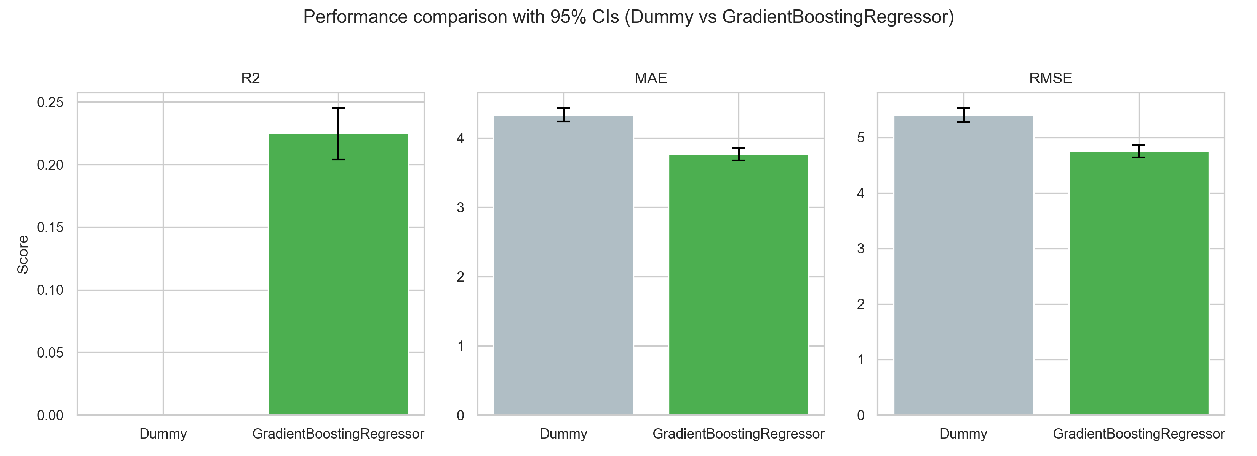
Supplementary Figure S2b. Baseline (DummyRegressor) vs. Gradient Boosting Regressor performance with 95% bootstrap CIs. Bar chart comparing DummyRegressor (mean predictor) against Gradient Boosting Regressor (best performer). R², MAE, and RMSE are displayed with bias-corrected and accelerated (BCa) bootstrap confidence intervals.

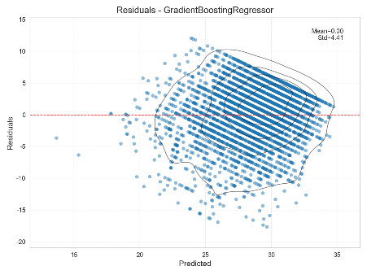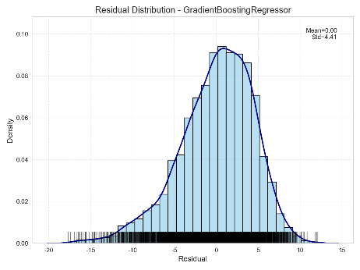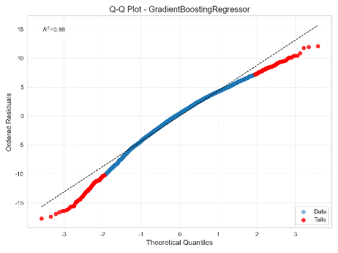
Supplementary Figure S3. Residual diagnostics for Gradient Boosting Regressor (residual–fitted, histogram, Q–Q plot). These diagnostics confirm mild heteroskedasticity and approximate normality of residuals at the center, with heavier tails.

Supplementary Table S3. Baseline vs. Best model performance metrics
This table reports mean cross-validated R², MAE, and RMSE for the DummyRegressor (mean predictor baseline) and the best-performing model (Gradient Boosting Regressor). Values represent out-of-fold predictions under the primary 10-fold CV regime.
MODEL | R2 | R2_CI_LOW | R2_CI_HIGH | MAE | MAE_CI_LOW | MAE_CI_HIGH | RMSE | RMSE_CI_LOW | RMSE_CI_HIGH
DummyRegressor(mean) | -0.0006732780512410663 | -0.0019974948259009195 | -0.0002577734738493543 | 4.334461728510901 | 4.234350740246228 | 4.433033356399589 | 5.403594630832395 | 5.27770030347875 | 5.530174053974853
GradientBoostingRegressor | 0.233983164352145321 | 0.203990470113694263 | 0.245113253795991942 | 3.700492126498491 | 3.675086110148004 | 3.854849044449318 | 4.719097228152426 | 4.639657392736935 | 4.866270970982543

Supplementary Table S4a. Compact FDR summary of protocol comparisons.
Minimum and maximum Benjamini–Hochberg adjusted p-values across metrics (R², MAE, RMSE).
No differences were significant at α = 0.05.
METRIC | MIN ADJ. P | MAX ADJ. P | SIGNIFICANT (α=0.05)
MAE | 0.625 | 1.0 | Not Significant
R² | 0.332 | 1.0 | Not Significant
RMSE | 0.326 | 1.0 | Not Significant

Supplementary Table S4b. Full FDR-adjusted pairwise tests.
Pairwise comparisons between resampling protocols (10-fold K-Fold, Repeated K-Fold, Nested CV). Values include raw p-values, adjusted p-values, and H₀ rejection status.
METRIC | COMPARISON | RAW P-VALUE | FDR ADJ. P | REJECT H0
R² | KFold vs. Repeated | 1.0 | 1.0 | False
R² | KFold vs. Nested | 0.1755809852410919 | 0.3315473496881443 | False
R² | Repeated vs. Nested | 0.2210315664587629 | 0.3315473496881443 | False
RMSE | KFold vs. Repeated | 1.0 | 1.0 | False
RMSE | KFold vs. Nested | 0.1719919217016319 | 0.32567179671084 | False
RMSE | Repeated vs. Nested | 0.21711453114056 | 0.32567179671084 | False
MAE | KFold vs. Repeated | 1.0 | 1.0 | False
MAE | KFold vs. Nested | 0.3663492979615572 | 0.6254318862892301 | False
MAE | Repeated vs. Nested | 0.4169545908594867 | 0.6254318862892301 | False

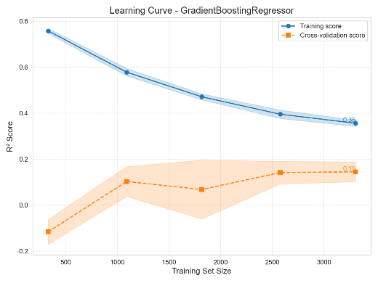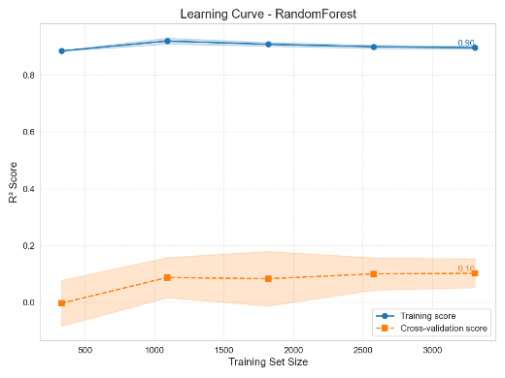
Supplementary Figure S4. Learning curves for RandomForest and Gradient Boosting Regressor.
Cross-validated $R^{2}$increased rapidly up to ~40 % of training data and stabilized near 0.23 for both models at full data, matching Table 1 results.
Early points (10–30 %) yielded lower $R^{2}$≈ 0.10–0.15, indicating initial underfitting before convergence.

Supplementary S5. Pairwise protocol tests and explainability stability
Supplementary Table S5. Corrected pairwise t-tests across CV protocols
Corrected repeated t-tests (Nadeau & Bengio, 2003) comparing K-Fold, Repeated K-Fold, and Nested CV protocols for R², MAE, and RMSE. Raw and FDR-adjusted p-values are reported alongside the decision to reject the null hypothesis (H₀). No contrasts reached significance (all FDR-adjusted p ≥ 0.33).
METRIC | COMPARISON | T_STAT | RAW_P | FDR_P | REJECT_H0
R2 | KFold vs. Repeated | 0.0 | 1.0 | 1.0 | False
R2 | KFold vs. Nested | 0.12679128308110496 | 0.9107031901786196 | 1.0 | False
R2 | Repeated vs. Nested | 0.10812796952215425 | 0.9237644846961541 | 1.0 | False
RMSE | KFold vs. Repeated | 0.0 | 1.0 | 1.0 | False
RMSE | KFold vs. Nested | -0.9351288628028848 | 0.44843985836163736 | 0.7632151175392976 | False
RMSE | Repeated vs. Nested | -0.7974805737375293 | 0.5088100783595317 | 0.7632151175392976 | False
MAE | KFold vs. Repeated | 0.0 | 1.0 | 1.0 | False
MAE | KFold vs. Nested | -1.2676620821043052 | 0.332528992541145 | 0.5890330602256082 | False
MAE | Repeated vs. Nested | -1.08106585600593 | 0.39268870681707213 | 0.5890330602256082 | False

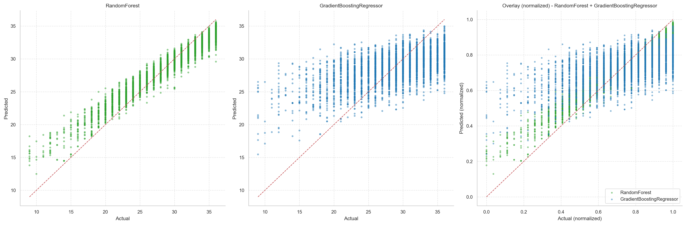
Supplementary Figure S5. Predicted vs. observed happiness scores for the two best-performing models.
Left: Random Forest; middle: Gradient Boosting Regressor; right: normalized overlay of both models. Each model is fit on the full dataset and predictions are plotted against the corresponding observed scores (dashed red line: 45° identity; solid black line: least-squares fit). Both models show moderate concordance, with greater dispersion at higher scores consistent with heteroskedasticity. In the normalized overlay, Gradient Boosting tracks the identity more closely across the range, aligning with its superior out-of-sample performance reported in Table S3a.
Supplementary S6. Model assumptions and calibration slopes
Supplementary Table S6a. Breusch–Pagan heteroskedasticity test results
The Breusch–Pagan test rejected the null hypothesis of homoskedasticity for Gradient Boosting Regressor residuals, indicating heteroskedastic variance. Both LM and F statistics were highly significant (p < .001).
Test | Statistic | df1 | df2 | p-value | Note
LM | 99.835 | — | — | 2.16 × 10⁻⁸ | Breusch–Pagan
F | 4.139 | — | — | 3.44 × 10⁻¹¹ | Breusch–Pagan

Supplementary Table S6b. Calibration intercepts and slopes
Calibration slopes and intercepts quantify proportionality and bias between predicted and observed outcomes
MODEL | INTERCEPT | SLOPE | R² (PRED VS OBS) | R² (TRAIN) | R² (CV) | ΔR² (TRAIN – CV)
GradientBoostingRegressor | -3.63 | 1.13 | 0.23 | 0.337 | 0.229 | 0.109
RandomForest | 0.66 | 0.98 | 0.232 | 0.896 | 0.231 | 0.662

Supplementary Table S7a. Gradient Boosting Regressor – binned calibration metrics
Observed and predicted outcome means by decile of predicted values. Errors (MAE, RMSE) quantify calibration fit within each bin.
BIN | N | Y_MEAN | YHAT_MEAN | MAE | RMSE | BIN_LEFT | BIN_RIGHT | BIN_RANGE
0 | 414 | 23.14 | 24.12 | 4.32 | 5.53 | 14.95 | 25.57 | 14.95-25.57
1 | 413 | 25.81 | 26.2 | 4.21 | 5.27 | 25.57 | 26.75 | 25.57-26.75
2 | 413 | 27.23 | 27.17 | 4.31 | 5.43 | 26.75 | 27.58 | 26.75-27.58
3 | 414 | 28.08 | 27.88 | 4.03 | 5.04 | 27.58 | 28.2 | 27.58-28.20
4 | 413 | 28.25 | 28.46 | 3.69 | 4.66 | 28.2 | 28.74 | 28.20-28.74
5 | 413 | 29.42 | 29.02 | 3.74 | 4.69 | 28.74 | 29.3 | 28.74-29.30
6 | 414 | 29.73 | 29.58 | 3.66 | 4.57 | 29.3 | 29.87 | 29.30-29.87
7 | 413 | 30.38 | 30.16 | 3.37 | 4.25 | 29.87 | 30.49 | 29.87-30.49
8 | 413 | 31.27 | 30.93 | 3.19 | 3.94 | 30.49 | 31.38 | 30.49-31.38
9 | 414 | 32.33 | 32.25 | 2.92 | 3.65 | 31.38 | 35.04 | 31.38-35.04

Supplementary Table S7b. Random Forest – binned calibration metrics
BIN | N | Y_MEAN | YHAT_MEAN | MAE | RMSE | BIN_LEFT | BIN_RIGHT | BIN_RANGE
0 | 414 | 22.8 | 23.34 | 4.07 | 5.35 | 15.58 | 25.1 | 15.58-25.10
1 | 413 | 26.05 | 25.88 | 4.02 | 5.16 | 25.1 | 26.55 | 25.10-26.55
2 | 421 | 27.73 | 27.02 | 4.03 | 4.99 | 26.55 | 27.43 | 26.55-27.43
3 | 410 | 28.31 | 27.8 | 3.96 | 5.02 | 27.43 | 28.14 | 27.43-28.14
4 | 411 | 28.18 | 28.51 | 3.85 | 4.98 | 28.14 | 28.85 | 28.14-28.85
5 | 414 | 28.99 | 29.19 | 3.78 | 4.87 | 28.85 | 29.5 | 28.85-29.50
6 | 413 | 29.98 | 29.82 | 3.47 | 4.41 | 29.5 | 30.15 | 29.50-30.15
7 | 418 | 30.26 | 30.48 | 3.33 | 4.21 | 30.15 | 30.79 | 30.15-30.79
8 | 406 | 30.99 | 31.26 | 3.35 | 4.41 | 30.79 | 31.8 | 30.79-31.80
9 | 414 | 32.4 | 32.66 | 2.93 | 3.7 | 31.8 | 35.2 | 31.80-35.20

Supplementary Table S8. Combined feature importance (raw and normalized values)
Raw importances from Random Forest (RF) and Gradient Boosting Regressor, normalized within each learner (0–100), and their averaged combined index. The combined index provides a model-agnostic ranking of predictors.
feature | rf_importance | gbr_importance | rf_norm100 | gbr_norm100 | combined_mean
bullying_score | 0.59 | 0.17 | 100 | 100 | 100
monthly_books_read | 0.29 | 0.06 | 49.54 | 34.17 | 41.86
region | 0.27 | 0.07 | 44.62 | 38.92 | 41.77
daily_mobile_usage | 0.25 | 0.04 | 42.81 | 26.28 | 34.54
gender | 0.25 | 0.05 | 42.09 | 26.63 | 34.36
teacher_intervention | 0.14 | 0.04 | 23.95 | 21.68 | 22.81
daily_tv_time | 0.11 | 0.01 | 19.31 | 8.75 | 14.03
mother_education_level | 0.11 | 0.02 | 18.44 | 9.54 | 13.99
father_education_level | 0.10 | 0.01 | 16.57 | 8.40 | 12.49
age | 0.09 | 0.01 | 14.67 | 5.58 | 10.13
reporting_to_family | 0.04 | 0.02 | 7.01 | 13.02 | 10.01
household_size | 0.07 | 0.01 | 11.21 | 6.58 | 8.90
number_of_siblings | 0.06 | 0.01 | 10.55 | 6.06 | 8.31
grade_level | 0.07 | 0.01 | 11.92 | 4.28 | 8.10
sibling_order | 0.07 | 0.01 | 12.15 | 3.51 | 7.83
mother_occupation | 0.05 | 0.00 | 7.67 | 2.57 | 5.12
household_income | 0.04 | 0.00 | 7.43 | 1.68 | 4.56
parental_marital_status | 0.01 | 0.00 | 2.39 | 2.68 | 2.54
father_occupation | 0.01 | 0.00 | 2.28 | 1.41 | 1.85
nationality | 0.00 | 0.00 | 0.14 | 0.00 | 0.07

Supplementary Table S9. Top-10 inclusion frequencies.
This table reports the frequency with which each feature entered the top-10 ranked predictors across 1,000 bootstrap replications. High inclusion frequency indicates stability of feature relevance across resampled datasets, providing a complementary measure of robustness to the importance indices shown in Supplementary S8.
bullying_score | 1,000 | 1
region | 1,000 | 1
monthly_books_read | 1,000 | 1
gender | 1,000 | 1
daily_mobile_usage | 999 | 1.00
teacher_intervention | 957 | 0.96
daily_tv_time | 661 | 0.66
mother_education_level | 604 | 0.60
father_education_level | 569 | 0.57
age | 408 | 0.41
reporting_to_family | 351 | 0.35
household_size | 297 | 0.30
grade_level | 288 | 0.29
number_of_siblings | 276 | 0.28
sibling_order | 211 | 0.21
mother_occupation | 123 | 0.12
household_income | 108 | 0.11
father_occupation | 59 | 0.06
parental_marital_status | 54 | 0.05
nationality | 35 | 0.04

Supplementary Table S10. Computational environment and model hyperparameters. Panel A details the software and hardware environment. Panel B lists the exact hyperparameters for the top-performing models (Gradient Boosting Regressor and Random Forest) to ensure reproducibility. Parameters not listed retained their default values in scikit-learn v1.7.2.
Panel A: Software Environment
Component | Version | Notes
Python | 3.11.9 | Windows-11
NumPy | 2.2.6 | Numerical computing
Pandas | 2.3.2 | Data manipulation
Scikit-learn | 1.7.2 | Machine learning estimators
XGBoost | 3.0.5 | Gradient boosting reference

Panel B: Model Hyperparameters
Model | Parameter | Value | Description
Gradient Boosting | n_estimators | 100 | Number of boosting stages to perform
Regressor (GBR) | learning_rate | 0.1 | Contribution of each tree (shrinkage)
 | max_depth | 3 | Maximum depth of individual regression estimators
 | subsample | 1.0 | Fraction of samples used for fitting learner
 | min_samples_split | 2 | Minimum samples required to split an internal node
 | loss | 'squared_error' | Loss function optimized (Least Squares)
 | random_state | 42 | Random seed for reproducibility
Random Forest | n_estimators | 500 | Number of trees in the forest
Regressor (RF) | max_depth | None | Nodes are expanded until all leaves are pure
 | max_features | 1.0 | Percentage of features to consider (100%)
 | min_samples_leaf | 1 | Minimum number of samples at a leaf node
 | random_state | 42 | Random seed for bootstrapping and sampling
Global Settings | RSTATE | 42 | Global random seed for all stochastic processes
 | CV_FOLDS | 10 | Cross-validation strategy (K-Fold) used in Table 1

Supplementary Table S11. Gradient Boosting Regressor SHAP summary statistics for the top predictors of School Happiness.
This table reports mean absolute SHAP values (|SHAP|) for the predictors, averaged across 10-fold cross-validation folds. Larger |SHAP| values indicate stronger contributions to the model’s predictions.
feature | pretty | mean_abs_shap
bullying_score | Bullying: Score | 1.036828
gender | Gender | 0.703017
monthly_books_read | Monthly: Books Read | 0.646042
daily_mobile_usage | Daily: Mobile Usage | 0.620987
region | Region | 0.50344
teacher_intervention | Teacher: Intervention | 0.476115
mother_education_level | Mother: Education Level | 0.255657
reporting_to_family | Reporting: To Family | 0.238621
father_education_level | Father: Education Level | 0.202985
daily_tv_time | Daily: TV Time | 0.194864
age | Age | 0.137716
mother_occupation | Mother: Occupation | 0.11848
grade_level | Grade: Level | 0.113417
parental_marital_status | Parental: Marital Status | 0.072395
number_of_siblings | Number: Of Siblings | 0.06651
sibling_order | Sibling: Order | 0.058131
household_size | Household: Size | 0.057927
household_income | Household: Income | 0.040454
father_occupation | Father: Occupation | 0.019859
nationality | Nationality | 0

Supplementary Table S12. Little’s MCAR test results for the raw versus analytic dataset schema.
The raw schema showed minimal missingness but formally deviated from MCAR assumptions. After the pre-specified exclusions, the analytic modeling matrix contained no missing values, rendering MCAR testing inapplicable by definition.
DATASET_SCOPE | CHI2 | DF | P_VALUE | ROWS | TOTAL_CELLS | TOTAL_MISSING_PCT
RAW_SCHEMA | N/A | N/A | N/A | 4134 | 206700 | 0.00%
ANALYTIC_CLEANED | N/A | N/A | N/A | 4134 | 103350 | 0.00%

Supplementary Table S13. Ordinary Least Squares regression summary (N = 4134).
Dependent variable: School Happiness Score.
PREDICTOR | COEF. | STD. ERR. | T | P>|T| | 95% CI (LOWER) | 95% CI (UPPER)
bullying_score | -0.15402008184641355 | 0.009440847353205767 | -16.31422223918428 | 5.023952846230898e-58 | -0.17252925342943798 | -0.13551091026338913
monthly_books_read | 0.6526652091906837 | 0.06138265589570381 | 10.632730038590005 | 4.5646998334374986e-26 | 0.5323219743422212 | 0.7730084440391463
gender | -1.46556877378905 | 0.15205769705714492 | -9.638241287044307 | 9.348931753868348e-22 | -1.7636841759403785 | -1.1674533716377213
teacher_intervention | 0.5896082620859129 | 0.07139437845890739 | 8.25846901132804 | 1.96804341146316e-16 | 0.44963663120146863 | 0.7295798929703572
daily_mobile_usage | -0.5835309847345225 | 0.07255269370314364 | -8.0428576108021 | 1.137876360005618e-15 | -0.7257735405477044 | -0.44128842892134057
reporting_to_family | -1.0596922570037621 | 0.2233140862829642 | -4.745299656829584 | 2.1527296386658914e-06 | -1.4975087564426783 | -0.6218757575648459
region | 0.14557973529425797 | 0.04065303602908094 | 3.581029844612792 | 0.0003462021509846419 | 0.06587777729388554 | 0.22528169329463038
father_education_level | -0.2669099692203443 | 0.08287842682074305 | -3.2204999474427924 | 0.0012896399185625426 | -0.42939655174467384 | -0.10442338669601478
daily_tv_time | -0.20279962648759353 | 0.07672858812316737 | -2.6430777816744473 | 0.008246795092805034 | -0.3532291959703236 | -0.05237005700486347
mother_occupation | 0.4342337396168004 | 0.1743949192072595 | 2.4899448997177243 | 0.01281551181086677 | 0.09232528987168614 | 0.7761421893619147
age | -0.24462567789505518 | 0.10126065082071428 | -2.415801951818125 | 0.01574393211890002 | -0.4431513706140352 | -0.04609998517607514
parental_marital_status | -0.5532359064102714 | 0.309537986940114 | -1.7872956785666034 | 0.07396337592288883 | -1.1600979281538055 | 0.05362611533326267
household_income | 0.23470788958556293 | 0.1422684289602649 | 1.649753858258434 | 0.09906970502521056 | -0.04421524770875018 | 0.513631026879876
mother_education_level | -0.12626362978720904 | 0.08019423104310983 | -1.5744727288342448 | 0.11545516887175453 | -0.28348773550708384 | 0.030960475932665793
sibling_order | -0.1122534099290827 | 0.08608383140507206 | -1.304001089366809 | 0.19230623708939218 | -0.281024320673613 | 0.0565175008154476
household_size | -0.07892653351598125 | 0.08095436778805906 | -0.9749508973081386 | 0.3296419949592123 | -0.2376409187534091 | 0.07978785172144659
number_of_siblings | -0.05601510776024941 | 0.10162064563955923 | -0.5512177905160214 | 0.5815143492711388 | -0.2552465852061415 | 0.14321636968564272
grade_level | -0.05320841351290351 | 0.11807480853071464 | -0.4506330704661907 | 0.6522777982950302 | -0.28469895763081565 | 0.17828213060500867
nationality | -0.057526739786852805 | 1.1113292980825473 | -0.05176390102025352 | 0.9587193353281867 | -2.2363337783803985 | 2.1212802988066928
father_occupation | 0.003148211187605939 | 0.2951164021457687 | 0.010667693034733203 | 0.991489091611603 | -0.5754396972829249 | 0.5817361196581367

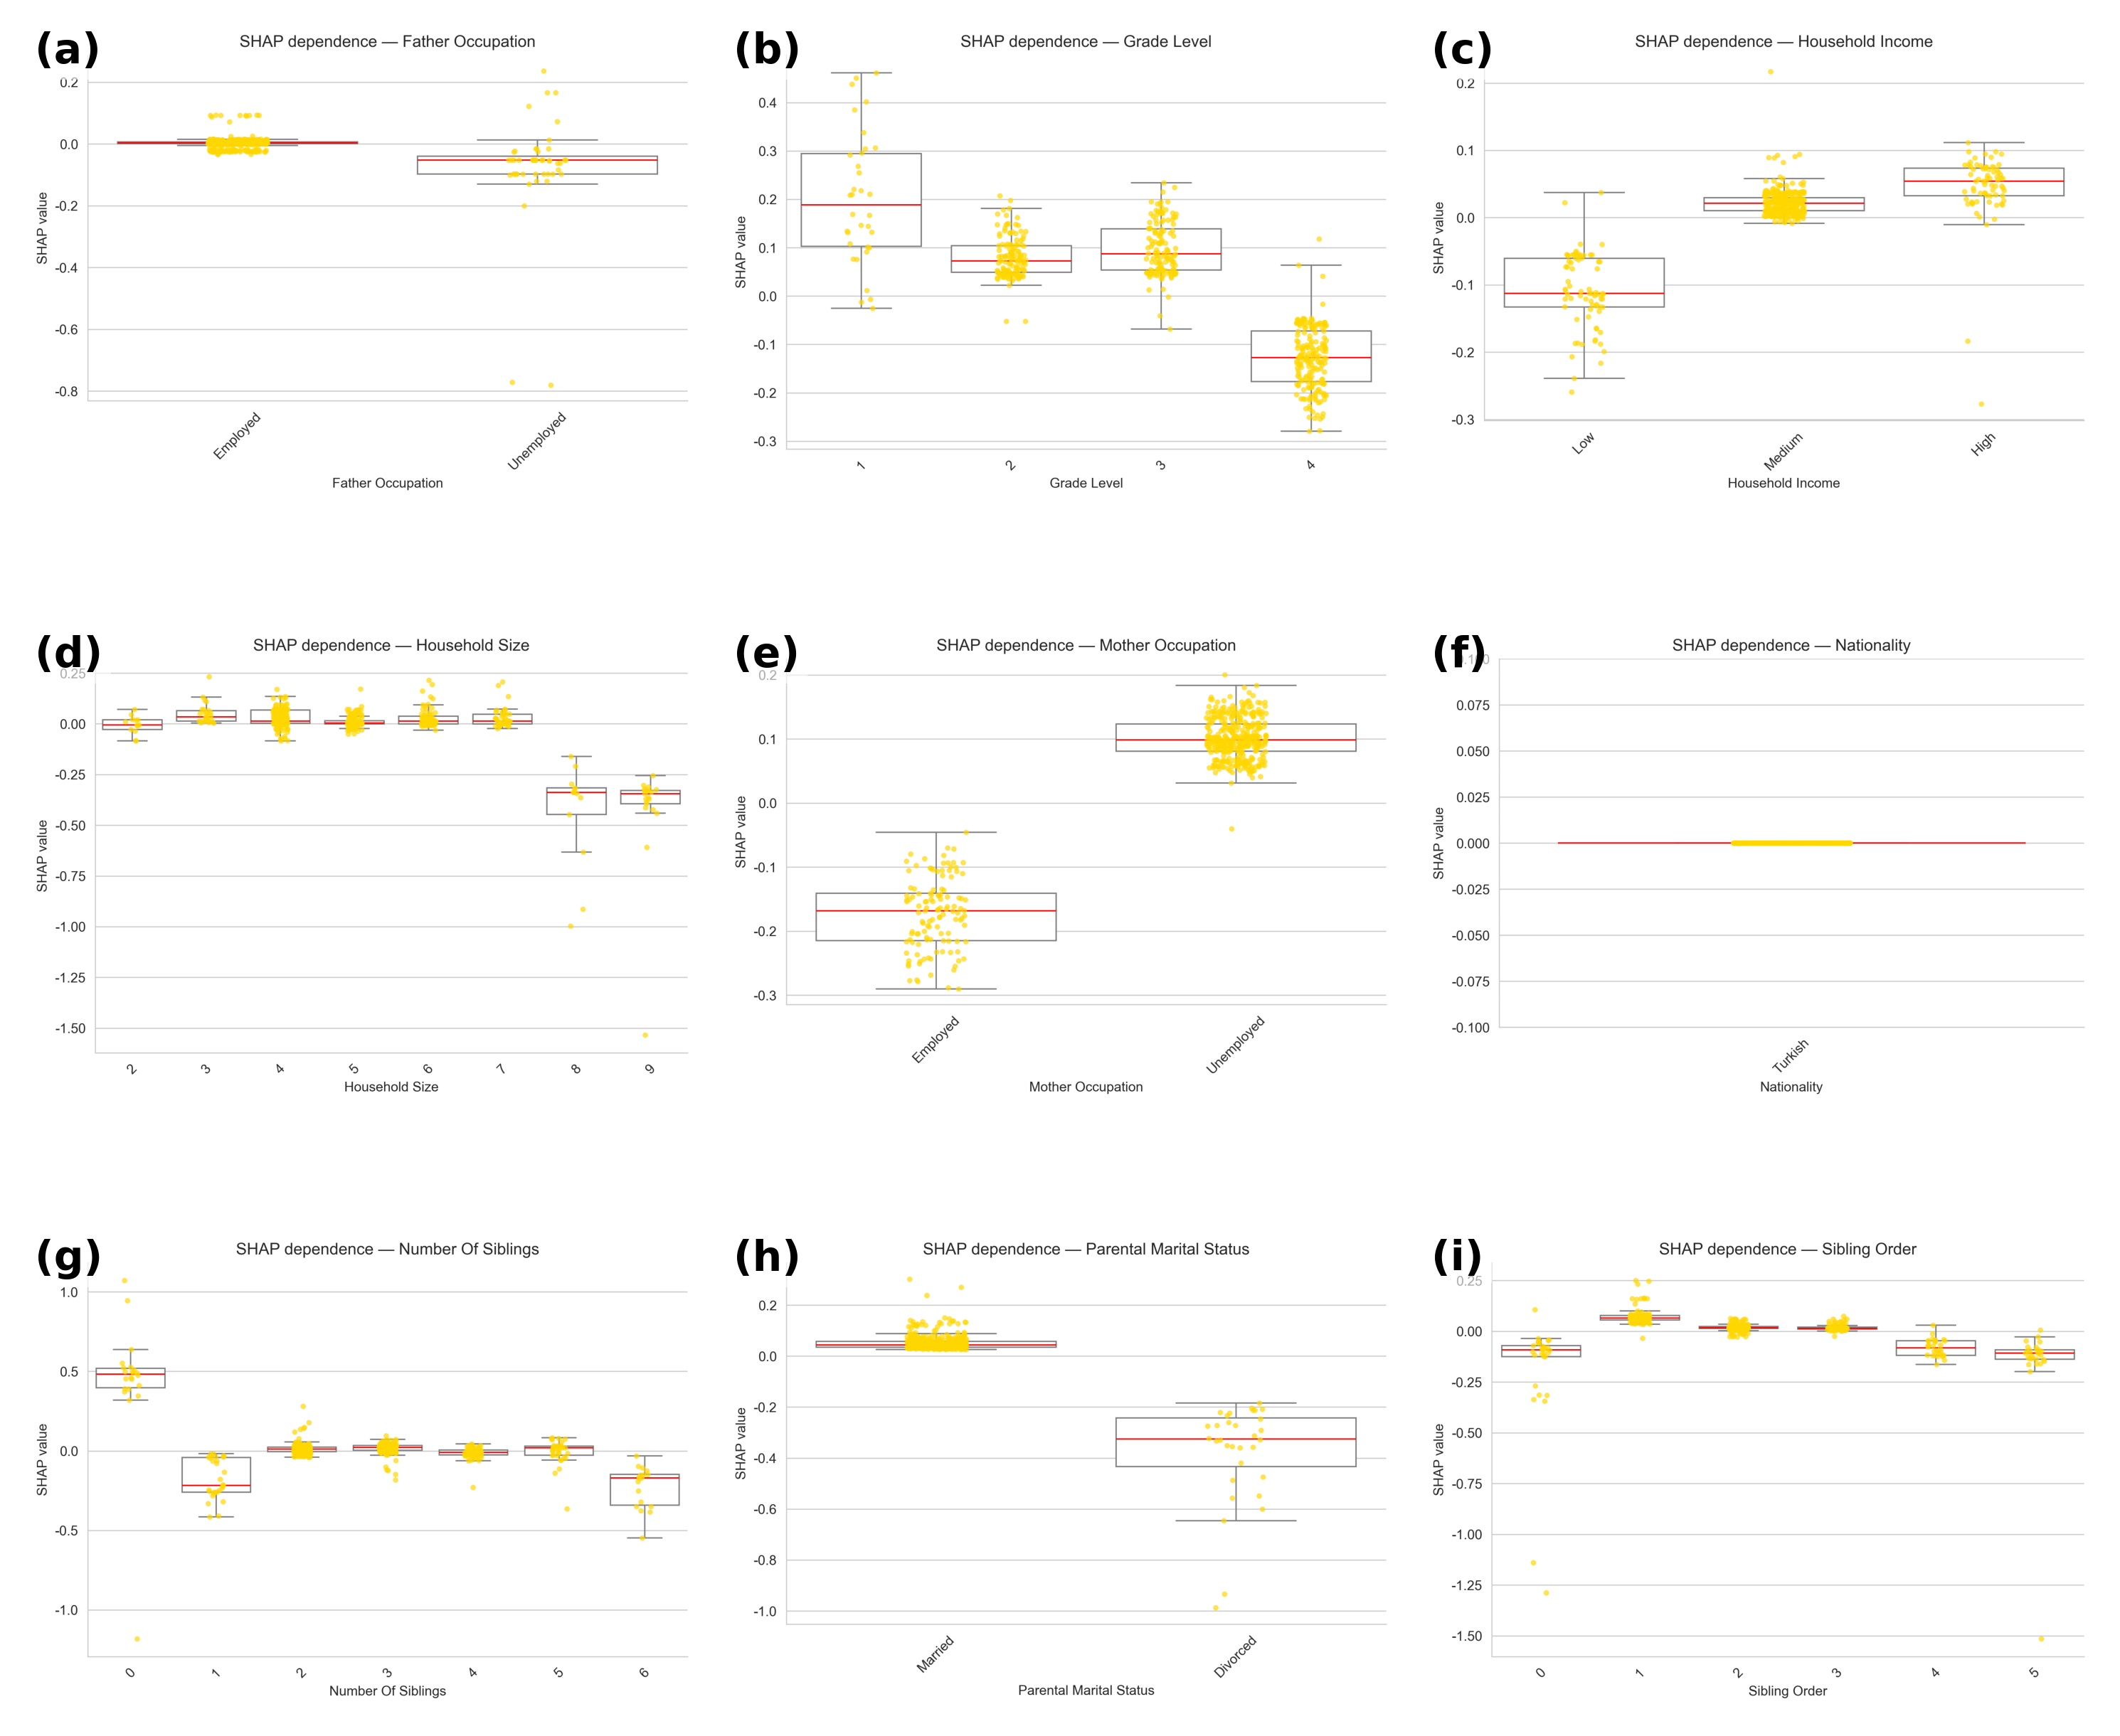
Supplementary Figure S6. SHAP dependence plots for low-importance socio-demographic predictors in the Gradient Boosting Regressor model.
This figure illustrates SHAP dependence relationships for nine low-importance features—(a) Father Occupation, (b) Grade Level, (c) Household Income, (d) Household Size, (e) Mother Occupation, (f) Nationality, (g) Number of Siblings, (h) Parental Marital Status, and (i) Sibling Order. Each subplot depicts the marginal effect of a single predictor on the model output (SHAP value), with other variables held constant. Yellow points denote individual observations; boxplots summarize the dispersion, and red horizontal lines indicate medians.
Across all panels, SHAP distributions remain tightly clustered around zero (typical median range ≈ −0.1 to +0.1), confirming that these attributes exert minimal influence on predicted student happiness.
(a) Father Occupation and (e) Mother Occupation show nearly flat, symmetric distributions, implying that parental employment status has negligible explanatory power once behavioral and psychosocial variables are included.
(b) Grade Level and (g) Number of Siblings display small, non-monotonic variations without directional consistency, suggesting random variance rather than systematic effects.
(c) Household Income and (d) Household Size yield weak and inconsistent trends (mean |SHAP| < 0.15), aligning with prior findings that economic proxies contribute marginally when psychosocial indicators dominate the variance structure.
(f) Nationality remains effectively constant (SHAP ≈ 0 for all cases), reflecting sample homogeneity.
(h) Parental Marital Status and (i) Sibling Order show only sporadic deviations from baseline, reinforcing their non-predictive character.
Collectively, these variables exhibit mean |SHAP| values below 0.25, validating their classification as tertiary or noise-level predictors. While included here for completeness, their limited explanatory contribution underscores that the model’s predictive structure is overwhelmingly driven by behavioral, communicative, and psychosocial dimensions rather than static household demographics.
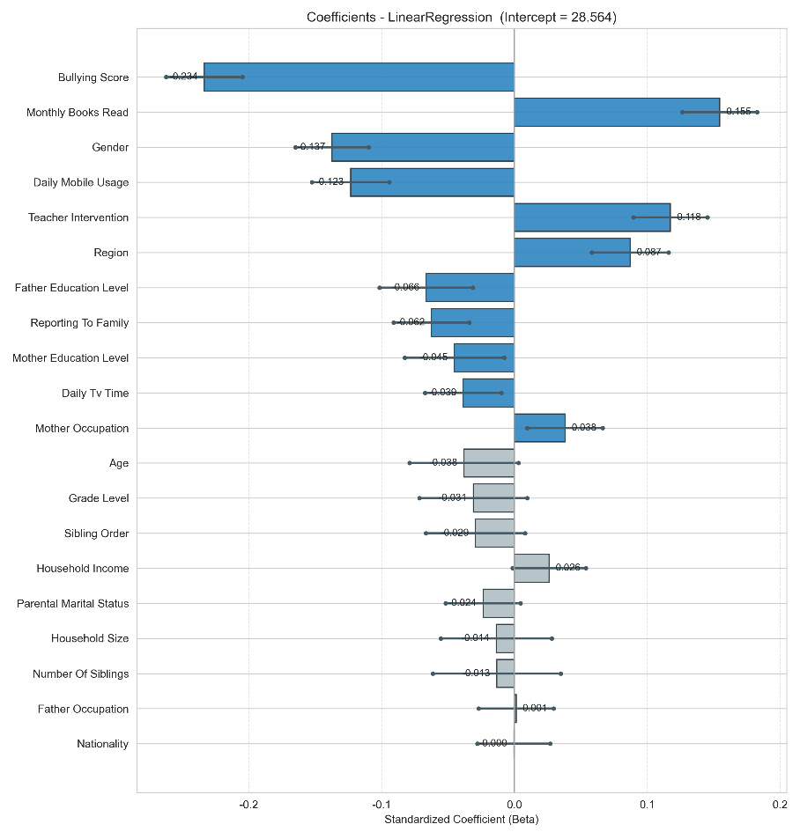
Supplementary Figure S7. Standardized beta coefficients from the Ordinary Least Squares (OLS) regression model (N = 4,134).
Bars indicate standardized effect sizes (β), with error bars representing ± 1 standard error.
Negative coefficients (e.g., Bullying Score, Daily Mobile Usage, Daily TV Time) denote adverse associations with School Happiness, whereas positive coefficients (e.g., Monthly Books Read, Teacher Intervention, Region, Mother Occupation) reflect protective or supportive influences.
Among all predictors, Bullying Score (β = −0.23, p < 0.001) emerged as the strongest negative determinant, followed by mobile-phone and television use. Conversely, Monthly Books Read (β = 0.15, p < 0.001) and Teacher Intervention (β = 0.12, p < 0.001) were the most influential positive correlates of School Happiness.
Background and household variables (e.g., Age, Household Size, Nationality) exhibited coefficients near zero and were statistically non-significant (p > 0.05).
This figure complements Supplementary Table S13 by providing an effect-size hierarchy in standardized units, highlighting that behavioral and academic-engagement factors outweigh socio-economic background variables in predicting students’ School Happiness (F-statistic = 54.65, p < 0.001).

