Supplementary materials

Machine Learning-Driven Discovery and Experimental Validation of Novel STING Inhibitors from Traditional Chinese Medicine

Tian Zhao¹ ² ³ , Dan Chen ¹ ² ³, Zongjun Chen ⁴, Qionghui Wang¹ ² ³, Jun Qing¹ ² ³, Qiang Huang¹ ² ³, Yihuan Zhao^{1 2 3*}, Lei Zhu^{1 2 3*}

¹ School of Pharmacy, Zunyi Medical University, Zunyi, Guizhou 563006, China.
² Key Laboratory of Basic Pharmacology of Ministry of Education, Zunyi Medical University, Zunyi, Guizhou 563006, China
³The Key Laboratory of Clinical Pharmacy of Zunyi City, Zunyi Medical University, Zunyi, Guizhou 563006, China
⁴Department of Endocrinology, Kweichow Moutai Hospital, Renhuai, Guizhou 564500, China

* Corresponding author: Dr. Lei Zhu , Dr. Yihuan Zhao
Email address: zhuleilei@live.cn, zhuleimail@zmu.edu.cn (Lei Zhu); 2225694159@qq.com (Yihuan Zhao )

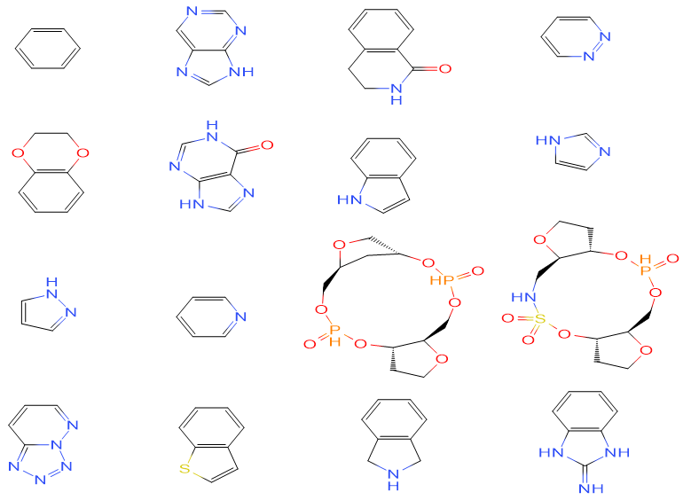

Fig. S1 The top 16 plain rings of 492 STING inhibitors dataset

Table S1 The top 26 plain ring had a frequency exceeding 10 of 492 STING inhibitors dataset
SMILES | Frequency
c1ccccc1 | 379
n1c2[nH]cnc2cnc1 | 125
O=C1NCCc2c1cccc2 | 95
n1ncccc1 | 79
O1c2c(OCC1)cccc2 | 78
O=c1[nH]cnc2c1nc[nH]2 | 71
[nH]1c2c(cc1)cccc2 | 62
n1c[nH]cc1 | 62
n1[nH]ccc1 | 50
n1ccccc1 | 27
P1(=O)O[C@@H]2[C@H](OCC2)COP(=O)O[C@@H]2C[C@@H](CO1)OC2 | 24
S1(=O)(=O)O[C@@H]2[C@H](OCC2)COP(=O)O[C@@H]2[C@@H](CN1)OCC2 | 23
n1n2nnnc2ccc1 | 21
s1c2c(cc1)cccc2 | 20
N1Cc2c(C1)cccc2 | 18
N=c1[nH]c2c([nH]1)cccc2 | 16
O=c1[nH]cnc2c1cc[nH]2 | 16
C1CCCCC1 | 16
O=c1c2c([nH]c3c1cccc3)cccc2 | 15
n1c2c([nH]c1)cccc2 | 14
n1c2n(ncc2)ccc1 | 13
C1CC1 | 11
P1(=O)O[C@@H]2[C@@H](COP(=O)O[C@@H]3C[C@@H](CO1)OC3)CCC2 | 11
o1c2c(cc1)cccc2 | 10
N1CCCCC1 | 10
O1CCNCC1 | 10

Table S2 The top 30 Murcko scaffold of 492 STING inhibitors
SMILES | Frequency
O=C1N(c2ccccc2)[C@H](c2cc3OCCOc3cc2)Cc2c1cccc2 | 21
P1(=O)O[C@H]2[C@@H](O[C@@H](C2)COP(=O)O[C@@H]2[C@@H](CO1)O[C@H](C2)n1c2ncncc2nc1)n1c2nc[nH]c(=O)c2nc1 | 16
O=C1N(c2ccccc2)[C@@H](c2cc3OCCOc3cc2)Cc2c1cccc2 | 16
O=C(Nc1ccccc1)Nc1c2c([nH]c1)cccc2 | 13
S1(=O)(=O)O[C@@H]2[C@H](O[C@H](C2)n2c3nc[nH]c(=O)c3nc2)COP(=O)O[C@@H]2[C@@H](CN1)O[C@H](C2)n1c2ncncc2nc1 | 12
s1c2c(cc1)cc(cc2)OCCCOc1cc2c(cc1)CNC2 | 12
S(=O)(=O)(Nc1cc(NC(=O)c2ccc(cc2)c2ccccc2)ccc1)c1ccccc1 | 10
O=c1c2c([nH]c3c1cccc3)cccc2 | 9
P1(=O)OC2[C@H](O[C@H](C2)n2c3ncncc3nc2)COP(=O)OC2[C@@H](CO1)O[C@H](C2)n1c2nc[nH]c(=O)c2cc1 | 8
P1(=O)OC2[C@H](O[C@H](C2)n2c3ncncc3nc2)COP(=O)O[C@H]2[C@@H](CO1)O[C@H](C2)n1c2ncncc2nc1 | 7
P1(=O)OC2C(OC(C2)COP(=O)OC2C(CO1)OC(C2)n1c2ncncc2nc1)n1c2nc[nH]c(=O)c2nc1 | 7
P1(=O)O[C@H]2[C@@H](O[C@@H](C2)COP(=O)O[C@@H]2[C@@H](CO1)O[C@H](C2)n1c2ncncc2nc1)n1c2nc[nH]c(=O)c2cc1 | 7
O=C(NCc1oc2c(c1)cccc2)c1c2ncccn2nc1 | 7
S1(=O)(=O)O[C@@H]2[C@H](O[C@H](C2)n2c3ncncc3nc2)COP(=O)O[C@@H]2[C@@H](CN1)O[C@H](C2)n1c2nc[nH]c(=O)c2nc1 | 6
O=C(Nc1ccccc1)c1nnc(cc1)n1cccc1 | 6
O=C(Nc1cc(ccc1)CCCc1cc(NC(=O)c2nn3nnnc3cc2)ccc1)c1nnc(cc1)n1cncc1 | 5
S1(=O)(=O)O[C@@H]2[C@H](O[C@H](C2)n2c3ncncc3nc2)COP(=O)O[C@@H]2[C@@H](CN1)O[C@H](C2)n1c2ncncc2nc1 | 5
P1(=O)O[C@@H]2[C@@H](COP(=O)O[C@@H]3C[C@@H](CO1)O[C@H]3n1c3nc[nH]c(=O)c3nc1)C[C@H](C2)n1c2ncncc2cc1 | 5
O=C1N(c2ccncc2)[C@@H](c2cc3OCCOc3cc2)Cc2c1cccc2 | 5
O=C(Nc1ccccc1)c1occc1 | 4
P1(=O)OC2[C@H](O[C@H](C2)n2c3ncncc3nc2)COP(=O)O[C@H]2[C@@]3(CO1)O[C@H](C2OC3)n1c2ncncc2nc1 | 4
P1(=O)O[C@H]2[C@@H](O[C@@H](C2)COP(=O)O[C@@H]2[C@@]3(CO1)O[C@H]([C@@H]2OC3)n1c2ncncc2nc1)n1c2nc[nH]c(=O)c2nc1 | 4
O=C(Nc1cc(ccc1)CCOc1cc(NC(=O)c2nn3nnnc3cc2)ccc1)c1nnc(cc1)n1cncc1 | 4
O=C(Nc1cc(OCCc2cc(NC(=O)c3nnc(cc3)n3cncc3)ccc2)ccc1)c1nnc(cc1)n1cncc1 | 4
s1c(nc(c1)c1ccccc1)C(=O)Nc1ccccc1 | 4
O=C(Nc1ccccc1)c1cnn(c1)c1ccccc1 | 4
O=C(Nc1ccccc1)c1nnc(cc1)c1cnncc1 | 4
O=C(Nc1cc2[nH]ccc2cc1)Nc1ccccc1 | 4
O=C(Nc1cc(OCCCCOc2cc(NC(=O)c3nn4nnnc4cc3)ccc2)ccc1)c1nnc(cc1)n1cncc1 | 3
O=C1N(c2ccc(cc2)N2CCOCC2)[C@@H](c2cc3OCCOc3cc2)Cc2c1cccc2 | 3

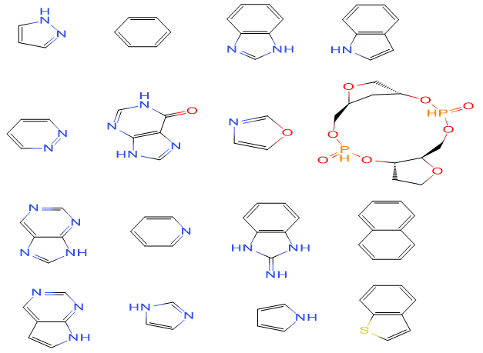

Fig. S2 The top 16 plain rings of 522 STING agonists dataset

Table S3 The top 21 plain ring had a frequency exceeding 10 of 522 STING agonists dataset
SMILES | Frequency
n1[nH]ccc1 | 288
c1ccccc1 | 268
n1c2c([nH]c1)cccc2 | 237
[nH]1c2c(cc1)cccc2 | 62
n1ncccc1 | 58
O=c1[nH]cnc2c1nc[nH]2 | 45
o1cncc1 | 42
n1c2[nH]cnc2cnc1 | 37
P1(=O)O[C@@H]2[C@H](OCC2)COP(=O)O[C@@H]2C[C@@H](CO1)OC2 | 37
n1ccccc1 | 34
N=c1[nH]c2c([nH]1)cccc2 | 29
n1c[nH]cc1 | 21
c12c(cccc1)cccc2 | 19
s1c2c(cc1)cccc2 | 18
o1c2c(cc1)cccc2 | 16
n1c2[nH]ccc2cnc1 | 16
[nH]1cccc1 | 16
O1CCNCC1 | 15
n1cnccc1 | 14
n1c2n(ncc2)ccc1 | 12
n1ncc[nH]1 | 11

Table S4 The top 30 Murcko scaffold of 522 STING agonists
SMILES | frequency
O=C(OCc1ccccc1)NCCCn1c(nc2c1cccc2)NC(=O)c1[nH]ncc1 | 32
O=C(Nc1nc2c([nH]1)cccc2)c1[nH]ncc1 | 22
O=C(Nc1nc2c(n1CCCNc1oc(cn1)c1ccccc1)cccc2)c1[nH]ncc1 | 21
O=C(Nc1ccccc1)c1nnc(cc1)n1cccc1 | 14
O=C(Nc1ccccc1)c1nnc(cc1)c1cnncc1 | 11
s1c2c(cc1)cccc2 | 10
O=C(Nc1nc2c(n1NCCCC(=O)NCc1ccccc1)cccc2)c1[nH]ncc1 | 10
O=C(NCc1oc2c(c1)cccc2)c1c2ncccn2nc1 | 9
O=C(NC/C=C/Cn1c(nc2c1cccc2)NC(=O)c1[nH]ncc1)c1ccccc1 | 7
O=c1c2c([nH]c3c1cccc3)cccc2 | 7
P1(=O)O[C@@H]2[C@@H](COP(=O)O[C@@H]3C[C@@H](CO1)O[C@H]3n1c3nc[nH]c(=O)c3nc1)C[C@H](C2)Oc1ncncc1 | 6
O=C(/N=c\1/n(c2c([nH]1)cccc2)C/C=C/Cn1/c(=N/C(=O)c2[nH]ncc2)/[nH]c2c1cccc2)c1[nH]ncc1 | 5
O=C(Nc1c2c([nH]c1)cccc2)c1cnn(c1)Cc1ccccc1 | 5
O=C(Nc1c2c([nH]c1)cccc2)c1n[nH]c(c1)c1ccccc1 | 5
O=C(Nc1nc2c(n1C/C=C/Cn1c(nc3c1cccc3)NC(=O)c1[nH]ncc1)cccc2)c1[nH]ncc1 | 4
O=C(Nc1nc2c(n1C/C=C/Cn1c3c(nc1)cccc3)cccc2)c1[nH]ncc1 | 4
P1(=O)O[C@H]2[C@@H](O[C@@H](C2)COP(=O)O[C@@H]2[C@@H](CO1)O[C@H](C2)n1c2ncncc2nc1)n1c2nc[nH]c(=O)c2nc1 | 4
O=C1N(c2c(C1)ccc(c2)C(=O)NCc1ccccc1)Cc1ccccc1 | 4
O=c1c2c(oc3c1cccc3)cccc2 | 4
O=C1c2c(Nc3c(C1)cccc3)cccc2 | 3
O=C(Nc1c2c([nH]c1)cccc2)c1ncn(c1)Cc1ccccc1 | 3
O=C(Nc1c2c([nH]c1)ccnc2)c1cnn(c1)Cc1ccccc1 | 3
O=C(Nc1c2c([nH]c1)cccc2)c1nnn(c1)c1cnccc1 | 3
[se]1c2c(cc1)cccc2 | 2
O=C(OCc1ccccc1)NCCCn1c(nc2c1cccc2)NC(=O)c1nnccc1 | 2
O=C(OCc1ccccc1)NCCCn1c(nc2c1cccc2)NC(=O)c1ncccc1 | 2
O=C(/N=c\1/n(c2c([nH]1)cccc2OCCCN1CCOCC1)C/C=C/Cn1/c(=N/C(=O)c2[nH]ncc2)/[nH]c2c1cccc2)c1[nH]ncc1 | 2
O=C(NCc1cc2c(cc1)cccc2)NCCCNn1c(nc2c1cccc2)NC(=O)c1[nH]ncc1 | 2
P1(=O)O[C@H]2[C@@H](O[C@@H](C2)COP(=O)O[C@@H]2[C@@H](CO1)O[C@H](C2)[C@H]1c2ncncc2N=C1)n1cncc1 | 2
O=C(Nc1nc2c(n1C/C=C/Cn1c(nc3c1cccc3)NC(=O)c1ocnc1)cccc2)c1ocnc1 | 2

Table S5 The descriptions of the molecular fingerprints used in the study
Fingerprint | Number | Description
CDK fingerprint | 1024 | Fingerprint of length 1024 and search depth of 8
CDK extended fingerprint | 1024 | Extends the Fingerprinter with additional bits describing ring features
Substructure fingerprint | 307 | Presence of SMARTS Patterns for Functional Group Classification by Christian Laggner
Substructure fingerprint count | 307 | Count of SMARTS Patterns for Functional Group Classification by Christian Laggner

Table S6 Optimal Parameter Values for Different Classification Machine Learning Prediction Models
LightGBM |  | RF |  | KNN
Number of estimators | 300 | Number of estimators | 300 | n_neighbors | 4
learning rate | 0.01 | Min samples split | 10
feature_fraction | 0.8 | Min samples leaf | 1
num_leaves | 10
min_child_samples | 60
MLP |  | DT |  | LR
activation | logistic | Min samples split | 2 | solver | sag
solver | adam | Min samples leaf | 16 | max_iter | 100
max_iter | 500 | max_features | 4 | verbose | 0
alpha | 0.0001 | min_weight_fraction_leaf | 0.0 | C | 0.1

Table S7 Optimal Parameter Values for Different regression machine learning prediction models
LightGBM |  | RF |  | LASSO |  | KNN
number of estimators | int, [100, 500] step=20 | number of estimators | int, [100, 500] step=20 | max_iter | int, [100, 500] step= | n_  neighbors | int, [2, 50]
learning rate | float, [0.0001, 1] |  |  | alpha | float, [0.0001, 1]
n_estimators=100, learning rate=0.1 |  | n_estimators=220 |  | max_iter=100, alpha=0.04 |  | n_neighbors = 4
PLS |  | XGBoost |  | SVR
n_components | int, [2, 50] | number of estimators | int, [100, 500] step=20 | gamma | float, [0.0001, 1]
 |  |  |  | kernel | string, {rbf, sigmoid, linear}
 |  |  |  | C | float, [0, 1500]
n_components=6 |  | n_estimators=100 |  | gamma=0.02, C=122, kernel=rbf

Table S8 The binding mode of seven potential STING inhibitors with STING
Compound | Conventional hydrogen bond | π-σ interactions | π-alkyl and Alkyl
Cassiaside | Ser162,Gly166 | None | Tyr167
Plantaginin | Ser162,Ser241,Pro209,ASP210,  Tyr245,Thr263 | None | Pro264
Iristectorigenin B | Ser162,ASP210,Thr267,Val208 | Pro264 | None
Parishin E | Ser241,Ser243,ASP210,Thr263,  Thr267,Val208 | None | Ala270
Specnuezhenide | Ser162,Gly166,Gln266,Thr263,  ASP210 | None | None
Rubrofusarin gentiobioside | Ser241,Ser243,Gln266,Tyr167,  Tyr245,Tyr167,Pro209 | None | Pro264
Nor-rubrofusarin gentiobioside | Ser162,Gly166 | None | Tyr167

Table S9 ADMET Prediction Results of 7 potential STING compounds
S.No | Molecules | Mol.MW | QPlogPo/w | GI Absorption | Bioavailability Score | Lipinski Rule of 5 | Ames | H-HT
1 | Cassiaside | 420.37g/mol | 0.29 | Low | 0.55 | Yes: 1 Violation | 0.944 | 0.746
2 | Plantaginin | 448.38 g/mol | 1.42 | Low | 0.17 | No; 2 violation | 0.307 | 0.648
3 | Iristectorigenin b | 330.29 g/mol | 2.11 | High | 0.55 | Yes: 0 Violation | 0.541 | 0.487
4 | Parishin E | 460.39 g/mol | 0.44 | Low | 0.11 | Yes: 1 Violation | 0.352 | 0.479
5 | Specnuezhenide | 686.66 g/mol | -1.28 | Low | 0.11 | N0: 3 Violation | 0.775 | 0.451
6 | Rubrofusarin gentiobioside | 596.53 g/mol | -1.07 | Low | 0.17 | No; 3 violation | 0.885 | 0.517
7 | Nor-rubrofusarin gentiobioside | 582.51g/mol | -1.46 | Low | 0.17 | No: 3 Violation | 0.975 | 0.648

