Seasonal variations in rhizosphere soil bacterial and fungal communities of Quercus franchetii along an elevational gradient in the Yuanmou dry-hot valley, Southwest China
Xuedan Xie^{1,2}, Guanping Li¹, Jiao Wu¹, Cailan Liu¹, Haitao Yue¹, Dacai Zhang^{1*}

¹ Key Laboratory of Forest Resources Conservation and Utilization in the Southwest Mountains of China Ministry of Education, Southwest Forestry University, Kunming, 650224, China
² Yunnan Key Laboratory of Plant Diversity and Biogeography, Kunming Institute of Botany, Chinese Academy of Sciences, Kunming 650201, China

* Correspondence: Dacai Zhang dczhang24@163.com
This supplementary file includes:
1.Appendix for methods
Appendix 1 Method for rhizosphere soil sample collection
Appendix 2 Method for DNA extraction and high-throughput sequencing
2.Supplementary figures
Fig. S1 Seasonal variations in the relative abundance of major soil bacterial functional groups along the altitudinal gradient.
Fig.S2 Seasonal variations in the relative abundance of major soil fungal trophic modes along the altitudinal gradient.
3.Supplementary tables
Table. S1 Seasonal variations in rhizosphere soil physicochemical properties along the altitudinal gradient
Table. S2 ART nonparametric ANOVA results of the effects of season and elevation on the α-diversity of bacterial and fungal communities
Table. S3 PERMANOVA results of the effects of season and elevation on the β-diversity of bacterial and fungal communities
Table. S4 Redundancy analysis of fungal and bacterial communities with soil physicochemical properties
Table. S5 Seasonal variations in the topological features of the fungal and bacterial co-occurrence network along the altitudinal gradient

Appendix 1 Method for rhizosphere soil sample collection
Three 10×10 m quadrats were established at each plot. The distance between each quadrat was no less than 5 m. Within each quadrat, 5 trees with similar diameter at breast height (DBH) were selected as sample trees. Within a 50 cm radius from the base of each sample tree with 5-20 cm depth, plant root systems were located, and soil within a 1 cm radius around the roots was collected as rhizosphere soil. The soil samples were placed into self-sealing bags and promptly transported to the laboratory, where they were sieved through a 40-mesh sieve to remove residual roots and small stones. The soil samples from each quadrat were mixed evenly by mass and divided into two portions, then 60 soil samples were collected. 30 samples were stored in liquid nitrogen for high-throughput sequencing, and 30 samples were air-dried for determination of physicochemical properties.
Appendix 2 Method for DNA extraction and high-throughput sequencing
About 5 g of fresh soil samples of each sample were ready for high-throughput sequencing. Total DNA was extracted using the OMEGA Soil DNA Kit (M5635-02, Omega Bio-Tek, Norcross, GA, USA). The DNA concentration and purity were examined by using the NanoDrop NC 2000 spectrophotometer (Thermo Fisher Scientific, Waltham, MA, USA), and the DNA extraction quality was tested by 1.2% agarose gel electrophoresis. The bacterial 16S rRNA gene V3-V4 region was amplified by the forward primers 338F (ACTCCTACGGGAGGCAGCA) and the reverse primer 806R (GGACTACHVGGGTWTCTAAT), and the ITS1 region of the fungal ribosomal gene was amplified with the primers ITS5 (GGAAGTAAAAGTCGTAACAAGG) and ITS1 (GCTGCGTTCTTCATCGATGC). PCR amplicons were purified with Vazyme VAHTSTM DNA Clean Beads (Vazyme, Nanjing, China) and quantified using the Quant-iT PicoGreen dsDNA Assay Kit (Invitrogen, Carlsbad, CA, USA). Paired-end sequencing of the bacterial and fungal amplicons was then performed on the Illumina NovaSeq platform (Personalbio, Shanghai, China).
Raw bacterial and fungal reads were processed using the QIIME 2 pipeline. The reads were first quality-trimmed and assigned based on their barcodes. Chimeric sequences and singletons were removed. The filtered reads were then clustered into amplicon sequence variants (ASVs) with ≥ 99% similarity, using the classify-sklearn naïve Bayes taxonomy classifier in feature-classifier plugin against the Database: SILVA Release 13.8 for bacterial 16S rRNA gene and the UNITE Release 8.0 for fungal ITS1. Based on the statistics of the effective sequences of the 30 samples collected, the high-quality 16S rRNA reads (mean = 414 bp) obtained from the rhizosphere soil ranged from 70,048 to 115,135 per sample (mean = 96,638). These reads were clustered into ASVs with ≥ 97% similarity. In total, 2,899,158 high-quality bacterial sequences were grouped into 94,544 ASVs. The high-quality ITS1 reads (mean = 250 bp) obtained from the rhizosphere soil ranged from 67,917 to 99,433 per sample (mean = 82,683). These reads were clustered into ASVs with ≥ 97% similarity. In total, 2,480,503 high-quality fungal sequences were grouped into 10,195 ASVs.
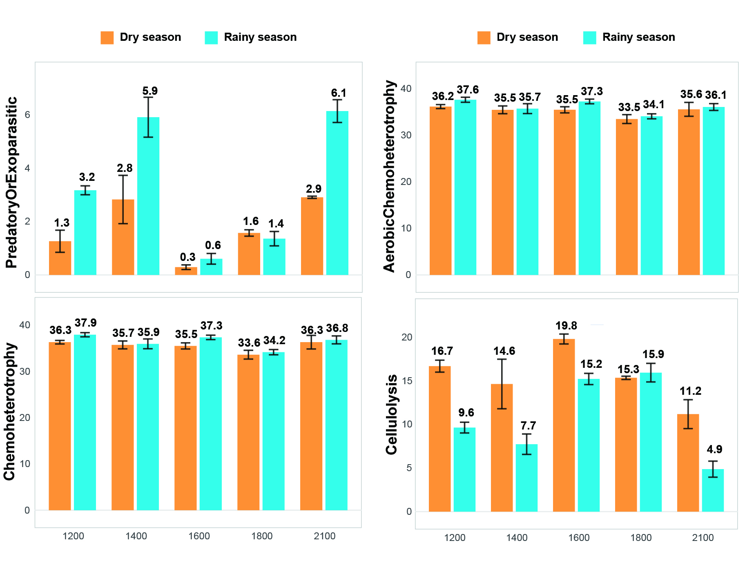
Fig. S1 Seasonal variations in the relative abundance of major soil bacterial functional groups along the altitudinal gradient.
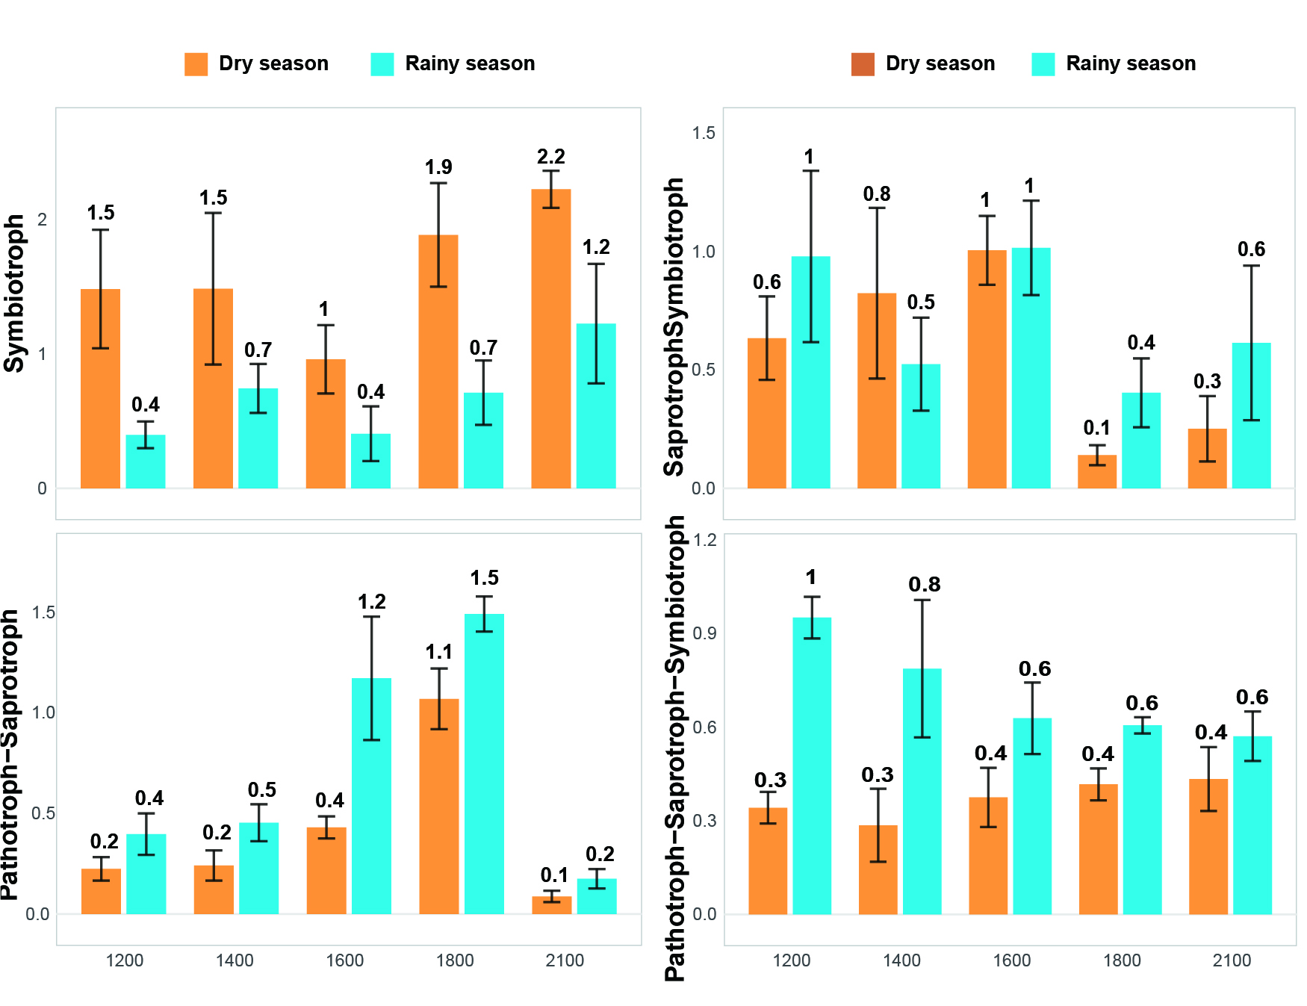
Fig.S2 Seasonal variations in the relative abundance of major soil fungal trophic modes along the altitudinal gradient.
Table. S1 Seasonal variations in rhizosphere soil physicochemical properties along the altitudinal gradient
Index | season | Elevation (m)
Index | season | 1200 | 1400 | 1600 | 1800 | 2100
Soil water content  (WC)/(%) | Dry | 2.86±0.58 ab | 2.18±1.38 a | 3.46±0.24 ab | 9.27±0.30 b | 5.80±0.76 ab
Soil water content  (WC)/(%) | Rainy | 6.85±0.55 A | 9.68±1.02 AB | 6.70±0.37 A | 18.75±2.24 AB | 28.65±1.14 B
pH value  (pH) | Dry | 5.37±0.16 a | 5.33±0.28 a | 4.93±0.13 a | 4.97±0.10 a | 5.38±0.38 a
pH value  (pH) | Rainy | 5.47±0.07 AB | 5.34±0.03 AB | 4.79±0.09 A | 5.10±0.09 AB | 5.66±0.12 B
Soil organic carbon content  (SOC)/(g•kg-1) | Dry | 12.04±1.62 ab | 7.43±0.74 a | 13.44±1.77 ab | 7.38±1.29 a | 23.65±1.61 b
Soil organic carbon content  (SOC)/(g•kg-1) | Rainy | 11.45±0.58 AB | 8.10±1.15 A | 13.41±1.46 AB | 8.22±1.02 A | 25.07±1.19 B
Total nitrogencontent  (TN)/(g•kg-1) | Dry | 1.18±0.12 ab | 1.05±0.10 ab | 1.24±0.16 ab | 0.94±0.04 a | 1.72±0.15 b
Total nitrogencontent  (TN)/(g•kg-1) | Rainy | 1.07±0.02 A | 1.05±0.10 A | 1.07±0.13 A | 1.05±0.08 A | 1.59±0.04 A
available nitrogen content  (AN)/(mg•kg-1) | Dry | 69.48±7.77 ab | 62.89±3.23 ab | 78.54±8.46 ab | 52.75±7.38 a | 132.42±8.77 b
available nitrogen content  (AN)/(mg•kg-1) | Rainy | 68.45±1.37 AB | 60.12±2.56 AB | 87.44±5.52 AB | 45.27±12.53 A | 147.77±11.66 B
Total Phosphorus content  (TP) /(g•kg-1) | Dry | 0.14±0.02 a | 0.16±0.02 ab | 0.23±0.02 ab | 0.17±0.02 ab | 0.40±0.01 b
Total Phosphorus content  (TP) /(g•kg-1) | Rainy | 0.16±0.02 A | 0.14±0.03 A | 0.23±0.02 A | 0.15±0.02 A | 0.37±0.02 A
available Phosphorus content  (AP)/(mg•kg-1) | Dry | 5.40±1.38 ab | 4.91±0.58 ab | 16.57±0.90 ab | 4.57±1.92 a | 39.60±3.07 b
available Phosphorus content  (AP)/(mg•kg-1) | Rainy | 4.18±0.42 AB | 3.28±0.85 A | 15.94±3.76 AB | 5.09±3.01 AB | 39.62±2.58 B
C/N | Dry | 10.29±1.62 ab | 7.07±0.09 a | 10.86±1.02 ab | 7.80±1.015 ab | 13.76±0.77 b
C/N | Rainy | 10.74±0.77 AB | 7.75±0.78 A | 12.54±1.21 AB | 7.88±1.20 A | 15.75±0.46 B
Note: Data in the table are presented as mean ± standard deviation. Different lowercase letters indicate significant differences in a given rhizosphere soil index among plots during the dry season (p < 0.05), while different uppercase letters indicate such differences during the rainy season. Significance was tested using the Kruskal-Wallis test followed by Dunn's multiple comparison test in R, with p-values adjusted using the Bonferroni method.

Table. S2 ART nonparametric ANOVA results of the effects of season and elevation on the α-diversity of bacterial and fungal communities
Index | Source of variation | Df | Df.res | F value | Pr (>F) | contrast
Bacterial Chao1 index | Season | 1 | 20 | 11.8107 | 0.002610 ** | Altitude_1200m _vs_ Altitude_1600 ***; Altitude_1200m _vs_ Altitude_1800 **  Altitude_1400m _vs_ Altitude_1600 ***; Altitude_1400m _vs_ Altitude_1800 **  Altitude_1600m _vs_ Altitude_2100 ***; Altitude_1800m _vs_ Altitude_2100 ***
Bacterial Chao1 index | Elevation | 4 | 20 | 24.1595 | < 0.0001 ***
Bacterial Chao1 index | Season ╳ Elevation | 4 | 20 | 0.3322 | 0.853002
Bacterial Shannon index | Season | 1 | 20 | 5.8099 | 0.025681 ** | Altitude_1200m _vs_ Altitude_1600 ***; Altitude_1200m _vs_ Altitude_1800 **  Altitude_1400m _vs_ Altitude_1600 ***; Altitude_1400m _vs_ Altitude_1800 **  Altitude_1600m _vs_ Altitude_2100 ***; Altitude_1800m _vs_ Altitude_2100 ***
Bacterial Shannon index | Elevation | 4 | 20 | 17.8049 | < 0.0001 ***
Bacterial Shannon index | Season ╳ Elevation | 4 | 20 | 0.3325 | 0.852821
Fungal Chao1 index | Season | 1 | 20 | 37.6860 | < 0.0001 ***
Fungal Chao1 index | Elevation | 4 | 20 | 1.9868 | 0.135410
Fungal Chao1 index | Season ╳ Elevation | 4 | 20 | 0.4945 | 0.739920
Fungal Shannon index | Season | 1 | 20 | 10.0454 | 0.004821 **
Fungal Shannon index | Elevation | 4 | 20 | 0.7764 | 0.553505
Fungal Shannon index | Season ╳ Elevation | 4 | 20 | 0.4344 | 0.782184

Table. S3 PERMANOVA results of the effects of season and elevation on the β-diversity of bacterial and fungal communities
Bacteria |  |  |  |  | Fungi
Group1 | Group2 | Sample size | pseudo-F | q-value | Group1 | Group2 | Sample size | pseudo-F | q-value
dry season | rainy season | 30 | 1.029054 | 0.39 | dry season | rainy season | 30 | 1.107227 | 0.293
S1200 | S1400 | 12 | 3.063585 | 0.004 | S1200 | S1400 | 12 | 2.937256 | 0.003
S1200 | S1600 | 12 | 7.055955 | 0.004 | S1200 | S1600 | 12 | 3.898846 | 0.004
S1200 | S1800 | 12 | 10.21304 | 0.004 | S1200 | S1800 | 12 | 6.464898 | 0.004
S1200 | S2100 | 12 | 5.799883 | 0.004 | S1200 | S2100 | 12 | 3.981084 | 0.003
S1400 | S1600 | 12 | 5.881357 | 0.004 | S1400 | S1600 | 12 | 2.690165 | 0.004
S1400 | S1800 | 12 | 7.250529 | 0.004 | S1400 | S1800 | 12 | 4.236038 | 0.003
S1400 | S2100 | 12 | 3.652390 | 0.004 | S1400 | S2100 | 12 | 2.663319 | 0.004
S1600 | S1800 | 12 | 9.667211 | 0.004 | S1600 | S1800 | 12 | 4.571408 | 0.004
S1600 | S2100 | 12 | 7.967127 | 0.004 | S1600 | S2100 | 12 | 4.041581 | 0.004
S1800 | S2100 | 12 | 8.519718 | 0.004 | S1800 | S2100 | 12 | 5.544552 | 0.004

Table. S4 Redundancy analysis of fungal and bacterial communities with soil physicochemical properties
Index | All bacterial genera |  | All fungal genera |  | the top 10 dominant bacterial genera |  | the top 10 dominant fungal genera
Index | R² | Pr(>r) | R² | Pr(>r) | R² | Pr(>r) | R² | Pr(>r)
WC(%) | 0.52 | 0.001 | 0.034 | 0.632 | 0.31 | 0.008 | 0.04 | 0.533
pH | 0.74 | 0.001 | 0.57 | 0.001 | 0.57 | 0.001 | 0.56 | 0.001
SOC (g•kg-1) | 0.28 | 0.013 | 0.47 | 0.002 | 0.39 | 0.005 | 0.34 | 0.004
TN (g•kg-1) | 0.25 | 0.017 | 0.52 | 0.003 | 0.37 | 0.005 | 0.39 | 0.004
AN (mg•kg-1) | 0.34 | 0.004 | 0.52 | 0.002 | 0.47 | 0.001 | 0.39 | 0.003
TP (g•kg-1) | 0.18 | 0.062 | 0.38 | 0.005 | 0.30 | 0.016 | 0.23 | 0.032
AP (mg•kg-1) | 0.19 | 0.049 | 0.40 | 0.005 | 0.32 | 0.009 | 0.26 | 0.026
C/N | 0.22 | 0.038 | 0.29 | 0.014 | 0.32 | 0.010 | 0.20 | 0.054
Table. S5 Seasonal variations in the topological features of the fungal and bacterial co-occurrence network along the altitudinal gradient
Taxon | Sample size | Group | Vertex | Edge | Positive edges (%) | Negative edges (%) | Average degree | Average path length | Clustering coefficient | Modularity
Bacteria | 15 | Dry season | 277 | 7441 | 71.89% (10698) | 28.11% (4184) | 53.73 | 2.20 | 0.576 | 0.136
Bacteria | 15 | Rainy season | 287 | 12207 | 67.51% (16482) | 32.49% (7932) | 85.07 | 2.00 | 0.675 | 0.140
Bacteria | 6 | Altitude_1200m | 280 | 4445 | 65.15% (5792) | 34.85% (3098) | 31.75 | 2.67 | 0.540 | 0.360
Bacteria | 6 | Altitude_1400m | 284 | 3684 | 60.37% (4448) | 39.63% (2920) | 25.94 | 2.73 | 0.520 | 0.399
Bacteria | 6 | Altitude_1600m | 233 | 2078 | 61.98% (2576) | 38.02% (1580) | 17.84 | 2.84 | 0.499 | 0.472
Bacteria | 6 | Altitude_1800m | 251 | 2241 | 56.76% (2544) | 43.24% (1938) | 17.86 | 2.84 | 0.476 | 0.474
Bacteria | 6 | Altitude_2100m | 279 | 4237 | 58.89% (4990) | 41.11% (3484) | 30.37 | 2.66 | 0.524 | 0.375
Fungi | 15 | Dry season | 133 | 753 | 64.01% (964) | 35.99% (542) | 11.32 | 2.79 | 0.470 | 0.402
Fungi | 15 | Rainy season | 144 | 854 | 58.90% (1006) | 41.10% (702) | 11.86 | 2.71 | 0.429 | 0.428
Fungi | 6 | Altitude_1200m | 138 | 824 | 57.65% (950) | 42.35% (698) | 11.94 | 2.96 | 0.506 | 0.438
Fungi | 6 | Altitude_1400m | 145 | 980 | 67.75% (1328) | 32.24% (632) | 13.52 | 2.96 | 0.519 | 0.460
Fungi | 6 | Altitude_1600m | 113 | 553 | 60.94% (674) | 39.06% (432) | 9.79 | 2.98 | 0.494 | 0.526
Fungi | 6 | Altitude_1800m | 118 | 523 | 64.24% (672) | 35.76% (374) | 8.86 | 3.18 | 0.472 | 0.496
Fungi | 6 | Altitude_2100m | 117 | 693 | 66.52% (922) | 33.48% (464) | 11.858 | 2.99 | 0.520 | 0.434
Bacteria  +  Fungi | 15 | Dry season | 410 | 11599 | 65.41% (15174) | 34.59% (8024) | 56.580 | 2.329 | 0.518 | 0.230
Bacteria  +  Fungi | 15 | Rainy season | 431 | 18094 | 64.78% (23444) | 35.22% (12744) | 83.96 | 2.16 | 0.584 | 0.177
Bacteria  +  Fungi | 6 | Altitude_1200m | 418 | 8739 | 62.42% (10910) | 37.58% (6568) | 41.81 | 2.61 | 0.528 | 0.332
Bacteria  +  Fungi | 6 | Altitude_1400m | 429 | 7978 | 60.70% (9686) | 39.30% (6270) | 37.19 | 2.65 | 0.511 | 0.355
Bacteria  +  Fungi | 6 | Altitude_1600m | 346 | 4726 | 59.31% (5606) | 40.69% (3846) | 27.32 | 2.71 | 0.500 | 0.430
Bacteria  +  Fungi | 6 | Altitude_1800m | 369 | 4878 | 57.20% (5580) | 42.80% (4176) | 26.44 | 2.72 | 0.481 | 0.470
Bacteria  +  Fungi | 6 | Altitude_2100m | 396 | 8156 | 60.51% (9870) | 39.49% (6442) | 41.19 | 2.60 | 0.525 | 0.338

