Supplementary Tables
Table1 Supplementary: Summary of Quantitative Characteristics among HFNC (n=45) and Nasal Oxygen (n=23) Groups
Characteristic | Oxygen Support Group | Mean ± SD | 95% CI for Mean | Median | 95% CI Median | Shapiro-Wilk test  for Normal distribution
Age in months | HFNC | 11.73 ± 11.45 | 8.29 to 15.17 | 7.00 | 4.00 to 12.00 | W=0.800  Reject Normality (P<0.0001)
Age in months | Nasal Oxygen | 16.56 ± 11.83 | 11.44 to 21.68 | 18.00 | 6.00 to 24.00 | W=0.8636  Reject Normality (P=0.0048)
Weight in Kgs | HFNC | 7.63 ± 2.44 | 6.90 to 8.37 | 8.00 | 6.24 to 8  .81 | W=0.9653  accept Normality (P=0.1941)
Weight in Kgs | Nasal Oxygen | 8.57 ± 3.09 | 7.23 to 9.91 | 9.60 | 6.43 to 10.72 | W=0.9487  accept Normality (P=0.2751)
Days of O2 Support | HFNC | 2.62 ± 0.68 | 2.41 to 2.82 | 3.00 | 2.00 to 3.00 | W=0.7407  reject Normality (P<0.0001
Days of O2 Support | Nasal Oxygen | 1.65 ± 0.48 | 1.44 to 1.86 | 2.00 | 1.00 to 2.00 | W=0.6054  reject Normality (P<0.0001)
SpO2 at 0-hours | HFNC | 91.06 ± 2.57 | 90.29 to 91.84 | 91.00 | 90.00 to 91.00 | W=0.9234  reject Normality (P=0.0055)
SpO2 at 0-hours | Nasal Oxygen | 93.26 ± 2.94 | 91.98 to 94.53 | 92.00 | 91.00 to 96.00 | W=0.9063  reject Normality (P=0.0342)
RR at 0-hours | HFNC | 70.84 ± 12.75 | 67.01 to 74.67 | 72.00 | 62.92 to 78.00 | W=0.9715  accept Normality (P=0.3268)
RR at 0-hours | Nasal Oxygen | 61.30 ± 9.50 | 57.19 to 65.41 | 62.00 | 58.00 to 64.00 | W=0.9730  accept Normality (P=0.7593)
HR at 0-hours | HFNC | 153.24 ± 14.84 | 148.78 to 157.70 | 152.00 | 146.92 to 155.07 | W=0.9540  accept Normality (P=0.0722)
HR at 0-hours | Nasal Oxygen | 143.34 ± 18.32 | 135.42 to 151.27 | 142.00 | 138.00 158.00 | W=0.9326  accept Normality (P=0.1247)
SPO2 at 6 hours | HFNC | 98.60 ± 1.23 | 98.23 to 98.97 | 99.00 | 98.00 to 99.00 | W=0.8810  reject Normality (P=0.0003)
SPO2 at 6 hours | Nasal Oxygen | 98.91 ± 1.12 | 98.43 to 99.40 | 99.00 | 98.00 to 100.00 | W=0.8440  reject Normality (P=0.0021)
RR at 6 hours | HFNC | 45.33 ± 6.41 | 43.41 to 47.26 | 45.00 | 42.00 to 46.62 | W=0.9624  accept Normality (P=0.1509)
RR at 6 hours | Nasal Oxygen | 41.04 ± 7.54 | 37.78 to 44.30 | 42.00 | 36.70 to 44.00 | W=0.9672  accept Normality (P=0.6219)
HR at 6 hours | HFNC | Geometric mean: 112.00 | 109.40 to 114.66 | 112.0 | 110.00 to 117.00 | W=0.9499  accept Normality (P=0.0504)
HR at 6 hours | Nasal Oxygen | Geometric mean: 104.89 | 100.84 to 109.09 | 102.00 | 98.35 to 110.00 | W=0.9211  accept Normality (P=0.0705)

Table 2 Supplementary: Summary of RSS and MCS Scores Timewise among HFNC (n=45) and
Nasal Oxygen (n=23) Groups
Characteristic | Group | Mean ± SD | 95% CI for Mean | Median | 95% CI Median | Shapiro-Wilk test  for Normal distribution
RSS at 0-hours | HFNC | 7.71 ± 0.99 | 7.41 to 8.01 | 8.00 | 8.00 to 8.00 | W=0.8688  reject Normality (P=0.0001
RSS at 0-hours | Nasal Oxygen | 6.34 ± 1.11 | 5.86 to 6.82 | 6.00 | 6.00 to 7.00 | W=0.9242  accept Normality (P=0.0818)
RSS at 6-hours | HFNC | 2.82 ± 1.02 | 2.51 to 3.13 | 3.00 | 2.00 to 3.00 | W=0.8538  reject Normality (P<0.0001)
RSS at 6-hours | Nasal Oxygen | 1.86 ± 1.14 | 1.37 to 2.36 | 1.00 | 1.00 to 2.65 | W=0.7396  reject Normality (P<0.0001)
RSS at 12-hours | HFNC | 0.97 ± 0.91 | 0.70-1.25 | 1.00 | 1.00-1.00 | W=0.7865  reject Normality (P<0.0001)
RSS at 12-hours | Nasal Oxygen | 0.60 ± 0.94 | 0.20-1.01 | 0.00 | 0.00-1.00 | W=0.6801  reject Normality (P<0.0001)
RSS at 24-hours | HFNC | 0.44 ± 0.65 | 0.24-0.64 | 0.00 | 0.00-1.00 | W=0.6599  reject Normality (P<0.0001)
RSS at 24-hours | Nasal Oxygen | 0.26 ± 0.44 | 0.06-0.45 | 0.00 | 0.00-0.00 | W=0.5512  reject Normality (P<0.0001)
Modified Comfort Score at 0-hours | HFNC | 22.62 ± 2.29 | 21.93 to 23.31 | 23.00 | 21.46 to 23.00 | W=0.9671  accept Normality (P=0.2257)
Modified Comfort Score at 0-hours | Nasal Oxygen | 20.71 (Geometric mean) | 19.61 to 21.86 | 20.00 | 19.00 to 22.64 | W=0.9151  accept Normality (P=0.0525)
Modified Comfort Score at 6-hours | HFNC | 13.82 ± 1.70 | 13.30 to 14.33 | 14.0 | 14.00 to 14.00 | W=0.9028  reject Normality (P=0.0012)
Modified Comfort Score at 6-hours | Nasal Oxygen | 12.86 ± 1.51 | 12.21 to 13.5 | 13.00 | 12.00 14.00 | W=0.8926  reject Normality (P=0.0178)
Modified Comfort Score at 12-hours | HFNC | 8.0 ± 0.73 | 7.77 to 8.22 | 8.00 | 8.00 to 8.00 | W=0.5746  reject Normality (P<0.0001)
Modified Comfort Score at 12-hours | Nasal Oxygen | 7.82 ± 0.38 | 7.65 to 7.99 | 8.00 | 8.00 to 8.00 | W=0.4634  reject Normality (P<0.0001)
Modified Comfort Score at 24-hours | HFNC | 7.17 ± 0.38 | 7.06 to 7.29 | 7.00 | 7.00 to 7.00 | W=0.4646  reject Normality (P<0.0001)
Modified Comfort Score at 24-hours | Nasal Oxygen | 7.04 ± 0.20 | 6.95 to 7.13 | 7.00 | 7.00 to 7.00 | W=0.2150  reject Normality (P<0.0001)

Table 3 Supplementary: Summary of Qualitative Characteristics among HFNC (n=45) and Nasal Oxygen Groups (n=23)
Characteristic | Group | O2Support  Group | Frequency | Percent | Exact 95% Confidence Limits
 |  |  |  |  | Lower C.I Limit | Upper C.I Limit
Sex | Female | HFNC | 19 | 42.22 | 27.66 | 57.85
Sex | Male | HFNC | 26 | 57.78 | 42.15 | 72.34
Sex | Female | Nasal O2 | 07 | 30.43 | 13.21 | 52.92
Sex | Male | Nasal O2 | 16 | 69.57 | 47.08 | 86.79
Fever | No | HFNC | 25 | 55.56 | 40.00 | 70.36
Fever | Yes | HFNC | 20 | 44.44 | 29.64 | 60.00
Fever | No | Nasal O2 | 11 | 47.83 | 26.82 | 69.41
Fever | Yes | Nasal O2 | 12 | 52.17 | 30.59 | 73.18
Cough | Yes | HFNC | 45 | 100.00 | 92.13 | 100.00
Cough | Yes | Nasal O2 | 23 | 100.00 | 85.18 | 100.00
Breathing difficulty | No | HFNC | 02 | 4.44 | 0.54 | 15.15
Breathing difficulty | Yes | HFNC | 43 | 95.56 | 84.85 | 99.46
Breathing difficulty | No | Nasal O2 | 04 | 17.39 | 4.95 | 38.78
Breathing difficulty | Yes | Nasal O2 | 19 | 82.61 | 61.22 | 95.05

Table 4 Supplementary: Quantitative Characteristics comparison between HFNC (n=45) and Nasal Oxygen (n=23) Groups
Characteristic | Group | Summary statistics | Statistical test  Test Statistics &  Two-tailed Probability | Effect Sizes
Age in months | HFNC | Median: 7.00,  (95% CI: 4.00 to 12.00) | Mann-Whitney test (independent samples)  Mann-Whitney U: 390.00.  Test statistic Z: -1.662.  P = 0.0964 | Hodges-Lehmann median difference: 4.0000, 95% CI: 0.0000 to 12.0000.  Rank Biserial correlation: -0.246, S.E 0.148, 95% CI -0.496 to 0.041.
Age in months | Nasal Oxygen | Median: 18.00,  (95% CI: 6.00 to 24.00)
Weight  in Kgs | HFNC | Mean ± SD:  7.63 ± 2.44.  (95% CI: 6.90 to 8.37) | T-test assuming equal variances  Test statistic t: 1.362.  DF: 66.  P = 0.1777 | Difference between means: 0.-9361(95% CI -0.4357 to 2.3079.  Cohen’s d: -0.349, S.E: 0.259, 95% CI -0.854 to 0.158.
Weight  in Kgs | Nasal Oxygen | Mean ± SD:  8.57 ± 3.09  (95% CI: 7.23 to 9.91)
Days of O2 Support | HFNC | Median: 3.00,  (95% CI: 2.00 to 3.00) | Mann-Whitney test independent samples  Mann-Whitney U: 157.50.  Test statistic Z: -5.151.  P<0.0001 | Hodges-Lehmann median difference: -1.0000, 95% CI: -1.0000 to  -1.0000.  Rank Biserial correlation: 0.696, S.E 0.148, 95% CI 0.513 to 0.818.
Days of O2 Support | Nasal Oxygen | Median: 2.00,  (95% CI: 1.00 to 2.00)
SpO2% at 0-hours | HFNC | Median: 91.00,  (95% CI: 90.00 to 91.00) | Mann-Whitney test independent samples  Mann-Whitney U: 284.00  Test statistic Z: -3.060.  P=0.0022 | Hodges-Lehmann median difference:  -2.0000,  95% CI: -4.000 to -1.000.  Rank-Biserial Correlation: -0.451, S.E: 0.148, 95% CI -0.652 to -0.192.
SpO2% at 0-hours | Nasal Oxygen | Median: 92.00,  (95% CI: 91.00 to 96.00)
RR per minute at 0-hours | HFNC | Mean ± SD:  70.84 ± 12.75,  (95% CI: 67.01 to 74.67) | T-test assuming unequal variances  Test statistic t: -3.162.  DF: 66  P = 0.0024 | Difference between means:  -9.5401(95% CI: -15.5634 to -3.5168).  Cohen’s d: 0.811, S.E: 0.270, 95% CI 0.287 to 1.329
RR per minute at 0-hours | Nasal Oxygen | Mean ± SD:  61.30 ± 9.50,  (95% CI: 57.19 to 65.41)
HR per minute at 0-hours | HFNC | Mean ± SD:  153.24 ± 14.84,  (95% CI: 148.78 to 157.70) | T-test assuming equal variances  Test statistic t: 2.400.  DF: 66.  P = 0.0192 | Difference between means:  -9.897 (95% CI: -18.1282 to -1.6650).  Cohen’s d: 0.615, S.E: 0.264, 95% CI 0.100 to 1.126.
HR per minute at 0-hours | Nasal Oxygen | Mean ± SD:  143.34 ± 18.32,  (95% CI: 135.42 to 151.27)
SpO2% at 6 hours | HFNC | Median: 99.00,  (95% CI: 98.00 to 99.00) | Mann-Whitney test (independent samples)  Mann-Whitney U: 444.00  Test statistic Z: -0.988.  P=0.3232 | Hodges-Lehmann median difference: 0.0000, 95% CI: 0.0000 to 1.0000.  Rank-Biserial Correlation:  -0.142, S.E: 0.148, 95% CI  -0.410 to 0.148.
SpO2% at 6 hours | Nasal Oxygen | Median: 99.00,  (95% CI: 98.00 to 100.00)
RR per minute at 6 hours | HFNC | Mean ± SD:  45.33 ± 6.41,  (95% CI: 43.41 to 47.26) | T-test (assuming equal variances)  Test statistic t: 2.458.  DF: 66.  P = 0.0166 | Difference between means:  4.290 (95% CI: 7.7739 to -0.8058).  Cohen’s d: 0.630, S.E: 0.265, 95% CI 0.114 to 1.142
RR per minute at 6 hours | Nasal Oxygen | Mean ± SD:  41.04 ± 7.54,  (95% CI: 37.78 to 44.30)
HR per minute at 6 hours | HFNC | Mean ± SD: 112.33 ± 8,83.  (95% CI: 109.68 to 114.98) | T-test (assuming equal variances)  after Logarithmic transformation.  Test statistic t: 3.008.  DF: 66.  P = 0.0037 | Difference between means: 7.03 (95% CI 2.36 to 11.69).  Cohen’s d: 0.771, S.E: 0.269, 95% CI 0.249 to 1.288
HR per minute at 6 hours | Nasal Oxygen | Mean ± SD: 105.30 ± 9.66.  (95% CI: 101.12 to 109.48)

Table 5 Supplementary: Qualitative Characteristics comparison between HFNC (n=45) and Nasal Oxygen (n=23) Groups
Characteristic | Group | Summary statistics | Statistical test | Test Statistics | Two-tailed  probability
Sex | HFNC | Female: 19  Male: 26 | Fisher's exact test | Total sample size: 68.  Odds Ratio: 1.658.  95% C.I: 0.516 to 5.757 | P = 0.433
Sex | Nasal Oxygen | Female: 07  Male: 16 | Fisher's exact test |  | P = 0.433
Fever | HFNC | Yes: 20  No: 25 | Fisher's exact test | Total sample size: 68.  Odds Ratio: 1.357.  95% C.I: 0.442 to 4.216 | P = 0.613
Fever | Nasal Oxygen | Yes: 12  No: 11 | Fisher's exact test |  | P = 0.613
Breathing difficulty | HFNC | Yes: 43:  No: 02 | Fisher's exact test | Total sample size: 68.  Odds Ratio: 0.226.  95% C.I: 0.019 to 1.734 | P=0.169
Breathing difficulty | Nasal Oxygen | Yes: 19  No: 04 | Fisher's exact test |  | P=0.169

Table 6 Supplementary: RSS Score Pattern Over Time in HFNC Group (n=45)
Friedman test
Descriptive statistics
 | N | Minimum | 25th percentile |  | Median | 75th percentile | Maximum
RSS at 0 Hours | 45 | 5.00 | 7.00 |  | 8.00 | 8.00 | 9.00
RSS at 6 Hours | 45 | 1.00 | 2.00 |  | 3.00 | 4.00 | 4.00
RSS at 12 Hours | 45 | 0.00 | 0.00 |  | 1.00 | 1.00 | 3.00
RSS at 24 Hours | 45 | 0.00 | 0.00 |  | 0.00 | 1.00 | 3.00
F |  |  |  |  | 1050.4855
DF 1 |  |  |  |  | 3
DF 2 |  |  |  |  | 132
P |  |  |  |  | <0.00001
Multiple comparisons
Variable |  | Mean rank |  | Different (P<0.05) from variable nr
(1) RSS at 0 Hours |  | 4.0000 |  | (2) (3) (4)
(2) RSS at 6 Hours |  | 2.9556 |  | (1) (3) (4)
(3) RSS at 12 Hours |  | 1.7444 |  | (1) (2) (4)
(4) RSS at 24 Hours |  | 1.3000 |  | (1) (2) (3)
Minimum required difference of mean rank: 0.1053

Table 7 Supplementary: RSS Score Pattern Over Time in Nasal Oxygen Group (n=23)
Friedman test
Descriptive statistics
 | n | Minimum |  | 25th percentile |  | Median | 75th percentile | Maximum
RSS at 0 Hours | 23 | 4.0000 |  | 6.000 |  | 6.000 | 7.000 | 9.000
RSS at 6 Hours | 23 | 1.0000 |  | 1.000 |  | 1.000 | 3.000 | 4.000
RSS at 12 Hours | 23 | 0.0000 |  | 0.000 |  | 0.000 | 1.000 | 3.000
RSS at 24 Hours | 23 | 0.0000 |  | 0.000 |  | 0.000 | 0.750 | 1.000
F |  |  |  |  |  | 199.7930
DF 1 |  |  |  |  |  | 3
DF 2 |  |  |  |  |  | 66
P |  |  |  |  |  | <0.00001
Multiple comparisons
Variable |  |  | Mean rank |  | Different (P<0.05) from variable nr
(1) RSS at 0 Hours |  |  | 4.0000 |  | (2) (3) (4)
(2) RSS at 6 Hours |  |  | 2.7609 |  | (1) (3) (4)
(3) RSS at 12 Hours |  |  | 1.7391 |  | (1) (2) (4)
(4) RSS at 24 Hours |  |  | 1.5000 |  | (1) (2) (3)
Minimum required difference of mean rank: 0.2277

Table 8 Supplementary: Modified Comfort Score (MCS) Pattern Over Time in HFNC Group (n=45)
Friedman test
Descriptive statistics
 | n | Minimum | 25th percentile | Median |  | 75th percentile | Maximum
MCS At 0 Hour | 45 | 17.0000 | 21.000 | 23.000 |  | 24.000 | 28.000
MCS At 6 Hours | 45 | 9.0000 | 12.750 | 14.000 |  | 15.000 | 18.000
MCS At 12 Hours | 45 | 7.0000 | 8.000 | 8.000 |  | 8.000 | 11.000
MCS At 24 Hours | 45 | 7.0000 | 7.000 | 7.000 |  | 7.000 | 8.000
F |  |  |  | 1945.1244
DF 1 |  |  |  | 3
DF 2 |  |  |  | 132
P |  |  |  | <0.00001
Multiple comparisons
Variable |  |  | Mean rank |  | Different (P<0.05) from variable nr
(1) MCS At 0 Hour |  |  | 4.0000 |  | (2) (3) (4)
(2) MCS At 6 Hours |  |  | 3.0000 |  | (1) (3) (4)
(3) MCS At 12 Hours |  |  | 1.8444 |  | (1) (2) (4)
(4) MCS At 24 Hours |  |  | 1.1556 |  | (1) (2) (3)
Minimum required difference of mean rank: 0.07971

Table 9 Supplementary: Modified Comfort Score (MCS) Pattern Over Time in Nasal Oxygen Group (n=23)
Friedman test
Descriptive statistics
 | n | Minimum | 25th percentile |  | Median |  | 75th percentile | Maximum
MCS At 0 Hour | 23 | 17.0000 | 18.250 |  | 20.000 |  | 23.000 | 25.000
MCS At 6 Hours | 23 | 9.0000 | 12.000 |  | 13.000 |  | 14.000 | 15.000
MCS At 12 Hours | 23 | 7.0000 | 8.000 |  | 8.000 |  | 8.000 | 8.000
MCS At 24 Hours | 23 | 7.0000 | 7.000 |  | 7.000 |  | 7.000 | 8.000
F |  |  |  |  | 1243.0000
DF 1 |  |  |  |  | 3
DF 2 |  |  |  |  | 66
P |  |  |  |  | <0.00001
Multiple comparisons
Variable |  |  |  | Mean rank |  | Different (P<0.05) from variable nr
(1) MCS At 0 Hour |  |  |  | 4.0000 |  | (2) (3) (4)
(2) MCS At 6 Hours |  |  |  | 3.0000 |  | (1) (3) (4)
(3) MCS At 12 Hours |  |  |  | 1.8913 |  | (1) (2) (4)
(4) MCS At 24 Hours |  |  |  | 1.1087 |  | (1) (2) (3)
Minimum required difference of mean rank: 0.1014

Tables

Table 1: RSS and MCS Scores comparison between HFNC (n=45) and Nasal Oxygen (n=23) Groups
Characteristic | Group | Summary statistics | Statistical test  Test Statistics &  Two-tailed probability | Effect Sizes
RSS at 0 hours | HFNC | Median: 8.0000  95% CI 8.0000 to 8.0000 | Mann-Whitney U test  Mann-Whitney U: 844.00.  P<0.0001 | Hodges-lehmann Estimate: 1.000.  Rank-Biserial Correlation: 0.631, SE: 0.148, 95% CI 0.423 to 0.776
RSS at 0 hours | Nasal Oxygen | Median: 6.0000  95% CI 6.0000 to 7.0000 | Mann-Whitney U test  Mann-Whitney U: 844.00.  P<0.0001
RSS at 6 hours | HFNC | Median: 3.0000  95% CI 2.0000 to 3.0000 | Mann-Whitney U test  Mann-Whitney U: 759.50.  P<0.0001 | Hodges-lehmann Estimate: 1.000.  Rank-Biserial Correlation: 0.468, SE: 0.148, 95% CI 0.212 to 0.664
RSS at 6 hours | Nasal Oxygen | Median: 1.0000  95% CI 1.0000 to 2.6512 | Mann-Whitney U test  Mann-Whitney U: 759.50.  P<0.0001
RSS at 12 hours | HFNC | Median: 1.0000  95% CI 1.0000 to 1.0000 | Mann-Whitney U test  Mann-Whitney U: 660.50.  P=0.045. | Hodges-lehmann Estimate: 1.000.  Rank-Biserial Correlation: 0.276, SE: 0.148, 95% CI -0.008 to 0.520.
RSS at 12 hours | Nasal Oxygen | Median: 0.0000  95% CI 0.0000 to 0.0000 | Mann-Whitney U test  Mann-Whitney U: 660.50.  P=0.045.
RSS at 24 hours | HFNC | Median: 0.0000  95% CI 0.0000 to 1.0000 | Mann-Whitney U test  Mann-Whitney U: 584.00.  P=0.300. | Hodges-lehmann Estimate: 1.000.  Rank-Biserial Correlation: 0.129, SE: 0.148, 95% CI -0.162 to 0.398.
RSS at 24 hours | Nasal Oxygen | Median: 0.0000  95% CI 0.0000 to 0.0000 | Mann-Whitney U test  Mann-Whitney U: 584.00.  P=0.300.
MCS at 0 hours | HFNC | Median: 23.0000  95% CI 21.4608 to 23.0000 | Mann-Whitney U test  Mann-Whitney U: 717.00.  P=0.009. | Hodges-lehmann Estimate: 2.000.  Rank-Biserial Correlation: 0.386, SE: 0.148, 95% CI 0.114 to 0.604.
MCS at 0 hours | Nasal Oxygen | Median: 20.0000  95% CI 19.000 to 22.6512 | Mann-Whitney U test  Mann-Whitney U: 717.00.  P=0.009.
MCS at 6 hours | HFNC | Median: 14.0000  95% CI 14.000 to 14.000 | Mann-Whitney U test  Mann-Whitney U: 684.50.  P=0.024. | Hodges-lehmann Estimate: 1.000.  Rank-Biserial Correlation: 0.323, SE: 0.148, 95% CI 0.042 to 0.556.
MCS at 6 hours | Nasal Oxygen | Median: 13.0000  95% CI 12.000 to 14.000 | Mann-Whitney U test  Mann-Whitney U: 684.50.  P=0.024.
MCS at 12 hours | HFNC | Median: 8.0000  95% CI 8.000 to 8.000 | Mann-Whitney U test  Mann-Whitney U: 555.50.  P=0.490. | Hodges-lehmann Estimate: 0.000.  Rank-Biserial Correlation: 0.073, SE: 0.148, 95% CI -0.215 to 0.350.
MCS at 12 hours | Nasal Oxygen | Median: 8.0000  95% CI 8.000 to 8.000 | Mann-Whitney U test  Mann-Whitney U: 555.50.  P=0.490.
MCS at 24 hours | HFNC | Median: 7.0000  95% CI 7.000 to 7.000 | Mann-Whitney U test  Mann-Whitney U: 587.50.  P=0.128 | Hodges-lehmann Estimate: 0.000.  Rank-Biserial Correlation: 0.134, SE: 0.148, 95% CI -0.156 to 0.403.
MCS at 24 hours | Nasal Oxygen | Median: 7.0000  95% CI 7.000 to 7.000 | Mann-Whitney U test  Mann-Whitney U: 587.50.  P=0.128

Table 2: Analysis of covariance (ANCOVA) to evaluate the effect of type of oxygen support: High-Flow Nasal Cannula (HFNC) versus Nasal Oxygen (Nasal O₂) on SpO2 at 6 hours,
while controlling for baseline SpO2 (SpO2 at 0 hours)
Dependent: SpO2 at 6 Hours
Sample size: 68
Levene's test for equality of variances
F |  | DF 1 |  | DF 2 | P
0.4069 |  | 1 |  | 66 | 0.526
Homogeneity of regression slopes
Source | Sum of Squares | DF | Mean Square | F | P
Heterogeneity of slopes | 0.449 | 1 | 0.449 | 0.334 | 0.565
Individual residual | 86.036 | 64 | 1.344
Tests of Between-Subjects Effects
Source | Sum of Squares | DF | Mean Square | F | P
Corrected Model | 9.633 | 2 | 4.816 | 3.620 | 0.032
Intercept | 428.166 | 1 | 428.166 | 321.799 | <0.001
SPO2 at 0 Hours | 8.141 | 1 | 8.141 | 6.119 | 0.016
O2 Support | 0.0105 | 1 | 0.0105 | 0.00792 | 0.929
Residual | 86.485 | 65 | 1.331
Total | 662610.000 | 68
Corrected Total | 96.118 | 67
Coefficient of determination R² |  |  |  | 0.1002
R²-adjusted |  |  |  | 0.07253
Estimated Marginal Means
O2 Support | n | Mean | Std. Error | 95% Confidence interval
HFNC | 45 | 98.6963 | 0.1763 | 98.3442 to 99.0484
NASAL O2 | 23 | 98.7246 | 0.2523 | 98.2207 to 99.2285
Pairwise comparisons
Factors | Mean difference | Std. Error | P ª | 95% CI ª
HFNC-NASAL O2 | -0.02825 | 0.3173 | 0.9293 | -0.6619 to 0.6054
NASAL O2-HFNC | 0.02825 | 0.3173 | 0.9293 | -0.6054 to 0.6619
^{6a} Bonferroni corrected
Summary statistics for dependent variable and covariate(s)
Variable |  | Mean |  | Standard deviation
SpO2 at 6 Hours |  | 98.7059 |  | 1.1977
SpO2 at 0 Hours |  | 91.8088 |  | 2.8820
Residuals
D'Agostino-Pearson test  for Normal distribution |  |  | accept Normality (P=0.2540)

Table 3: Analysis of covariance (ANCOVA) to evaluate the effect of type of oxygen support—High-Flow Nasal Cannula (HFNC) versus Nasal Oxygen (NASAL O₂) on RR at 6 hours,
while controlling for baseline RR (RR at 0 hours)
Dependent: RR at 6 Hours
Sample size: 68
Levene's test for equality of variances
F |  | DF 1 |  | DF 2 | P
1.1394 |  | 1 |  | 66 | 0.290
Homogeneity of regression slopes
Source | Sum of Squares | DF | Mean Square | F | P
Heterogeneity of slopes | 39.539 | 1 | 39.539 | 1.626 | 0.207
Individual residual | 1556.639 | 64 | 24.322
Tests of Between-Subjects Effects
Source | Sum of Squares | DF | Mean Square | F | P
Corrected Model | 1742.881 | 2 | 871.440 | 35.487 | <0.001
Intercept | 568.635 | 1 | 568.635 | 23.156 | <0.001
RR at 0 Hour | 1462.778 | 1 | 1462.778 | 59.568 | <0.001
O2 Support | 2.969 | 1 | 2.969 | 0.121 | 0.729
Residual | 1596.178 | 65 | 24.557
Total | 134284.000 | 68
Corrected Total | 3339.059 | 67
Coefficient of determination R² |  |  |  | 0.5220
R²-adjusted |  |  |  | 0.5073
Estimated Marginal Means
O2 Support | n | Mean | Std. Error | 95% Confidence interval
HFNC | 45 | 44.0426 | 0.7574 | 42.5300 to 45.5553
NASAL O2 | 23 | 43.5687 | 1.0839 | 41.4041 to 45.7333
Pairwise comparisons
Factors | Mean difference | Std. Error | P ª | 95% CI ª
HFNC-NASAL O2 | 0.4739 | 1.3630 | 0.7292 | -2.2482 to 3.1960
NASAL O2-HFNC | -0.4739 | 1.3630 | 0.7292 | -3.1960 to 2.2482
ª Bonferroni corrected
Summary statistics for dependent variable and covariate(s)
Variable |  | Mean |  | Standard deviation
RR at 6 Hours |  | 43.8824 |  | 7.0595
RR at 0 Hours |  | 67.6176 |  | 12.5354
Residuals
D'Agostino-Pearson test  for Normal distribution |  |  | accept Normality (P=0.5858)

Table 4: Analysis of covariance (ANCOVA) to evaluate the effect of type of oxygen support—High-Flow Nasal Cannula (HFNC) versus Nasal Oxygen (NASAL O₂) on HR at 6 hours,
while controlling baseline HR (HR at 0 hours)
Dependent: HR at 6 Hours
Sample size: 68
Levene's test for equality of variances
F |  | DF 1 |  | DF 2 | P
0.1228 |  | 1 |  | 66 | 0.727
Homogeneity of regression slopes
Source | Sum of Squares | DF | Mean Square | F | P
Heterogeneity of slopes | 7.232 | 1 | 7.232 | 0.176 | 0.676
Individual residual | 2628.577 | 64 | 41.072
Tests of Between-Subjects Effects
Source | Sum of Squares | DF | Mean Square | F | P
Corrected Model | 3601.058 | 2 | 1800.529 | 44.402 | <0.001
Intercept | 1784.408 | 1 | 1784.408 | 44.004 | <0.001
HR at 0 Hours | 2849.060 | 1 | 2849.060 | 70.259 | <0.001
O2 Support | 124.853 | 1 | 124.853 | 3.079 | 0.084
Residual | 2635.809 | 65 | 40.551
Total | 828377.000 | 68
Corrected Total | 6236.868 | 67
Coefficient of determination R² |  |  |  | 0.5774
R²-adjusted |  |  |  | 0.5644
Estimated Marginal Means
O2 Support | n | Mean | Std. Error | 95% Confidence interval
HFNC | 45 | 110.9660 | 0.9632 | 109.0424 to 112.8896
NASAL O2 | 23 | 107.9795 | 1.3656 | 105.2522 to 110.7069
Pairwise comparisons
Factors | Mean difference | Std. Error | P ª | 95% CI ª
HFNC-NASAL O2 | 2.9865 | 1.7020 | 0.0840 | -0.4127 to 6.3856
NASAL O2-HFNC | -2.9865 | 1.7020 | 0.0840 | -6.3856 to 0.4127
ª Bonferroni corrected
Summary statistics for dependent variable and covariate(s)
Variable |  | Mean |  | Standard deviation
HR at 6Hours |  | 109.9559 |  | 9.6482
HR at 0 Hours |  | 149.8971 |  | 16.6466
Residuals
D'Agostino-Pearson test  for Normal distribution |  |  | accept Normality (P=0.9401)

Table 5: Analysis of covariance (ANCOVA) to evaluate the effect of type of oxygen support: High-Flow Nasal Cannula (HFNC) versus Nasal Oxygen (NASAL O₂) on RSS at 6 hours,
while controlling baseline RSS (RSS at 0 hours)
Dependent: RSS at 6 Hours
Sample size: 68
Levene's test for equality of variances
F |  | DF 1 |  | DF 2 | P
0.003531 |  | 1 |  | 66 | 0.953
Homogeneity of regression slopes
Source | Sum of Squares | DF | Mean Square | F | P
Heterogeneity of slopes | 0.103 | 1 | 0.103 | 0.128 | 0.722
Individual residual | 51.537 | 64 | 0.805
Tests of Between-Subjects Effects
Source | Sum of Squares | DF | Mean Square | F | P
Corrected Model | 37.360 | 2 | 18.680 | 23.513 | <0.001
Intercept | 4.111 | 1 | 4.111 | 5.174 | 0.026
RSS at 0 Hours | 23.546 | 1 | 23.546 | 29.638 | <0.001
O2 Support | 0.294 | 1 | 0.294 | 0.370 | 0.545
Residual | 51.640 | 65 | 0.794
Total | 514.000 | 68
Corrected Total | 89.000 | 67
Coefficient of determination R² |  |  |  | 0.4198
R²-adjusted |  |  |  | 0.4019
Estimated Marginal Means
O2 Support | n | Mean | Std. Error | 95% Confidence interval
HFNC | 45 | 2.5557 | 0.1416 | 2.2729 | 2.8385
NASAL O2 | 23 | 2.3911 | 0.2091 | 1.9735 | 2.8087
Pairwise comparisons
Factors | Mean difference | Std. Error | P ª | 95% CI ª
HFNC-NASAL O2 | 0.1646 | 0.2705 | 0.5450 | -0.3756 | 0.7047
NASAL O2-HFNC | -0.1646 | 0.2705 | 0.5450 | -0.7047 | 0.3756
ª Bonferroni corrected
Summary statistics for dependent variable and covariate(s)
Variable |  | Mean |  | Standard deviation
RSS at 6 Hours |  | 2.5000 |  | 1.1525
RSS at 0 Hours |  | 7.2500 |  | 1.2140
Residuals
D'Agostino-Pearson test for Normal distribution |  |  | accept Normality (P=0.5635)

Table 6: Analysis of covariance (ANCOVA) to evaluate the effect of type of oxygen support,
High-Flow Nasal Cannula (HFNC) versus Nasal Oxygen on MCS at 6 hours,
while controlling baseline MCS (MCS at 0 hours)
Dependent: MCS at 6 Hours
Sample size: 68
Levene's test for equality of variances
F |  | DF 1 |  | DF 2 | P
1.9256 |  | 1 |  | 66 | 0.170
Homogeneity of regression slopes
Source | Sum of Squares | DF | Mean Square | F | P
Heterogeneity of slopes | 0.00506 | 1 | 0.00506 | 0.00292 | 0.957
Individual residual | 110.908 | 64 | 1.733
Tests of Between-Subjects Effects
Source | Sum of Squares | DF | Mean Square | F | P
Corrected Model | 82.086 | 2 | 41.043 | 24.053 | <0.001
Intercept | 14.350 | 1 | 14.350 | 8.409 | 0.005
MCS at 0 Hour | 68.273 | 1 | 68.273 | 40.011 | <0.001
Oxygen Support | 0.638 | 1 | 0.638 | 0.374 | 0.543
Residual | 110.914 | 65 | 1.706
Total | 12586.000 | 68
Corrected Total | 193.000 | 67
Coefficient of determination R² |  |  |  | 0.4253
R²-adjusted |  |  |  | 0.4076
Estimated Marginal Means
O2 Support | n | Mean | Std. Error | 95% Confidence interval
HFNC | 45 | 13.5733 | 0.1987 | 13.1765 | 13.9701
Nasal Oxygen | 23 | 13.3566 | 0.2831 | 12.7913 | 13.9219
Pairwise comparisons
Factors | Mean difference | Std. Error | P ª | 95% CI ª
HFNC-Nasal Oxygen | 0.2167 | 0.3545 | 0.5431 | -0.4912 | 0.9246
Nasal Oxygen-HFNC | -0.2167 | 0.3545 | 0.5431 | -0.9246 | 0.4912
ª Bonferroni corrected
Summary statistics for dependent variable and covariate(s)
Variable |  | Mean |  | Standard deviation
MCS at 6 Hours |  | 13.5000 |  | 1.6972
MCS at 0 Hours |  | 22.0294 |  | 2.5449
Residuals
D'Agostino-Pearson test  for Normal distribution |  |  | accept Normality (P=0.0783)

Table 7: RSS trend over time in HFNC and Nasal Oxygen Groups
Repeated measures ANOVA
(Number of subjects=68)
Within-subjects factors  (MCS-Repeated measurements) |  |  |  |  | Between-subjects factors  Oxygen support group (n)
RSS at 0 Hours |  |  |  |  | HFNC (n=45)
RSS at 6 Hours |  |  |  |  | Nasal Oxygen (n=23)
RSS at 12 Hours |  |  |  |  | Total (n=68)
RSS at 24 Hours |  |  |  |  | ----
Sphericity
Method |  |  |  |  | Epsilon
Greenhouse-Geisser |  |  |  |  | 0.805
Huynh-Feldt |  |  |  |  | 0.838
Test of Between-Subjects Effects
Source of variation |  | Sum of Squares |  |  | DF | Mean Square |  | F |  | P |  | Partial eta squared (ή²p)
Groups (Oxygen Support) |  | 31.312 |  |  | 1 | 31.312 |  | 18.63 |  | <0.001 |  | 0.220
Residual |  | 110.934 |  |  | 66 | 1.681
Test of Within-Subjects Effects
Source of variation |  |  | Sum of  Squares | DF |  |  | Mean  Square |  | F |  | P | Partial eta squared (ή²p)
Factor | Sphericity assumed  Greenhouse-Geisser  Huynh-Feldt |  | 1704.464  1704.464  1704.464 | 3  2.416  2.514 |  |  | 568.155  705.510  677.916 |  | 980.64  980.64  980.64 |  | <0.001  <0.001  <0.001 | --  0.937  0.937
Group x  Factor  interaction | Sphericity assumed  Greenhouse-Geisser  Huynh-Feldt |  | 13.376  13.376  13.376 | 3  2.416  2.514 |  |  | 4.459  5.537  5.320 |  | 7.70  7.70  7.70 |  | <0.001  <0.001  <0.001 | --  0.104  0.104
Residual | Sphericity assumed  Greenhouse-Geisser  Huynh-Feldt |  | 114.716  114.716  114.716 | 198  159.452  165.942 |  |  | 0.579  0.719  0.691

Table 8: MCS trend over time in HFNC and Nasal Oxygen Groups
Repeated measures ANOVA
(Number of subjects=68)
Within-subjects factors  (MCS-Repeated measurements) |  |  | Between-subjects factors  Oxygen support group (n)
MCS at 0 Hour |  |  | HFNC (45)
MCS at 6 Hours |  |  | Nasal Oxygen (23)
MCS at 12 Hours |  |  | Total (68)
MCS at 24 Hours |  |  | ---
Sphericity
Method |  |  | Epsilon
Greenhouse-Geisser |  |  | 0.573
Huynh-Feldt |  |  | 0.586
Test of Between-Subjects Effects
Source of variation |  | Sum of Squares | DF | Mean  Square | F | P | Partial eta squared (ή²p)
Groups (O2Support) |  | 34.556 | 1 | 34.556 | 8.96 | 0.004 | 0.120
Residual |  | 254.514 | 66 | 3.856
Test of Within-Subjects Effects
Source of variation |  | Sum of  Squares | DF | Mean  Square | F | P | Partial eta squared (ή²p)
Factor | Sphericity assumes  Greenhouse-Geisser  Huynh-Feldt | 8297.306  8297.306  8297.306 | 3  1.718  1.759 | 2765.769  4829.933  4715.950 | 1579.54  1579.54  1579.54 | <0.001  <0.001  <0.001 | 0.960  0.960  0.960
Group x  Factor  interaction | Sphericity assumed  Greenhouse-Geisser  Huynh-Feldt | 26.747  26.747  26.747 | 3  1.718  1.759 | 8.916  15.570  15.202 | 5.09  5.09  5.09 | 0.002  0.011  0.010 | 0.072  0.072  0.072
Residual | Sphericity assumed  Greenhouse-Geisser  Huynh-Feldt | 346.698  346.698  346.698 | 198  113.381  116.121 | 1.751  3.058  2.986

Figure 1 RSS trend over time in HFNC group
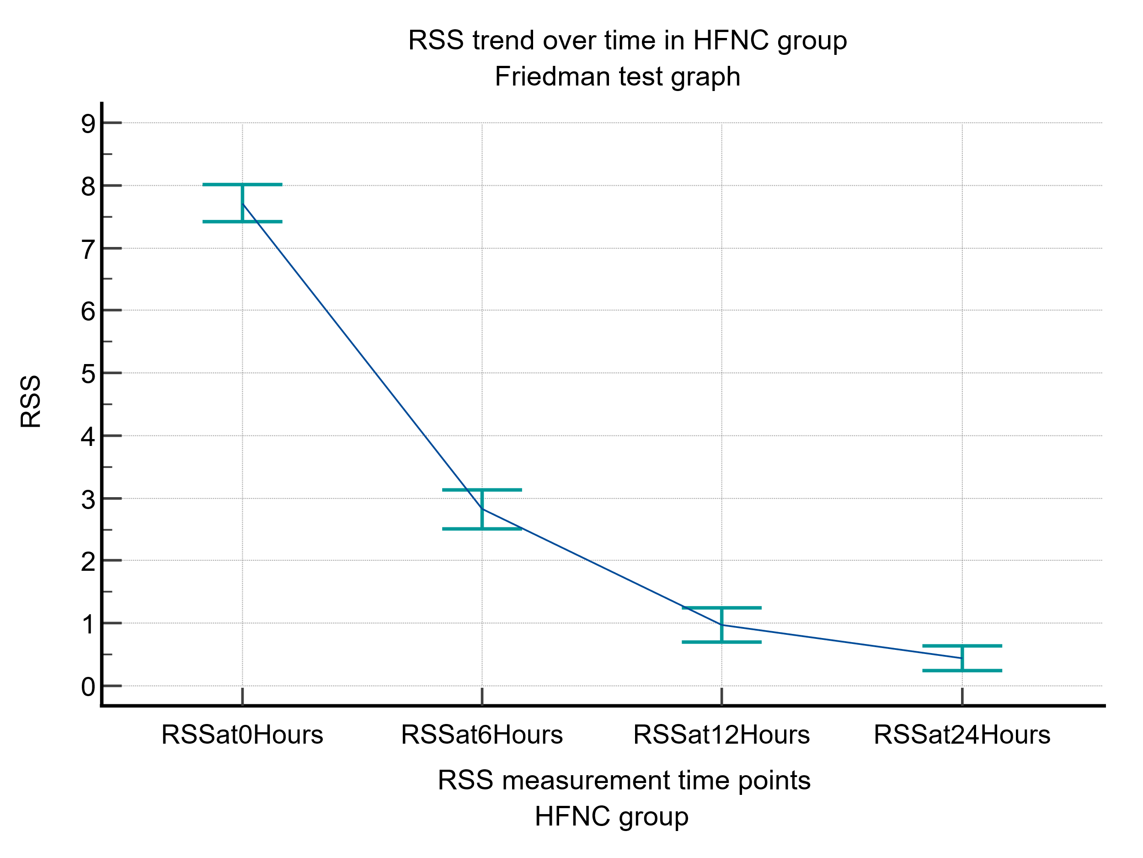

Figure 2 RSS trend over time in Nasal oxygen group
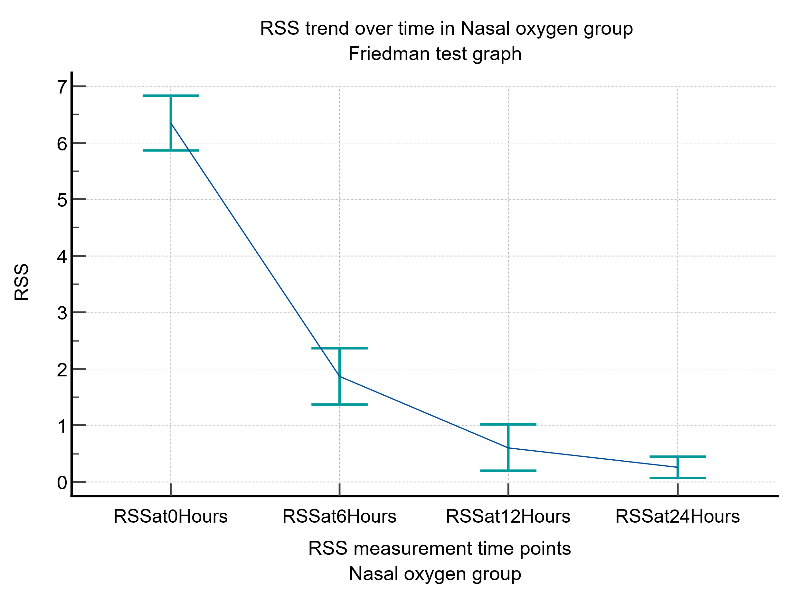

Figure 3 MCS trend over time in HFNC group
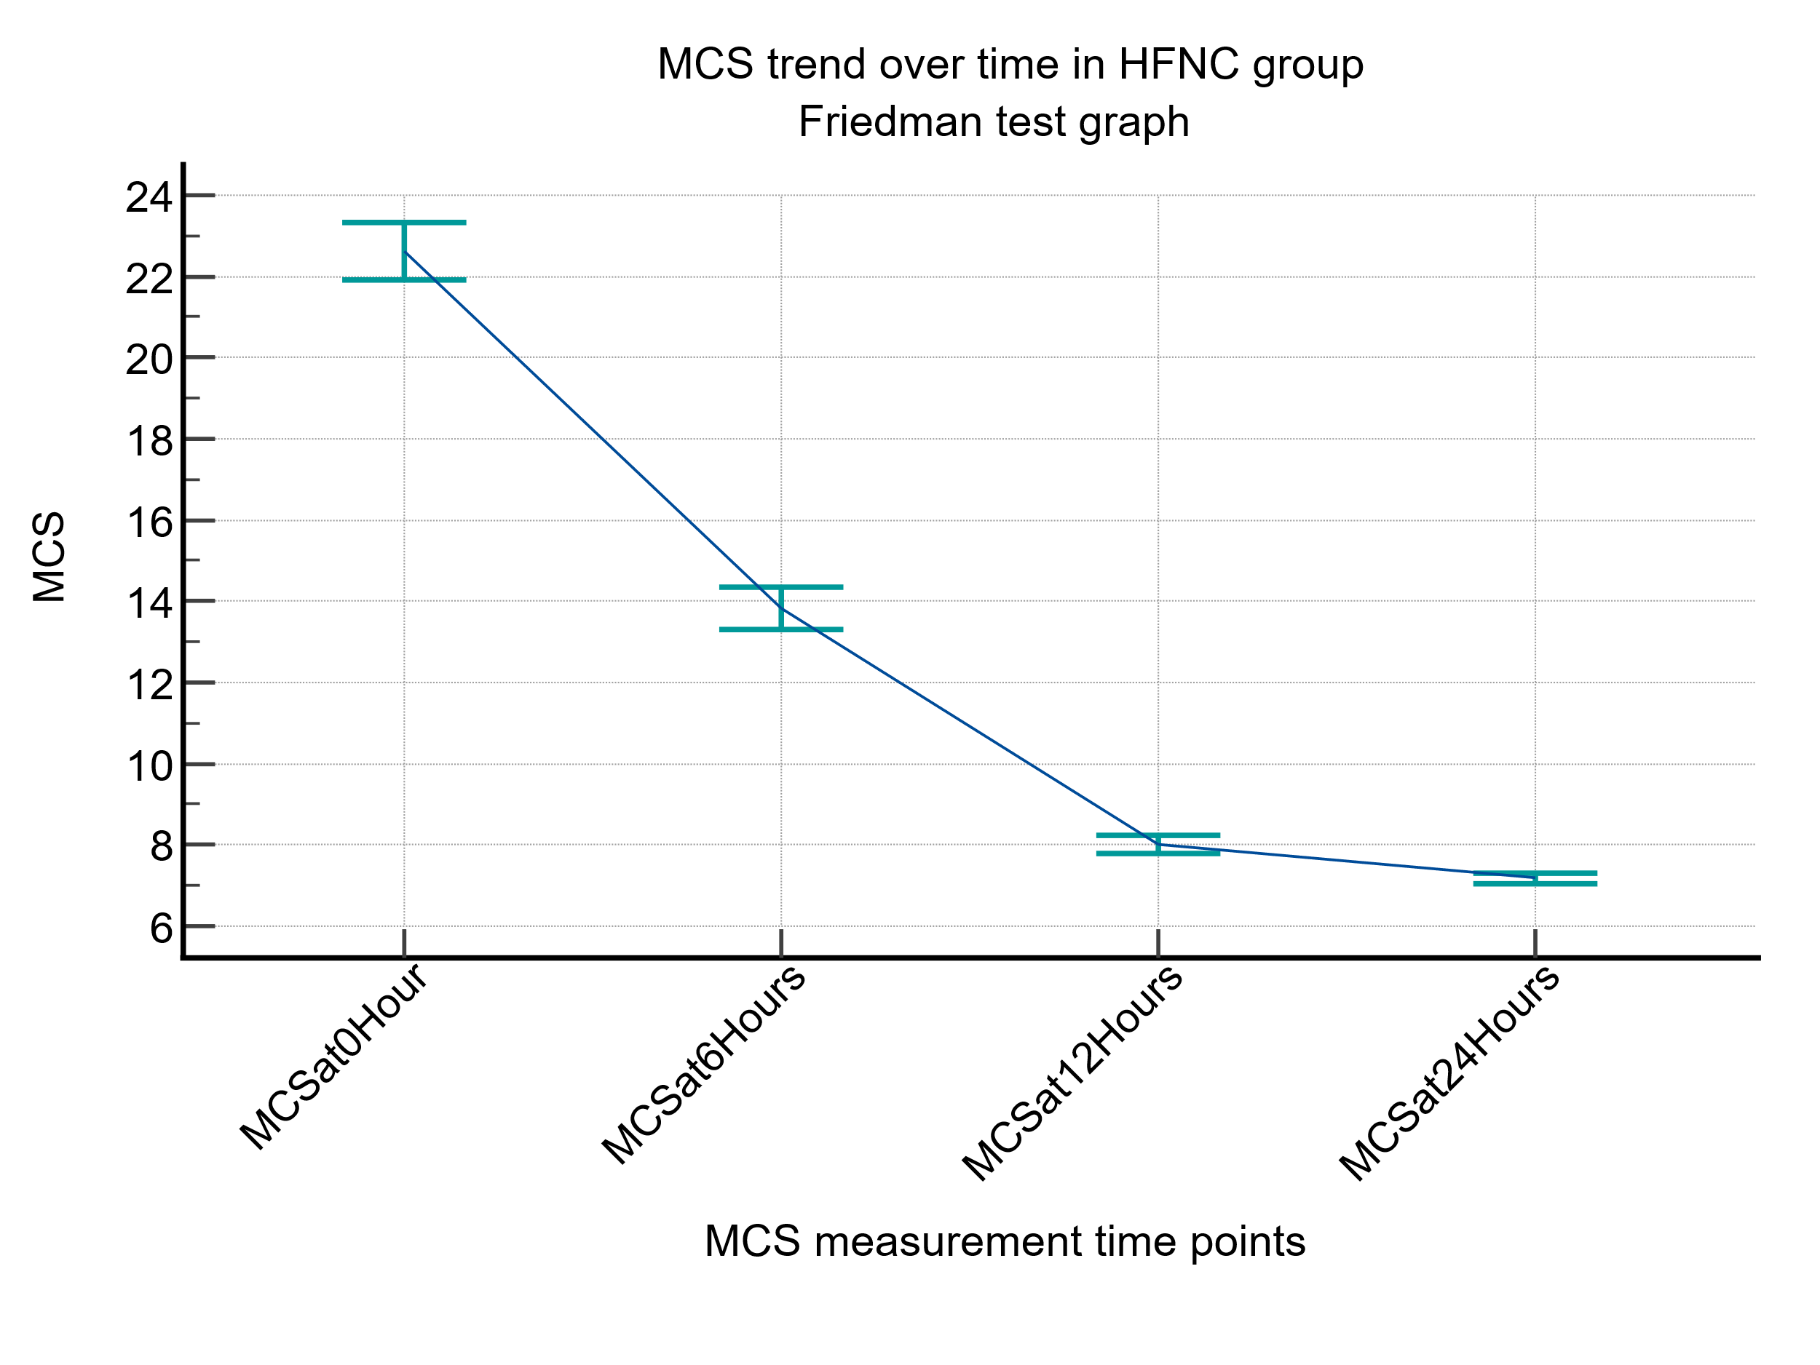

Figure 4 MCS trend over time in Nasal oxygen group
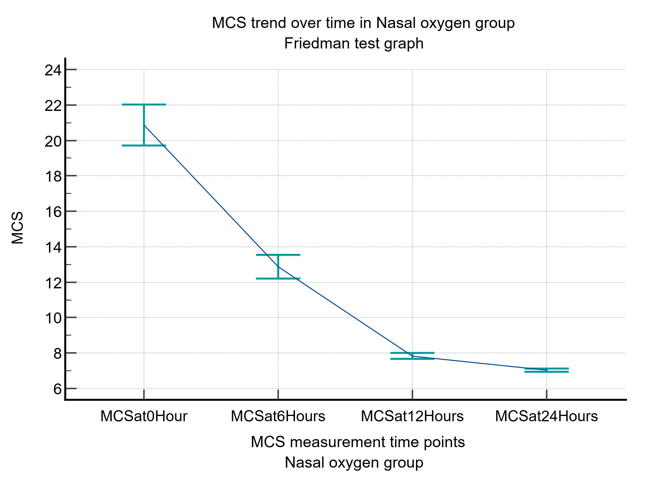

Figure 5 RSS changing pattern comparison over time in HFNC and Nasal oxygen groups
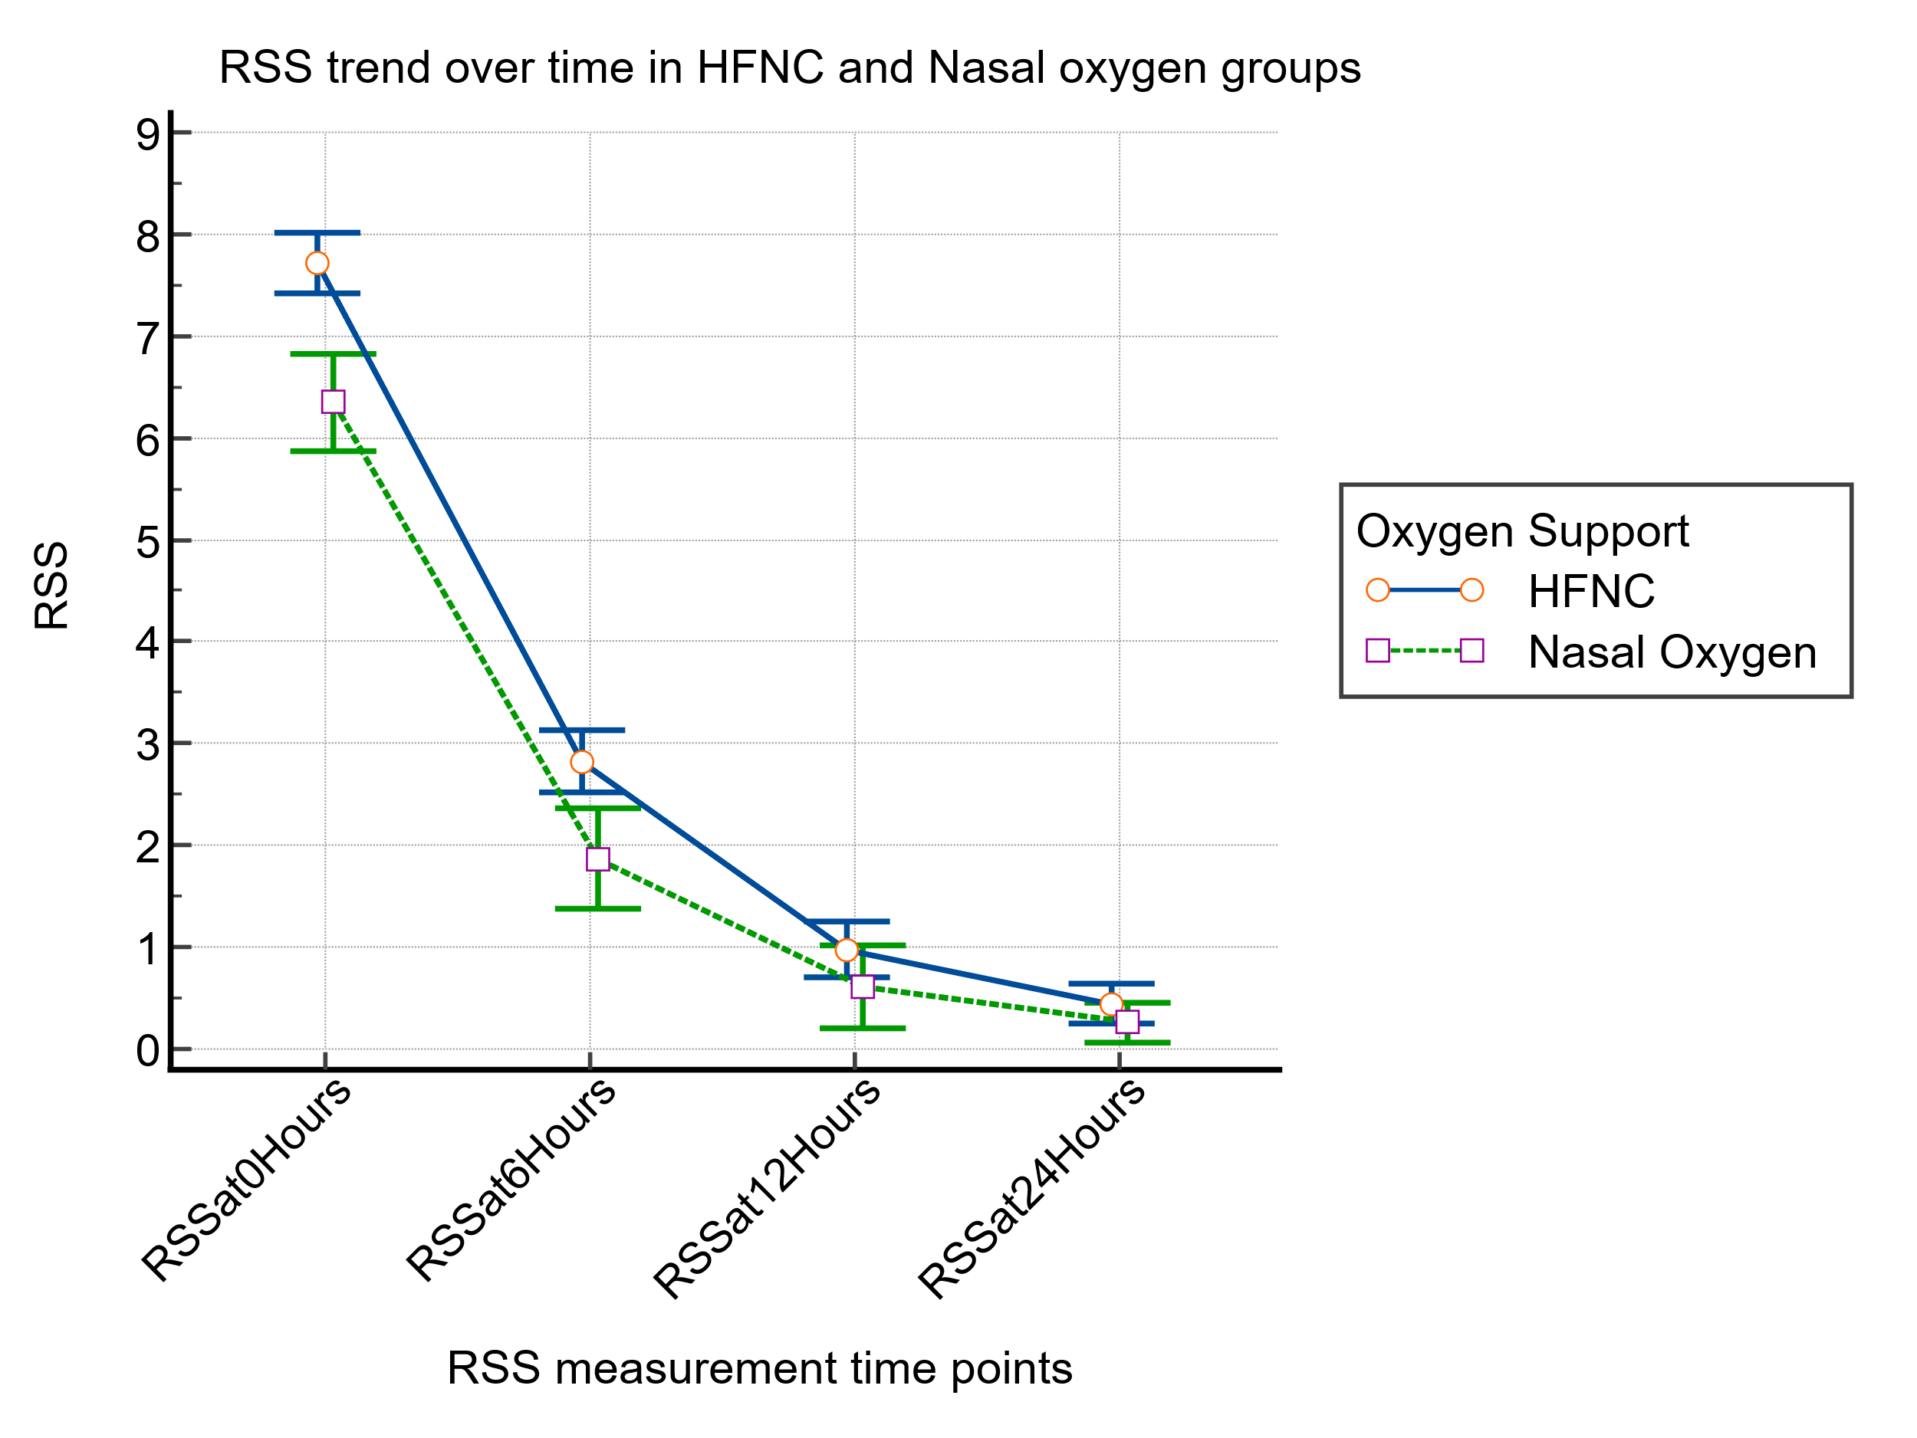

Figure 6 MCS changing pattern comparison over time in HFNC and Nasal oxygen groups
