Title: Efficacy of Scalp Cooling combined with DHL-HisZnNa Lotion in the Prevention of Chemotherapy-Induced Alopecia in Patients with Breast Cancer
Journal name: Supportive Care in Cancer
Authors:
Misato Araki, Koshi Matsui, Emi Kanaya, Shiho Nagasawa, Ameri Urasaki, Mutsuki Furukawa, Shinichi Sekine, Tsutomu Fujii
Institutions:
Department of Surgery and Science, Faculty of Medicine, Academic Assembly,
University of Toyama, 2630, Sugitani, Toyama, 930-0194, Japan.
Corresponding author:
Tsutomu Fujii, MD, PhD, FACS
Department of Surgery and Science, Faculty of Medicine, Academic Assembly, University of Toyama, 2630 Sugitani, Toyama 930-0194, Japan
E-mail: fjt@med.u-toyama.ac.jp

Supplementary Material
Figure S1: Changes in alopecia grade by chemotherapy regimen

The proportion of patients with alopecia during chemotherapy is shown by CTCAE grade for each regimen. The vertical axis indicates percentage (0–100%), and the horizontal axis shows treatment cycles and follow-up (Day 30, Day 60, and Day 90). Stacked bars represent grades 0–2.
Panels (a)–(f) correspond to the following regimens:
(a) ddAC→ ddPTX (n = 7)
(b) HP + DTX →ddAC (n = 8)
(c) TC (n = 2)
(d) HP + DTX (n = 3)
(e) PTV + DTX (n = 2)
(f) PEM + TC →Pem + AC (n = 2)

- ddAC→ddPTX (n = 7)
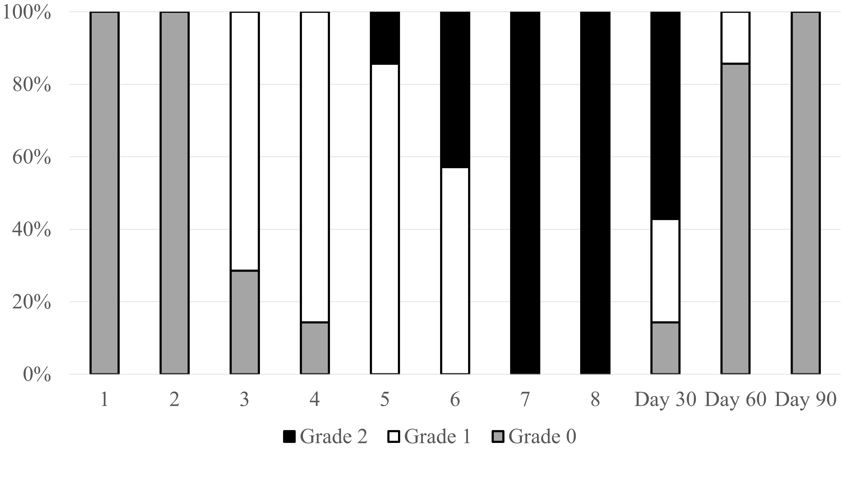

(b) HP + DTX→ddAC (n=8)
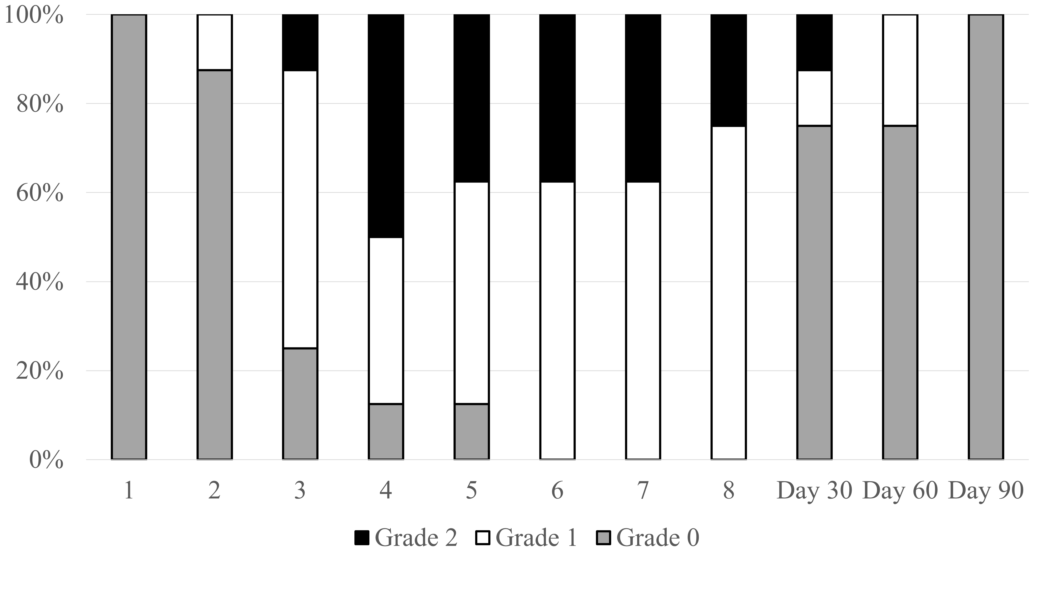

(c) TC (n=2)
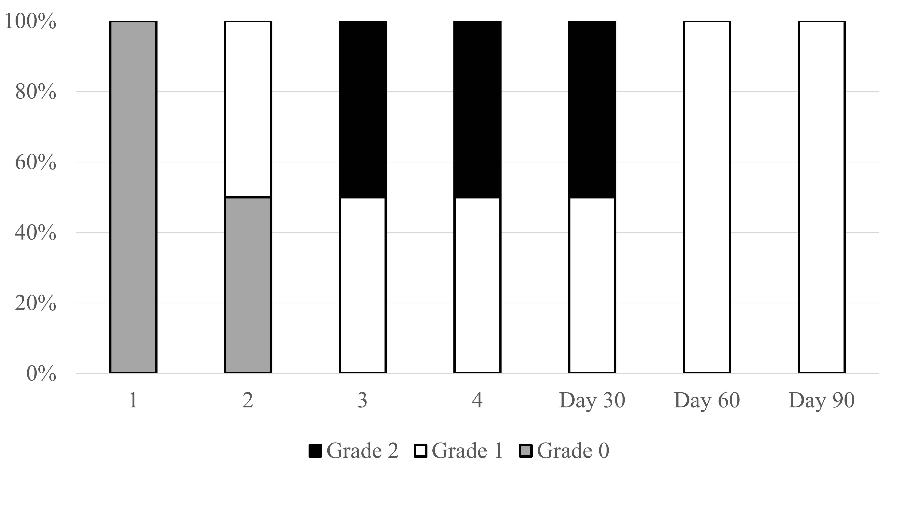

(d) HP ＋ DTX (n=3)
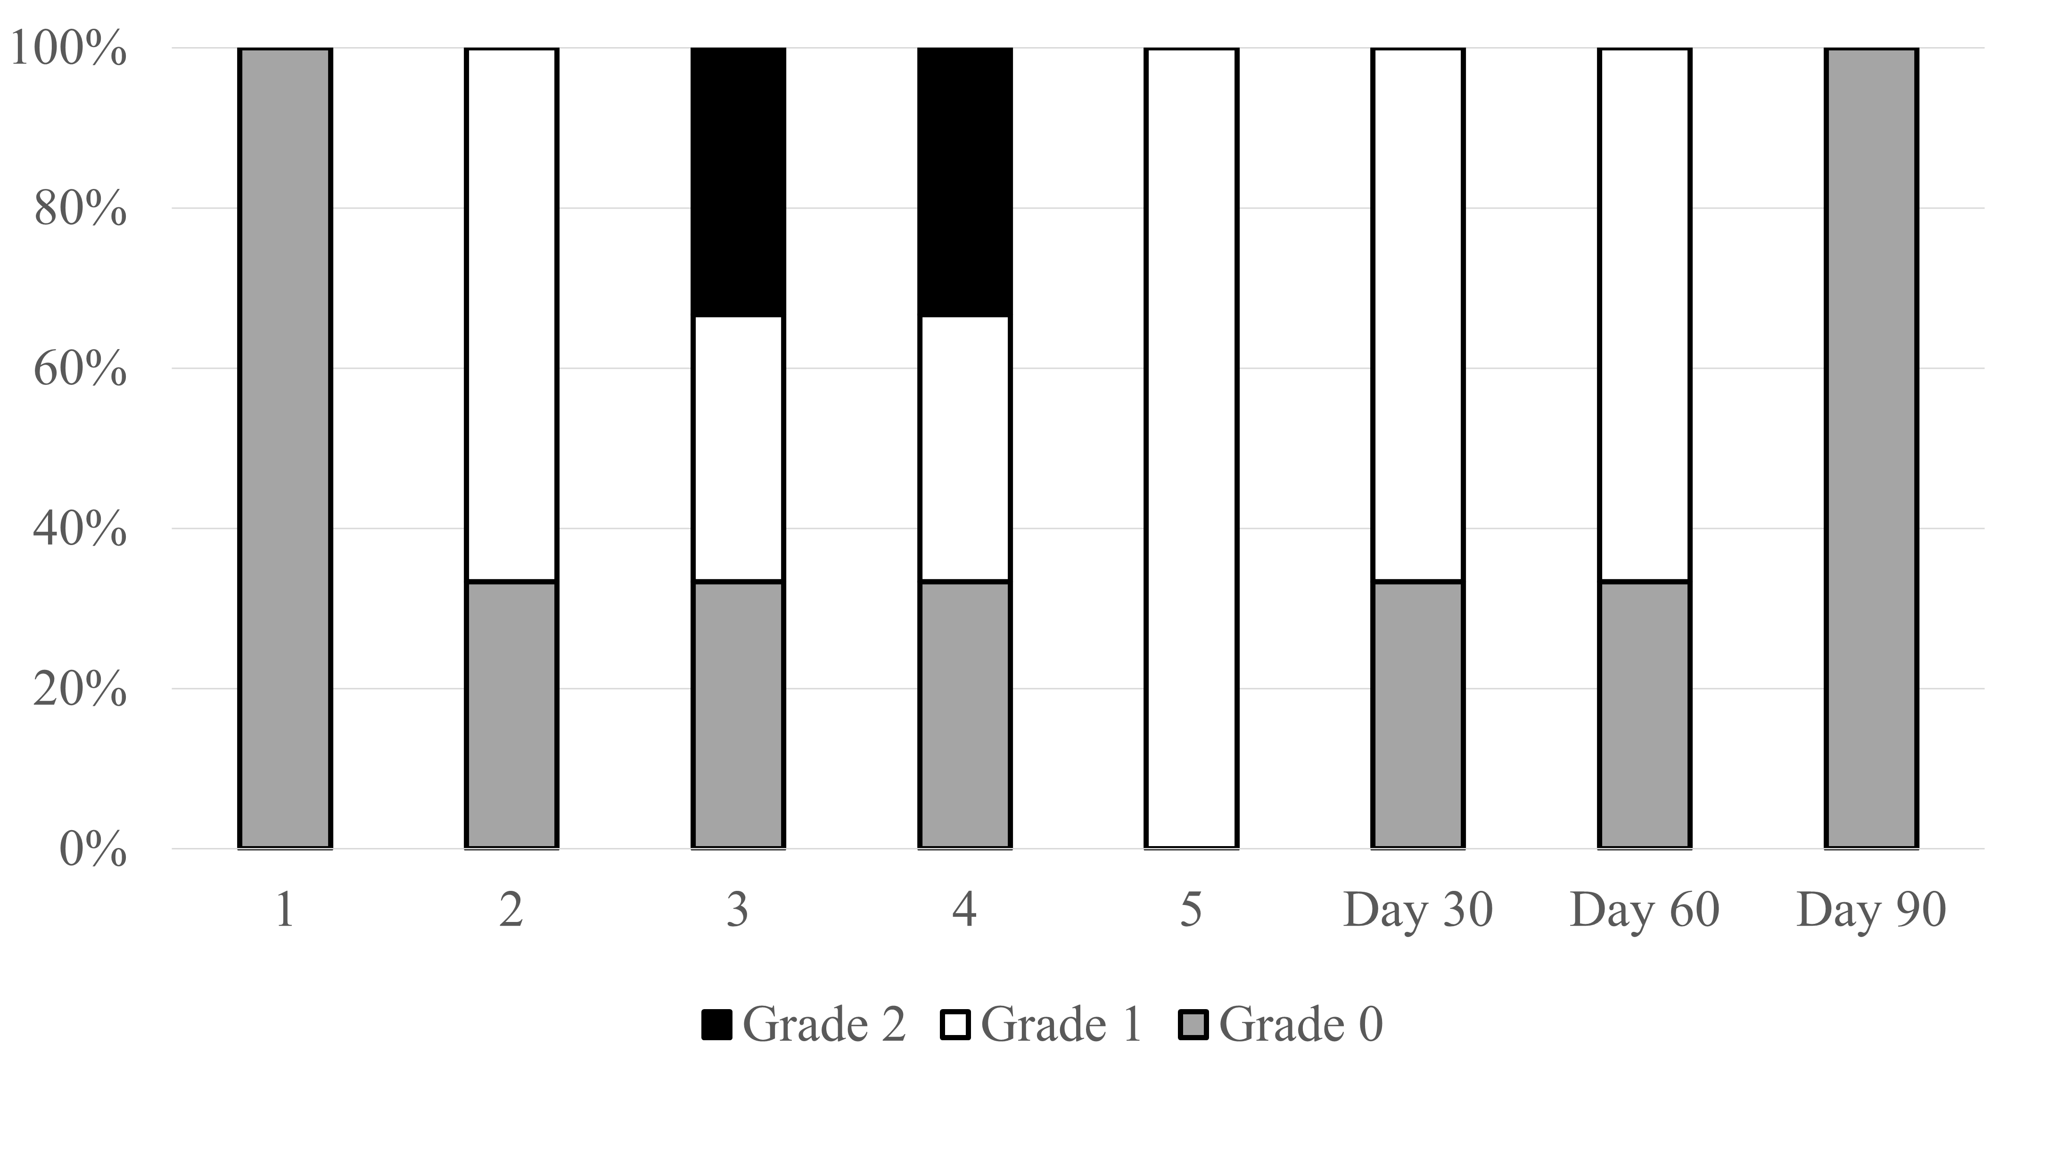

(e) PTV ＋ DTX (n=2)
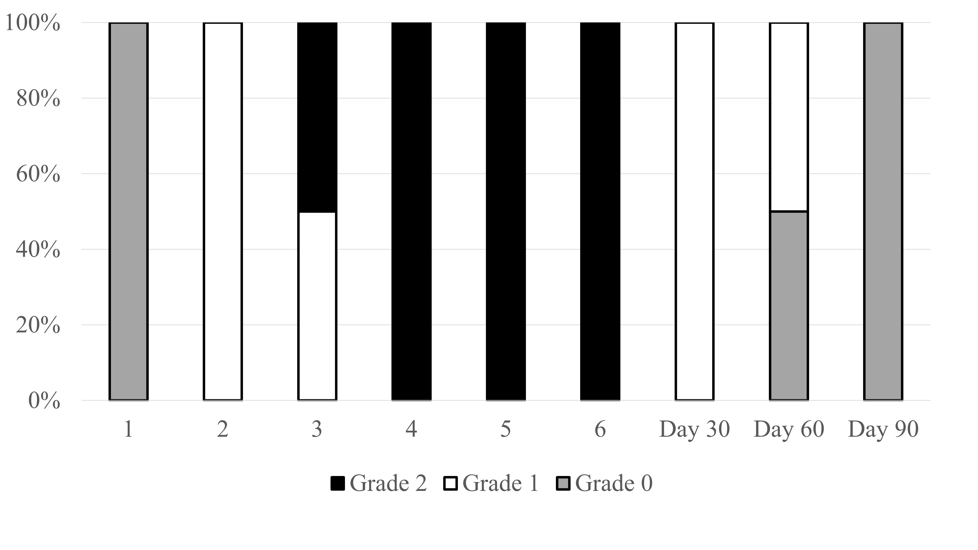

(f) Pem + TC→Pem＋AC (n=2)
