A Two-Stage Fragment-Connection Framework for Infrared-Spectrum-Driven Molecular Structure Elucidation
Limin Yu^{1,2}, Qingyu Zhou³, Zhenghui Pan¹, Jing Wang⁴, Yanqi Zhang^{1,}*
¹School of Medical Imaging, Division of Medical Technology, Tianjin Key Laboratory of Functional Imaging, Tianjin Medical University, Tianjin 300203, China
²School of Pharmacy, Tianjin Medical University, Tianjin 300070, China
³School of Biomedical Engineering and Technology, Tianjin Medical University, Tianjin 300070, China
⁴Department of Clinical Biochemistry and Molecular Diagnostics, College of Medical Technology, Tianjin Medical University, Tianjin 300203, China
*Corresponding author: Yanqi Zhang. E-mail: zhangyanqi1991@tmu.edu.cn.
Supplementary Information
To better understand how scaffold-level failure patterns depend on evaluation design, we performed additional scaffold-level failure analyses for three representative settings using seed 0:
(i) an unfiltered random split,
(ii) a complexity-controlled random split restricted to samples with mask_sum ≥ 3
(iii) a scaffold-disjoint split.
For each setting, we summarized scaffold-level Top-1 failure counts, Top-1 failure rates, Top-5 failure rates, and the Top-1 success/failure composition of the most frequent scaffolds. These analyses were intended as illustrative, dataset-specific portraits rather than as universal scaffold-difficulty rankings.
In the unfiltered random split, the largest absolute numbers of failures were mainly contributed by highly frequent scaffolds, showing that the overall scaffold-frequency distribution strongly shaped the absolute error budget. However, the scaffolds with the highest failure rates did not fully coincide with those contributing the most failures, indicating that scaffold prevalence and scaffold difficulty were not equivalent.
After restricting evaluation to the mask_sum ≥ 3 subset, the ranking of high-failure scaffolds changed substantially. This suggests that complexity control altered the interpretability of scaffold-level failure rates by reducing the influence of lower-complexity molecules, thereby yielding a portrait more closely related to multi-fragment reconstruction difficulty.
Under scaffold-disjoint evaluation, scaffold-level failures became more fold-sensitive. The highest-failure scaffolds and the highest-failure-rate scaffolds no longer simply mirrored the random-split pattern, but instead depended strongly on the specific composition of the held-out scaffold families. In this setting, some scaffolds showed simultaneously high Top-1 and Top-5 failure rates, suggesting that the dominant errors were not limited to candidate ranking, but also involved incomplete candidate coverage and less stable connection discrimination under out-of-scaffold generalization.
We emphasize that these observations are specific to the dataset and experimental setup used in this study. Accordingly, they are interpreted here as dataset-dependent evidence that scaffold-level failure portraits can vary substantially with split protocol, scaffold composition, and complexity control, even when the model architecture and decoding pipeline remain fixed.
A. Unfiltered random split, seed 0
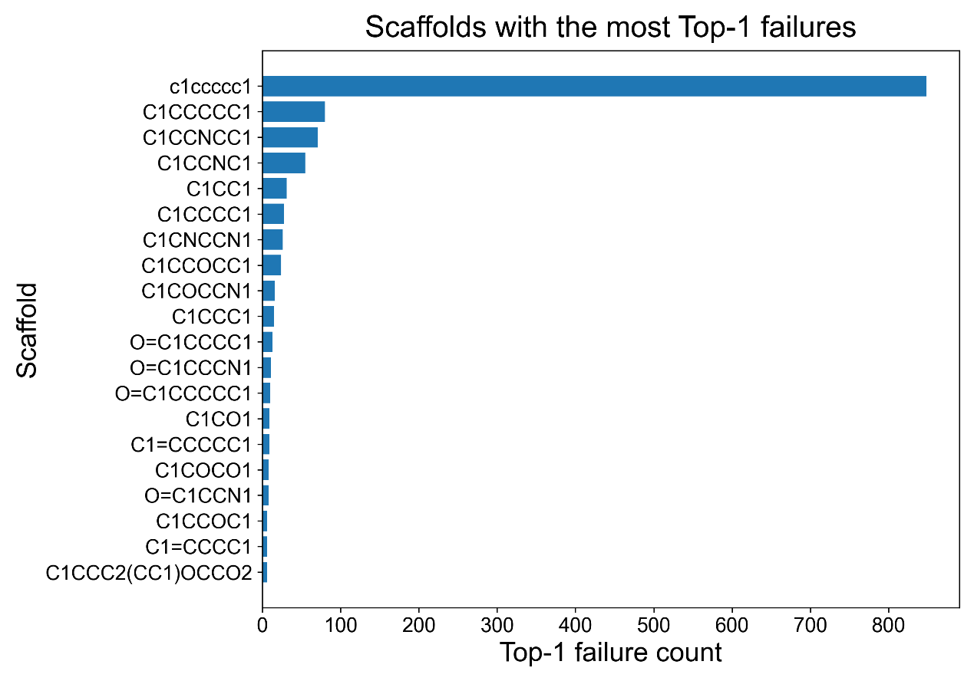
Figure S1. Scaffold-level Top-1 failure counts in the unfiltered random-split setting (seed 0). The plot shows the scaffolds contributing the largest absolute numbers of Top-1 failures. These counts reflect the combined influence of scaffold prevalence in the test set and scaffold-specific reconstruction difficulty.

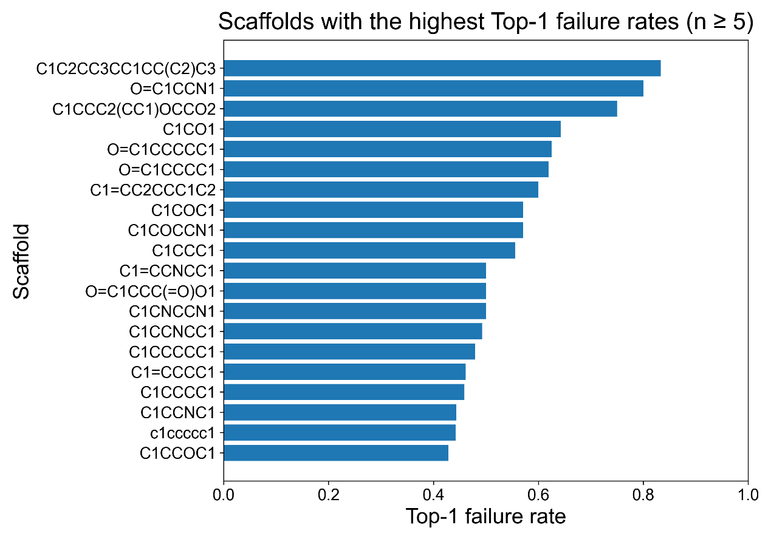
Figure S2. Relative Top-1 failure rate for scaffolds with at least five test-set samples under the unfiltered random-split evaluation (seed 0). Unlike the corresponding failure counts, this view highlights scaffolds that are exceptionally difficult relative to their prevalence, rather than those that simply contribute many errors because they are frequent in the test set.

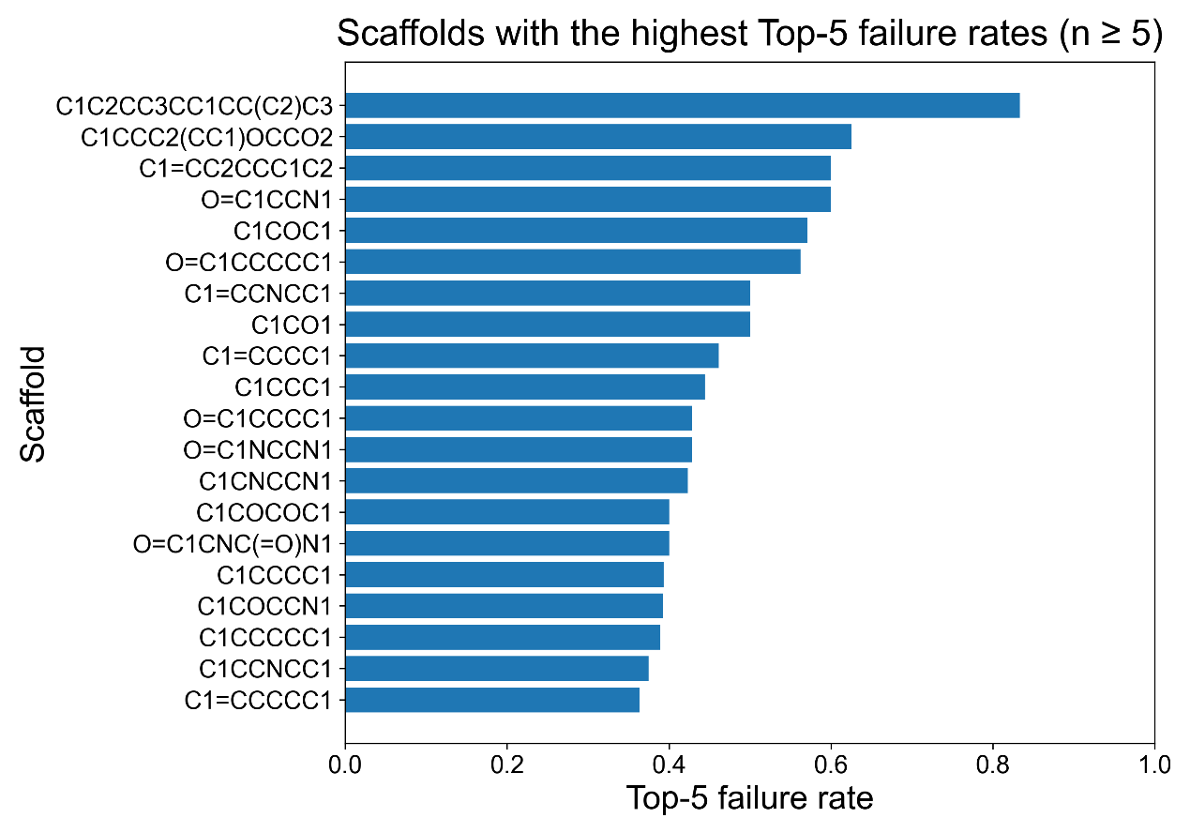
Figure S3. Scaffold-level Top-5 failure rates in the unfiltered random-split setting (seed 0) for scaffolds with at least five test samples. This view provides a rough indication of whether scaffold failures are more related to candidate-ranking ambiguity or insufficient candidate representativity.

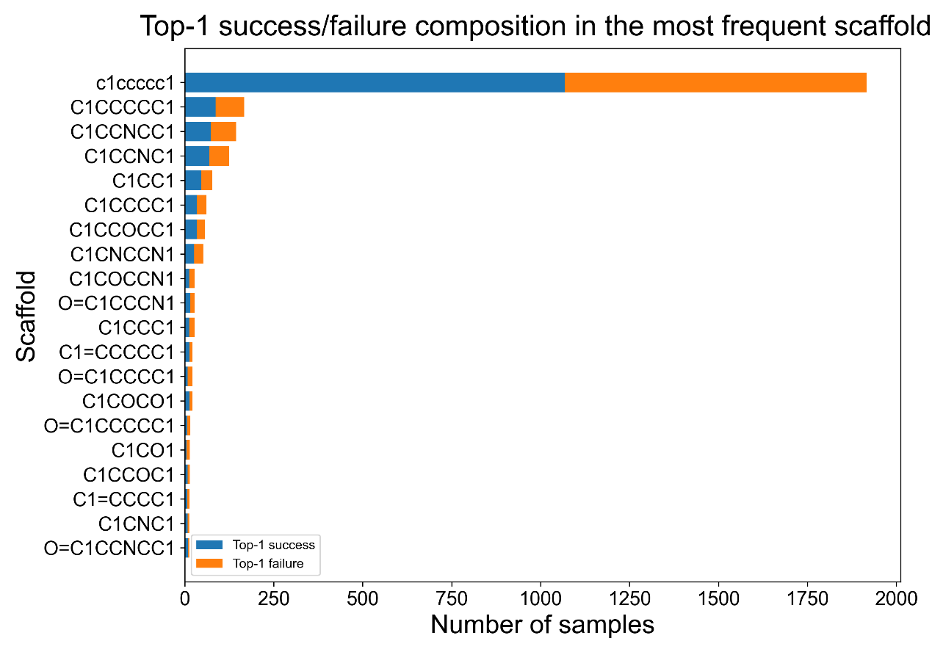
Figure S4. Top-1 passes and failures for the most frequent scaffolds in the unfiltered random-split test set (seed 0). This plot illustrates the negative correlation between the contribution of highly frequent scaffolds to the absolute error budget and the fact that scaffold prevalence and scaffold difficulty are not the same.

B. Complexity-controlled random split (mask_sum ≥ 3), seed 0

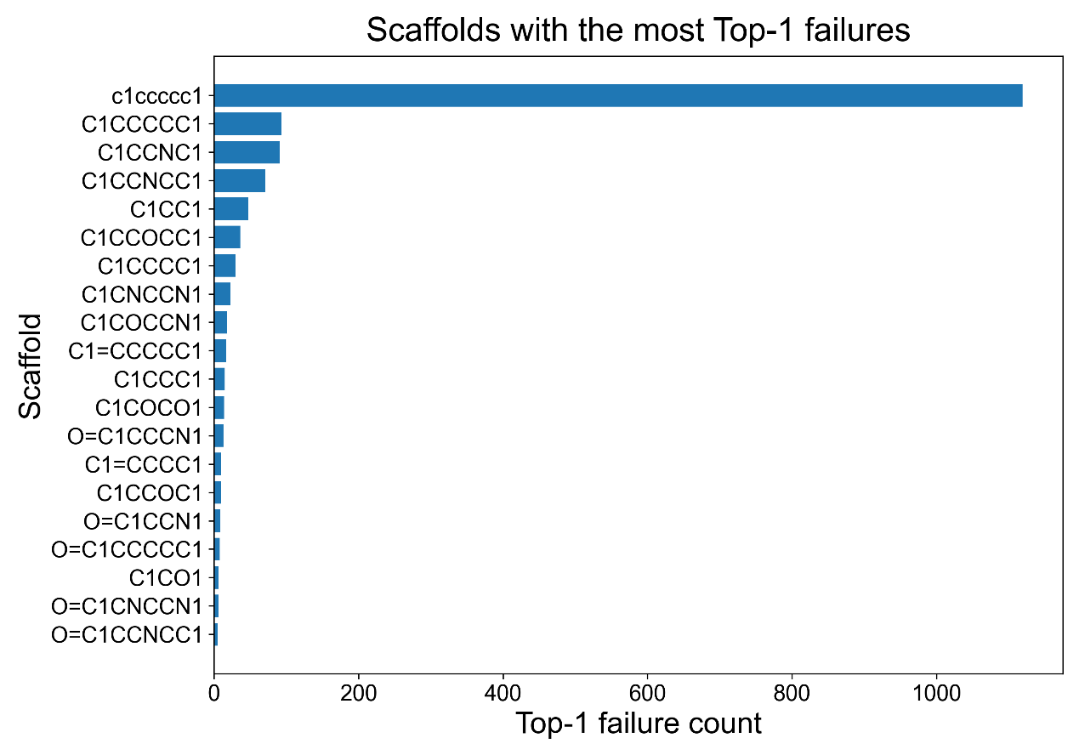
Figure S5. Scaffold-level Top-1 failure counts in the complexity-controlled random-split setting (mask_sum ≥ 3, seed 0). By restricting evaluation to molecules with at least three BRICS fragment nodes, this view reduces the contribution of lower-complexity samples and better reflects scaffold-level errors in multi-fragment reconstruction.

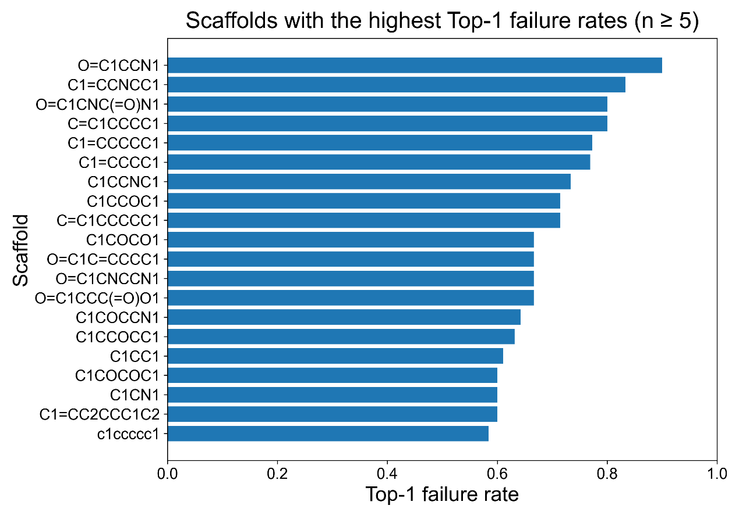
Figure S6. Scaffold-level Top-1 failure rates in the complexity-controlled random-split setting (mask_sum ≥ 3, seed 0), calculated for scaffolds with at least five test samples. Relative to the unfiltered setting, the change in the ranking of high-failure scaffolds indicates that complexity control alters the interpretability of scaffold-level difficulty.

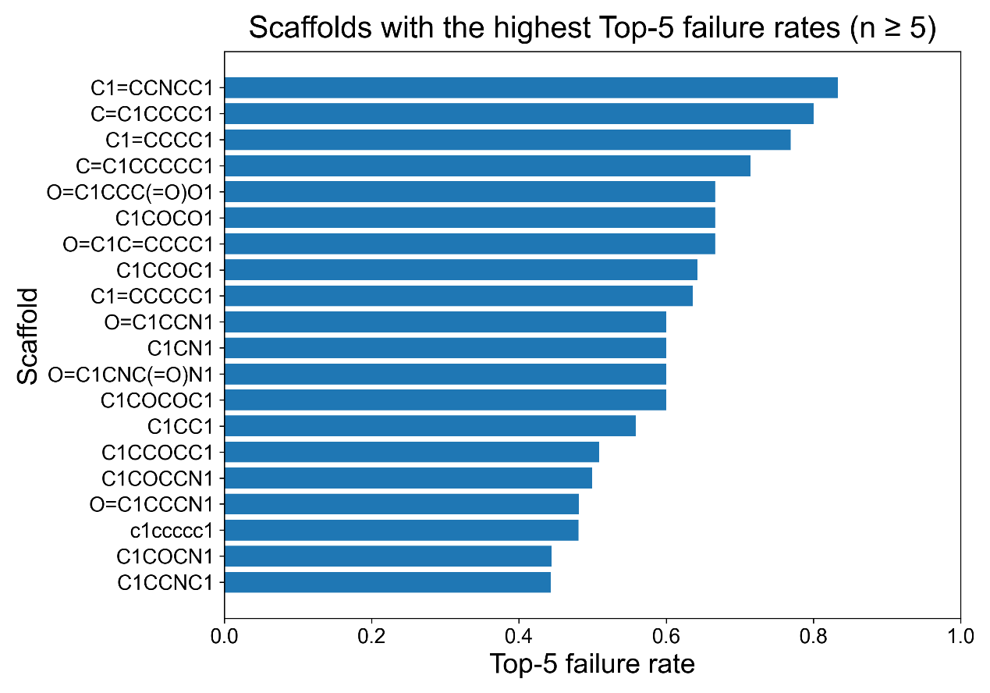
Figure S7. Scaffold-level Top-5 failure rates in the complexity-controlled random-split setting (mask_sum ≥ 3, seed 0), calculated for scaffolds with at least five test samples. This view provides additional evidence on whether the remaining scaffold-level errors are mainly associated with candidate ranking ambiguity or with broader reconstruction failure within the top candidate set.

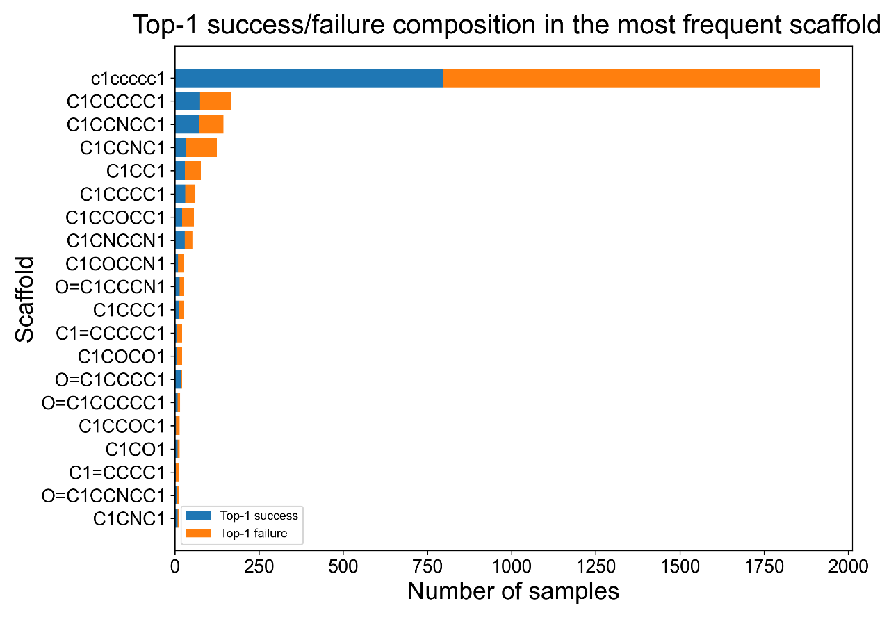
Figure S8. Top-1 success/failure composition of the most frequent scaffolds in the complexity-controlled random-split setting (mask_sum ≥ 3, seed 0). Compared with the unfiltered setting, this figure highlights scaffold-level error patterns after suppressing distortion from lower-complexity molecules.

C. Scaffold-disjoint split, seed 0
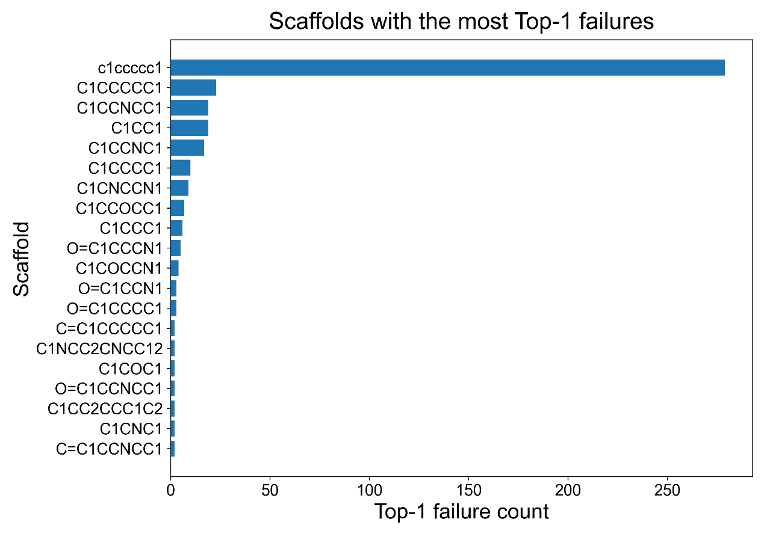
Figure S9. Scaffold-level Top-1 failure counts in the scaffold-disjoint setting (seed 0). Because the test set is composed of held-out scaffold families, the absolute failure distribution reflects not only scaffold frequency but also fold-specific out-of-scaffold generalization difficulty.

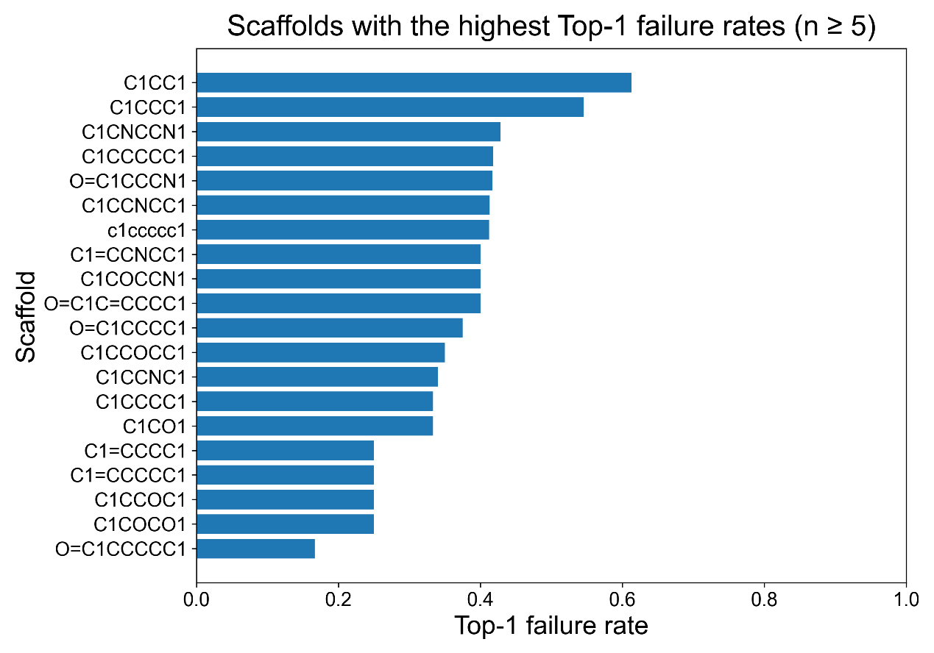
Figure S10. Scaffold-level Top-1 failure rates in the scaffold-disjoint setting (seed 0), calculated for scaffolds with at least five test samples. The concentration of high failure rates in specific held-out scaffold families indicates that scaffold-disjoint evaluation is highly sensitive to the structural composition of the test fold.

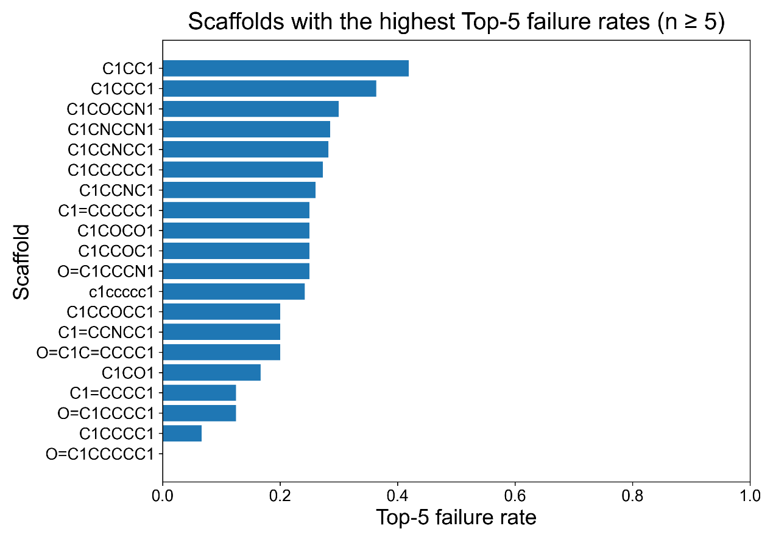
Figure S11. Scaffold-level Top-5 failure rates in the scaffold-disjoint setting (seed 0), calculated for scaffolds with at least five test samples. Scaffolds with simultaneously high Top-1 and Top-5 failure rates suggest that errors under scaffold-disjoint evaluation are not limited to candidate ranking, but may also involve incomplete candidate coverage or less stable connection discrimination.

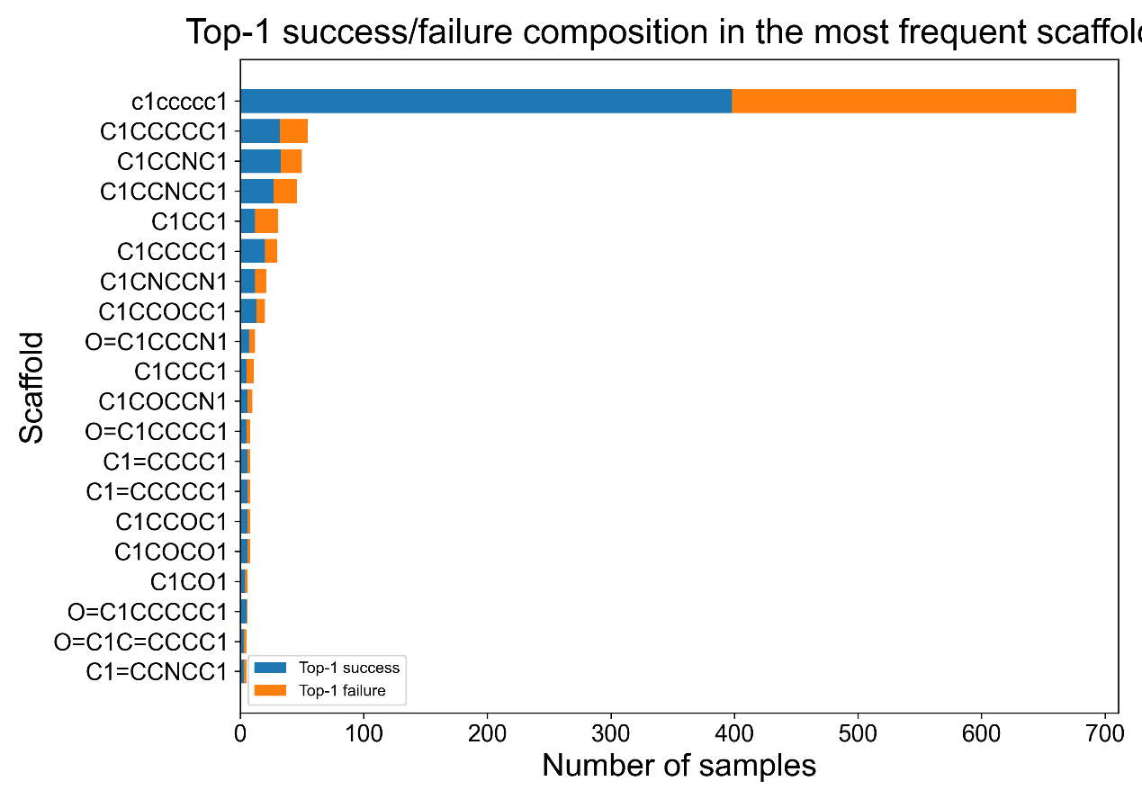
Figure S12. Top-1 success/failure composition of the most frequent scaffolds in the scaffold-disjoint setting (seed 0). This figure illustrates how scaffold-disjoint evaluation reshapes the scaffold-level error portrait relative to random splitting, with error concentration depending strongly on the composition of held-out scaffold families.

D. Multimodal ablation
To examine whether additional spectral modalities can further improve reconstruction under the current fragment-connection framework, we implemented a multimodal variant that augments the infrared representation with auxiliary ${}_{ }^{1}H$ peak-table, ${}_{ }^{13}C$ peak-table, and HSQC peak-table inputs. The multimodal model was trained and decoded under the same filtered 63.0k benchmark used in the main experiments, so that the comparison with the IR-only model reflects the effect of adding these modalities rather than changes in the evaluation protocol.
Under this setting, the multimodal model achieved Top-1 = 0.5268, Top-5 = 0.6646, Validity = 1.0000, Empty = 0.0000, and Avg best Tanimoto = 0.8790. The corresponding IR-only baseline achieved Top-1 = 0.5357, Top-5 = 0.6623, Validity = 1.0000, Empty = 0.0000, and Avg best Tanimoto = 0.8783. These results indicate that introducing the additional modalities did not produce a consistent overall improvement under the current implementation. The multimodal model remained stable and chemically valid, but its Top-1 performance was slightly lower than that of the IR-only model, while Top-5 and Tanimoto were only marginally different.
This finding suggests that the current bottleneck is not simply the number of spectral modalities provided to the model. Instead, performance may be limited more by cross-modal fusion quality, fragment-level representation learning, and downstream connection discrimination. Therefore, the IR-only formulation is retained as the main setting in this study, while multimodal modeling is treated as a supplementary ablation direction.
Table S1. Multimodal ablation compared with the IR-only baseline.
Model | Top1 | Top5 | Validity | Empty | Tanimoto
IR-only | 0.5357 | 0.6623 | 1.0000 | 0.0000 | 0.8783
IR + ${}_{ }^{1}H$+ ${}_{ }^{13}C$ + HSQC | 0.5268 | 0.6646 | 1.0000 | 0.0000 | 0.8790

E. Sparse export comparison
We additionally compared sparse export with top-32 and top-64 candidate retention under the filtered 63.0k setting. This comparison was intended to verify whether increasing the number of retained pairwise connection candidates materially changes reconstruction behavior once the candidate set is already moderately large.
Under scaffold-disjoint evaluation, the differences between top-32 and top-64 were small. For scaffold fold 0, top-32 achieved Top-1 = 0.5957, Top-5 = 0.7528, Validity = 1.0000, Empty = 0.0000, and Avg best Tanimoto = 0.9214, while top-64 achieved Top-1 = 0.5949, Top-5 = 0.7528, Validity = 1.0000, Empty = 0.0000, and Avg best Tanimoto = 0.9172. For scaffold fold 1, top-32 achieved Top-1 = 0.6506, Top-5 = 0.7873, Validity = 1.0000, Empty = 0.0000, and Avg best Tanimoto = 0.9433, while top-64 achieved Top-1 = 0.6506, Top-5 = 0.7873, Validity = 1.0000, Empty = 0.0000, and Avg best Tanimoto = 0.9421. These results indicate that increasing sparse export from 32 to 64 does not materially improve reconstruction in this setting and mainly enlarges the candidate space without meaningful gains.
Taken together, these observations support the use of top-32 as the main export setting in this work. It provides competitive reconstruction performance while avoiding unnecessary expansion of the downstream candidate space. This supplementary comparison is therefore consistent with the main paper’s choice to use moderate sparse export as a practical and methodologically stable setting.

Table S2. Sparse export comparison under scaffold-disjoint evaluation on the filtered 63.0k dataset.
Setting | Top1 | Top5 | Validity | Empty | Tanimoto
Scaffold fold 0, top-32 | 0.5957 | 0.7528 | 1.0000 | 0.0000 | 0.9214
Scaffold fold 0, top-64 | 0.5949 | 0.7528 | 1.0000 | 0.0000 | 0.9172
Scaffold fold 1, top-32 | 0.6506 | 0.7873 | 1.0000 | 0.0000 | 0.9433
Scaffold fold 1, top-64 | 0.6506 | 0.7873 | 1.0000 | 0.0000 | 0.9421

