SUPPLEMENTARY MATERIAL
Figure S1. Comparison of Ameroglossum topologies obtained from different markers and phylogenetic inference methods to test incongruence among trees. (A) ITS with Neighbor-Joining; (B) matK + rps16 with Neighbor-Joining; (C) ITS with RAxML; (D) matK + rps16 with RAxML; (E) ITS + matK + rps16 with Neighbor-Joining; (F) ITS + matK + rps16 with RAxML. Analyses were performed using nuclear (ITS) and plastid (matK, rps16) data.
,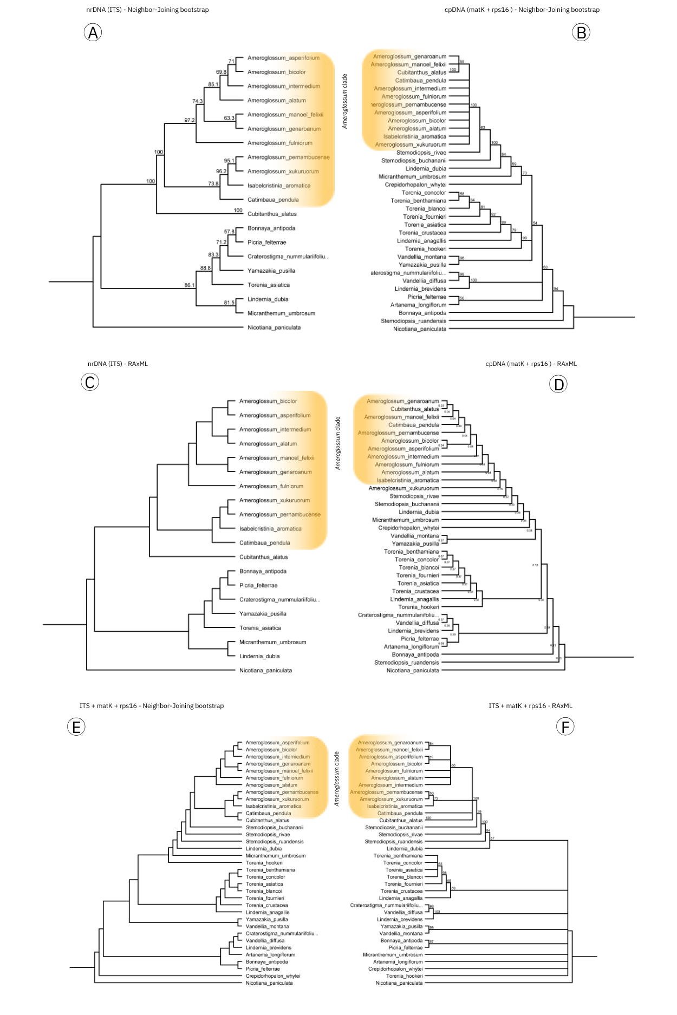
Figure S2. Comparison of Dyckia topologies obtained from different markers and phylogenetic inference methods to test incongruence among trees. (A) ITS with Neighbor-Joining; (B) matK + rps16 with Neighbor-Joining; (C) ITS with RAxML; (D) matK + rps16 with RAxML; (E) ITS + matK + rps16 with Neighbor-Joining; (F) ITS + matK + rps16 with RAxML. Analyses were performed using nuclear (ITS) and plastid (matK, rps16) data.
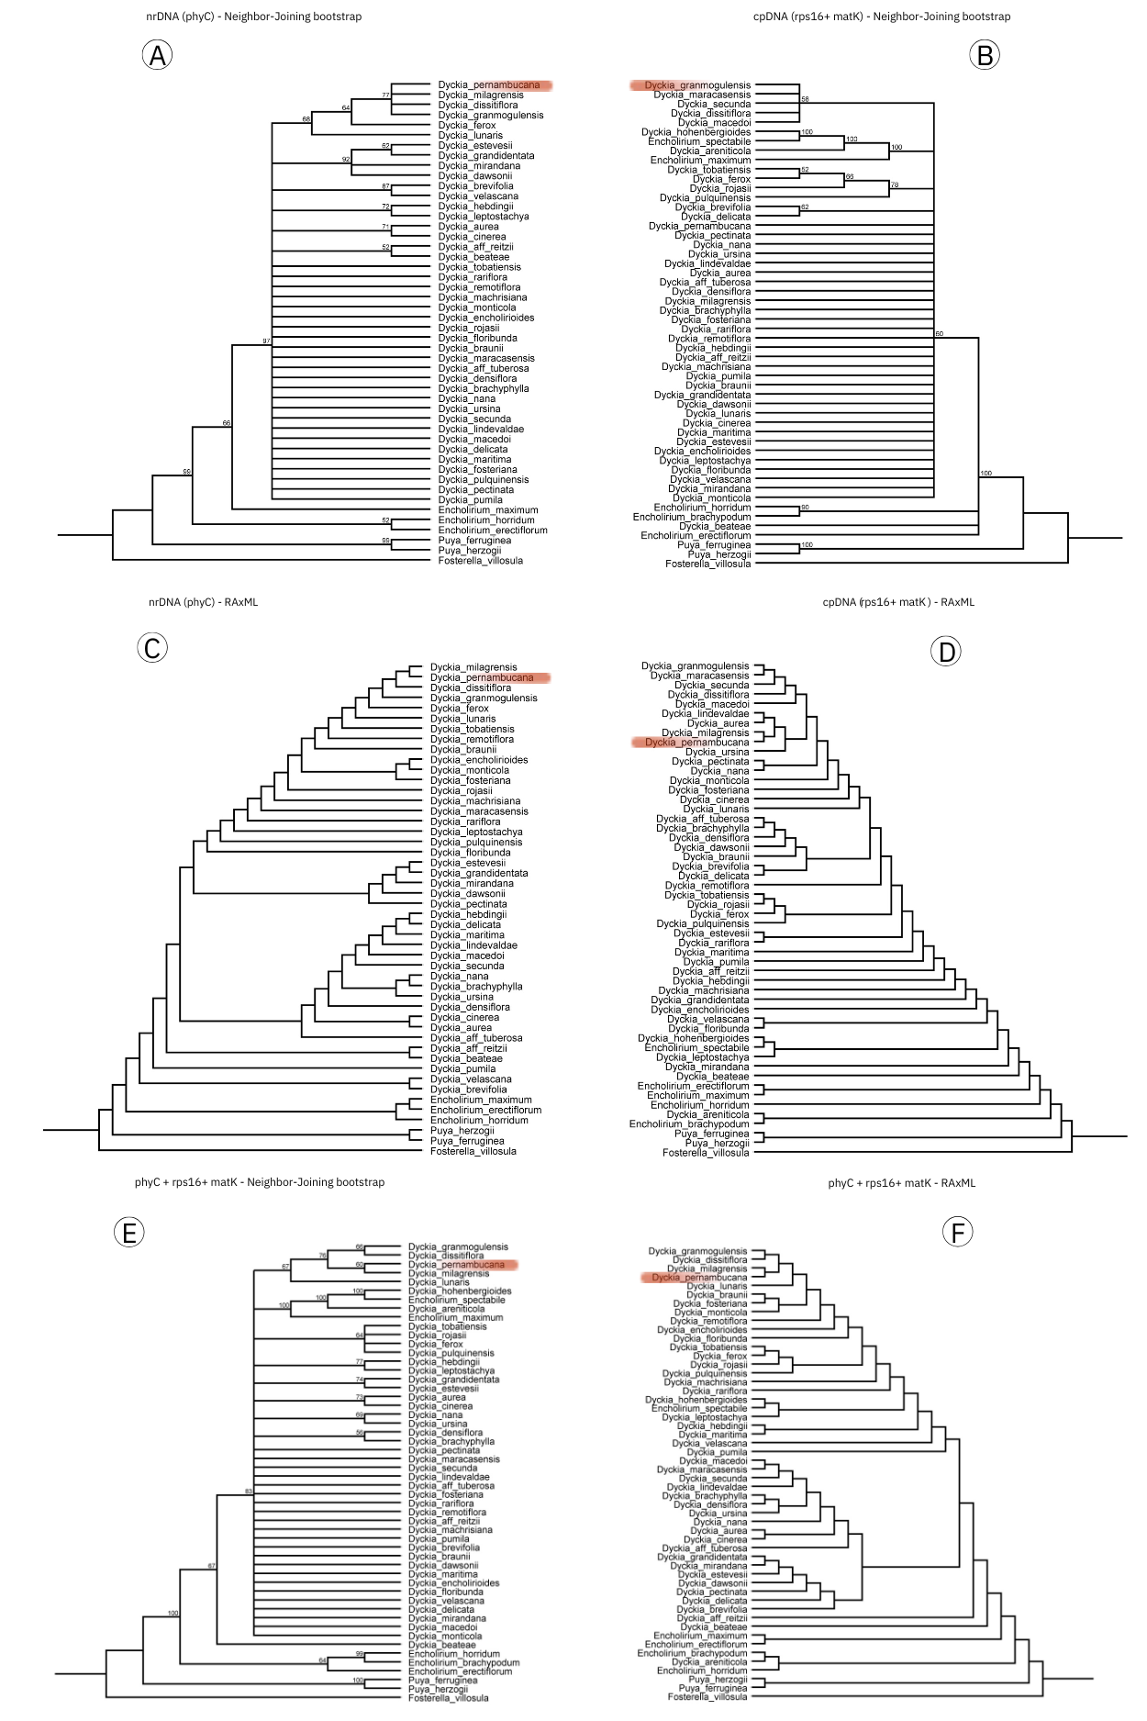
Figure S3. Comparison of Orthophytum topologies obtained from different markers and phylogenetic inference methods to test incongruence among trees. (A) ITS with Neighbor-Joining; (B) matK + rps16 with Neighbor-Joining; (C) ITS with RAxML; (D) matK + rps16 with RAxML; (E) ITS + matK + rps16 with Neighbor-Joining; (F) ITS + matK + rps16 with RAxML. Analyses were performed using nuclear (ITS) and plastid (matK, rps16) data.
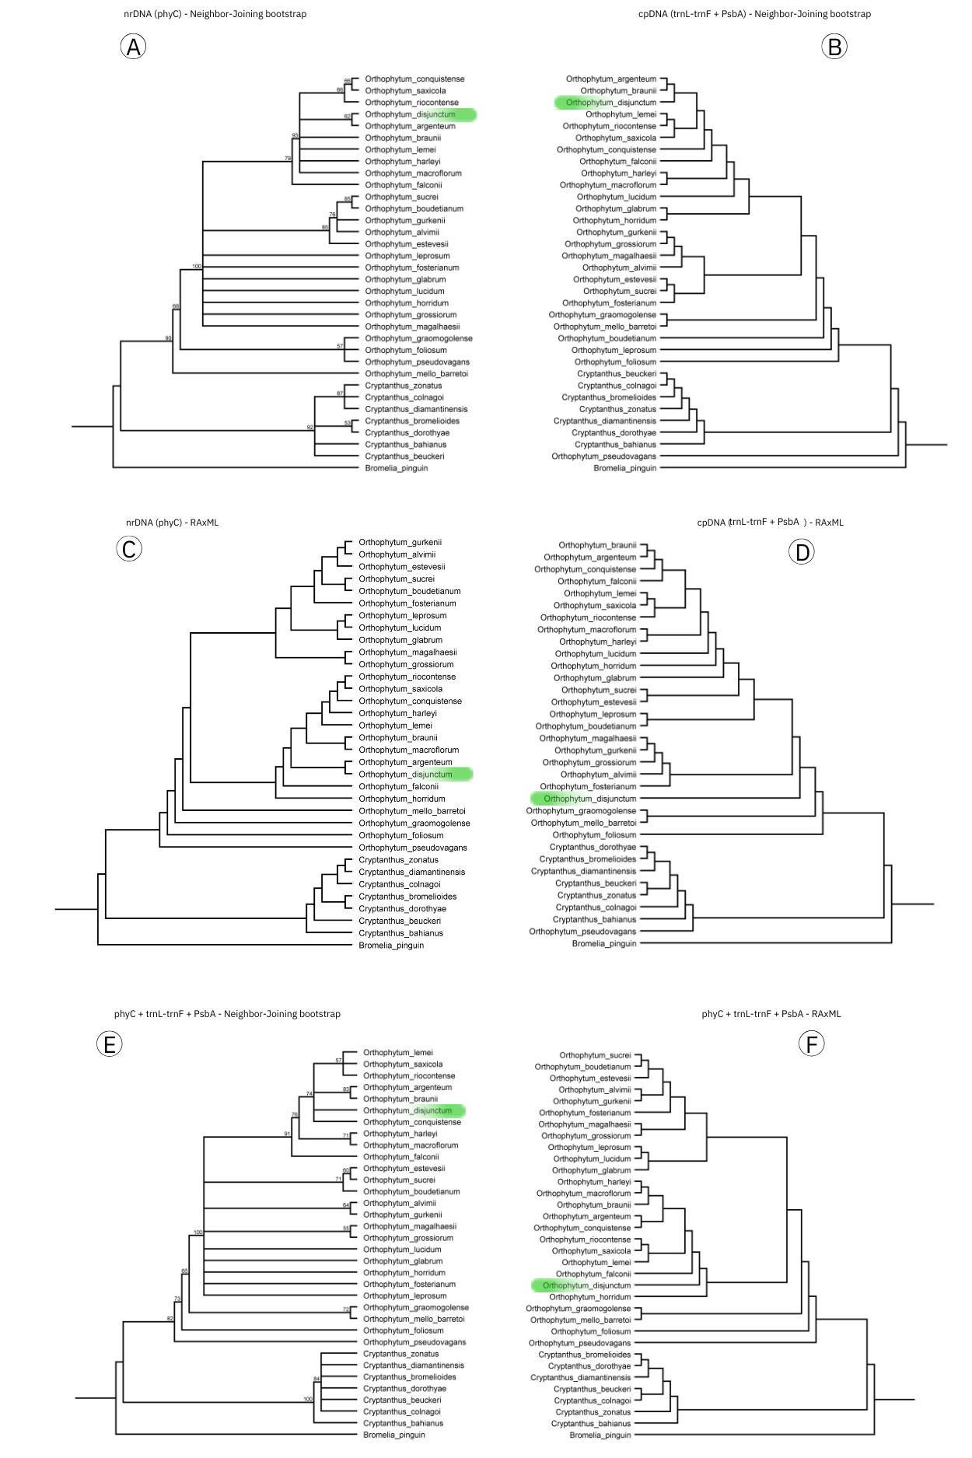

Table S1. Relative importance of explanatory variables in the distribution models of the four studied species (A. pernambucense complex, D. pernambucana, M. dardanoi, and O. disjunctum) across different climatic scenarios: LIG (Last Interglacial), LGM (Last Glacial Maximum), MH (Mid-Holocene), Current (present climatic conditions), SSP1-2.6 and SSP5-8.5 (future climate change scenarios). The values indicate the variable importance value / standard deviation, both ranging from 0 to 1, indicating the contribution of the variable to the model prediction and the variation across model iterations.
Species | Var | LIG | LGM | HM | Current | SSP1-2.6 | SSP5-8.5
A. pernambucense complex | Bio02 | 0.440 / 0.227 | 0.0944 / 0.0868 | 0.279 / 0.174 | 0.0783 / 0.0709 | 0.0828 / 0.0677 | 0.196 / 0.0891
 | Bio03 | 0.198 / 0.209 | 0.269 / 0.214 | 0.91 / 0.192 | 0.240 / 0.132 | 0.231 / 0.108 | 0.119 / 0.123
 | Bio04 | 0.165 / 0.137 | 0.205 / 0.123 | 0.187 / 0.190 | 0.196 / 0.150 | 0.122 / 0.0932 | 0.263 / 0.173
 | Bio08 | 0.125 / 0.121 | 0.105 / 0.118 | 0.200 / 0.148 | 0.287 / 0.152 | 0.271 / 0.126 | 0.255 / 0.108
 | Bio09 | 0.392 / 0.328 | 0.138 / 0.142 | 0.0986 / 0.104 | 0.144 / 0.152 | 0.0818 / 0.0853 | 0.0969 / 0.0930
 | Bio13 | 0.0542 / 0.0587 | 0.360 / 0.260 | 0.148 / 0.186 | 0.219 / 0.197 | 0.0940 / 0.0728 | 0.206 / 0.133
 | Bio15 | 0.348 / 0.203 | 0.136 / 0.0956 | 0.227 / 0.158 | 0.116 / 0.0762 | 0.160 / 0.0836 | 0.291 / 0.187
 | Bio18 | 0.114 / 0.0890 | 0.236 / 0.120 | 0.0879 / 0.0794 | 0.0950 / 0.0681 | 0.158 / 0.0800 | 0.0531 / 0.0417
 | Bio19 | 0.101 / 0.0766 | 0.480 / 0.281 | 0.330 / 0.238 | 0.455 / 0.256 | 0.324 / 0.221 | 0.207 / 0.109
 | Elev | 0.144 / 0.131 | 0.162 / 0.138 | 0.227 / 0.199 | 0.367 / 0.289 | 0.293 / 0.211 | 0.279 / 0.179
D. pernambucana | Bio02 | 0.339 / 0.304 | 0.284 / 0.274 | 0.360 / 0.311 | 0.128 / 0.144 | 0.118 / 0.143 | 0.141 / 0.164
 | Bio03 | 0.213 / 0.239 | 0.166 / 0.242 | 0.237 / 0.308 | 0.244 / 0.205 | 0.230 / 0.225 | 0.235 / 0.253
 | Bio04 | 0.171 / 0.220 | 0.239 / 0.285 | 0.258 / 0.269 | 0.191 / 0.222 | 0.223 / 0.250 | 0.191 / 0.247
 | Bio08 | 0.469 / 0.409 | 0.369 / 0.315 | 0.333 / 0.288 | 0.469 / 0.383 | 0.296 / 0.275 | 0.449 / 0.347
 | Bio09 | 0.205 / 0.259 | 0.250 / 0.223 | 0.210 / 0.289 | 0.162 / 0.209 | 0.122 / 0.170 | 0.123 / 0.169
 | Bio13 | 0.200 / 0.249 | 0.241 / 0.263 | 0.282 / 0.299 | 0.286 / 0.270 | 0.150 / 0.140 | 0.191 / 0.184
 | Bio15 | 0.268 / 0.292 | 0.427 / 0.371 | 0.400 / 0.338 | 0.295 / 0.327 | 0.144 / 0.163 | 0.175 / 0.218
 | Bio18 | 0.158 / 0.240 | 0.164 / 0.207 | 0.219 / 0.276 | 0.0567 / 0.0814 | 0.221 / 0.167 | 0.207 / 0.164
 | Bio19 | 0.135 / 0.138 | 0.416 / 0.304 | 0.164 / 0.174 | 0.282 / 0.255 | 0.146 / 0.162 | 0.234 / 0.243
 | Elev | 0.506 / 0.360 | 0.651 / 0.319 | 0.682 / 0.350 | 0.452 / 0.375 | 0.743 / 0.239 | 0.580 / 0.238
M. dardanoi | Bio02 | 0.101 / 0.115 | 0.0943 / 0.146 | 0.248 / 0.258 | 0.204 / 0.165 | 0.207 / 0.166 | 0.0965 / 0.0889
 | Bio03 | 0.307 / 0.205 | 0.0484 / 0.0490 | 0.200 / 0.268 | 0.115 / 0.136 | 0.118 / 0.135 | 0.145 / 0.140
 | Bio04 | 0.298 / 0.241 | 0.150 / 0.177 | 0.285 / 0.274 | 0.165 / 0.115 | 0.165 / 0.116 | 0.168 / 0.114
 | Bio08 | 0.199 / 0.176 | 0.118 / 0.103 | 0.643 / 0.292 | 0.173 / 0.172 | 0.179 / 0.147 | 0.130 / 0.140
 | Bio09 | 0.414 / 0.317 | 0.228 / 0.168 | 0.0593 / 0.0689 | 0.0938 / 0.0702 | 0.0937 / 0.0735 | 0.0808 / 0.0968
 | Bio13 | 0.140 / 0.153 | 0.128 / 0.142 | 0.0543 / 0.0769 | 0.113 / 0.147 | 0.111 / 0.145 | 0.0931 / 0.121
 | Bio15 | 0.161 / 0.180 | 0.144 / 0.0889 | 0.112 / 0.104 | 0.106 / 0.0693 | 0.105 / 0.0724 | 0.0973 / 0.0988
 | Bio18 | 0.112 / 0.155 | 0.109 / 0.0849 | 0.0953 / 0.0646 | 0.0806 / 0.0435 | 0.0795 / 0.0417 | 0.0647 / 0.0480
 | Bio19 | 0.0807 / 0.0560 | 0.325 / 0.235 | 0.0953 / 0.119 | 0.268 / 0.184 | 0.274 / 0.184 | 0.257 / 0.175
 | Elev | 0.0991 / 0.110 | 0.238 / 0.199 | 0.117 / 0.106 | 0.464 / 0.304 | 0.456 / 0.309 | 0.538 / 0.242
O. disjunctum | Bio02 | 0.109 / 0.123 | 0.185 / 0.208 | 0.236 / 0.189 | 0.0710 / 0.0897 | 0.0591 / 0.0730 | 0.0708 / 0.0851
 | Bio03 | 0.199 / 0.205 | 0.22 / 0.207 | 0.138 / 0.101 | 0.280 / 0.140 | 0.320 / 0.173 | 0.140 / 0.0963
 | Bio04 | 0.143 / 0.0992 | 0.177 / 0.145 | 0.268 / 0.142 | 0.125 / 0.114 | 0.141 / 0.125 | 0.285 / 0.119
 | Bio08 | 0.0758 / 0.0792 | 0.104 / 0.107 | 0.465 / 0.379 | 0.267 / 0.131 | 0.408 / 0.207 | 0.192 / 0.109
 | Bio09 | 0.678 / 0.250 | 0.145 / 0.163 | 0.438 / 0.223 | 0.130 / 0.112 | 0.132 / 0.0974 | 0.188 / 0.120
 | Bio13 | 0.310 / 0.221 | 0.358 / 0.298 | 0.118 / 0.113 | 0.181 / 0.164 | 0.288 / 0.162 | 0.336 / 0.186
 | Bio15 | 0.167 / 0.141 | 0.243 / 0.159 | 0.211 / 0.209 | 0.143 / 0.125 | 0.0960 / 0.0714 | 0.125 / 0.0961
 | Bio18 | 0.134 / 0.152 | 0.103 / 0.0944 | 0.120 / 0.107 | 0.0640 / 0.0512 | 0.0565 / 0.0433 | 0.0334 / 0.0260
 | Bio19 | 0.280 / 0.234 | 0.471 / 0.265 | 0.214 / 0.247 | 0.207 / 0.130 | 0.181 / 0.102 | 0.273 / 0.131
 | Elev | 0.164 / 0.123 | 0.519 / 0.213 | 0.223 / 0.122 | 0.380 / 0.250 | 0.236 / 0.211 | 0.212 / 0.124

Table S2. Specimens and GenBank accession numbers for the rps16, matK and ITS sequences used in the phylogeny of Ameroglossum.
Species | rps16 | matK | ITS
Ameroglossum alatum E.M.Almeida, A.M.Wanderley and L.P.Felix | OQ223255.1 | OQ305566.1 | OQ240965.1
Ameroglossum bicolor E.M.Almeida, A.M.Wanderley and L.P.Felix | OQ223261.1 | OQ305573.1 | OQ240972.1
Ameroglossum fulniorum E.M.Almeida, A.M.Wanderley and L.P.Felix | OQ223262.1 | OQ305574.1 | OQ240973.1
Ameroglossum xukuruorum E.M.Almeida, Christenh. and L.P.Felix | OQ223284.1 | OQ305596.1 | OQ240995.1
Ameroglossum asperifolium E.M.Almeida, J.M.P.Cordeiro and L.P.Felix | OQ223258.1 | OQ305569.1 | OQ240968.1
Ameroglossum genaroanum E.M.Almeida, J.M.P.Cordeiro and L.P.Felix | OQ223264.1 | OQ305576.1 | OQ240975.1
Ameroglossum intermedium E.M.Almeida, A.M.Wanderley and L.P.Felix | OQ223269.1 | OQ305581.1 | OQ240980.1
Ameroglossum manoel-felixii L. P. Felix and E. M. Almeida | OQ223270.1 | OQ305582.1 | OQ240981.1
Ameroglossum pernambucense Eb. Fisch. et al. | OQ223275.1 | OQ305587.1 | OQ240986.1
Artanema longifolium (L.) Vatke | KF257676.1 | FR728403.1
Bonnaya antipoda (L.) Druce | KF257675.1 | MH212301.1 | OQ786055.1
Catimbaua pendula L.P.Felix and E.M Almeida | OQ223287 | OQ305598 | OQ240998
Craterostigma nummulariifolium (D.Don) Eb.Fisch., Schäferh. and Kai Müll. | KF257709.1 | FR728392.1 | MH808607
Crepidorhopalon whytei (Skan) Eb.Fisch. | KF257686.1 | KF257413.1
Cubitanthus alatus (Cham. and Schltdl.) Barringer | OQ223288.1 | OQ305599.1 | OQ240999.1
Isabelcristinia aromatica L.P.Felix and E.M Almeida | OQ223289.1 | OQ305600 | OQ241000
Torenia anagallis (Burm.f.) Wannan, W.R.Barker and Y.S.Liang | KF257674.1 | KF257401.1
Linderniella brevidens (Skan) Eb.Fisch., Schäferh. and Kai Müll. | KF257697.1 | KF257424.1
Lindernia dubia (L.) Pennell | KF257688.1 | KJ772896.1 | MG220205.1
Micranthemum umbrosum (J.F.Gmel.) S.F.Blake | KF257705.1 | FN773548.1 | AY492113.1
Picria fel-terrae Lour. | KF257712.1 | KF257439.1 | OQ786067.1
Stemodiopsis buchananii Skan | AJ609137.1
Stemodiopsis rivae Engl. | AJ609229.1
Stemodiopsis ruandensis Eb.Fisch. | FN794110.1 | FN773559.1
Torenia asiatica L. | KF257724.1 | KF257451.1 | OQ786069
Torenia benthamiana Hance | KF257725.1 | KF257452.1
Torenia blancoi Merr. | KF257677.1 | KF257404.1
Torenia concolor Lindl. | KF257727.1 | KF257454.1
Torenia crustacea (L.) Cham. and Schltdl. | KF257687.1 | KF257414.1 | GU359049.1
Torenia fournieri Linden ex E.Fourn. | KF257731.1 | KF257458.1
Torenia hookeri (C.B.Clarke ex Hook.f.) A.Pal and M.Chowdhury | KF257690.1 | KF257417.1
Vandellia diffusa L. | KF257698.1 | FR728399.1
Vandellia montana (Blume) Benth. | KF257707.1 | KF257434.1
Yamazakia pusilla (Willd.) W.R.Barker, Y.S.Liang and Wannan | KF257714.1 | MH212325.1 | OQ786075
Nicotiana paniculata L. | BK010741.1 | AB039988.1 | AJ492413.1

Table S3. Specimens and GenBank accession numbers for the matK, rps16 and phyC sequences used in the phylogeny of Dyckia.

Species | matK | rps16 | PhyC
Dyckia reitzii L.B.Sm. | KF784645.1 | KF784273.1 | KF784025.1
Dyckia tuberosa (Vell.) Beer | KF784724.1 | KF784352.1 | KF784104.1
Dyckia areniticola Leme | MH587475.1 | MH587399.1
Dyckia aurea L.B.Sm. | KF784720.1 | KF784348.1 | KF784100.1
Dyckia beateae E.Gross and Rauh | KF784675.1 | KF784303.1 | KF784055.1
Dyckia brachyphylla L.B.Sm. | KF784642.1 | KF784270.1 | KF784022.1
Dyckia braunii Rauh | KF784639.1 | KF784267.1 | KF784019.1
Dyckia brevifolia Baker | KF784652.1 | KF784280.1 | KF784032.1
Dyckia cinerea Mez | KF784643.1 | KF784271.1 | KF784023.1
Dyckia dawsonii L.B.Sm. | KF784640.1 | KF784268.1 | KF784020.1
Dyckia delicata Larocca and Sobral | KF784713.1 | KF784341.1 | KF784093.1
Dyckia densiflora Schult. and Schult.f. | KF784727.1 | KF784355.1 | KF784107.1
Dyckia encholirioides (Gaudich.) Mez | KF784679.1 | KF784307.1 | KF784059.1
Dyckia estevesii Rauh | KF784633.1 | KF784261.1 | KF784013.1
Dyckia ferox Mez | KF784651.1 | KF784279.1 | KF784031.1
Dyckia floribunda Griseb. | KF784692.1 | KF784320.1 | KF784072.1
Dyckia fosteriana L.B.Sm. | KF784678.1 | KF784306.1 | KF784058.1
Dyckia grandidentata P.J.Braun and Esteves | KF784712.1 | KF784340.1 | PQ196305.1
Dyckia granmogulensis Rauh | KF784611.1 | KF784239.1 | KF783991.1
Dyckia hebdingii L.B.Sm. | KF784696.1 | KF784324.1 | KF784076.1
Dyckia hohenbergioides Leme and Esteves | MH587478.1 | MH587455.1
Dyckia leptostachya Baker | KF784648.1 | KF784276.1 | PQ196337.1
Dyckia lindevaldae Rauh | KF784622.1 | KF784250.1 | KF784002.1
Dyckia lunaris Leme | KF784719.1 | KF784347.1 | KF784099.1
Dyckia macedoi L.B.Sm. | KF784686.1 | KF784314.1 | KF784066.1
Dyckia machrisiana L.B.Sm. | KF784715.1 | KF784343.1 | KF784095.1
Dyckia maracasensis Ule | KF784671.1 | KF784299.1 | KF784051.1
Dyckia maritima Baker | KF784697.1 | KF784325.1 | KF784077.1
Dyckia milagrensis Leme | KF784680.1 | KF784308.1 | KF784060.1
Dyckia mirandana Leme and Z.J.G.Miranda | KF784723.1 | KF784351.1 | KF784103.1
Dyckia monticola L.B.Sm. and Reitz | KF784672.1 | KF784300.1 | KF784052.1
Dyckia nana Leme and O.B.C.Ribeiro | KF784717.1 | KF784345.1 | KF784097.1
Dyckia pectinata L.B.Sm. and Reitz | KF784714.1 | KF784342.1 | KF784094.1
Dyckia pernambucana L.B.Sm. | KF784682.1 | KF784310.1 | KF784062.1
Dyckia pulquinensis Wittm. | KF784722.1 | KF784350.1 | KF784102.1
Dyckia pumila L.B.Sm. | KF784677.1 | KF784305.1 | KF784057.1
Dyckia rariflora Schult. and Schult.f. | KF784637.1 | KF784265.1 | KF784017.1
Dyckia remotiflora A.Dietr. | KF784653.1 | KF784281.1 | KF784033.1
Dyckia leptostachya Baker | KF784721.1 | KF784349.1 | KF784101.1
Dyckia secunda L.B.Sm. | KF784718.1 | KF784346.1 | KF784098.1
Dyckia tobatiensis Hassl. | KF784621.1 | KF784249.1 | KF784001.1
Dyckia ursina L.B.Sm. | KF784673.1 | KF784301.1 | KF784053.1
Dyckia velascana Mez | KF784689.1 | KF784317.1 | KF784069.1
Dyckia dissitiflora Schult. and Schult.f. | KF784711.1 | KF784339.1 | KF784091.1
Encholirium brachypodum L.B.Sm. and Read |  | MH587425.1
Encholirium erectiflorum L.B.Sm. | KF784707.1 | KF784335.1 | KF784087.1
Encholirium horridum L.B.Sm. | KF784654.1 | KF784282.1 | KF784034.1
Encholirium maximum Forzza and Leme | MH587490.1 | KF784336.1 | KF784088.1
Encholirium spectabile Mart. ex Schult. and Schult.f. | MH587495.1 | MH587472.1
Fosterella villosula (Harms) L.B.Sm. | KF784660.1 | KF784288.1 | KF784040.1
Puya ferruginea (Ruiz and Pav.) L.B.Sm. | KF784666.1 | KF784294.1 | FJ968286.1
Puya herzogii Wittm. | KF784705.1 | KF784333.1 | KF784085.1

Table S4. Specimens and GenBank accession numbers for the trnH-psbA, trnL-trnF and phyC sequences used in the phylogeny of Orthophytum.
Species | trnH-psbA | trnL-trnF | PhyC
Orthophytum alvimii W. Weber | KJ666542 | KJ676915.1 | KJ716291.1
Orthophytum argenteum Louzada and Wand. | KJ666544.1 | KJ676917.1 | KJ716293.1
Orthophytum boudetianum Leme and L. Kollmann | KJ666546.1 | KJ676918.1 | KJ716295.1
Orthophytum braunii Leme | KJ666547.1 | KJ676919.1 | KJ716296.1
Orthophytum conquistense Leme and M.Machado | KJ666549.1 | KJ676922.1 | KJ716298.1
Orthophytum disjunctum L.B.Sm. | KJ580246.1 | KU762908.1 | MF169354.1
Orthophytum estevesii (Rauh) Leme | KJ666550.1 | KJ676923.1 | KJ716299.1
Orthophytum falconii Leme | KJ666551.1 | KJ676924.1 | KJ716300.1
Orthophytum foliosum L.B. Sm. | KJ666552.1 | KU702809.1 | KJ716301.1
Orthophytum fosterianum L.B. Sm. | KJ580248.1 | KJ676926.1 | MF169378.1
Orthophytum glabrum (Mez) Mez | KJ666554.1 | KJ676927.1 | KJ716303.1
Orthophytum graomogolense Leme and C.C. Paula | KJ666555.1 | KJ676928.1 | KJ716304.1
Orthophytum grossiorum Leme and C.C. Paula | KJ666556.1 | KJ676929.1 | KJ716305.1
Orthophytum gurkenii Hutchison | KJ666557.1 | KJ676930.1 | KJ716306.1
Orthophytum harleyi Leme and M. Machado | KJ666558.1 | KJ676931.1 | KJ716307.1
Orthophytum horridum Leme | KJ666561.1 | KJ676934.1 | KJ716310.1
Orthophytum lemei E. Pereira and I.A. Penna | KJ666564.1 | KJ676937.1 | KJ716313.1
Orthophytum leprosum (Mez) Mez |  | KJ676918.1 | MF169381.1
Orthophytum lucidum Leme and H. Luther | KJ666565.1 | KJ676939.1 | KJ716314.1
Orthophytum macroflorum Leme and M. Machado | KJ666566.1 | KJ676939.1 | KJ716315.1
Orthophytum magalhaesii L.B. Sm. | KJ666567.1 | KJ676940.1 | KJ716316.1
Orthophytum mello-barretoi L.B. Sm. | KJ666568.1 | KJ676941.1 | MF169382.1
Orthophytum pseudovagans Leme and L. Kollmann | KJ666572.1 | KJ676945.1 | KJ716319.1
Orthophytum riccoetanes Leme | KJ666573.1 | KJ676947.1 | KJ716320.1
Orthophytum saxicola (Ule) L.B.Sm. | KJ666574.1 | KJ676947.1 | KJ716321.1
Orthophytum sucrei H. Luther | KJ666577 | KJ676950.1 | KJ716324.1
Bromelia pinguin L. | KJ676896.1 | JX649511.1 | JX649422.1
Cryptanthus bahianus L.B.Sm. | KJ676898.1 | KJ676905.1 | JX649431.1
Cryptanthus beuckeri É.Morren | KJ580215.1 | KJ580361.1 | MF169371.1
Cryptanthus bromelioides Otto and A.Dietr. | KJ580216.1 | KJ580362.1 | MF169361.1
Cryptanthus colnagoi Rauh and Leme | KJ676899.1 | KJ676906.1 | JX649432.1
Cryptanthus diamantinensis Leme | KJ580217.1 | KJ580363.1 | JX649433.1
Cryptanthus dorothyae Leme | KJ580218.1 | KJ580364.1 | FJ968238.1
Cryptanthus zonatus (Lem.) Vis. | KJ676903.1 | KJ676912.1 | KJ716288.1

Table S5. Sequence length (bp), GC content (%GC), and pairwise identity obtained from the aligned datasets for each marker in Ameroglossum (rps16, matK, and ITS), Dyckia (matK, rps16, and phyC), and Orthophytum (trnH-psbA, trnL-trnF, and phyC).
Taxa | Marker | Sequence length (bp) | %GC | Pairwise identity
Ameroglossum | rps16 | 1,016 | 33.7% | 87.7%
 | matK | 2,600 | 33.1% | 57.0%
 | ITS | 875 | 62.8% | 80.1%
Dyckia | matK | 1,212 | 31.8% | 99.3%
 | rps16 | 954 | 30.2% | 93.1%
 | phyC | 1,198 | 49.8% | 99.0%
Orthophytum | trnH–psbA | 596 | 33.2% | 98.2%
 | trnL–trnF | 934 | 38.8% | 97.4%
 | phyC | 1,202 | 49.7% | 93.6%

