Supplementary information
Representative video recordings of cardiomyocyte beating have been provided. More are available under request.

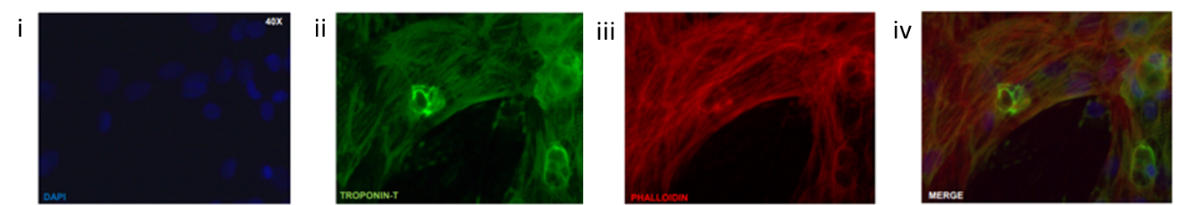
Supplementary Figure 1: Immunohistochemistry of cardiomyocytes stained for cardiac cell markers, i) DAPI, which was used as a counterstain for cell nuclei, ii) troponin-T, iii) phalloidin, iv) merged.

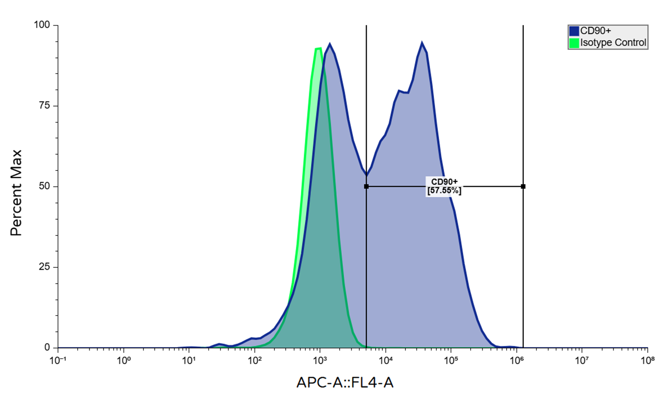Supplementary Figure 2: Characterization of cardiac fibroblasts in terms of CD90 expression by flow cytometry.

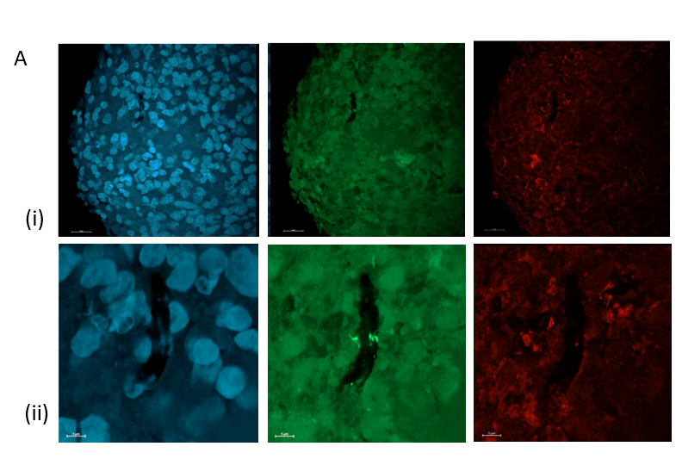
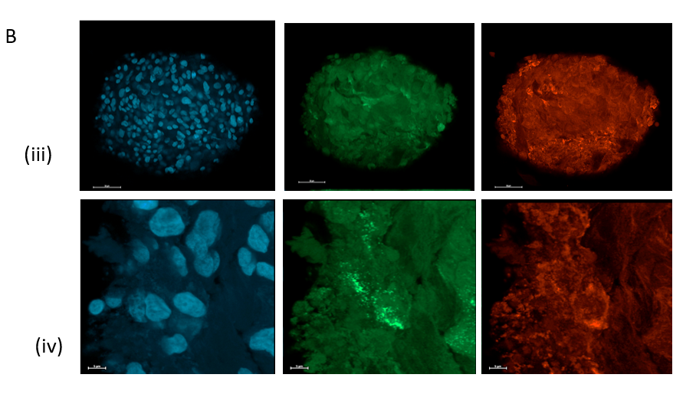
Supplementary Figure 3: Immunofluorescence staining of cardiomyocyte (A) and cardiomyocyte/cardiac fibroblast (B) spheroids of the separate channels with DAPI (blue), Cx43 (green), and α-actinin (red) captured with a 10×/0.3 NA (dry) lens (i and iii) and a section of the spheroids captured with a 20×/0.5 NA (dry) lens (ii and iv).

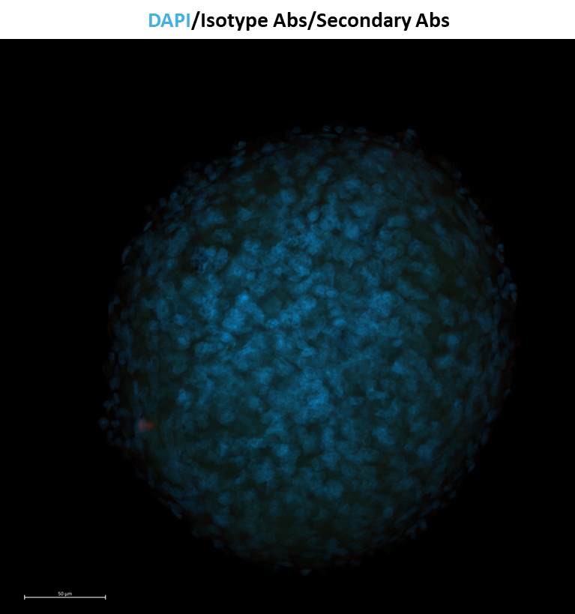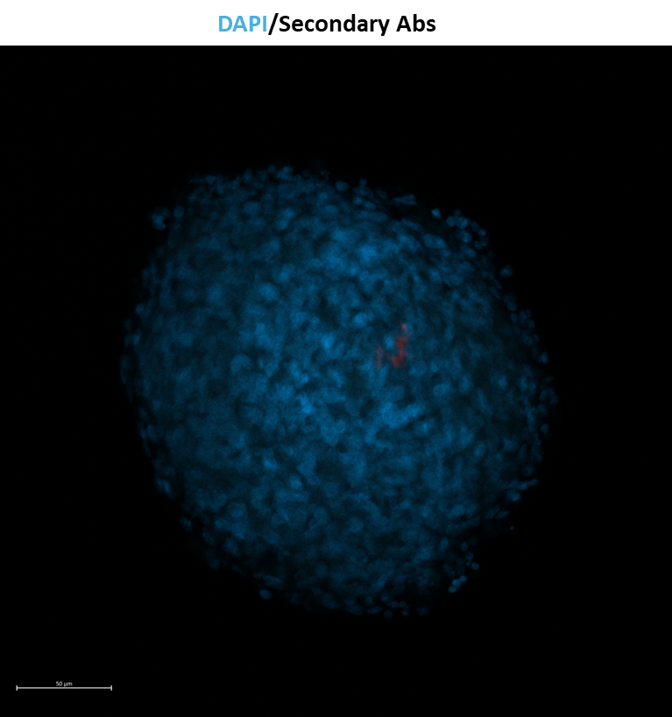
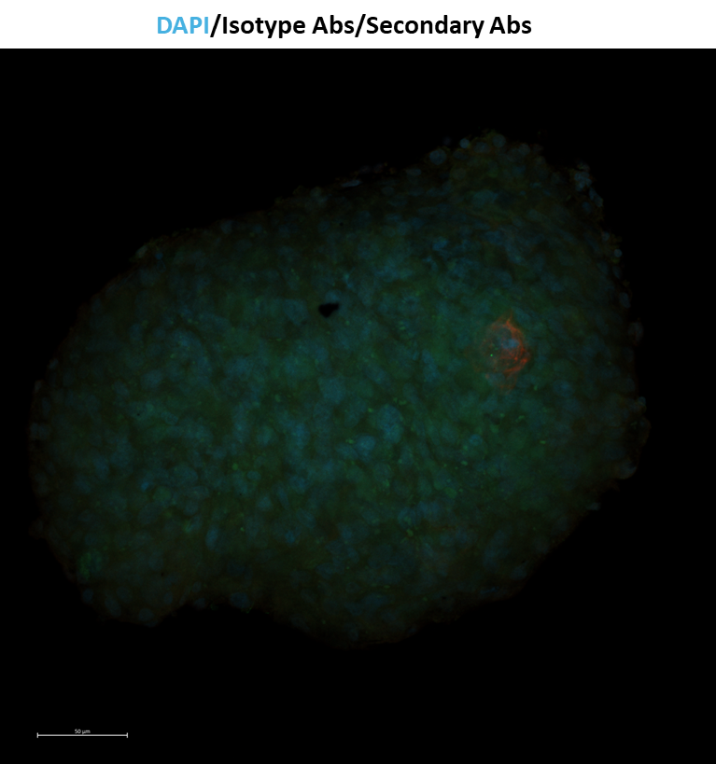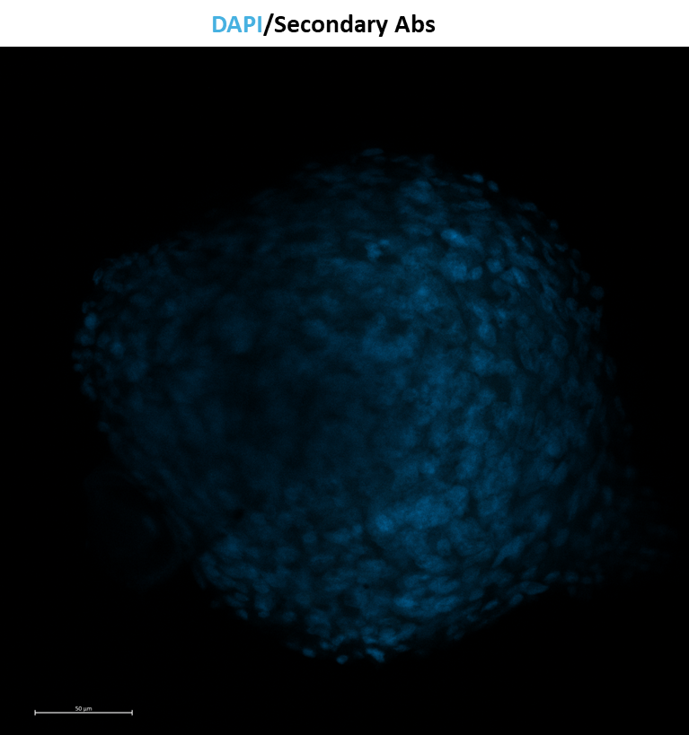
Supplementary Figure 4: Immunofluorescence staining of cardiomyocyte and cardiomyocyte/cardiac fibroblast spheroids with isotype IgG Abs, secondary antibodies, and DAPI captured with a 10×/0.3 NA (dry) lens.

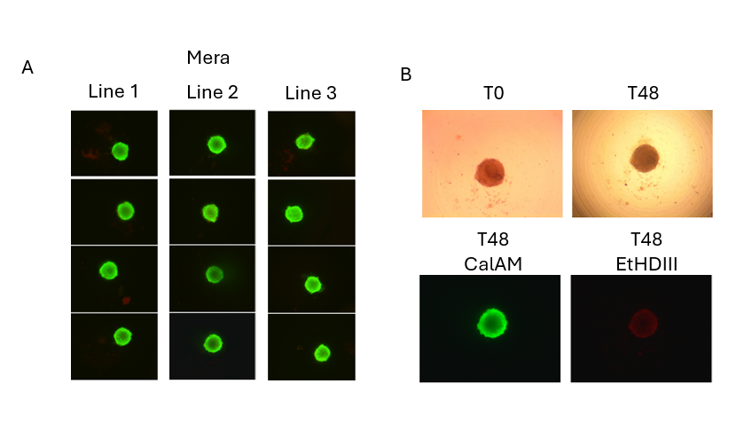
Supplementary Figure 5: Representative images of Cardiomyocyte spheroids A) in three fluidic lines within Mera after 48h. Spheroids were stained in Mera with 2 µM Calcein-AM and imaged offline using an Olympus IX70 microscope. B) Representative brightfield and fluorescence images of cardiomyocyte spheroids taken at 0 and 48h and stained with 2 µM Calcein-AM and 10 µM EtHDIII.

