Appendix
Triple interaction：
Supplementary Table S1. Migrant Populations Face Stronger Housing Cost Crowding-Out
 | (1) | (2) | (3)
 | Per Capita Consumption | Retail Sales Share | Consumption Propensity
lndensity | -0.123*** | -0.004 | -0.078**
 | (-2.81) | (-0.09) | (-2.53)
lnhouse | -0.004 | 0.022 | 0.002
 | (-0.18) | (0.99) | (0.11)
c.lndensity#c.lnhouse | 0.004 | -0.005 | 0.002
 | (1.21) | (-1.39) | (0.89)
float_ratio | -1.900* | 3.949*** | -1.390*
 | (-1.84) | (4.19) | (-1.92)
c.lndensity#c.float_ratio | 0.434*** | -0.555*** | 0.306***
 | (2.76) | (-3.86) | (2.78)
c.lnhouse#c.float_ratio | 0.226** | -0.379*** | 0.171**
 | (1.98) | (-3.65) | (2.14)
c.lndensity#c.lnhouse#c.float_ratio | -0.051*** | 0.051*** | -0.036***
 | (-2.95) | (3.26) | (-3.05)
lngovern | 0.044*** | -0.060*** | 0.031***
 | (4.88) | (-7.32) | (4.83)
fuwu | 0.057* | 0.411*** | 0.048**
 | (1.77) | (13.94) | (2.12)
lngdp | -0.034*** | -0.030*** | -0.024***
 | (-3.67) | (-3.58) | (-3.70)
lnincome | 0.938*** | 0.017 | -0.042***
 | (62.81) | (1.27) | (-4.01)
lnfirm | -0.008 | 0.011** | -0.007*
 | (-1.56) | (2.28) | (-1.84)
finance | 0.001 | 0.012*** | 0.001
 | (0.44) | (4.43) | (0.41)
Year FE | YES | YES | YES
City FE | YES | YES | YES
N | 3112 | 3112 | 3112
R2 | 0.991 | 0.768 | 0.727
Adj. R2 | 0.990 | 0.747 | 0.702

Supplementary Table S2. Migrant Populations Alleviate Consumption Inhibition from Traffic Congestion
 | (1) | (2) | (3)
 | Per Capita Consumption | Retail Sales Share | Consumption Propensity
lndensity | 0.046 | 0.213 | 0.041
 | (0.32) | (0.99) | (0.44)
gd_congestion_mean | -0.509** | 0.255 | -0.354***
 | (-2.47) | (0.82) | (-2.59)
c.lndensity#c.gd_congestion_mean | 0.090*** | -0.041 | 0.062***
 | (2.71) | (-0.81) | (2.82)
float_ratio | 5.991*** | -4.856* | 4.029***
 | (3.61) | (-1.93) | (3.66)
c.lndensity#c.float_ratio | -0.860*** | 0.674* | -0.571***
 | (-3.50) | (1.82) | (-3.51)
c.gd_congestion_mean#c.float_ratio | -3.157*** | 2.249* | -2.095***
 | (-3.63) | (1.71) | (-3.63)
c.lndensity#c.gd_congestion_mean#c.float_ratio | 0.469*** | -0.319 | 0.308***
 | (3.66) | (-1.64) | (3.62)
lngovern | 0.083*** | -0.079** | 0.056***
 | (3.81) | (-2.38) | (3.90)
fuwu | 0.153** | 0.276*** | 0.114**
 | (2.17) | (2.59) | (2.44)
lngdp | 0.009 | 0.015 | 0.006
 | (0.38) | (0.40) | (0.39)
lnincome | 0.834*** | 0.321*** | -0.119**
 | (11.58) | (2.95) | (-2.49)
lnfirm | 0.029** | -0.004 | 0.019**
 | (2.14) | (-0.20) | (2.07)
finance | -0.003 | -0.015 | -0.003
 | (-0.39) | (-1.33) | (-0.62)
Year FE | YES | YES | YES
City FE | YES | YES | YES
N | 550 | 550 | 550
R2 | 0.992 | 0.750 | 0.882
Adj. R2 | 0.990 | 0.690 | 0.854

Supplementary Table S3. Migrant Populations Face Significantly Stronger Effects of Inadequate Social Security
 | (1) | (2) | (3)
 | Per Capita Consumption | Retail Sales Share | Consumption Propensity
lndensity | -0.116*** | 0.062 | -0.083***
 | (-2.72) | (1.44) | (-2.83)
security_ratio | -0.456 | 0.250 | -0.314
 | (-1.35) | (0.74) | (-1.35)
c.lndensity#c.security_ratio | 0.071 | -0.038 | 0.049
 | (1.28) | (-0.68) | (1.27)
float_ratio | -0.171 | 0.412* | -0.106
 | (-0.76) | (1.83) | (-0.68)
c.lndensity#c.float_ratio | 0.033 | -0.080** | 0.021
 | (0.92) | (-2.23) | (0.84)
c.security_ratio#c.float_ratio | -621.442** | -260.987 | -410.954**
 | (-2.56) | (-1.08) | (-2.45)
c.lndensity#c.security_ratio#c.float_ratio | 110.202*** | 63.106 | 73.924***
 | (2.68) | (1.54) | (2.60)
lngovern | 0.014 | -0.067*** | 0.008
 | (1.14) | (-5.40) | (0.95)
fuwu | 0.028 | 0.478*** | 0.021
 | (0.72) | (12.26) | (0.79)
lngdp | -0.011 | 0.020* | -0.006
 | (-0.97) | (1.86) | (-0.83)
lnincome | 0.949*** | 0.060** | -0.038**
 | (35.53) | (2.24) | (-2.03)
finance | -0.004 | 0.002 | -0.003
 | (-1.02) | (0.64) | (-1.06)
lnfirm | -0.027*** | -0.012* | -0.019***
 | (-3.88) | (-1.75) | (-4.00)
_cons | 0.748 | 0.711 | 1.538***
 | (1.63) | (1.54) | (4.82)
Year FE | YES | YES | YES
City FE | YES | YES | YES
N | 2143 | 2143 | 2143
R2 | 0.985 | 0.775 | 0.744
Adj. R2 | 0.983 | 0.746 | 0.711
Robust Check：
Supplementary Table S4. Impact of Registered Population Density on Household Consumption
 | (1) | (2) | (3)
 | Per Capita Consumption | Retail Sales Share | Consumption Propensity
lnhuji | -0.093*** | 0.020 | -0.064***
 | (-2.787) | (0.530) | (-2.750)
lngovern | 0.056*** | -0.061*** | 0.039***
 | (3.497) | (-3.950) | (3.325)
fuwu | 0.064 | 0.412*** | 0.052
 | (1.031) | (8.060) | (1.218)
lngdp | -0.025* | -0.019 | -0.018*
 | (-1.677) | (-1.153) | (-1.739)
lnincome | 0.951*** | 0.026 | -0.033
 | (32.278) | (1.168) | (-1.506)
lnfirm | -0.003 | 0.018 | -0.003
 | (-0.242) | (1.591) | (-0.397)
finance | 0.002 | 0.014** | 0.001
 | (0.317) | (2.499) | (0.294)
Year FE | YES | YES | YES
City FE | YES | YES | YES
N | 3129 | 3129 | 3129
R2 | 0.991 | 0.761 | 0.719
Adj. R2 | 0.990 | 0.741 | 0.694
Supplementary Table S5. Impact of Population Agglomeration on Household Consumption (2003-2019)
 | (1) | (2) | (3)
 | Per Capita Consumption | Retail Sales Share | Consumption Propensity
lndensity | -0.117*** | -0.143*** | -0.083***
 | (-3.249) | (-4.933) | (-3.200)
lngovern | 0.050*** | -0.043*** | 0.035***
 | (2.994) | (-3.954) | (2.899)
fuwu | 0.098 | 0.286*** | 0.081*
 | (1.474) | (6.447) | (1.758)
lngdp | -0.032** | -0.090*** | -0.023**
 | (-2.052) | (-5.696) | (-2.148)
lnincome | 0.916*** | -0.008 | -0.057**
 | (30.239) | (-0.389) | (-2.524)
lnfirm | 0.001 | 0.001 | -0.000
 | (0.137) | (0.096) | (-0.045)
finance | 0.005 | 0.019*** | 0.003
 | (0.847) | (3.714) | (0.852)
Year FE | YES | YES | YES
City FE | YES | YES | YES
N | 2515 | 2515 | 2515
R2 | 0.991 | 0.849 | 0.717
Adj. R2 | 0.990 | 0.833 | 0.688
Supplementary Table S6. Impact of Population Agglomeration on Household Consumption (Excluding Municipalities)
 | (1) | (2) | (3)
 | Per Capita Consumption | Retail Sales Share | Consumption Propensity
lndensity | -0.103*** | -0.081*** | -0.071***
 | (-2.651) | (-2.652) | (-2.576)
lngovern | 0.045*** | -0.058*** | 0.031**
 | (2.656) | (-3.775) | (2.532)
fuwu | 0.078 | 0.439*** | 0.064
 | (1.254) | (8.449) | (1.483)
lngdp | -0.019 | -0.033* | -0.014
 | (-1.334) | (-1.953) | (-1.423)
lnincome | 0.939*** | 0.007 | -0.040*
 | (32.806) | (0.290) | (-1.923)
lnfirm | -0.013 | 0.015 | -0.010
 | (-1.349) | (1.379) | (-1.568)
finance | 0.002 | 0.011** | 0.001
 | (0.388) | (2.013) | (0.334)
Year FE | YES | YES | YES
City FE | YES | YES | YES
N | 3050 | 3050 | 3050
R2 | 0.991 | 0.769 | 0.715
Adj. R2 | 0.990 | 0.749 | 0.690

Descriptive statistics and migration context. Table S7 presents summary statistics for the main variables. The log of per capita consumption expenditure has a mean of 9.055 and a standard deviation of 0.548, indicating substantial cross-city variation in consumption levels. Retail sales share averages 0.378, broadly consistent with China's aggregate household consumption-to-GDP ratio over the sample period. Consumption propensity averages 0.683, with a tighter standard deviation (0.070), suggesting that while cities vary considerably in consumption levels, the share of income allocated to current consumption is more uniform across the sample. Log population density has a mean of 6.073 and a standard deviation of 0.721, providing sufficient within- and between-city variation to identify nonlinear density effects.
Supplementary Table S7. Descriptive Statistics of Main Variables
 | N | Mean | SD | Min | Median | Max
lncons | 3131 | 9.055 | 0.548 | 7.297 | 9.13 | 10.314
retail ratio | 3131 | .378 | 0.098 | .036 | .369 | .826
tendency | 3131 | .683 | 0.070 | .484 | .678 | .967
lndensity | 3131 | 6.073 | 0.721 | 4.077 | 6.207 | 8.232
lngdp | 3131 | 10.237 | 0.684 | 7.958 | 10.27 | 12.322
lnincome | 3131 | 9.441 | 0.572 | 7.559 | 9.517 | 10.854
fuwu | 3131 | .415 | 0.099 | .136 | .406 | .839
lngovern | 3131 | 23.873 | 1.069 | 20.546 | 23.97 | 27.568
finance | 3131 | 2.415 | 1.138 | .784 | 2.113 | 8.877
lnfirm | 3131 | 6.886 | 1.050 | 2.944 | 6.854 | 9.841
In Fig. S1, per capita expenditure rose steadily throughout the period, yet consumption propensity declined persistently—from approximately 0.79 in 2000 to 0.68 by 2024 indicating that income growth systematically outpaced consumption growth. The retail sales share followed a non-monotonic path, falling sharply through 2007, recovering to a peak near 0.43 around 2016, and contracting again thereafter. The divergence between rising absolute expenditure and falling propensity is the macro-level manifestation of the structural puzzle this study addresses: agglomeration has coincided with income growth but not with a commensurate expansion of consumption willingness.
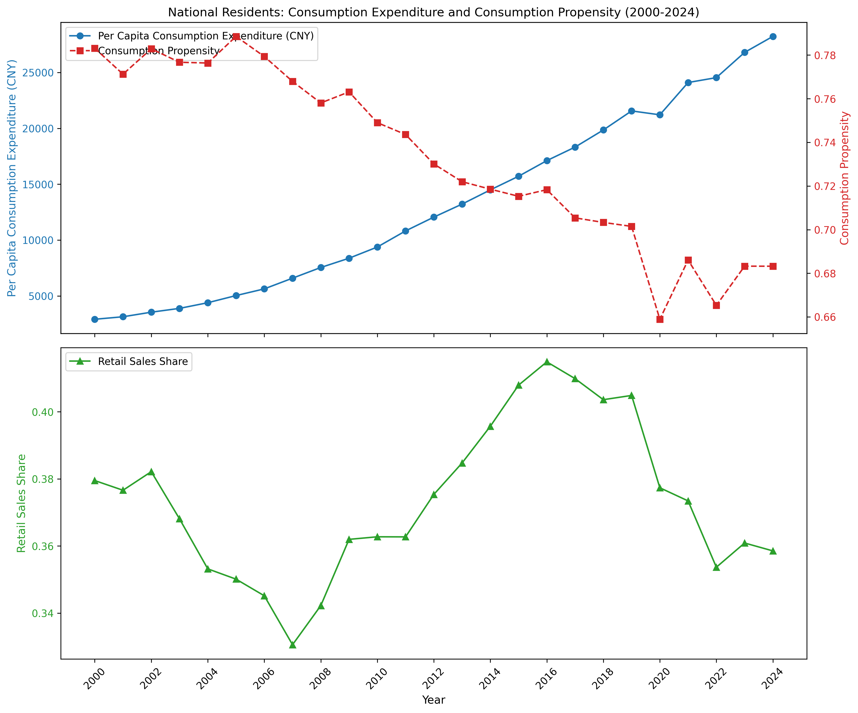
Supplementary Fig. S1. National trends in per capita consumption, propensity, and retail-sales share (2000-2024).
Fig. S2-4 document the regional migration dynamics that shaped city-level density and migrant composition across the sample period, revealing three structurally distinct phases. During 2000–2003—China's WTO accession phase—net inflows to the East surged from approximately 11 million to 30 million persons as export-oriented manufacturing expanded rapidly along the coast, while the Central and Western regions simultaneously turned net negative. This established the southeast concentration of population density that defines the study's sample. During 2003–2012, Eastern net inflows stabilised at 25–30 million before jumping to roughly 50 million in 2012 following the systematic incorporation of Sixth Census data, while outflows from the Central and Western regions deepened—the period of most intense density divergence and the richest source of variation for the net in-migrant share mechanism variable. From 2012 onward, the gap between Eastern resident and registered populations began to narrow. Registered population in the East grew from approximately 450 million to nearly 490 million, outpacing the rise in resident population, as accumulated migrants converted to hukou holders through point-based settlement and talent attraction programmes. Crucially, this narrowing gap does not indicate the elimination of institutional consumption constraints, since large numbers of non-registered residents remain outside full public service coverage. The Northeast presents a distinctive trajectory: its resident population declined steadily from roughly 110 million to below that level, while its apparent net inflow figures rose modestly after 2015—an artefact of historical out-migrants deregistering their hukou faster than resident population fell, rather than genuine return migration.
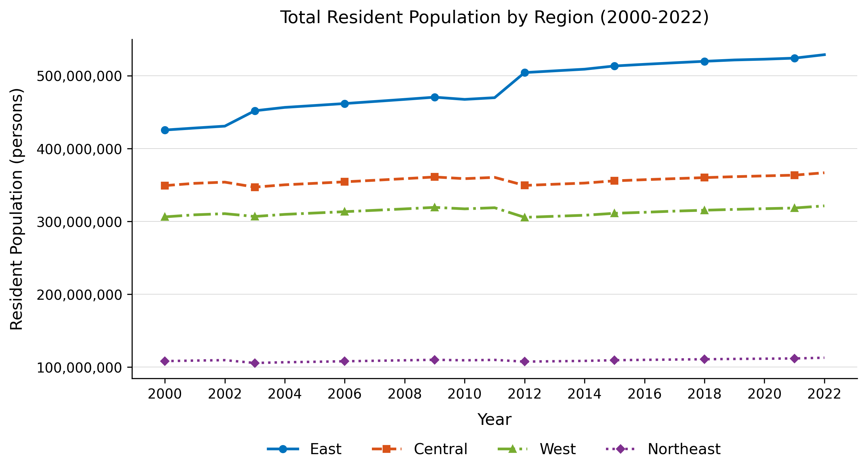
Supplementary Fig. S2. Trends in resident population across four major regions (2000-2022).

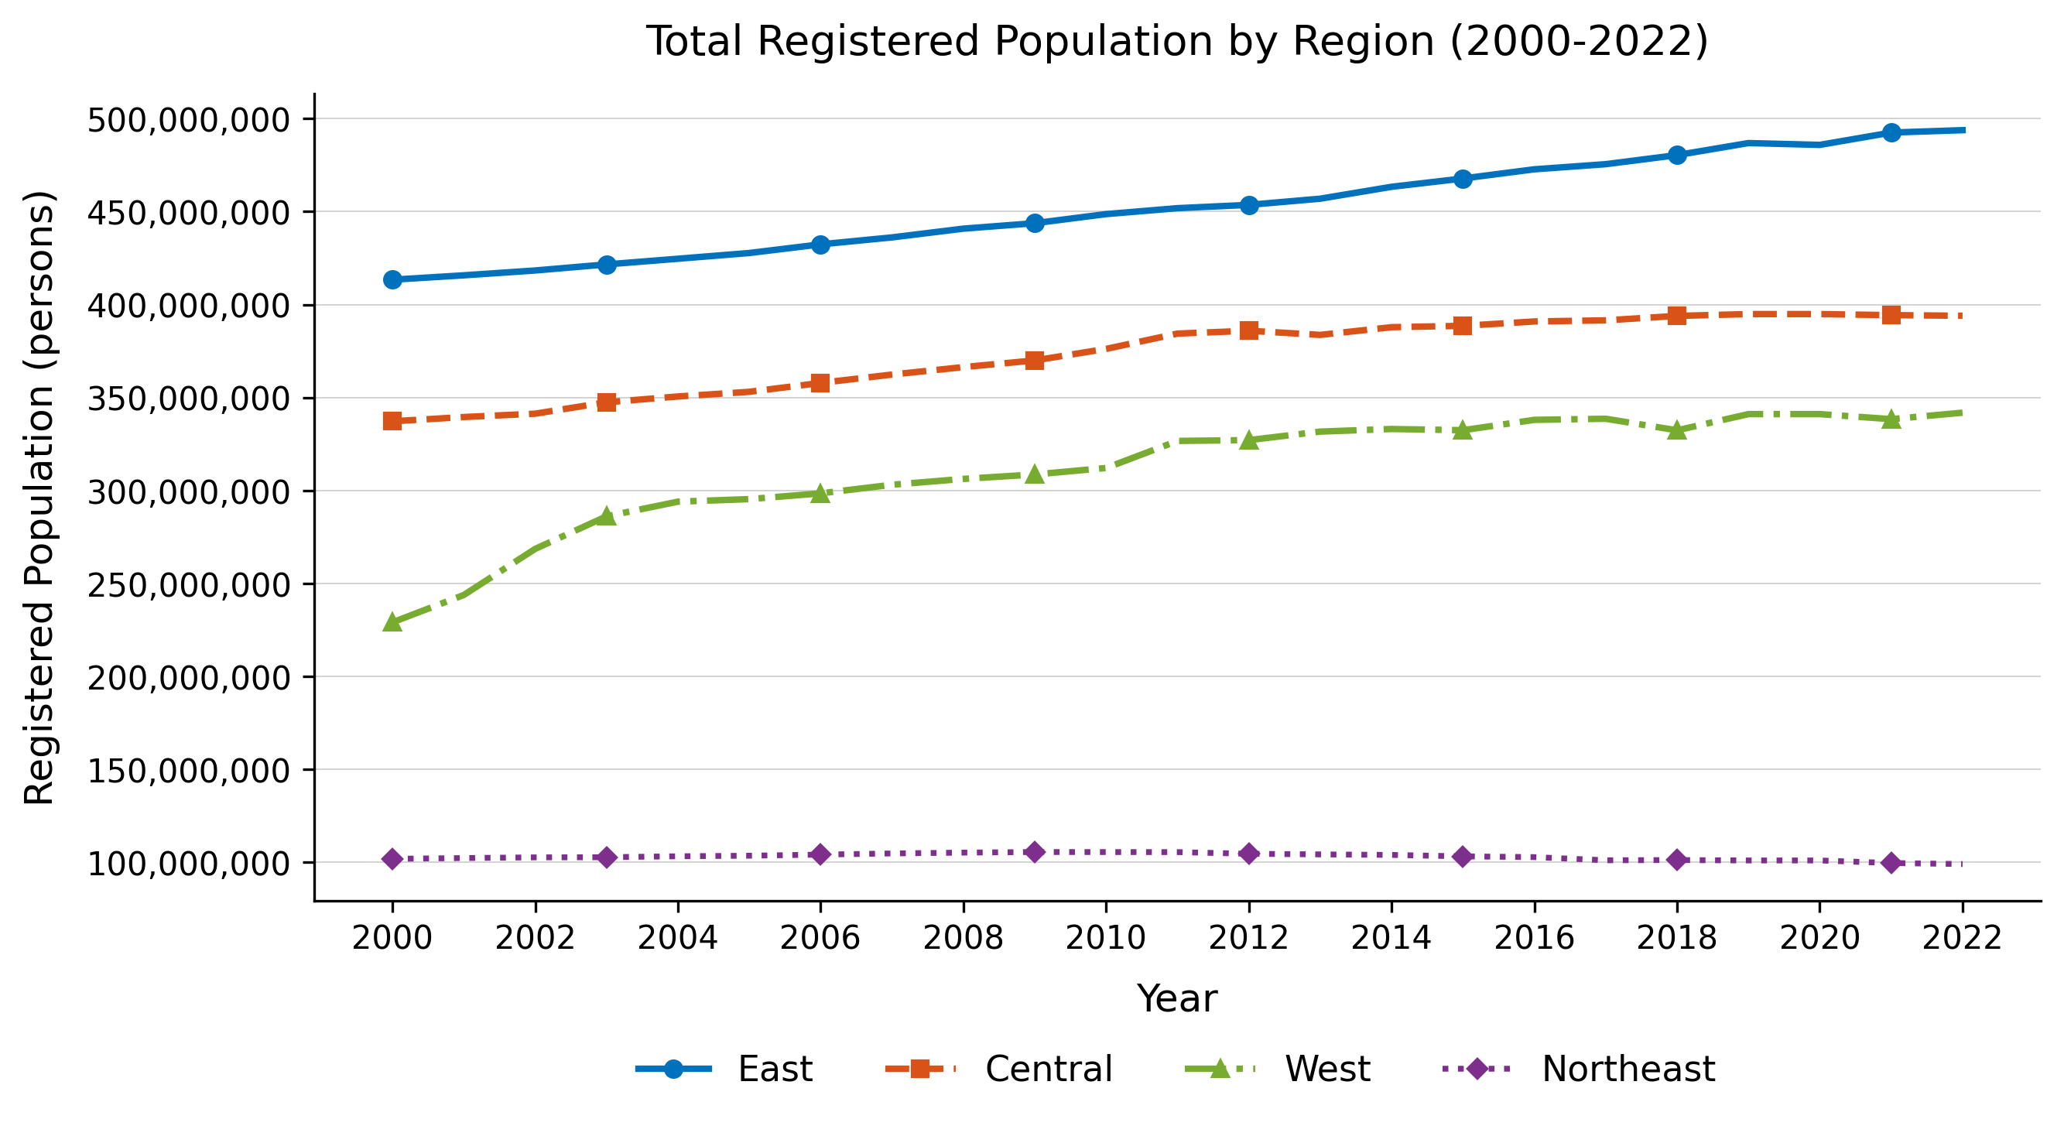
Supplementary Fig. S3. Trends in registered (hukou) population across four major regions (2000-2022).

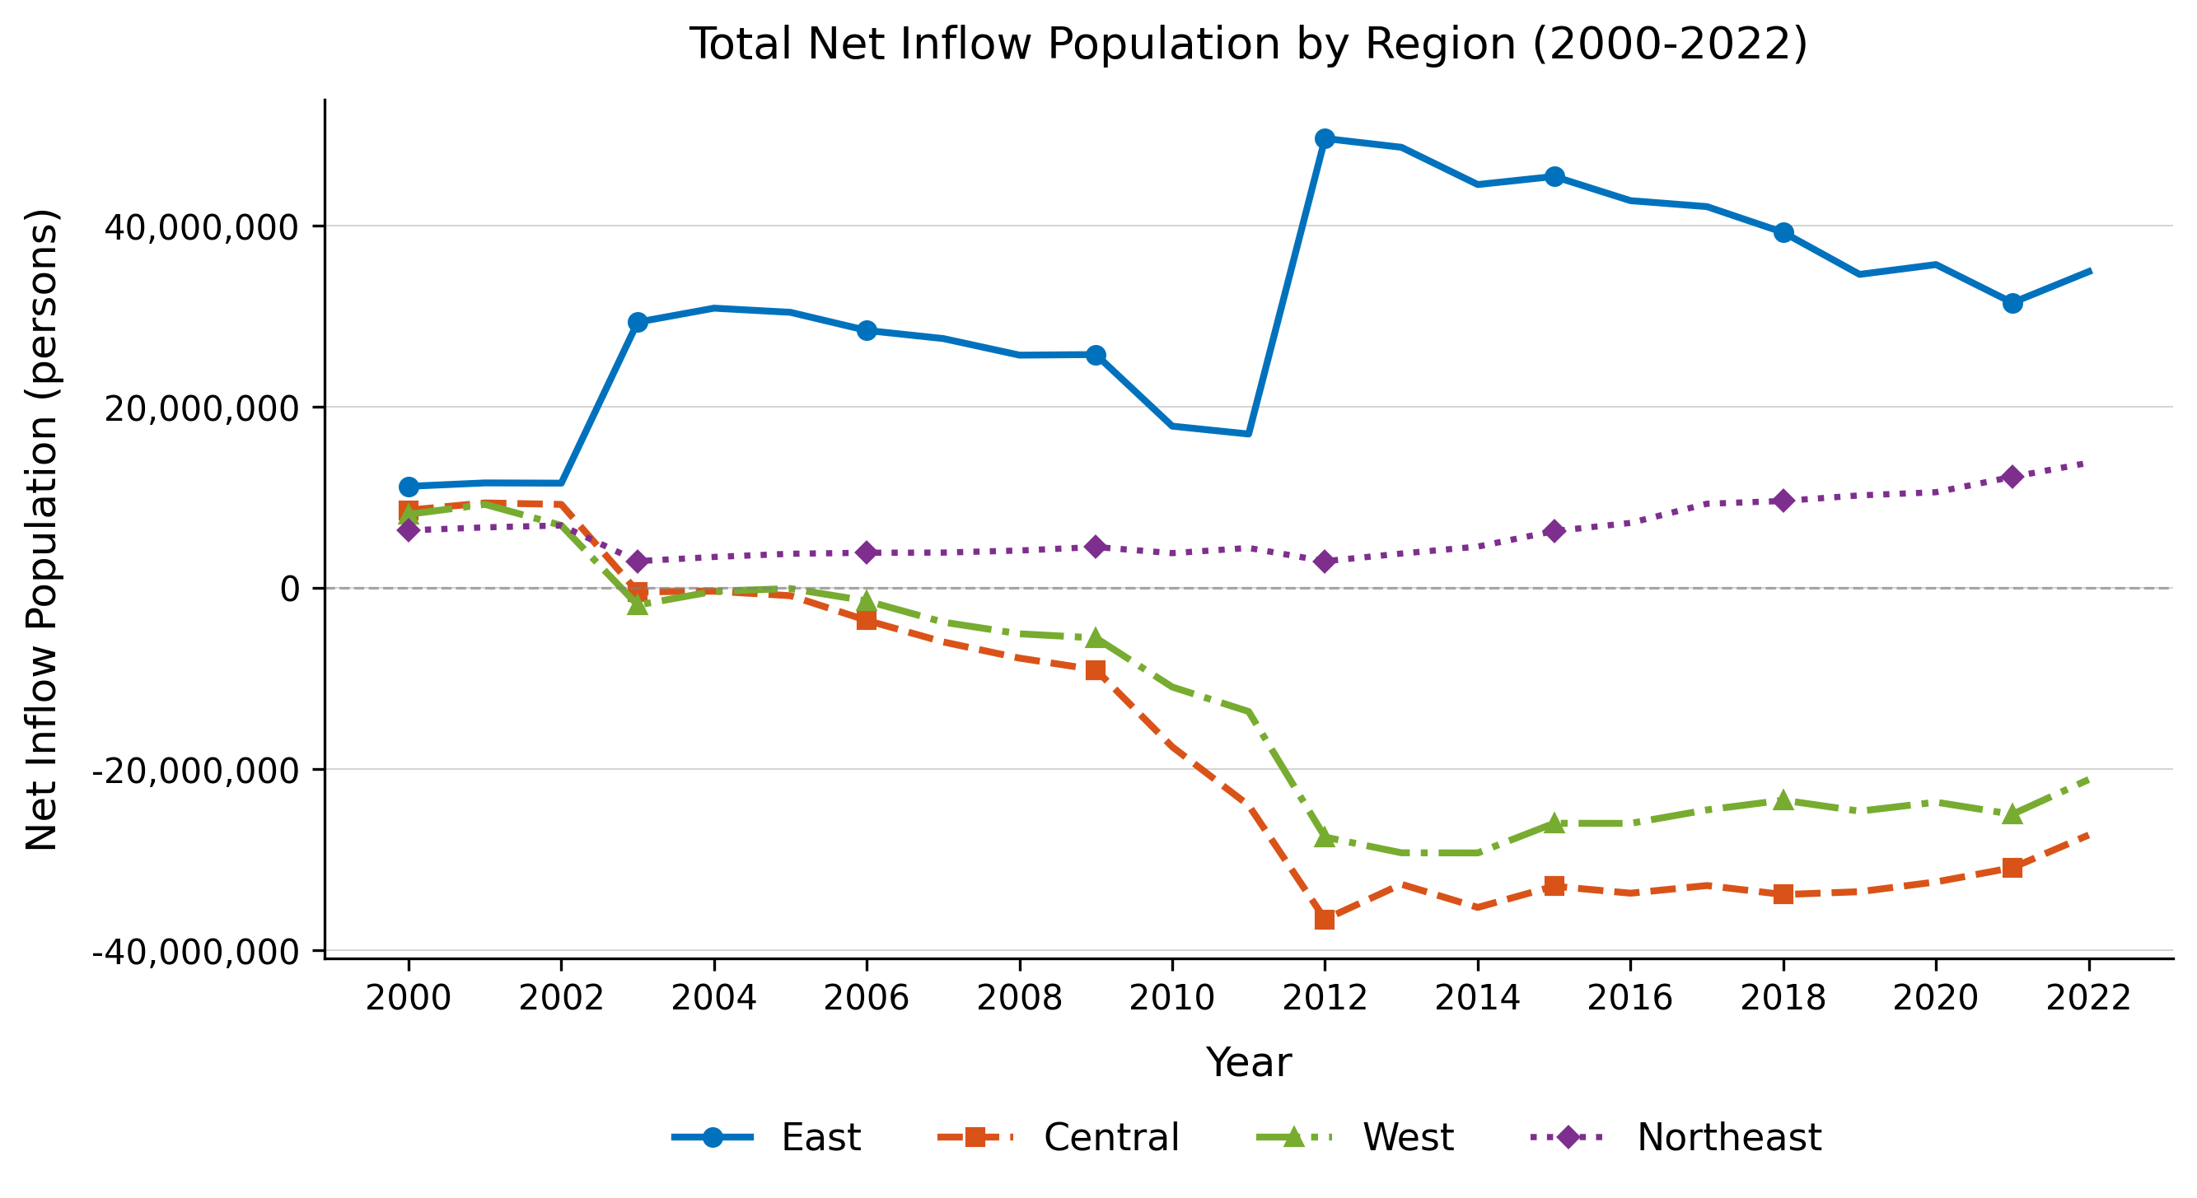
Supplementary Fig. S4. Trends in net in-migrant population across four major regions (2000-2022).
These three phases correspond closely to the dynamic pattern identified in Section 4.3: density-suppression effects moderated during the early rapid-urbanisation period (2003–2010), rebounded as housing costs accelerated (2011–2016), and intensified from 2017 onward as both cost pressures and the institutionally constrained migrant population reached their greatest combined magnitude.

