Supplementary information to:
Winter climate or species-specific traits? Controls on tundra winter nitrogen uptake along an Arctic climate gradient
Laura Helene Rasmussen^{1,2 *}, Louise Rütting^{3,4}, Anders Michelsen⁵
¹Department of Geoscience, University of Tromsø, Tromsø, Norway
²Department of Mathematical Sciences, University of Copenhagen, Copenhagen, Denmark
³Chair of Soil and Plant Systems, Brandenburg University of Technology Cottbus-Senftenberg, Cottbus, Germany
⁴Department of Earth Sciences, University of Gothenburg, Gothenburg, Sweden
⁵Department of Biology, University of Copenhagen, Copenhagen, Denmark

Contents
Supplementary Tables S1-9
Supplementary Figures S1-13
Supplementary R code S1-3

Supplementary Tables: Winter N uptake
Table S1: Air temperature and snow depth for the five locations Northern, Eastern, Southeastern, Southern and Western.
Table S1: Mean monthly air temperatures (°C) and snow depth (mm) where available for the five meteorological stations closest to the mesocosm sampling sites from Early to Late winter (October-April). Data was retrieved from Danish Meteorological Institute (Jensen et al. 2024) as available in Rasmussen et al. (2025).
 | Northern |  | Eastern | Southeastern |  |  |  | Southern
 | Ittoqottoormiit |  | Aputiteeq | Tasilaaq |  |  |  | Anqissoq
Month | Air temperature (°C) |  | Air temperature (°C) | Air temperature (°C) |  | Snow depth (mm) |  | Air temperature (°C)
October | -5 ± 0.7 |  | 0.08 ± 0.2 | 0.3 ± 0.1 |  | 74 ± 8 |  | 2.3 ± 0.02
November | -9 ± 1 |  | -3.1 ± 0.2 | -2.5 ± 0.1 |  | 154 ± 7 |  | 0.3 ± 0.02
December | -12 ± 0.7 |  | -7.0 ± 0.3 | -5.1 ± 0.1 |  | 212 ± 7 |  | -1.3 ± 0.03
January | -11.5 ± 0.5 |  | -8.1 ± 0.3 | -6.0 ± 0.2 |  | 237 ± 11 |  | -2.6 ± 0.03
February | -11.3 ± 1.7 |  | -7.0 ± 0.3 | -5.9 ± 0.2 |  | 283 ± 18 |  | -3.2 ± 0.03
March | -14.5 ± 1.5 |  | -8.9 ± 0.3 | -6.0 ± 0.1 |  | 456 ± 34 |  | -2.7 ± 0.03
April | -8 ± 2.1 |  | -4.4 ± 0.3 | -2.3 ± 0.1 |  | 398 ± 66 |  | -0.4 ± 0.02
Station ID (DMI) | 4339 |  | 4351 | 4360 |  |  |  | 4285
Date (M/DD) |  | 9/1 | 9/8 |  | 9/15 |  | 9/22 |  | 9/29
Northern |  | 15 | 14 |  | 13 |  | 12 |  | 11
Eastern |  | 15 | 14 |  | 13 |  | 12 |  | 11
Southeastern |  | 14 | 13.5 |  | 12.5 |  | 12 |  | 11
Southern |  | 13.5 | 13 |  | 12.5 |  | 12 |  | 11

Table S3: ¹⁵N recovery (%) in the Northern ecosystem in % of added tracer
Winter_stage | Aboveground stem | Aboveground leaf | Microbial biomass | Fine roots | Coarse roots |  | Soil water
Early_Winter | 3.70 ± 0.05 | 1.63 ± 0.01 | 12.22 ± 1.73 | 0.27 ± 0.09 | 0.21 ± 0.06 | 2.73 ± 0.90
Midwinter_I | 2.93 ± 0.03 | 1.05 ± 0.01 | 27.22 ± 9.21 | 0.08 ± 0.03 | 0.32 ± 0.14 | 10.17 ± 3.19
Midwinter_II | 3.16 ± 0.03 | 1.03 ± 0.01 | 12.44 ± 3.90 | 0.04 ± 0.01 | 0.17 ± 0.05 | 3.85 ± 1.51
Late_Winter_C | 3.37 ± 0.04 | 1.59 ± 0.01 | 5.97 ± 4.07 | 0.10 ± 0.03 | 0.73 ± 0.57 | 2.11 ± 0.56
Late_Winter_WW | 3.18 ± 0.03 | 0.92 ± 0.01 | 11.19 ± 1.72 | 0.06 ± 0.02 | 0.32 ± 0.15 | 0.92 ± 0.29

Table S4: ¹⁵N recovery (%) in the Eastern ecosystem in % of added tracer
Winter_stage | Aboveground stem | Aboveground leaf | Microbial biomass | Fine roots | Coarse roots | Soil water
Early_Winter | 1.80 ± 0.02 | 1.27 ± 0.02 | 58.06 ± 16.05 | 0.69 ± 0.22 | 0.98 ± 0.20 | 5.32 ± 4.47
Midwinter_I | 2.49 ± 0.03 | 1.34 ± 0.02 | 33.02 ± 16.99 | 0.42 ± 0.15 | 1.90 ± 0.63 | 5.65 ± 2.62
Midwinter_II | 2.01 ± 0.03 | 1.33 ± 0.02 | 15.56 ± 3.06 | 0.36 ± 0.13 | 0.99 ± 0.38 | 3.36 ± 1.60
Late_Winter_C | 1.69 ± 0.02 | 1.37 ± 0.02 | 11.66 ± 1.85 | 0.30 ± 0.17 | 1.90 ± 0.90 | 1.98 ± 1.26
Late_Winter_WW | 2.07 ± 0.02 | 1.14 ± 0.01 | 13.40 ± 1.57 | 0.77 ± 0.48 | 0.63 ± 0.47 | 0.54 ± 0.23

Table S5: ¹⁵N recovery (%) in the Southeastern ecosystem in % of added tracer
Winter_stage | Aboveground stem |  | Aboveground leaf | Microbial biomass | Fine roots | Coarse roots | Soil water
Early_Winter | 3.36 ± 0.05 | 2.68 ± 0.03 |  | 13.03 ± 3.42 | 0.16 ± 0.04 | 0.65 ± 0.41 | 3.57 ± 2.36
Midwinter_I | 2.24 ± 0.03 | 2.08 ± 0.02 |  | 21.38 ± 9.72 | 0.32 ± 0.07 | 6.09 ± 5.03 | 5.33 ± 2.03
Midwinter_II | 2.53 ± 0.04 | 2.39 ± 0.03 |  | 15.28 ± 1.03 | 0.17 ± 0.07 | 1.92 ± 0.98 | 1.89 ± 0.67
Late_Winter_C | 1.99 ± 0.05 | 2.54 ± 0.03 |  | 6.20 ± 4.97 | 0.28 ± 0.19 | 4.19 ± 3.71 | 1.94 ± 1.02
Late_Winter_WW | 3.09 ± 0.05 | 2.37 ± 0.03 |  | 4.66 ± 1.52 | 0.55 ± 0.45 | 1.14 ± 0.89 | 2.64 ± 1.47

Table S6: ¹⁵N recovery (%) in the Southern ecosystem in % of added tracer
Winter_stage | Aboveground stem | Aboveground leaf | Microbial biomass | Fine roots | Coarse roots | Soil water
Early_Winter | 5.79 ± 0.17 | 2.07 ± 0.02 | 28.93 ± 5.93 | 0.05 ± 0.02 | 0.82 ± 0.41 | 1.90 ± 1.46
Midwinter_I | 1.92 ± 0.03 | 1.56 ± 0.01 | 44.62 ± 14.41 | 0.06 ± 0.02 | 1.50 ± 0.49 | 2.40 ± 0.74
Midwinter_II | 6.02 ± 0.19 | 1.94 ± 0.02 | 17.75 ± 4.11 | 0.05 ± 0.03 | 0.61 ± 0.23 | 0.75 ± 0.54
Late_Winter_C | 5.44 ± 0.15 | 1.58 ± 0.02 | 8.28 ± 1.58 | 0.01±0.005 | 0.82 ± 0.27 | 0.79 ± 0.45
Late_Winter_WW | 4.95 ± 0.13 | 2.11 ± 0.02 | 4.92 ± 3.12 | 0.06 ± 0.03 | 0.49 ± 0.32 | 0.17 ± 0.09

Table S7: Microbial C, N and C/N ratios of microbes pr g dry soil
Site | Early Winter |  | Midwinter_I | Midwinter_II | Late_Winter_C | Late_Winter_WW
µg C/g dry soil
Northern | 787.60 ± 229 |  | 1325.53 ± 328 | 1264.80 ± 565 | 195.43 ± 186 | 113.92 ± 42
Eastern | 1703.26 ± 689 |  | 1643.31 ± 873 | 496.07 ± 126 | 110.40 ± 31 | 340.30 ± 20
Southeastern | 638.99 ± 180 |  | 937.29 ± 477 | 987.08 ± 215 | 111.17 ± 93 | 353.92 ± 78
Southern | 478.46 ± 153 |  | 2428.10 ± 997 | 622.67 ± 176 | 153.58 ± 40 | 132.88 ± nan
µg N/g dry soil
Northern | 92.96 ± 30 |  | 148.50 ± 35 | 111.86 ± 48 | 41.00 ± 37 | 10.02 ± 4
Eastern | 117.89 ± 57 |  | 132.28 ± 73 | 37.95 ± 11 | 8.53 ± 2 | 14.58 ± 4
Southeastern | 41.36 ± 11 |  | 91.06 ± 50 | 115.19 ± 26 | 18.52 ± nan | 40.07 ± 9
Southern | 25.11 ± 4 |  | 107.78 ± 43 | 47.82 ± 14 | 14.93 ± 5 | 3.78 ± 3
C/N ratio of microbes
Northern | 10.41 ± 1 |  | 8.86 ± 1 | 6.82 ± 1 | 3.20 ± 1 | 10.96 ± 2
Eastern | 14.32 ± 1 |  | 12.39 ± 2 | 11.04 ± 1 | 13.34 ± 2 | 9.89 ± 0.4
Southeastern | 14.54 ± 2 |  | 9.26 ± 2 | 9.25 ± 2 | 11.03 ± nan | 8.85 ± 0.5
Southern | 15.21 ± 1 |  | 17.39 ± 2 | 13.11 ± 1 | 12.46 ± 3 | 13.84 ± nan

Table S8: Species-specific differences of mg ¹⁵N excess pr g dry weight biomass as calculated using the estimated marginal means with pairwise comparison between species (Tukey adjusted). Results are calculated for leaf biomass and stem biomass respectively.
contrast species | Estimate of difference (mg ¹⁵Nexcess/g dry weight biomass) | SE | df | t.ratio | p.value
Stem_leaf = Leaf:
contrast
Salix arctica - Betula | 0.106072 | 0.016916 | 853 | 6.27 | <.0001
Salix arctica - Cassiope | 0.113804 | 0.014158 | 853 | 8.038 | <.0001
Salix arctica - Dryas | 0.151453 | 0.023042 | 853 | 6.573 | <.0001
Salix arctica - Empetrum | 0.158431 | 0.010673 | 853 | 14.844 | <.0001
Salix arctica - Grass | 0.108667 | 0.010619 | 853 | 10.233 | <.0001
Salix arctica - Lichen | 0.280387 | 0.013904 | 853 | 20.166 | <.0001
Salix arctica - Moss | 0.232478 | 0.010412 | 853 | 22.329 | <.0001
Salix arctica - Pileurt | 0.149993 | 0.01487 | 853 | 10.087 | <.0001
Salix arctica - Salix herbacea | 0.089602 | 0.022635 | 853 | 3.959 | 0.0039
Salix arctica - Vaccinum | 0.17546 | 0.010642 | 853 | 16.488 | <.0001
Betula - Cassiope | 0.007732 | 0.01882 | 853 | 0.411 | 1
Betula - Dryas | 0.045381 | 0.026169 | 853 | 1.734 | 0.8176
Betula - Empetrum | 0.05236 | 0.016551 | 853 | 3.164 | 0.0605
Betula - Grass | 0.002595 | 0.016731 | 853 | 0.155 | 1
Betula - Lichen | 0.174315 | 0.018469 | 853 | 9.438 | <.0001
Betula - Moss | 0.126407 | 0.016347 | 853 | 7.732 | <.0001
Betula - Pileurt | 0.043921 | 0.019361 | 853 | 2.268 | 0.4567
Betula - Salix herbacea | -0.01647 | 0.025934 | 853 | -0.635 | 0.9999
Betula - Vaccinum | 0.069388 | 0.016582 | 853 | 4.185 | 0.0016
Cassiope - Dryas | 0.037649 | 0.024069 | 853 | 1.564 | 0.8968
Cassiope - Empetrum | 0.044627 | 0.014322 | 853 | 3.116 | 0.0694
Cassiope - Grass | -0.00514 | 0.014056 | 853 | -0.365 | 1
Cassiope - Lichen | 0.166583 | 0.016479 | 853 | 10.109 | <.0001
Cassiope - Moss | 0.118674 | 0.013471 | 853 | 8.809 | <.0001
Cassiope - Pileurt | 0.036189 | 0.016393 | 853 | 2.208 | 0.4999
Cassiope - Salix herbace | a -0.02420251 | 0.024563 | 853 | -0.985 | 0.9962
Cassiope - Vaccinum | 0.061656 | 0.013683 | 853 | 4.506 | 0.0004
Dryas - Empetrum | 0.006978 | 0.023133 | 853 | 0.302 | 1
Dryas - Grass | -0.04279 | 0.022945 | 853 | -1.865 | 0.7402
Dryas - Lichen | 0.128934 | 0.024491 | 853 | 5.264 | <.0001
Dryas - Moss | 0.081025 | 0.022628 | 853 | 3.581 | 0.0159
Dryas - Pileurt | -0.00146 | 0.024495 | 853 | -0.06 | 1
Dryas - Salix herbacea | -0.06185 | 0.030551 | 853 | -2.025 | 0.6317
Dryas - Vaccinum | 0.024007 | 0.022755 | 853 | 1.055 | 0.9935
Empetrum - Grass | -0.04976 | 0.009943 | 853 | -5.005 | <.0001
Empetrum - Lichen | 0.121955 | 0.0132 | 853 | 9.239 | <.0001
Empetrum - Moss | 0.074047 | 0.009936 | 853 | 7.452 | <.0001
Empetrum - Pileurt | -0.00844 | 0.015026 | 853 | -0.562 | 1
Empetrum - Salix herbace | a -0.06882988 | 0.022134 | 853 | -3.11 | 0.0707
Empetrum - Vaccinum | 0.017029 | 0.010206 | 853 | 1.669 | 0.8513
Grass - Lichen | 0.17172 | 0.01359 | 853 | 12.636 | <.0001
Grass - Moss | 0.123811 | 0.009919 | 853 | 12.482 | <.0001
Grass - Pileurt | 0.041326 | 0.014773 | 853 | 2.797 | 0.1607
Grass - Salix herbacea | -0.01907 | 0.0223 | 853 | -0.855 | 0.9989
Grass - Vaccinum | 0.066793 | 0.010118 | 853 | 6.601 | <.0001
Lichen - Moss | -0.04791 | 0.013246 | 853 | -3.617 | 0.014
Lichen - Pileurt | -0.13039 | 0.017094 | 853 | -7.628 | <.0001
Lichen - Salix herbacea | -0.19079 | 0.023864 | 853 | -7.995 | <.0001
Lichen - Vaccinum | -0.10493 | 0.01353 | 853 | -7.755 | <.0001
Moss - Pileurt | -0.08249 | 0.014218 | 853 | -5.802 | <.0001
Moss - Salix herbacea | -0.14288 | 0.022305 | 853 | -6.406 | <.0001
Moss - Vaccinum | -0.05702 | 0.009868 | 853 | -5.778 | <.0001
Pileurt - Salix herbacea | -0.06039 | 0.02498 | 853 | -2.418 | 0.3564
Pileurt - Vaccinum | 0.025467 | 0.014418 | 853 | 1.766 | 0.7997
Salix herbacea - Vaccinum | 0.0858586 | 0.022417 | 853 | 3.83 | 0.0064
Stem_leaf = Stem:
contrast | estimate | SE | df | t.ratio | p.value
Salix arctica - Betula | -0.02453 | 0.017459 | 853 | -1.405 | 0.6248
Salix arctica - Cassiope | 0.054565 | 0.013962 | 853 | 3.908 | 0.001
Salix arctica - Dryas | nonEst | NA | NA | NA | NA
Salix arctica - Empetrum | 0.109757 | 0.010131 | 853 | 10.834 | <.0001
Salix arctica - Vaccinum | 0.023463 | 0.010424 | 853 | 2.251 | 0.1622
Betula - Cassiope | 0.079091 | 0.019409 | 853 | 4.075 | 0.0005
Betula - Empetrum | 0.134283 | 0.017275 | 853 | 7.773 | <.0001
Betula - Vaccinum | 0.047989 | 0.01737 | 853 | 2.763 | 0.0462
Cassiope - Empetrum | 0.055192 | 0.014228 | 853 | 3.879 | 0.0011
Cassiope - Vaccinum | -0.0311 | 0.013749 | 853 | -2.262 | 0.1583

Table S9: Atomic percentage excess of ¹⁵N (tracer N excess per unit N) for each site, winter stage and species.
Site | Winter_stage | Species | Stem_leaf | ¹⁵NAPE%
North | Early_Winter | Betula | Leaf | 0.018403
North | Early_Winter | Betula | Stem | 0.020193
North | Early_Winter | Cassiope | Leaf | 0.022466
North | Early_Winter | Cassiope | Stem | 0.021486
North | Early_Winter | Dryas | Leaf | 0.015949
North | Early_Winter | Grass | Leaf | 0.015569
North | Early_Winter | Lichen | Leaf | 0.012669
North | Early_Winter | Bryophytes | Leaf | 0.015188
North | Early_Winter | Pileurt | Leaf | 0.017499
North | Early_Winter | Salix | Leaf | 0.017168
North | Early_Winter | Salix | Stem | 0.018613
North | Early_Winter | Vaccinum | Leaf | 0.019667
North | Early_Winter | Vaccinum | Stem | 0.019861
North | Late_Winter_C | Betula | Leaf | 0.015724
North | Late_Winter_C | Betula | Stem | 0.018479
North | Late_Winter_C | Cassiope | Leaf | 0.022348
North | Late_Winter_C | Cassiope | Stem | 0.021139
North | Late_Winter_C | Dryas | Leaf | 0.017274
North | Late_Winter_C | Grass | Leaf | 0.015667
North | Late_Winter_C | Bryophytes | Leaf | 0.011547
North | Late_Winter_C | Pileurt | Leaf | 0.016599
North | Late_Winter_C | Salix | Leaf | 0.017226
North | Late_Winter_C | Salix | Stem | 0.018482
North | Late_Winter_C | Vaccinum | Leaf | 0.016759
North | Late_Winter_C | Vaccinum | Stem | 0.0217
North | Late_Winter_WW | Betula | Leaf | 0.015823
North | Late_Winter_WW | Betula | Stem | 0.020464
North | Late_Winter_WW | Cassiope | Leaf | 0.021515
North | Late_Winter_WW | Cassiope | Stem | 0.020908
North | Late_Winter_WW | Grass | Leaf
North | Late_Winter_WW | Bryophytes | Leaf | 0.014646
North | Late_Winter_WW | Pileurt | Leaf | 0.016722
North | Late_Winter_WW | Salix | Leaf | 0.019886
North | Late_Winter_WW | Salix | Stem | 0.01768
North | Late_Winter_WW | Vaccinum | Leaf | 0.016311
North | Late_Winter_WW | Vaccinum | Stem | 0.0231
North | Midwinter_I | Betula | Leaf | 0.016552
North | Midwinter_I | Betula | Stem | 0.020709
North | Midwinter_I | Cassiope | Leaf | 0.021918
North | Midwinter_I | Cassiope | Stem | 0.021711
North | Midwinter_I | Grass | Leaf | 0.013988
North | Midwinter_I | Lichen | Leaf | 0.014629
North | Midwinter_I | Bryophytes | Leaf | 0.014541
North | Midwinter_I | Pileurt | Leaf | 0.017869
North | Midwinter_I | Salix | Leaf | 0.016588
North | Midwinter_I | Salix | Stem | 0.018245
North | Midwinter_I | Vaccinum | Leaf | 0.018123
North | Midwinter_I | Vaccinum | Stem | 0.02067
North | Midwinter_II | Betula | Leaf | 0.014641
North | Midwinter_II | Betula | Stem | 0.016272
North | Midwinter_II | Cassiope | Leaf | 0.020692
North | Midwinter_II | Cassiope | Stem | 0.021411
North | Midwinter_II | Grass | Leaf | 0.014029
North | Midwinter_II | Bryophytes | Leaf | 0.014031
North | Midwinter_II | Pileurt | Leaf | 0.018031
North | Midwinter_II | Salix | Leaf | 0.015624
North | Midwinter_II | Salix | Stem | 0.016741
North | Midwinter_II | Vaccinum | Leaf | 0.017872
North | Midwinter_II | Vaccinum | Stem | 0.021471
East | Early_Winter | Empetrum | Leaf | 0.022198
East | Early_Winter | Empetrum | Stem | 0.022047
East | Early_Winter | Grass | Leaf | 0.015324
East | Early_Winter | Lichen | Leaf | 0.008039
East | Early_Winter | Bryophytes | Leaf | 0.01026
East | Early_Winter | Salix | Leaf | 0.018088
East | Early_Winter | Salix | Stem | 0.019995
East | Early_Winter | Vaccinum | Leaf | 0.01904
East | Early_Winter | Vaccinum | Stem | 0.020619
East | Late_Winter_C | Empetrum | Leaf | 0.020734
East | Late_Winter_C | Empetrum | Stem | 0.02118
East | Late_Winter_C | Grass | Leaf | 0.015154
East | Late_Winter_C | Bryophytes | Leaf | 0.011711
East | Late_Winter_C | Salix | Leaf | 0.019243
East | Late_Winter_C | Salix | Stem | 0.01651
East | Late_Winter_C | Vaccinum | Leaf | 0.018129
East | Late_Winter_C | Vaccinum | Stem | 0.01934
East | Late_Winter_WW | Empetrum | Leaf | 0.02061
East | Late_Winter_WW | Empetrum | Stem | 0.021246
East | Late_Winter_WW | Grass | Leaf | 0.015783
East | Late_Winter_WW | Bryophytes | Leaf | 0.013341
East | Late_Winter_WW | Salix | Leaf | 0.016665
East | Late_Winter_WW | Salix | Stem | 0.01753
East | Late_Winter_WW | Salix herbacea | Leaf | 0.016583
East | Late_Winter_WW | Vaccinum | Leaf | 0.016954
East | Late_Winter_WW | Vaccinum | Stem | 0.020908
East | Midwinter_I | Empetrum | Leaf | 0.020944
East | Midwinter_I | Empetrum | Stem | 0.020884
East | Midwinter_I | Grass | Leaf | 0.015003
East | Midwinter_I | Bryophytes | Leaf | 0.009105
East | Midwinter_I | Salix | Leaf | 0.017023
East | Midwinter_I | Salix | Stem | 0.017881
East | Midwinter_I | Vaccinum | Leaf | 0.018197
East | Midwinter_I | Vaccinum | Stem | 0.019666
East | Midwinter_II | Empetrum | Leaf | 0.020749
East | Midwinter_II | Empetrum | Stem | 0.020463
East | Midwinter_II | Grass | Leaf | 0.015174
East | Midwinter_II | Bryophytes | Leaf | 0.01451
East | Midwinter_II | Salix | Leaf | 0.015035
East | Midwinter_II | Salix | Stem | 0.017772
East | Midwinter_II | Vaccinum | Leaf | 0.019235
East | Midwinter_II | Vaccinum | Stem | 0.020901
Southeast | Early_Winter | Empetrum | Leaf | 0.022073
Southeast | Early_Winter | Empetrum | Stem | 0.021884
Southeast | Early_Winter | Grass | Leaf | 0.015742
Southeast | Early_Winter | Lichen | Leaf | 0.015534
Southeast | Early_Winter | Bryophytes | Leaf | 0.005735
Southeast | Early_Winter | Salix | Leaf | 0.017783
Southeast | Early_Winter | Salix | Stem | 0.019121
Southeast | Early_Winter | Salix herbacea | Leaf | 0.019014
Southeast | Early_Winter | Vaccinum | Leaf | 0.019373
Southeast | Early_Winter | Vaccinum | Stem | 0.019897
Southeast | Late_Winter_C | Empetrum | Leaf | 0.020524
Southeast | Late_Winter_C | Empetrum | Stem | 0.021613
Southeast | Late_Winter_C | Grass | Leaf | 0.017059
Southeast | Late_Winter_C | Bryophytes | Leaf | 0.017629
Southeast | Late_Winter_C | Salix | Leaf | 0.019013
Southeast | Late_Winter_C | Salix | Stem | 0.017044
Southeast | Late_Winter_C | Vaccinum | Leaf | 0.016691
Southeast | Late_Winter_C | Vaccinum | Stem
Southeast | Late_Winter_WW | Empetrum | Leaf | 0.020922
Southeast | Late_Winter_WW | Empetrum | Stem | 0.020013
Southeast | Late_Winter_WW | Grass | Leaf | 0.014068
Southeast | Late_Winter_WW | Bryophytes | Leaf | 0.010926
Southeast | Late_Winter_WW | Salix | Leaf | 0.015888
Southeast | Late_Winter_WW | Salix | Stem | 0.0164
Southeast | Late_Winter_WW | Vaccinum | Leaf | 0.016213
Southeast | Late_Winter_WW | Vaccinum | Stem | 0.021576
Southeast | Midwinter_I | Empetrum | Leaf | 0.020055
Southeast | Midwinter_I | Empetrum | Stem | 0.020337
Southeast | Midwinter_I | Grass | Leaf | 0.016386
Southeast | Midwinter_I | Bryophytes | Leaf | 0.012828
Southeast | Midwinter_I | Salix | Leaf | 0.01752
Southeast | Midwinter_I | Salix | Stem | 0.018155
Southeast | Midwinter_I | Salix herbacea | Leaf | 0.016818
Southeast | Midwinter_I | Vaccinum | Leaf | 0.017849
Southeast | Midwinter_I | Vaccinum | Stem | 0.016106
Southeast | Midwinter_II | Empetrum | Leaf | 0.021814
Southeast | Midwinter_II | Empetrum | Stem | 0.020971
Southeast | Midwinter_II | Grass | Leaf | 0.014537
Southeast | Midwinter_II | Bryophytes | Leaf | 0.010437
Southeast | Midwinter_II | Salix | Leaf | 0.015892
Southeast | Midwinter_II | Salix | Stem | 0.015182
Southeast | Midwinter_II | Vaccinum | Leaf | 0.019082
Southeast | Midwinter_II | Vaccinum | Stem | 0.019786
South | Early_Winter | Betula | Leaf | 0.016438
South | Early_Winter | Betula | Stem | 0.021851
South | Early_Winter | Empetrum | Leaf | 0.022331
South | Early_Winter | Empetrum | Stem | 0.022056
South | Early_Winter | Grass | Leaf | 0.015502
South | Early_Winter | Lichen | Leaf | 0.015416
South | Early_Winter | Bryophytes | Leaf | 0.015812
South | Early_Winter | Salix | Leaf | 0.018191
South | Early_Winter | Salix | Stem | 0.018973
South | Early_Winter | Salix herbacea | Leaf | 0.019698
South | Early_Winter | Vaccinum | Leaf | 0.018972
South | Early_Winter | Vaccinum | Stem | 0.019301
South | Late_Winter_C | Betula | Leaf | 0.021861
South | Late_Winter_C | Betula | Stem | 0.020179
South | Late_Winter_C | Empetrum | Leaf | 0.020023
South | Late_Winter_C | Empetrum | Stem | 0.020527
South | Late_Winter_C | Lichen | Leaf | 0.014473
South | Late_Winter_C | Bryophytes | Leaf
South | Late_Winter_C | Salix | Leaf | 0.017629
South | Late_Winter_C | Salix | Stem | 0.018279
South | Late_Winter_C | Salix herbacea | Leaf | 0.015272
South | Late_Winter_C | Vaccinum | Leaf | 0.016198
South | Late_Winter_C | Vaccinum | Stem | 0.020694
South | Late_Winter_WW | Betula | Leaf | 0.014747
South | Late_Winter_WW | Betula | Stem | 0.019341
South | Late_Winter_WW | Empetrum | Leaf | 0.020133
South | Late_Winter_WW | Empetrum | Stem | 0.020111
South | Late_Winter_WW | Grass | Leaf | 0.015334
South | Late_Winter_WW | Bryophytes | Leaf | 0.016349
South | Late_Winter_WW | Salix | Leaf | 0.01632
South | Late_Winter_WW | Salix | Stem | 0.01851
South | Late_Winter_WW | Salix herbacea | Leaf
South | Late_Winter_WW | Vaccinum | Leaf | 0.016868
South | Late_Winter_WW | Vaccinum | Stem | 0.021256
South | Midwinter_I | Betula | Leaf | 0.015079
South | Midwinter_I | Betula | Stem
South | Midwinter_I | Empetrum | Leaf | 0.02072
South | Midwinter_I | Empetrum | Stem | 0.019798
South | Midwinter_I | Grass | Leaf | 0.015856
South | Midwinter_I | Lichen | Leaf | 0.014514
South | Midwinter_I | Bryophytes | Leaf | 0.014886
South | Midwinter_I | Salix | Leaf | 0.016551
South | Midwinter_I | Salix | Stem | 0.01825
South | Midwinter_I | Salix herbacea | Leaf | 0.017813
South | Midwinter_I | Vaccinum | Leaf | 0.01897
South | Midwinter_I | Vaccinum | Stem | 0.020671
South | Midwinter_II | Betula | Leaf | 0.0152
South | Midwinter_II | Betula | Stem | 0.021651
South | Midwinter_II | Empetrum | Leaf | 0.019824
South | Midwinter_II | Empetrum | Stem | 0.022016
South | Midwinter_II | Grass | Leaf | 0.015498
South | Midwinter_II | Lichen | Leaf | 0.015003
South | Midwinter_II | Bryophytes | Leaf | 0.0143
South | Midwinter_II | Salix | Leaf | 0.015658
South | Midwinter_II | Salix | Stem | 0.019343
South | Midwinter_II | Salix herbacea | Leaf | 0.017522
South | Midwinter_II | Vaccinum | Leaf | 0.016968
South | Midwinter_II | Vaccinum | Stem | 0.01847

Supplementary Figures

Figure S1: conceptual representation of recovery calculations
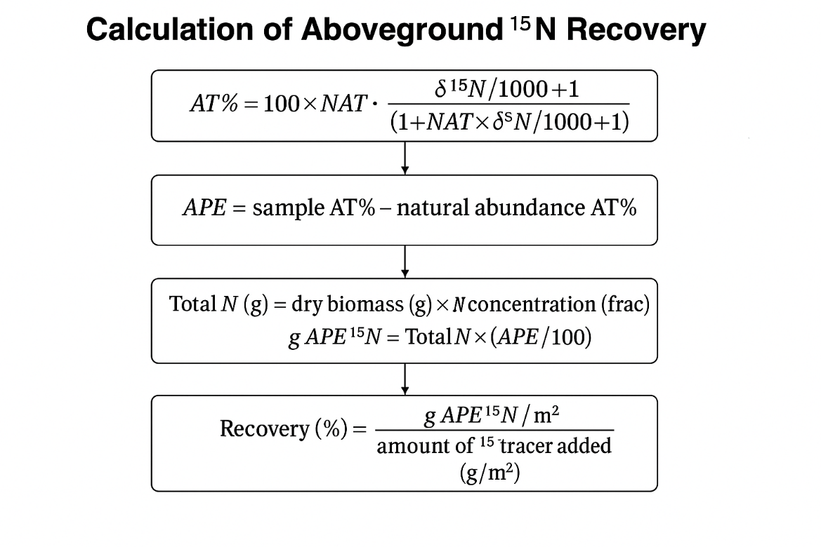

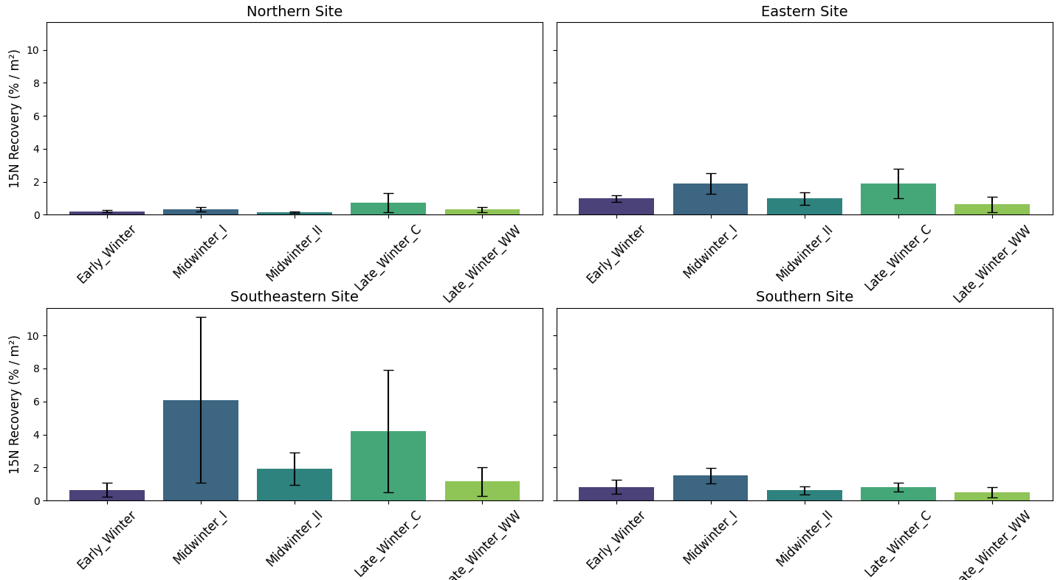
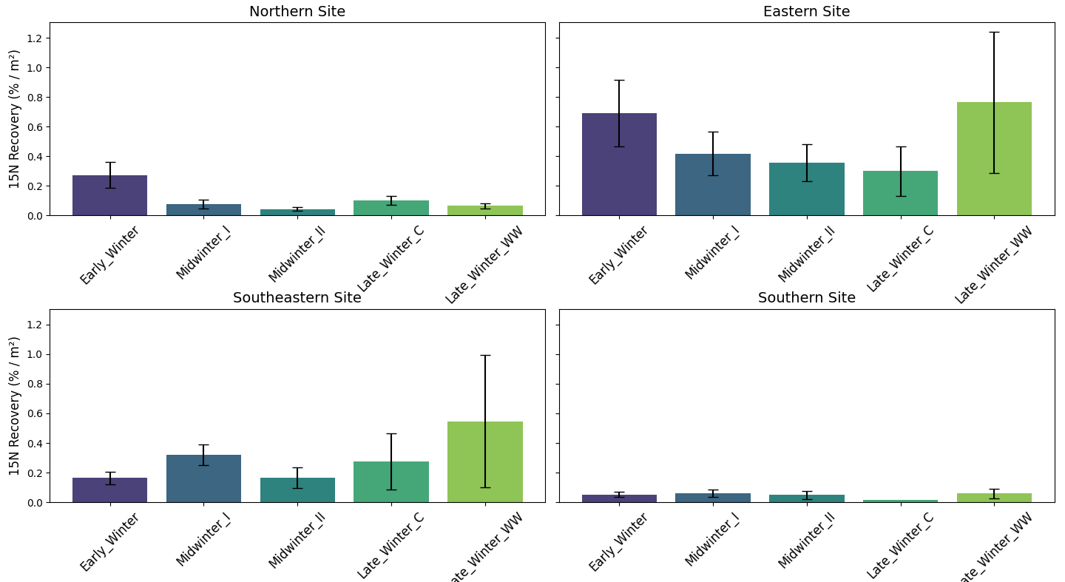
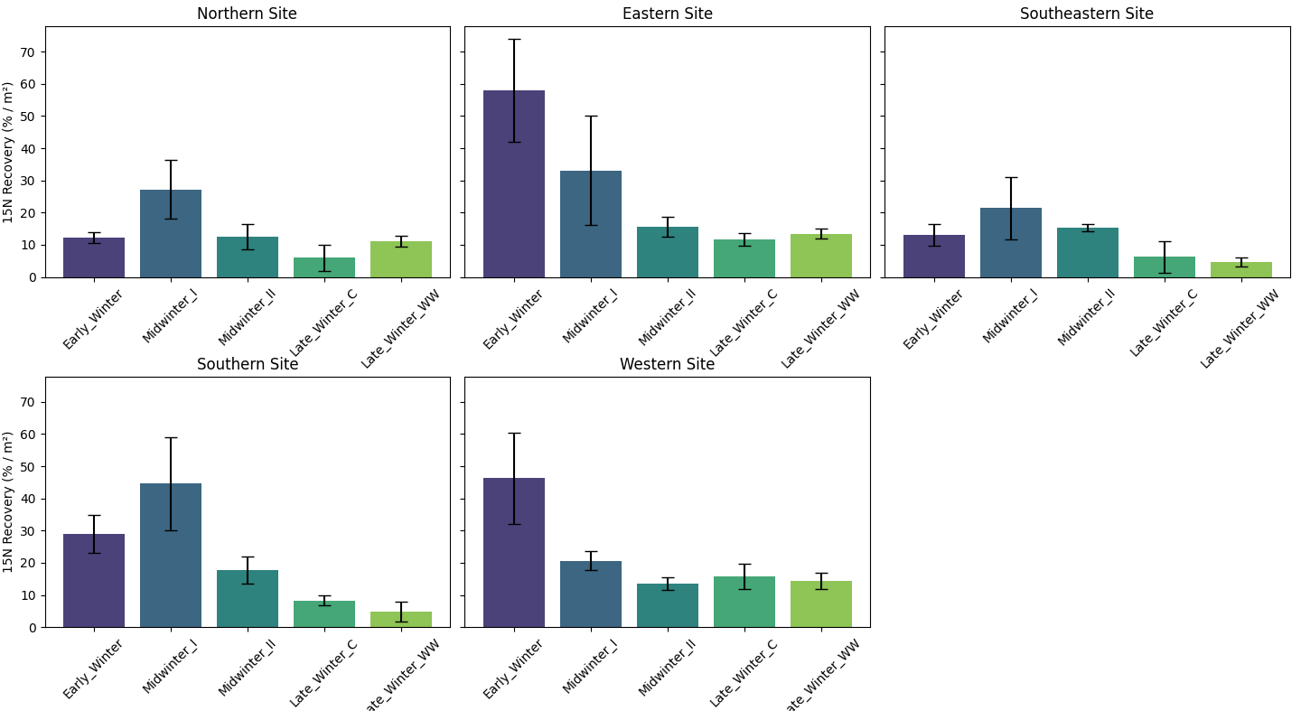
Figure S2: Root recovery of tracer N
Coarse > 1mm
Coarse > 1mm
Coarse > 1mm
Coarse > 1mm
Fine < 1mm
Fine < 1mm
Fine < 1mm
Fine < 1mm
Figure S2: ¹⁵N recovery (%) of tracer N injection in roots: Coarse roots >1 mm (lower), Fine roots (Upper). A: Northern site, B: Eastern site, C: Southeastern site and D: Southern site.

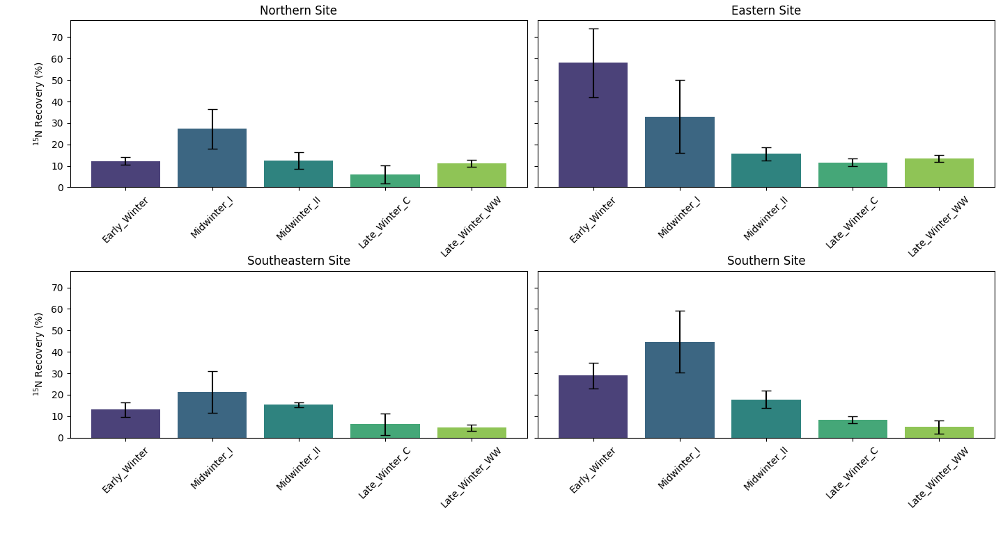
Figure S3: Microbial N recovery

Figure S3: ¹⁵N recovery (%) of tracer N injection in microbes split on site over the winter stages.
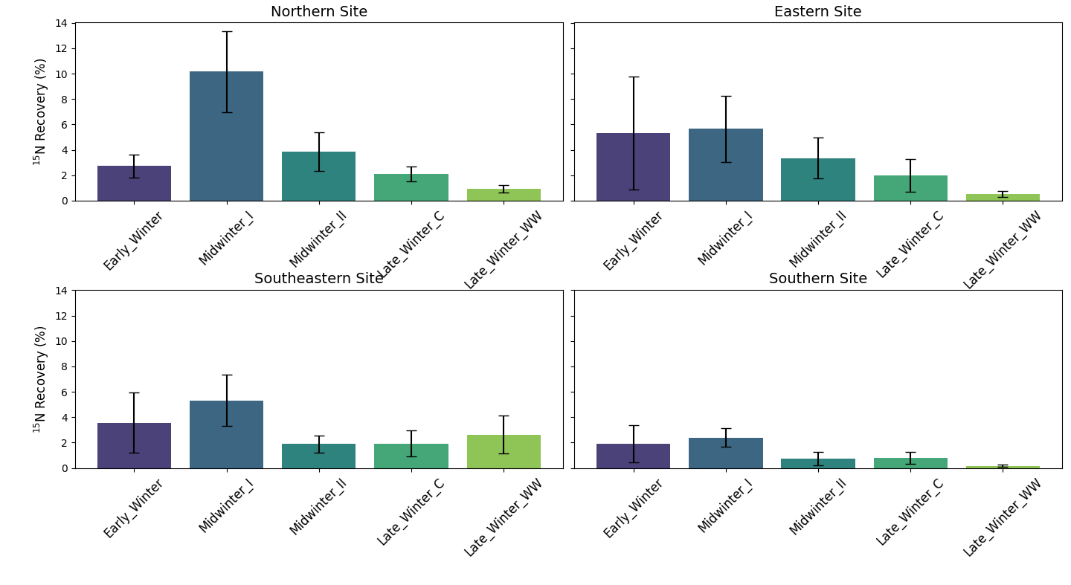
Figure S4: Soil water content of tracer N

Figure S4: ¹⁵N recovery (%) of tracer N injection in soil solution.
Figure S5: Aboveground recovery (%) on unit area basis species-specifically – North:
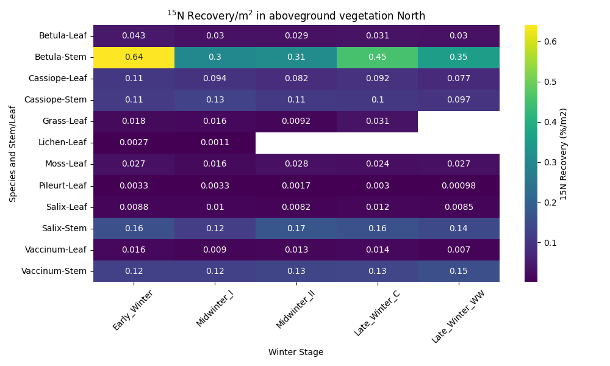Figure S5+S6: ¹⁵N recovery (% of tracer injected) in aboveground biomass species-specifically and split in fractions in the Northern site (S6) and in the Eastern site (S7).
¹⁵N recovery (%)
Figure S6: Aboveground recovery (%) on unit area basis species-specifically – East:
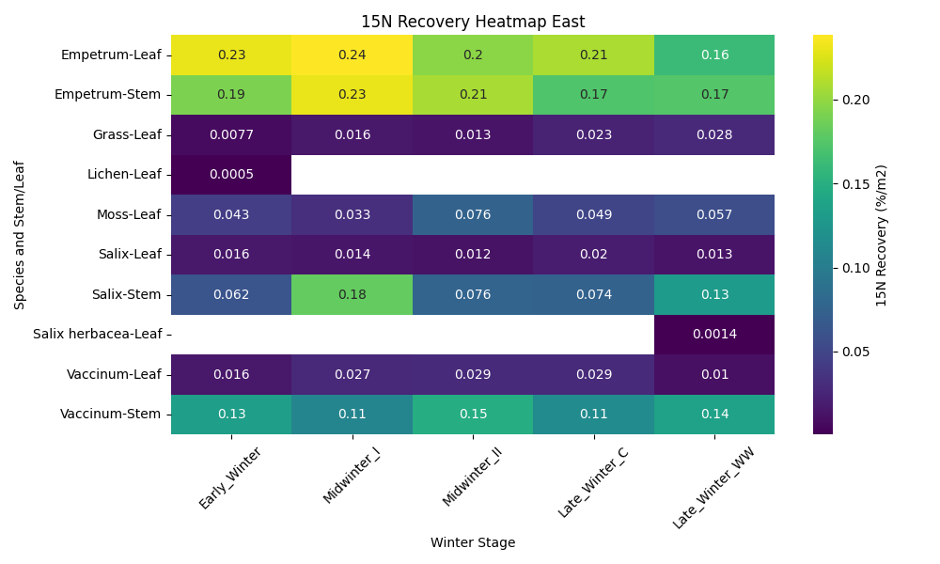
¹⁵N recovery (%)
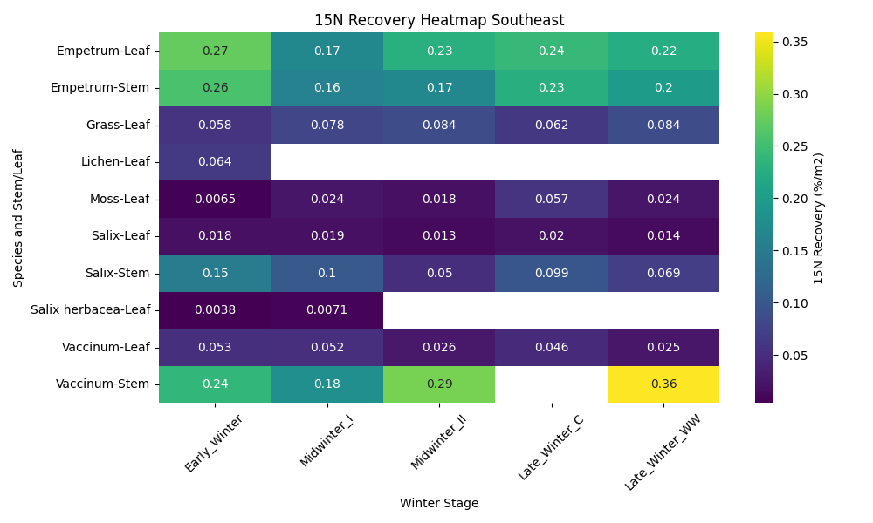
Figure S7: Aboveground recovery (%) on unit area basis species-specifically – Southeast:

¹⁵N recovery (%)

Figure S7+S8: ¹⁵N recovery (% of tracer injected) in aboveground biomass species-specifically and split in fractions in the Southeastern site (S9) and in the Southern site (S10).
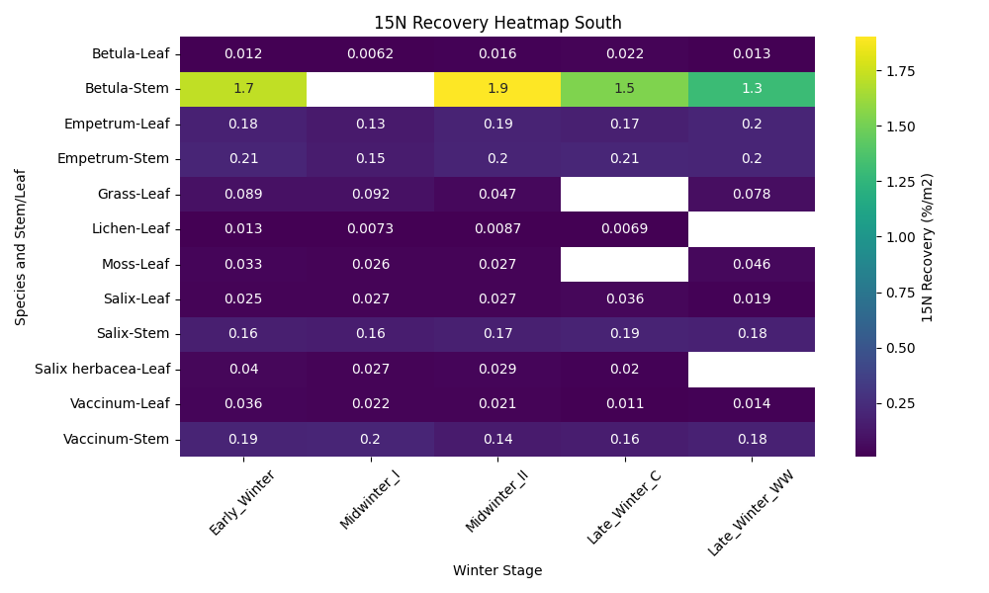
Figure S8: Aboveground recovery (%) on unit area basis species-specifically – South:
¹⁵N recovery (%)

Figure S9: Aboveground ¹⁵N recovery species-specifically averaged over site and winter stage, including comparison to Empetrum

Figure S9: Species-specific ¹⁵N recovery per unit area across the climate gradient and winter stage

Salix arctica
Bistorta
Bryophytes

Figure S9: Winter-released ¹⁵N uptake per unit area for the dominating vegetation (leaf and stem pooled) to the level of species (shrubs and common forbs) and plant functional type (Bryophyteses, grasses, lichen). Pairwise comparisons were made with Tukey’s adjusted pairwise t-test, df=853,,significance level = 0.05). Genus terms refer to: Empetrum nigrum, Betula nana, Cassiope tetragona, Dryas integrifolia, Vaccinum uliginosum, Salix arctica, Polygonum viviparum.

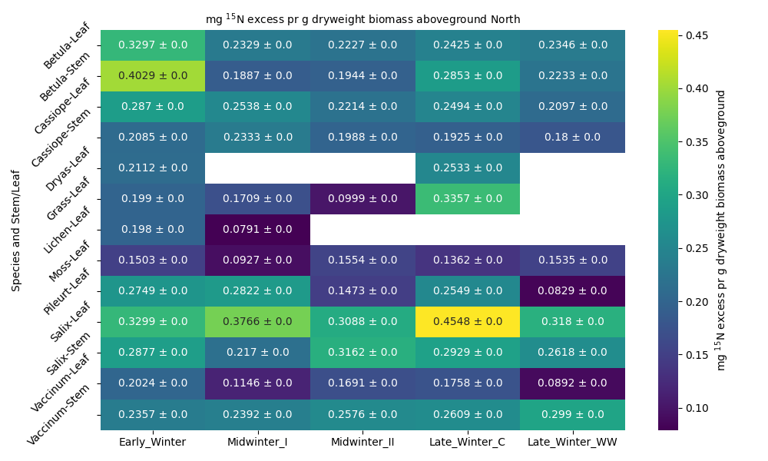
Figure S10: Species-specific ¹⁵N excess pr g dry weight in aboveground vegetation Northern site
Figure S10: ¹⁵N recovery (mg excess) in aboveground biomass/g dryweight biomass species-specifically and split in fractions in the Northern site.

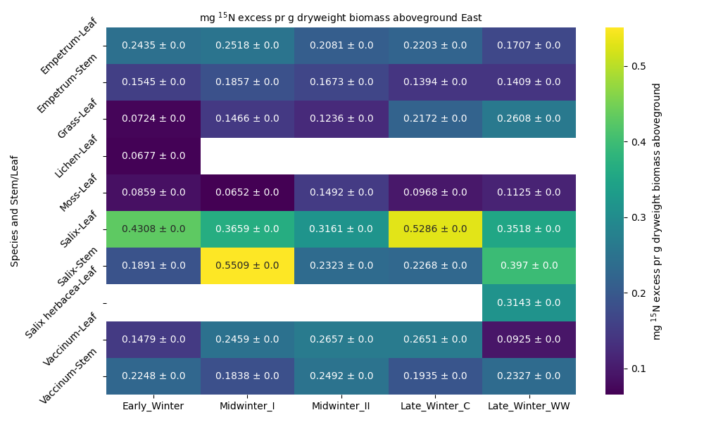
Figure S11: Species-specific ¹⁵N excess pr g dry weight in aboveground vegetation Eastern site
Figure S11: ¹⁵N recovery (mg excess) in aboveground biomass/ g dry weight biomass species-specifically in the Eastern site.

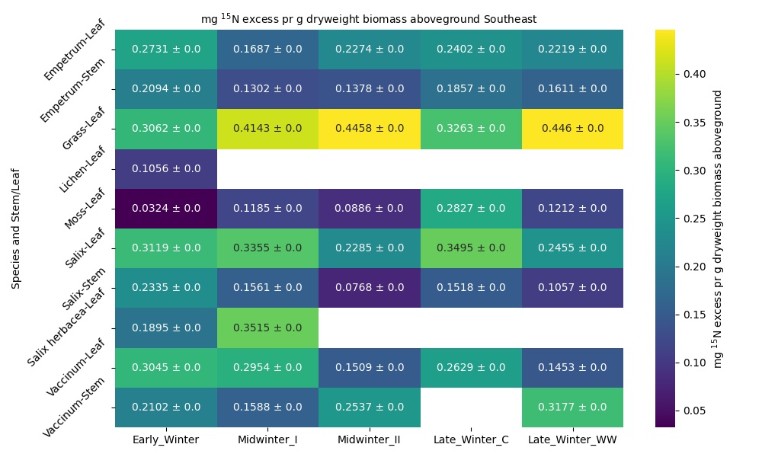
Figure S12: Species-specific ¹⁵N excess pr g dry weight in aboveground vegetation Southeastern site
Figure S12: ¹⁵N recovery (mg excess) in aboveground biomass/g dry weight biomass species-specifically in the Southeastern site.

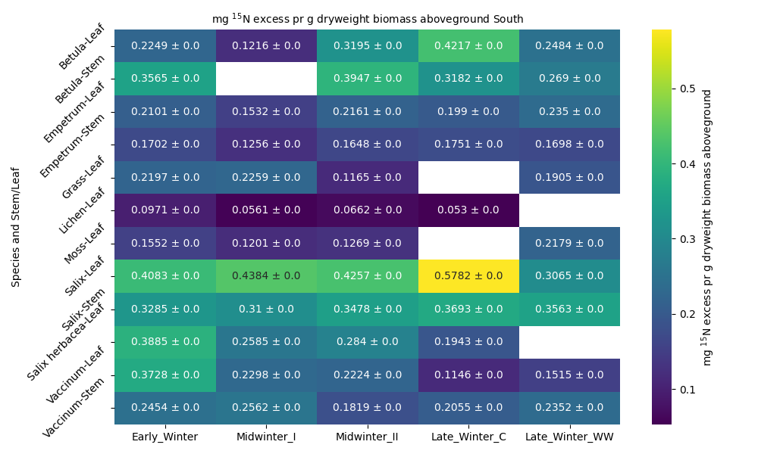
Figure S13: Species-specific ¹⁵N excess pr g dry weight in aboveground vegetation Southern site
Figure S13: ¹⁵N recovery (mg excess) in aboveground biomass/g dry weight biomass species-specifically in the Southern site.

GLMM_supplementary_code_S1-3
2026-01-14

Supplementary code S1: Roots
Read in the data and factorize the factors
df_roots <- read_xlsx("Your_directory/df_roots.xlsx")
New names:
• `` -> `...1`
df_roots <- df_roots %>% rename(APE15N_pr_m2='g_root_15APE%_per_m2')
df_roots <- df_roots %>% rename(APE15N='15NAPE%')
df_roots <- df_roots %>% mutate(Fine_coarse=factor(Fine_coarse))
df_roots <- df_roots %>% mutate(Winter_stage=factor(Winter_stage))
df_roots <- df_roots %>% mutate(Site=factor(Site))
Test whether it is normally distributed and transform to get as close to normality as possible
print(bestNormalize(df_roots$APE15N_pr_m2))
Best Normalizing transformation with 254 Observations
Estimated Normality Statistics (Pearson P / df, lower => more normal):
- arcsinh(x): 8.5545
- Box-Cox: 1.0225
- Center+scale: 10.7064
- Double Reversed Log_b(x+a): 9.9826
- Exp(x): 17.3163
- Log_b(x+a): 1.0024
- orderNorm (ORQ): 1.0479
- sqrt(x + a): 3.4418
- Yeo-Johnson: 3.0786
Estimation method: Out-of-sample via CV with 10 folds and 5 repeats
Based off these, bestNormalize chose:
Standardized Log_b(x + a) Transformation with 254 nonmissing obs.:
Relevant statistics:
- a = 0.0001335876
- b = 10
- mean (before standardization) = -1.101368
- sd (before standardization) = 0.7389304
print(bestNormalize(df_roots$Recovery_15N_pr_m2))
Best Normalizing transformation with 254 Observations
Estimated Normality Statistics (Pearson P / df, lower => more normal):
- arcsinh(x): 6.5333
- Box-Cox: 1.2859
- Center+scale: 10.6635
- Double Reversed Log_b(x+a): 9.5439
- Exp(x): 21.6822
- Log_b(x+a): 1.2058
- orderNorm (ORQ): 1.345
- sqrt(x + a): 3.7949
- Yeo-Johnson: 2.634
Estimation method: Out-of-sample via CV with 10 folds and 5 repeats
Based off these, bestNormalize chose:
Standardized Log_b(x + a) Transformation with 254 nonmissing obs.:
Relevant statistics:
- a = 0
- b = 10
- mean (before standardization) = -0.7277019
- sd (before standardization) = 0.7438546
print(bestNormalize(df_roots$APE15N))
Best Normalizing transformation with 257 Observations
Estimated Normality Statistics (Pearson P / df, lower => more normal):
- arcsinh(x): 1.3737
- Box-Cox: 1.0746
- Center+scale: 3.5264
- Double Reversed Log_b(x+a): 4.6838
- Exp(x): 21.3275
- Log_b(x+a): 1.2661
- orderNorm (ORQ): 1.143
- sqrt(x + a): 1.4426
- Yeo-Johnson: 1.1145
Estimation method: Out-of-sample via CV with 10 folds and 5 repeats
Based off these, bestNormalize chose:
Standardized Box Cox Transformation with 257 nonmissing obs.:
Estimated statistics:
- lambda = 0.165728
- mean (before standardization) = -0.01004242
- sd (before standardization) = 1.05502
print(bestNormalize(df_roots$mg_root_15NAPE_per_g_dry_root))
Best Normalizing transformation with 257 Observations
Estimated Normality Statistics (Pearson P / df, lower => more normal):
- arcsinh(x): 4.1183
- Box-Cox: 1.0598
- Center+scale: 4.4527
- Double Reversed Log_b(x+a): 4.8265
- Exp(x): 6.8689
- Log_b(x+a): 1.3185
- orderNorm (ORQ): 1.1444
- sqrt(x + a): 1.4811
- Yeo-Johnson: 1.0602
Estimation method: Out-of-sample via CV with 10 folds and 5 repeats
Based off these, bestNormalize chose:
Standardized Box Cox Transformation with 257 nonmissing obs.:
Estimated statistics:
- lambda = 0.1331583
- mean (before standardization) = -2.172784
- sd (before standardization) = 0.7453817
print(bestNormalize(df_roots$Total_dryweight_roots_mesocosm))
Best Normalizing transformation with 269 Observations
Estimated Normality Statistics (Pearson P / df, lower => more normal):
- arcsinh(x): 1.2001
- Box-Cox: 1.131
- Center+scale: 6.5614
- Double Reversed Log_b(x+a): 8.0404
- Exp(x): 14.6902
- Log_b(x+a): 1.1311
- orderNorm (ORQ): 1.332
- sqrt(x + a): 2.2967
- Yeo-Johnson: 1.197
Estimation method: Out-of-sample via CV with 10 folds and 5 repeats
Based off these, bestNormalize chose:
Standardized Box Cox Transformation with 269 nonmissing obs.:
Estimated statistics:
- lambda = 0.03515886
- mean (before standardization) = 1.66349
- sd (before standardization) = 1.437278
#Log transform the response variable
df_roots <- df_roots %>%
mutate(Total_dryweight_roots_mesocosm=log(Total_dryweight_roots_mesocosm))
#Log transform the response variable
df_roots <- df_roots %>% mutate(APE15N_pr_m2=log(APE15N_pr_m2))
df_roots <- df_roots %>% mutate(mg_root_15NAPE_per_g_dry_root=log(mg_root_15NAPE_per_g_dry_root))
df_roots <- df_roots %>% mutate(Recovery_15N_pr_m2=log(Recovery_15N_pr_m2))
#YeoJOhnson tranform the APE data (not scaled pr m2)
rootAPE_data <- df_roots$APE15N
#Apply the orderNorm transformation
yeo_johnson <- yeojohnson(rootAPE_data, lambda = -0.8330408)
#Transformed data
df_roots$APE15N <- yeo_johnson$x.t

Modelling: root biomass
This model tests the effect of Site, Winter stage and root fraction on root biomass. It also puts the intercept between site and winter stage as a random factor, taking into account the non-independence of Winter stage within each site (repeated measures)
df_roots$Site <- relevel(df_roots$Site, ref = "Southern")
root_biomass_mesocosm <- glmmTMB(Total_dryweight_roots_mesocosm ~ Site * Winter_stage + Site*Fine_coarse + (1 | Site:Winter_stage), data = df_roots, family = gaussian)
plot (residuals(root_biomass_mesocosm))
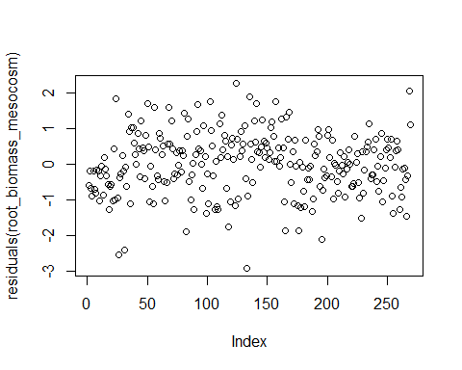
summary(root_biomass_mesocosm)
Family: gaussian ( identity )
Formula:
Total_dryweight_roots_mesocosm ~ Site * Winter_stage + Site *
Fine_coarse + (1 | Site:Winter_stage)
Data: df_roots
AIC BIC logLik -2*log(L) df.resid
734.2 827.6 -341.1 682.2 243
Random effects:
Conditional model:
Groups Name Variance Std.Dev.
Site:Winter_stage (Intercept) 1.583e-10 1.258e-05
Residual 7.394e-01 8.599e-01
Number of obs: 269, groups: Site:Winter_stage, 20
Dispersion estimate for gaussian family (sigma^2): 0.739
Conditional model:
Estimate Std. Error z value
(Intercept) 2.292005 0.243674 9.406
SiteEastern 0.747447 0.344826 2.168
SiteNorthern 0.520809 0.325135 1.602
SiteSoutheastern 0.714236 0.342547 2.085
Winter_stageLate_Winter_C -0.170769 0.376524 -0.454
Winter_stageLate_Winter_WW 0.163158 0.376524 0.433
Winter_stageMidwinter_I 0.379592 0.304612 1.246
Winter_stageMidwinter_II 0.009464 0.309124 0.031
Fine_coarseFine -2.520772 0.215182 -11.715
SiteEastern:Winter_stageLate_Winter_C -0.102832 0.532485 -0.193
SiteNorthern:Winter_stageLate_Winter_C -0.817734 0.502673 -1.627
SiteSoutheastern:Winter_stageLate_Winter_C -0.404805 0.529535 -0.764
SiteEastern:Winter_stageLate_Winter_WW -1.286326 0.532485 -2.416
SiteNorthern:Winter_stageLate_Winter_WW -1.500043 0.502673 -2.984
SiteSoutheastern:Winter_stageLate_Winter_WW -0.889162 0.529535 -1.679
SiteEastern:Winter_stageMidwinter_I -0.550008 0.433989 -1.267
SiteNorthern:Winter_stageMidwinter_I -0.880010 0.410731 -2.143
SiteSoutheastern:Winter_stageMidwinter_I -0.177912 0.433989 -0.410
SiteEastern:Winter_stageMidwinter_II -0.608974 0.437168 -1.393
SiteNorthern:Winter_stageMidwinter_II -0.953925 0.411701 -2.317
SiteSoutheastern:Winter_stageMidwinter_II -0.261967 0.433570 -0.604
SiteEastern:Fine_coarseFine 0.959771 0.305449 3.142
SiteNorthern:Fine_coarseFine 0.969645 0.289424 3.350
SiteSoutheastern:Fine_coarseFine 0.753439 0.305449 2.467
Pr(>|z|)
(Intercept) < 2e-16 ***
SiteEastern 0.030189 *
SiteNorthern 0.109195
SiteSoutheastern 0.037063 *
Winter_stageLate_Winter_C 0.650158
Winter_stageLate_Winter_WW 0.664777
Winter_stageMidwinter_I 0.212709
Winter_stageMidwinter_II 0.975576
Fine_coarseFine < 2e-16 ***
SiteEastern:Winter_stageLate_Winter_C 0.846867
SiteNorthern:Winter_stageLate_Winter_C 0.103785
SiteSoutheastern:Winter_stageLate_Winter_C 0.444597
SiteEastern:Winter_stageLate_Winter_WW 0.015705 *
SiteNorthern:Winter_stageLate_Winter_WW 0.002844 **
SiteSoutheastern:Winter_stageLate_Winter_WW 0.093125 .
SiteEastern:Winter_stageMidwinter_I 0.205037
SiteNorthern:Winter_stageMidwinter_I 0.032150 *
SiteSoutheastern:Winter_stageMidwinter_I 0.681846
SiteEastern:Winter_stageMidwinter_II 0.163620
SiteNorthern:Winter_stageMidwinter_II 0.020502 *
SiteSoutheastern:Winter_stageMidwinter_II 0.545704
SiteEastern:Fine_coarseFine 0.001677 **
SiteNorthern:Fine_coarseFine 0.000807 ***
SiteSoutheastern:Fine_coarseFine 0.013638 *
---
Signif. codes: 0 '***' 0.001 '**' 0.01 '*' 0.05 '.' 0.1 ' ' 1

Get emmeans and back-transform to original scale
Create reference grid and specify transformation
rg <- ref_grid(root_biomass_mesocosm)
rg <- update(rg, tran = "log") # explicitly tell emmeans it's log-transformed
em_site <- emmeans(rg, ~ Site)
NOTE: Results may be misleading due to involvement in interactions
summary(em_site, type = "response")
Site response SE df lower.CL upper.CL
Southern 3.03 0.345 243 2.42 3.79
Eastern 6.21 0.709 243 4.96 7.77
Northern 3.61 0.368 243 2.95 4.41
Southeastern 6.37 0.728 243 5.09 7.98
Results are averaged over the levels of: Winter_stage, Fine_coarse
Confidence level used: 0.95
Intervals are back-transformed from the log scale

Modelling: root N uptake
This model tests the effect of Site, WInter stage and root fraction. It also puts the intercept between site and winter stage as a random factor, taking into account the non-independence of Winter stage within each site (repeated measures)
In this model, we fit root 15N excess pr m2 (unit area) with Eastern site as the base level.
df_roots$Site <- relevel(df_roots$Site, ref = "Eastern")
df_roots$Winter_stage <- relevel(df_roots$Winter_stage, ref = "Late_Winter_C")
roots_m2_model <- glmmTMB(APE15N_pr_m2 ~ Site * Winter_stage + Fine_coarse + (1 | Site:Winter_stage), data = df_roots, family = gaussian)
plot(residuals(roots_m2_model))
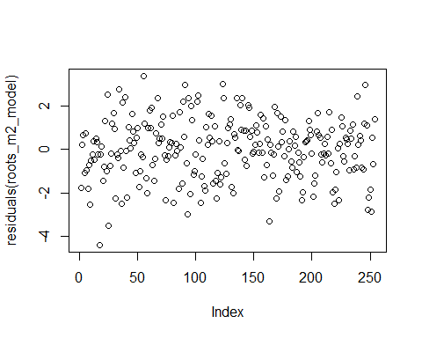
shapiro.test(residuals(roots_m2_model))
Shapiro-Wilk normality test
data: residuals(roots_m2_model)
W = 0.99431, p-value = 0.458
summary(roots_m2_model)
Family: gaussian ( identity )
Formula:
APE15N_pr_m2 ~ Site * Winter_stage + Fine_coarse + (1 | Site:Winter_stage)
Data: df_roots
AIC BIC logLik -2*log(L) df.resid
930.5 1011.9 -442.3 884.5 231
Random effects:
Conditional model:
Groups Name Variance Std.Dev.
Site:Winter_stage (Intercept) 6.879e-10 2.623e-05
Residual 1.905e+00 1.380e+00
Number of obs: 254, groups: Site:Winter_stage, 20
Dispersion estimate for gaussian family (sigma^2): 1.9
Conditional model:
Estimate Std. Error z value
(Intercept) -0.93227 0.49573 -1.881
SiteSouthern -1.06585 0.78858 -1.352
SiteNorthern -1.32158 0.65469 -2.019
SiteSoutheastern -0.23603 0.71443 -0.330
Winter_stageEarly_Winter 0.11334 0.60428 0.188
Winter_stageLate_Winter_WW -0.30293 0.69010 -0.439
Winter_stageMidwinter_I 0.15180 0.60428 0.251
Winter_stageMidwinter_II -0.23902 0.60428 -0.396
Fine_coarseFine -1.30104 0.17470 -7.447
SiteSouthern:Winter_stageEarly_Winter -0.47493 0.94557 -0.502
SiteNorthern:Winter_stageEarly_Winter -0.02118 0.80678 -0.026
SiteSoutheastern:Winter_stageEarly_Winter -1.10731 0.86986 -1.273
SiteSouthern:Winter_stageLate_Winter_WW -0.56408 1.04790 -0.538
SiteNorthern:Winter_stageLate_Winter_WW -0.09995 0.93728 -0.107
SiteSoutheastern:Winter_stageLate_Winter_WW -0.44698 0.99331 -0.450
SiteSouthern:Winter_stageMidwinter_I 0.10562 0.93529 0.113
SiteNorthern:Winter_stageMidwinter_I -0.92533 0.81330 -1.138
SiteSoutheastern:Winter_stageMidwinter_I 0.20005 0.87993 0.227
SiteSouthern:Winter_stageMidwinter_II -0.53588 0.94036 -0.570
SiteNorthern:Winter_stageMidwinter_II -0.58738 0.80678 -0.728
SiteSoutheastern:Winter_stageMidwinter_II -0.36586 0.86986 -0.421
Pr(>|z|)
(Intercept) 0.0600 .
SiteSouthern 0.1765
SiteNorthern 0.0435 *
SiteSoutheastern 0.7411
Winter_stageEarly_Winter 0.8512
Winter_stageLate_Winter_WW 0.6607
Winter_stageMidwinter_I 0.8016
Winter_stageMidwinter_II 0.6924
Fine_coarseFine 9.54e-14 ***
SiteSouthern:Winter_stageEarly_Winter 0.6155
SiteNorthern:Winter_stageEarly_Winter 0.9791
SiteSoutheastern:Winter_stageEarly_Winter 0.2030
SiteSouthern:Winter_stageLate_Winter_WW 0.5904
SiteNorthern:Winter_stageLate_Winter_WW 0.9151
SiteSoutheastern:Winter_stageLate_Winter_WW 0.6527
SiteSouthern:Winter_stageMidwinter_I 0.9101
SiteNorthern:Winter_stageMidwinter_I 0.2552
SiteSoutheastern:Winter_stageMidwinter_I 0.8202
SiteSouthern:Winter_stageMidwinter_II 0.5688
SiteNorthern:Winter_stageMidwinter_II 0.4666
SiteSoutheastern:Winter_stageMidwinter_II 0.6741
---
Signif. codes: 0 '***' 0.001 '**' 0.01 '*' 0.05 '.' 0.1 ' ' 1
drop1(roots_m2_model, test = 'Chisq')
Single term deletions
Model:
APE15N_pr_m2 ~ Site * Winter_stage + Fine_coarse + (1 | Site:Winter_stage)
Df AIC LRT Pr(>Chi)
<none> 930.51
Fine_coarse 1 978.68 50.164 1.414e-12 ***
Site:Winter_stage 12 919.74 13.228 0.3527
---
Signif. codes: 0 '***' 0.001 '**' 0.01 '*' 0.05 '.' 0.1 ' ' 1
We then get the estimated marginal means
rg <- ref_grid(roots_m2_model)
rg <- update(rg, tran = "log") # explicitly tell emmeans it's log-transformed
# Get emmeans and back-transform to original scale
em_site <- emmeans(rg, ~ Site)
NOTE: Results may be misleading due to involvement in interactions
summary(em_site, type = "response")
Site response SE df lower.CL upper.CL
Eastern 0.1943 0.03600 231 0.1349 0.2799
Southern 0.0499 0.01020 231 0.0334 0.0746
Northern 0.0374 0.00625 231 0.0269 0.0520
Southeastern 0.1088 0.02050 231 0.0751 0.1576
Results are averaged over the levels of: Winter_stage, Fine_coarse
Confidence level used: 0.95
Intervals are back-transformed from the log scale
emmeans(roots_m2_model, ~Site|Winter_stage, type = 'response')
Winter_stage = Late_Winter_C:
Site emmean SE df lower.CL upper.CL
Eastern -1.58 0.488 231 -2.54 -0.621
Southern -2.65 0.619 231 -3.87 -1.428
Northern -2.90 0.436 231 -3.76 -2.044
Southeastern -1.82 0.522 231 -2.85 -0.791
Winter_stage = Early_Winter:
Site emmean SE df lower.CL upper.CL
Eastern -1.47 0.356 231 -2.17 -0.767
Southern -3.01 0.383 231 -3.77 -2.255
Northern -2.81 0.309 231 -3.42 -2.204
Southeastern -2.81 0.345 231 -3.49 -2.133
Winter_stage = Late_Winter_WW:
Site emmean SE df lower.CL upper.CL
Eastern -1.89 0.488 231 -2.85 -0.924
Southern -3.52 0.488 231 -4.48 -2.554
Northern -3.31 0.460 231 -4.21 -2.401
Southeastern -2.57 0.488 231 -3.53 -1.607
Winter_stage = Midwinter_I:
Site emmean SE df lower.CL upper.CL
Eastern -1.43 0.356 231 -2.13 -0.729
Southern -2.39 0.357 231 -3.09 -1.688
Northern -3.68 0.325 231 -4.32 -3.037
Southeastern -1.47 0.369 231 -2.19 -0.740
Winter_stage = Midwinter_II:
Site emmean SE df lower.CL upper.CL
Eastern -1.82 0.356 231 -2.52 -1.120
Southern -3.42 0.369 231 -4.15 -2.696
Northern -3.73 0.309 231 -4.34 -3.123
Southeastern -2.42 0.345 231 -3.10 -1.744
Results are averaged over the levels of: Fine_coarse
Confidence level used: 0.95
emmeans(roots_m2_model, ~Fine_coarse, type = 'response')
Fine_coarse emmean SE df lower.CL upper.CL
Coarse -1.88 0.123 231 -2.13 -1.64
Fine -3.19 0.133 231 -3.45 -2.92
Results are averaged over the levels of: Site, Winter_stage
Confidence level used: 0.95
We further fit a model where the response is root 15NAPE pr g dry root (unit mass).
roots_prdryweight_model <- glmmTMB(mg_root_15NAPE_per_g_dry_root ~ Site * Winter_stage + Fine_coarse + (1 | Site:Winter_stage), data = df_roots, family = gaussian)
# Plot residuals
plot(residuals(roots_prdryweight_model))
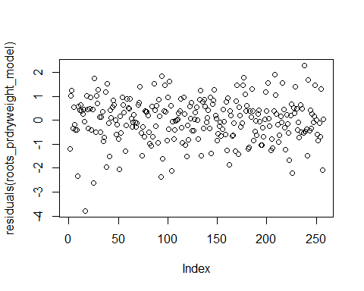
shapiro.test(residuals(roots_prdryweight_model))
Shapiro-Wilk normality test
data: residuals(roots_prdryweight_model)
W = 0.98395, p-value = 0.005452
summary(roots_prdryweight_model)
Family: gaussian ( identity )
Formula:
mg_root_15NAPE_per_g_dry_root ~ Site * Winter_stage + Fine_coarse +
(1 | Site:Winter_stage)
Data: df_roots
AIC BIC logLik -2*log(L) df.resid
724.6 806.2 -339.3 678.6 234
Random effects:
Conditional model:
Groups Name Variance Std.Dev.
Site:Winter_stage (Intercept) 2.224e-10 1.491e-05
Residual 8.207e-01 9.059e-01
Number of obs: 257, groups: Site:Winter_stage, 20
Dispersion estimate for gaussian family (sigma^2): 0.821
Conditional model:
Estimate Std. Error z value
(Intercept) -2.34165 0.32531 -7.198
SiteSouthern -0.03066 0.51758 -0.059
SiteNorthern -0.31392 0.42972 -0.731
SiteSoutheastern -0.11259 0.46893 -0.240
Winter_stageEarly_Winter -0.18592 0.39228 -0.474
Winter_stageLate_Winter_WW 0.40826 0.45296 0.901
Winter_stageMidwinter_I -0.08973 0.39663 -0.226
Winter_stageMidwinter_II -0.03285 0.39663 -0.083
Fine_coarseFine 0.42555 0.11384 3.738
SiteSouthern:Winter_stageEarly_Winter 0.03756 0.61426 0.061
SiteNorthern:Winter_stageEarly_Winter -0.61363 0.52629 -1.166
SiteSoutheastern:Winter_stageEarly_Winter -0.95054 0.56787 -1.674
SiteSouthern:Winter_stageLate_Winter_WW -1.18379 0.68780 -1.721
SiteNorthern:Winter_stageLate_Winter_WW -0.33921 0.61520 -0.551
SiteSoutheastern:Winter_stageLate_Winter_WW -0.06237 0.65197 -0.096
SiteSouthern:Winter_stageMidwinter_I 0.02175 0.61389 0.035
SiteNorthern:Winter_stageMidwinter_I -1.17601 0.53157 -2.212
SiteSoutheastern:Winter_stageMidwinter_I 0.14442 0.57755 0.250
SiteSouthern:Winter_stageMidwinter_II -0.70469 0.61721 -1.142
SiteNorthern:Winter_stageMidwinter_II -0.74081 0.52955 -1.399
SiteSoutheastern:Winter_stageMidwinter_II -0.27449 0.57094 -0.481
Pr(>|z|)
(Intercept) 6.1e-13 ***
SiteSouthern 0.952760
SiteNorthern 0.465062
SiteSoutheastern 0.810257
Winter_stageEarly_Winter 0.635526
Winter_stageLate_Winter_WW 0.367420
Winter_stageMidwinter_I 0.821017
Winter_stageMidwinter_II 0.933997
Fine_coarseFine 0.000185 ***
SiteSouthern:Winter_stageEarly_Winter 0.951241
SiteNorthern:Winter_stageEarly_Winter 0.243634
SiteSoutheastern:Winter_stageEarly_Winter 0.094159 .
SiteSouthern:Winter_stageLate_Winter_WW 0.085227 .
SiteNorthern:Winter_stageLate_Winter_WW 0.581367
SiteSoutheastern:Winter_stageLate_Winter_WW 0.923793
SiteSouthern:Winter_stageMidwinter_I 0.971737
SiteNorthern:Winter_stageMidwinter_I 0.026942 *
SiteSoutheastern:Winter_stageMidwinter_I 0.802550
SiteSouthern:Winter_stageMidwinter_II 0.253566
SiteNorthern:Winter_stageMidwinter_II 0.161827
SiteSoutheastern:Winter_stageMidwinter_II 0.630688
---
Signif. codes: 0 '***' 0.001 '**' 0.01 '*' 0.05 '.' 0.1 ' ' 1
drop1(roots_prdryweight_model, test = 'Chisq')
Single term deletions
Model:
mg_root_15NAPE_per_g_dry_root ~ Site * Winter_stage + Fine_coarse +
(1 | Site:Winter_stage)
Df AIC LRT Pr(>Chi)
<none> 724.55
Fine_coarse 1 736.16 13.606 0.0002254 ***
Site:Winter_stage 12 730.37 29.822 0.0029701 **
---
Signif. codes: 0 '***' 0.001 '**' 0.01 '*' 0.05 '.' 0.1 ' ' 1
Backtransforming and getting the emmeans.
rg <- ref_grid(roots_prdryweight_model)
rg <- update(rg, tran = "log") # explicitly tell emmeans it's log-transformed
# Get emmeans and back-transform to original scale
em_site <- emmeans(rg, ~ Site)
NOTE: Results may be misleading due to involvement in interactions
em_fraction <- emmeans(rg, ~ Fine_coarse)
summary(em_site, type = "response")
Site response SE df lower.CL upper.CL
Eastern 0.1214 0.01470 234 0.0956 0.1540
Southern 0.0816 0.01090 234 0.0628 0.1061
Northern 0.0499 0.00546 234 0.0403 0.0619
Southeastern 0.0863 0.01070 234 0.0677 0.1100
Results are averaged over the levels of: Winter_stage, Fine_coarse
Confidence level used: 0.95
Intervals are back-transformed from the log scale
summary(em_fraction, type = "response")
Fine_coarse response SE df lower.CL upper.CL
Coarse 0.0653 0.00528 234 0.0557 0.0766
Fine 0.1000 0.00861 234 0.0844 0.1185
Results are averaged over the levels of: Site, Winter_stage
Confidence level used: 0.95
Intervals are back-transformed from the log scale

Supplementary code S2: Microbes and soil water
df_microbes <- read_xlsx("Your_directory/df_microbes.xlsx")
df_microbes <- df_microbes %>%
rename(Microbial_µg15N_pr_m2='microgram Microbial 15N exess pr m2 to 10 cm')
df_microbes <- df_microbes %>%
mutate(Winter_stage=factor(Winter_stage))
df_microbes <- df_microbes %>%
mutate(Site=factor(Site))
df_microbes <- df_microbes %>%
mutate(Microbial_µg15N_pr_m2=log(Microbial_µg15N_pr_m2))
Warning: There was 1 warning in `mutate()`.
ℹ In argument: `Microbial_µg15N_pr_m2 = log(Microbial_µg15N_pr_m2)`.
Caused by warning in `log()`:
! NaNs produced
df_microbes$Site <- relevel(df_microbes$Site, ref = "Western")

Modelling: microbial N uptake
This model tests the effect of Site and Winter stage on microbial 15N excess/m2. It also puts the intercept between site and winter stage as a random factor, taking into account the non-independence of Winter stage within each site (repeated measures).
microbes_m2_model <- glmmTMB(Microbial_µg15N_pr_m2 ~ Site * Winter_stage + (1 | Site:Winter_stage), data = df_microbes, family = gaussian)
plot(residuals(microbes_m2_model))
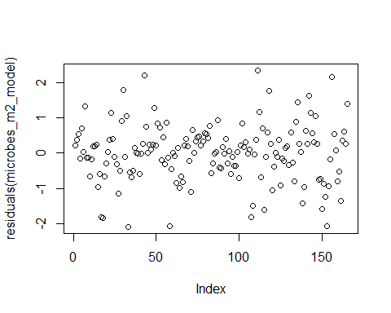
# Shapiro-Wilk test for normality
shapiro.test(residuals(microbes_m2_model))
Shapiro-Wilk normality test
data: residuals(microbes_m2_model)
W = 0.9799, p-value = 0.0169
#Summary
summary(microbes_m2_model)
Family: gaussian ( identity )
Formula:
Microbial_µg15N_pr_m2 ~ Site * Winter_stage + (1 | Site:Winter_stage)
Data: df_microbes
AIC BIC logLik -2*log(L) df.resid
449.8 533.7 -197.9 395.8 138
Random effects:
Conditional model:
Groups Name Variance Std.Dev.
Site:Winter_stage (Intercept) 1.696e-10 1.302e-05
Residual 6.447e-01 8.029e-01
Number of obs: 165, groups: Site:Winter_stage, 25
Dispersion estimate for gaussian family (sigma^2): 0.645
Conditional model:
Estimate Std. Error z value
(Intercept) 12.86068 0.35909 35.81
SiteEastern -0.77922 0.45775 -1.70
SiteNorthern -2.12104 0.43979 -4.82
SiteSoutheastern -1.96982 0.47016 -4.19
SiteSouthern -1.36890 0.45775 -2.99
Winter_stageLate_Winter_C -1.07150 0.53863 -1.99
Winter_stageLate_Winter_WW -1.05945 0.50783 -2.09
Winter_stageMidwinter_I -0.74716 0.43979 -1.70
Winter_stageMidwinter_II -1.17216 0.43308 -2.71
SiteEastern:Winter_stageLate_Winter_C -0.25786 0.72931 -0.35
SiteNorthern:Winter_stageLate_Winter_C -0.38197 0.69537 -0.55
SiteSoutheastern:Winter_stageLate_Winter_C -0.76652 0.73716 -1.04
SiteSouthern:Winter_stageLate_Winter_C -0.03319 0.72931 -0.05
SiteEastern:Winter_stageLate_Winter_WW -0.09686 0.74390 -0.13
SiteNorthern:Winter_stageLate_Winter_WW 1.00818 0.67179 1.50
SiteSoutheastern:Winter_stageLate_Winter_WW -0.15332 0.71496 -0.21
SiteSouthern:Winter_stageLate_Winter_WW -1.22068 0.70687 -1.73
SiteEastern:Winter_stageMidwinter_I -0.19205 0.59548 -0.32
SiteNorthern:Winter_stageMidwinter_I 1.26112 0.57404 2.20
SiteSoutheastern:Winter_stageMidwinter_I 0.81913 0.61451 1.33
SiteSouthern:Winter_stageMidwinter_I 1.02223 0.59548 1.72
SiteEastern:Winter_stageMidwinter_II 0.04803 0.59054 0.08
SiteNorthern:Winter_stageMidwinter_II 0.74086 0.56891 1.30
SiteSoutheastern:Winter_stageMidwinter_II 1.33788 0.60972 2.19
SiteSouthern:Winter_stageMidwinter_II 0.75852 0.59054 1.28
Pr(>|z|)
(Intercept) < 2e-16 ***
SiteEastern 0.08870 .
SiteNorthern 1.42e-06 ***
SiteSoutheastern 2.79e-05 ***
SiteSouthern 0.00279 **
Winter_stageLate_Winter_C 0.04667 *
Winter_stageLate_Winter_WW 0.03696 *
Winter_stageMidwinter_I 0.08934 .
Winter_stageMidwinter_II 0.00680 **
SiteEastern:Winter_stageLate_Winter_C 0.72366
SiteNorthern:Winter_stageLate_Winter_C 0.58280
SiteSoutheastern:Winter_stageLate_Winter_C 0.29842
SiteSouthern:Winter_stageLate_Winter_C 0.96370
SiteEastern:Winter_stageLate_Winter_WW 0.89640
SiteNorthern:Winter_stageLate_Winter_WW 0.13342
SiteSoutheastern:Winter_stageLate_Winter_WW 0.83020
SiteSouthern:Winter_stageLate_Winter_WW 0.08419 .
SiteEastern:Winter_stageMidwinter_I 0.74706
SiteNorthern:Winter_stageMidwinter_I 0.02803 *
SiteSoutheastern:Winter_stageMidwinter_I 0.18254
SiteSouthern:Winter_stageMidwinter_I 0.08604 .
SiteEastern:Winter_stageMidwinter_II 0.93518
SiteNorthern:Winter_stageMidwinter_II 0.19283
SiteSoutheastern:Winter_stageMidwinter_II 0.02822 *
SiteSouthern:Winter_stageMidwinter_II 0.19898
---
Signif. codes: 0 '***' 0.001 '**' 0.01 '*' 0.05 '.' 0.1 ' ' 1

Modelling: soil water 15N
df_soilwater <- read_xlsx("Your_directory/df_soil_water.xlsx")
New names:
• `` -> `...1`
df_soilwater <- df_soilwater %>%
rename(Soil_water_µg15N_pr_m2='microgram soil water 15N exess pr m2 to 10 cm')
df_soilwater <- df_soilwater %>%
mutate(Winter_stage=factor(Winter_stage))
df_soilwater <- df_soilwater %>%
mutate(Site=factor(Site))
df_soilwater <- df_soilwater %>%
mutate(Soil_water_µg15N_pr_m2=log(Soil_water_µg15N_pr_m2))
Warning: There was 1 warning in `mutate()`.
ℹ In argument: `Soil_water_µg15N_pr_m2 = log(Soil_water_µg15N_pr_m2)`.
Caused by warning in `log()`:
! NaNs produced
#CHanging the levels to zoom in on each specific site and any differences between Late Winter C and late winter WW:
df_soilwater$Site <- relevel(df_soilwater$Site, ref = "Western")
df_soilwater$Winter_stage <- relevel(df_soilwater$Winter_stage, ref = "Late_Winter_C")
soilwater_m2_model <- glmmTMB(Soil_water_µg15N_pr_m2 ~ Site * Winter_stage + (1 | Site:Winter_stage), data = df_soilwater, family = gaussian)
plot(residuals(soilwater_m2_model))
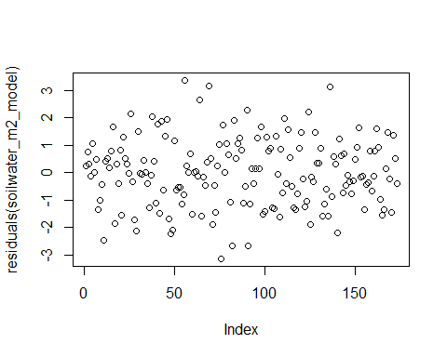
# Shapiro-Wilk test for normality
shapiro.test(residuals(soilwater_m2_model))
Shapiro-Wilk normality test
data: residuals(soilwater_m2_model)
W = 0.99509, p-value = 0.8404
#Summary
summary(soilwater_m2_model)
Family: gaussian ( identity )
Formula:
Soil_water_µg15N_pr_m2 ~ Site * Winter_stage + (1 | Site:Winter_stage)
Data: df_soilwater
AIC BIC logLik -2*log(L) df.resid
617.8 702.9 -281.9 563.8 146
Random effects:
Conditional model:
Groups Name Variance Std.Dev.
Site:Winter_stage (Intercept) 6.948e-10 2.636e-05
Residual 1.523e+00 1.234e+00
Number of obs: 173, groups: Site:Winter_stage, 25
Dispersion estimate for gaussian family (sigma^2): 1.52
Conditional model:
Estimate Std. Error z value
(Intercept) 11.18658 0.61709 18.128
SiteEastern -2.74569 0.87269 -3.146
SiteNorthern -2.25302 0.82791 -2.721
SiteSoutheastern -2.08472 0.94262 -2.212
SiteSouthern -3.56166 0.87269 -4.081
Winter_stageEarly_Winter -0.69264 0.73015 -0.949
Winter_stageLate_Winter_WW -2.65475 0.82791 -3.207
Winter_stageMidwinter_I -1.23952 0.73015 -1.698
Winter_stageMidwinter_II -1.77480 0.72060 -2.463
SiteEastern:Winter_stageEarly_Winter 0.82026 1.05086 0.781
SiteNorthern:Winter_stageEarly_Winter 0.08838 0.99502 0.089
SiteSoutheastern:Winter_stageEarly_Winter 0.26339 1.10961 0.237
SiteSouthern:Winter_stageEarly_Winter 0.73795 1.05086 0.702
SiteEastern:Winter_stageLate_Winter_WW 1.77121 1.25457 1.412
SiteNorthern:Winter_stageLate_Winter_WW 1.79436 1.13785 1.577
SiteSoutheastern:Winter_stageLate_Winter_WW 2.15241 1.25457 1.716
SiteSouthern:Winter_stageLate_Winter_WW 1.15142 1.20292 0.957
SiteEastern:Winter_stageMidwinter_I 1.95709 1.05086 1.862
SiteNorthern:Winter_stageMidwinter_I 2.13402 0.99502 2.145
SiteSoutheastern:Winter_stageMidwinter_I 1.63224 1.10961 1.471
SiteSouthern:Winter_stageMidwinter_I 2.28830 1.05086 2.178
SiteEastern:Winter_stageMidwinter_II 2.06333 1.04425 1.976
SiteNorthern:Winter_stageMidwinter_II 1.89307 0.98804 1.916
SiteSoutheastern:Winter_stageMidwinter_II 1.21762 1.11561 1.091
SiteSouthern:Winter_stageMidwinter_II 0.84633 1.04425 0.810
Pr(>|z|)
(Intercept) < 2e-16 ***
SiteEastern 0.00165 **
SiteNorthern 0.00650 **
SiteSoutheastern 0.02699 *
SiteSouthern 4.48e-05 ***
Winter_stageEarly_Winter 0.34281
Winter_stageLate_Winter_WW 0.00134 **
Winter_stageMidwinter_I 0.08958 .
Winter_stageMidwinter_II 0.01378 *
SiteEastern:Winter_stageEarly_Winter 0.43506
SiteNorthern:Winter_stageEarly_Winter 0.92922
SiteSoutheastern:Winter_stageEarly_Winter 0.81237
SiteSouthern:Winter_stageEarly_Winter 0.48254
SiteEastern:Winter_stageLate_Winter_WW 0.15801
SiteNorthern:Winter_stageLate_Winter_WW 0.11480
SiteSoutheastern:Winter_stageLate_Winter_WW 0.08623 .
SiteSouthern:Winter_stageLate_Winter_WW 0.33848
SiteEastern:Winter_stageMidwinter_I 0.06255 .
SiteNorthern:Winter_stageMidwinter_I 0.03198 *
SiteSoutheastern:Winter_stageMidwinter_I 0.14129
SiteSouthern:Winter_stageMidwinter_I 0.02944 *
SiteEastern:Winter_stageMidwinter_II 0.04817 *
SiteNorthern:Winter_stageMidwinter_II 0.05537 .
SiteSoutheastern:Winter_stageMidwinter_II 0.27508
SiteSouthern:Winter_stageMidwinter_II 0.41767
---
Signif. codes: 0 '***' 0.001 '**' 0.01 '*' 0.05 '.' 0.1 ' ' 1

Supplementary code S3: Aboveground vegetation
df_above_north <- read_xlsx("Your_directory/df_aboveground_north.xlsx")
New names:
• `` -> `...1`
df_above_east <- read_xlsx("Your_directory/df_aboveground_east.xlsx")
New names:
• `` -> `...1`
df_above_southeast <- read_xlsx("Your_directory/df_aboveground_southeast.xlsx")
New names:
• `` -> `...1`
df_above_south <- read_xlsx("Your_directory/df_aboveground_south.xlsx")
New names:
• `` -> `...1`
df_above_west <- read_xlsx("Your_directory/df_aboveground_west.xlsx")
New names:
• `` -> `...1`
df_above <- bind_rows(df_above_north,df_above_east,df_above_southeast,df_above_south, df_above_west)
df_above <- df_above %>%
mutate(Winter_stage=factor(Winter_stage))
df_above <- df_above %>%
mutate(Site=factor(Site))
df_above <- df_above %>%
mutate(Stem_leaf=factor(Stem_leaf))
df_above <- df_above %>%
mutate(PFT=factor(PFT))
df_above <- df_above %>%
mutate(Species=factor(Species))
Fitting a model, testing for normal residuals and transforming for a better model, then fitting again.
This model tests the effect of Site, Winter stage, fraction of the plant (Stem or leaf) and Plant functional type (PFT) on aboveground 15N recovery. It also puts the intercept between site and winter stage as a random factor, taking into account the non-independence of Winter stage within each site (repeated measures) and makes PFT and Stem_leaf because we have an expectation that leaf and stem distribution of N will vary between plant functional types.
above_m2_model <- glmmTMB(g_15N_APE_pr_m2 ~ Site * Winter_stage + Stem_leaf * PFT + (1 | Site:Winter_stage), data = df_above, family = gaussian)
dropping columns from rank-deficient conditional model: SiteWestern:Winter_stageLate_Winter_C, SiteWestern:Winter_stageLate_Winter_WW, SiteWestern:Winter_stageMidwinter_I, SiteWestern:Winter_stageMidwinter_II, Stem_leafStem:PFTMoss
plot(residuals(above_m2_model))
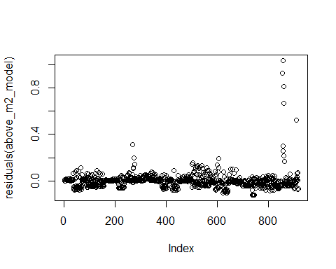
# Shapiro-Wilk test for normality
shapiro.test(residuals(above_m2_model))
Shapiro-Wilk normality test
data: residuals(above_m2_model)
W = 0.51474, p-value < 2.2e-16
print(bestNormalize(df_above$g_15N_APE_pr_m2))
Best Normalizing transformation with 917 Observations
Estimated Normality Statistics (Pearson P / df, lower => more normal):
- arcsinh(x): 16.5224
- Box-Cox: 1.5963
- Center+scale: 17.4118
- Double Reversed Log_b(x+a): 17.3692
- Exp(x): 17.2756
- Log_b(x+a): 2.1011
- orderNorm (ORQ): 1.0644
- sqrt(x + a): 3.5743
- Yeo-Johnson: 9.2798
Estimation method: Out-of-sample via CV with 10 folds and 5 repeats
Based off these, bestNormalize chose:
orderNorm Transformation with 917 nonmissing obs and ties
- 901 unique values
- Original quantiles:
0% 25% 50% 75% 100%
0.000 0.004 0.019 0.062 1.168
print(bestNormalize(residuals(above_m2_model)))
Best Normalizing transformation with 917 Observations
Estimated Normality Statistics (Pearson P / df, lower => more normal):
- arcsinh(x): 6.7889
- Center+scale: 7.1806
- Double Reversed Log_b(x+a): 8.6863
- Exp(x): 9.9369
- Log_b(x+a): 6.203
- orderNorm (ORQ): 1.079
- sqrt(x + a): 5.2002
- Yeo-Johnson: 3.8929
Estimation method: Out-of-sample via CV with 10 folds and 5 repeats
Based off these, bestNormalize chose:
orderNorm Transformation with 917 nonmissing obs and ties
- 900 unique values
- Original quantiles:
0% 25% 50% 75% 100%
-0.123 -0.036 -0.002 0.012 1.038
#So I make the transformation:
above_data <- df_above$g_15N_APE_pr_m2
# Apply the orderNorm transformation
order_norm <- orderNorm(above_data)
Warning in orderNorm(above_data): Ties in data, Normal distribution not guaranteed
# Transformed data
df_above$g_15N_APE_pr_m2 <- order_norm$x.t
above_m2_model_PFTint <- glmmTMB(g_15N_APE_pr_m2 ~ Site * Winter_stage + Stem_leaf * PFT + (1 | Site:Winter_stage), data = df_above, family = gaussian)
dropping columns from rank-deficient conditional model: SiteWestern:Winter_stageLate_Winter_C, SiteWestern:Winter_stageLate_Winter_WW, SiteWestern:Winter_stageMidwinter_I, SiteWestern:Winter_stageMidwinter_II, Stem_leafStem:PFTMoss
plot(residuals(above_m2_model_PFTint))
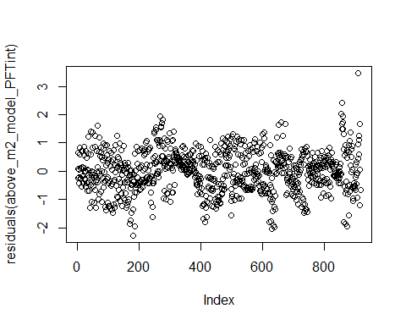
summary(above_m2_model)
Family: gaussian ( identity )
Formula:
g_15N_APE_pr_m2 ~ Site * Winter_stage + Stem_leaf * PFT + (1 |
Site:Winter_stage)
Data: df_above
AIC BIC logLik -2*log(L) df.resid
-2087.2 -1957.0 1070.6 -2141.2 890
Random effects:
Conditional model:
Groups Name Variance Std.Dev.
Site:Winter_stage (Intercept) 1.104e-12 1.051e-06
Residual 5.668e-03 7.529e-02
Number of obs: 917, groups: Site:Winter_stage, 21
Dispersion estimate for gaussian family (sigma^2): 0.00567
Conditional model:
Estimate Std. Error z value
(Intercept) 0.0023870 0.0126658 0.188
SiteNorthern 0.0030087 0.0151754 0.198
SiteSoutheastern 0.0251212 0.0168691 1.489
SiteSouthern 0.0447533 0.0169052 2.647
SiteWestern -0.0037848 0.0190089 -0.199
Winter_stageLate_Winter_C -0.0000717 0.0175135 -0.004
Winter_stageLate_Winter_WW 0.0015088 0.0172771 0.087
Winter_stageMidwinter_I 0.0089478 0.0175135 0.511
Winter_stageMidwinter_II 0.0032143 0.0175135 0.184
Stem_leafStem 0.0811325 0.0069811 11.622
PFTEvergreen 0.0513047 0.0077817 6.593
PFTMoss -0.0009492 0.0078576 -0.121
SiteNorthern:Winter_stageLate_Winter_C -0.0019508 0.0217900 -0.090
SiteSoutheastern:Winter_stageLate_Winter_C -0.0033529 0.0245742 -0.136
SiteSouthern:Winter_stageLate_Winter_C -0.0005649 0.0245706 -0.023
SiteWestern:Winter_stageLate_Winter_C NA NA NA
SiteNorthern:Winter_stageLate_Winter_WW -0.0094859 0.0219288 -0.433
SiteSoutheastern:Winter_stageLate_Winter_WW -0.0056453 0.0240582 -0.235
SiteSouthern:Winter_stageLate_Winter_WW -0.0016822 0.0244048 -0.069
SiteWestern:Winter_stageLate_Winter_WW NA NA NA
SiteNorthern:Winter_stageMidwinter_I -0.0172337 0.0217952 -0.791
SiteSoutheastern:Winter_stageMidwinter_I -0.0258553 0.0240801 -1.074
SiteSouthern:Winter_stageMidwinter_I -0.0484489 0.0241564 -2.006
SiteWestern:Winter_stageMidwinter_I NA NA NA
SiteNorthern:Winter_stageMidwinter_II -0.0103692 0.0219568 -0.472
SiteSoutheastern:Winter_stageMidwinter_II -0.0132184 0.0242277 -0.546
SiteSouthern:Winter_stageMidwinter_II -0.0021030 0.0240133 -0.088
SiteWestern:Winter_stageMidwinter_II NA NA NA
Stem_leafStem:PFTEvergreen -0.0785429 0.0114225 -6.876
Stem_leafStem:PFTMoss NA NA NA
Pr(>|z|)
(Intercept) 0.85052
SiteNorthern 0.84284
SiteSoutheastern 0.13644
SiteSouthern 0.00811 **
SiteWestern 0.84218
Winter_stageLate_Winter_C 0.99673
Winter_stageLate_Winter_WW 0.93041
Winter_stageMidwinter_I 0.60942
Winter_stageMidwinter_II 0.85438
Stem_leafStem < 2e-16 ***
PFTEvergreen 4.31e-11 ***
PFTMoss 0.90385
SiteNorthern:Winter_stageLate_Winter_C 0.92866
SiteSoutheastern:Winter_stageLate_Winter_C 0.89147
SiteSouthern:Winter_stageLate_Winter_C 0.98166
SiteWestern:Winter_stageLate_Winter_C NA
SiteNorthern:Winter_stageLate_Winter_WW 0.66532
SiteSoutheastern:Winter_stageLate_Winter_WW 0.81448
SiteSouthern:Winter_stageLate_Winter_WW 0.94505
SiteWestern:Winter_stageLate_Winter_WW NA
SiteNorthern:Winter_stageMidwinter_I 0.42911
SiteSoutheastern:Winter_stageMidwinter_I 0.28295
SiteSouthern:Winter_stageMidwinter_I 0.04490 *
SiteWestern:Winter_stageMidwinter_I NA
SiteNorthern:Winter_stageMidwinter_II 0.63675
SiteSoutheastern:Winter_stageMidwinter_II 0.58535
SiteSouthern:Winter_stageMidwinter_II 0.93021
SiteWestern:Winter_stageMidwinter_II NA
Stem_leafStem:PFTEvergreen 6.15e-12 ***
Stem_leafStem:PFTMoss NA
---
Signif. codes: 0 '***' 0.001 '**' 0.01 '*' 0.05 '.' 0.1 ' ' 1
#If you want to try different sites or PFTs as baselevel, run variations of the below code snippets in the console and then run this chunk again:
#df_above$Site <- relevel(df_above$Site, ref = "Southern")
#df_above$PFT <- relevel(df_above$PFT, ref = "Evergreen")
#df_above$Winter_stage <- relevel(df_above$Winter_stage, ref = "Late_Winter_C")
#df_above$Species <- relevel(df_above$Species, ref = "Grass")

#Removing Moslyng and Western in order to make estimated marginal means
df_above <- subset(df_above, Species != "Moslyng")
df_above <-subset(df_above, Site != "Western")
df_above <-subset(df_above, PFT != "Moss")
df_above <- droplevels(df_above)

#Rerunning the model with those conditions
above_m2_model_PFTint <- glmmTMB(g_15N_APE_pr_m2 ~ Site * Winter_stage + Stem_leaf * PFT + (1 | Site:Winter_stage), data = df_above, family = gaussian)

#Now we get the estimated marginal means of WInter stage
emm_winterstages <- emmeans(above_m2_model_PFTint, ~Winter_stage|Site, type = 'response')
emm_winterstages

‘> emm_winterstages
Site = Eastern:
Winter_stage emmean SE df lower.CL upper.CL
Early_Winter 0.12778 0.1250 733 -0.11798 0.374
Late_Winter_C 0.25440 0.1250 733 0.00865 0.500
Late_Winter_WW 0.19769 0.1220 733 -0.04108 0.436
Midwinter_I 0.33615 0.1250 733 0.09040 0.582
Midwinter_II 0.20709 0.1250 733 -0.03866 0.453

Site = Northern:
Winter_stage emmean SE df lower.CL upper.CL
Early_Winter 0.18950 0.0946 733 0.00381 0.375
Late_Winter_C 0.18739 0.0946 733 0.00170 0.373
Late_Winter_WW -0.09231 0.1020 733 -0.29327 0.109
Midwinter_I 0.03651 0.0986 733 -0.15710 0.230
Midwinter_II -0.00793 0.0986 733 -0.20154 0.186

Site = Southeastern:
Winter_stage emmean SE df lower.CL upper.CL
Early_Winter 0.67107 0.1150 733 0.44595 0.896
Late_Winter_C 0.63290 0.1250 733 0.38754 0.878
Late_Winter_WW 0.60485 0.1180 733 0.37383 0.836
Midwinter_I 0.51132 0.1150 733 0.28620 0.736
Midwinter_II 0.54504 0.1180 733 0.31403 0.776

Site = Southern:
Winter_stage emmean SE df lower.CL upper.CL
Early_Winter 0.67549 0.1270 733 0.42697 0.924
Late_Winter_C 0.61619 0.1310 733 0.35926 0.873
Late_Winter_WW 0.64128 0.1290 733 0.38868 0.894
Midwinter_I 0.38519 0.1310 733 0.12800 0.642
Midwinter_II 0.64232 0.1270 733 0.39380 0.891

Results are averaged over the levels of: Stem_leaf, PFT
Confidence level used: 0.95
‘
#And then a post-hoc test between stages (Tukey test)
pairs(emm_winterstages, adjust = "tukey")
‘
> pairs(emm_winterstages, adjust = "tukey")
Site = Eastern:
contrast estimate SE df t.ratio p.value
Early_Winter - Late_Winter_C -0.12662 0.176 733 -0.719 0.9522
Early_Winter - Late_Winter_WW -0.06991 0.174 733 -0.403 0.9945
Early_Winter - Midwinter_I -0.20837 0.176 733 -1.183 0.7612
Early_Winter - Midwinter_II -0.07931 0.176 733 -0.450 0.9915
Late_Winter_C - Late_Winter_WW 0.05671 0.174 733 0.327 0.9975
Late_Winter_C - Midwinter_I -0.08175 0.176 733 -0.464 0.9905
Late_Winter_C - Midwinter_II 0.04731 0.176 733 0.269 0.9989
Late_Winter_WW - Midwinter_I -0.13846 0.174 733 -0.798 0.9312
Late_Winter_WW - Midwinter_II -0.00941 0.174 733 -0.054 1.0000
Midwinter_I - Midwinter_II 0.12906 0.176 733 0.733 0.9488

Site = Northern:
contrast estimate SE df t.ratio p.value
Early_Winter - Late_Winter_C 0.00211 0.132 733 0.016 1.0000
Early_Winter - Late_Winter_WW 0.28181 0.138 733 2.040 0.2477
Early_Winter - Midwinter_I 0.15299 0.135 733 1.132 0.7895
Early_Winter - Midwinter_II 0.19743 0.135 733 1.461 0.5882
Late_Winter_C - Late_Winter_WW 0.27970 0.138 733 2.025 0.2549
Late_Winter_C - Midwinter_I 0.15088 0.135 733 1.117 0.7979
Late_Winter_C - Midwinter_II 0.19532 0.135 733 1.445 0.5984
Late_Winter_WW - Midwinter_I -0.12882 0.141 733 -0.913 0.8918
Late_Winter_WW - Midwinter_II -0.08438 0.141 733 -0.598 0.9753
Midwinter_I - Midwinter_II 0.04444 0.138 733 0.322 0.9977

Site = Southeastern:
contrast estimate SE df t.ratio p.value
Early_Winter - Late_Winter_C 0.03816 0.169 733 0.226 0.9994
Early_Winter - Late_Winter_WW 0.06622 0.164 733 0.404 0.9944
Early_Winter - Midwinter_I 0.15975 0.162 733 0.988 0.8606
Early_Winter - Midwinter_II 0.12603 0.164 733 0.769 0.9394
Late_Winter_C - Late_Winter_WW 0.02806 0.171 733 0.164 0.9998
Late_Winter_C - Midwinter_I 0.12159 0.169 733 0.719 0.9522
Late_Winter_C - Midwinter_II 0.08787 0.171 733 0.513 0.9861
Late_Winter_WW - Midwinter_I 0.09353 0.164 733 0.571 0.9793
Late_Winter_WW - Midwinter_II 0.05981 0.166 733 0.360 0.9964
Midwinter_I - Midwinter_II -0.03372 0.164 733 -0.206 0.9996

Site = Southern:
contrast estimate SE df t.ratio p.value
Early_Winter - Late_Winter_C 0.05930 0.182 733 0.326 0.9976
Early_Winter - Late_Winter_WW 0.03421 0.180 733 0.190 0.9997
Early_Winter - Midwinter_I 0.29030 0.182 733 1.595 0.5013
Early_Winter - Midwinter_II 0.03317 0.179 733 0.185 0.9997
Late_Winter_C - Late_Winter_WW -0.02510 0.183 733 -0.137 0.9999
Late_Winter_C - Midwinter_I 0.23099 0.185 733 1.248 0.7231
Late_Winter_C - Midwinter_II -0.02613 0.182 733 -0.144 0.9999
Late_Winter_WW - Midwinter_I 0.25609 0.184 733 1.395 0.6308
Late_Winter_WW - Midwinter_II -0.00103 0.180 733 -0.006 1.0000
Midwinter_I - Midwinter_II -0.25712 0.182 733 -1.412 0.6199

Results are averaged over the levels of: Stem_leaf, PFT
P value adjustment: tukey method for comparing a family of 5 estimates ’

Modelling: Species-specific N uptake
Fitting the model species-specifically across Stem_leaf, Site and Winter stage, based on the unit mass, with Salix as the baselevel. We take out PFT because it will not add anything now that we include Species, and we include interaction between Species and Stem_leaf (fraction) because we expect the distribution of leaf and stem to be different between species.
It turns out that Moslyng has only 1 data point, so I exclude that to be able to estimate marginal means. Further, Western site has only one time point, which makes the model destabilize at this level of detail, so if I want to estimate marginal means, I need to take Western out of the model.
df_above_species <- subset(df_above, Species != "Moslyng")
df_above_species <-subset(df_above_species, Site != "Western")
Fitting the model per unit area (g 15N excess pr m2) with Empetrum as baselevel:
df_above$Species <- relevel(df_above$Species, ref = "Empetrum")
above_m2_model_species <- glmmTMB(g_15N_APE_pr_m2 ~ Site * Winter_stage + Stem_leaf * Species + (1 | Site:Winter_stage), data = df_above, family = gaussian)
dropping columns from rank-deficient conditional model: SiteWestern:Winter_stageLate_Winter_C, SiteWestern:Winter_stageLate_Winter_WW, SiteWestern:Winter_stageMidwinter_I, SiteWestern:Winter_stageMidwinter_II, Stem_leafStem:SpeciesDryas, Stem_leafStem:SpeciesGrass, Stem_leafStem:SpeciesLichen, Stem_leafStem:SpeciesMoss, Stem_leafStem:SpeciesPileurt, Stem_leafStem:SpeciesSalix herbacea
summary(above_m2_model_species)
Family: gaussian ( identity )
Formula:
g_15N_APE_pr_m2 ~ Site * Winter_stage + Stem_leaf * Species +
(1 | Site:Winter_stage)
Data: df_above
AIC BIC logLik -2*log(L) df.resid
1898.2 2081.4 -911.1 1822.2 879
Random effects:
Conditional model:
Groups Name Variance Std.Dev.
Site:Winter_stage (Intercept) 1.011e-10 1.005e-05
Residual 4.271e-01 6.535e-01
Number of obs: 917, groups: Site:Winter_stage, 21
Dispersion estimate for gaussian family (sigma^2): 0.427
Conditional model:
Estimate Std. Error z value
(Intercept) 0.54216 0.12439 4.358
SiteNorthern 0.08520 0.13605 0.626
SiteSoutheastern 0.47368 0.14686 3.225
SiteSouthern 0.37136 0.14792 2.510
SiteWestern -0.14491 0.16568 -0.875
Winter_stageLate_Winter_C 0.16334 0.15212 1.074
Winter_stageLate_Winter_WW 0.12828 0.15044 0.853
Winter_stageMidwinter_I 0.21414 0.15212 1.408
Winter_stageMidwinter_II 0.14411 0.15212 0.947
Stem_leafStem 0.01687 0.09134 0.185
SpeciesBetula -1.20372 0.15997 -7.525
SpeciesCassiope -0.48460 0.13594 -3.565
SpeciesDryas -0.59985 0.22868 -2.623
SpeciesGrass -1.17816 0.09715 -12.127
SpeciesLichen -1.84447 0.13013 -14.174
SpeciesMoss -1.16127 0.09635 -12.053
SpeciesPileurt -2.11202 0.14783 -14.287
SpeciesSalix -1.57460 0.10372 -15.181
SpeciesSalix herbacea -1.58831 0.21913 -7.248
SpeciesVaccinum -1.25381 0.09924 -12.634
SiteNorthern:Winter_stageLate_Winter_C -0.16856 0.18917 -0.891
SiteSoutheastern:Winter_stageLate_Winter_C -0.18009 0.21365 -0.843
SiteSouthern:Winter_stageLate_Winter_C -0.18443 0.21369 -0.863
SiteWestern:Winter_stageLate_Winter_C NA NA NA
SiteNorthern:Winter_stageLate_Winter_WW -0.27633 0.19136 -1.444
SiteSoutheastern:Winter_stageLate_Winter_WW -0.19053 0.20988 -0.908
SiteSouthern:Winter_stageLate_Winter_WW -0.17988 0.21268 -0.846
SiteWestern:Winter_stageLate_Winter_WW NA NA NA
SiteNorthern:Winter_stageMidwinter_I -0.34069 0.18987 -1.794
SiteSoutheastern:Winter_stageMidwinter_I -0.35064 0.20904 -1.677
SiteSouthern:Winter_stageMidwinter_I -0.42441 0.20987 -2.022
SiteWestern:Winter_stageMidwinter_I NA NA NA
SiteNorthern:Winter_stageMidwinter_II -0.24186 0.19123 -1.265
SiteSoutheastern:Winter_stageMidwinter_II -0.27280 0.21055 -1.296
SiteSouthern:Winter_stageMidwinter_II -0.20647 0.20851 -0.990
SiteWestern:Winter_stageMidwinter_II NA NA NA
Stem_leafStem:SpeciesBetula 2.42911 0.22641 10.729
Stem_leafStem:SpeciesCassiope 0.20945 0.17858 1.173
Stem_leafStem:SpeciesDryas NA NA NA
Stem_leafStem:SpeciesGrass NA NA NA
Stem_leafStem:SpeciesLichen NA NA NA
Stem_leafStem:SpeciesMoss NA NA NA
Stem_leafStem:SpeciesPileurt NA NA NA
Stem_leafStem:SpeciesSalix 1.20797 0.13960 8.653
Stem_leafStem:SpeciesSalix herbacea NA NA NA
Stem_leafStem:SpeciesVaccinum 1.15296 0.13572 8.495
Pr(>|z|)
(Intercept) 1.31e-05 ***
SiteNorthern 0.531170
SiteSoutheastern 0.001258 **
SiteSouthern 0.012056 *
SiteWestern 0.381775
Winter_stageLate_Winter_C 0.282925
Winter_stageLate_Winter_WW 0.393837
Winter_stageMidwinter_I 0.159200
Winter_stageMidwinter_II 0.343437
Stem_leafStem 0.853471
SpeciesBetula 5.28e-14 ***
SpeciesCassiope 0.000364 ***
SpeciesDryas 0.008713 **
SpeciesGrass < 2e-16 ***
SpeciesLichen < 2e-16 ***
SpeciesMoss < 2e-16 ***
SpeciesPileurt < 2e-16 ***
SpeciesSalix < 2e-16 ***
SpeciesSalix herbacea 4.22e-13 ***
SpeciesVaccinum < 2e-16 ***
SiteNorthern:Winter_stageLate_Winter_C 0.372886
SiteSoutheastern:Winter_stageLate_Winter_C 0.399286
SiteSouthern:Winter_stageLate_Winter_C 0.388085
SiteWestern:Winter_stageLate_Winter_C NA
SiteNorthern:Winter_stageLate_Winter_WW 0.148732
SiteSoutheastern:Winter_stageLate_Winter_WW 0.363996
SiteSouthern:Winter_stageLate_Winter_WW 0.397656
SiteWestern:Winter_stageLate_Winter_WW NA
SiteNorthern:Winter_stageMidwinter_I 0.072755 .
SiteSoutheastern:Winter_stageMidwinter_I 0.093471 .
SiteSouthern:Winter_stageMidwinter_I 0.043147 *
SiteWestern:Winter_stageMidwinter_I NA
SiteNorthern:Winter_stageMidwinter_II 0.205957
SiteSoutheastern:Winter_stageMidwinter_II 0.195099
SiteSouthern:Winter_stageMidwinter_II 0.322072
SiteWestern:Winter_stageMidwinter_II NA
Stem_leafStem:SpeciesBetula < 2e-16 ***
Stem_leafStem:SpeciesCassiope 0.240839
Stem_leafStem:SpeciesDryas NA
Stem_leafStem:SpeciesGrass NA
Stem_leafStem:SpeciesLichen NA
Stem_leafStem:SpeciesMoss NA
Stem_leafStem:SpeciesPileurt NA
Stem_leafStem:SpeciesSalix < 2e-16 ***
Stem_leafStem:SpeciesSalix herbacea NA
Stem_leafStem:SpeciesVaccinum < 2e-16 ***
---
Signif. codes: 0 '***' 0.001 '**' 0.01 '*' 0.05 '.' 0.1 ' ' 1
Fitting the model per unit biomass (mg 15N excess per g dryweight biomass).
df_above_species$Species <- relevel(df_above_species$Species, ref = "Salix")
above_gdryweight_model_species_fraction <- glmmTMB(
mg_15NAPE_per_g_dryweight_biomass ~ Site * Winter_stage + Species * Stem_leaf + (1 | Site:Winter_stage),
data = df_above_species,
family = gaussian
)
dropping columns from rank-deficient conditional model: SpeciesDryas:Stem_leafStem, SpeciesGrass:Stem_leafStem, SpeciesLichen:Stem_leafStem, SpeciesMoss:Stem_leafStem, SpeciesPileurt:Stem_leafStem, SpeciesSalix herbacea:Stem_leafStem
Warning in finalizeTMB(TMBStruc, obj, fit, h, data.tmb.old): Model convergence
problem; function evaluation limit reached without convergence (9). See
vignette('troubleshooting'), help('diagnose')
summary(above_gdryweight_model_species_fraction)
Family: gaussian ( identity )
Formula:
mg_15NAPE_per_g_dryweight_biomass ~ Site * Winter_stage + Species *
Stem_leaf + (1 | Site:Winter_stage)
Data: df_above_species
AIC BIC logLik -2*log(L) df.resid
-2240.8 -2063.6 1157.4 -2314.8 853
Random effects:
Conditional model:
Groups Name Variance Std.Dev.
Site:Winter_stage (Intercept) 1.658e-06 0.001288
Residual 4.345e-03 0.065919
Number of obs: 890, groups: Site:Winter_stage, 20
Dispersion estimate for gaussian family (sigma^2): 0.00435
Conditional model:
Estimate Std. Error z value
(Intercept) 0.32526 0.01310 24.823
SiteNorthern 0.06094 0.01386 4.397
SiteSoutheastern 0.05948 0.01493 3.985
SiteSouthern 0.06530 0.01504 4.343
Winter_stageLate_Winter_C 0.04607 0.01545 2.981
Winter_stageLate_Winter_WW 0.04017 0.01528 2.628
Winter_stageMidwinter_I 0.06388 0.01545 4.134
Winter_stageMidwinter_II 0.02148 0.01545 1.390
SpeciesBetula -0.10731 0.01693 -6.341
SpeciesCassiope -0.11477 0.01417 -8.102
SpeciesDryas -0.15337 0.02305 -6.653
SpeciesEmpetrum -0.15911 0.01068 -14.900
SpeciesGrass -0.10947 0.01062 -10.304
SpeciesLichen -0.28095 0.01391 -20.196
SpeciesMoss -0.23307 0.01042 -22.374
SpeciesPileurt -0.15069 0.01488 -10.128
SpeciesSalix herbacea -0.09065 0.02265 -4.003
SpeciesVaccinum -0.17633 0.01065 -16.562
Stem_leafStem -0.10185 0.01079 -9.436
SiteNorthern:Winter_stageLate_Winter_C -0.04699 0.01925 -2.440
SiteSoutheastern:Winter_stageLate_Winter_C -0.03051 0.02170 -1.406
SiteSouthern:Winter_stageLate_Winter_C -0.05302 0.02171 -2.442
SiteNorthern:Winter_stageLate_Winter_WW -0.09343 0.01947 -4.798
SiteSoutheastern:Winter_stageLate_Winter_WW -0.04377 0.02133 -2.052
SiteSouthern:Winter_stageLate_Winter_WW -0.04859 0.02161 -2.249
SiteNorthern:Winter_stageMidwinter_I -0.10100 0.01932 -5.227
SiteSoutheastern:Winter_stageMidwinter_I -0.07426 0.02124 -3.496
SiteSouthern:Winter_stageMidwinter_I -0.11141 0.02133 -5.224
SiteNorthern:Winter_stageMidwinter_II -0.06608 0.01946 -3.396
SiteSoutheastern:Winter_stageMidwinter_II -0.04138 0.02139 -1.934
SiteSouthern:Winter_stageMidwinter_II -0.03876 0.02119 -1.829
SpeciesBetula:Stem_leafStem 0.13265 0.02401 5.524
SpeciesCassiope:Stem_leafStem 0.06020 0.01910 3.152
SpeciesDryas:Stem_leafStem NA NA NA
SpeciesEmpetrum:Stem_leafStem 0.04943 0.01434 3.446
SpeciesGrass:Stem_leafStem NA NA NA
SpeciesLichen:Stem_leafStem NA NA NA
SpeciesMoss:Stem_leafStem NA NA NA
SpeciesPileurt:Stem_leafStem NA NA NA
SpeciesSalix herbacea:Stem_leafStem NA NA NA
SpeciesVaccinum:Stem_leafStem 0.15289 0.01489 10.268
Pr(>|z|)
(Intercept) < 2e-16 ***
SiteNorthern 1.10e-05 ***
SiteSoutheastern 6.75e-05 ***
SiteSouthern 1.40e-05 ***
Winter_stageLate_Winter_C 0.002870 **
Winter_stageLate_Winter_WW 0.008584 **
Winter_stageMidwinter_I 3.56e-05 ***
Winter_stageMidwinter_II 0.164428
SpeciesBetula 2.29e-10 ***
SpeciesCassiope 5.40e-16 ***
SpeciesDryas 2.88e-11 ***
SpeciesEmpetrum < 2e-16 ***
SpeciesGrass < 2e-16 ***
SpeciesLichen < 2e-16 ***
SpeciesMoss < 2e-16 ***
SpeciesPileurt < 2e-16 ***
SpeciesSalix herbacea 6.26e-05 ***
SpeciesVaccinum < 2e-16 ***
Stem_leafStem < 2e-16 ***
SiteNorthern:Winter_stageLate_Winter_C 0.014672 *
SiteSoutheastern:Winter_stageLate_Winter_C 0.159833
SiteSouthern:Winter_stageLate_Winter_C 0.014596 *
SiteNorthern:Winter_stageLate_Winter_WW 1.61e-06 ***
SiteSoutheastern:Winter_stageLate_Winter_WW 0.040134 *
SiteSouthern:Winter_stageLate_Winter_WW 0.024509 *
SiteNorthern:Winter_stageMidwinter_I 1.72e-07 ***
SiteSoutheastern:Winter_stageMidwinter_I 0.000473 ***
SiteSouthern:Winter_stageMidwinter_I 1.75e-07 ***
SiteNorthern:Winter_stageMidwinter_II 0.000684 ***
SiteSoutheastern:Winter_stageMidwinter_II 0.053112 .
SiteSouthern:Winter_stageMidwinter_II 0.067397 .
SpeciesBetula:Stem_leafStem 3.30e-08 ***
SpeciesCassiope:Stem_leafStem 0.001623 **
SpeciesDryas:Stem_leafStem NA
SpeciesEmpetrum:Stem_leafStem 0.000568 ***
SpeciesGrass:Stem_leafStem NA
SpeciesLichen:Stem_leafStem NA
SpeciesMoss:Stem_leafStem NA
SpeciesPileurt:Stem_leafStem NA
SpeciesSalix herbacea:Stem_leafStem NA
SpeciesVaccinum:Stem_leafStem < 2e-16 ***
---
Signif. codes: 0 '***' 0.001 '**' 0.01 '*' 0.05 '.' 0.1 ' ' 1
I then get the estimated marginal means and do a pairwise comparison between all species (Tukey’s adjusted).
em_species_fraction <- emmeans(above_gdryweight_model_species_fraction, ~ Species | Stem_leaf)
em_species_fraction_df <- as.data.frame(em_species_fraction)
#Pairwise comparisons with Tukey adjustment
pairwise_species_fraction <- pairs(em_species_fraction, adjust = "tukey", specs = ~ Species | Stem_leaf)
pairwise_df_fraction <- as.data.frame(pairwise_species_fraction)
pairwise_df_fraction
Stem_leaf = Leaf:
contrast estimate SE df t.ratio p.value
Salix - Betula 0.10731401 0.016925018 853 6.341 <.0001
Salix - Cassiope 0.11476910 0.014165329 853 8.102 <.0001
Salix - Dryas 0.15336707 0.023053996 853 6.653 <.0001
Salix - Empetrum 0.15911030 0.010678380 853 14.900 <.0001
Salix - Grass 0.10947197 0.010624202 853 10.304 <.0001
Salix - Lichen 0.28094715 0.013911166 853 20.196 <.0001
Salix - Moss 0.23306630 0.010416868 853 22.374 <.0001
Salix - Pileurt 0.15068561 0.014877784 853 10.128 <.0001
Salix - Salix herbacea 0.09065034 0.022646594 853 4.003 0.0033
Salix - Vaccinum 0.17633129 0.010646901 853 16.562 <.0001
Betula - Cassiope 0.00745509 0.018829735 853 0.396 1.0000
Betula - Dryas 0.04605306 0.026182557 853 1.759 0.8039
Betula - Empetrum 0.05179629 0.016559168 853 3.128 0.0671
Betula - Grass 0.00215795 0.016739166 853 0.129 1.0000
Betula - Lichen 0.17363313 0.018478593 853 9.396 <.0001
Betula - Moss 0.12575229 0.016355852 853 7.689 <.0001
Betula - Pileurt 0.04337159 0.019371391 853 2.239 0.4776
Betula - Salix herbacea -0.01666368 0.025947661 853 -0.642 0.9999
Betula - Vaccinum 0.06901727 0.016590063 853 4.160 0.0017
Cassiope - Dryas 0.03859797 0.024081388 853 1.603 0.8811
Cassiope - Empetrum 0.04434120 0.014329066 853 3.094 0.0738
Cassiope - Grass -0.00529713 0.014063223 853 -0.377 1.0000
Cassiope - Lichen 0.16617805 0.016487273 853 10.079 <.0001
Cassiope - Moss 0.11829720 0.013478198 853 8.777 <.0001
Cassiope - Pileurt 0.03591651 0.016401089 853 2.190 0.5127
Cassiope - Salix herbacea -0.02411876 0.024575392 853 -0.981 0.9964
Cassiope - Vaccinum 0.06156219 0.013689893 853 4.497 0.0004
Dryas - Empetrum 0.00574323 0.023145023 853 0.248 1.0000
Dryas - Grass -0.04389510 0.022956908 853 -1.912 0.7094
Dryas - Lichen 0.12758008 0.024503769 853 5.207 <.0001
Dryas - Moss 0.07969923 0.022639913 853 3.520 0.0195
Dryas - Pileurt -0.00268146 0.024507250 853 -0.109 1.0000
Dryas - Salix herbacea -0.06271674 0.030566288 853 -2.052 0.6123
Dryas - Vaccinum 0.02296421 0.022766386 853 1.009 0.9955
Empetrum - Grass -0.04963833 0.009947966 853 -4.990 <.0001
Empetrum - Lichen 0.12183685 0.013207060 853 9.225 <.0001
Empetrum - Moss 0.07395600 0.009941569 853 7.439 <.0001
Empetrum - Pileurt -0.00842469 0.015033765 853 -0.560 1.0000
Empetrum - Salix herbacea -0.06845996 0.022145621 853 -3.091 0.0745
Empetrum - Vaccinum 0.01722099 0.010211209 853 1.686 0.8424
Grass - Lichen 0.17147518 0.013596736 853 12.611 <.0001
Grass - Moss 0.12359433 0.009923969 853 12.454 <.0001
Grass - Pileurt 0.04121364 0.014780601 853 2.788 0.1642
Grass - Salix herbacea -0.01882163 0.022311761 853 -0.844 0.9990
Grass - Vaccinum 0.06685932 0.010123228 853 6.605 <.0001
Lichen - Moss -0.04788085 0.013252864 853 -3.613 0.0142
Lichen - Pileurt -0.13026154 0.017103281 853 -7.616 <.0001
Lichen - Salix herbacea -0.19029681 0.023876614 853 -7.970 <.0001
Lichen - Vaccinum -0.10461586 0.013537300 853 -7.728 <.0001
Moss - Pileurt -0.08238069 0.014225112 853 -5.791 <.0001
Moss - Salix herbacea -0.14241596 0.022316185 853 -6.382 <.0001
Moss - Vaccinum -0.05673501 0.009873519 853 -5.746 <.0001
Pileurt - Salix herbacea -0.06003527 0.024992836 853 -2.402 0.3664
Pileurt - Vaccinum 0.02564568 0.014425850 853 1.778 0.7932
Salix herbacea - Vaccinum 0.08568095 0.022428520 853 3.820 0.0067
Stem_leaf = Stem:
contrast estimate SE df t.ratio p.value
Salix - Betula -0.02533175 0.017468421 853 -1.450 0.5953
Salix - Cassiope 0.05456995 0.013969128 853 3.906 0.0010
Salix - Dryas nonEst NA NA NA NA
Salix - Empetrum 0.10967937 0.010136126 853 10.821 <.0001
Salix - Grass nonEst NA NA NA NA
Salix - Lichen nonEst NA NA NA NA
Salix - Moss nonEst NA NA NA NA
Salix - Pileurt nonEst NA NA NA NA
Salix - Salix herbacea nonEst NA NA NA NA
Salix - Vaccinum 0.02344490 0.010429151 853 2.248 0.1632
Betula - Cassiope 0.07990170 0.019418929 853 4.115 0.0004
Betula - Dryas nonEst NA NA NA NA
Betula - Empetrum 0.13501112 0.017283989 853 7.811 <.0001
Betula - Grass nonEst NA NA NA NA
Betula - Lichen nonEst NA NA NA NA
Betula - Moss nonEst NA NA NA NA
Betula - Pileurt nonEst NA NA NA NA
Betula - Salix herbacea nonEst NA NA NA NA
Betula - Vaccinum 0.04877665 0.017379141 853 2.807 0.0408
Cassiope - Dryas nonEst NA NA NA NA
Cassiope - Empetrum 0.05510943 0.014234834 853 3.871 0.0011
Cassiope - Grass nonEst NA NA NA NA
Cassiope - Lichen nonEst NA NA NA NA
Cassiope - Moss nonEst NA NA NA NA
Cassiope - Pileurt nonEst NA NA NA NA
Cassiope - Salix herbacea nonEst NA NA NA NA
Cassiope - Vaccinum -0.03112504 0.013755576 853 -2.263 0.1582
Dryas - Empetrum nonEst NA NA NA NA
Dryas - Grass nonEst NA NA NA NA
Dryas - Lichen nonEst NA NA NA NA
Dryas - Moss nonEst NA NA NA NA
Dryas - Pileurt nonEst NA NA NA NA
Dryas - Salix herbacea nonEst NA NA NA NA
Dryas - Vaccinum nonEst NA NA NA NA
Empetrum - Grass nonEst NA NA NA NA
Empetrum - Lichen nonEst NA NA NA NA
Empetrum - Moss nonEst NA NA NA NA
Empetrum - Pileurt nonEst NA NA NA NA
Empetrum - Salix herbacea nonEst NA NA NA NA
Empetrum - Vaccinum -0.08623447 0.010244896 853 -8.417 <.0001
Grass - Lichen nonEst NA NA NA NA
Grass - Moss nonEst NA NA NA NA
Grass - Pileurt nonEst NA NA NA NA
Grass - Salix herbacea nonEst NA NA NA NA
Grass - Vaccinum nonEst NA NA NA NA
Lichen - Moss nonEst NA NA NA NA
Lichen - Pileurt nonEst NA NA NA NA
Lichen - Salix herbacea nonEst NA NA NA NA
Lichen - Vaccinum nonEst NA NA NA NA
Moss - Pileurt nonEst NA NA NA NA
Moss - Salix herbacea nonEst NA NA NA NA
Moss - Vaccinum nonEst NA NA NA NA
Pileurt - Salix herbacea nonEst NA NA NA NA
Pileurt - Vaccinum nonEst NA NA NA NA
Salix herbacea - Vaccinum nonEst NA NA NA NA
Results are averaged over the levels of: Site, Winter_stage
P value adjustment: tukey method for varying family sizes

