Additional file 1: Web-based difficult airway prediction application
This appendix provides supplementary material related to the web-based difficult airway prediction tool developed in this study.
Figure S1 demonstrates the user interface of the web application, showing the input fields for routine preoperative airway assessment parameters and the corresponding predicted risk output.
Figure S1. Web application interface
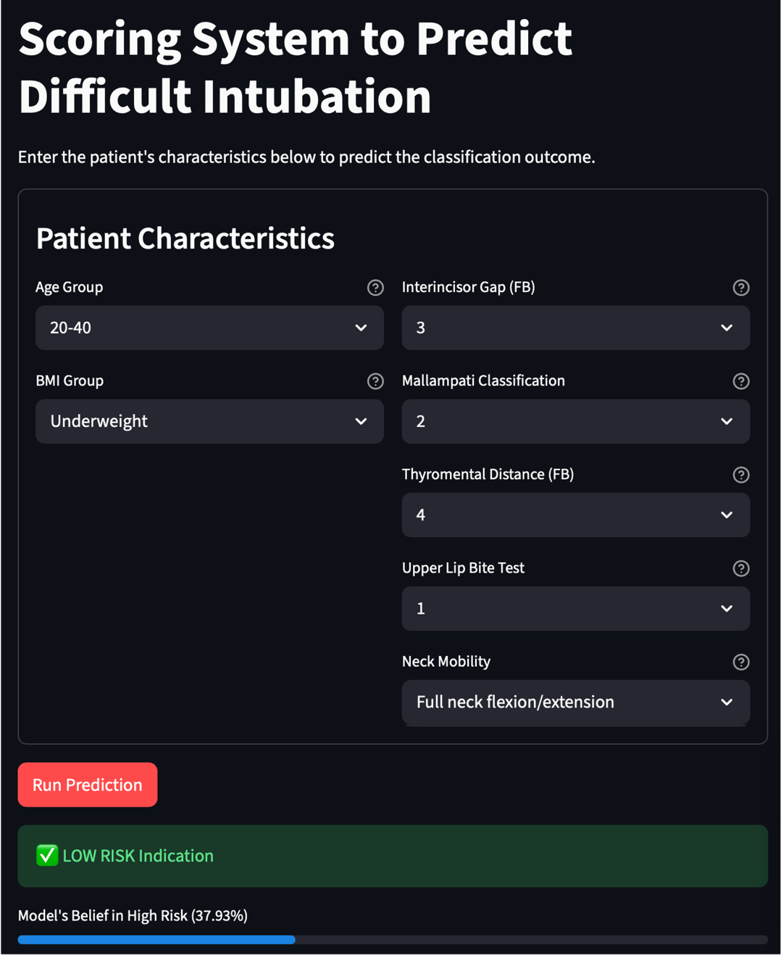
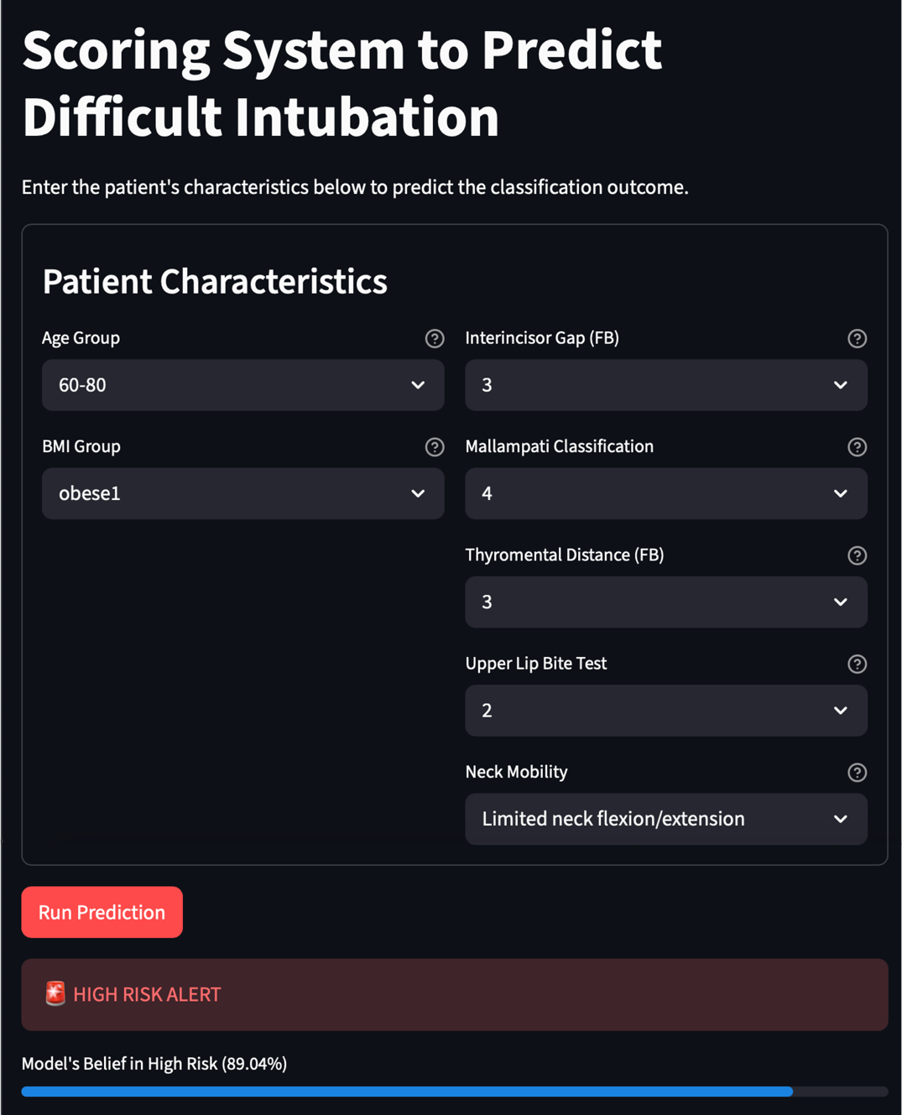

Figure S2 presents the QR code that allows direct access to the web-based application (https://difficultairway.dida.psu.ac.th/) using a mobile device.

Figure S2. QR code for web-based application


The application is intended as a clinical decision-support tool to assist anesthesiologists in preoperative airway assessment and preparedness. It is not intended to replace clinical judgment.

